SGS Flight Handling Reports
Database Design Document
Document 08 of 12
Version 1.0 — September 2026
Technical documentation set: HLD · LLD · Architecture · Data flow · Database · Servers · UAT · GitHub · Code review

Item | Value
Engine | MySQL 8.0, InnoDB
Database | sgs_forms_db
Character set | utf8mb4 (Arabic text), tables use utf8mb4_0900_ai_ci (case- and accent-insensitive comparisons)
Tables | 15 application tables + __efmigrationshistory
Schema management | EF Core code-first migrations, applied automatically at start-up; SQL Deploy/01_schema.sql creates the same schema manually
Migrations | InitialCreate (2026-06-18), AddArrivalBaggageAndAuditLog, RenameStaffCountToPaxExec, AddPaxVip, AddReportListIndex, AddCoordinationSheets, DropCoordSvTcToc, SimplifyCoordActivities, DynamicRolesAndPermissions (2026-08-19)

1. Entity-relationship diagram
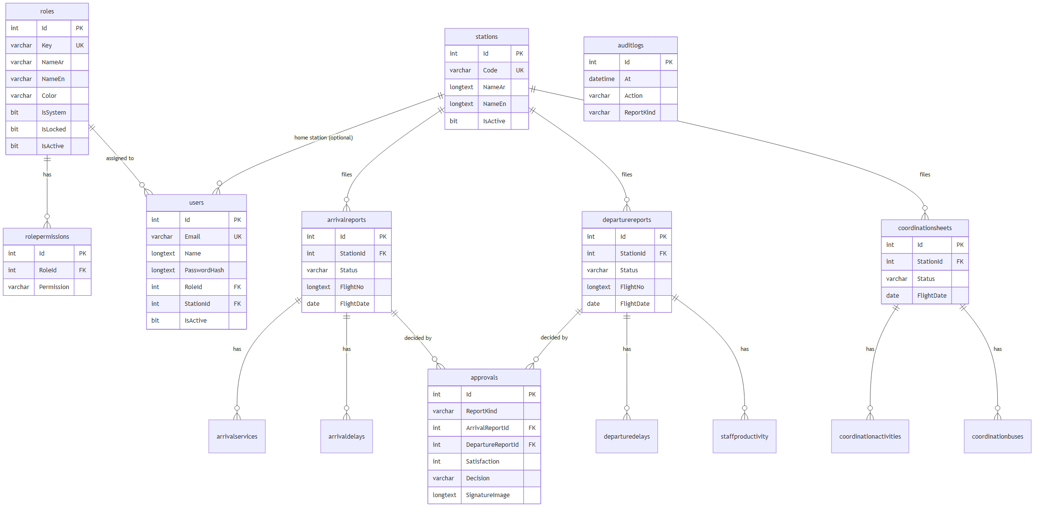
auditlogs has no foreign keys on purpose: log entries survive deletion of the report, user or station they mention.

2. Tables
Type notation: ? = nullable. All Id columns are int AUTO_INCREMENT primary keys. Times are stored in UTC.

Security and reference data
Table | Columns
roles | Id, Key varchar(40) unique, NameAr varchar(80), NameEn varchar(80), Color varchar(20), IsSystem bit, IsLocked bit, IsActive bit, CreatedAt datetime(6)
rolepermissions | Id, RoleId → roles (cascade), Permission varchar(60); unique (RoleId, Permission)
users | Id, Name, Email varchar(255) unique, PasswordHash (BCrypt), RoleId → roles (restrict), StationId? → stations (set null), IsActive bit, LastLogin? datetime(6), CreatedAt, UpdatedAt
stations | Id, Code varchar(255) unique (IATA, 3 letters), NameAr, NameEn, IsActive bit, CreatedAt

Flight handling reports
Table | Columns
arrivalreports | Id, StationId → stations (restrict), Status varchar(20) (Draft / Submitted / Approved / Returned), FlightNo, Route, AircraftReg?, FlightDate date, Sta?, Ata?, SupervisorName?, ReportTime?, GateNo?, GateOpen?, GateClose?, FirstPaxTime?, LastPaxTime?, TtlPaxArr, TtlWchr, PaxVip, BagTotal, ActualPax, NoShow, Offloaded, Remarks?, CreatedByUserId, CreatedAt, UpdatedAt, SubmittedAt?, DraftExpiresAt?
arrivalservices | Id, ArrivalReportId → arrivalreports (cascade), Name, Count
arrivaldelays | Id, ArrivalReportId → arrivalreports (cascade), Code?, Reason?, DurationMinutes
departurereports | Id, StationId → stations (restrict), Status, FlightNo, Route, AircraftReg?, FlightDate, Std?, Atd?, CounterNo?, CountersStartedAt?, SupervisorName?, ReportTime?, PaxExec, PaxF, PaxJ, PaxW, PaxY, PaxInf, PaxHajj, PaxVip, PaxTotal, BagNormal, BagWchr, BagCbbg, BagStcr, BagAvih, BagVip, BagZamzam, BagHajj, BagTotal, ExcessTickets, ExcessSales decimal(12,2), BoardingGate?, BoardingMode? (Jetway / Bus), BoardingStarted?, BoardingCompleted?, GateOpened?, GateClosed?, TotalBuses, SpecialHandling?, ActualPax, NoShow, Offloaded, Remarks?, CreatedByUserId, CreatedAt, UpdatedAt, SubmittedAt?, DraftExpiresAt?
departuredelays | Id, DepartureReportId → departurereports (cascade), Code?, Reason?, DurationMinutes
staffproductivity | Id, DepartureReportId → departurereports (cascade), StaffName, PassengersServed, Comments?
approvals | Id, ReportKind varchar(20), StationId, ArrivalReportId? → arrivalreports (cascade), DepartureReportId? → departurereports (cascade), Satisfaction (1–5; 0 for returns), AirlineRemarks?, AirlineRepName, AirlineCompany, AirlineRepPosition?, SignatureImage? (base64 data URL, longtext), Decision (Approved / Returned), ReturnReason?, ApprovedByUserId, ApprovedAt datetime(6)

Coordination sheets
Table | Columns
coordinationsheets | Id, StationId → stations (restrict), Status (Draft / Submitted), FlightDate, AcType?, AcReg?, ArrFlightNo?, ArrFrom?, ArrPaxF/J/Y, DepFlightNo?, DepTo?, DepPaxF/J/Y, Turnaround bit, Transit bit, Terminating bit, Originating bit, Sta?, Ata?, Std?, Atd?, GainTime?, DlyAmount (minutes), DelayCode?, SupervisorName?, ReportTime?, Remarks?, CreatedByUserId, CreatedAt, UpdatedAt, SubmittedAt?, DraftExpiresAt?
coordinationactivities | Id, CoordinationSheetId → coordinationsheets (cascade), ActivityKey varchar(40) (one of 24 keys), ActualStart?, ActualFinish?, Remarks?
coordinationbuses | Id, CoordinationSheetId → coordinationsheets (cascade), Phase varchar(10) (arrival / departure), BusNo?, Time?

Audit
Table | Columns
auditlogs | Id, At datetime(6), UserId?, UserName, UserRole, StationId?, StationCode?, Action varchar(20) (create / update / submit / approve / return / delete), ReportKind varchar(20) (arrival / departure / coordination), ReportId?, FlightNo?, Details?

3. Indexes
Table | Index | Used by
arrivalreports, departurereports, coordinationsheets | (StationId, Status), (Status, FlightDate), (FlightDate) | Lists by status, station and date; dashboard
approvals | (ArrivalReportId), (DepartureReportId), (ReportKind, ArrivalReportId, DepartureReportId) | Latest decision of a report
auditlogs | (At) | Activity log ordered by time
users | Email unique, (StationId), (RoleId) | Login, joins
child tables | FK column | Loading a report with its rows

4. Integrity rules
Rule | Enforcement
A station with users or reports cannot be deleted | Application check (409) + FK RESTRICT
A role in use cannot be deleted | Application check + FK RESTRICT
Deleting a report deletes its services, delays, staff rows and approvals | FK CASCADE
Deleting a coordination sheet deletes its activities and buses | FK CASCADE
Approved reports cannot be edited or deleted | Application rule
E-mail, station code, role key are unique | Unique indexes

5. Volume estimates
Measured on the current database (September 2026): report rows are about 2–3 KB each including child rows; the dominant item is the signature image stored with each approval — average 37 KB, largest 111 KB (13 approvals).
Volume assumption | Reports per year | Approvals with signature | Approx. growth per year
50 reports / day, half approved | ≈ 18,000 | ≈ 9,000 | ≈ 50 MB rows + ≈ 330 MB signatures ≈ 0.4 GB
200 reports / day, half approved | ≈ 73,000 | ≈ 36,500 | ≈ 200 MB rows + ≈ 1.3 GB signatures ≈ 1.5 GB

Indexes and InnoDB overhead add roughly 30–50 %. Backups compress well except for the signature images.

6. Accounts
Account | Rights | Use
root | Everything | Installation only; must not be used by the application
sgs_app (from 00_create_database.sql) | SELECT, INSERT, UPDATE, DELETE, CREATE, ALTER, INDEX, DROP, REFERENCES on sgs_forms_db | Application (needs DDL rights because migrations run at start-up) — restrict its host to the application server

