Take 3 machine Ubuntu 24 lts

Jenkins t2 large 25 gb t2.large

Snar and nexus 20 gb t2.medium

On Jenkins server

# run as a non root user

sudo apt install openjdk-17-jre-headless

vi jen.sh

type on googleinstall jenkins

sudo chmod +x jen.sh

./jen.sh

sudo snap install kubectl –classic

# install docker

curl -fsSL https://get.docker.com -o get-docker.sh

sudo chmod +x get-docker.sh

./get-docker.sh

sudo chmod 666 /var/run/docker.sock

#take yhe ip and paste on google <ip:8080>

#install sonarqube on sonarqube server

sudo snap install docker -y

sudo chmod 666 /var/run/docker.sock

sudo docker run -d -p 9000:9000 sonarqube:lts-community

admin

admin

# install nexus on nexus server

sudo snap install docker -y

sudo chmod 666 /var/run/docker.sock

sudo docker run -d -p 8081:8081 sonatype/nexus3

sign in

admin

docker exec <conid> cat /nexus-data/admin.password

anonymus enable

now goto Jenkins install plugin

[Pipeline: Stage View](https://plugins.jenkins.io/pipeline-stage-view) 🡪 view the running pipeline over the stages

[Eclipse Temurin installer](https://plugins.jenkins.io/adoptopenjdk) 🡪to install the multiple version java

[SonarQube Scanner](https://plugins.jenkins.io/sonar) 🡪 for code quality and publish artifact to sonarqube

[Maven Integration](https://plugins.jenkins.io/maven-plugin) 🡪 build as a tool

[Config File ProviderVersion](https://plugins.jenkins.io/config-file-provider) 🡪 when u want to publish your artifact to nexus u need to authenticate to nexus the so the credential for authenticating to nexus is provided inside file name as setting.xml file that file have inside Jenkins and that file we get by this file

[Pipeline Maven Integration](https://plugins.jenkins.io/pipeline-maven) 🡪

[Docker](https://plugins.jenkins.io/docker-plugin)

[Docker Pipeline](https://plugins.jenkins.io/docker-workflow)

[Kubernetes](https://plugins.jenkins.io/kubernetes)

[Kubernetes CLI](https://plugins.jenkins.io/kubernetes-cli)

Once this tools install we have to configure few of them that we are configure inside tool section

Manage Jenkins 🡪 tools

JDK installations

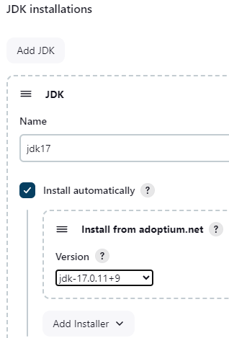

SonarQube Scanner installations

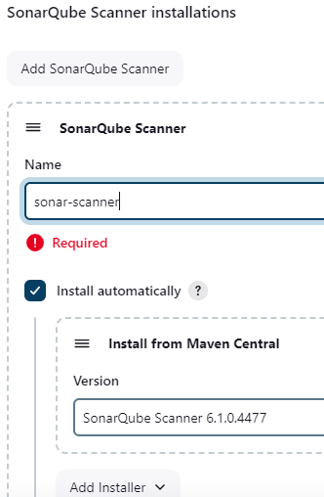

Maven installations

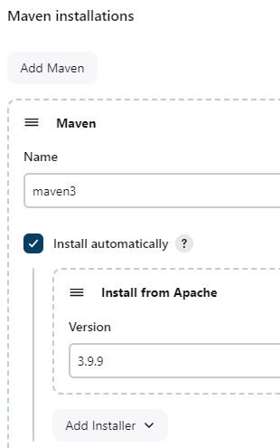

Docker installations

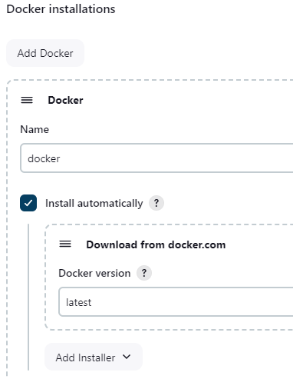

Now tool has been configured

Now start writing pipeline 🡪 new item

Checkout stage

Pipeline syntax

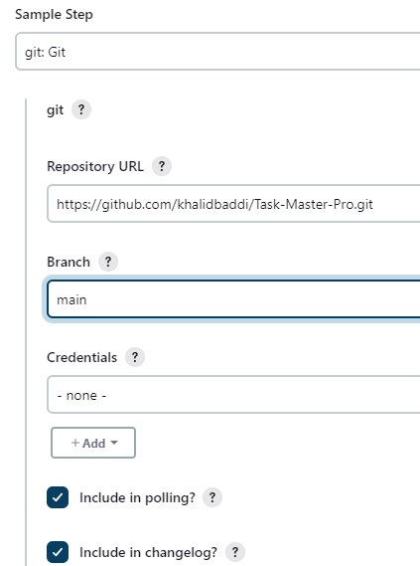

Generate syntax

Stage compile

Stage unit test

Stage trivy install trivy on Jenkins server

Trivy install on Ubuntu

Vi trivy.sh

sudo chmod +x trivy.sh

./trivy.sh

Stage sonarqube analysis

Configure build tool into pipeline

Now we want soncanner publish the report on sonarqub server and server need to authenticate for that create token

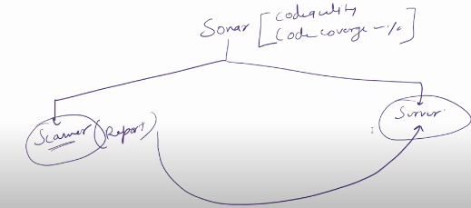

Goto sonarqube server 🡪 administration🡪 security🡪 user🡪 create token click on token

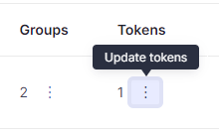

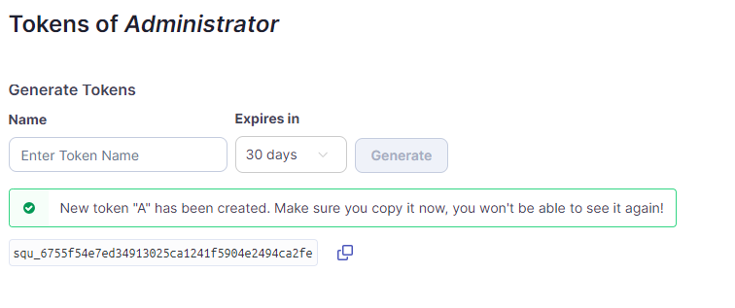

Goto manage credential 🡪

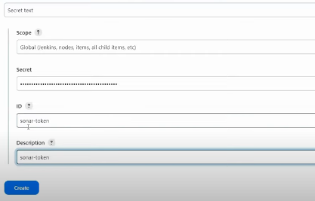

Goto system to configure sonarqube system

Take url of sonarqube remove last slash

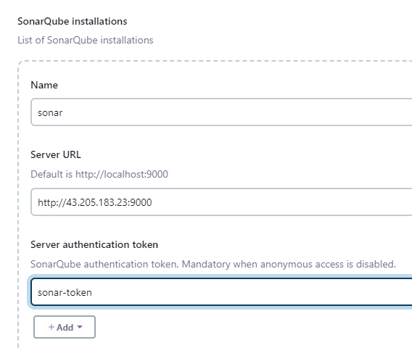

Pipeline syntax

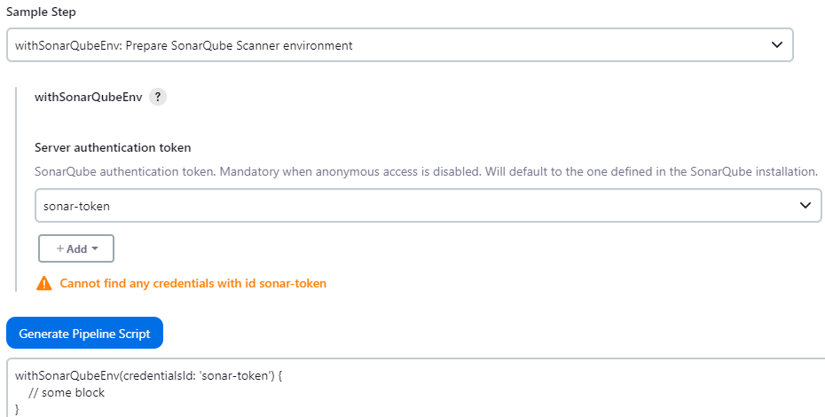

In this block we need to provide the information about the server and report publish on server

So we have already configure the server in systeme with name “sonar”

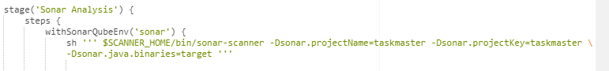

Stage application build

Sh ‘mvn package’

Now configure nexus inside Jenkins

Two we need to configure nexus into Jenkins

Nexus url

Nexus credential

Goto nexus 🡪 browse🡪 copy maven snapshot and release and paste in pom.xml

<distributionManagement>

<repository>

<id>maven-releases</id>

<url> http://43.205.183.23:8081/repository/maven-releases/ </url>

</repository>

<snapshotRepository>

<id>maven-snapshots</id>

<url> http://43.205.183.23:8081/repository/maven-snapshots/ </url>

</snapshotRepository>

</distributionManagement>

Now goto manage Jenkins 🡪 manage file 🡪 add new config 🡪 global maven settings.xml🡪 give name like settings-maven 🡪 click on next

Will get some content file below here we have to provide some credential

Cut the arrow from bottom and paste to top

Provide user and passwd of nexus

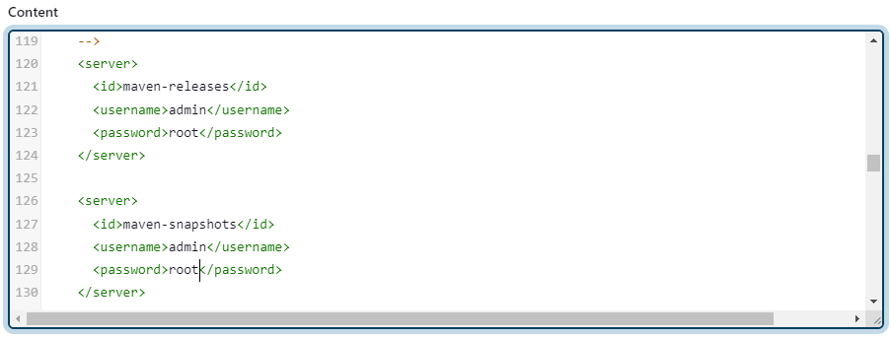

submit

pipeline syntax

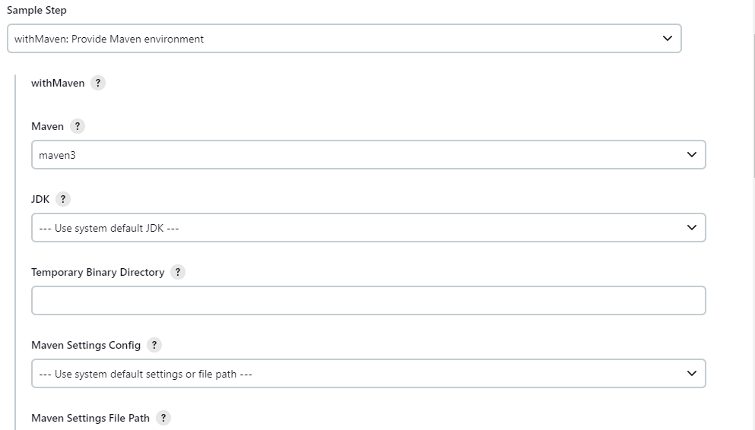

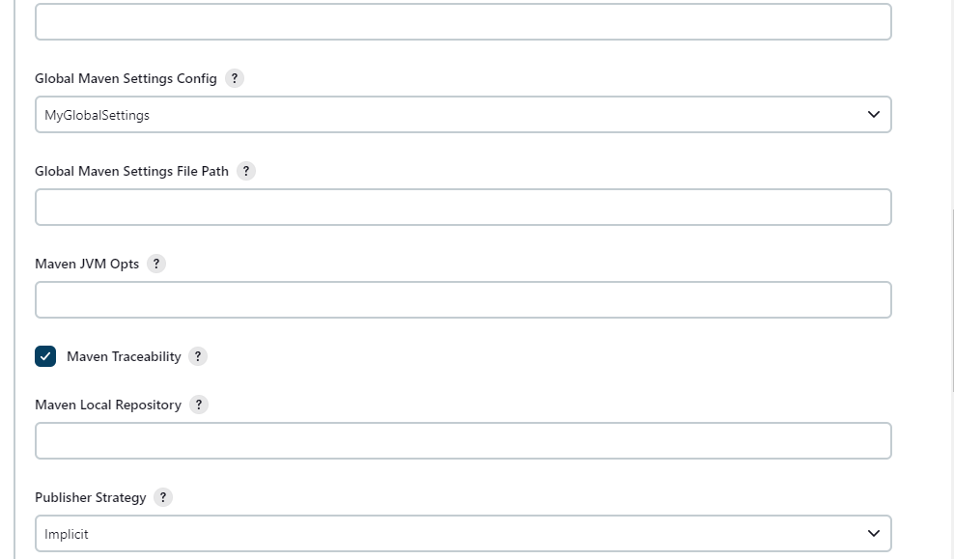 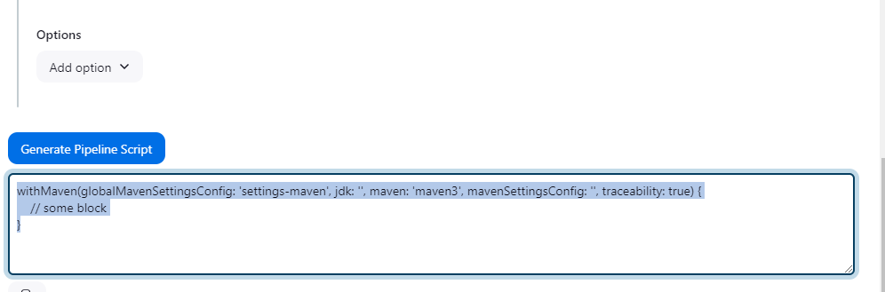



Stage docker build and tag

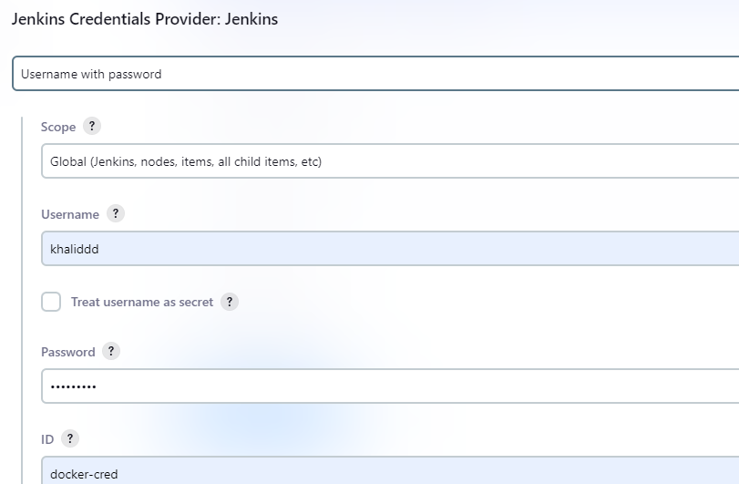

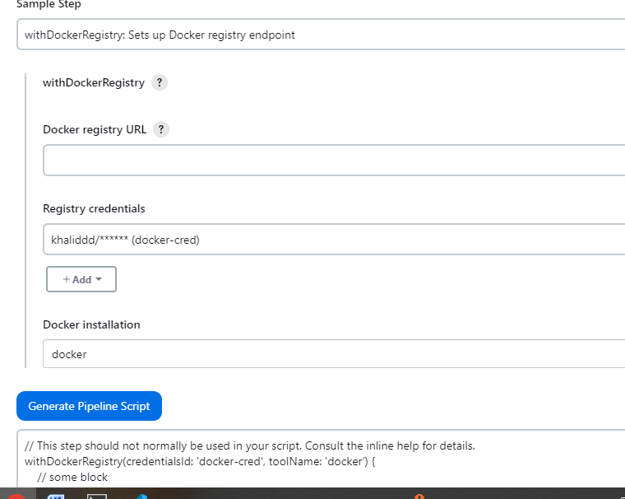

Stage trivy scan image

Stage push image to dockerhub

Now create the RBAC to authenticate link is below

<https://github.com/jaiswaladi246/Task-Master-Pro/blob/main/RBAC.md>

goto eks server

# create service account vi sa.yaml

#Create namespace

kubectl create ns webapps

Download file from here

<https://github.com/khalidbaddi/jenkins-k8s-authentication>

# vvi put the namespace ahead

kubectl apply -f sec.yaml -n webapps

# describe the secret

kubectl describe secret mysecretname -n webapps

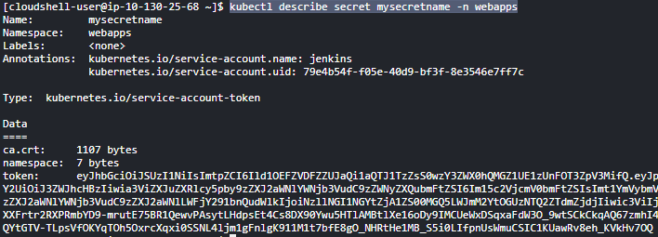

Now goto Jenkins

Stage k8s deploy

Create token

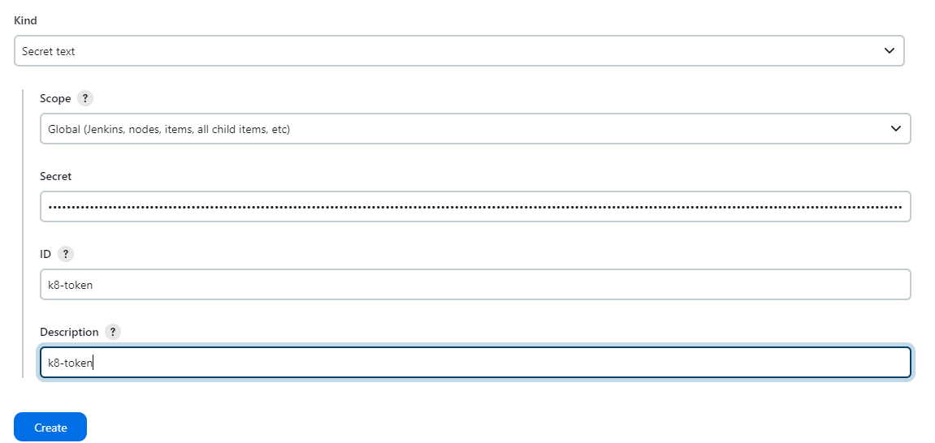

Pipeline syntax

