SAUDI WATER AUTHORITY — INTERNAL PLATFORM DOCUMENTATION
Tadawul Platform
Technical & UX Reference — Task Management System
Version 1.0 | May 2026 | Audience: Development Team | Status: Draft

1. System Overview
The Task Management System (اجتماع تداول) is the core workflow module of the Tadawul platform. It enables cross-departmental task creation, assignment, tracking, and approval — all within a role-based access model that reflects the organisational hierarchy of the Saudi Water Authority.

1.1 User Roles

Admin / مشرف  Full visibility across all departments. Can create, edit, delete and approve any task. | Deputy / وكيل  Cross-department read/write. Creates tasks, approves change requests, exports reports. | Manager / مدير  Department-scoped. Manages own department tasks, approves employee submissions. | Employee / موظف  Personal task view. Updates status, adds comments, submits change requests.

2. UX Walkthrough

2.1 Landing / Hub Page
After login, all users land on a unified hub page that surfaces the systems they are authorised to access. The hub adapts to the user's role — an employee sees only relevant systems, while an admin sees all five. The topbar shows the user's name, role, last login timestamp, and a live server-status indicator dot.

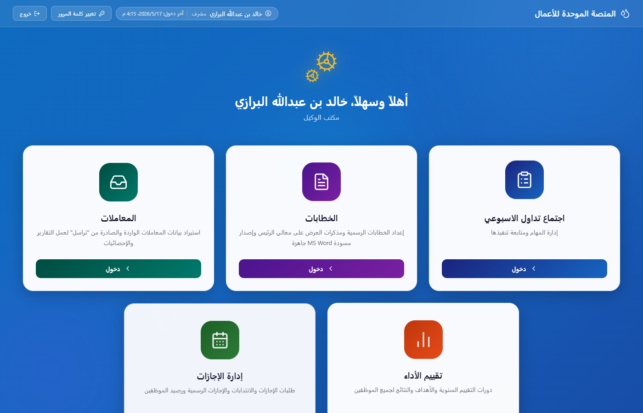
Figure 1 — Hub landing page (Admin view, showing all 5 systems)

2.2 Deputy / Admin View
The deputy/admin dashboard provides a full cross-department view. Key elements:
- Department tabs — filter tasks by department with live task counts per tab.
- KPI cards — at-a-glance counts for pending approval, high priority, in-progress, and completed tasks.
- Approval queue — dedicated panel showing tasks awaiting sign-off, separate from the main list.
- Stopwatch widget — floating draggable meeting timer for weekly review sessions.
- Export — one-click Excel export of the current filtered view.
- Kanban / Table toggle — switch between tabular and board-style task views.

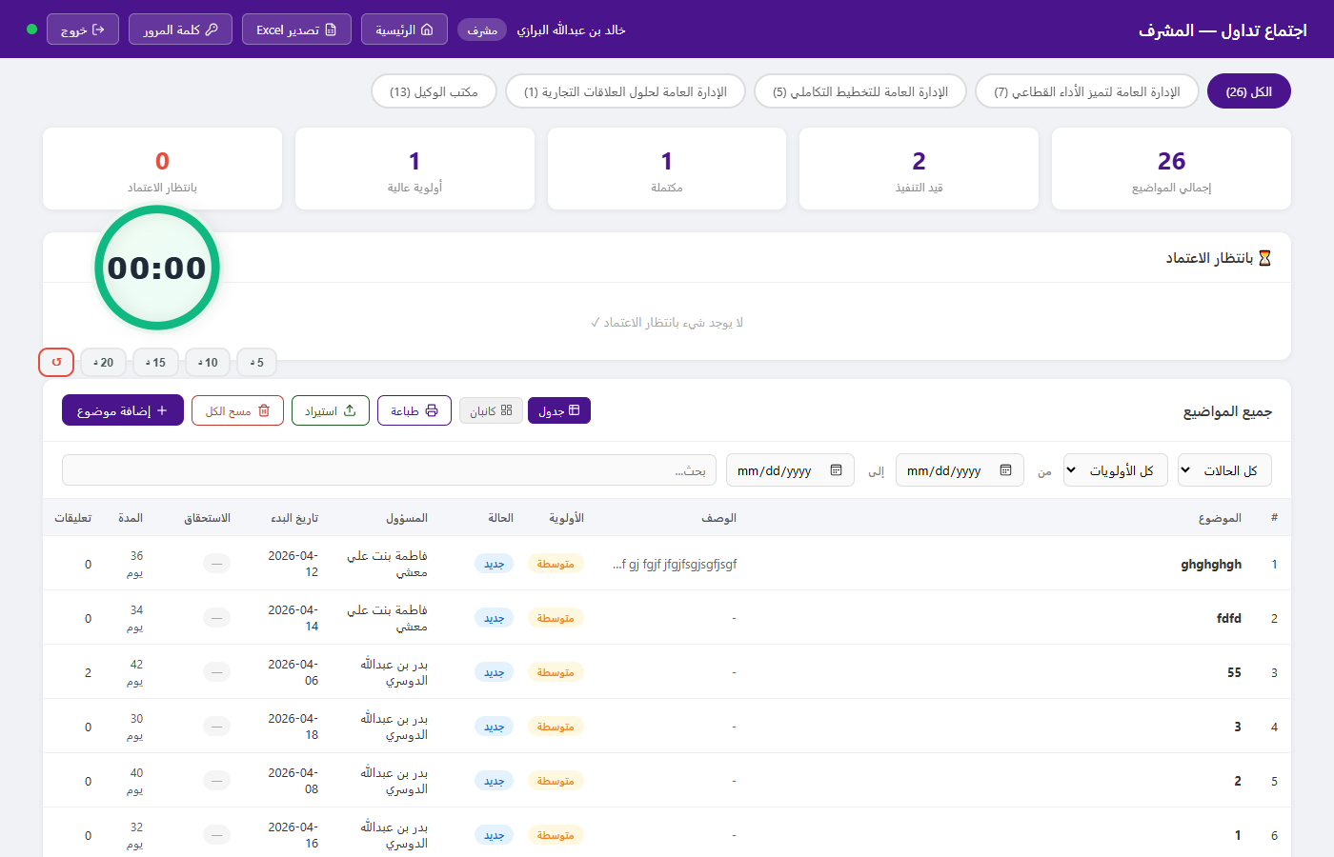
Figure 2 — Deputy/Admin task dashboard (cross-department view, KPI cards, approval queue)

2.3 Task Creation
Tasks are created via a modal dialog accessible to managers, deputies, and admins. Fields include title, description, target department, assignee, priority, start date, and due date. On save, the task becomes immediately visible to the assigned employee and department manager via a real-time Server-Sent Events (SSE) push — no page refresh required.

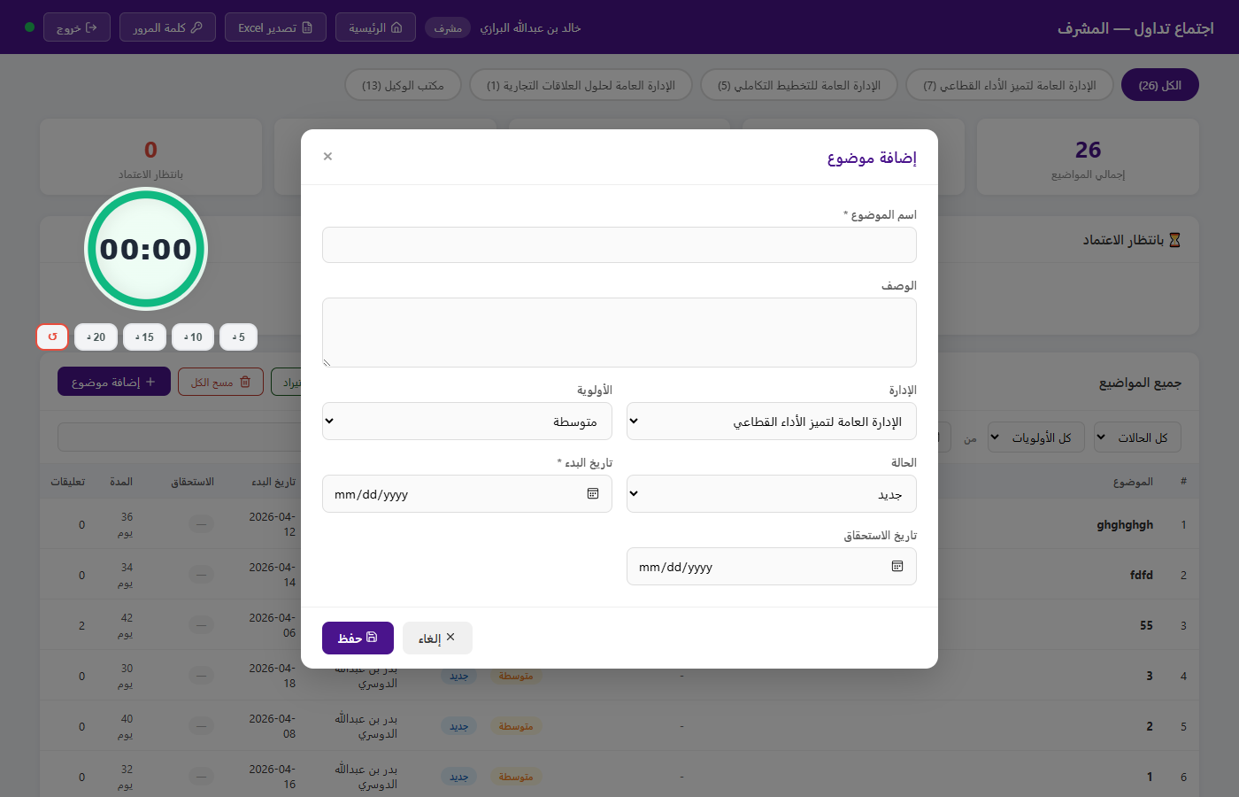
Figure 3 — Task creation modal (Deputy view)

2.4 Manager View
Managers see tasks scoped to their department only. The interface includes an approval queue for employee-submitted change requests (status updates, due date adjustments) and a full task list with filters for status, priority, assignee, and date range.

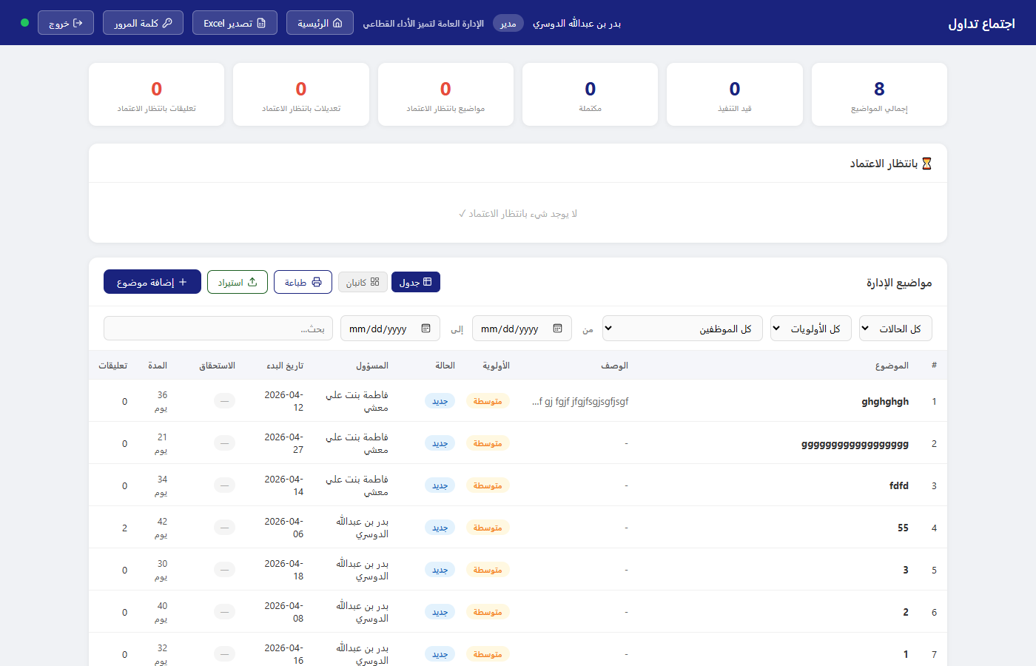
Figure 4 — Manager task dashboard (department-scoped)

2.5 Employee View
Employees see only tasks assigned to them. They can update task status (with manager approval required for certain transitions), add comments, and submit change requests for due dates. The interface intentionally omits cross-department visibility and administrative controls.

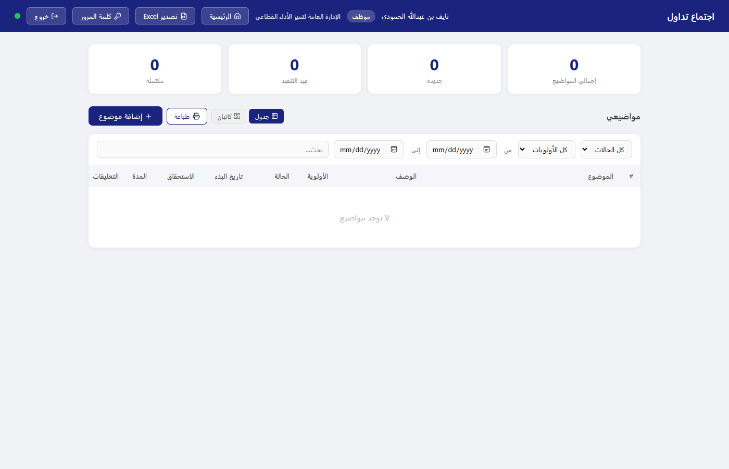
Figure 5 — Employee task view (personal tasks only)

3. Key Business Rules

3.1 Task Status Workflow
Tasks progress through three states: جديد (New) → قيد التنفيذ (In Progress) → مكتملة (Completed)
Status transitions submitted by employees generate change requests that appear in the manager's approval queue. Deputies and admins can transition any task directly without an approval step.

3.2 Change Request Approval
- Employees submit requests to change status or due date — changes do not apply immediately.
- The request appears in the manager's and deputy's approval panel.
- On approval, the change is applied and all connected clients refresh automatically via SSE.
- On rejection, the task remains unchanged and the request is marked declined.

3.3 Real-Time Synchronisation

All connected clients receive live updates when any task is created, modified, or approved. This is implemented via Server-Sent Events (SSE) — an open HTTP stream that pushes a broadcast signal on any data change. Clients silently re-fetch their own data slice in the background. No manual refresh is needed.

4. Technical Architecture

4.1 Current Stack

Layer | Technology | Purpose
Runtime | Node.js 20 + Express 5 | HTTP server, REST API, SSE endpoint
Database | SQLite (better-sqlite3) | All persistent data — tasks, users, departments, history
Authentication | JWT (jsonwebtoken, bcryptjs) | Stateless tokens, 8-hour expiry, role embedded in payload
Real-time | Server-Sent Events (SSE) | One-way server-to-client broadcast on data changes
Frontend | Vanilla HTML / CSS / JS | Static files served by Express; no framework, no build step
Icons | Lucide (CDN) | Consistent icon set across all pages
Export | SheetJS / XLSX (CDN) | Client-side Excel generation from filtered task data

4.2 Data Model — Tasks

Field | Type | Description
id | TEXT (UUID) | Primary key
name | TEXT | Task title
description | TEXT | Optional detail body
priority | TEXT | عالية / متوسطة / منخفضة
status | TEXT | جديد / قيد التنفيذ / مكتملة
dept_id | INTEGER (FK) | → departments
assigned_to | TEXT (FK) | → employees
created_by / role | TEXT | Creator ID and role at time of creation
start_date / due_date | TEXT (ISO 8601) | Task date range
approved | INTEGER (0/1) | 1 = live, 0 = pending deputy approval
created_at | TEXT (ISO 8601) | Server-generated timestamp

4.3 API Endpoints — Tasks

Method | Endpoint | Access | Description
GET | /api/tasks/all | Deputy, Admin | All tasks across all departments
GET | /api/tasks/dept/:id | Manager | Tasks for own department only
GET | /api/tasks/my | Employee | Tasks assigned to the calling user
POST | /api/tasks | Manager+ | Create a new task
PATCH | /api/tasks/:id | Manager+ | Update task fields directly
POST | /api/tasks/:id/changes | Employee | Submit a change request
PATCH | /api/tasks/changes/:id | Manager+ | Approve or reject a change request
DELETE | /api/tasks/:id | Deputy, Admin | Delete a task permanently

4.4 Authentication Flow
POST /api/auth/login → JWT issued (role + ID embedded) → Stored in sessionStorage (tab-scoped) → Bearer header on every API call → Middleware validates token and injects req.user

4.5 Real-Time Architecture
A single /api/events SSE endpoint maintains an open connection to every active browser tab. On any write operation (task create/update/delete/approve), the server calls broadcast() which sends a lightweight signal to all connected clients. Each client re-fetches only its own data slice. A server-side heartbeat (every 5 seconds) keeps connections alive and allows clients to detect server unavailability via a 12-second silence threshold.

Server status indicator: A coloured dot in every page's topbar reflects live connectivity — green (server up), red (server unreachable). State is driven by a 3-second HTTP ping and the SSE heartbeat. No user action is required to reconnect after a server restart or PC wake from sleep.

