Login Page: Enhancement/Bugs:

* Company LOGO should be displayed on the page when launching the login page .
* Welcome message should be appear stating what is this page about. E.g. “Please sign to continue to qa test page” OR Sign in to continue to qa crowdsurge page
* Need Help ( or forget username or password) missing
* If email address is incomplete , error message should be thrown for the email address but instead it displays error message for both username & password. e.g. abc@gmail
* If email text box has one character e.g. “a” , message should be displayed to enter correct email address but it appears telling user that next character is missing e.g. “@”

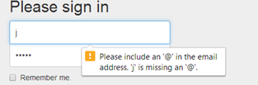

After Login Screen: Bug/Enhancement:

* Change the color of crowdsurge (home button) and logout button and plus the banner
* Crowdsurge link does not work , it should direct to the home page
* Username name should be presented on the banner

