**IDENTITY SERVER for UTeM**

1. **Identity Server is an authentication server that implements OpenID**

**Connect (OIDC) and OAuth 2.0 standards for ASP.NET Core. It's**

**designed to provide a common way to authenticate requests to all of UTeM applications, whether they're web, native, mobile, or API endpoints.**

1. **This documentation is base on following website :**

<https://duendesoftware.com/products/identityserver>

<https://identityserver4.readthedocs.io/en/latest/>

1. **Terminology Server in UTeM (Before Identity Server) :**

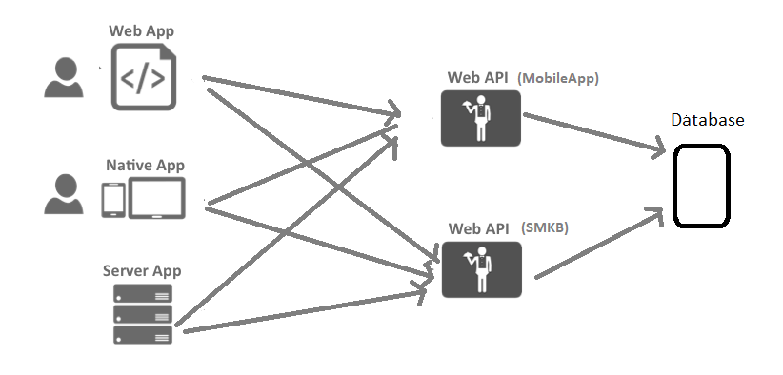

1. **Terminology Server in UTeM (After Implementation Identity Server) :**

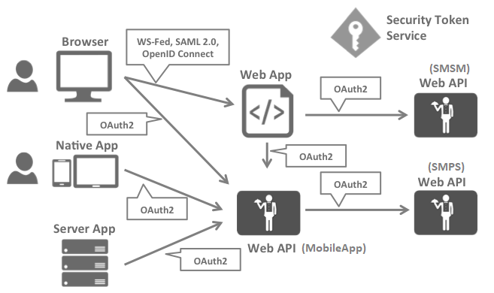

1. **System testing is necessary because it helps to identify any defects or issues that may arise when the identity server**

**is deployed at UTeM . It is also an effective way of ensuring**

**that the software conforms to the specifications and meets the business requirements :**

\\10.10.0.125\identity_server\SampleClientTesting

Server terlibat :

<https://devmobile.utem.edu.my/smps/>

<https://devmobile.utem.edu.my/smsm/>

<https://devmobile.utem.edu.my/identity/>

<https://devmobile.utem.edu.my/notify/>