Phishing Campaign
Security Awareness Assessment Report
Conducted using GoPhish Framework

CONFIDENTIAL — FOR AUTHORIZED USE ONLY

1. Executive Summary
This report documents a simulated phishing campaign conducted using the GoPhish framework as part of a security awareness assessment. The campaign was designed to evaluate user susceptibility to credential harvesting attacks by impersonating Google security notifications and directing targets to a cloned Google login page.
The campaign successfully demonstrated the full phishing attack lifecycle — from sending a convincing phishing email to capturing credentials entered by the target on a fake login portal. The results highlight the effectiveness of social engineering techniques and the importance of user security training.

2. Campaign Configuration
The following table summarizes the key configuration parameters used in this phishing campaign:

Campaign Name | HACKER
Email Template | Google — "2-Step Verification turned on"
Landing Page | Google.login (Cloned Google Sign-In)
Sending Profile | Male (SMTP via smtp.gmail.com:587)
SMTP From | khalidk2623@gmail.com
Target Group | khan
Target | khalid khan (khalidk5251@gmail.com)
Phishing URL | http://192.168.100.45

3. Campaign Setup — Step by Step

3.1 Sending Profile Configuration
The sending profile named "Male" was configured to use Gmail's SMTP server on port 587 (STARTTLS). The "Ignore Certificate Errors" option was enabled. This profile authenticated using the attacker-controlled Gmail account and served as the mail delivery mechanism for the phishing emails.
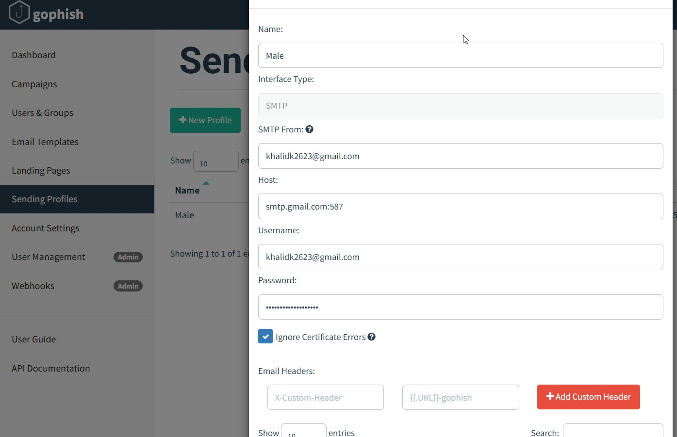
Figure 1: GoPhish Sending Profile — SMTP configuration using Gmail

3.2 Landing Page — Cloned Google Login
A fake landing page named "Google.login" was created by importing and cloning the authentic Google sign-in page HTML. The "Capture Submitted Data" and "Capture Passwords" options were both enabled, meaning any credentials entered by the target would be recorded in the GoPhish database in cleartext. The system displayed a warning that captured passwords are not encrypted.
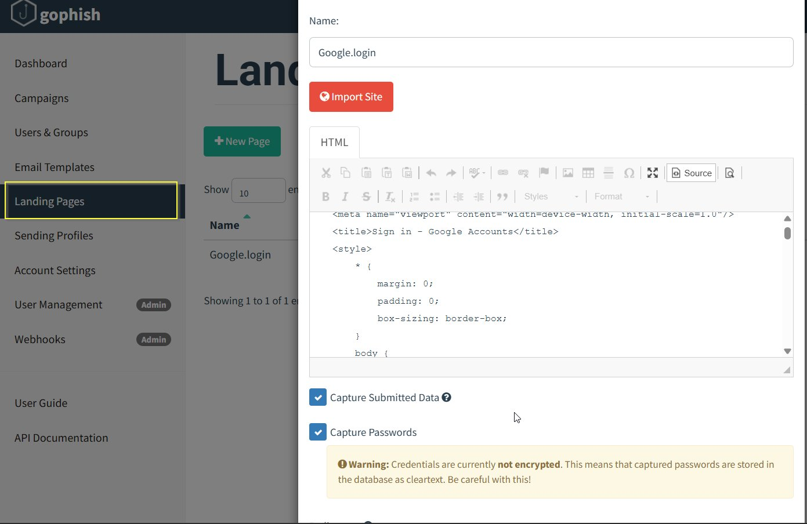
Figure 2: GoPhish Landing Page — Cloned Google login with credential capture enabled

3.3 Email Template
The phishing email template was named "Google" and impersonated a legitimate Google security alert. The subject line "2-Step Verification turned on" was chosen to create urgency and appear authentic. The email body closely mimicked Google's actual 2-Step Verification notification format, including the target's email address and a call-to-action link. A tracking pixel was also added to detect when the email was opened.
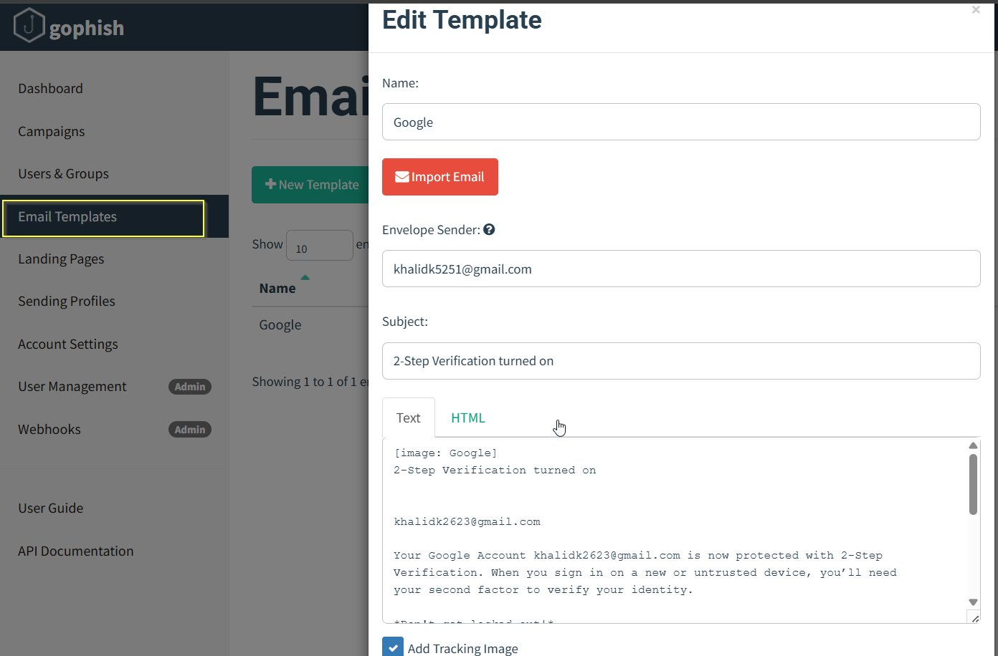
Figure 3: GoPhish Email Template — Google 2-Step Verification impersonation

3.4 Target Group
A user group named "khan" was created containing a single target: khalid khan (khalidk5251@gmail.com). In a real-world engagement, this group would typically contain multiple targets sourced from OSINT or provided by the client organization.
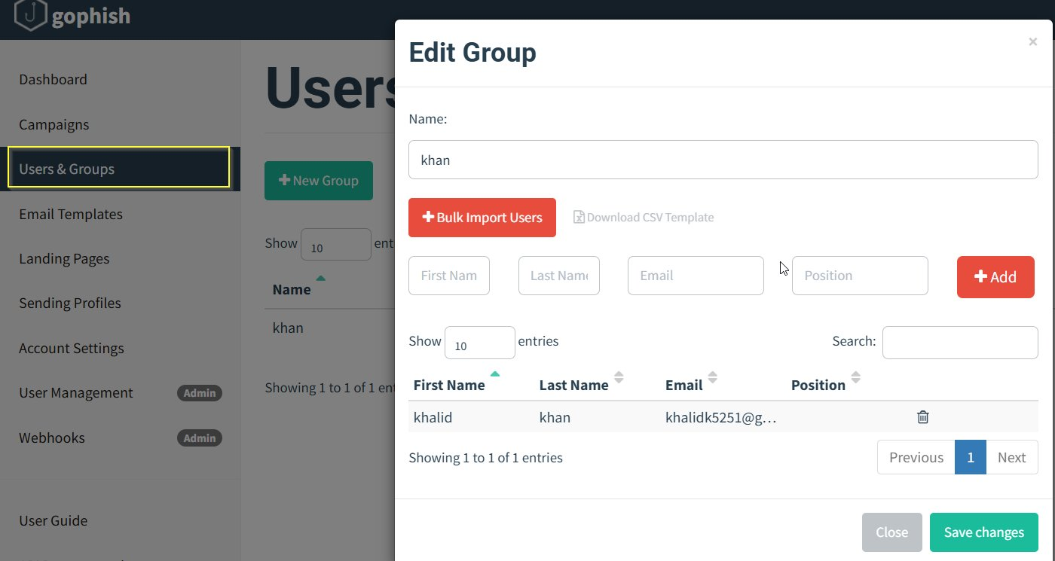
Figure 4: GoPhish Users & Groups — Target "khalid khan" in group "khan"

3.5 Campaign Launch
The campaign named "HACKER" was configured with all the above components and launched. The phishing URL pointed to the attacker's server at http://192.168.100.45 where the cloned Google login page was hosted. The campaign was launched immediately upon configuration.
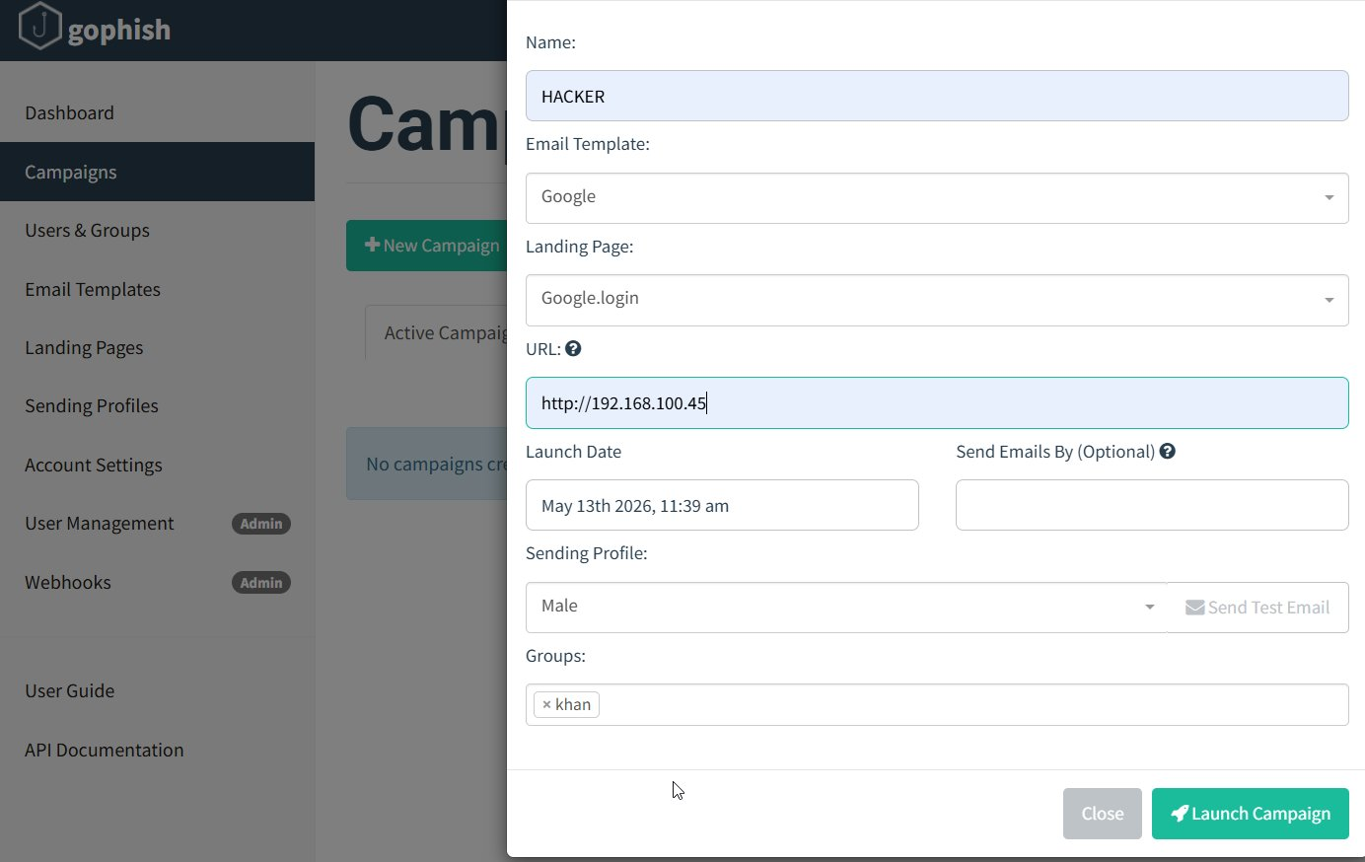
Figure 5: GoPhish Campaign Launch — All components tied together

4. Attack Execution

4.1 Email Delivery
Upon launching the campaign, GoPhish confirmed that 1 email was successfully sent. The campaign dashboard showed the email as delivered, with Email Opened, Clicked Link, Submitted Data, and Email Reported all at 0 at the time of initial launch — pending the target's interaction.
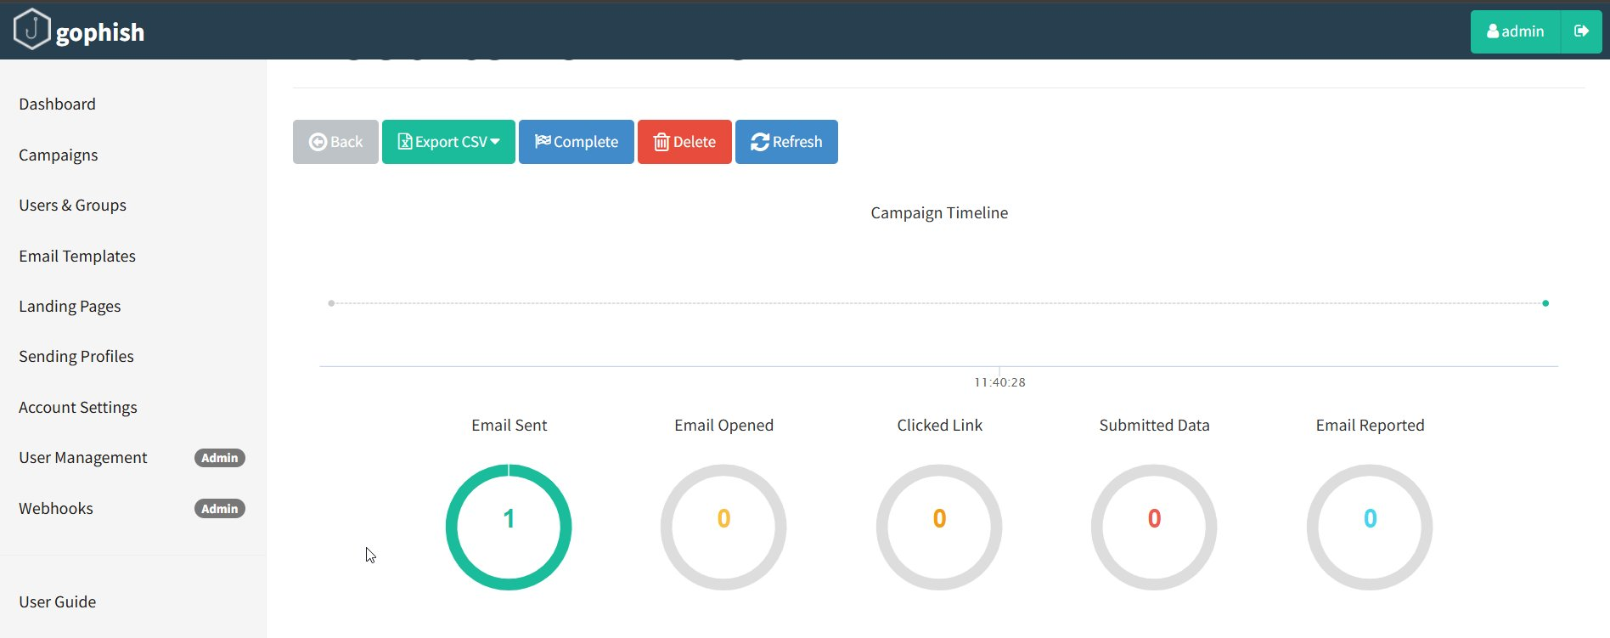
Figure 6: GoPhish Dashboard — Campaign launched, 1 email sent

4.2 Phishing Email as Received by Target
The target received the phishing email, which appeared visually identical to a legitimate Google 2-Step Verification notification. The email displayed the Google logo, the target's email address, and professional formatting indistinguishable from genuine Google security emails. The embedded tracking link was embedded within the email content.
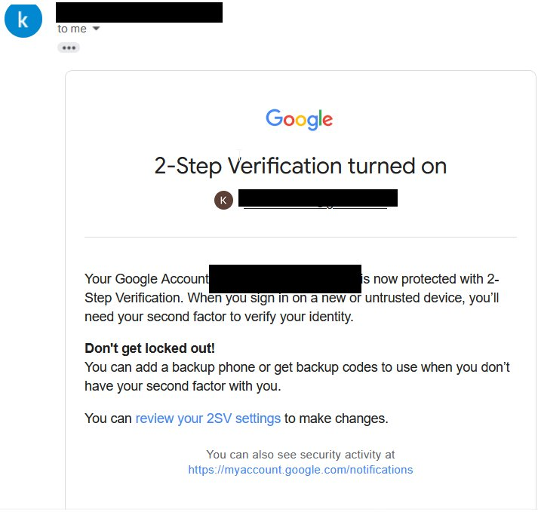
Figure 7: Phishing email as received — convincing Google 2-Step Verification impersonation

4.3 Fake Login Page
When the target clicked the link in the phishing email, they were redirected to the cloned Google login page hosted at http://192.168.100.45. The URL included a unique tracking parameter (?rid=EZZ4tr9) allowing GoPhish to attribute the visit to the specific target. The browser flagged the connection as "Not Secure" due to the absence of HTTPS, but the visual appearance of the page closely replicated the legitimate Google sign-in interface.
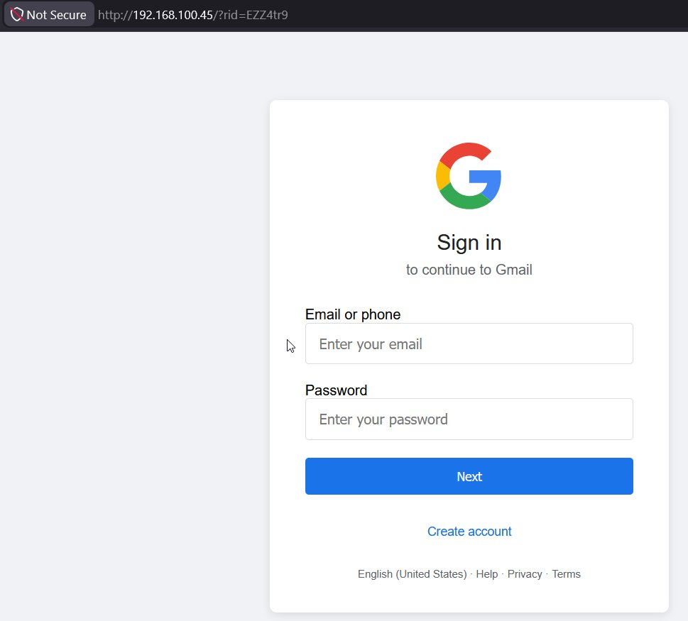
Figure 8: Fake Google login page served from attacker's server (192.168.100.45)

5. Campaign Results

5.1 Dashboard Statistics
After the target interacted with the campaign, the GoPhish dashboard updated to reflect the full attack chain completion. All four key metrics — Email Sent, Email Opened, Clicked Link, and Submitted Data — each registered a count of 1, confirming 100% success across every stage of the phishing lifecycle.
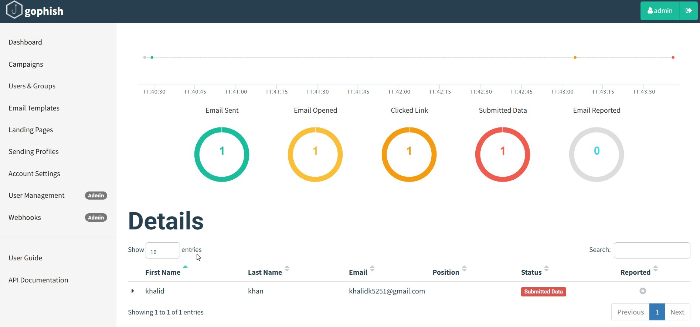
Figure 9: GoPhish Results Dashboard — All stages completed: Sent, Opened, Clicked, Submitted

5.2 Captured Credentials
The individual target timeline confirms the complete attack sequence for khalid khan. GoPhish recorded the campaign creation, email delivery, link click (from Windows 10 / Firefox 150.0), and credential submission. The "View Details" section reveals the credentials captured from the fake login form:

Username | hacker
Password | hack12356

The "Replay Credentials" feature was also available, which could be used to attempt automated login to the real Google service using the stolen credentials.
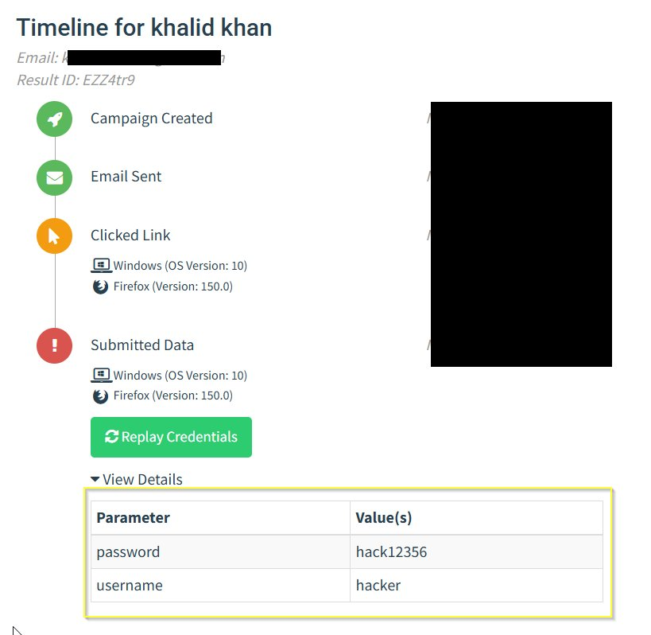
Figure 10: Target timeline and captured credentials — username and password harvested

6. Campaign Results Summary
Emails Sent | Emails Opened | Links Clicked | Data Submitted | Reported
1 | 1 | 1 | 1 | 0

7. Key Findings
- The target opened the phishing email, demonstrating susceptibility to Google-branded social engineering.
- The target clicked the malicious link despite the browser showing a "Not Secure" warning for the HTTP URL.
- The target submitted credentials on a visually convincing but fake login page hosted on a local IP address.
- Username and password were captured in plaintext in the GoPhish database.
- The attack achieved a 100% success rate across all measured engagement metrics.

8. Recommendations
- Security Awareness Training: Conduct regular phishing awareness training, particularly focusing on identifying social engineering tactics impersonating trusted brands like Google.
- URL Verification: Train users to always inspect URLs before entering credentials, especially checking for HTTPS and correct domain names.
- Multi-Factor Authentication: Enforce hardware-based MFA (e.g., FIDO2/WebAuthn) which is resistant to phishing, unlike SMS or TOTP codes.
- Email Filtering: Implement advanced email filtering solutions to detect and quarantine phishing emails before they reach end users.
- Incident Reporting: Establish and promote a clear procedure for users to report suspicious emails.

This report was generated for authorized security awareness testing purposes only. All activities were conducted in a controlled environment.

