DebtOS — Advanced Product Requirements Document
DebtOS is a predictive financial survival platform focused on helping users understand future cashflow pressure, EMI stacking, debt reduction, and safe spending behavior. Unlike traditional budgeting apps, DebtOS focuses on forecasting and behavioral intervention rather than historical expense tracking.

1. Product Vision
DebtOS exists to solve one core problem:
People do not understand the future consequences of today's financial decisions.
The product should become:
- a live financial command center
- a debt reduction system
- a cashflow prediction engine
- a behavioral spending control platform
The long-term vision is to become:
"The operating system for personal financial survival."

2. Core User Psychology
Users do not overspend because they are bad people.
Users overspend because:
- EMIs psychologically feel small
- Minimum dues create false safety
- Future obligations are invisible
- Existing apps do not simulate consequences
- Salary creates temporary confidence
DebtOS must visualize:
- future pain
- debt duration
- utilization stress
- cashflow collapse risk
- spending consequences

3. Core Product Pillars
Pillar 1: Future Visibility
Pillar 2: Behavioral Control
Pillar 3: Debt Elimination
Pillar 4: Financial Anxiety Reduction
Pillar 5: Real-Time Decision Assistance

4. Primary Features
A. Live Cashflow Dashboard
- Salary tracking
- EMI obligations
- Upcoming bills
- Debt overview
- Daily burn rate
- Emergency runway
- Safe-to-spend amount
B. EMI Intelligence System
- EMI creation
- Remaining tenure tracking
- Interest tracking
- Auto categorization
- End-date visualization
- Monthly burden analysis
C. Credit Card Risk Engine
- Utilization tracking
- Revolving interest warnings
- Due-date alerts
- Risk scoring
D. Financial Stress Engine
Inputs:
- EMI/salary ratio
- Debt/income ratio
- Revolving balances
- Savings ratio
Outputs:
- Stable
- Warning
- Dangerous
- Critical
E. Purchase Simulator
Users enter:
- price
- tenure
- interest rate
System predicts:
- future burden
- cashflow reduction
- stress increase
- debt freedom delay

5. Continuous Development Philosophy
DebtOS should be designed for continuous shipping rather than milestone releases.
The system architecture must support:
- rapid feature deployment
- modular AI workflows
- live experimentation
- incremental automation
- agent-driven development
Claude/AI-assisted development should continuously:
- improve UX
- refine forecasting
- generate components
- optimize calculations
- improve onboarding
- test scenarios
Development becomes:
continuous evolution instead of fixed releases.

6. AI Layer
AI must function as:
- financial analyst
- behavioral coach
- cashflow predictor
- repayment strategist
Examples:
- "Your EMI burden exceeds healthy threshold."
- "This purchase delays debt freedom by 4 months."
- "Closing EMI X frees ₹4,580 monthly."
Future AI capabilities:
- smart repayment sequencing
- emotional spending detection
- anomaly detection
- voice financial assistant

7. Advanced Forecasting Engine
The forecasting engine is the core moat.
Inputs:
- salary date
- EMI schedules
- bills
- recurring expenses
- spending behavior
Outputs:
- future balance graph
- negative cashflow prediction
- survival runway
- utilization forecast
- debt freedom timeline
The engine should simulate:
- purchase scenarios
- salary changes
- emergencies
- job loss
- new EMIs

8. UX Philosophy
The app should feel:
- calming
- premium
- predictive
- emotionally intelligent
Avoid:
- spreadsheet feel
- accounting complexity
- banking app aesthetics
Design references:
- Linear
- Apple Wallet
- Arc Browser
- Notion dashboards
Core UI priorities:
- clarity
- speed
- emotional impact
- visual forecasting

9. Gamification
Gamification should reward:
- EMI closures
- debt reduction
- safe spending streaks
- utilization reduction
Examples:
- debt-free countdown
- monthly stress reduction score
- survival streak
- emergency fund milestones

10. Monetization
Free Tier:
- dashboard
- manual tracking
- EMI tracking
Pro Tier:
- AI forecasting
- SMS parsing
- advanced simulations
- smart payoff strategies
- predictive alerts
Future:
- family finance plans
- financial wellness SaaS
- lending partnerships

11. Technical Stack
Frontend:
- Next.js
- Tailwind
- Framer Motion
- shadcn/ui
Backend:
- Supabase
- PostgreSQL
- Edge functions
AI:
- OpenAI API
- Claude API
Charts:
- Recharts
Notifications:
- Firebase

12. Future Roadmap
Future capabilities:
- WhatsApp integration
- bank sync
- SMS auto-detection
- AI financial advisor
- spouse/shared finance mode
- voice assistant
- automated repayment recommendations
- investment planning layer
- tax planning layer
- AI debt negotiation assistant

13. Example Financial Visualization
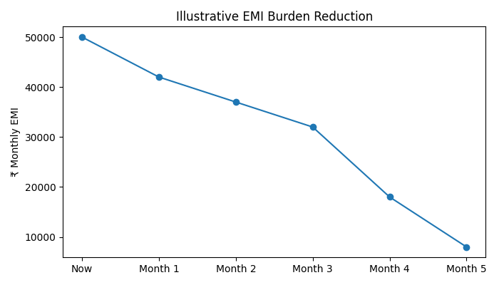
This graph demonstrates how DebtOS should help users visualize cashflow recovery over time as EMIs close and debt reduces.

14. Final Positioning
DebtOS is not an expense tracker.
DebtOS is a financial operating system designed to predict and prevent financial collapse caused by EMI stacking and invisible future obligations.

