Medrelief LIMS + Billing
Phase 1 Requirements Document
v0.6.0 Prototype + Production Additions + Auth Model
April 2026
Khalid Shaikh · Noshtek
Live PWA: khalidnoshtek.github.io/medrelief/app/
Repo: github.com/khalidnoshtek/medrelief

Table of Contents
Part I — Current Prototype Flow (16 screenshots, end-to-end patient journey)
Part II — LIMS Flows & Status Transitions
Part III — Production Additions (behavior to enforce in prod)
Part IV — System Additions (core model + tracking)
Part V — New Feature Requests
Part VI — Authorization Model + Multi-Center Org Hierarchy
Part VII — Action Items & Open Questions

Part I — Current Prototype Flow (v0.6.0)
End-to-end patient journey captured on the live production PWA in mobile view (390×844). One patient (Pooja Jha), three roles (receptionist, lab tech, pathologist), 16 stages.
Stack: React 19 PWA + Express/TypeScript + Prisma + Neon Postgres + Claude Vision OCR + Razorpay test sandbox.

A. Receptionist: Register, Bill, Pay

Stage 1: Login — Receptionist
Route: /login
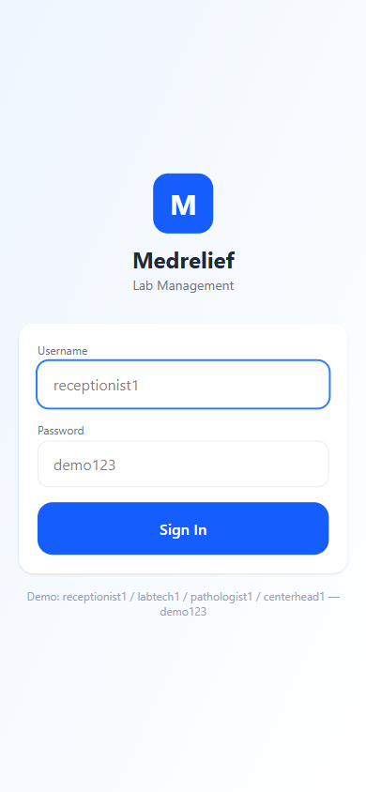
- Priya Sharma signs in as receptionist1 with demo password.
- Auth is JWT, scoped to branch (MDH-MAIN) and role permissions.

Stage 2: Kiosk Home
Route: /home
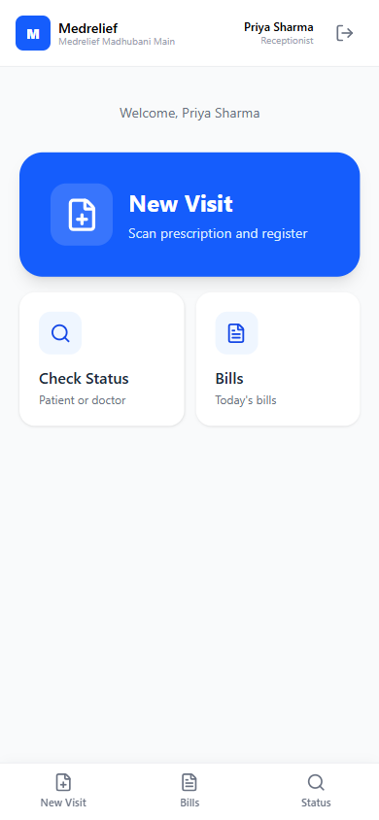
- Three entry tiles: New Visit, Check Status, Bills.
- Mobile-first kiosk UI — thumb-reachable primary actions.

Stage 3: Capture Prescription
Route: /visit/new
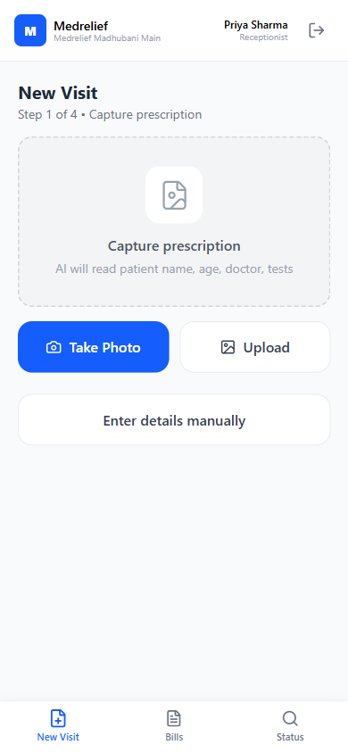
- Step 1/4. Take Photo or Upload triggers Claude Vision OCR.
- Enter details manually fallback when prescription is illegible.

Stage 4: Verify Details
Route: /visit/verify
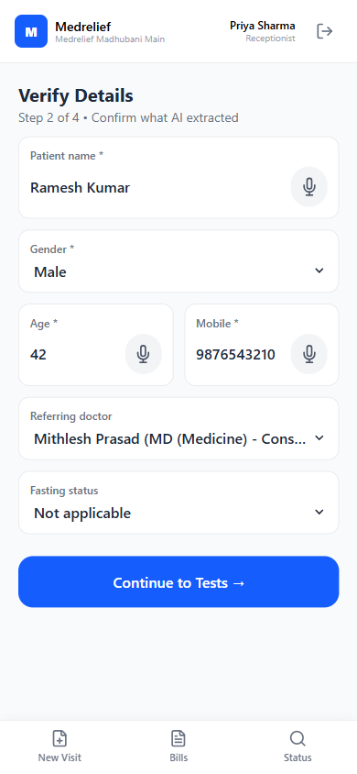
- Step 2/4. Patient, gender, age, mobile, referring doctor, fasting.
- AI-extracted fields carry confidence badges for quick review.

Stage 5: Select Tests
Route: /visit/tests
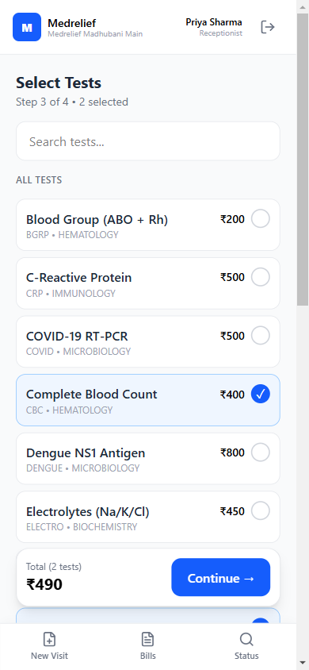
- Step 3/4. Searchable catalog; rate-plan resolver prices each test.
- Running total at bottom for constant visibility.

Stage 6: Payment Mode
Route: /visit/payment
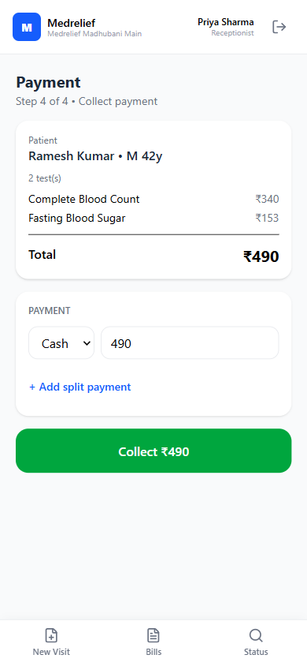
- Step 4/4. Cash / UPI / Card / NEFT, split payments supported.
- Rate plan applied: CBC ₹340, FBS ₹153.

Stage 7: Razorpay Checkout
Route: /visit/payment (overlay)
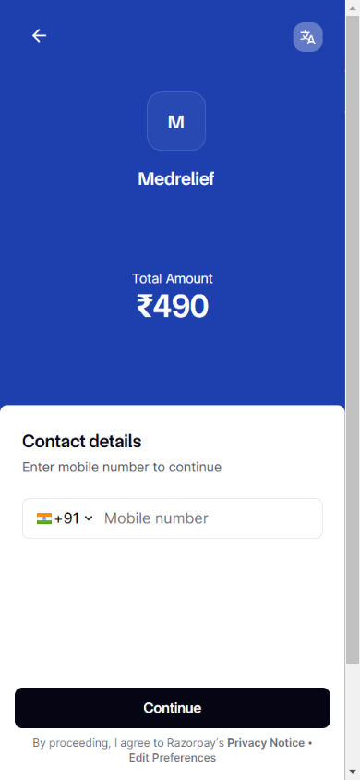
- UPI / Card via Razorpay test sandbox with Medrelief branding.
- Webhook transitions bill PENDING_PAYMENT → PAID.

Stage 8: Paid Bill + Receipt + Labels
Route: /bills/:billId
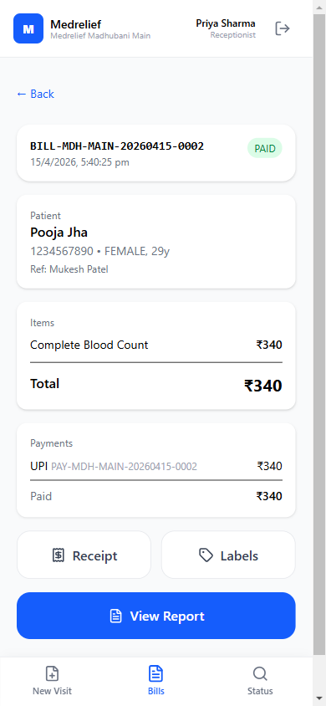
- Accession auto-created; samples grouped by sample_type.
- Receipt + barcode/QR label prints one tap away.

B. Lab Technician: Collect and Process

Stage 9: Login — Lab Technician
Route: /login
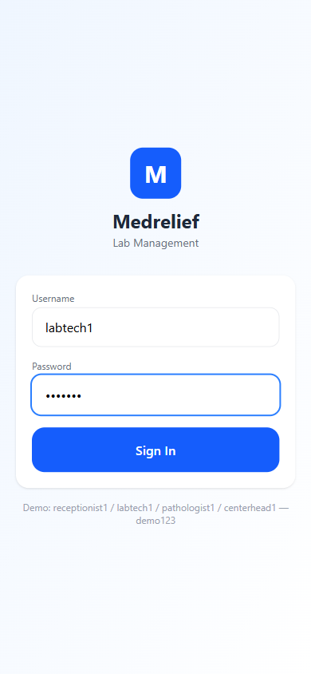
- Role handoff: labtech1 (Amit Kumar) takes over.
- Permissions shift: lims:read, lims:update — no billing.

Stage 10: Lab Worklist
Route: /lab/worklist
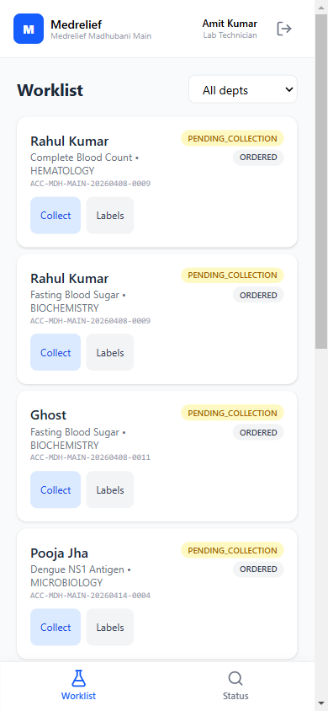
- Filterable by department; each card shows accession + status.
- Collect → Receive → Start → Enter Result state machine.

Stage 11: Sample Collected
Route: /lab/worklist
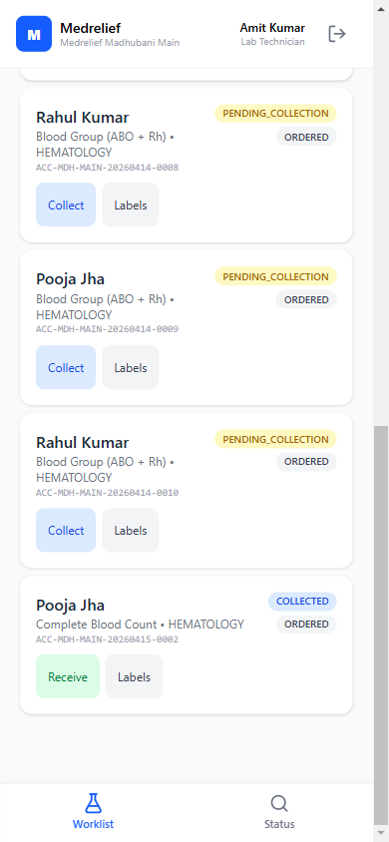
- Pooja Jha CBC moved PENDING_COLLECTION → COLLECTED.
- Next action (Receive) inline — no extra navigation.

Stage 12: Enter Result
Route: /lab/result/:id
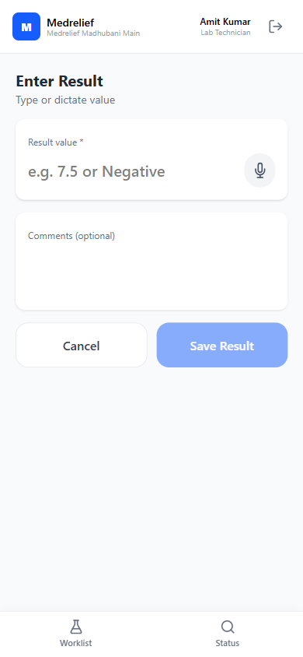
- Value + optional comment. Voice dictation for hands-busy lab.
- Auto-flags NORMAL / HIGH / LOW / CRITICAL vs reference range.

C. Pathologist: Review and Sign Off

Stage 13: Login — Pathologist
Route: /login
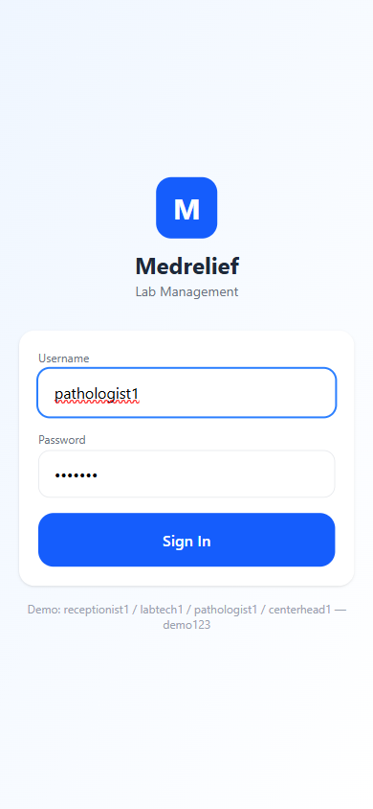
- Role handoff: pathologist1 (Dr. Meena Singh) reviews results.
- Permissions: lims:sign-off, report:read.

Stage 14: Sign-Off Queue
Route: /lab/sign-off
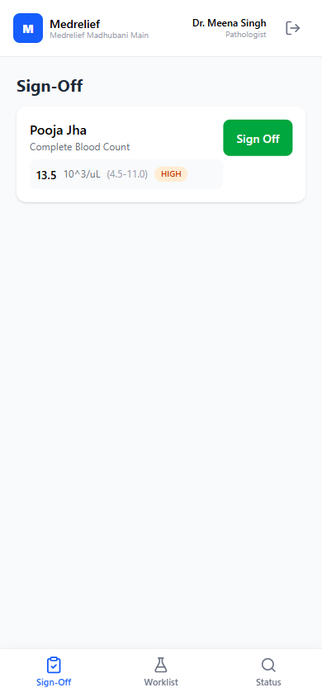
- Only COMPLETED test orders awaiting approval shown.
- Value + reference range + flag (HIGH) visible inline.

Stage 15: Sign-Off Cleared
Route: /lab/sign-off
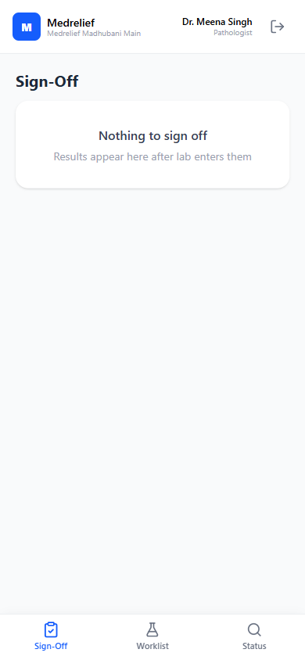
- Test order: COMPLETED → APPROVED.
- Empty state confirms all queued work cleared.

D. Report Delivery

Stage 16: Report Viewer + Delivery
Route: /reports/:accessionId
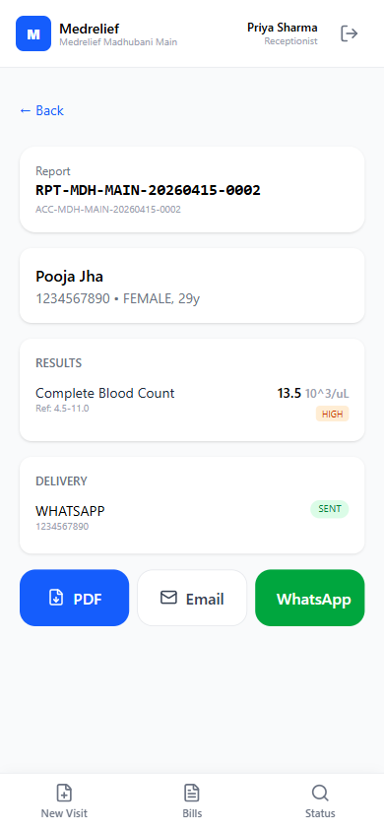
- Report auto-generated when all tests APPROVED.
- PDF / Email / WhatsApp delivery; log shows SENT.

Part II — LIMS Flows & Status Transitions

Flow 1: Registration → Billing → Payment → Accession
- Receptionist searches patient by mobile number
- Selects existing or creates new patient
- Sets visit type, payer type, referring doctor
- Adds tests via search (quick-pick)
- Rate plan resolver auto-prices each test based on priority chain
- Bill created in PENDING_PAYMENT status
- Receptionist selects payment mode (Cash/UPI/Card) and confirms
- Payment recorded, bill transitions to PAID
- BillConfirmed event emitted
- Accession auto-created with samples grouped by sample_type and test orders

Flow 2: Sample Collection → Lab Processing → Result Entry → Sign-Off
- Lab technician views worklist (filtered by department, auto-refreshes)
- Collects samples (PENDING_COLLECTION → COLLECTED)
- Receives samples at lab (COLLECTED → RECEIVED_AT_LAB)
- Starts processing test orders (ORDERED → IN_PROCESS)
- Enters result values (auto-derives flag: NORMAL/HIGH/LOW/CRITICAL)
- Test order transitions to COMPLETED
- Pathologist reviews results on sign-off screen
- Signs off each test (COMPLETED → APPROVED)
- ResultSignedOff event emitted per test

Flow 3: Report Generation → Delivery
- System checks if ALL test orders in accession are APPROVED
- Creates report stub (report_number, status: GENERATED)
- Creates delivery log entries for WhatsApp + email
- Delivery logs created with status PENDING
- Manual resend available via API

Status Transitions
Bill: DRAFT → PENDING_PAYMENT → PARTIALLY_PAID → PAID → (CANCELLED | REFUNDED)
Sample: PENDING_COLLECTION → COLLECTED → RECEIVED_AT_LAB → IN_PROCESS → COMPLETED → (REJECTED)
Test Order: ORDERED → IN_PROCESS → COMPLETED → APPROVED
Report: GENERATED → SIGNED_OFF → AMENDED

Part III — Production Additions
Behavior to enforce before going live. Source: stakeholder review, 16 April 2026.
- Override discount at report collection. Override discount at report collection.
Allow receptionist (or authorized role) to apply discount — but only before report delivery. After delivery, discounts locked.
- Approval workflow on override discount. Approval workflow on override discount.
No direct bill amendment without approvals. Routes through approval chain; only approver can commit.
- Post-settlement: write-off only. Post-settlement: write-off only.
Once report delivered or bill settled, only write-off is permitted. Discount edits blocked at API + UI.
- Rural / low-balance case. Rural / low-balance case.
Support discount-at-pickup for hardship (e.g., ₹450 pending). Same approval workflow as any other override.

Part IV — System Additions (Core Model + Tracking)
- Transaction-level identifier. Assign document_id per invoice — canonical unit for tracking, audits, reporting.
- Main status + sub-status per transaction. Top-level state + operational sub-state for fine-grained tracking.

Payment Status Taxonomy
- PAYMENT_IN_PROGRESS
- PARTIAL_PAYMENT
- FULL_PAYMENT
- (Future: REFUND_IN_PROGRESS / REFUNDED / WRITTEN_OFF)

Report Status Tracking
- REPORT_GENERATED
- REPORT_COLLECTED (physical pickup at counter)
- REPORT_DELIVERED (handed to patient)
- REPORT_SENT_WHATSAPP
- (Future: REPORT_SENT_EMAIL, REPORT_SENT_SMS, REPORT_DELIVERY_FAILED)

Settlement Rule
A bill is NOT settled until the report is delivered. Gate all permission checks, locks, and automations on this rule — not on payment alone.

Document Capture + AI Status View
Every captured document (prescription, bill, report) exposes its complete status flow in one consolidated timeline.

Auditability on Amendments
Every bill amendment records: who requested, who approved, what changed, when, why. Surfaced in document timeline + audit log.

Part V — New Feature Requests

5.1 Role-Based Notification System
- Receptionist: report ready; payment received; discount decisions.
- Lab technician: new sample collected; processing reminders.
- Pathologist: result awaiting sign-off; amendments requested.
- Center head: discount approvals; daily close; critical flags.
- Finance: reconciliation mismatches; close checklist; refunds.
Open: channels (in-app + WhatsApp for urgent), grouping, escalation paths, SLA thresholds.

5.2 WhatsApp API Integration (Customer-Facing)
- Delivery channel for patient reports only — not internal comms.
- Primary recipient: registered patient mobile.
- Additional WhatsApp field: optional secondary number (family, doctor).
- Scope v1: report delivery. Later: reminders, receipts.
Open: provider (Meta Cloud / Gupshup / AiSensy / WATI), template approval, opt-in capture.

5.3 In-App Report Viewer
- Default action: open system-rendered report view (not PDF download).
- Actions from viewer: Download PDF, Send WhatsApp, Email, Print, Close.
- Single data source for rendered view and PDF.
- Offline-tolerant: cached last-generated view for rural branches.
Open: responsive layout, watermark/copy protection, amendment version indicator.

5.4 Conversational AI Voice Assistant
- Replace per-field voice buttons with single continuous assistant.
- User taps once; speaks natural sentence; LLM extracts structured fields.
- Hindi + English + code-switching (Roman Hindi).
- STT → Claude extraction → form autofill → user confirms.
Open: STT provider (Whisper / Google / Sarvam / Bhashini), tap-to-talk vs wake word, offline fallback, privacy.

Part VI — Authorization Model + Multi-Center Org Hierarchy
Source: TimeFlow app (ntapp01-d432c.web.app) flow analysis. Patterns cloned, not UI.

6.1 Role Hierarchy (4 Tiers)
- L0 — Super Admin: Org-wide. System config, org structure, user management, rate plans, global MDM.
- L1 — Center Head: Assigned center(s). Full operational authority. Approves discounts, overrides, daily close.
- L2 — Department Lead: Department within center. Senior lab tech / receptionist. Review, shift oversight. Optional tier.
- L3 — Staff: Role-specific (Receptionist, Lab Tech, Pathologist, Finance). Fixed permission set scoped to function.

6.2 Role Switching (Cloned from TimeFlow)
- Profile page shows current active role + Switch Role list.
- Session-scoped — no re-login required.
- Example: Dr. Meena Singh switches between Pathologist and Center Head.
- Audit logs record the role active at time of action.

6.3 Multi-Center Org Hierarchy
Tenant: Medrelief
└ Region: Bihar (optional grouping)
└ Center: Bihar Sharif Main Lab
└ Sub-center: Collection Point A, B
└ Center: Madhubani Main Lab
└ Sub-center: Collection Point 1, 2
- Centers are primary operational unit — own users, rate plans, billing, daily close.
- Sub-centers are collection-only. Samples accessioned under parent center.
- Region is optional reporting layer. No functional gating.
- Cross-center access for roving roles (pathologist covering multiple centers).
- Tenant-level MDM: test catalogs, doctor master, rate plan templates.

6.4 Approval Chains
- Action types: DISCOUNT_OVERRIDE, WRITE_OFF, BILL_AMENDMENT, REFUND.
- Each chain: configurable steps (e.g., step 1 = Center Head, step 2 = Super Admin).
- Request lifecycle: PENDING → APPROVED | REJECTED | EXPIRED.
- Every decision records: who, which role, comment, timestamp.

6.5 Notification Routing (Role + Scope)
- Report ready → Receptionist (same center) — in-app, normal.
- New sample pending → Lab Tech (same center, dept) — in-app, normal.
- Result awaiting sign-off → Pathologist (same center) — in-app + push, high.
- Discount override requested → Center Head — in-app + WhatsApp, high.
- Critical result flag → Pathologist + Center Head — in-app + WhatsApp + push, urgent.
- Daily close pending (past 8 PM) → Center Head + Finance — in-app + WhatsApp, high.
- Payment reconciliation mismatch → Finance — in-app, high.

6.6 Proposed DB Schema (Key Tables)
org_tenants, org_regions, org_centers — org hierarchy with center_type (MAIN_LAB | COLLECTION_POINT) and parent_center_id for sub-centers.
auth_roles — tenant-scoped, with level (0-3), permissions JSONB array, is_system flag for seed roles.
auth_user_assignments — many-to-many-to-many: user ↔ role ↔ center. is_primary flag for default login role.
approval_chains, approval_requests, approval_decisions — configurable multi-step approval per action type per center.
notifications — role-scoped, multi-channel (IN_APP, WHATSAPP, EMAIL, PUSH), priority levels, read/dismiss tracking.
Full SQL in PROTOTYPE-FEEDBACK-ADDITIONS.md Section 7.4.

Part VII — Action Items & Open Questions

Action Items
- Create document_id + transaction model for invoice-level tracking.
- Design main-status + sub-status flow (payment, sample, report).
- Define payment sub-statuses: PAYMENT_IN_PROGRESS / PARTIAL_PAYMENT / FULL_PAYMENT.
- Define report sub-statuses: REPORT_COLLECTED / DELIVERED / SENT_WHATSAPP.
- Draft override-discount-at-pickup workflow: trigger → approval → apply → audit.
- Build org hierarchy tables (org_tenants, org_regions, org_centers).
- Build auth model tables (auth_roles, auth_user_assignments).
- Build approval chain tables + API endpoints.
- Build notification system (events → routing → multi-channel delivery).
- Integrate WhatsApp Business API for report delivery.
- Replace per-field voice input with conversational AI assistant.
- Build in-app report viewer (replace PDF-first download).

Open Questions
- Discount vs write-off: exact transition point (report delivery? or payment + delivery both?).
- Who initiates override discount at report collection? Who approves? (receptionist → center head likely).
- Settlement definition: payment completion, report delivery, or both?
- WhatsApp provider: Meta Cloud API / Gupshup / AiSensy / WATI?
- STT provider for voice assistant: Whisper / Google / Sarvam AI / Bhashini?
- Is WhatsApp sent sufficient, or need SMS, email, re-send, failed delivery states?
- Report viewer: responsive (1 template) or mobile + desktop (2 templates)?
- Region layer: mandatory or optional for initial rollout?
- Department Lead (L2) tier: include from day 1 or defer?

Document History
- 16 April 2026 — Initial creation. Combines prototype flow, stakeholder feedback, auth model.
- Source files preserved intact: Medrelief-Prototype-Flow.docx, PROTOTYPE-FEEDBACK-ADDITIONS.md, LIMS-FLOWS.md.

