Medrelief LIMS
Prototype Flow — End-to-End Patient Journey
v0.6.0 · April 2026 · Mobile view (390×844)
Live PWA: khalidnoshtek.github.io/medrelief/app/
Repo: github.com/khalidnoshtek/medrelief

What this document shows
Medrelief is a modular-monolith LIMS + Billing system built for Indian diagnostic labs. Phase 1 covers registration, billing, sample accessioning, lab processing, pathologist sign-off, and report delivery. This walkthrough follows one patient, Pooja Jha, through the happy path across three roles.
Stack in one line: React 19 PWA + Express/TypeScript + Prisma + Neon Postgres + Claude Vision OCR + Razorpay test sandbox, deployed on GitHub Pages and Render.

Flow map
- Register — receptionist captures prescription, verifies patient + doctor, selects tests.
- Bill + Pay — rate-plan resolver prices tests, Razorpay collects UPI/Card payment.
- Accession — samples auto-generated on PAID, barcoded and queued for the lab.
- Collect → Process — lab tech walks each sample through its state machine.
- Sign-off — pathologist reviews results, approves or amends.
- Deliver — report auto-generated when all tests APPROVED; PDF + WhatsApp + Email.

Part A — Receptionist: Register, Bill, Pay

1. Login — Receptionist
Route: /login
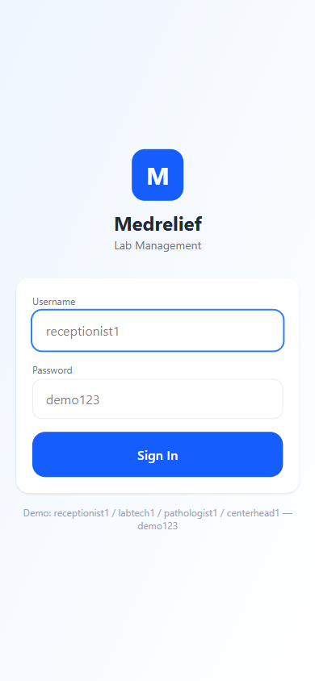
- Priya Sharma signs in as receptionist1 with demo password.
- Auth is JWT, scoped to branch (MDH-MAIN) and role permissions.

2. Kiosk Home
Route: /home
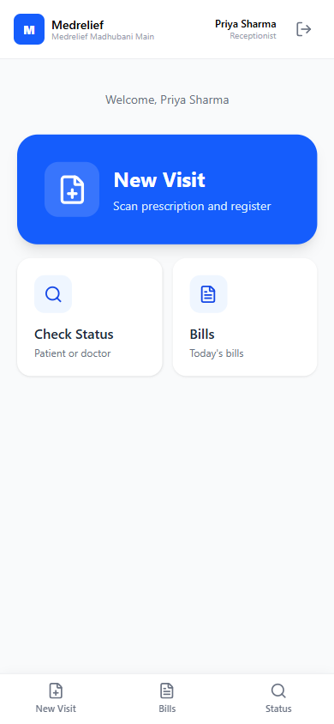
- Receptionist sees three entry tiles: New Visit, Check Status, Bills.
- Mobile-first kiosk UI — thumb-reachable primary actions.

3. Capture Prescription
Route: /visit/new
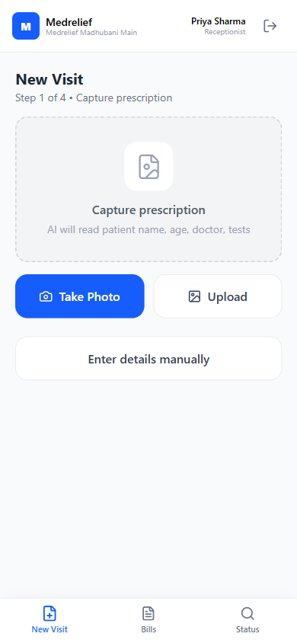
- Step 1 of 4. Take Photo or Upload triggers Claude Vision OCR (~₹0.08/scan).
- Enter details manually is the fallback when the prescription is illegible.

4. Verify Details
Route: /visit/verify
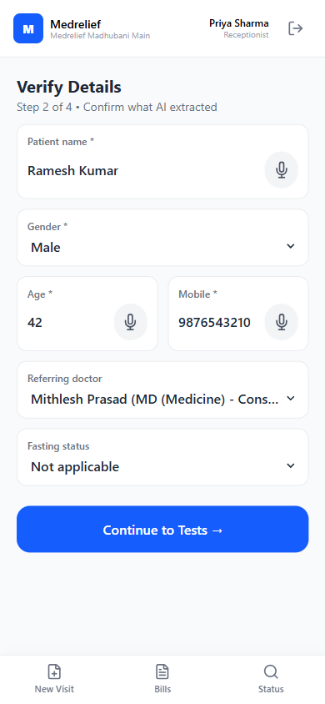
- Step 2 of 4. Patient, gender, age, mobile, referring doctor, fasting status.
- AI-extracted fields carry confidence badges (high/medium/low) for quick review.

5. Select Tests
Route: /visit/tests
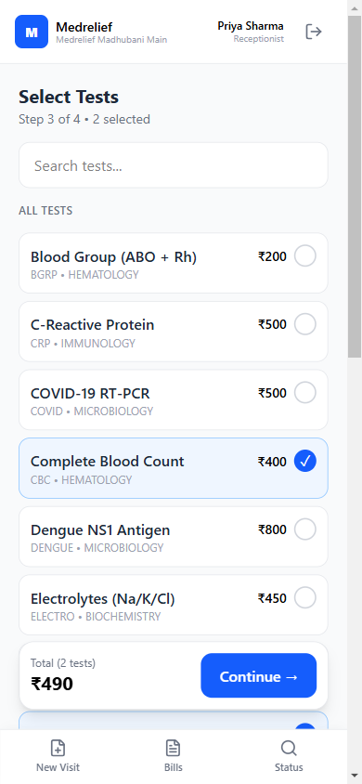
- Step 3 of 4. Catalog is searchable; rate-plan resolver prices each test by payer priority.
- Running total and selected count fixed at the bottom for constant visibility.

6. Payment Mode
Route: /visit/payment
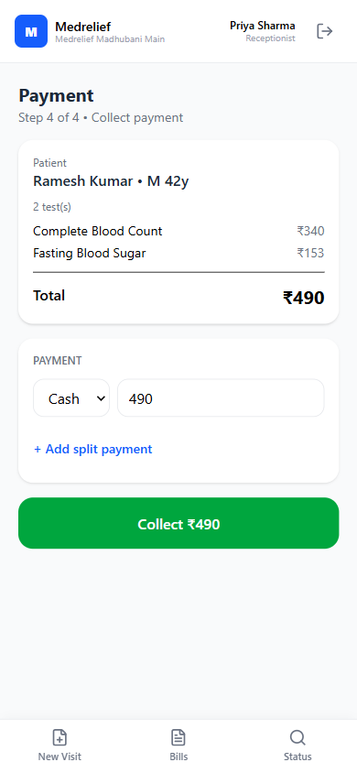
- Step 4 of 4. Cash / UPI / Card / NEFT, split payments supported.
- Rate plan applied: CBC ₹340, FBS ₹153 (list ₹400 + ₹180).

7. Razorpay Checkout
Route: /visit/payment (overlay)
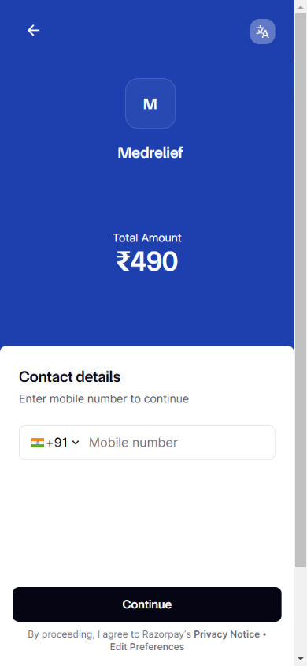
- UPI / Card selection opens Razorpay test sandbox with Medrelief branding.
- Webhook transitions the bill from PENDING_PAYMENT to PAID on success.

8. Paid Bill + Receipt + Labels
Route: /bills/:billId
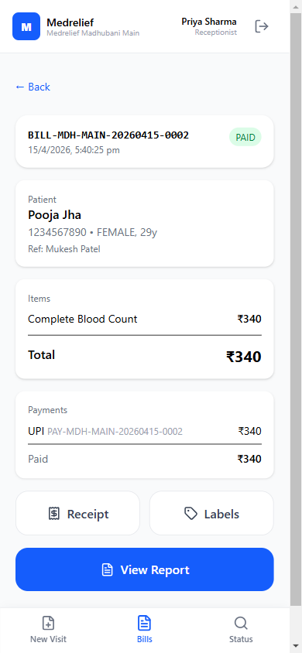
- On PAID, the accession is auto-created and samples grouped by sample_type.
- Receipt and sample-label (barcode + QR) prints are one tap away.

Part B — Lab Technician: Collect and Process

9. Login — Lab Technician
Route: /login
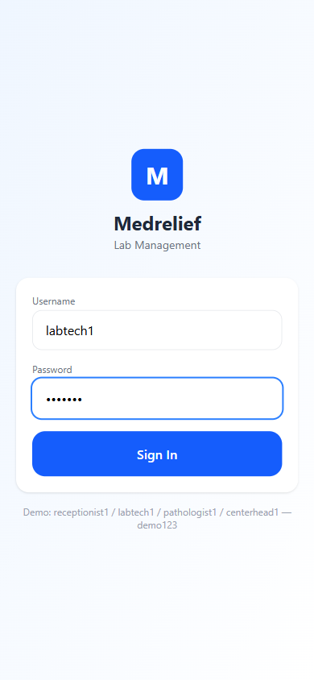
- Role handoff: labtech1 / demo123. Amit Kumar takes over in the lab.
- Auth scope shifts permissions: lims:read, lims:update — no billing access.

10. Lab Worklist
Route: /lab/worklist
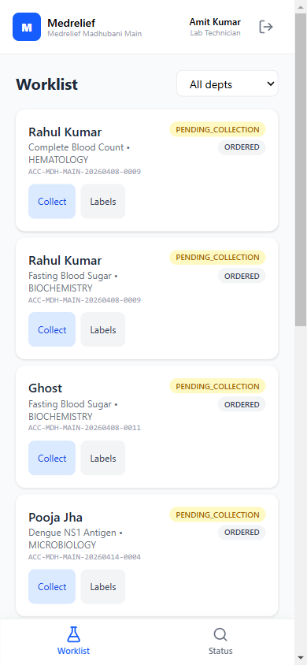
- Samples are filterable by department; each card shows accession + test + status.
- Collect → Receive → Start → Enter Result walks the sample through its states.

11. Sample Collected
Route: /lab/worklist
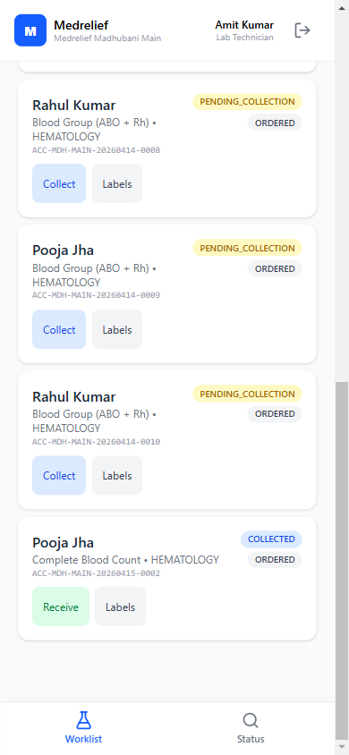
- Pooja Jha CBC moved from PENDING_COLLECTION to COLLECTED with a single tap.
- Next action (Receive) is now inline — no extra navigation.

12. Enter Result
Route: /lab/result/:testOrderId
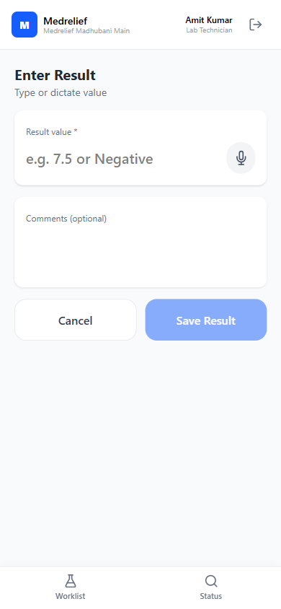
- Value + optional comment. Voice-dictation supported for hands-busy lab workflow.
- System auto-flags NORMAL / HIGH / LOW / CRITICAL against the reference range.

Part C — Pathologist: Review and Sign Off

13. Login — Pathologist
Route: /login
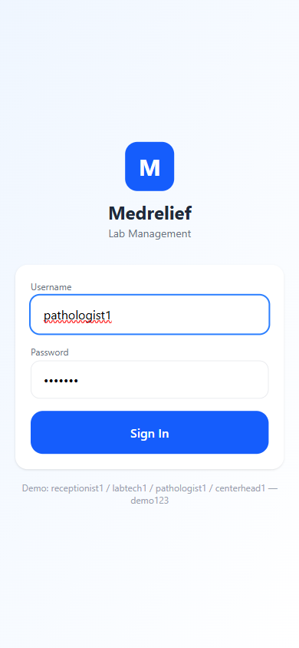
- Role handoff: pathologist1 / demo123. Dr. Meena Singh reviews completed tests.
- Permissions include lims:sign-off, report:read.

14. Sign-Off Queue
Route: /lab/sign-off
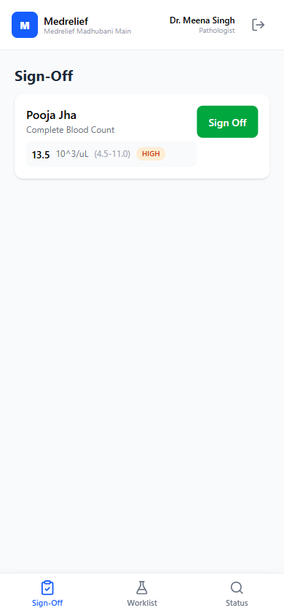
- Pathologist sees only COMPLETED test orders awaiting approval.
- Value + reference range + flag (HIGH shown) visible without a drill-down.

15. Sign-Off Cleared
Route: /lab/sign-off
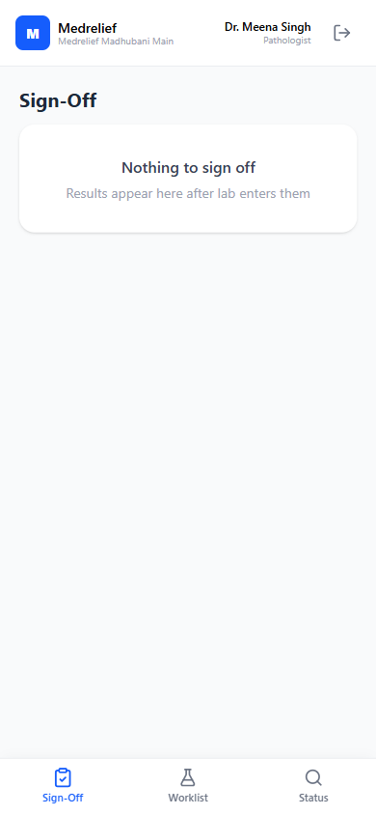
- On Sign Off, the test order moves COMPLETED → APPROVED.
- Empty state confirms all queued work is cleared.

Part D — Report Delivery

16. Report Viewer + Delivery
Route: /reports/:accessionId
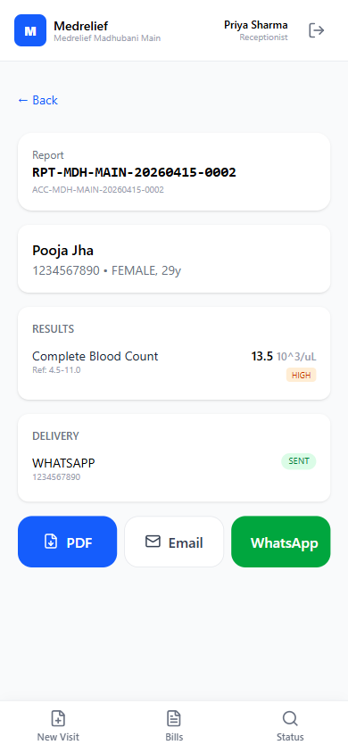
- Report auto-generates when all test orders in the accession hit APPROVED.
- PDF / Email / WhatsApp delivery buttons; delivery log already shows SENT.

What’s next
- B2B partners + commissions — referrer splits, tiered pricing, API access.
- Offline mode + Hindi UI — field kiosks in low-connectivity branches.
- Android APK — wrap the PWA for Play Store and native camera/barcode access.
- Real WhatsApp + Email delivery (currently stubbed at the log level).
- Prisma 6 → 7 upgrade, S3 attachment storage.

