Medrelief Integrated ERP – Phase 1 (LIMS, Billing, Basic Finance)
Attribute | Details
Document Title | Medrelief Integrated ERP – Phase 1 (LIMS, Billing, Basic Finance) – Product Requirements Document
Version | Build-ready (Phase 1)
Scope (Phase 1) | LIMS, Billing, Payments, Basic Finance & Daily Reconciliation, Core MDM, Access Control, Report Delivery (WhatsApp/Email)
Out of Scope (Phase 1) | Full AR/AP, HR & Payroll, Inventory & Procurement, Incentives, Advanced Analytics
Target Delivery | 4 weeks (single dev squad, modular monolith)
Tech Stack | Backend: Node.js/Java/.NET; DB: PostgreSQL; Frontend: React/Angular/Vue; Auth: JWT/session-based RBAC
1. Architectural Principles (Modular Monolith)
1.1 High-Level Architecture
Phase 1 will be implemented as a modular monolith: a single deployable application with clear internal domain boundaries and a single shared PostgreSQL database.
Modules (logical, not separate services in Phase 1):
- LIMS (orders, accession, samples, results)
- Billing & Payments
- Basic Finance & Daily Reconciliation
- Master Data (MDM)
- Auth & RBAC
- Reporting (read-only)
All modules live in a single codebase and database, but respect strict boundaries at code and schema level for future extraction into microservices.
1.2 Modular Monolith Design Rules
- Configuration management: Use two sources only: (1) environment variables for deployment/static secrets (DB/Redis credentials, JWT secret, storage and provider keys), and (2) DB config tables for runtime business configuration (discount limits, rounding rules, allowed payment modes per branch, report retention, duplicate merge rules). Resolution order: branch config → tenant config → code default. Cache resolved config briefly (e.g., 5 minutes) and invalidate on update.
- Caching: Use Redis cache-aside for rate plan resolution, test catalog, configuration, and the RBAC permission matrix. Do not cache mutable payment state or live bill totals during payment. Suggested TTLs: rate plans ~10 min, test catalog ~30 min, config ~5 min, RBAC ~30 min. Invalidation must happen on master/config changes as defined below.
Cache invalidation rules (mandatory)
Cached object | Cache key pattern | Invalidate when | Action
Rate plans | rateplan:{tenantId}:* | Rate plan create/update/deactivate; rate-plan-test row change; doctor/organization plan linkage change | Delete all matching tenant keys immediately
Test catalog | testcatalog:{tenantId} | Test create/update/deactivate; package update; package-child mapping change | Delete tenant test catalog key
Config | config:{tenantId}:* | Tenant config change; branch config change; payment-mode config change; rounding-rule change | Delete tenant/branch config keys
RBAC | rbac:{tenantId}:* | Role/permission update; user role reassignment | Delete affected role/user keys
- Implementation rule: publish invalidation through module service methods only; controllers/repositories must not delete Redis keys directly.
- Engineering conventions: File names use kebab-case; classes use PascalCase; variables/functions use camelCase; DB tables use snake_case with module prefix; columns use snake_case; API routes use kebab-case; enums use PascalCase type with UPPER values; constants use UPPER_SNAKE_CASE.
- Domain packages / namespaces per module (e.g., lims, billing, finance, mdm, auth).
- Each module owns its service layer, repository layer and REST controllers.
- No cross-module repository access; cross-module interactions happen via module service interfaces (internal APIs), not direct DB access into other modules' tables.
- Shared DB but schema-level ownership:
  - Option A: single schema, table naming by module prefix (e.g., lims_accessions, billing_bills).
  - Option B (preferred): multiple schemas per module — lims.*, billing.*, finance.*, mdm.*.
- DTOs for external API contracts; internal entities are not leaked across module boundaries.
1.3 API-First Internal Boundaries
Even in the monolith, every module exposes a versioned internal API (service interface + REST where needed):
- LIMS API (e.g., POST /api/v1/lims/accessions, POST /api/v1/lims/results)
- Billing API (e.g., POST /api/v1/billing/bills, POST /api/v1/billing/payments)
- MDM API (lookup-only for tests, doctors, rate plans from other modules)
- Finance API (e.g., POST /api/v1/finance/daily-close)
These APIs are internal in Phase 1 but must be designed as if they could be called over the network later: consistent request/response models, idempotency where relevant, consistent status codes, error contracts.
Request context
- Required fields: requestId, tenantId, branchId (optional), userId, roleCodes, ipAddress, userAgent.
- The context must be available to middleware, structured logs, audit events, service methods, and background job payloads.
1.4 Shared PostgreSQL DB Design Rules
- Single physical PostgreSQL instance for Phase 1.
- All tables must have:
  - Synthetic primary key (id as UUID or bigint sequence)
  - created_at, created_by, updated_at, updated_by, version (for optimistic locking)
  - branch_id for all transactional records
- Foreign keys enforced at DB level between core relations.
- Use enum-like lookup tables OR CHECK constraints on status columns.
- Hard rules:
  - No module may write directly into another module's tables without going via its service/API.
  - No cross-schema joins in ORM models (joins allowed in reporting/analytics queries only, via separate reporting layer or DB views).
1.4.1 Required DB Indexes (Phase 1)
Phase 1 performance depends on explicit indexes for patient search, bill lookups, accession scans, and payment joins. These indexes must be included in the initial migration set.
Mandatory indexes
CREATE INDEX idx_patients_mobile ON mdm_patients(tenant_id, mobile); CREATE INDEX idx_bills_branch_date ON billing_bills(tenant_id, branch_id, bill_date DESC); CREATE INDEX idx_accession_number ON lims_accessions(tenant_id, accession_number); CREATE INDEX idx_test_orders_accession ON lims_test_orders(tenant_id, accession_id); CREATE INDEX idx_payments_bill ON billing_payments(tenant_id, bill_id);
Recommended supporting indexes
CREATE UNIQUE INDEX ux_patients_patient_code ON mdm_patients(tenant_id, patient_code); CREATE UNIQUE INDEX ux_bills_bill_number ON billing_bills(tenant_id, bill_number); CREATE INDEX idx_visits_patient_created ON lims_visits(tenant_id, patient_id, created_at DESC); CREATE INDEX idx_bills_status_payment_status ON billing_bills(tenant_id, bill_status, payment_status); CREATE INDEX idx_samples_accession ON lims_samples(tenant_id, accession_id); CREATE INDEX idx_results_test_order ON lims_results(tenant_id, test_order_id);
Index usage rules
- All repository queries must include tenant_id first in multi-tenant transactional tables.
- All list APIs must be paginated; indexes are not a substitute for bounded result sets.
- Run EXPLAIN ANALYZE on patient search, bill search, accession scan, shift-close totals, and test worklist queries before production release.
1.5 Event-Lite Approach
Instead of a full event bus, Phase 1 will implement event-lite patterns inside the monolith:
- Domain events persisted to an event outbox table for future integration.
- Critical events only in Phase 1:
  - BillConfirmed – bill locked, accession allowed
  - PaymentReceived – collection logged
  - SampleAccessioned
  - ResultSignedOff
  - DailyBranchCloseCompleted – for finance and reporting
Event consumers are internal handlers registered in the same process.
Background jobs and async processing
- Long-running operations must run via a Redis-backed worker queue inside the monolith.
- Minimum queues: report-generation, report-dispatch-whatsapp, report-dispatch-email, payment-reconciliation, daily-close.
- Jobs must be idempotent and include tenantId, branchId, requestId, and the business entity id in the payload.
- Job failures must not corrupt transactional state (e.g., report generation failure must not change sign-off state).
1.6 Migration Path to Microservices
Step | Action
Step 1 – Schema boundary hardening | Keep all tables for a domain in its own schema; prohibit cross-module writes
Step 2 – Outbox pattern | Maintain event tables per module that can be polled by future message brokers
Step 3 – API hardening | Move internal service interfaces to external REST/gRPC endpoints
Step 4 – Data ownership | When a module is extracted, its schema is moved to its own DB; others call its public APIs

2. UI / UX Design Principles
2.1 Vending-Machine Style UX
- Search-first for existing patients by mobile number with auto-fill.
- Default values for visit type, branch, current date/time, standard payment mode.
- Single-screen Registration + Billing with bill preview always visible.
- Large, high-contrast buttons: "Add Test", "Collect Payment", "Confirm Bill".
- Frequent actions at fixed positions (bottom-right primary CTA, top search bar), no hidden menus.
2.2 Touch-First Interactions
- All primary screens optimized for 13–15 inch touch-enabled devices and tablets.
- Button hit areas ≥ 44×44 px.
- On-screen keypad for numeric fields (age, amount, OTP).
- Minimal free-text fields; rely on dropdowns, quick-pick lists, and autosuggest.
2.3 2–3 Clicks per Core Action
Design guideline targets:
- Create and confirm a simple bill (existing patient, 1–3 tests, cash):
  - Click 1: Search patient by mobile → select.
  - Click 2: Add tests via quick-pick → rate plan auto-applied.
  - Click 3: "Collect Payment" → confirm amount → auto-print bill & accession.
- Accession & label print: triggered automatically on bill confirm.
- Report resend: single "Resend Report" button from bill or patient screen.
2.4 Role-Based Screen Simplification
Role | Screens Visible | Restricted From
Receptionist | Registration + Billing + Payment + Basic Patient History | Rate plan config, finance staging, cross-branch reports, employee data
Lab Technician | Worklist, Sample Status, Result Entry, QC flags | Financial values, discounts
Pathologist | Result review & sign-off, doctor comments, critical values | Billing screens, payment screens, rate plans
Center Head | Branch dashboards, reconciliation, override approvals | Other centers, system-level code settings
2.5 Error-Proof & Constraint-Aware Workflows
- No manual price entry; all prices from rate plans.
- No free-text referring doctor; select from master only.
- Mobile-based deduplication with prominent duplicate alert.
- Mandatory fields visually obvious (asterisk + color), real-time error messages.
- All long operations (report generation, WhatsApp send) are async with toasts and logs.
- Keyboard shortcuts: F2 = New Bill, F4 = Payment.
- Labels in plain language with Hindi helper text where helpful.

3. Phase 1 LIMS & Billing Data Model
3.1 Core Transactional Tables
Table | Purpose | Key Fields (partial)
mdm_branches | Branch master | id, code, name, address, gstin, status
mdm_patients | Patient master | id, patient_code, full_name, gender, dob, age_years, mobile, email, address, status
mdm_doctors | Referring doctor master | id, doctor_code, name, specialty, mobile, linked_rate_plan_id, status
mdm_tests | Test catalog | id, test_code, name, department, sample_type, tat_hours, base_mrp, lis_mapping_code, active
mdm_packages | Package master (billable bundles) | id, package_code, name, active
mdm_package_tests | Package → child test mapping | id, package_id, test_id, active
mdm_rate_plans | Rate plan header | id, name, plan_type, priority, effective_from, effective_to, status
mdm_rate_plan_tests | Per-test price per plan | id, rate_plan_id, test_id, price, discount_percent, is_package, package_id
lims_visits | Patient visit context | id, visit_number, patient_id, branch_id, visit_type, payer_type, referrer_id, created_at
billing_bills | Bill header | id, bill_number, visit_id, branch_id, bill_date, gross_amount, discount_amount, net_amount, tax_amount, rounding_adjustment, bill_status, payment_status, payer_type, referrer_id
billing_bill_items | Bill line items (tests/packages) | id, bill_id, test_id, item_type (TEST/PACKAGE), parent_bill_item_id (nullable), billing_visible, package_id, quantity, mrp_amount, rate_plan_id, line_discount_amount, final_amount, referral_economic_value
billing_payments | Payments collected | id, payment_reference, bill_id, branch_id, mode, amount, instrument_details, upi_rrn, gateway_txn_id, status, received_at, shift_id
billing_adjustments | Credit notes and refunds (append-only adjustments on confirmed bills) | id, adjustment_number, bill_id, type (CREDIT_NOTE/REFUND), amount, status (DRAFT/APPROVED/POSTED/VOID), approved_by
lims_accessions | Accession per visit/bill | id, accession_number, visit_id, bill_id, branch_id, accession_status, accessioned_at
lims_samples | Physical sample tubes | id, accession_id, sample_code, sample_type, collection_time, received_time, sample_status
lims_test_orders | Test execution orders | id, accession_id, bill_item_id, test_id, department, sample_id, order_status, assigned_to, started_at, completed_at
lims_results | Test results | id, test_order_id, raw_value, unit, reference_range, flag, approved_by, approved_at
lims_reports | Report bundles | id, accession_id, report_number, generated_at, signed_off_by, signed_off_at, report_status
lims_report_delivery_logs | Delivery audit | id, report_id, channel, target, status, sent_at, failure_reason
billing_adjustments (DDL)
CREATE TABLE billing_adjustments ( id UUID PRIMARY KEY, tenant_id UUID NOT NULL, branch_id UUID NOT NULL, bill_id UUID NOT NULL REFERENCES billing_bills(id) ON DELETE RESTRICT, adjustment_number VARCHAR(50) NOT NULL, type VARCHAR(20) NOT NULL CHECK (type IN ('CREDIT_NOTE', 'REFUND')), amount NUMERIC(12,2) NOT NULL CHECK (amount > 0), reason_code VARCHAR(50) NOT NULL, remarks TEXT NULL, status VARCHAR(20) NOT NULL CHECK (status IN ('DRAFT', 'APPROVED', 'POSTED', 'VOID')), approved_by UUID NULL, approved_at TIMESTAMPTZ NULL, created_at TIMESTAMPTZ NOT NULL, created_by UUID NOT NULL, updated_at TIMESTAMPTZ NOT NULL, updated_by UUID NOT NULL, version INTEGER NOT NULL DEFAULT 1 );
billing_adjustments (required indexes)
CREATE UNIQUE INDEX ux_billing_adjustments_number ON billing_adjustments(tenant_id, adjustment_number); CREATE INDEX idx_billing_adjustments_bill ON billing_adjustments(tenant_id, bill_id); CREATE INDEX idx_billing_adjustments_type_status ON billing_adjustments(tenant_id, type, status);
3.2 Relationships (ER-Style Description)
- Patient 1–N Visits: mdm_patients.id → lims_visits.patient_id
- Visit 1–1 Bill: one primary bill per visit in Phase 1
- Bill 1–N Bill Items: billing_bills.id → billing_bill_items.bill_id
- Bill 1–N Payments: billing_payments.bill_id (allow partial payments)
- Visit/Bill 1–1 Accession: lims_accessions.visit_id, lims_accessions.bill_id
- Accession 1–N Samples: lims_samples.accession_id
- Accession 1–N Test Orders: lims_test_orders.accession_id
- Test Order 1–1 Result: lims_results.test_order_id
- Accession 1–N Reports: lims_reports.accession_id
- Report 1–N Delivery Logs: lims_report_delivery_logs.report_id
All transactional tables carry branch_id referencing mdm_branches.id.
3.3 Key Constraints
Uniqueness:
- mdm_patients.mobile unique per tenant (soft warning for shared family numbers)
- mdm_doctors.doctor_code, mdm_tests.test_code, mdm_branches.code unique
- billing_bills.bill_number unique per branch
- lims_accessions.accession_number globally unique
Adjustments (credit notes/refunds):
- billing_adjustments.adjustment_number unique per tenant.
- Index (tenant_id, bill_id) to keep bill-level adjustment lookups fast.
- Index (tenant_id, type, status) for finance queues (approval/posting/void).
Foreign Keys (all with ON DELETE RESTRICT):
- lims_visits.patient_id → mdm_patients.id
- billing_bills.visit_id → lims_visits.id
- billing_bill_items.test_id → mdm_tests.id
- billing_bill_items.rate_plan_id → mdm_rate_plans.id
- billing_bills.referrer_id → mdm_doctors.id (nullable)
- billing_payments.bill_id → billing_bills.id
- lims_accessions.bill_id → billing_bills.id
- lims_results.test_order_id → lims_test_orders.id
Status Enums (CHECK constraints):
- bill_status: DRAFT, PENDING_PAYMENT, PARTIALLY_PAID, PAID, CANCELLED, REFUNDED
- payment_status: UNPAID, PARTIALLY_PAID, PAID (bill-level payment completion status). Individual payment attempts/rows track their own statuses (e.g., INITIATED/SUCCESS/FAILED/REVERSED) on payment records.
- accession_status: PENDING, IN_PROGRESS, COMPLETED, CANCELLED
- sample_status: PENDING_COLLECTION, COLLECTED, RECEIVED_AT_LAB, IN_PROCESS, COMPLETED, REJECTED
- report_status: GENERATED, SIGNED_OFF, AMENDED
3.4 Audit Fields & Versioning
All tables except pure lookup tables must include:
- created_at (timestamp with time zone)
- created_by (user id)
- updated_at
- updated_by
- version (integer) – incremented on each update, used for optimistic locking
- source (optional: WEB, MOBILE, BATCH)
3.5 Status Flows
3.5.1 Bill Lifecycle
DRAFT → PENDING_PAYMENT → PAID
→ PARTIALLY_PAID → PAID
↓ ↓
CANCELLED CANCELLED (with audit)
→ REFUNDED (via Credit Note)
- DRAFT: in progress, editable.
- PENDING_PAYMENT: tests selected, amount finalized.
- PAID: payment success triggers BillConfirmed event, accession creation, label print.
- Cancellation: always requires reason code + audit log. Cancellation is allowed only before accession creation; after accession, use adjustment workflows instead (credit note/refund) to preserve audit integrity.
- Credit Note / Refund (post-confirmation): confirmed bills are immutable. Any post-confirmation reduction or money return must be recorded as an append-only row in billing_adjustments with type = CREDIT_NOTE or REFUND.
- Approval: approved_by is mandatory for adjustments above the branch-configured threshold.
- Status: DRAFT → APPROVED → POSTED (or VOID). Posted adjustments must be reflected in finance summaries and audit dashboards.
3.5.2 Sample & Result Lifecycle
Sample: PENDING_COLLECTION → COLLECTED → RECEIVED_AT_LAB → IN_PROCESS → COMPLETED
→ REJECTED
Test Order: ORDERED → IN_PROCESS → COMPLETED → APPROVED
Report: GENERATED → SIGNED_OFF → AMENDED (new version, old kept)

4. Master Data Model (MDM) – Phase 1
4.1 Master Entities & Ownership
Master Entity | Key Attributes (partial) | Owning Module | Consumers
Patient | Demographics, contact, status | LIMS/MDM | LIMS, Billing, Finance, Reporting
Doctor / Referrer | Identity, specialty, contact, linked rate plan | Admin/MDM | LIMS, Billing, Finance
Organization / Corporate | Name, contact, rate plan, credit limit | Admin/MDM | Billing, Finance
Test Catalog | Test metadata, LIS mapping, base MRP | LIMS/MDM | LIMS, Billing, Reporting
Rate Plan | Plan header, type, priority, effective dates | Finance/MDM | Billing
Rate Plan – Test Mapping | Test-level price per plan | Finance/MDM | Billing
Branch | Branch identity, GSTIN, status | Admin/MDM | All modules
Employee (basic) | Identity & branch mapping for auth | Auth/MDM | Auth, LIMS, Billing, Finance
4.2 Ownership Rules
- Each master is owned by a single module; others may read but not write directly.
- Master maintenance screens are restricted to Center Head, Finance Manager, or System Admin as appropriate.
4.3 Versioning Rules (Rate Plans & Tests)
- Rate plans are immutable by time: changes insert new rows with newer effective_from dates; no in-place updates.
- At billing time: system selects the correct plan based on plan_type, priority, and bill date between effective_from and effective_to.
- Tests: changes create a new test with a new code; old test marked INACTIVE.
Rate plan resolution (deterministic): Use strict priority: (1) explicit bill-level override plan (Finance Manager/System Admin only), (2) referrer-linked active plan, (3) organization/corporate active plan, (4) payer-type mapped plan, (5) branch default plan, (6) tenant default MRP plan. Plan must be ACTIVE and effective for billDateTime (effective_from ≤ billDateTime < effective_to; effective_to may be null). If multiple plans match at the same priority: choose highest explicit priority, then latest effective_from, then lowest internal id (tie-breaker). If a test is missing in the resolved plan, fall back down the chain for that test only; if still missing, fall back to tenant MRP for that test. If any tests remain unresolved: reject bill creation with a clear error listing unresolved tests (no silent pricing fallback).
Example (rate plan resolution): Dr X + Corporate Y
Assume the following plans are active on the bill date:
- Dr X linked plan: CBC = 250, FBS = 120.
- Corporate Y linked plan: CBC = 220, FBS = 110.
- Payer type CORPORATE mapped plan: CBC = 230, FBS = 115.
- Branch default plan: CBC = 300, FBS = 140.
- Tenant MRP plan: CBC = 400, FBS = 180.
Scenario: Patient is referred by Dr X, belongs to Corporate Y, payer type is CORPORATE, and selected tests are CBC and FBS.
Resolution: No explicit bill override exists, so the referrer-linked plan for Dr X is evaluated first and wins for tests present in that plan. Therefore CBC = 250 and FBS = 120 from Dr X plan. Corporate/payer/branch/MRP plans are ignored for those tests.
Variant edge case: If Dr X plan had CBC only (no FBS row), then CBC would come from Dr X plan and FBS would fall through to Corporate Y plan because per-test fallback down the priority chain is allowed.
4.4 Validation Rules
Entity | Validation
Patient | Mobile: India 10-digit; soft duplicate warning; Age or DOB mandatory
Doctor | No duplicate doctor_code; must link to default rate plan if participating in special pricing
Rate Plan | At least one mdm_rate_plan_tests row; no overlapping date ranges for same plan name
Branch | Unique code and gstin
All Masters | Soft delete via status column (ACTIVE/INACTIVE); no physical deletes

5. Personas
5.1 Receptionist
- Goals: Register patients quickly, generate accurate bills, collect payments without errors or delays, keep queue moving.
- Pain Points: Slow software, manual price entry, bill edits, UPI confusion, long training time, unclear duplicate alerts.
- Tech Comfort: Basic; comfortable with WhatsApp and simple web apps. Learns by doing.
5.2 Phlebotomist
- Goals: Collect samples efficiently (lab or home), ensure correct labeling, minimize recollections.
- Pain Points: Paper forms, unclear patient addresses, lost or unlabeled samples, manual status updates.
- Tech Comfort: Basic smartphone user; moderate comfort with mobile apps.
5.3 Lab Technician
- Goals: Process assigned samples, enter/verify results accurately, meet TAT targets, avoid data entry errors.
- Pain Points: Worklist chaos, unclear priorities, manual result entry across multiple systems, LIS mismatches.
- Tech Comfort: Moderate; comfortable with structured lab software and keyboards.
5.4 Pathologist
- Goals: Review and sign off results efficiently, focus on abnormal/critical cases, maintain medico-legal quality.
- Pain Points: Hunting for abnormal cases, fragmented patient history, manual stamping and signing.
- Tech Comfort: Moderate to high; comfortable with structured UI but not heavy configuration.
5.5 Center Head
- Goals: Monitor branch revenue and TAT, approve discount/refund exceptions, close daily reconciliation, ensure smooth operations.
- Pain Points: No real-time view, manual reconciliation, staff dependency for data access.
- Tech Comfort: Moderate; uses dashboards and Excel regularly.
5.6 Finance Manager
- Goals: Ensure revenue integrity, perform daily reconciliation across modes, export accurate journals to Zoho, manage referral economics.
- Pain Points: Manual Zoho entry, no automated reconciliation, no audit trail for discounts.
- Tech Comfort: High in finance tools; comfortable with complex reports.

6. Persona → Module & Feature Mapping
Persona | Modules Used | Key Actions | Must NOT Access
Receptionist | LIMS/Billing (front-office), MDM (read-only), Report Delivery | Patient search & registration, test ordering, bill creation, payment collection, report resend | Rate plan config, finance staging, cross-branch reports, employee data
Phlebotomist | LIMS (sample collection), Mobile app | View assigned collections, mark collection, update sample status, patient confirmation | Billing amounts, discounts, finance dashboards, master data edits
Lab Technician | LIMS (worklist, results) | View worklist, update sample status, enter results, flag critical values | Billing screens, payment screens, rate plans, finance exports
Pathologist | LIMS (result review/sign-off), Reporting | Review results, sign off, amend reports, add clinical notes | Billing/discount edits, reconciliation screens, master admin
Center Head | LIMS/Billing (branch-wide), Basic Finance, Reporting | Approve high discounts/refunds, branch dashboards, daily close, exception overrides | System-wide finance, rate plan design for other branches
Finance Manager | Finance, MDM (rate plans), Reporting | Configure rate plans, review collections, reconcile UPI/gateway, export to Zoho | Patient-level PHI beyond billing summaries, test result details

7. End-to-End Workflows
7.1 Patient Registration → Billing → Payment → Accession
Target Time: < 2 minutes for a simple walk-in case.
Screens: New Visit, Unified Registration + Billing, Payment popup, Accession confirmation dialog.
Step | Action | Screen | Time Target
1 | Receptionist clicks “New Visit”; branch pre-selected | Receptionist Dashboard | 5 sec
2 | Search patient by mobile; auto-populate or create new (name, gender, age/DOB, mobile) | Registration screen | 15 sec
3 | Select visit type, referring doctor/organization, payer type (auto-derived) | Registration screen | 10 sec
4 | Add tests/packages via quick-pick or search; rate plan auto-applied | Billing screen | 20–30 sec
5 | Review bill summary (gross, discount, tax, net, rounding); confirm with patient | Bill preview | 10 sec
6 | Click “Collect Payment”; select mode; for UPI generate dynamic QR or enter RRN | Payment popup | 20–30 sec
7 | Payment success → bill locked; BillConfirmed event emitted | System (auto) | < 2 sec
8 | Accession number auto-generated; barcode labels printed | Accession dialog | 5 sec
Failure Scenarios
- Network loss during UPI: bill stays PENDING_PAYMENT; staff can switch to cash or manual UPI entry.
- Wrong tests before confirm: allowed to edit in DRAFT/PENDING_PAYMENT only.
- Edit after payment: disallowed; use Credit Note/Refund flow.
- Delayed gateway success callback: all external payment attempts require payment_attempt_id + idempotency key; callbacks must be safe to replay. If bill was already closed by another mode, route the callback payment to a finance exception state (do not auto-apply).
- Partial payments: allow multiple payment rows per bill; bill payment_status transitions UNPAID → PARTIALLY_PAID → PAID; emit BillConfirmed only on transition to fully paid unless an approved credit rule allows accession earlier.
7.2 Sample Collection → Lab Processing → Result Entry → Sign-off
Screens: Phlebotomist Collection List (web/mobile), Lab Technician Worklist, Result Entry screen, Pathologist Review & Sign-off screen.
Step | Action | Time Target
1 | Phlebotomist views assigned collections; confirms patient identity (name + mobile/OTP) | —
2 | Collects samples; taps “Collected” → COLLECTED | ≤ 10 sec/sample
3 | Lab technician scans barcode at accession desk → RECEIVED_AT_LAB | ≤ 10 sec
4 | Technician views TAT-prioritized worklist; starts processing → IN_PROCESS | —
5 | Results arrive via LIS or manual entry; derived parameters auto-calculated | —
6 | Pathologist reviews cases (abnormal/critical flagged first); signs off → APPROVED | ≤ 60 sec/panel
7 | ResultSignedOff event emitted; report generated; dispatch queued | Auto
Failure Scenarios
- Missing/mis-labeled sample: mark REJECTED with reason; system alerts receptionist for recollection.
- Analyzer/LIS downtime: switch to manual result entry; sync later.
- Pathologist disagreement: amend results; previous values kept in audit history.
- Missing/mis-labeled sample: mark REJECTED with reason; system alerts receptionist for recollection.
- Analyzer/LIS downtime: switch to manual result entry; sync later.
- Pathologist disagreement: amend results; previous values kept in audit history.
- Sample rejection → recollection: rejection reason mandatory (e.g., HEMOLYZED, INSUFFICIENT_QTY, LEAKED, MISLABELED). On rejection, create a recollection task and mark impacted tests RECOLLECTION_REQUIRED; MVP default is same accession with a new sample sequence.
- Partial completion: support report states PARTIAL/FINAL/AMENDED in the data model; patient-facing partial release disabled by default.
7.3 Report Delivery (WhatsApp/Email)
Step | Action | Time Target
1 | On sign-off, system auto-generates PDF report | Auto
2 | Send to patient's registered mobile (WhatsApp API) and/or email | ≤ 10 sec
3 | Optionally send doctor copy based on settings | Auto
4 | Log delivery: channel, target, status, timestamp | Auto
5 | Manual resend from bill/visit/report screen if needed | ≤ 15 sec
Failure Scenarios:
- Invalid contact: dispatch fails → UI prompts staff to correct and resend.
- WhatsApp API outage: retry with backoff; allow email alternative; log failures.
Dispatch retry policy: WhatsApp/email dispatch should retry with exponential backoff (with jitter). After retries are exhausted, mark delivery as FAILED in delivery logs and allow manual resend; do not alter report sign-off state.
Report storage: Store generated PDFs in local disk for dev and S3-compatible object storage for staging/prod (never as DB blobs). Use private storage; access via signed URL or backend proxy after auth + RBAC + tenant/branch checks. Suggested naming: tenants/{tenantId}/branches/{branchId}/reports/{yyyy}/{mm}/{accessionNumber}/{reportVersion}.pdf. Signed links expire (configurable, e.g., 24–72 hours). Retain physical report files per tenant policy (MVP default: 2 years). Amended reports keep prior versions; never overwrite old files.
7.4 Payment → Finance Entry → Daily Reconciliation
Step | Action | Screen | Time Target
1 | Every payment logged in billing_payments with mode, amount, external refs | Auto | —
2 | Cashier opens “Shift Close”; system shows totals by mode for the shift | Shift Close screen | —
3 | Cashier enters physical cash count, UPI dashboard total, POS slips total | Shift Close screen | ≤ 10 min
4 | System computes variance per mode; cashier enters reason if variance exists | Shift Close screen | —
5 | Center Head approves if variance exceeds threshold | Approval workflow | —
6 | Center Head runs “Daily Close”; system freezes all bills/payments; generates branch summary | Daily Close screen | ≤ 15 min

8. Phase 1 Delivery Plan (4 Weeks)
DevOps baseline: Local dev via Docker Compose (app, postgres, redis, optional Mailhog and MinIO). Use three environments only: dev, staging, prod (separate DB/Redis/storage and credentials). CI/CD stages: lint, unit tests, integration tests, build container, migration dry check, deploy to staging; manual approval for prod. Provide /health/live and /health/ready endpoints; fail startup if DB/Redis unavailable outside dev; run migrations via release pipeline (not app boot) in prod.
8.1 Weekly Plan
Week | Focus Areas | Key Deliverables
Week 1 | UX flows, DB schema, auth foundation | Figma flows for all personas; PostgreSQL DDL for core tables; auth & RBAC skeleton; initial seed data for masters. Seed approach: (1) code-based seed scripts for deterministic platform bootstrap data (roles, permissions, payment modes, reason codes, numbering configs, default branch config templates) and (2) CSV imports for tenant-specific operational data (tests, packages, rate plans, rate-plan-test prices, doctors, corporates, branches, users). Week 1 exit criteria: one realistic demo tenant with seeded tests, one default MRP plan, one doctor-linked plan, one corporate plan, and at least one user each for receptionist, pathologist, and finance roles.
Week 2 | Billing & patient backend, basic UI | Patient & visit APIs, billing & payment APIs, basic web UI for registration + billing, login & role-based menus, unit tests for domain logic
Week 3 | LIMS flows, reporting, payments polish | Accession, samples, worklist, result capture & sign-off, report generation & dispatch, UPI/card/payment flows, daily close & basic finance summaries
Week 4 | Testing & hardening | Functional test runs for key workflows, performance checks, bug fixing, deployment pipeline, smoke-test checklist
8.2 Dependencies
- DB schema and auth frozen by end of Week 1 to avoid rework.
- Seed data mechanism (idempotent seed scripts + validated CSV import) ready by end of Week 1 so end-to-end flows can be exercised from Week 2.
- Test catalog, branch, and minimal rate plan masters ready for testing by mid-Week 2.
- UPI/card integration provider confirmed by start of Week 3.
- WhatsApp/email provider credentials finalized by start of Week 3.
8.3 Risks & Mitigations
Risk | Impact | Mitigation
Scope creep from future phases (HR, Inventory) | Delays Phase 1 delivery | Freeze Phase 1 scope strictly; defer to later phases
Unclear UPI/WhatsApp integration details | Blocked payment/report automation | Start with stub services; abstract provider layer; finalize mid-sprint
Data model churn | Rework & migration issues | Validate schema with real sample data in Week 1; involve finance & ops stakeholders early
Limited QA capacity | Undetected regressions | Automated unit tests for domain logic; manual smoke-test key workflows in Week 4
8.4 Critical Path
DB Schema → Billing Engine → LIMS → Report Dispatch is the primary critical path.
- Delays in schema finalization directly delay LIMS and reporting.
- Auth/RBAC and basic UI scaffolding must be ready by early Week 2 to enable parallel front-end and back-end work.

9. API Contract Examples
9.1 Create / Update Patient
Endpoint: POST /api/v1/patients
Request:
{
"full_name": "Rahul Kumar",
"gender": "MALE",
"dob": "1990-05-15",
"age_years": 34,
"mobile": "9876543210",
"email": "rahul@example.com",
"address": "Madhubani, Bihar",
"allow_merge_with_existing": true
}
Response (201 Created):
{
"id": "pat_12345",
"patient_code": "MR-PAT-00001",
"full_name": "Rahul Kumar",
"mobile": "9876543210",
"status": "ACTIVE"
}
Error (409 Conflict – duplicate mobile):
{
"error_code": "PATIENT_DUPLICATE_MOBILE",
"message": "A patient with this mobile already exists.",
"existing_patient_id": "pat_67890"
}
9.2 Create Bill & Confirm Payment
Endpoint: POST /api/v1/billing/bills
Request:
{
"branch_id": "br_mdh_01",
"patient_id": "pat_12345",
"visit_type": "WALK_IN",
"payer_type": "SELF",
"referrer_id": "doc_001",
"tests": [
{ "test_id": "test_cbc", "quantity": 1 },
{ "test_id": "test_fbs", "quantity": 1 }
],
"manual_discount_percent": 5,
"discount_reason_code": "SENIOR_CITIZEN",
"payment": {
"mode": "UPI",
"amount": 750.00,
"initiated_by": "user_001"
}
}
Response (201 Created):
{
"bill_id": "bill_1001",
"bill_number": "MDH-20260401-0001",
"gross_amount": 800.00,
"discount_amount": 40.00,
"net_amount": 760.00,
"rounding_adjustment": -10.00,
"final_amount": 750.00,
"bill_status": "PAID",
"payment_status": "SUCCESS",
"accession_number": "ACC-MDH-20260401-0001"
}
9.3 Result Sign-off
Endpoint: POST /api/v1/lims/results/{test_order_id}/sign-off
Request:
{
"approved_by": "user_path_01",
"comments": "Normal CBC. No significant abnormality."
}
Response (200 OK):
{
"test_order_id": "to_56789",
"status": "APPROVED",
"approved_at": "2026-04-01T18:32:00+05:30"
}

10. Error Handling Strategy
10.1 API Error Envelope (All Non-2xx Responses)
{
"error_code": "BILL_INVALID_STATE",
"message": "Bill cannot be edited after payment is confirmed.",
"details": {
"bill_id": "bill_1001",
"current_status": "PAID"
},
"correlation_id": "1f3d8c24-..."
}
- error_code: machine-readable, namespaced by module (PATIENT_*, BILLING_*, LIMS_*, FIN_*)
- message: user-safe summary; no stack traces or internal details
- details: optional structured context
- correlation_id: used to trace logs
10.2 Front-End Error UX
- Inline field errors for validation issues.
- Non-blocking toasts for transient errors (e.g., WhatsApp service down); allow retry.
- Critical failures (e.g., payment captured but bill not updated): clear instruction to user + auto-logged incident.

11. Concurrency & Consistency Handling
11.1 Optimistic Locking
- All critical entities (billing_bills, lims_accessions, lims_results) use version column.
- On update: DB query includes WHERE version = :old_version. If no rows updated → return *_CONFLICT error → front-end reloads entity and prompts user.
11.2 Transactions
- Bill creation, payment, and accession creation wrapped in a single DB transaction.
- For external gateway payments, use saga-like pattern:
  - Create bill in PENDING_PAYMENT
  - Initiate payment (external)
  - On success callback: in a single transaction — mark payment SUCCESS, bill PAID, trigger BillConfirmed event, create accession
11.3 Concurrent Edits – Same Bill
- Application-level edit-session lock: For high-conflict screens (bill edit), add: locked_by_user_id, lock_acquired_at, lock_expires_at (TTL ~ 5 minutes, renewable). UI behavior: first editor gets the lock; other users see a read-only view with “currently edited by …”.
- Hard guardrail: DB-level optimistic locking (version column) remains mandatory; edits failing version checks must return a conflict error and force reload.
- State-based editability: DRAFT editable; PENDING_PAYMENT editable except during live payment attempt; PARTIALLY_PAID limited edits with supervisor approval; PAID and ACCESSIONED not directly editable (only refund/credit note workflows).
- Optional locked_by + lock_expires_at fields on billing_bills.
- Prevent receptionist from editing a bill once payment is initiated.

12. Offline Handling (Basic Fallback)
12.1 Scope
Scenario | Support Level
Reception – short network blip (≤ 15 min) | Browser local storage / in-memory queue
Phlebotomist (field) | Mobile app offline collection queue, sync on reconnect
UPI/gateway payments | Cannot be fully offline; fallback to manual cash entry
12.2 Design Principles
- Assign temporary local IDs for offline-created records; map to server IDs on sync.
- Maintain offline action queue: create patient/visit/bill, mark sample collected.
- On reconnect: sync actions in sequence; server handles conflicts (e.g., duplicate patient) via defined rules.

13. Logging & Audit Design
13.1 Application Logging
Structured logs (JSON) with mandatory fields:
- timestamp, level, module, action, user_id, branch_id, correlation_id, message
Log levels:
- INFO: normal operations (bill created, sample collected)
- WARN: recoverable issues (duplicate patient detected, retrying WhatsApp)
- ERROR: failed operations requiring support attention
Do not log sensitive fields (full PAN/Aadhaar, full UPI IDs); mask where required.
PII masking: Mask sensitive fields by default in list views (e.g., mobile as 98XXXX3210; email partially masked; address truncated). Show full details only where role permits. Logs must never store full report links, auth tokens, passwords, or raw payment secrets.
13.2 Business Audit Trail
Entity | Events Audited
Bills | Creation, discounts applied, status changes, refunds/credit notes
Payments | Mode changes, reversals, reconciliation notes
Results & Reports | Initial entry, each amendment, sign-off events
Masters | Any create/edit/deactivate on patient, doctor, rate plan, test
Sensitive access logging: Add an access_logs table to record sensitive read actions (patient detail viewed, report downloaded/viewed, refund screen opened, merge attempted). Minimum fields: id, tenant_id, user_id, role_code, action, entity_type, entity_id, branch_id, ip_address, user_agent, viewed_at.
Implementation options:
- Generic audit_logs table: (entity_type, entity_id, action, old_value, new_value, user_id, timestamp)
- Per-entity history tables for high-risk entities (bills, results)
Audit trail is read-only for all users; System Admin can only manage retention policy, not edit entries.

13.3 Monitoring & Alerting (Operational Ownership)
In addition to logs and audit tables, Phase 1 requires clear alert ownership so critical operational failures (payments, report delivery, reconciliation) reach the correct roles quickly.
Alert | Trigger | Owner | Channel
Failed payments spike | More than X failed payment attempts in 15 minutes per branch or payment provider | Center Head + Finance Manager + System Admin | Email + WhatsApp internal ops group
WhatsApp failures | Delivery failure rate above configured threshold over rolling 30 minutes | Center Head + System Admin | Email + dashboard alert
Reconciliation mismatch | Shift close variance above threshold or unresolved mismatch at daily close | Finance Manager + Center Head | Email + in-app blocking alert
Minimum alert thresholds (defaults)
{ "alerts.payment_failure_spike.count": 10, "alerts.payment_failure_spike.window_minutes": 15, "alerts.whatsapp_failure_rate.percent": 25, "alerts.whatsapp_failure_rate.window_minutes": 30, "alerts.reconciliation_variance.amount": 500 }
- Alert thresholds should live in tenant or branch config (not code constants) because labs vary in volume and tolerance.
- All alerts must include tenant_id, branch_id, time window, metric value, and top affected entity ids so they are actionable.
- Alerts must create an audit/event record so repeated incidents can be reviewed from operational dashboards.
14. Phase 1 Scope Summary (Build-Ready)

Phase 1 delivers a production-usable, revenue-critical core of Medrelief ERP in a modular monolith:
LIMS + Billing (complete):
- Patient registration, visit management, doctor/corporate referrals
- Dynamic pricing via rate plans, controlled discount framework
- Bill creation, payment collection (cash/UPI/card), bill locking
- Accession, barcoding, sample tracking, worklists
- Result capture (LIS/manual), pathologist sign-off
- Automated report generation & WhatsApp/email dispatch
Basic Finance:
- Payment logging by mode
- Shift-level reconciliation & variance capture
- Daily branch close with frozen data and summary reports
Core MDM & RBAC:
- Branch, patient, doctor, test, rate plan masters
- Role-based menus and permissions aligned to all six personas
Non-Functional Foundations:
- Modular monolith with shared PostgreSQL; clear boundaries for future microservices extraction
- Event-lite implementation for five critical domain events
- Optimistic concurrency control, structured error handling, offline fallback
- Structured logging and full business audit trail

ADDENDUM: Production Requirements &amp; Prototype Learnings
PRODUCT VISION: Medrelief is an AI-first diagnostic lab system. Not a traditional LIMS with AI features added. The receptionist scans a prescription; AI reads it. The receptionist speaks; AI fills the form. The lab tech dictates results; AI enters them. Reports auto-generate. WhatsApp delivers them. Every manual entry point is replaced by AI assistance. The UI is kiosk-style (touch-first, mobile-first, vending-machine simplicity). A Siri/Alexa-style AI voice assistant helps every role — receptionist, lab tech, pathologist, center head — complete their tasks by speaking naturally instead of typing. The prototype (v0.6.0) demonstrates this product. The production build implements the same product from scratch with multi-center support, authorization controls, and the additional features documented below.
Added: April 2026. Sections 15–20 below extend the original PRD (sections 1–14) with production additions, new features, and the authorization model. The original sections are unchanged.
The core innovation: AI replaces manual data entry at every stage — prescription OCR at registration, conversational voice assistant for form filling, auto-flagging in the lab, AI-generated reports. The receptionist never types patient details; they scan and confirm.
Source documents: Medrelief-Prototype-Flow.docx (16 mobile screenshots), TimeFlow-Auth-Flow.docx (auth model screenshots), PROTOTYPE-FEEDBACK-ADDITIONS.md (full SQL schemas + open questions).

15. Product Definition (Prototype = Product)
Medrelief is not a traditional LIMS. It is an AI-first lab management system where the core flow is: scan prescription → AI extracts details → confirm → pay → auto-accession → lab processes → AI-assisted result entry → sign-off → auto-generated report → WhatsApp delivery. The v0.6.0 prototype below IS the product — the production system implements the same experience from scratch in a new codebase with production-grade infrastructure.
15.1 The Product (What Was Built and Shipped)
- Backend: Express + TypeScript + Prisma ORM on Render (Neon PostgreSQL, 27+ tables, 5 migrations).
- Frontend: React 19 + Vite + Tailwind 4 PWA on GitHub Pages (mobile-first kiosk, 390×844 viewport).
- AI: Claude Vision for prescription OCR (₹0.08/scan) + Claude Haiku business assistant.
- Payments: Razorpay test sandbox (UPI / Card / Netbanking).
- QR: qrcode (gen) + html5-qrcode (scan) + bwip-js (barcode labels).
- Tests: 37 unit (Vitest) + 48 E2E integration.
15.2 The Core Flow (Scan to Report)
- Registration → prescription OCR → patient verify → test selection → rate plan pricing → payment (Razorpay) → accession auto-creation.
- Lab worklist → sample collection → receive → start processing → result entry (with voice input) → auto-flagging (NORMAL/HIGH/LOW/CRITICAL).
- Pathologist sign-off → report auto-generation → delivery (WhatsApp + Email stubs).
- Center head dashboard with AI assistant, KPIs, daily close.
Stage 1: Login (Receptionist)
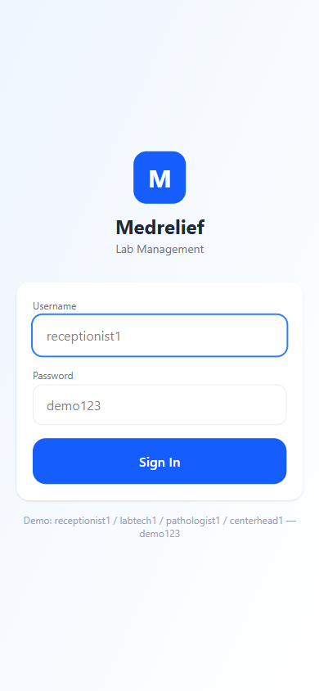
Stage 2: Kiosk Home
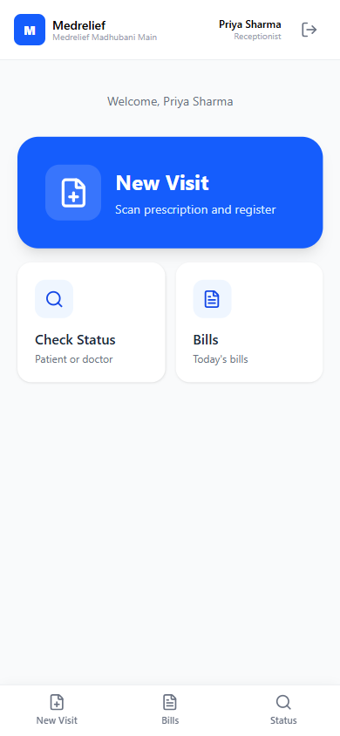
Stage 3: Capture Prescription (AI OCR)
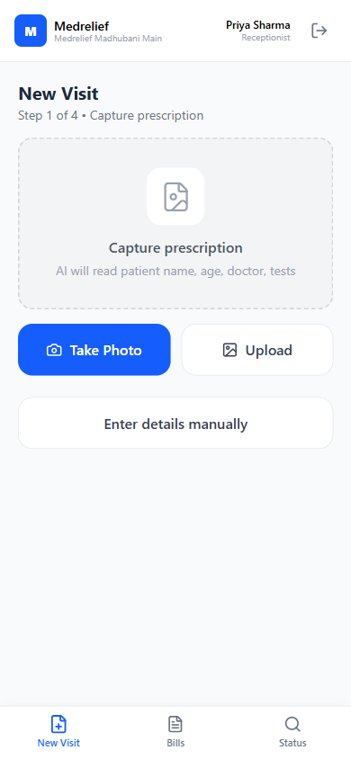
Stage 4: Verify Patient Details
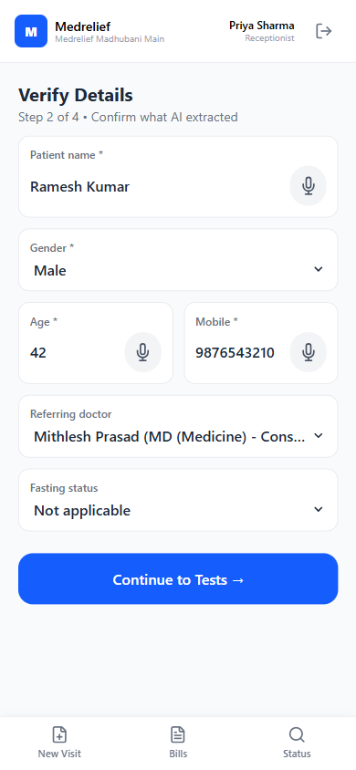
Stage 5: Select Tests (Rate Plan)
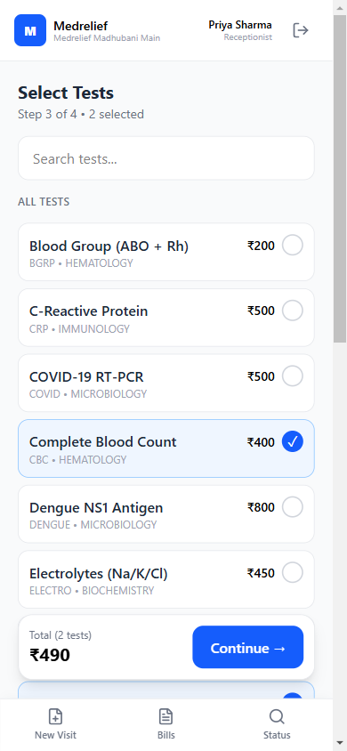
Stage 6: Payment Mode Selection
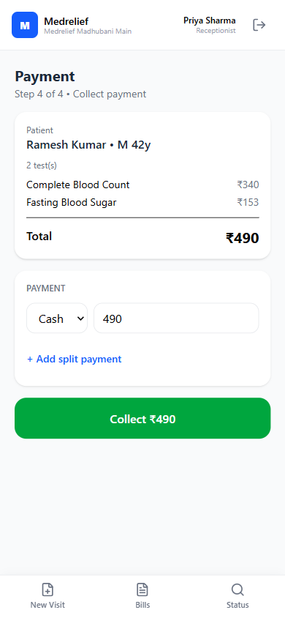
Stage 7: Razorpay Checkout
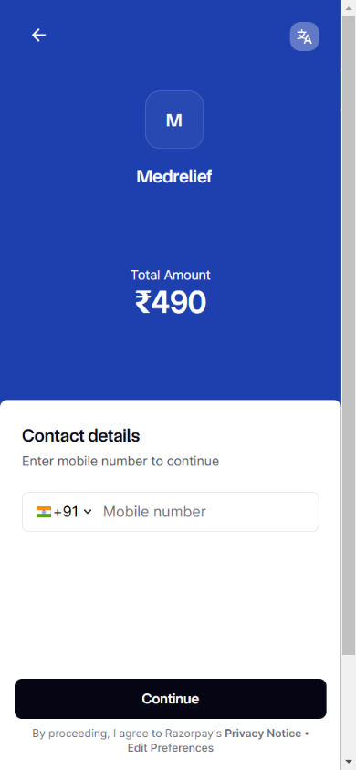
Stage 8: Paid Bill + Receipt + Labels
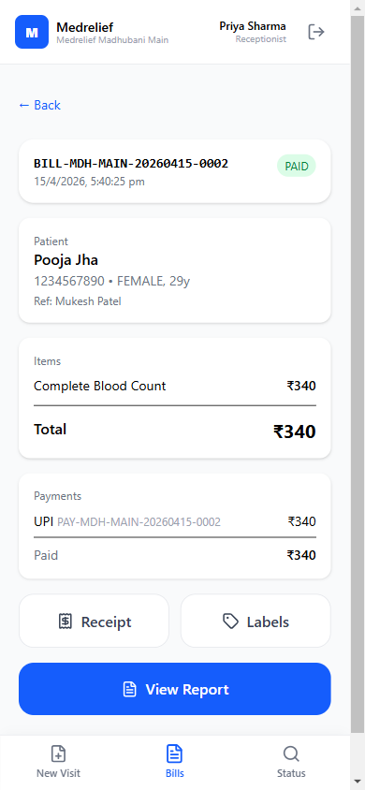
Stage 9: Login (Lab Technician)
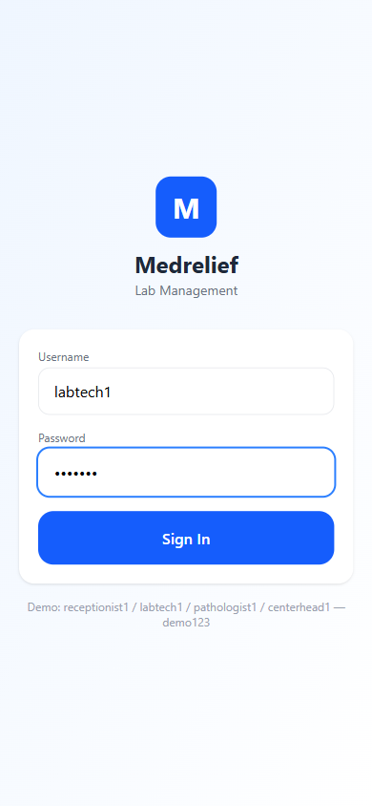
Stage 10: Lab Worklist
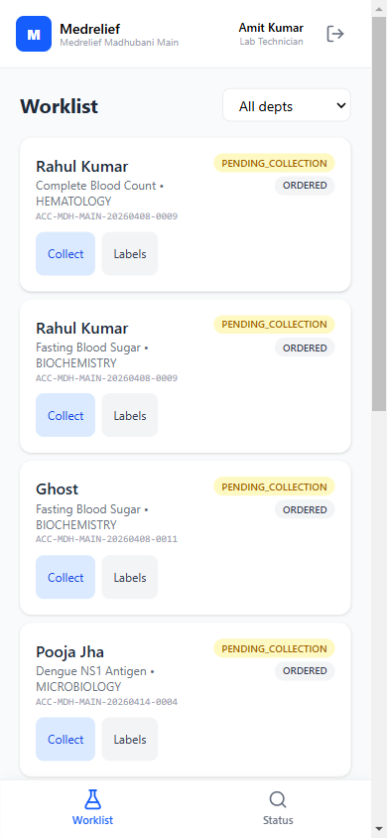
Stage 11: Sample Collected
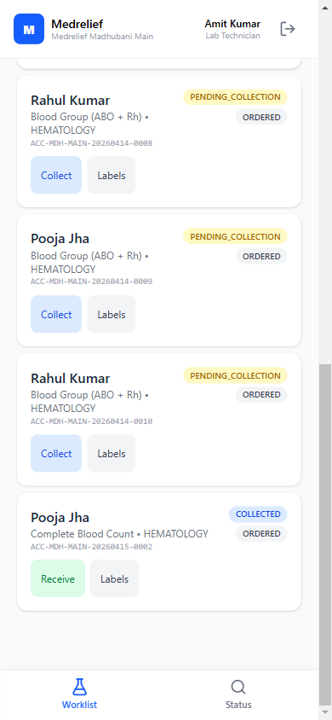
Stage 12: Enter Result
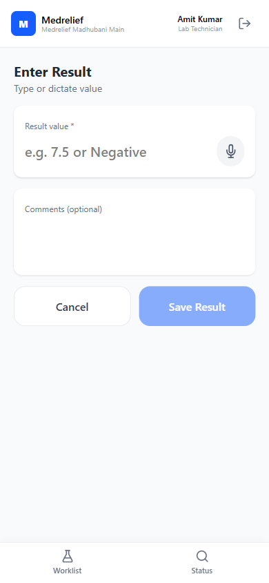
Stage 13: Login (Pathologist)
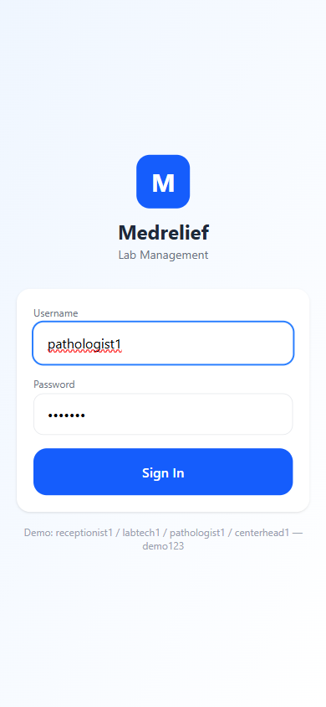
Stage 14: Sign-Off Queue (HIGH flag)
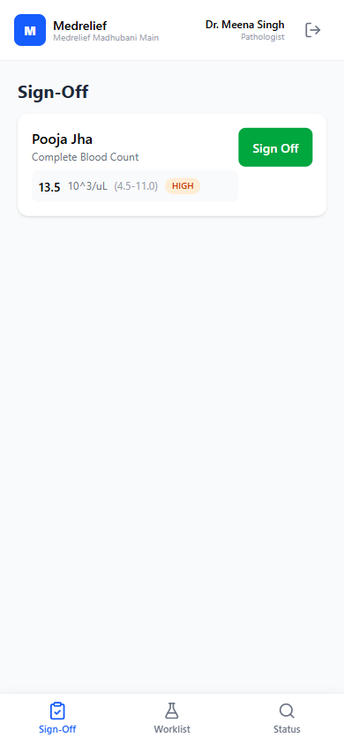
Stage 15: Sign-Off Cleared
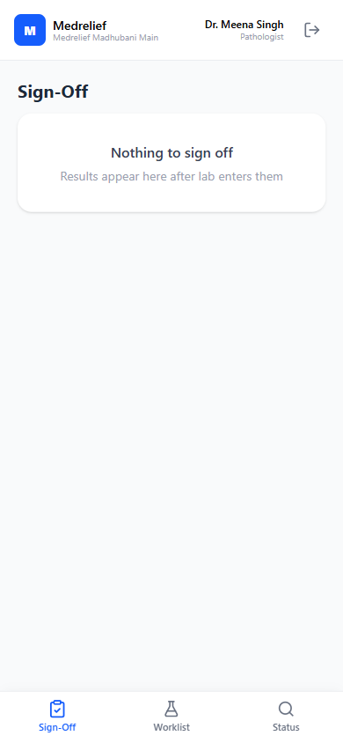
Stage 16: Report Viewer + Delivery
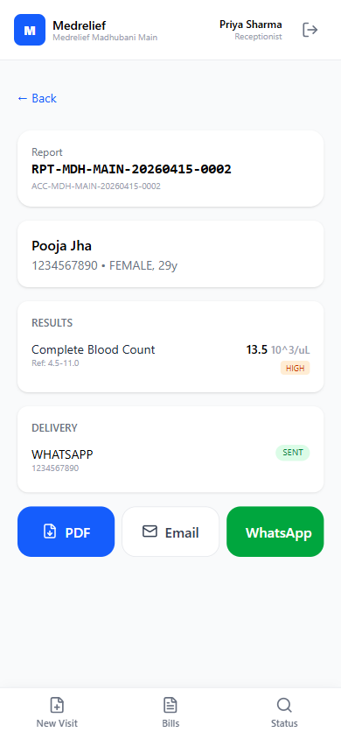
15.3 Production-Grade Additions (Same Product, Stronger Foundation)
The production system builds the same product from scratch in a new codebase. The prototype defines WHAT to build; the production architecture defines HOW. Same AI-first UX, same scan-to-report flow, same mobile-first kiosk — but with these production-grade additions:
- Multi-center org hierarchy (Tenant → Region → Center → Sub-center) vs prototype’s single-branch model.
- Full authorization model (4-tier RBAC + approval chains) vs prototype’s flat demo credentials.
- Transaction-level tracking with main status + sub-status vs prototype’s simpler bill/sample/test states.
- Real WhatsApp Business API integration vs prototype’s stub delivery logs.
- Conversational AI voice assistant vs prototype’s per-field voice input buttons.
- In-app report viewer with action bar vs prototype’s direct PDF download.

16. Production Additions
Behavioral requirements to enforce before go-live. These were surfaced during stakeholder review of the prototype.
16.1 Override Discount at Report Collection
Even when an agreed bill amount exists, allow an authorized role to apply a discount — but only before report delivery. After delivery, discounts are locked at the API and UI layer.
16.2 Approval Workflow on Override Discount
No direct bill amendment without approvals. The discount request routes through the configurable approval chain (see Section 19.4). Only the designated approver can commit the change.
16.3 Post-Settlement: Write-Off Only
Once the report is delivered or the bill is settled, the only permitted financial adjustment is a write-off. Discount edits must be blocked. This prevents informal bill amendments that field teams have historically done at pickup.
16.4 Rural / Low-Balance Case
Support a discount-at-pickup path for hardship scenarios (example: ₹450 still pending at report collection). Routed via the same approval workflow as any other override. The system must distinguish this from a standard discount.
16.5 Settlement Rule
A bill is NOT settled until the report is delivered.
Gate all permission checks, workflow locks, and automations on this rule — not on payment completion alone. This is the single source of truth for when a bill transitions from amendable to locked.

17. System Additions (Core Model + Tracking)
17.1 Transaction-Level Identifier
Assign a document_id (or transaction_id) per invoice. Treat each invoice as one transaction — the canonical unit for end-to-end tracking, audits, and reporting.
17.2 Main Status + Sub-Status Model
Every transaction carries a top-level state plus an operational sub-state. Enables fine-grained tracking without proliferating top-level statuses.
Payment Status Taxonomy
- PAYMENT_IN_PROGRESS
- PARTIAL_PAYMENT
- FULL_PAYMENT
- REFUND_IN_PROGRESS / REFUNDED / WRITTEN_OFF (future)
Report Status Tracking
- REPORT_GENERATED
- REPORT_COLLECTED (physical pickup at counter)
- REPORT_DELIVERED (handed to patient)
- REPORT_SENT_WHATSAPP
- REPORT_SENT_EMAIL / REPORT_SENT_SMS / REPORT_DELIVERY_FAILED (as channels expand)
17.3 Document Capture + AI Status View
Every captured document (prescription, bill, report) exposes its complete status flow — payment state, sample state, report state, delivery state — in one consolidated timeline per transaction.
17.4 Auditability on Amendments
Every bill amendment (discount, write-off, override) records: who requested, who approved, what changed, when, why. Surfaced in the document timeline and in a queryable audit log.

18. New Feature Requirements
18.1 Role-Based Notification System
Every role gets notifications scoped to their authorization and responsibilities:
- Receptionist: report ready for collection; payment received; discount approval decisions.
- Lab technician: new sample collected; sample transferred to lab; processing reminders.
- Pathologist: new completed result awaiting sign-off; amendments requested.
- Center head: discount/override approval requests; daily close pending; exceptions (critical flags, failed deliveries).
- Finance manager: reconciliation mismatches; end-of-day close checklist; refund requests.
Channels: in-app push (all), WhatsApp (urgent), email (digests). Escalation path when a role ignores a notification past SLA.
18.2 WhatsApp API Integration (Customer-Facing)
WhatsApp is a delivery channel for patient-facing communication only — not internal staff comms.
- Primary recipient: the registered patient mobile number.
- Additional WhatsApp field on patient or bill: optional secondary number (family member, referring doctor) that overrides or supplements the default.
- Scope in v1: report delivery. Later: appointment reminders, payment receipts.
Provider decision pending: Meta Cloud API direct, Gupshup, AiSensy, or WATI. Template approval pipeline required.
18.3 In-App Report Viewer (Replace PDF-First Download)
When a receptionist clicks Report, the default action opens a system-rendered report view — not a PDF download. From that view:
- Download PDF
- Send via WhatsApp
- Send via Email
- Print label
- Close
Report view reads from the same data model as the PDF renderer (single source of truth). Works offline-tolerant for rural branches.
18.4 Conversational AI Voice Assistant
Replace per-field voice input with a Siri/Bixby/Alexa-style AI assistant available to EVERY role, not just the receptionist. The assistant is always available via a floating mic button on every screen. User taps once; assistant listens and acts:
Example: “Patient name is Ramesh Kumar, age 42, male, mobile 9876543210, referred by Dr. Mithlesh, CBC and lipid profile.”
- Receptionist: “Patient Ramesh Kumar, male, 42, mobile 9876543210, Dr. Mithlesh referred, CBC and lipid profile.”
- Lab tech: “Pooja Jha CBC result 13.5, hemoglobin normal.”
- Pathologist: “Approve Pooja Jha CBC, comment looks normal.”
- Center head: “Show me today’s revenue and pending cases.”
- Speech-to-text → LLM extracts structured fields → populates form → user confirms.
- Language support: Hindi + English + code-switching (Roman Hindi).
- STT provider decision pending: Whisper API, Google Speech-to-Text, Sarvam AI, or Bhashini.
- Tap-to-talk (not wake word) for privacy in public reception areas.

19. Authorization Model + Multi-Center Org Hierarchy
Source: TimeFlow app (ntapp01-d432c.web.app) authorization flow analysis. Patterns cloned and extended for Medrelief’s multi-center diagnostic lab domain.
19.1 Role Hierarchy (4 Tiers)
L0 — Super Admin (Org-wide)
System configuration, org structure, user management, rate plans, global MDM. Spans the entire Medrelief tenant.
L1 — Center Head (Assigned center(s))
Full operational authority within their center. Approves discounts, overrides, daily close. Can be assigned to one or multiple centers.
L2 — Department Lead (Department within center)
Senior lab tech or senior receptionist. Review capability, shift oversight, escalation receiver. Optional tier — skip if center is small.
L3 — Staff (Role-specific within center)
Receptionist, Lab Technician, Phlebotomist, Pathologist, Finance Manager. Fixed permission set scoped to their function.
19.2 Role Switching (Cloned from TimeFlow)
- Profile page shows current active role + Switch Role list of all assigned roles.
- Session-scoped switch — no re-login required.
- Example: Dr. Meena Singh is both Pathologist (L3) and Center Head (L1). When in Center Head mode she sees Admin panel; in Pathologist mode she sees Sign-Off + Worklist only.
- Audit logs always record the role active at time of the action, not just user ID.
Login: Role Selection (Admin/Manager/Employee)
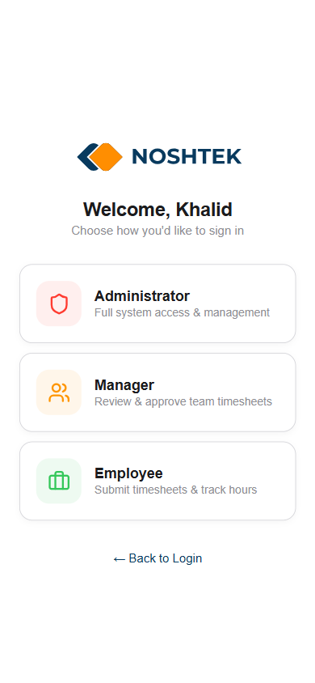
Admin Profile: Role Switch Panel
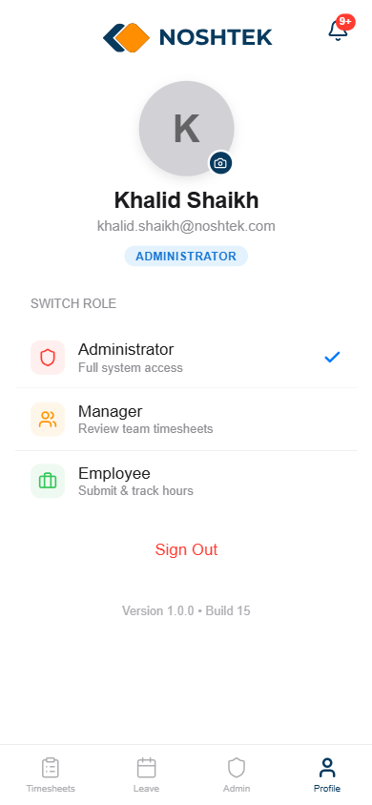
Admin Panel: Master Data Console
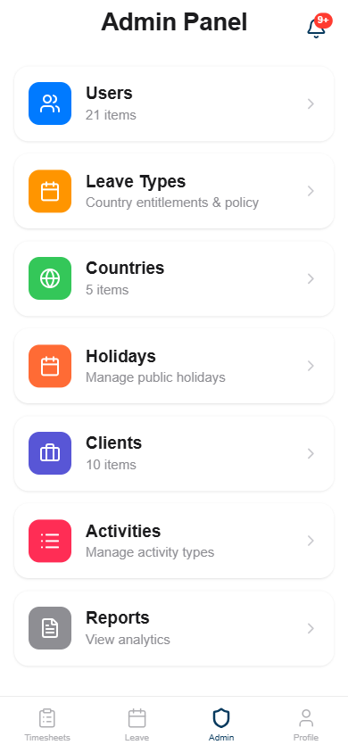
Admin: Users List (Active 13 / Blocked 8)
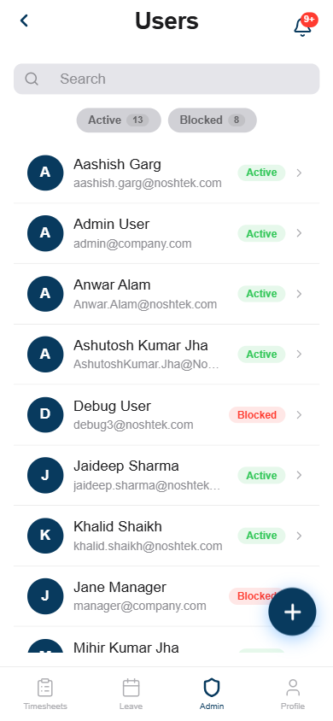
Admin: User Detail (Role Toggle + Assigned Manager)
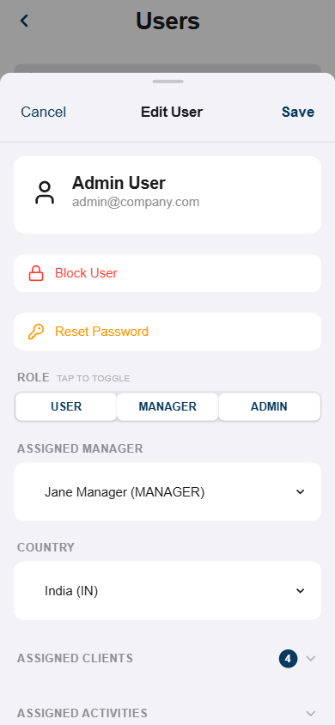
Admin: User Detail Expanded (Clients Assignment)
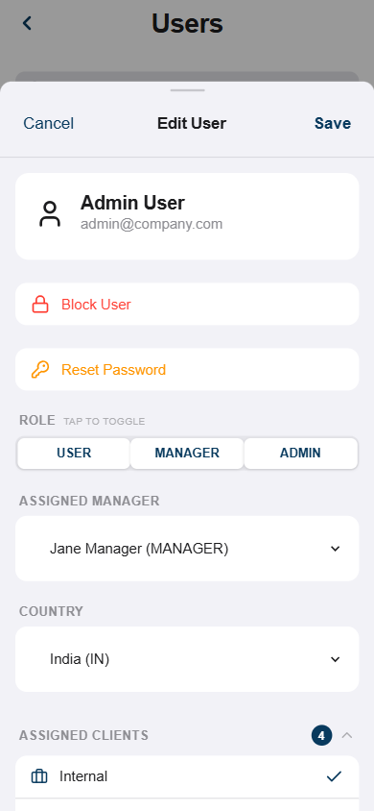
Admin: User Clients + Activities Assignment
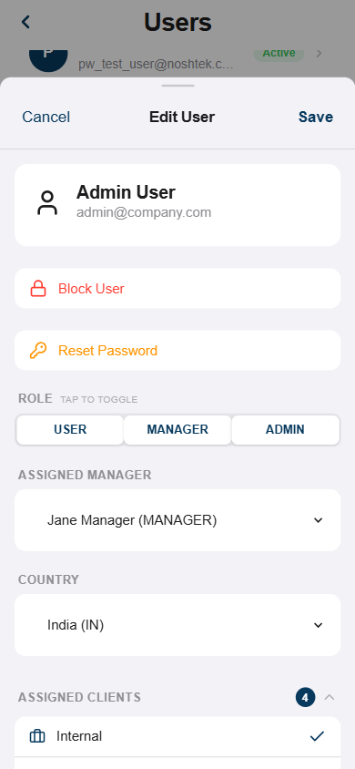
Notifications Panel (Role-Scoped)
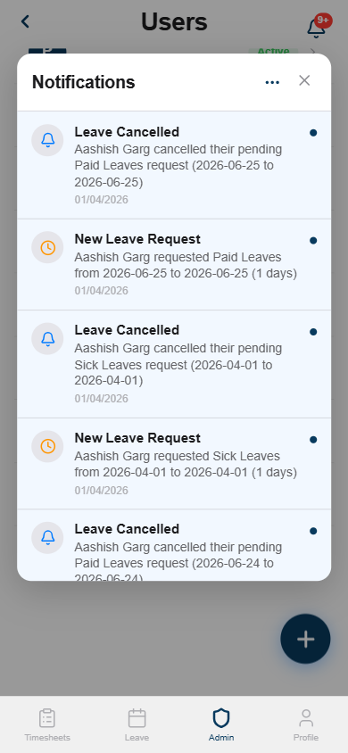
Manager View: Timesheets (team review)
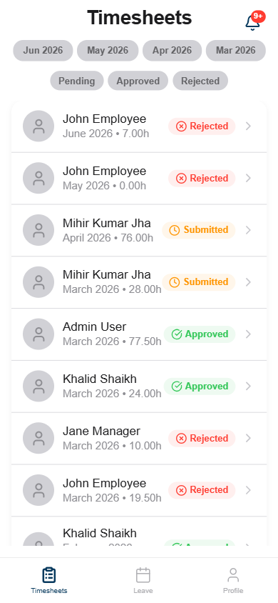
Manager Profile Badge (no Admin tab)
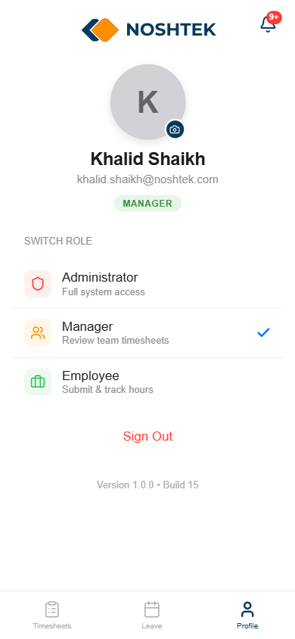
Employee View: Own Timesheets Only
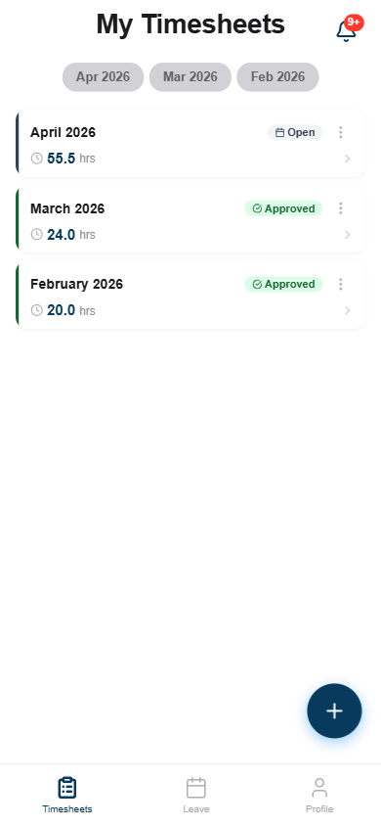
Employee Profile Badge
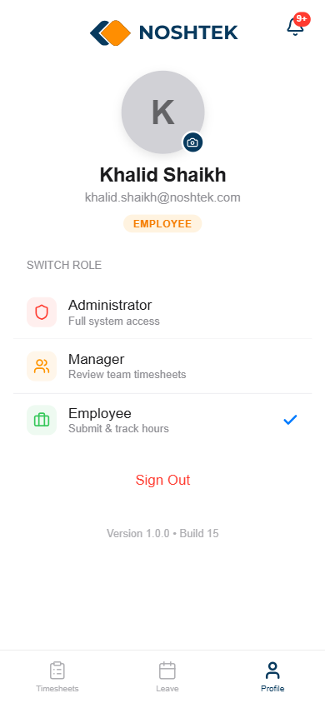
Admin View: All Users Timesheets
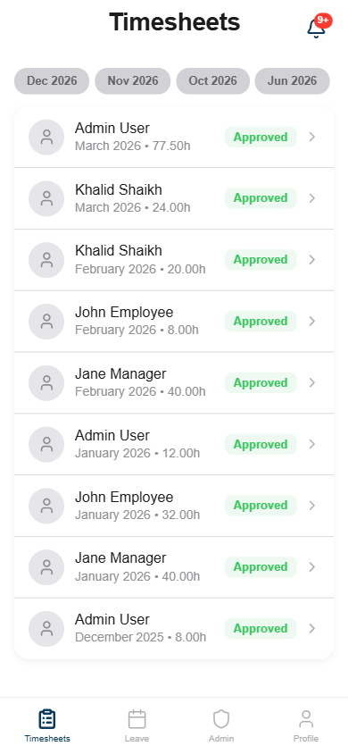
19.3 Multi-Center Org Hierarchy
Tenant: Medrelief
└ Region: Bihar (optional grouping layer for reporting)
└ Center: Bihar Sharif Main Lab
└ Sub-center: Bihar Sharif Collection Point A, B
└ Center: Madhubani Main Lab
└ Sub-center: Madhubani Collection Point 1, 2
- Centers are the primary operational unit. Each has own users, rate plans, billing, daily close.
- Sub-centers are collection-only or partial-test sites. Samples accessioned under parent center.
- Region is an optional grouping for dashboards and multi-center reports. No functional gating.
- Cross-center access for roving roles (pathologist covering multiple centers, super admin).
- Tenant-level MDM: test catalogs, doctor master, rate plan templates. Centers can override prices but not test definitions.
19.4 Approval Chains
Configurable multi-step approval per action type per center:
- Action types: DISCOUNT_OVERRIDE, WRITE_OFF, BILL_AMENDMENT, REFUND.
- Each chain: ordered steps (e.g., step 1 = Center Head, step 2 = Super Admin for large amounts).
- Request lifecycle: PENDING → APPROVED | REJECTED | EXPIRED.
- Every decision records: who decided, which role was active, comment, timestamp.
19.5 Notification Routing (Role + Scope)
Notifications triggered by domain events and routed by recipient’s role + center assignment:
- Report ready for collection → Receptionist (same center) — in-app, normal priority.
- New sample pending → Lab Tech (same center, same dept) — in-app, normal.
- Result awaiting sign-off → Pathologist (same center) — in-app + push, high.
- Discount override requested → Center Head (same center) — in-app + WhatsApp, high.
- Critical result flag → Pathologist + Center Head — in-app + WhatsApp + push, urgent.
- Daily close pending (past 8 PM) → Center Head + Finance — in-app + WhatsApp, high.
- Payment reconciliation mismatch → Finance (same center) — in-app, high.
19.6 Proposed DB Schema (Key Tables)
Full SQL in PROTOTYPE-FEEDBACK-ADDITIONS.md Section 7.4. Summary of new tables:
- org_tenants, org_regions, org_centers — org hierarchy with center_type (MAIN_LAB | COLLECTION_POINT) and parent_center_id.
- auth_roles — tenant-scoped, level (0–3), permissions JSONB, is_system flag.
- auth_user_assignments — many-to-many-to-many: user ↔ role ↔ center. is_primary for default login role.
- approval_chains, approval_requests, approval_decisions — configurable multi-step approval.
- notifications — role-scoped, multi-channel (IN_APP, WHATSAPP, EMAIL, PUSH), priority levels, read/dismiss.

20. Open Questions &amp; Action Items
20.1 Open Questions
- Discount vs write-off: exact transition point (report delivery? or payment + delivery both?).
- Who initiates override discount at report collection? Who approves? (receptionist → center head likely).
- Settlement definition: is it payment completion, report delivery, or both?
- WhatsApp Business API provider: Meta Cloud API / Gupshup / AiSensy / WATI?
- STT provider for voice assistant: Whisper / Google / Sarvam AI / Bhashini?
- Is WhatsApp-sent sufficient or need SMS, email, re-send, failed-delivery states?
- Report viewer: 1 responsive template or separate mobile + desktop?
- Region layer: mandatory or optional for initial rollout?
- Department Lead (L2) tier: include from day 1 or defer to post-launch?
20.2 Action Items
- Create document_id + transaction model for invoice-level tracking.
- Design main-status + sub-status flow (payment, sample, report).
- Draft override-discount-at-pickup workflow: trigger → approval → apply → audit.
- Build org hierarchy tables (org_tenants, org_regions, org_centers).
- Build auth model tables (auth_roles, auth_user_assignments) + seed data.
- Build approval chain tables + REST API endpoints.
- Build notification system (domain events → routing rules → multi-channel delivery).
- Integrate WhatsApp Business API for report delivery.
- Replace per-field voice input with conversational AI assistant.
- Build in-app report viewer with action bar (PDF / WhatsApp / Email / Print / Close).
20.3 Document History
- v2.1 (original) — Sections 1–14. Phase 1 LIMS, Billing, Basic Finance PRD.
- v3.0 (this version) — Sections 15–20 added. Prototype learnings, production additions, authorization model, new features.
- Source files preserved intact: Medrelief_ERP_PRD_v2.1-Phase-1.docx, Medrelief-Prototype-Flow.docx, PROTOTYPE-FEEDBACK-ADDITIONS.md.

