TimeFlow Authorization Model
Reference Flow for Medrelief LIMS
Roles, Access Levels, Notifications & Org Hierarchy
April 2026 · Source: ntapp01-d432c.web.app

1. Login + Role Selection
After authenticating with email/password, the user sees a role selection screen. Each user can hold multiple roles; they choose which one to activate for this session.
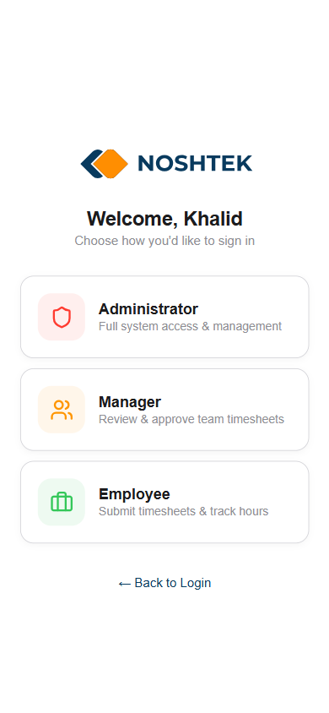
- Administrator — Full system access & management.
- Manager — Review & approve team timesheets.
- Employee — Submit timesheets & track hours.
The selected role determines which tabs appear in the bottom navigation and what data is visible. Role can be switched anytime from the Profile page without re-login.

2. Administrator View

2.1 Profile (Administrator badge)
Profile page shows the active role badge and the Switch Role selector. Administrator has a checkmark.
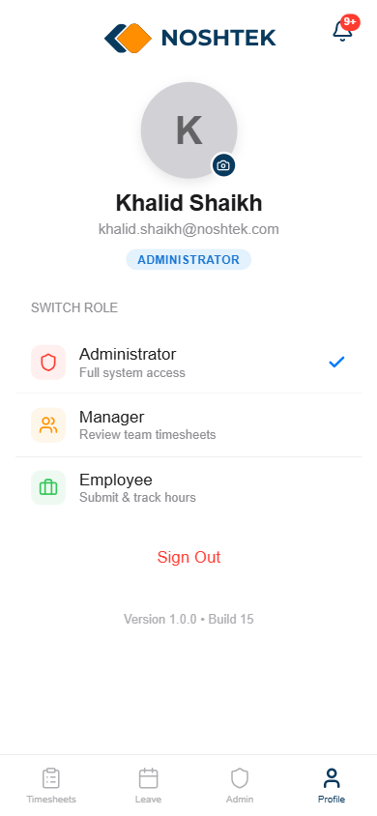
Bottom nav tabs visible: Timesheets, Leave, Admin, Profile
The Admin tab is ONLY visible to the Administrator role. Managers and Employees do not see it.

2.2 Admin Panel
The Admin tab opens a master-data console. Only Administrators can access this.
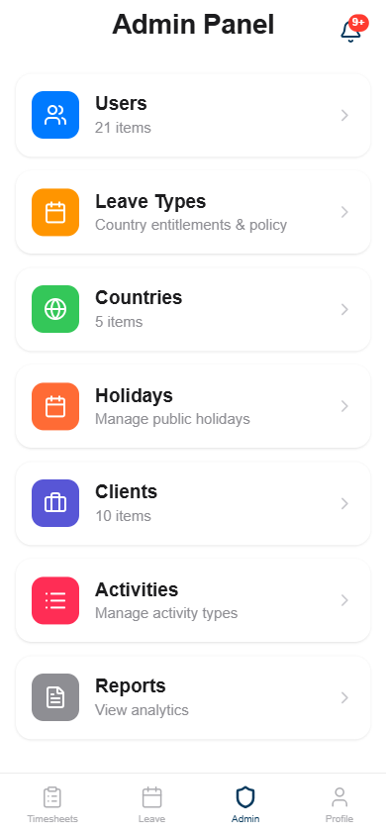
- Users (21) — Create, edit, block/unblock users. Assign roles, managers, country, clients, activities.
- Leave Types — Country-level leave entitlements and policy.
- Countries (5) — Geographic scope for user assignment.
- Holidays — Manage public holidays.
- Clients (10) — Client entities that users are assigned to.
- Activities — Activity types (Development, Testing, Documentation, etc.).
- Reports — View analytics across all users.

2.3 User Management
Admin sees all users (Active: 13, Blocked: 8) with search and status filter.
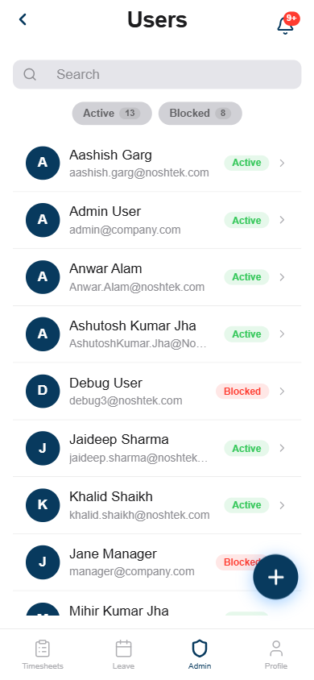
User states: Active / Blocked (soft-disable, data retained for audit).

2.4 User Detail — Role Assignment
Tapping a user opens the Edit User sheet. This is the core authorization control surface.
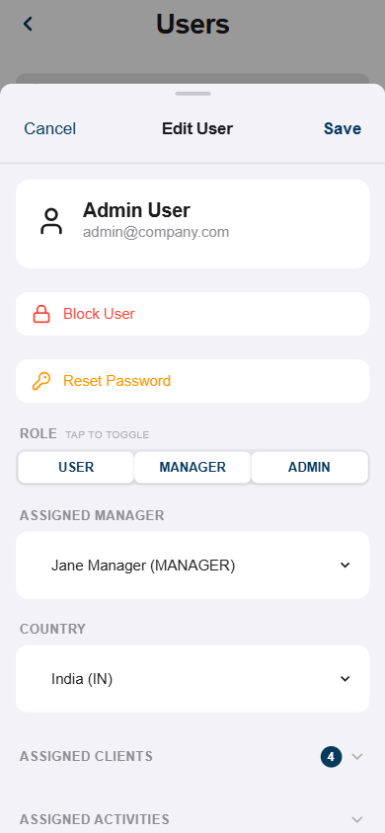
- Block User — Soft-disable. User cannot log in but data is preserved.
- Reset Password — Admin-initiated password reset.
- ROLE (tap to toggle) — Multi-select: USER, MANAGER, ADMIN. A user can hold all three simultaneously.
- Assigned Manager — Dropdown of users who have the MANAGER role. Shows role badges (e.g., "Khalid Shaikh (USER,MANAGER,ADMIN)").
- Country — Geographic assignment (India, US, Canada, Singapore, Taipei).
- Assigned Clients — Which clients/entities this user can work on.
- Assigned Activities — Which activity types this user can log time against.
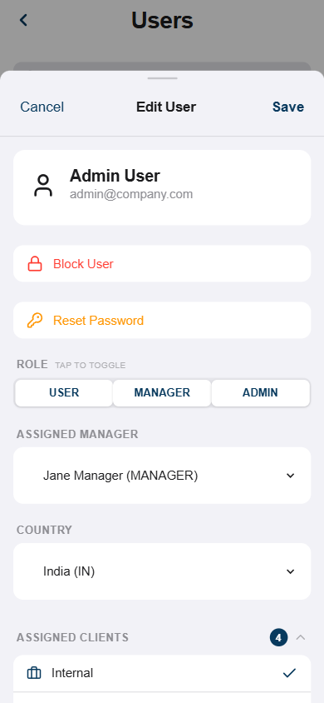
Clients are toggled with checkmarks. Medrelief equivalent: assigned Centers/Sub-centers.

2.5 Notifications (In-App)
Bell icon with unread count badge (9+). Opens a notification panel overlay.
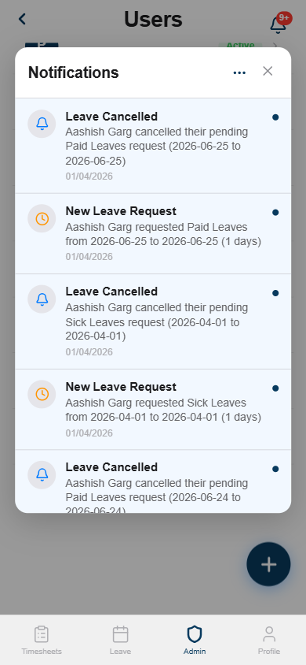
- Each notification: icon + title + description + date + unread indicator (blue dot).
- Types observed: Leave Cancelled, New Leave Request — routed to admin because admin sees all.
- Three-dot menu for mark-all-read / settings.
Medrelief equivalent: discount approval requests, critical result flags, daily close reminders, report-ready alerts — all role-scoped.

2.6 Admin Timesheets (all users visible)
Administrator sees timesheets from ALL users across all months. Title: "Timesheets" (not "My Timesheets").
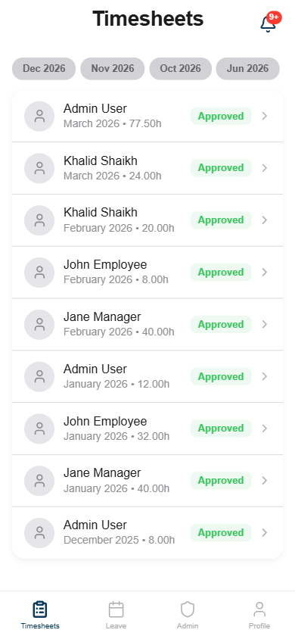
Key: Admin User, Khalid Shaikh, John Employee, Jane Manager — all visible. All statuses: Approved.

3. Manager View

3.1 Profile (Manager badge)
Same Switch Role UI but badge now shows MANAGER. Bottom nav: Timesheets, Leave, Profile — NO Admin tab.
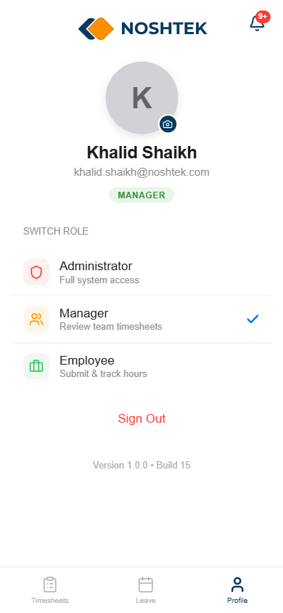

3.2 Team Timesheets (review + approve/reject)
Manager sees their team’s timesheets — not all users, only direct reports. Title still "Timesheets" but with status filters: Pending, Approved, Rejected.
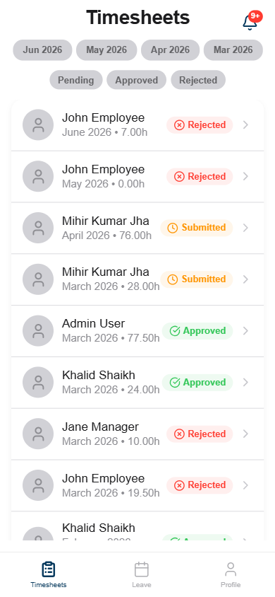
- Statuses visible: Submitted (pending review), Approved, Rejected.
- Manager can approve or reject — this is the approval workflow.
What’s hidden: Admin tab entirely. No user management, no MDM, no reports.

4. Employee View

4.1 Profile (Employee badge)
Badge: EMPLOYEE. Same Switch Role UI. Bottom nav: Timesheets, Leave, Profile — NO Admin tab.
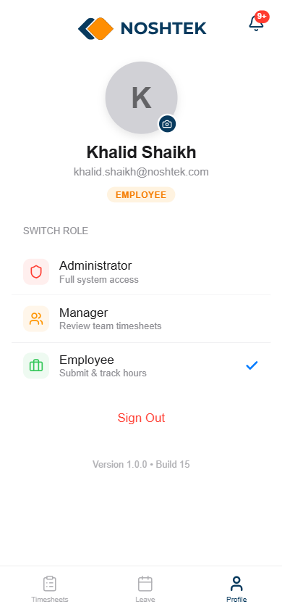

4.2 My Timesheets (own data only)
Title changes from "Timesheets" to "My Timesheets". Employee sees ONLY their own entries. FAB (+) to create new.
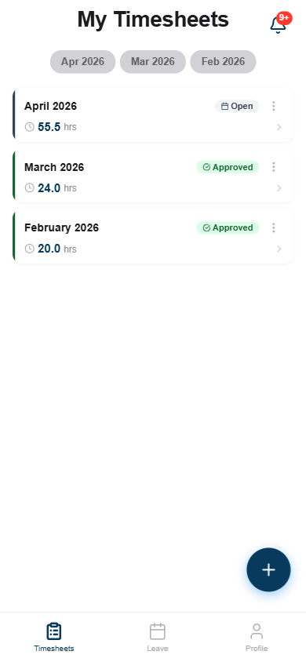
- April 2026: 55.5 hrs, Open (still editable).
- March 2026: 24 hrs, Approved (locked).
- February 2026: 20 hrs, Approved (locked).
What’s hidden: Other users’ data. Admin tab. Approve/reject actions.

5. Access Level Matrix
Summary of what each role can see and do.
Capability | Administrator | Manager | Employee
Admin tab visible | ✓ | ✗ | ✗
Manage users (create/block/roles) | ✓ | ✗ | ✗
Manage MDM (activities, holidays, clients) | ✓ | ✗ | ✗
View all timesheets | ✓ | Team only | Own only
Approve/reject timesheets | ✓ | ✓ | ✗
Submit own timesheets | ✓ | ✓ | ✓
View reports/analytics | ✓ | ✗ | ✗
Receive all notifications | ✓ | Team scope | Own scope
Switch role (Profile) | ✓ | ✓ | ✓

6. Mapping to Medrelief LIMS
TimeFlow’s 3-tier model maps directly. Medrelief extends it with center-level scoping and clinical roles.

6.1 Role mapping
TimeFlow | Medrelief | Scope / Notes
Administrator | Super Admin | Org-wide. All centers. User mgmt, MDM, rate plans, org structure.
Administrator | Center Head | Scoped to assigned center(s). Approve discounts, daily close, see all staff data within center.
Manager | Department Lead | Optional tier. Senior lab tech or senior receptionist. Review within their department.
Employee | Staff roles | Receptionist, Lab Tech, Pathologist, Finance. Role-specific permissions within assigned center.

6.2 Features to clone from TimeFlow
- Role selection at login — after auth, show assigned roles. User picks which one to activate.
- Role switching on Profile page — no re-login needed. Session-scoped. Audit logs record active role at time of action.
- User management (Admin only) — Active/Blocked states. Role toggle (multi-select). Assigned manager dropdown. Country → Center assignment.
- In-app notification panel — Bell icon + badge count. Scrollable list with title, description, date, unread dot. Role-scoped routing.
- Tab-level access gating — Admin tab hidden for non-admin roles. Data scope changes per role (all users vs team vs self).
- Assigned entities per user — TimeFlow: Clients + Activities. Medrelief: Centers + Sub-centers + Departments.

6.3 Extensions beyond TimeFlow
- Multi-center scoping — TimeFlow is single-org. Medrelief needs Tenant → Region → Center → Sub-center hierarchy.
- Approval chains — TimeFlow: approve/reject timesheets. Medrelief: discount overrides, write-offs, bill amendments, refunds — each with configurable approval steps.
- Clinical permissions — lims:sign-off (pathologist only), lims:create (lab tech), billing:override (center head + super admin).
- Cross-center roles — A pathologist covering Bihar Sharif + Madhubani sees sign-off queues from both centers.
- Notification channels — TimeFlow: in-app only. Medrelief: in-app + WhatsApp + push + email, with priority levels (Normal, High, Urgent).

7. Proposed Medrelief Org Hierarchy
Tenant: Medrelief
- Region: Bihar
- Center: Bihar Sharif Main Lab
- Sub-center: Bihar Sharif Collection Point A
- Sub-center: Bihar Sharif Collection Point B
- Center: Madhubani Main Lab
- Sub-center: Madhubani Collection Point 1
- Sub-center: Madhubani Collection Point 2

Centers are the primary operational unit. Sub-centers are collection-only or partial-test sites. Samples collected at sub-centers are accessioned under the parent center. Some roles (roving pathologist, super admin) span multiple centers.
See Section 7 of PROTOTYPE-FEEDBACK-ADDITIONS.md for the full DB schema (8 tables) covering org hierarchy, role assignments, approval chains, and notifications.

