Social Media Sentiment Analysis and Content Performance Dashboard
Project Definition Document (PDD)

Degree Program: BSc Computer Science, City, University of London
Author: Khalid Takar
Email: khalid.takar@city.ac.uk
Project Consultant: BSc CS, Riad Ibadulla
Project Proposed by: Self
Proprietary Interests & Agreements: No proprietary interests or external agreements.
Promises & Commitments: The project will strictly adhere to university guidelines and ethical considerations.
Word Count: 825 words

1. Proposal – Problem to be Solved

1.1 Problem Statement
The rise of social media has increased the need for real-time sentiment analysis. Individuals and businesses struggle to track audience engagement and comments across platforms like Twitter, YouTube, Reddit, Instagram, and WhatsApp. Existing tools:
- Provide basic sentiment analysis but lack deep insights.
- Are platform-restricted, requiring users to check each service separately.
- Do not offer actionable recommendations based on sentiment trends.
This project aims to build a website that reviews content creators’ public comments using sentiment analysis. The system will have two tiers: Basic and Premium (where it would be behind a paywall).
- Basic (MVP to be delivered first): Provides a percentage breakdown of sentiment (positive, negative, neutral, constructive, indifferent) and ranks user engagement using a hexagonal radar chart or a percentage loading circle and other engagement scores.
- Premium (Future Extension): Offers an in-depth sentiment breakdown, AI-generated summaries, insights on narrative management, and a personalised chatbot (LLM-based assistant) to advise users on content.
I believe such a website application would be a content creator goldmine.
If time permits, additional features will be implemented beyond the MVP.

1.2 References to Existing Work
The project builds upon already existing sentiment analysis frameworks:
- NLTK & TextBlob (Loper & Bird, 2002) – Basic sentiment processing.
- VADER Sentiment Analyzer (Hutto & Gilbert, 2014) – Optimized for social media.
- Hugging Face Transformers (Wolf et al., 2020) – State-of-the-art NLP models.
- Chart.js for visualization – Widely used for dynamic charts in web applications.
These references provide the foundation for the sentiment analysis model and visualisation techniques to be used in this project.

2. Proposal – Project Objectives

2.1 Main Objective
This project aims to develop a web-based application that allows users to analyse sentiment on social media comments and visualize trends using an interactive dashboard.

2.2 Sub-Objectives
- Develop a Flask-based backend for sentiment analysis using Python NLP libraries.
- Design a PostgreSQL database to store user inputs and sentiment results.
- Create a web interface using HTML, CSS, and JavaScript for input and visualization.
- Integrate Chart.js for displaying sentiment trends dynamically.
- Implement a hexagonal radar chart for a detailed sentiment overview.
- Deliver the Basic (MVP) version first and add additional Premium features if time permits.
- Ensure API scalability for potential cross-platform expansion.
- Develop a premium AI-driven chatbot for personalized insights.
Each objective will be assessed based on its functionality, performance, and user feedback.

3. Proposal – Project Beneficiaries
Beneficiary | Benefit
Content Creators | Understand audience sentiment and impression.
Social Media Managers | Improve brand perception and engagement.
Businesses | Analyse customer feedback at scale.
Marketing Analysts | Track real-time sentiment trends in social media.
Researchers | Study online sentiment variations and user behaviour.

4. Proposal – Work Plan

4.1 Development Timeline
Phase | Tasks | Timeframe
Setup | Install Flask, PostgreSQL, and Chart.js. | Weeks 1-2
Backend | Develop API endpoints for sentiment analysis. | Weeks 3-4
Database | Design & implement PostgreSQL schema. | Weeks 5-6
Frontend | Develop HTML/CSS/JavaScript UI. | Weeks 7-8
Feature Expansion | Implement Twitter API integration. | Weeks 9-10
Testing & Refinement | Conduct UI/UX and API testing. | Weeks 11-12
Deployment | Deploy using Heroku/Render & finalize docs. | Weeks 13-14
A Gantt chart detailing project milestones is available down below.
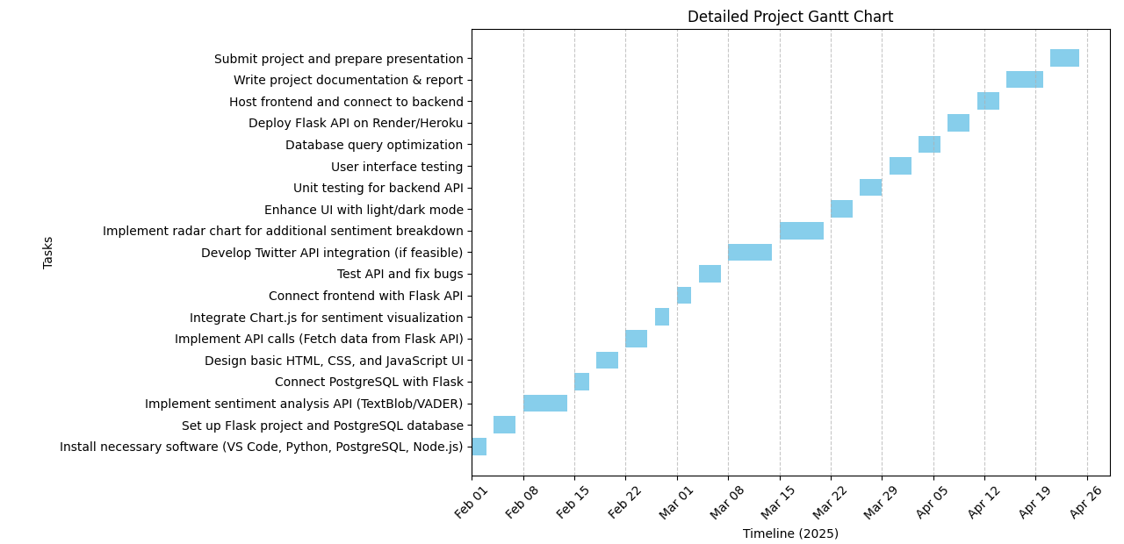

5. Proposal – Risks to the Project
Risk | Likelihood | Impact | Mitigation Strategy
Learning Curve with Flask | Medium | Medium | Follow online tutorials & documentation.
API Rate Limit Issues | High | High | Use pre-existing datasets for testing.
Ethical Concerns | Medium | High | Analyse only public comments, ensure GDPR compliance.
UI Development Delays | Medium | Medium | Use Bootstrap to streamline UI development.
Unexpected Errors | High | High | Maintain frequent backups & debugging logs.

6. Legal, Social, Ethical, and Professional Issues (LSEPI)

6.1 Data Privacy and Compliance
- The project will only analyse publicly available data to comply with GDPR.
- No personally identifiable data (PII) will be collected or stored.

6.2 Ethical Issues
- Bias in sentiment analysis models: Multiple models will be tested to ensure fairness.
- Potential misuse of the tool: Terms of Service will include prohibited use cases.

7. Research Ethics Checklist
Ethical Consideration | Actions Taken
Use of Public Data | No private user data will be stored.
Data Storage | Sentiment results stored without usernames.
Bias in AI models | Models will be tested for fairness.

8. References
- Loper, E., & Bird, S. (2002). NLTK: Natural Language Toolkit.
- Hutto, C., & Gilbert, E. (2014). VADER: A Parsimonious Rule-based Model for Sentiment Analysis of Social Media Text.
- Wolf, T., et al. (2020). Transformers: State-of-the-Art Natural Language Processing.

9. Approval of the PDD
By submitting this PDD, I confirm that:
- The project meets the module requirements.
- Ethical considerations have been addressed.
- Any major changes will require approval from my project consultant.
Student Name: Khalid Takar
Date: 01/02/2025

