Final Project Report

<<Dairy drop>>



Project Supervisor
<<Muhammad Hussaan>>

Submitted By

<<bc230412534>>

<<khalid usman>> <<bc230412534>>

Software Projects & Research Section,
Department of Computer Sciences,
Virtual University of Pakistan


CERTIFICATE

This is to certify that <<khalid usman>> (<<bc230412534>>) has worked on and completed their Software Project at Software & Research Projects Section, Department of Computer Sciences, Virtual University of Pakistan in partial fulfillment of the requirement for the degree of BS in Computer Sciences under my guidance and supervision.

In our opinion, it is satisfactory and up to the mark and therefore fulfills the requirements of BS in Computer Sciences.

Supervisor / Internal Examiner

<<Muhammad Hussan>>
Supervisor,
Software Projects & Research Section,
Department of Computer Sciences
Virtual University of Pakistan

___________________
(Signature)

External Examiner/Subject Specialist
<<External Supervisor Name>>

___________________
(Signature)

Accepted By:

_____________
(For office use)

EXORDIUM

In the name of Allah, the Compassionate, the Merciful.

Praise be to Allah, Lord of Creation,
The Compassionate, the Merciful,
King of Judgment-day!

You alone we worship, and to You alone we pray for help,
Guide us to the straight path

The path of those who You have favored,

Not of those who have incurred Your wrath,
Nor of those who have gone astray.

DEDICATION

The completed work to be devoted to someone closer to you e.g., Mother, Father etc.
My mother .

ACKNOWLEDGEMENT

Thankfulness to your loved ones for their support in the completeness of the project.

PREFACE

Represents Scope and Aim.

TABLE OF CONTENTS

CHAPTER NO. 1
Software requirements specification (SRS Document)

  - scope
The Dairy Drop project aims to develop a web-based platform that connects customers with dairy producers and distributors, enabling the online sale and distribution of dairy products such as milk, yogurt, cheese, butter, and cream. The system will provide features for user registration, product browsing, shopping cart management, order placement, and real-time order tracking. For producers and distributors, it will include tools for inventory management, product updates, and order processing. The platform focuses on delivering a reliable, user-friendly, and efficient digital solution that ensures timely product delivery, accurate stock management, and a seamless experience for both customers and businesses

  - Functional & non-fucntional)
A. Functional Requirements
- User Account Management
  - Users can register, log in, and log out securely.
  - Users can update their profile information, delivery addresses, and view order history.
  - Admins can manage all registered users and control their access levels.
- Product Management (Admin/Producer)
  - Admins or producers can add, edit, or remove products.
  - Products are organized into categories like milk, yogurt, cheese, butter, cream, and others.
  - Each product includes details such as price, nutritional facts, shelf life, description, and images.
- Product Browsing and Search
  - Customers can view product lists and detailed product pages.
  - Filters for price, category, brand, and nutritional content are available to simplify product selection.
- Shopping Cart and Checkout
  - Customers can add or remove products, update quantities, and view total costs in the shopping cart.
  - Checkout process captures delivery details and confirms orders for processing.
- Payment Options
  - Cash-on-Delivery (COD) is available for all orders.
  - Customers receive order confirmation after placing an order.
- Order Tracking
  - Customers can track the status of their orders (Pending, Packed, Out for Delivery, Delivered).
  - Admins can update order statuses and manage deliveries efficiently.
- Reviews and Ratings
  - Customers can provide feedback and rate purchased products.
  - Admins can manage reviews, removing inappropriate content when necessary.
B. Non-Functional Requirements
- Performance
  - Pages should load quickly (within 3 seconds) even with a large number of products.
  - Database queries must be optimized for fast data retrieval.
- Usability
  - The interface must be simple, intuitive, and responsive on desktops, tablets, and mobile devices.
  - Navigation and product selection should be user-friendly for all age groups.
- Security
  - User passwords must be securely stored using hashing algorithms.
  - Sensitive data must be protected against unauthorized access.
- Reliability
  - The system should be available 99% of the time.
  - Daily backups of critical data should be maintained to prevent data loss.
- Scalability
  - The system should support growing numbers of products, users, and concurrent orders without performance degradation.
- Maintainability
  - Code should be modular and well-documented for easy future updates and bug fixes.
- 1.3 Use Case Diagram
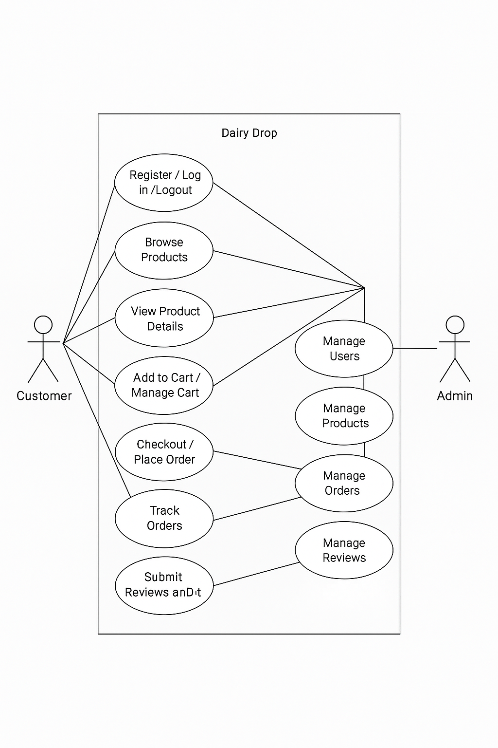

- 1.4 Work Plan (Use MS Project to create Schedule/Work Plan)

CHAPTER NO. 2
designing the project (Design Document)
2.1 Introduction of Design Document
2.2 Data Flow Diagram (DFD)
2.3 Entity Relationship Diagram (ERD)
2.4 Database Design
2.5 Interface Design

<<Dear Students, before starting each chapter the following would be the title page for each chapter on a separate page>>

CHAPTER 1
SOFTWARE REQUIREMENTS SPECIFICATION (SRS DOCUMENT)

1.1 Scope of Project:

<Write here in detail about the scope of your project>

1.2 Functional and non Functional Requirements:

<Write here in detail about the functional and non-functional requirements of your system in separate headings>

1.3 Use Case Diagram

<Provide Use Case Diagram of the system >

1.4 Work Plan (Use MS Project to create Schedule/Work Plan)

<Provide Gantt chart of your final project>

CHAPTER 2
Designing the Project
(Design Document)

  - Introduction of Design Document
<Write here in detail about what you have included in this document and also write about the benefits and purpose of this phase in a software development project >
  - Data Flow Diagram (DFD) (To be developed using Microsoft Visio or any other drawing software of your choice)
<Provide Data Flow Diagram (DFD) of your system>
  - Entity Relationship Diagram (ERD) (To be developed using Microsoft Visio or any other drawing software of your choice)
<Provide Entity Relationship Diagram (ERD) of your system>
  - Database Design

<Provide Database Design Diagram of the system>

  - Interface Design (Optional)

<Provide here the screenshots (GUI) of the system (Provide 3 or 4 main GUIs/interfaces, to show the most important features of the application as you are visualizing your application to be, in actual development phase. You can update these GUIs in Final Report and Final Presentation, in case they are changed after the actual development.>

REFERENCES

APPENDIX

Supplementary Material

