**PE-PRJ-TP-TCP-22679**

**Replacement Of damaged Thermal Duct Insulation**

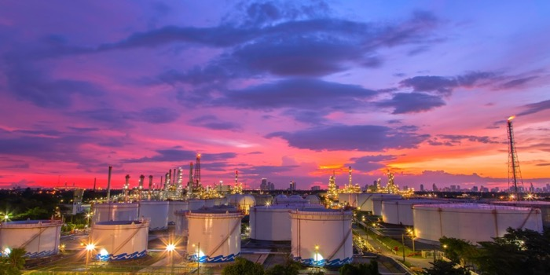

1. **Introduction**

DEWA, represented by the Procurement Division, intends to procure and install damaged thermal insulation at E-Station, Phase-1 H1 Building, Plant-1, Jebel Ali.

Our technical team evaluated furnished documents and provided the below offer.

1. **Scope of Work**

This service involves the supply and installation of necessary equipment and components.

**Inclusions**:

* Removal of existing old duct insulation.
* Cleaning and repairing of existing duct.
* Supply of insulation material.
* Re-insulation of supply and return air ducts with 1" glass wool board insulation sheet with foster and cloth.
* Thermal insulation for supply and return air ducts shall be of 1" thickness fiber-glass board insulation of density 64 Kg/cubic meter having canvas cloth with anti-fungus foster coating of rating 30-60 and 30-90 only.
* Proper housekeeping must be maintained on a daily basis during the work.
* Segregation and disposal of removed ducts and insulation to DEWA scrap yard by the contractor as per DEWA's existing Quantity, Safety & Environmental Procedure.
* Submission of complete duct insulation specifications, method statement, and job completion schedule by the suppliers.

**Exclusions**:

* Electricity- 3 Phase /other Yard Facilities (Air and/or water),
* Scaffolding / Rigging, all rigging tools (if required),
* Any Special tools other than the required to finalize the mentioned scope of work,
* Issuing gate passes required for site entry,
* Any works other than mentioned.

1. **Duration**

Duration required for this project is 15 Working days, after permit to work approval by DEWA.

1. **Technical Approach**

Our approach to this Project is based on dividing this task into eight main phases. The approach, to be used for each phase, will now be presented in some detail hereinafter.

**Work Execution**

**4-1. Mobilization:**

a. Mobilize manpower, tools, equipment, and materials to the job site as per the agreed-upon schedule.

b. Set up the necessary site facilities, including site office, storage area, and safety signage.

**4-2. Site Preparation:**   
a. Conduct a site survey to identify the location of ducts, access points, and any potential obstacles. b. Clear the work area of debris, obstructions, and any potential safety hazards.

c. Set up proper safety measures, personal protective equipment (PPE) for all workers.

**4-3. Removal of Existing Insulation:**   
a. Carefully remove the existing old duct insulation using appropriate tools, following safety regulations and procedures.

b. Dispose of the old insulation in compliance with local regulations and environmental requirements.

c. Inspect the ducts for any damage or leaks and repair them as necessary.

**4-4. Duct Cleaning and Repair:**  
a. Thoroughly clean the ducts using approved methods, such as vacuuming or brushing, to remove dust, dirt, and contaminants.

b. Repair any damage or leaks in the ducts, including sealing joints and seams with approved materials.

**4-5. Insulation Material Supply:**   
a. Procure the specified insulation material, which should be 1" glass wool board insulation sheet with foster and cloth, as per the approved materials submittal.

b. Verify the quality and quantity of the insulation material upon delivery and store it in a designated storage area in compliance with manufacturer's recommendations.

**4-6. Insulation Installation:**   
a. Prepare the duct surfaces by cleaning and priming them as per the manufacturer's instructions.  
 b. Cut and fit the insulation sheets to the ducts, ensuring proper alignment, fitting, and coverage.   
c. Apply suitable adhesives, staples, to secure the insulation sheets to the ducts, following the approved method statement and specifications.   
d. Install insulation in accordance with the project specifications, including proper thickness, density, and coverage, and ensure that there are no gaps, overlaps, or air pockets in the insulation.

e. Install insulation in supply and return air ducts, plenums, and any other specified areas, as per the approved drawings and specifications.

**4-7. Quality Control:**   
a. Monitor and inspect the quality of insulation installation at each stage, including checking for proper alignment, fitting, fastening, and coverage of insulation sheets.

b. Conduct density and thickness tests on a random sampling basis to ensure compliance with specifications.

c. Rectify any deficiencies or issues identified during inspections promptly to ensure the quality of work.

**4-8. Housekeeping:**   
a. Maintain proper housekeeping on a daily basis during the work, including cleaning up debris, waste materials, and tools.

b. Ensure that the work area is kept clean and safe at all times to prevent accidents and hazards.

1. **Work Force Deployment**

As per MSRA.

1. **Price**

The cost of the above-mentioned works is as per our online offers.

1. **Payment Terms**

TBD

1. **Force Majeure**

Our offer is governed by the Standard force majeure clause prevailing in UAE.

We hope we are in line with your requirements

1. **Validity of offer**

Our offer is kept valid till 30th April 2023.

1. **Attachments**

N/A.