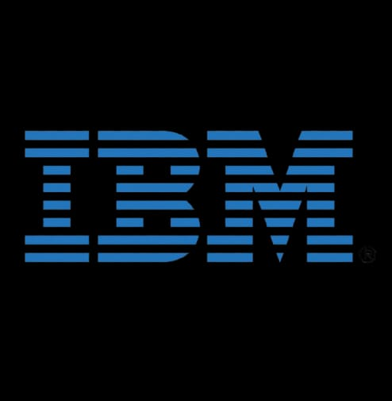

Internship Task 3 - Day 5

Name: Shaik Khalifa

Intern at: IBM

Mentor Name: P.A. Karunya

Task: Understanding and documenting Git and GitHub commands from the video tutorials.

**Introduction to Git & GitHub**

Git is a distributed version control system that helps developers track changes in their source code. GitHub is a platform built around Git, providing a collaborative space for developers to manage and store their Git repositories online.  
  
In the provided video tutorials, several Git commands were introduced and explained. These are essential for managing projects efficiently during development.

# Core Git Commands Explained

**1. `git init` –** This command initializes a new Git repository in your project folder. It creates a hidden `.git` folder where Git stores all the configuration and tracking data.  
**2.** **`git status` –** Shows the current state of your repository, including staged, unstaged, and untracked files.  
**3. `git add <filename>` –** Adds the specified file to the staging area, preparing it for commit.  
**4. `git add .` –** Adds all modified and untracked files to the staging area.  
**5. `git commit -m "message"` –** Commits the staged changes with a meaningful message, saving a snapshot of your project.  
**6. `git log` –** Displays the commit history in reverse chronological order.  
**7. `git remote add origin <URL>` –** Connects the local repo to a remote GitHub repository.  
**8. `git push -u origin main` –** Pushes your committed changes to the main branch of your GitHub repo for the first time.  
**9. `git clone <URL>` –** Copies a GitHub repo to your local machine.  
**10. `git pull` –** Fetches and merges changes from the remote repository to your local repo.

# My Understanding of Git Workflow

Watching the videos helped me clearly understand how Git helps in managing different versions of a project. Initially, I was confused between `git add` and `git commit`, but now I know that `add` stages the changes and `commit` saves them with a message.  
  
The `git push` command makes our local work available on GitHub. I understood the importance of writing good commit messages and pushing changes frequently to avoid losing work. Also, the use of `git clone` and `git pull` for collaborating with teams is now very clear to me.

**Hands-on Experience Using GitHub**

After watching the videos, I tried all the commands on a sample project. I created a folder, used `git init`, added files, and pushed them to a new GitHub repository. I also experimented with making changes, committing them, and using `git log` to check history.  
  
This practical use helped me understand how Git works behind the scenes and why developers trust it so much. I now feel more confident in using Git for version control and collaborating on projects.

**Conclusion and Impact on My Internship**

Learning Git and GitHub commands was a crucial step in my internship journey. These tools are essential for any developer, and having a clear understanding of how to use them will help me greatly in team-based projects.  
  
Thanks to the video tutorials and hands-on practice, I now see Git not just as a tool, but as a critical part of modern software development. I thank my mentor, P.A. Karunya, for this opportunity to enhance my skills and grow as a developer during my IBM internship.

**GitHub Repository Summary**

This project has been uploaded to my GitHub profile to demonstrate my understanding of Git and GitHub commands. The repository is named 'IBM-Internship-Git-GitHub-Task'.

This repository contains my Internship Task 3 (Day 5) submission during my IBM internship, guided by mentor P.A. Karunya. The task includes a comprehensive explanation and personal understanding of essential Git and GitHub commands, learned through video-based training.

GitHub Link: [(click here)](https://github.com/khalifa380/IBM-Internship-GitHub-Task.git)

**My Experience After Uploading the Project to GitHub**

Uploading this project to GitHub was a fulfilling experience. It not only allowed me to showcase my learning publicly but also helped me understand how developers share their work with the world.

I learned how to create a professional repository with proper documentation. I became familiar with committing, pushing to remote, and managing my GitHub profile in a presentable way. This also made me more confident in using GitHub as a portfolio platform for future opportunities.

After uploading the file, I reviewed my project and realized how important it is to write meaningful commit messages, organize content clearly, and maintain consistency. I now see GitHub not just as a tool for code, but as a platform for career development and collaboration.

I am grateful for this opportunity during my internship. It gave me hands-on exposure to real-world tools and prepared me to work in professional environments. Thank you to my mentor, P.A. Karunya, for guiding me in this journey.