GDG ON CAMPUS UNSRI MEMBER 2025/2026
COMMITMENT LETTER
Palembang, 1st January 2026
The undersigned:
Name : {{ nama_lengkap }}
Position : {{ nama_divisi }} Member
Hereby, I commit myself during my tenure as a Core Team at GDG on Campus Universitas Sriwijaya. I am willing to abide by the following rules:
- Attend a minimum of 75% of the events and activities organized by GDG on Campus Universitas Sriwijaya, or I will not be eligible to receive the member appreciation certificate.
- If my activity is deemed insufficient, I am willing to be given a first warning letter and monitored for a month. If it is still considered less active, a second warning letter will be given and monitored for a week. after that, if there is no change then I am willing to be given a third warning letter and immediately expelled from GDG on Campus Universitas Sriwijaya.
- Pay a monthly membership fee on time.
- Make immediate payment at the beginning of each period for GDG on Campus Universitas Sriwijaya swags.
- Promise to actively participate in all meetings and activities held by the community.
- Commit to follow the community's policies and guidelines, as well as adhere to instructions from GDG on Campus Universitas Sriwijaya community management.
- Ready to take responsibility in certain management or activities if requested.
- Commit to always maintain a professional attitude and behavior in every interaction with other members and with external parties.
I hereby declare this Commitment Letter in full sincerity for its proper use. If I violate these rules, I am prepared to face the sanctions and consequences imposed.
Witnessed,
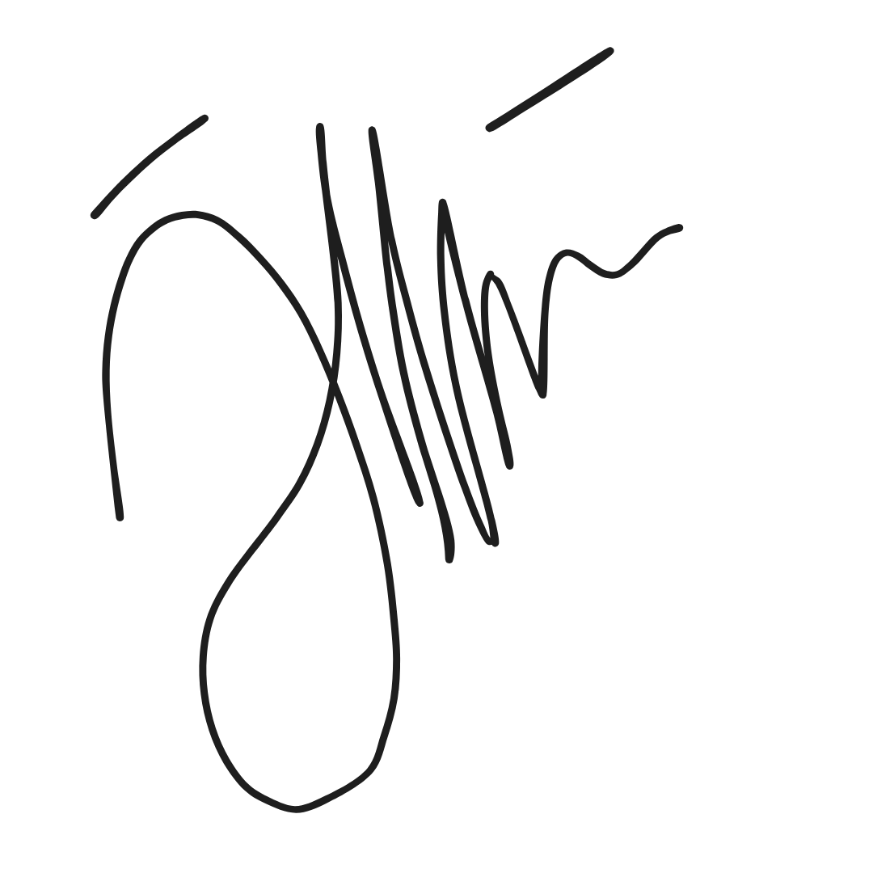  GDGoC UNSRI Lead 2025/2026  Andini Marsha Daniswara  NIM. 09021282328033 | Member {{ nama_divisi }}  {{ nama_lengkap }}  NIM. {{ nim_peserta}}

