

Figure 1- Customer and Unauthorized User Choose Seat use case diagram

|  |  |  |  |
| --- | --- | --- | --- |
| **USE CASE SPECIFICATION** | | | |
| **Use-case No.** |  | **Use-case Version** |  |
| **Use-case Name** | Customer and Unauthorized User Choose Seat | | |
| **Author** | Nguyen Ngoc Son | | |
| **Date** | 31/1/2013 | **Priority** | Normal |
| **Actor:**  Customer, Unauthorized User  **Summary:**  Customer and Unauthorized User choose seat after search trip  **Goal:**  It helps customer and unauthorized user choose seat  **Triggers**  Customer and unauthorized user select one bus after search.  **Preconditions:**  The page is fully loaded.  **Post Conditions:**  Success:   * Redirect to page provide booker’s info after click button “Tiếp Tục” * Show all seat selected in page provide booker’s info   Failure: System displays error message. Content of error message will be specified in Exception section.  **Main Success Scenario:**   |  |  | | --- | --- | | Actor Actions | System Response | | 1. Choose Bus  3. Click seats.  5. Click “Tiếp Tục” button to submit view [Alternative 1] | 2. Display a seats map   * Green seats : selected seats * Orange seats : not available seats * White seats : available seats * Submit [“Tiếp Tục”: button] * Back [“Quay Lại”: button]   4. Select seats [Alternative 2], [Alternative 3], [Alternative 4], [Alternative 5] , [Alternative 6] , [Alternative 7] , [Alternative 8]  6. Redirect to page provide booker’s info [Exception 1] |   **Alternative Scenario:**   |  |  | | --- | --- | | Ator Actions | System Response | | [Alternative 1]  1. User clicks on “Quay Lại” button.  [Alternative 2]  1. User selects available seats.  [Alternative 3]  1. User selects sold seats.  [Alternative 4]  1. User deselects a selected seat.  [Alternative 5]  1. If seats selected equals number of passengers.  [Alternative 6]  1. If User deselects a selected seat after all available seats change color to gray.  [Alternative 7]  1. If User chose return seat-map tab.  [Alternative 8]  1. If User chose out seat-map tab. | 2. Back to search result page.  2. Available seats change color to green  2. Show error message “Ghế đã có người đặt”  2. Selected seats change color to white.  2. All available seat change color to gray.  2. All available seat change color to white.  2. Display the seat-map for return trip.  2. Display the seat-map for out trip. |   **Exceptions:**   |  |  | | --- | --- | | Actor Actions | System Response | | [Exception 1]  1. User do not select any seat and submit page | 2. Display error message: “Bạn phải chọn ít nhất 1 ghế để tiếp tục.” |   **Relationships:**  Login, Create reservation  **Business Rules:**  The user must choose at least one seat. | | | |

Table 1: Customer and Unauthorized User Choose Seat Use Case Specification

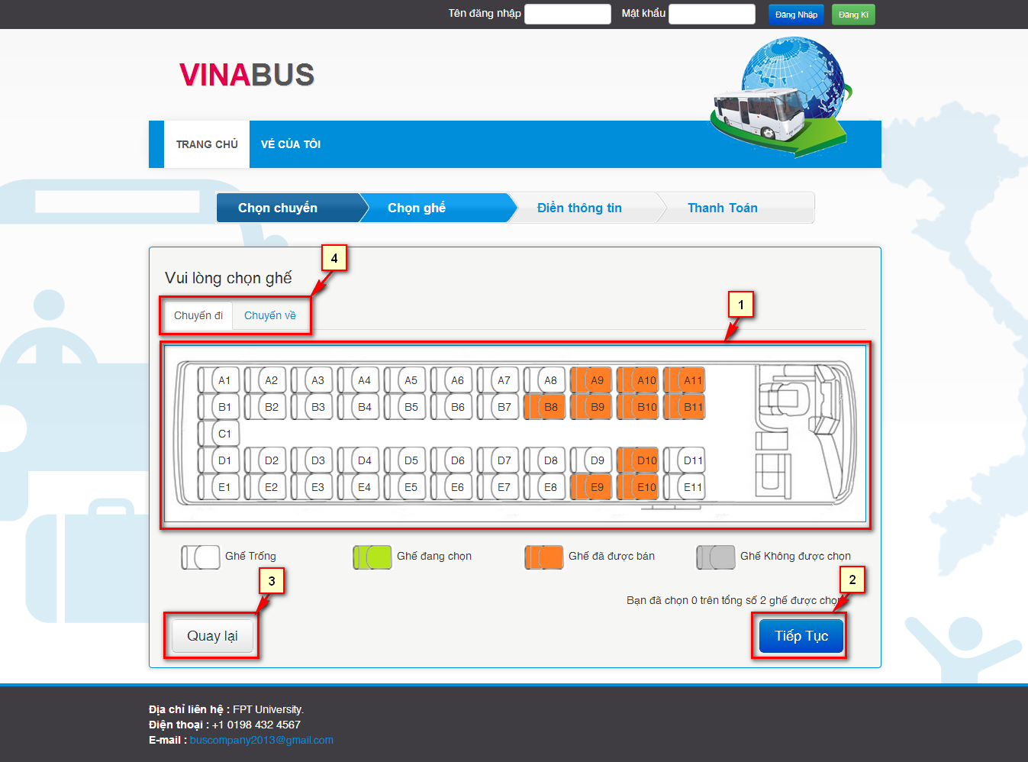

Figure 2- Customer and Unauthorized User Choose Seat screen

|  |  |  |
| --- | --- | --- |
| **No.** | **Name** | **Description** |
| **1** | Seat Map | Display the all seats status in bus selected |
| **2** | Submit – button (Tiếp Tục) | Continue to provide booker’s info page |
| **3** | Back – button (Quay lại) | Cancel booking and back to page search result |
| **4** | Select seat map tabs | Select seat map for one-way or round-trip |

Table 2: Customer and Unauthorized User Choose Seat’s Control



Figure 3- Customer and Unauthorized User Provide info use case diagram

|  |  |  |  |
| --- | --- | --- | --- |
| **USE CASE-UC003 SPECIFICATION** | | | |
| **Use-case No.** | UC003 | **Use-case Version** | v0.1 |
| **Use-case Name** | Provide booker’s details | | |
| **Author** | Nguyen Ngoc Son | | |
| **Date** | 31/1/2013 | **Priority** | Normal |
| **Actor:**  User  **Summary:**  User provide their information after select seats to create a reservation  **Goal:**  Get booker’s details  **Triggers**  User selects seats and clicks button “Tiếp Tục”.  **Preconditions:**  The page is fully loaded.  **Post Conditions:**  Success:   * Save user’s reservation. * Redirect to payment page   Failure: Reservation is not saved. System displays error message. Content of error message will be specified in Exception section.  **Main Success Scenario:**   |  |  | | --- | --- | | Actor Actions | System Response | | 1. Choose seats then click button “Tiếp Tục”  3. Fill information in the form and click “Thanh toán” button. [Alternative 2], [Alternative 3], [Alternative 4] | 2. Display a form to provide booker’s details [Alternative 1]   * First Name [“Tên”: textbox, min length: 1, max length: 30] * Last Name [“Họ”: textbox, min length: 1, max length: 30] * Phone [“Số điện thoại”: textbox, regular expression] * E-mail [“E-mail”: textbox, regular expression] * Pay [“Thanh toán”: button] * Back [“Quay Lại”: button]   4. Save reservation and redirect to page payment. [Exception 1][Exception 2][Exception 3][Exception 4][Exception 5] |   **Alternative Scenario:**   |  |  | | --- | --- | | Actor Actions | System Response | | [Alternative 1]  1. If the user is logged in.  [Alternative 2]  1. User clicks on “Quay lại” button.  [Alternative 3]  1. User clicks on “Thanh Toán” button.  [Alternative 4]  1. User clicks on check on seats ‘s checkbox and click button ”Bỏ ghế” | 2. Use the information of that user fulfill all field in form.  2. Redirect to choose seat page.  2. Redirect to payment page.  2. Remove all seats that user checked. Update price of the table reservation info. |   **Exceptions:**   |  |  | | --- | --- | | Actor Actions | System Response | | [Exception 1]  1. Set blank on First name field.  [Exception 2]  1. Set blank on Last name field.  [Exception 3]  1. Set blank on Email field.  [Exception 4]  1. Wrong phone number format.  [Exception 5]  1. Wrong email format.  [Exception 6]  1. User don’t check any seats and click button “Bỏ ghế”  [Exception 7]  1. User select all seats and click button “Bỏ ghế”  [Exception 8]  1. User select all seats in out trip and click button “Bỏ ghế”  [Exception 9]  1. User select all seats in return trip and click button “Bỏ ghế”  [Exception 10]  1. User delete seats successful. | 2. Show message "Vui lòng nhập tên.".  2. Show message "Vui lòng nhập họ.".  2. Show message "Vui lòng nhập địa chỉ email".  2. Show message "Số điện thoại không hợp lệ".  2. Show message "Địa chỉ email không hợp lệ".  2. Show message "Bạn chưa chọn ghế để bỏ.".  2. Show message "Không được phép bỏ chọn tất cả các ghế.".  2. Show message "Bạn không được phép bỏ chọn tất cả các ghế chuyến đi.".  2. Show message "Bạn không được phép bỏ chọn tất cả các ghế chuyến khứ hồi.".  2. Show message "Bỏ ghế thành công.". |   **Relationships:**  Choose seat  **Business Rules:**  User must fulfill the all field of the form except phone number. | | | |

Table 3: Customer and Unauthorized User Provide info Use Case Specification

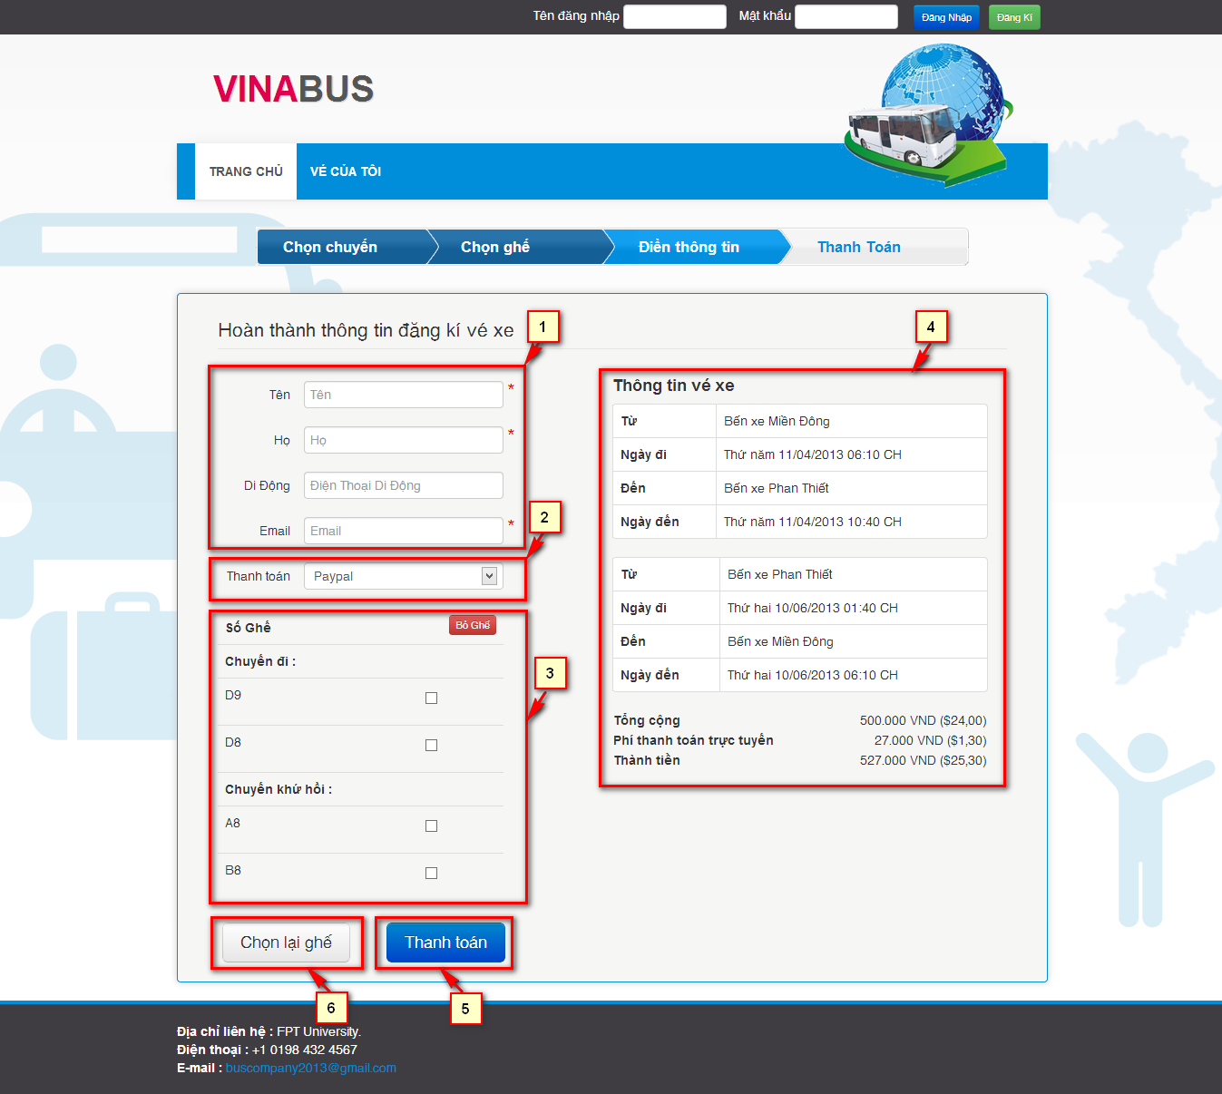

Figure 4- Customer and Unauthorized User Provide info screen

|  |  |  |
| --- | --- | --- |
| **No.** | **Name** | **Description** |
| **1** | Customer’s information – Editable  Lastname (Họ: textbox)  Firstname (Tên: textbox)  Phone (Di động: texbox)  Email (Email: textbox) | Get information of customer. |
| **2** | Payment method (Thanh Toán , Dropdown list) | Show payment method that system support. |
| **3** | User’s selected seats  Table checkbox | Let user delete selected seats. |
| **4** | User reservation info | Show the reservation info. |
| **5** | Submit Reservation(Thanh toán: button) | Redirect to payment page. |
| **6** | Back (Chọn lại ghế button) | Return back to booking page. |