1. **Red-hat Satellite Ansible commands.**

In Red Hat Satellite, Ansible commands are used to manage and automate tasks across your infrastructure. You can use Ansible commands directly in Satellite to run playbooks, install roles or collections, and perform various configurations on managed hosts.

In our case we have used the command (df -h)

Below is the example of Ansible command in Red-Hat Satellite GUI.

Scheduling the Job.

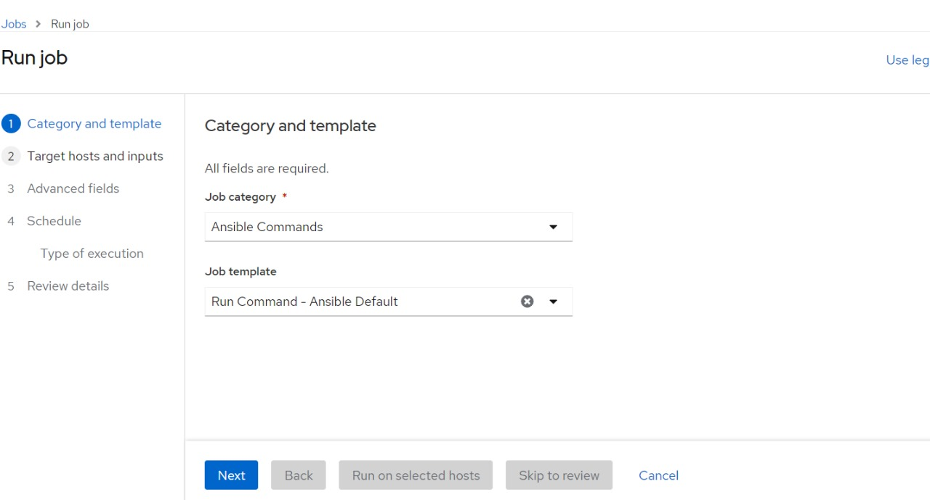

Selecting the hosts on which we need to execute the command.

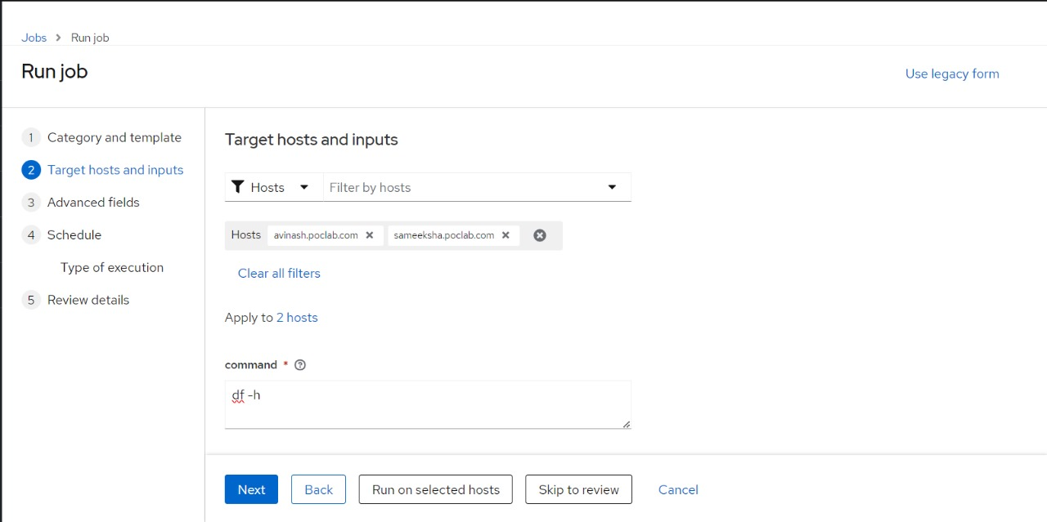

After selecting the Hosts, we can run the job and it will be successful.

The final output of the command via using the Ansible command in Red-Hat satellite GUI.

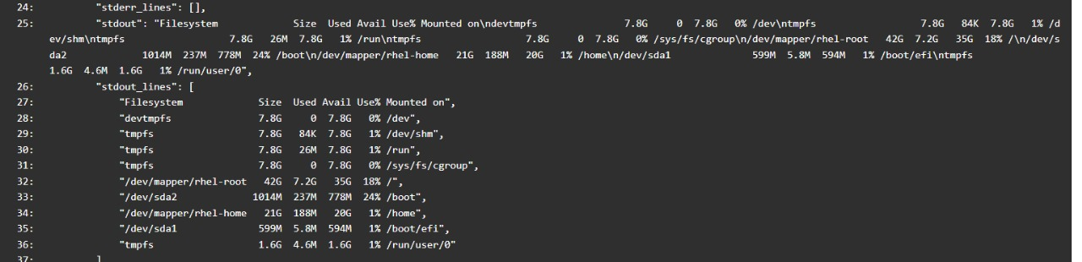

1. **Red-hat Satellite Ansible-packages.**

In Red Hat Satellite, "Ansible Packages" refers to the ability to manage software packages on remote hosts using Ansible playbooks. This feature is particularly useful for automating the installation, removal, and management of packages across multiple systems.

Below is the example of Ansible command in Red-Hat Satellite GUI.

Scheduling the Job.

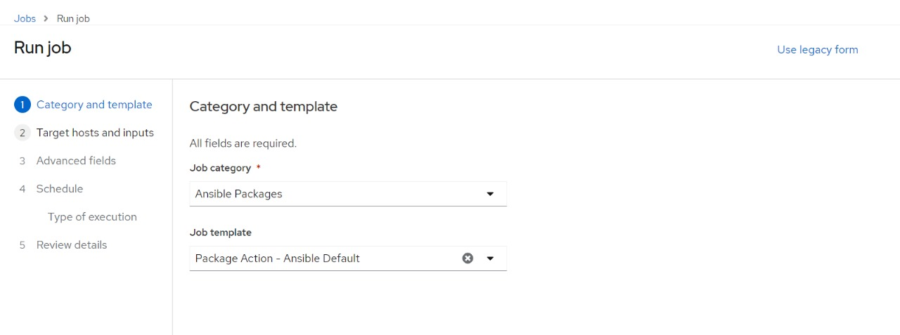

Installation of Package called httpd in the Selected Host.

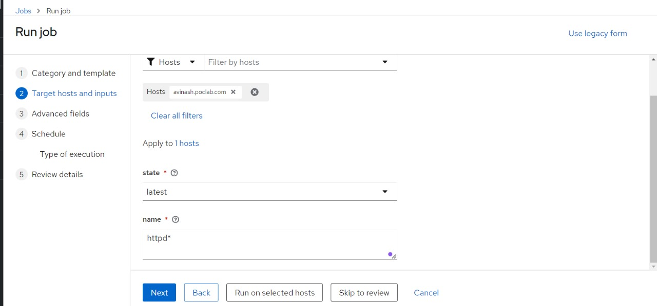

The Selected package has been installed successfully on the Selected host.

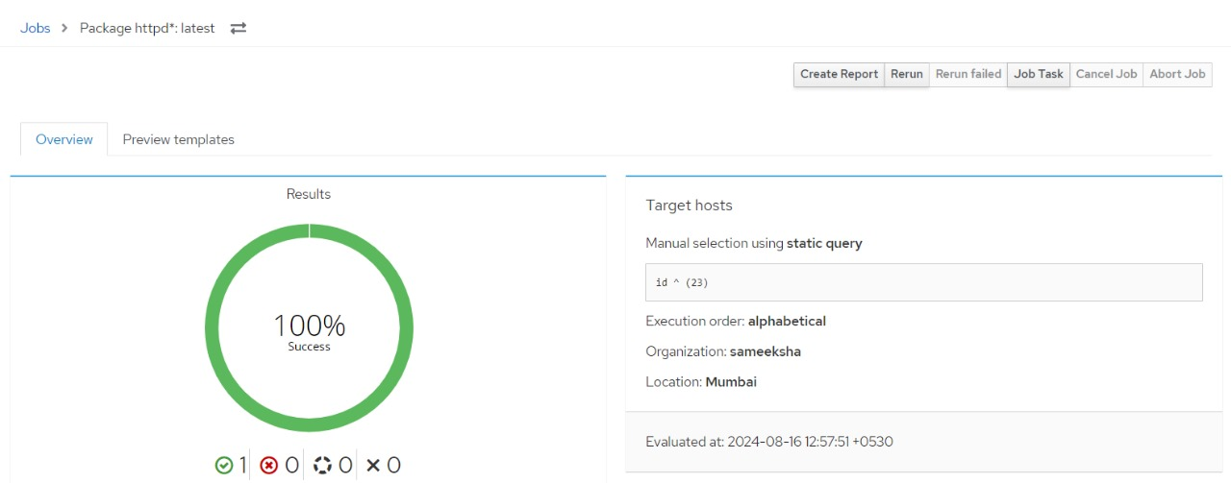

1. **Red-hat Satellite Ansible Playbook.**

In Red Hat Satellite, using ansible-playbook is similar to the process of managing Ansible packages, but it involves running a full Ansible playbook on the selected hosts. Here’s how to use ansible-playbook in Red Hat Satellite.

In our case we have used the below playbook.

**---**

**- name: Collect disk usage information**

**hosts: all**

**tasks:**

**- name: Run df -h command**

**command: df -h**

**register: df_output**

**- name: Show disk usage output**

**debug:**

**msg: "{{ df_output.stdout }}"**

Below is the example of Ansible command in Red-Hat Satellite GUI.

Scheduling the Job.

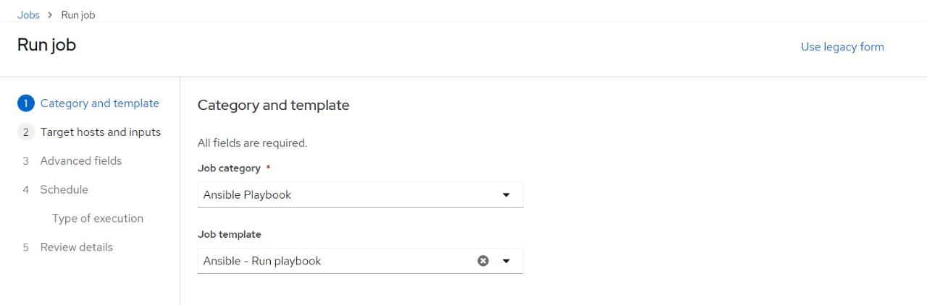

Selecting the host on which server we need to run the playbook.

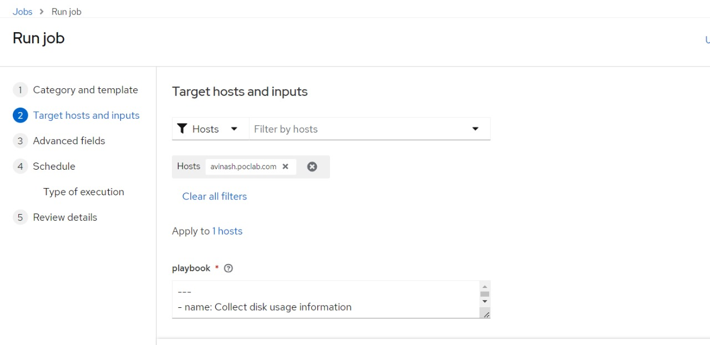

Our playbook has been successfully executed on the selected host.

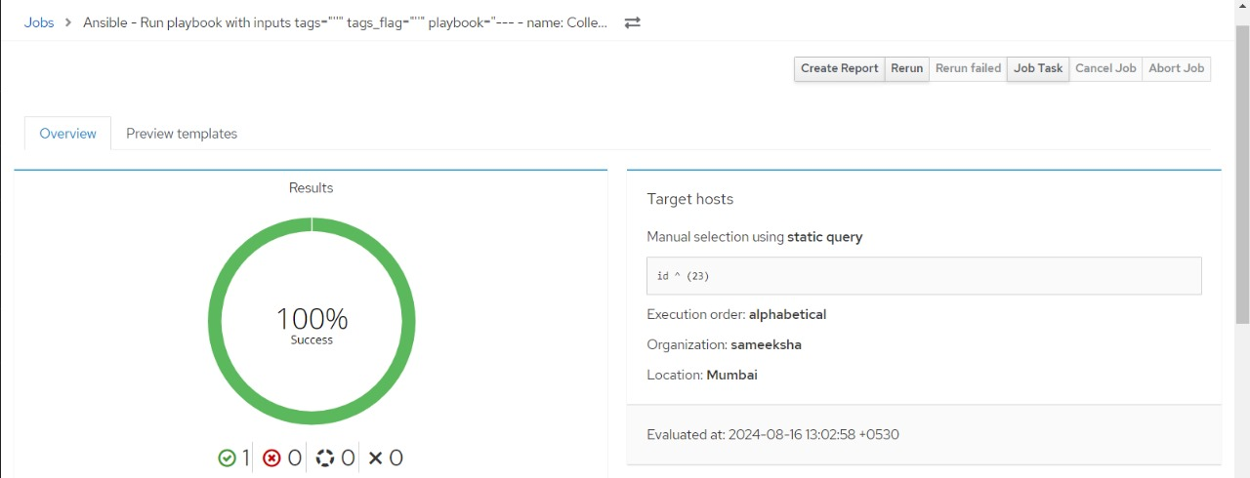

1. **Red-hat Satellite Ansible-Power.**

In Red Hat Satellite, "Ansible Power" refers to using Ansible to manage power-related tasks on remote hosts, such as restarting, shutting down, or powering on systems. This can be particularly useful for managing power states across multiple servers in a large environment.

Below is the example of Ansible Power in Red-Hat Satellite GUI.

Scheduling the Job.

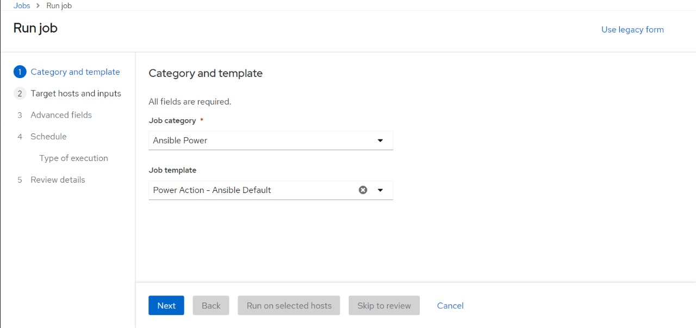

Scheduling the Ansible-Power Job in Selected Host.

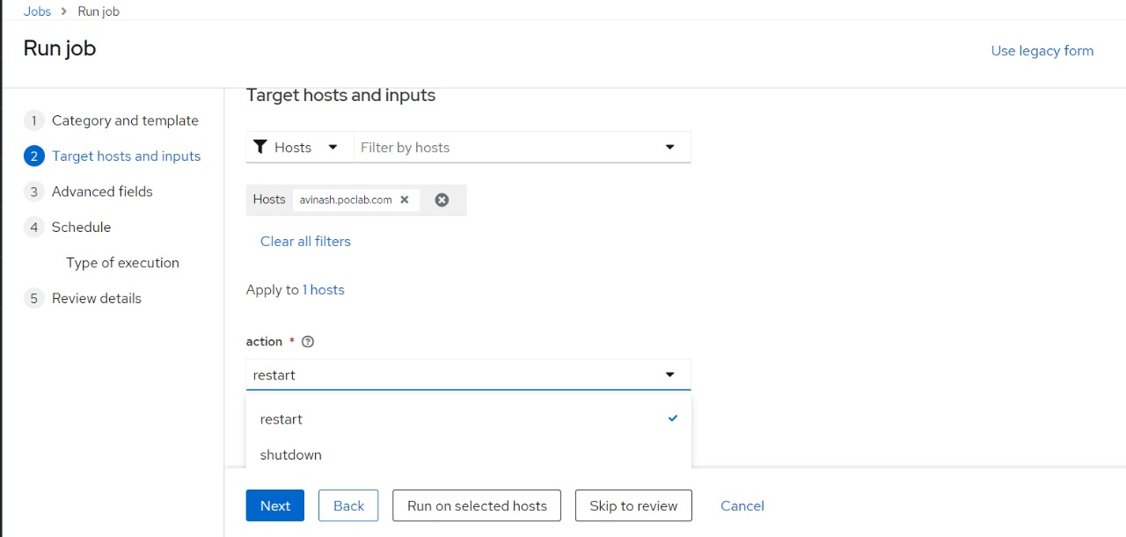

The Final output of the Ansible-Power job.



1. **Red-hat Satellite Ansible Service.**

In Red Hat Satellite, using Ansible for managing services allows you to start, stop, restart, enable, or disable services on remote hosts. This is essential for tasks like ensuring that critical services are running, disabling unnecessary services, or managing services during deployments.

Below is the example of Ansible Service in Red-Hat Satellite GUI.

Scheduling the Job.

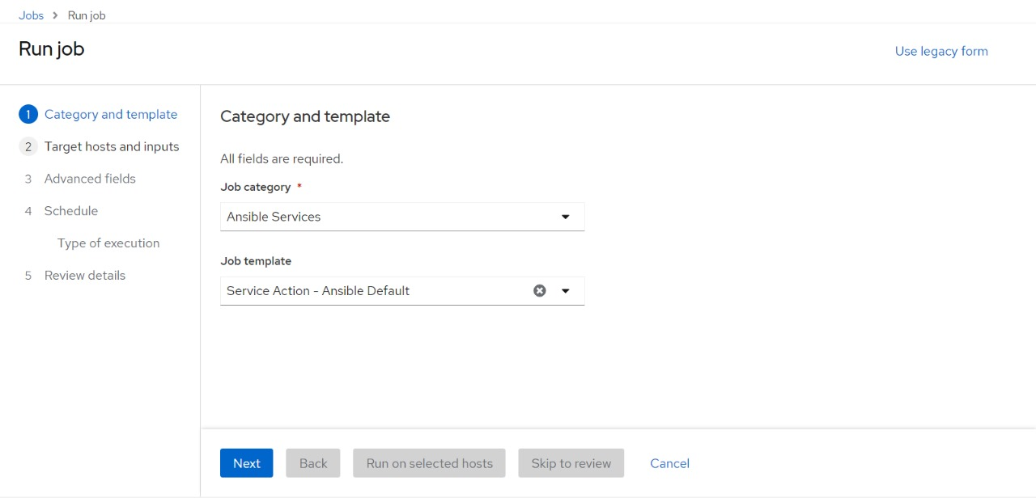

Scheduling the Ansible Service Job in Selected Host.

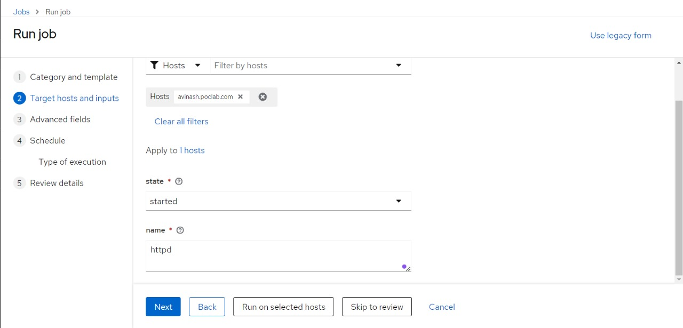

Our Ansible Service job has been successfully executed on the selected host.

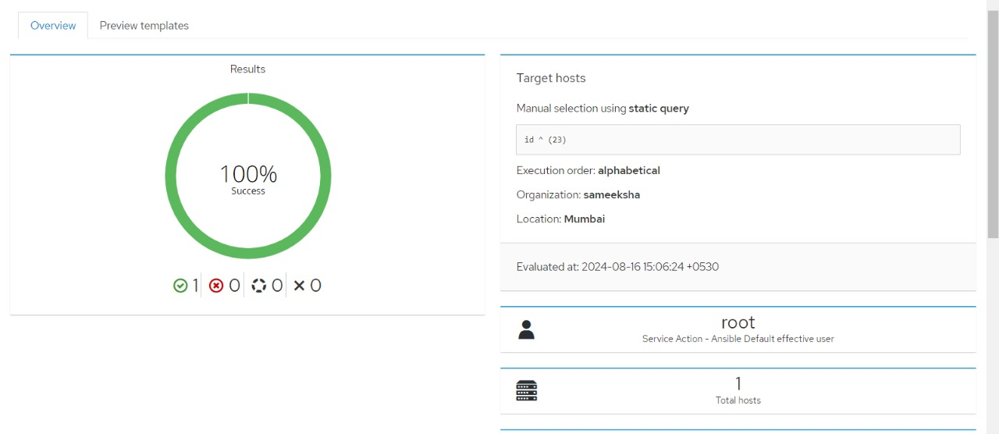

1. **Red-hat Satellite Ansible Roles Installation.**

In Red Hat Satellite, Ansible roles are reusable units of Ansible content that encapsulate automation tasks. You can install, manage, and use these roles to streamline the automation of common tasks across your infrastructure. Here’s how to install and use Ansible roles in Red Hat Satellite:

**NOTE > this task can be executed on Satellite server only.**

Below is the example of Ansible Role Installation in Red-Hat Satellite GUI.

Scheduling the Job.

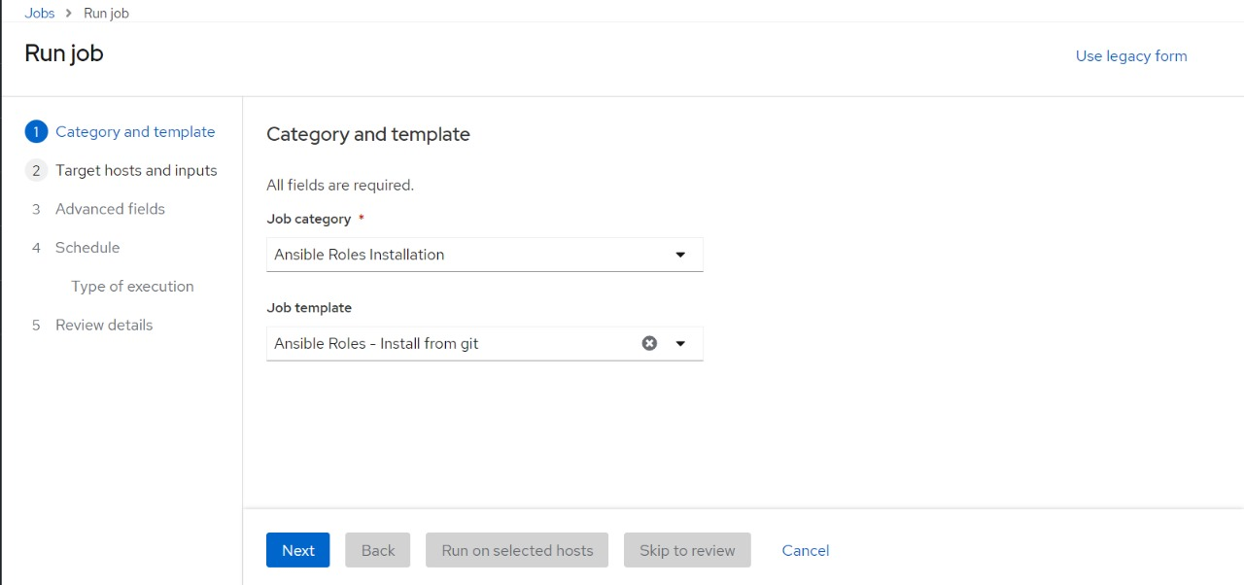

Executing the Task of ansible role installation using the job on the Satellite Server.

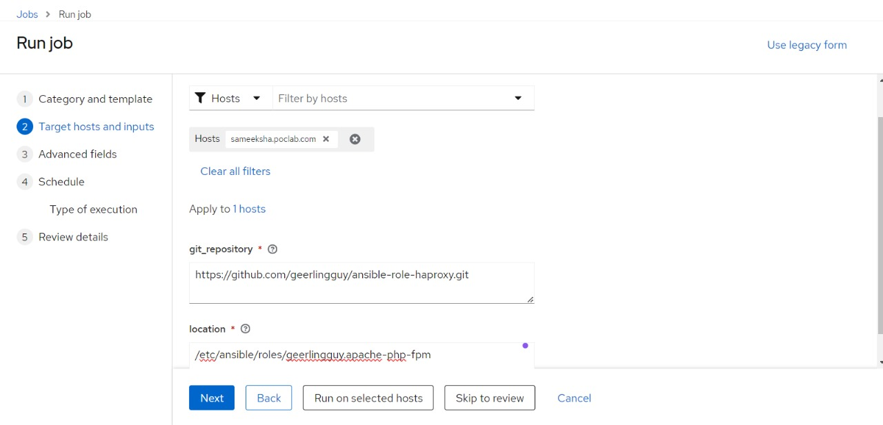

The role has been successfully installed in the Red-Hat satellite server on the selected location.

