openshift-image-registry configuration for production use.
______________________________________________________________
https://access.redhat.com/solutions/5391601
note: for production we need to store the image in storage for that we will configure pv,pvc for non production we can use empty dir.
_______________________________________________________________
mkdir /data/nfs-sc
chmod -R 777 /data/nfs-sc
[root@mohammed mohammed]# cat /etc/exports
/data/nfs-sc *(rw,sync,no_subtree_check,no_root_squash)
[root@mohammed mohammed]# cat registry-pv.yaml
apiVersion: v1
kind: PersistentVolume
metadata:
name: registry-pv
spec:
capacity:
storage: 100Gi
accessModes:
- ReadWriteMany # Change to RWX
persistentVolumeReclaimPolicy: Retain
storageClassName: manual
nfs: # Example using NFS
server: 172.40.20.230
path: /data/nfs-sc
[root@mohammed mohammed]# cat registry-pvc.yaml
apiVersion: v1
kind: PersistentVolumeClaim
metadata:
name: registry-pvc
namespace: openshift-image-registry
spec:
accessModes:
- ReadWriteMany # Change to RWX
resources:
requests:
storage: 100Gi
storageClassName: manual
volumeName: registry-pv
oc get configs.imageregistry.operator.openshift.io cluster -o yaml

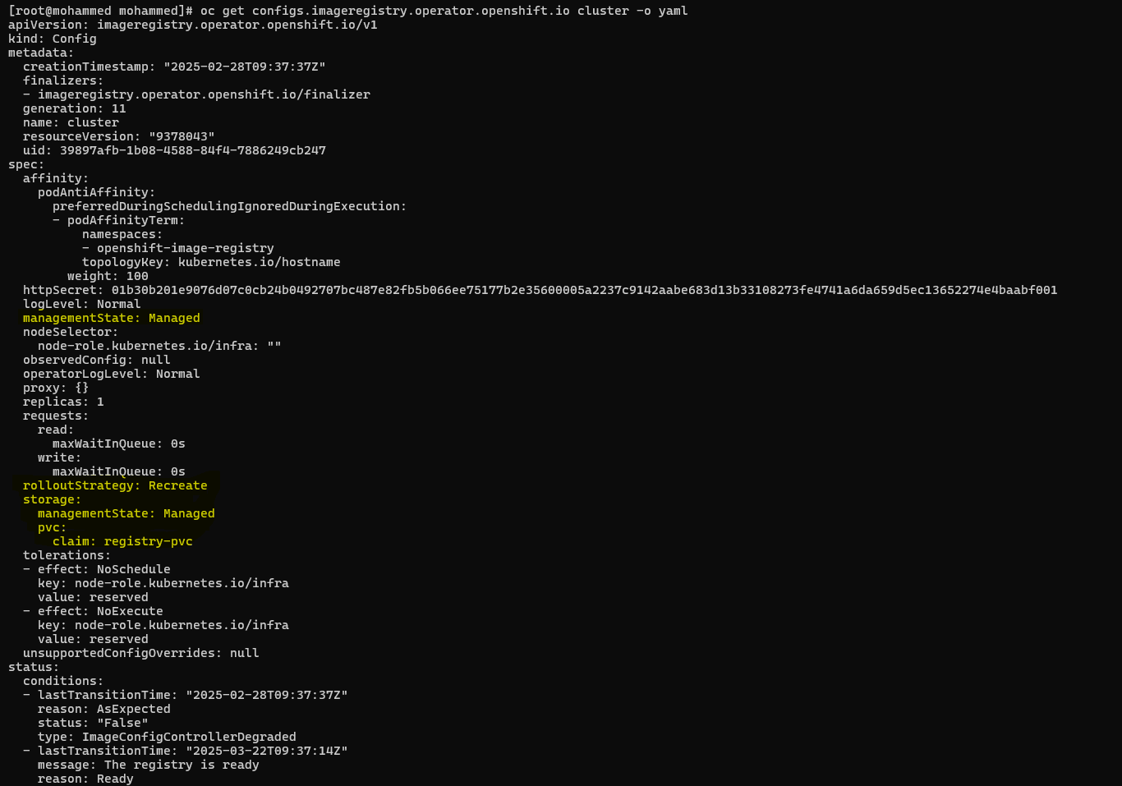
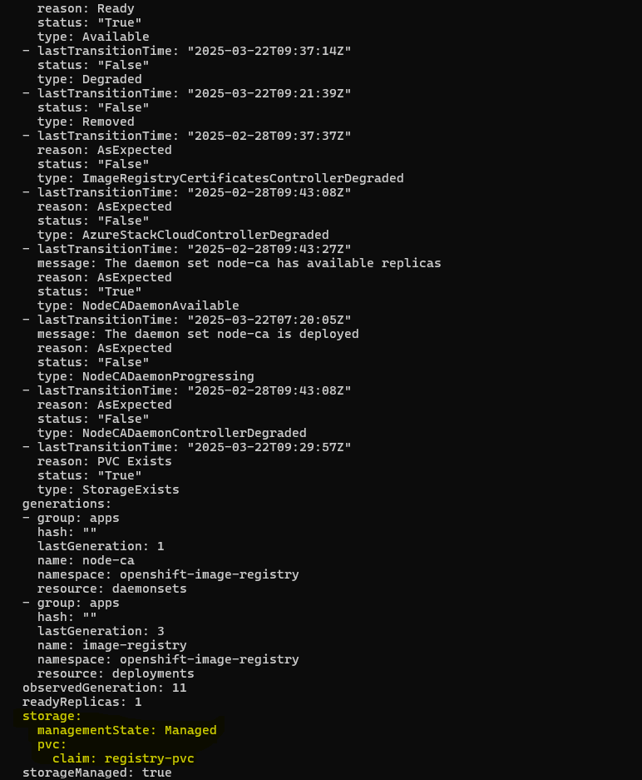

Oc get pod -n openshift-image-registry
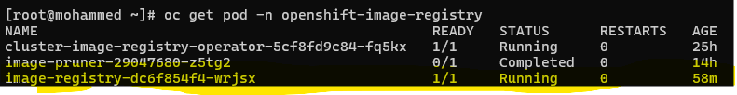
oc create route passthrough registry --service=image-registry -n openshift-image-registry
oc get route -n openshift-image-registry
Remember you’ll need to authenticate with:
oc login -u <username> -p <password> --server=<openshift_api_url> --insecure-skip-tls-verify
oc whoami -t
Podman login -u username -p $(token) registry-url
To find the registry url $oc get route -n openshift-image-registry
podman login -u khalifullah@wysetek.com -p $(oc whoami -t) registry-openshift-image-registry.apps.uae-ocp-v.example.com --tls-verify=false
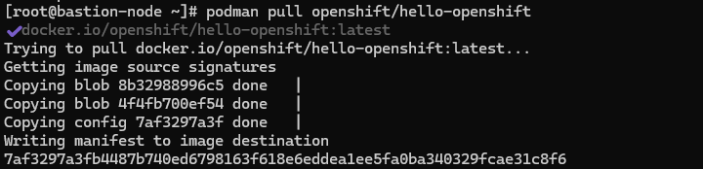

Pushing images to internal image registry:
oc project apl-dev
1: tag your image for the openshift registry:
podman tag local-image registry-openshift-image-registry.apps.mohammed.vcenterlocalhost.com/<project>/<image-name>
2: push the image to your project registry:
podman push registry-openshift-image-registry.apps.mohammed.vcenterlocalhost.com/<project>/<image-name> --tls-verify=false
3: Verify the image was pushed:
Oc get is -n apl-dev
4: Deploy the image
Deploying the application using the image which we pushed in the internal registry.
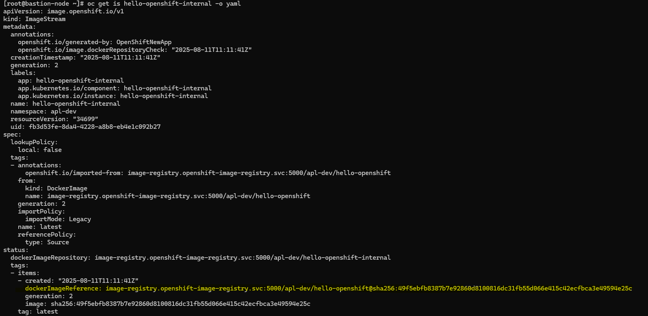
If u want to untagged or remove the image run the below cmd:
Podman rmi (imagename)
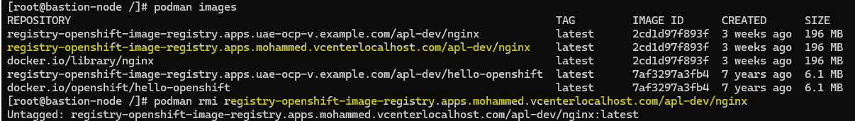
Deploying nginx

Use the ImageStream name
Since you already have an image stream nginx in apl-dev:
oc new-app --image-stream=nginx -n apl-dev --name=nginx

NGINX:ALPINE

podman pull nginx:alpine
podman tag docker.io/library/nginx registry-openshift-image-registry.apps.uae-ocp-v.example.com/apl-dev/nginx
podman pull registry-openshift-image-registry.apps.uae-ocp-v.example.com/apl-dev/nginx:latest
oc adm policy add-scc-to-user anyuid -z default -n apl-dev
oc new-app --image-stream=nginx:alpine -n apl-dev --name=nginx-alpine

