CHAPTER FIVE

SYSTEMS IMPLEMENTATION & OPERATION

5.0 Introduction
This chapter describes the practical implementation and deployment process of the EyeCare (Al-Ixsaan) Management System, including the development tools used, PostgreSQL and Prisma integration, role-based module implementation, user testing, and how the system operates in a real clinic environment. The EyeCare system is a web-based ophthalmology clinic management platform that supports patient registration, appointment scheduling, clinical examinations, prescriptions, pharmacy and optical dispensing, billing, and administrative reporting across multiple clinic branches.

5.1 Implementation Tools and Environment
The system was developed using the following tools and technologies:
Table 5.1 Implementation Tools
Tool / Platform | Purpose
Next.js | Frontend web application framework
React & TypeScript | User interface components and type-safe development
Tailwind CSS | Responsive styling and layout
Node.js | JavaScript runtime for the backend server
Express.js | REST API and route handling
Prisma ORM | Database schema management and queries
PostgreSQL | Relational database for clinic data
JWT (jsonwebtoken) | User authentication and session tokens
bcrypt | Secure password hashing
Joi | Server-side input validation
Socket.io | Real-time notifications
Axios | Frontend HTTP client for API requests
Recharts | Dashboard charts and analytics
jsPDF | PDF export for reports and receipts
Visual Studio Code | Integrated development environment

5.2 System Setup and Deployment Steps
1. Project Initialization — Created the project with a Next.js frontend and Node.js/Express backend, with modules for authentication, patients, appointments, examinations, prescriptions, pharmacy, optical shop, billing, and administration.
2. Database Configuration — Connected to PostgreSQL using Prisma. Configured DATABASE_URL in backend/.env and applied migrations with npx prisma migrate deploy.
3. Authentication Integration — Implemented login and password reset with JWT tokens. Each user is assigned a role: Super Admin, Administrator, Doctor, Receptionist, Pharmacist, or Optician.
4. Database Setup — Created relational tables for branches, users, patients, appointments, eye examinations, prescriptions, pharmacy items, optical items, billing, activity logs, and audit logs.
5. UI Design and Routing — Built responsive dashboards, data tables, forms, and sidebar navigation. Each role sees only permitted modules.
6. Testing & Debugging — Performed unit, integration, system, and user acceptance testing with sample clinic workflows.

5.3 System Operations
After deployment, the system operates as follows:
1. Receptionist — Logs in, registers patients, schedules appointments, generates bills, and views the appointment calendar. The Receptionist is responsible for Register Patient, Schedule Appointment, and Billing.
2. Doctor — Logs in, views the dashboard, conducts preliminary and clinical eye examinations, and creates medicine and optical prescriptions. The Doctor does not schedule appointments or handle billing.
3. Pharmacist — Views prescriptions, manages pharmacy inventory, dispenses medicine, and receives low-stock notifications.
4. Optician — Views optical prescriptions, manages optical inventory, and fulfills optical shop orders.
5. Administrator — Manages users and doctors, accesses reports, and monitors clinic activity.
6. Super Admin — Manages branches, configures role permissions, and reviews activity and audit logs.
7. Data Updates — All actions are saved to PostgreSQL via the REST API. Real-time notifications are pushed through Socket.io. Changes are immediately visible to authorized roles.

5.4 Coding and Modules
The system was structured into modules for better maintainability:
1. Authentication Module — User login, JWT token issuance, password reset, and role verification (/api/auth).
2. Patient Module — Patient registration, search, profile view, and medical history (/api/patients).
3. Appointment Module — Schedule, edit, cancel, and calendar view. Used by the Receptionist (/api/appointments).
4. Examination Module — Preliminary and clinical eye examinations recorded by the Doctor (/api/eye-examinations).
5. Prescription Module — Medicine and optical prescriptions created by the Doctor.
6. Pharmacy Module — Inventory management and medicine dispensing by the Pharmacist (/api/inventory/pharmacy).
7. Optical Shop Module — Frame/lens catalog and optical dispensing by the Optician (/api/inventory/optical).
8. Billing Module — Invoice creation and payment recording by the Receptionist (/api/billing).
9. Administration Module — Users, doctors, branches, and permissions (/api/users, /api/doctors, /api/branches, /api/permissions).
10. Reports Module — Clinical, financial, appointment, and operational reports (/api/reports).
11. Logging Module — Activity logs and audit trails (/api/activity-logs, /api/audit-logs).
12. Notification Module — Real-time alerts via Socket.io (/api/notifications).
13. Dashboard Module — Role-specific KPIs and summary statistics (/api/dashboard).

5.5 Testing Strategy

5.5.1 Purpose of Testing
System testing was conducted to verify that the implemented functionalities work correctly and meet the requirements defined during the analysis and design phases in Chapter Four. The aim was to ensure that all six user roles behave as expected under real clinic usage, and that each role can perform only the tasks assigned to them in the use case diagram.

5.5.2 Types of Testing Performed

5.5.2.1 Unit Testing
Individual components were tested in isolation, including login form validation, patient registration form, appointment scheduling form, billing form, and Joi validation on API endpoints.
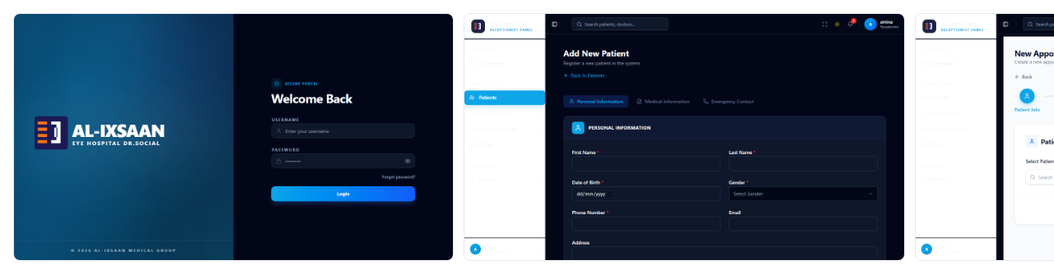
Figure 5.1: Screenshots of Tested Components (Login, Patient Registration, and Appointment Scheduling)

5.5.2.2 Integration Testing
Verified that different modules such as authentication, PostgreSQL queries, prescription workflows, and navigation work together smoothly.
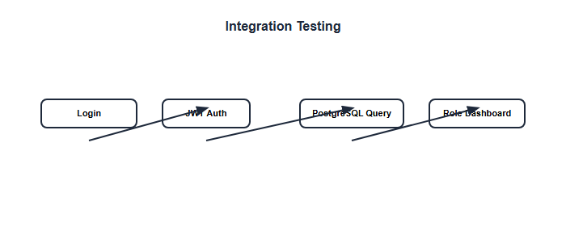
Figure 5.2: Integration Testing

5.5.2.3 System Testing
The entire system was tested end-to-end, including patient registration, appointment scheduling, clinical examination, prescription creation, pharmacy dispensing, billing, and report generation.
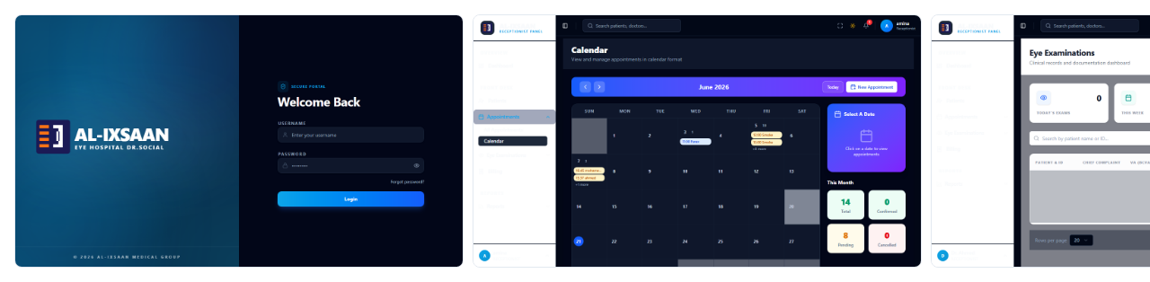
Figure 5.3: System Testing Flow Demonstrating Full End-to-End Functionality

5.5.2.4 User Acceptance Testing (UAT)
Selected users (or team members acting as role representatives) were allowed to use the system and provide feedback about usability, performance, and errors.
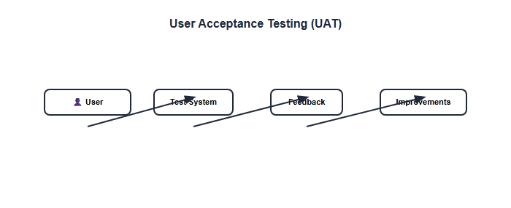
Figure 5.4: User Acceptance Testing Process and Feedback Flow

5.6 Test Cases and Results
Table 5.2 Testing Results
Test Case | Expected Result | Screenshot | Status
User login with valid credentials | JWT token issued; redirect to role dashboard | 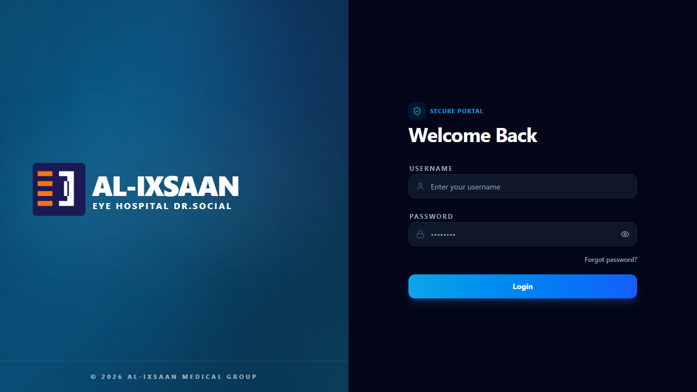 | Pass
Login with wrong password | Error message displayed; access denied |  | Pass
Receptionist registers patient | Patient saved and visible in patient list | 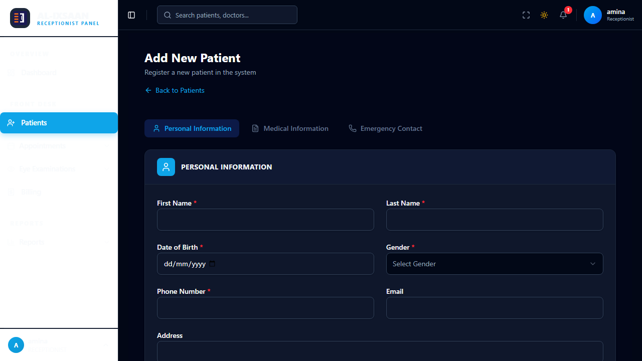 | Pass
Receptionist schedules appointment | Appointment saved with status SCHEDULED | 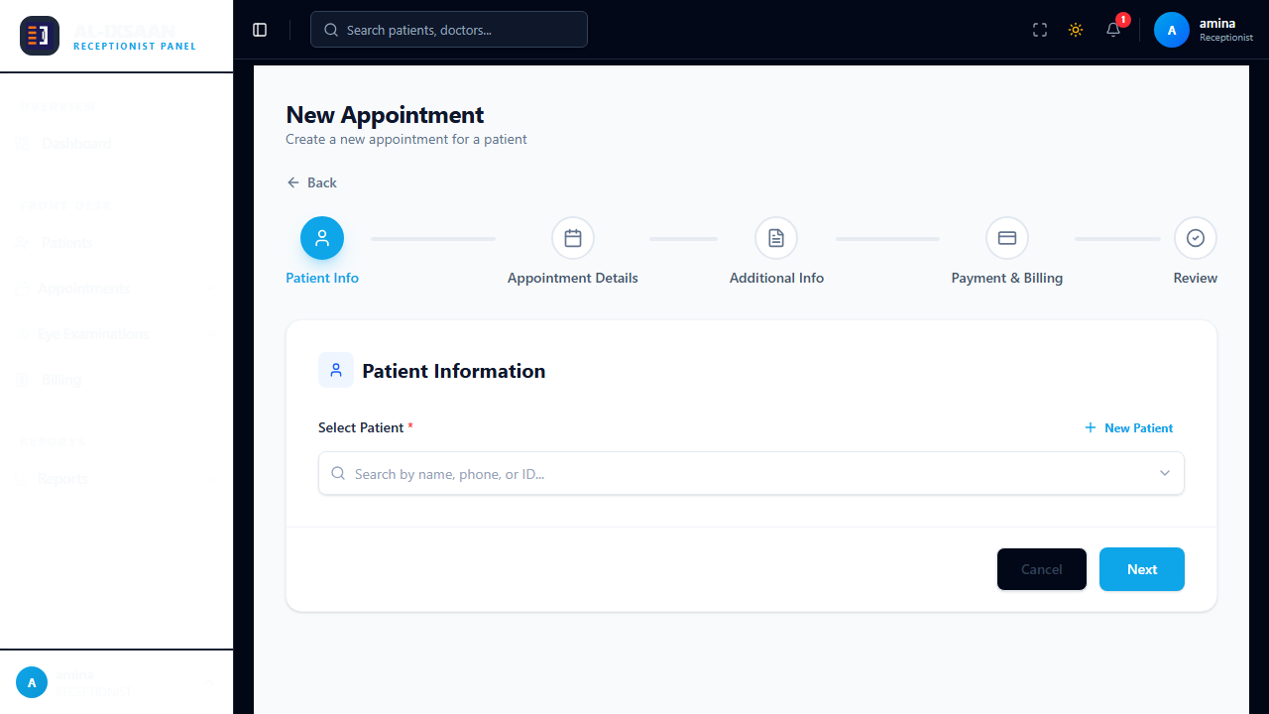 | Pass
Doctor tries to schedule appointment | Access denied — Receptionist only |  | Pass
Doctor conducts clinical examination | Examination record linked to patient | 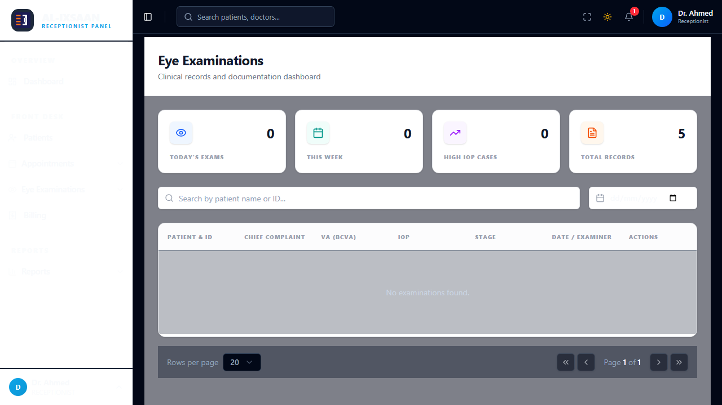 | Pass
Doctor creates medicine prescription | Prescription visible to pharmacist | 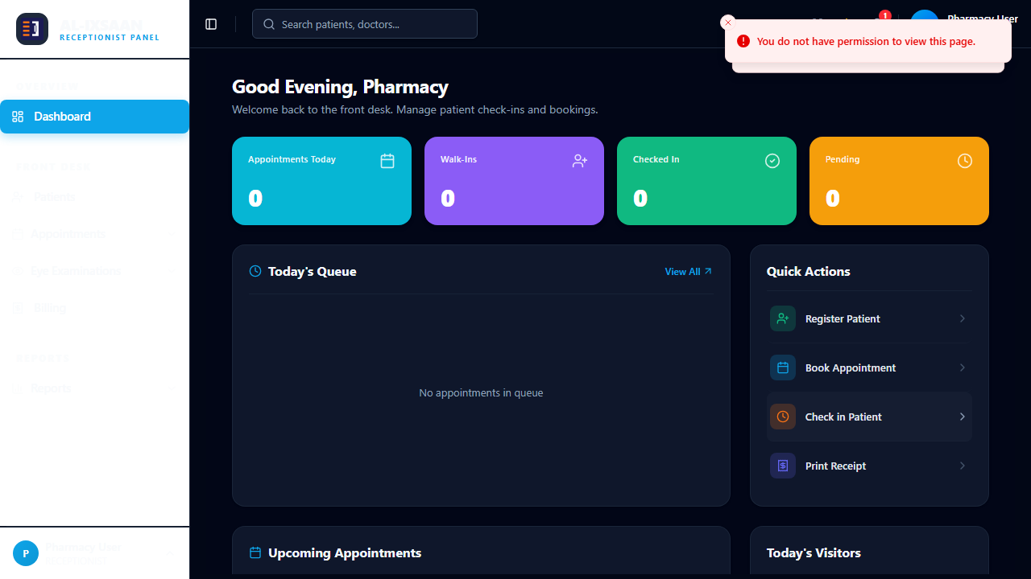 | Pass
Pharmacist dispenses medicine | Stock reduced; transaction logged |  | Pass
Receptionist creates bill | Invoice generated with correct total | 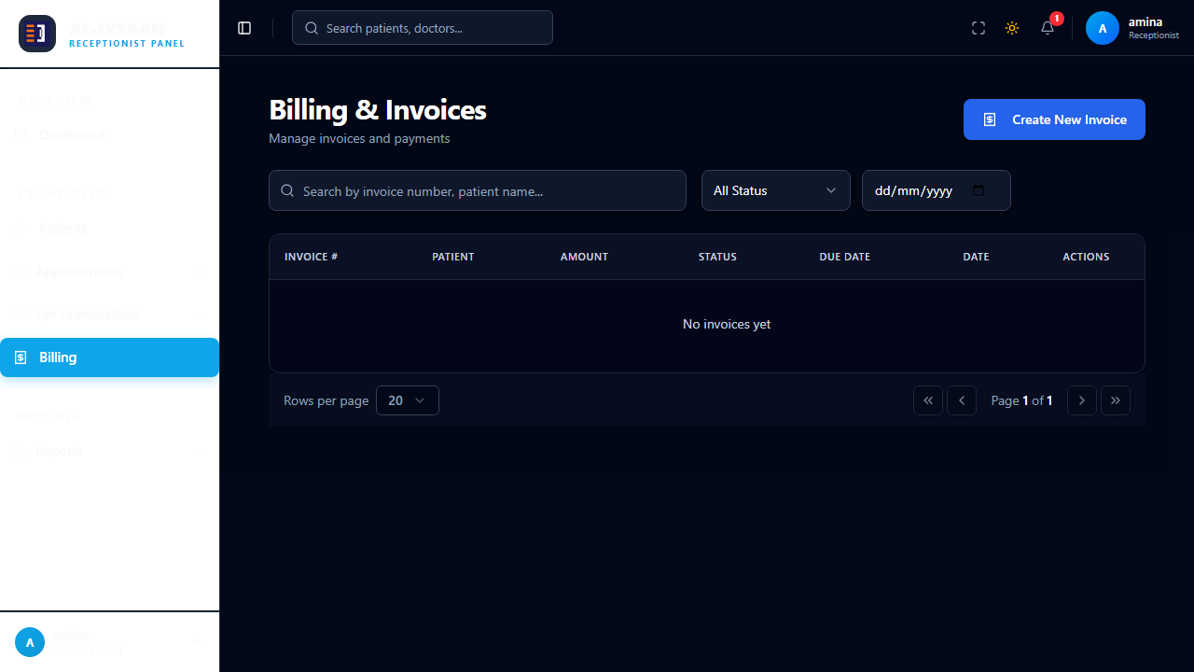 | Pass
Doctor accesses admin dashboard | Denied access or hidden route |  | Pass
Generate appointment report | Filtered data for date range | 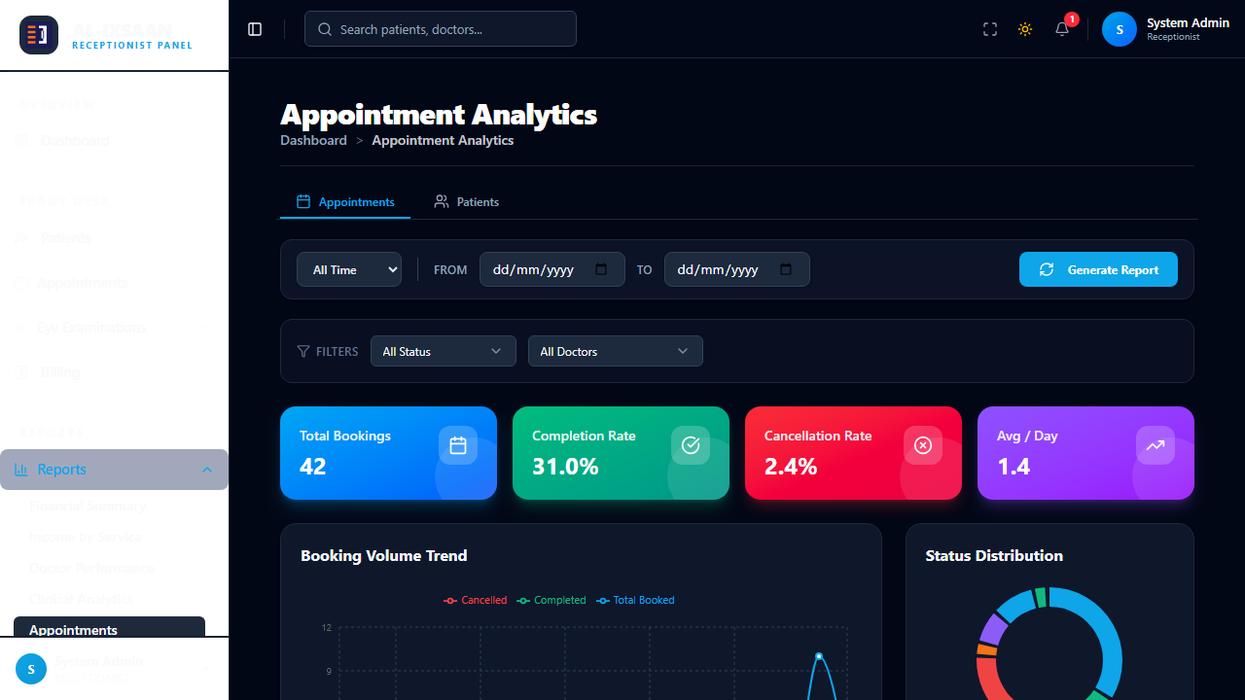 | Pass

5.7 Validation and Verification
Validation: Ensured that system functions meet the requirements specified in Chapter Four. Each use case from the use case diagram was verified — Receptionist (Register Patient, Schedule Appointment, Billing), Doctor (View Dashboard, Conduct Examination, Manage Prescriptions), Pharmacist, Optician, Administrator, and Super Admin roles all passed testing.
Verification: Confirmed that the implementation matches the design specifications — database schema matches the ERD, API endpoints correspond to the architecture diagram, and UI pages match the navigation structure from Chapter Four.
Security Measures: (1) Only authenticated users access protected features. (2) JWT middleware validates tokens on every request. (3) Role-based and permission-based access control. (4) Passwords hashed with bcrypt. (5) Activity and audit logs record sensitive operations.
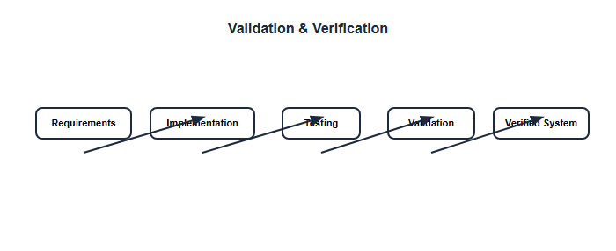
Figure 5.5: Validation and Verification Flow with Security Enforcement

5.8 Chapter Summary
The EyeCare (Al-Ixsaan) Management System was successfully implemented using Next.js, Node.js/Express, Prisma ORM, and PostgreSQL. The application handles patient management, appointment scheduling, clinical examinations, prescription workflows, pharmacy and optical dispensing, billing, and administrative reporting across multiple clinic branches. All major test cases passed, confirming that the Receptionist handles registration, scheduling, and billing, while the Doctor handles examinations and prescriptions. The next chapter presents results, evaluation metrics, and discussion of findings.

