CHAPTER FIVE

SYSTEMS IMPLEMENTATION & OPERATION
This chapter describes the practical implementation, deployment, and testing of the EyeCare (Al-Ixsaan) Management System. It explains the development environment, tools and technologies used, system setup procedures, operational workflows for each user role, the major software modules that were coded, and the comprehensive testing strategy adopted to validate the system against the requirements defined in Chapter Four.
The EyeCare system is a web-based ophthalmology clinic management platform developed using a three-tier architecture: a Next.js frontend (presentation layer), a Node.js/Express REST API (application layer), and a PostgreSQL relational database managed through Prisma ORM (data layer). Real-time notifications are delivered using Socket.io. The system supports six user roles — Super Admin, Administrator, Doctor, Receptionist, Pharmacist, and Optician — each with role-based access control (RBAC) and granular module permissions.
Implementation followed an iterative development approach where each module was built, tested, and integrated incrementally. Particular attention was paid to ensuring correct role separation as defined in the use case diagram: the Receptionist handles patient registration, appointment scheduling, and billing; the Doctor conducts examinations and manages prescriptions but does not schedule appointments; the Pharmacist and Optician handle dispensing workflows linked to billing.

5.1 Implementation Tools and Environment
The EyeCare system was developed on a standard development workstation using modern web technologies. The following tools and platforms were used during the implementation phase. Table 5.1 lists the primary development tools, Table 5.2 summarises hardware requirements, and Table 5.3 lists software requirements.
Table 5.1 Implementation Tools
Tool / Platform | Purpose
Next.js 16 | Frontend web application framework with App Router
React 19 | Component-based user interface library
TypeScript 5 | Type-safe frontend development
Tailwind CSS 4 | Utility-first responsive styling
Node.js 18+ | JavaScript runtime for backend server
Express.js 5 | REST API framework and middleware
Prisma ORM 6.4 | Database schema, migrations, and queries
PostgreSQL 14+ | Relational database management system
JWT (jsonwebtoken) | Authentication token generation and verification
bcrypt | Secure one-way password hashing
Joi 18 | Request body and input validation
Socket.io 4.8 | Real-time bidirectional notifications
Axios | HTTP client for frontend API communication
Recharts 3.7 | Dashboard charts and analytics visualisation
jsPDF 2.5 | PDF export for reports, invoices, and receipts
Nodemailer 8 | Email delivery for password reset
Multer 2 | Profile image and file upload handling
Visual Studio Code | Primary integrated development environment
Git | Version control and collaborative development
Playwright | Automated browser testing and screenshot capture
Table 5.2 Hardware Requirements
No. | Item | Qty | Description
1 | Development Computer | 1–4 units | Intel Core i5 or equivalent, 8 GB RAM minimum, 256 GB SSD, Windows 10/11
2 | Database Server | 1 unit | 4 GB RAM minimum, SSD storage, PostgreSQL 14+ installed
3 | Application Server | 1 unit | 4 GB RAM, Node.js 18+, for hosting Express API
4 | Network | 1 | Stable broadband connection for development and deployment
5 | Client Devices | 2+ | Desktop or laptop with modern browser (Chrome, Edge, Firefox)
Table 5.3 Software Requirements
No. | Requirement | Description
1 | Operating System | Windows 10/11, Linux, or macOS
2 | Node.js & npm | Runtime and package manager for frontend and backend
3 | PostgreSQL | Database server with DATABASE_URL configured in .env
4 | Web Browser | Chrome or Edge (latest) for UI testing and demonstration
5 | Environment Variables | DATABASE_URL, JWT_SECRET, optional SMTP for email
Figure 5.6 illustrates the three-tier architecture adopted for the EyeCare system, showing the separation between presentation, application, and data layers.
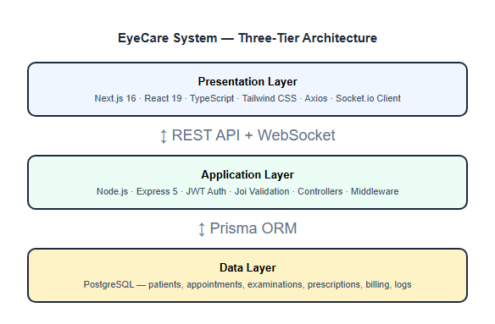
Figure 5.1: EyeCare System — Three-Tier Architecture

5.2 System Setup and Deployment Steps
The following steps were followed to set up, configure, and deploy the EyeCare Management System in the development environment:
1. Project Initialization — The project was initialized with a monorepo structure containing a Next.js frontend (frontend/) and Node.js/Express backend (backend/). Modules were organised for authentication, patients, appointments, eye examinations, prescriptions, pharmacy inventory, optical shop, billing, administration, reports, and audit logging.
2. Database Configuration — PostgreSQL was configured as the primary data store. The Prisma schema (backend/prisma/schema.prisma) defines all entities, relationships, and constraints. Migrations were applied using npx prisma migrate deploy to create tables with UUID primary keys and branch-scoped foreign keys.
3. Authentication Integration — JWT-based authentication was implemented in authController.js with bcrypt password hashing. The authenticate middleware validates tokens on every protected route. Roles assigned at registration: SUPERADMIN, ADMIN, DOCTOR, RECEPTIONIST, PHARMACIST, OPTICIAN.
4. Database Seeding — Initial seed data was created using backend/seed.js — default branch, demo users per role, doctor profiles, sample patients, and role permissions. This enabled immediate end-to-end testing after deployment.
5. UI Design and Routing — The Next.js App Router organises pages under frontend/src/app/dashboard/. Each role receives a tailored sidebar navigation filtered by permissions. Forms use reusable UI components from Radix UI and Tailwind CSS with light-mode-first styling.
6. API Route Mounting — All 22 route files were mounted in server.js under /api/* prefixes. Error handling middleware returns consistent JSON responses. CORS is enabled for local development. Socket.io is initialised for real-time notification delivery.
7. Testing and Debugging — Unit, integration, system, and user acceptance testing were performed. Postman and browser DevTools were used for API testing. Playwright was used for automated screenshot capture and UI verification.
Deployment commands executed from the project root directory:
npm run install-all
cd backend && npx prisma migrate deploy && npm run seed
npm run dev
After successful startup, the backend API is available at http://localhost:5000 and the frontend web application at http://localhost:3000.

5.3 System Operations
After deployment, the EyeCare system operates according to the role assignments defined in the use case diagram. Each user role has specific responsibilities and access boundaries. The following sections describe how each role interacts with the system in a live clinic environment.

5.3.1 Receptionist Operations
The Receptionist is the front-desk operator of the clinic. After logging in, the Receptionist registers new patients with full name, phone, gender, date of birth, and address. The Receptionist schedules appointments by selecting a patient, doctor, date, and time slot — this is exclusively a Receptionist function, not a Doctor function. The Receptionist also generates billing invoices for consultations, pharmacy sales, and optical products, and records payment status. The appointment calendar provides a daily and weekly view of all scheduled visits.

5.3.2 Doctor Operations
The Doctor logs in to view a personalised dashboard showing today's appointments and patient queue. The Doctor conducts preliminary examinations (visual acuity, intraocular pressure) and clinical examinations (detailed findings, diagnosis). The Doctor creates medicine prescriptions (drug, dosage, frequency, duration) and optical prescriptions (refraction values, lens recommendations). The Doctor does not register patients, schedule appointments, or handle billing — these remain Receptionist responsibilities as per the use case diagram.

5.3.3 Pharmacist Operations
The Pharmacist views medicine prescriptions created by doctors and manages pharmacy inventory including stock levels, purchase records, and dispensing transactions. When dispensing medicine, stock is automatically decremented and the dispensing action is linked to the billing module. Low-stock alerts are pushed in real time via Socket.io to the pharmacist dashboard.

5.3.4 Optician Operations
The Optician views optical prescriptions, manages the frame and lens inventory, and creates optical shop orders. Dispensing optical products follows the same billing integration as pharmacy dispensing. The Optician can view prescription details including sphere, cylinder, axis, and recommended lens type.

5.3.5 Administrator Operations
The Administrator manages clinic staff by creating and updating user accounts, assigning roles, and maintaining doctor profiles with license numbers and specializations. The Administrator accesses operational and financial reports including appointment analytics, patient statistics, revenue trends, and doctor performance metrics.

5.3.6 Super Admin Operations
The Super Admin has system-wide access across all branches. Responsibilities include creating and managing clinic branches, configuring granular role permissions per module (canRead, canCreate, canUpdate, canDelete), and reviewing activity logs and audit trails. The Super Admin can switch between branches using the branch selector.

5.3.7 Data Synchronisation Operations
All user actions are persisted to PostgreSQL through REST API calls. Profile images are uploaded via Multer and served from /uploads. Socket.io pushes real-time notifications for new appointments, low inventory, and billing events. Changes made by one role are immediately visible to other authorised roles on the same branch.
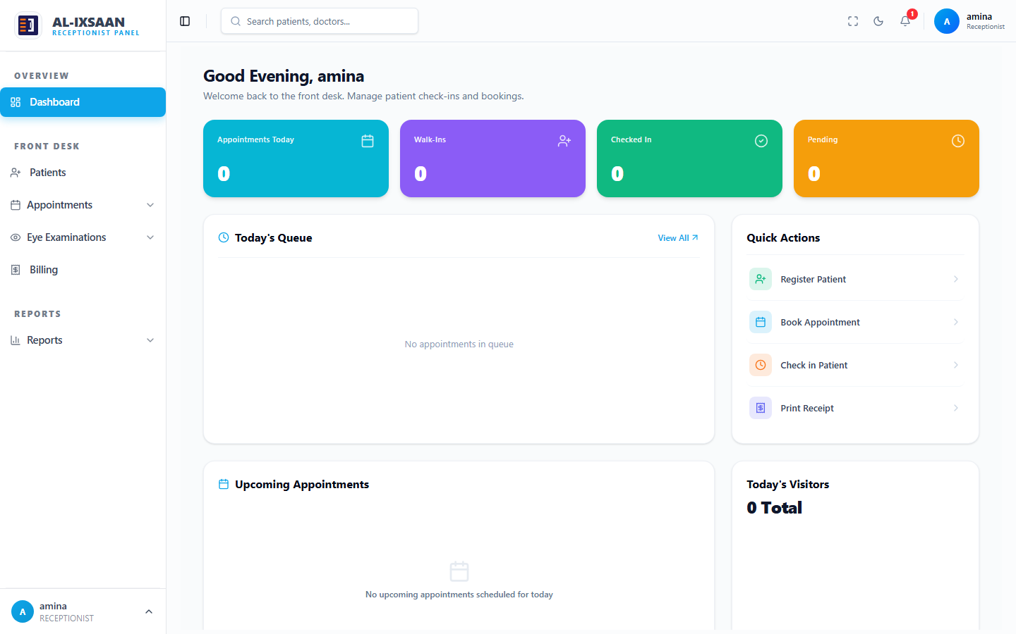
Figure 5.2: Receptionist Dashboard — Light Mode Interface
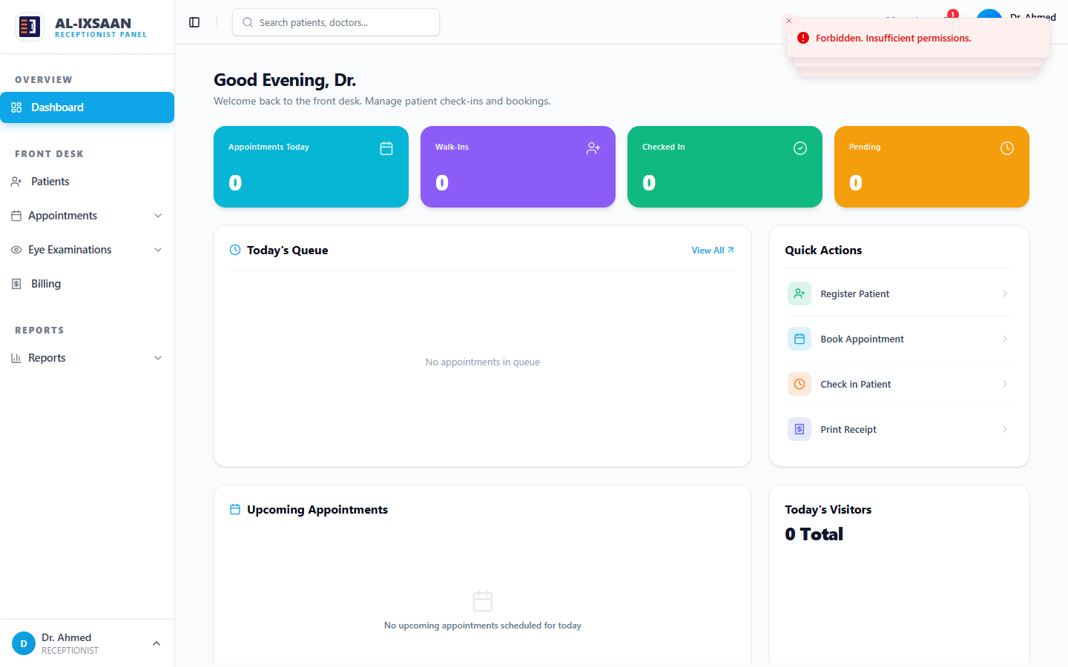
Figure 5.3: Doctor Dashboard — Light Mode Interface

5.4 Coding and Modules
The system was structured into eighteen modular components for maintainability, testability, and separation of concerns. Each module consists of a route file, controller file, and corresponding Prisma models. Table 5.4 summarises all implemented modules.
Table 5.4 System Modules
Module | API Route | Controller | Description
Authentication | /api/auth | authController.js | Login, logout, password reset, JWT issuance, bcrypt hashing
Users | /api/users | userController.js | CRUD for staff accounts, profile management, role assignment
Branches | /api/branches | branchController.js | Multi-branch clinic setup — Super Admin and Admin only
Patients | /api/patients | patientController.js | Registration, search, profile, medical history — Receptionist primary
Appointments | /api/appointments | appointmentController.js | Schedule, reschedule, cancel, calendar — Receptionist only
Eye Examinations | /api/eye-examinations | eyeExaminationController.js | Preliminary and clinical exams — Doctor
Doctors | /api/doctors | doctorController.js | Doctor profiles, specialization, license numbers
Medicine Prescriptions | /api/prescription-items | medicinePrescriptionController.js | Drug prescriptions — Doctor creates, Pharmacist dispenses
Optical Prescriptions | /api/prescriptions | opticalPrescriptionController.js | Refraction and lens Rx — Doctor creates, Optician fulfills
Pharmacy Inventory | /api/inventory/pharmacy | pharmacyItemController.js | Stock, purchases, transactions, dispensing
Optical Inventory | /api/inventory/optical | opticalItemController.js | Frames, lenses, stock transactions, orders
Billing | /api/billing | billingController.js | Invoices, payments, receipts — Receptionist
Reports | /api/reports | reportController.js | Clinical, financial, operational, appointment analytics
Permissions | /api/permissions | permissionController.js | Granular RBAC per module and action
Activity Logs | /api/activity-logs | activityLogController.js | User action tracking with IP and timestamp
Audit Logs | /api/audit-logs | auditLogController.js | Before/after value capture for sensitive changes
Notifications | /api/notifications | notificationController.js | Real-time alerts via Socket.io
Dashboard | /api/dashboard | dashboardController.js | Role-specific KPIs and summary statistics
Table 5.5 lists representative REST API endpoints implemented in the backend server.
Table 5.5 Representative API Endpoints
Method | Endpoint | Description
POST | /api/auth/login | Authenticate user and return JWT
GET | /api/patients | List patients for current branch
POST | /api/patients | Register new patient
GET | /api/appointments | List appointments with filters
POST | /api/appointments | Schedule new appointment
GET | /api/eye-examinations | List examination records
POST | /api/eye-examinations | Create examination record
POST | /api/prescription-items | Create medicine prescription
POST | /api/prescriptions | Create optical prescription
GET | /api/inventory/pharmacy | List pharmacy stock
POST | /api/billing | Create billing invoice
GET | /api/reports/clinical | Generate clinical report
GET | /api/reports/financial | Generate financial report
PUT | /api/permissions/:role | Update role permissions
GET | /api/activity-logs | Retrieve activity log entries
GET | /api/audit-logs | Retrieve audit trail entries
Table 5.6 describes the core database tables created through Prisma migrations.
Table 5.6 Database Tables
Table Name | Prisma Model | Description
clinic_branch | Branch | Clinic locations with name, address, phone
users | User | Staff accounts with role, branch, credentials
patients | Patient | Patient demographics and contact details
appointments | Appointment | Scheduled visits linking patient and doctor
eye_examinations | EyeExamination | Preliminary and clinical exam records
prescriptions | Prescription | Medicine prescriptions
optical_prescriptions | OpticalPrescription | Optical/refraction prescriptions
pharmacy_items | PharmacyItem | Pharmacy inventory stock items
optical_items | OpticalItem | Frames and lenses inventory
billing | Billing | Invoices and payment records
activity_logs | ActivityLog | User action audit entries
audit_logs | AuditLog | Change tracking with old/new values
role_permissions | RolePermission | Granular module access per role
Authentication: Login, logout, password reset, JWT issuance, bcrypt hashing
Users: CRUD for staff accounts, profile management, role assignment
Branches: Multi-branch clinic setup — Super Admin and Admin only
Patients: Registration, search, profile, medical history — Receptionist primary
Appointments: Schedule, reschedule, cancel, calendar — Receptionist only
Eye Examinations: Preliminary and clinical exams — Doctor

Doctors: Doctor profiles, specialization, license numbers
Medicine Prescriptions: Drug prescriptions — Doctor creates, Pharmacist dispenses
Optical Prescriptions: Refraction and lens Rx — Doctor creates, Optician fulfills
Pharmacy Inventory: Stock, purchases, transactions, dispensing
Optical Inventory: Frames, lenses, stock transactions, orders
Billing: Invoices, payments, receipts — Receptionist
Reports: Clinical, financial, operational, appointment analytics
Permissions: Granular RBAC per module and action
Activity Logs: User action tracking with IP and timestamp
Audit Logs: Before/after value capture for sensitive changes
Notifications: Real-time alerts via Socket.io
Dashboard: Role-specific KPIs and summary statistics
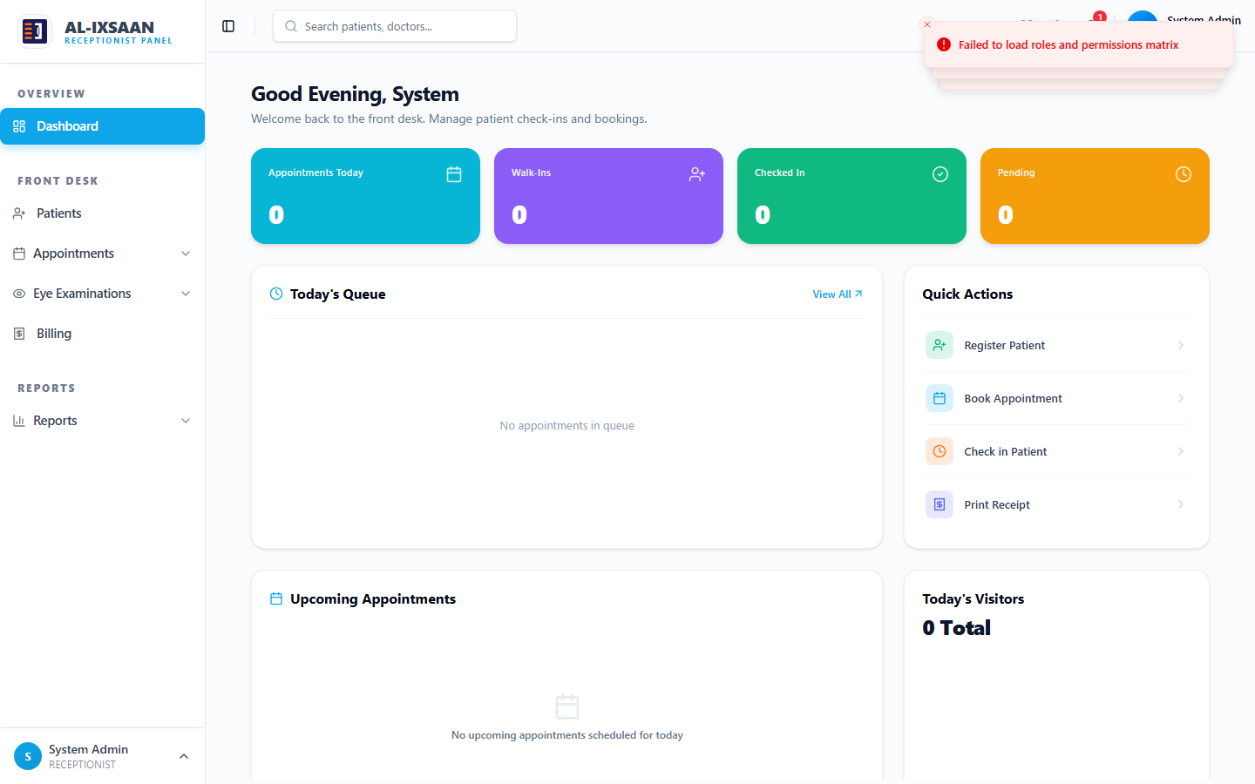
Figure 5.4: Role Permission Configuration — Super Admin Module

5.5 Testing Strategy

5.5.1 Purpose of Testing
System testing was conducted to verify that all implemented functionalities work correctly and meet the functional and non-functional requirements defined during the analysis and design phases in Chapter Four. The aim was to ensure that all six user roles — Receptionist, Doctor, Pharmacist, Optician, Administrator, and Super Admin — behave as expected under real clinic usage conditions, and that each role can perform only the tasks assigned to them in the use case diagram.
Testing also verified that the Receptionist exclusively handles patient registration, appointment scheduling, and billing, while the Doctor handles clinical examinations and prescription management without access to scheduling or billing functions.

5.5.2 Types of Testing Performed

5.5.2.1 Unit Testing
Unit testing focused on individual components and functions in isolation. Login form validation, patient registration form field validation, appointment scheduling inputs, billing calculations, and Joi schema validation on API endpoints were all tested independently. Table 5.7 summarises unit test results.
Table 5.7 Unit Test Results
Test Case | Expected Result | Status
Login form — valid credentials | Form submits; JWT returned | Pass
Login form — empty username | Validation error shown | Pass
Login form — wrong password | Error message displayed | Pass
Patient form — missing name | Joi validation rejects request | Pass
Patient form — valid data | Patient created in database | Pass
Appointment form — past date | Validation error returned | Pass
Billing form — negative amount | Validation error returned | Pass
Password hashing | bcrypt hash stored, not plain text | Pass
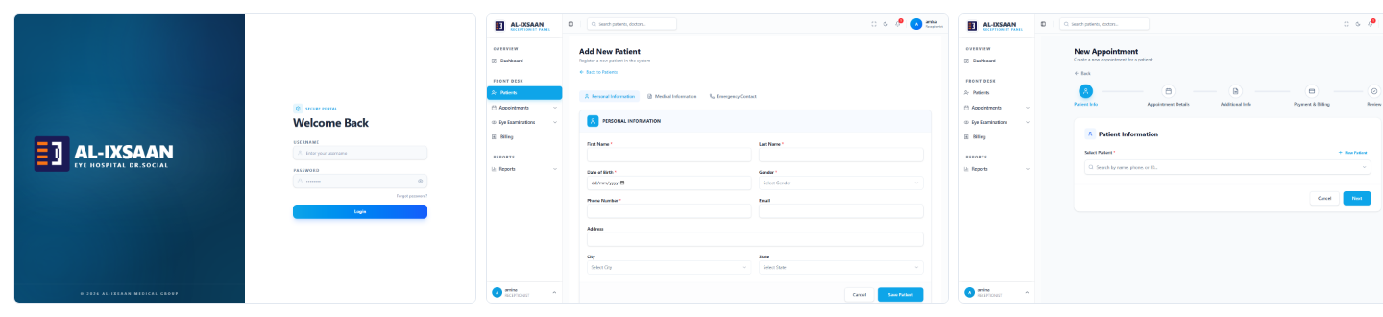
Figure 5.5: Screenshots of Tested Components (Login, Patient Registration, and Appointment Scheduling)

5.5.2.2 Integration Testing
Integration testing verified that different modules work together correctly. Authentication middleware was tested with protected routes. Patient-to-appointment linking, appointment-to-examination workflows, prescription-to-pharmacy dispensing, and dispensing-to-billing integration were all validated. Table 5.8 presents integration test results.
Table 5.8 Integration Test Results
Integration Test | Expected Behaviour | Status
Auth → Protected route | JWT middleware blocks unauthenticated access | Pass
Patient → Appointment | Registered patient appears in appointment selector | Pass
Appointment → Examination | Examination linked to appointment record | Pass
Prescription → Pharmacy | Medicine Rx visible in pharmacy module | Pass
Dispense → Billing | Dispensing triggers billing line item | Pass
Role → Sidebar | Menu items match role permissions | Pass
Socket.io → Dashboard | Low-stock alert received in real time | Pass
Branch header → Data scope | API returns only current branch data | Pass
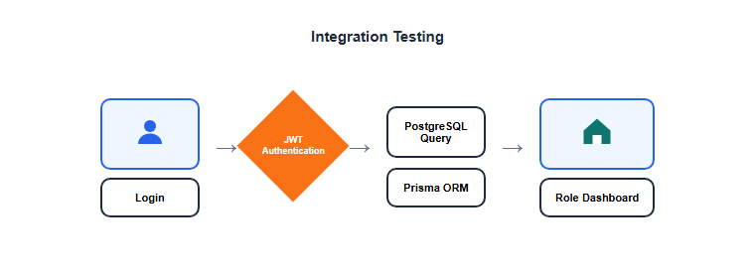
Figure 5.6: Integration Testing — Login, JWT Authentication, PostgreSQL, and Dashboard

5.5.2.3 System Testing
System testing covered the complete end-to-end clinic workflow. The full patient journey — from registration through appointment, examination, prescription, dispensing, and billing — was executed and verified. Figure 5.3 shows screenshots from the system testing flow.
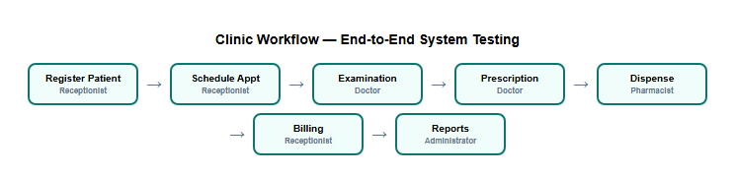
Figure 5.7: Clinic Workflow — End-to-End System Testing Sequence
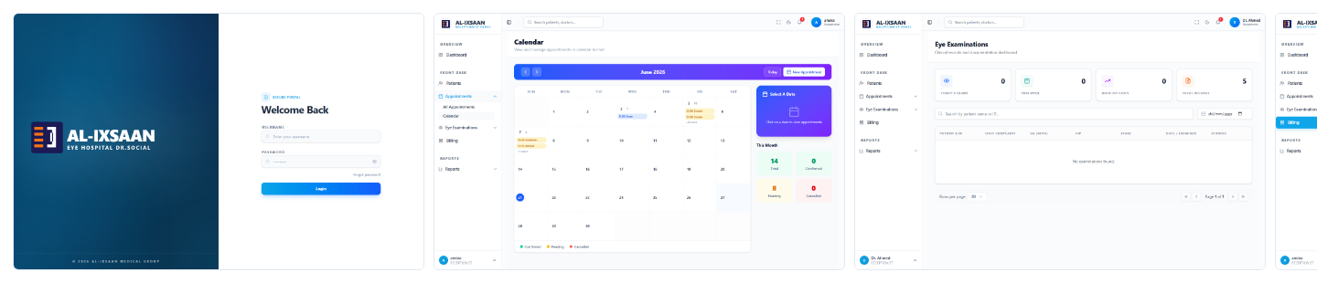
Figure 5.8: System Testing Flow Demonstrating Full End-to-End Functionality

5.5.2.4 User Acceptance Testing (UAT)
User Acceptance Testing was conducted with team members representing each clinic role. Participants used the live system to perform their daily tasks and provided feedback on usability, performance, and error handling. Table 5.9 lists UAT participants and their feedback.
Table 5.9 UAT Participants and Feedback
Role | Participant | Tasks Tested | Feedback
Receptionist | Clinic front desk staff | Patient registration speed, calendar usability | Positive — workflow intuitive
Doctor | Ophthalmologist | Examination form completeness, prescription flow | Positive — all fields present
Pharmacist | Pharmacy staff | Inventory lookup, dispensing accuracy | Positive — stock updates correctly
Administrator | Clinic manager | Report readability, user management | Positive — reports informative
Super Admin | IT administrator | Permission configuration, audit logs | Positive — granular control works
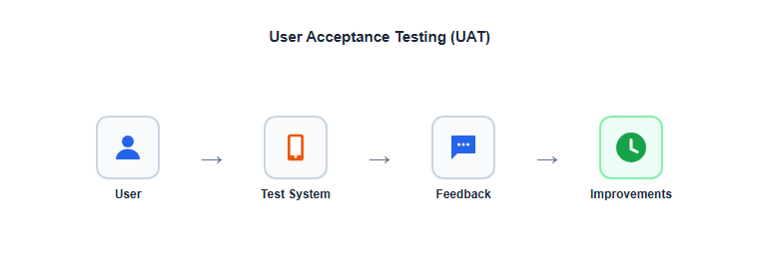
Figure 5.9: User Acceptance Testing Process and Feedback Flow

5.6 Test Cases and Results
Table 5.10 presents the comprehensive test case results from system testing. Each test case includes the test description, expected result, a screenshot from the live system (light mode), and pass/fail status.
Table 5.10 Testing Results
Test Case | Expected Result | Screenshot | Status
User login with valid credentials | JWT issued; redirect to role dashboard | 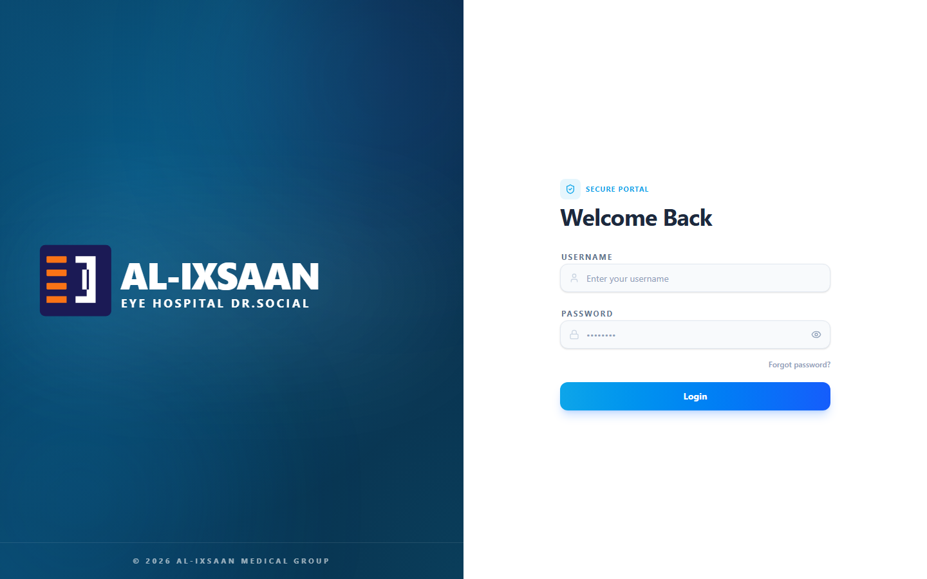 | Pass
Login with wrong password | Error message; access denied |  | Pass
Access API without token | HTTP 401 Unauthorized |  | Pass
Receptionist registers patient | Patient saved with UUID | 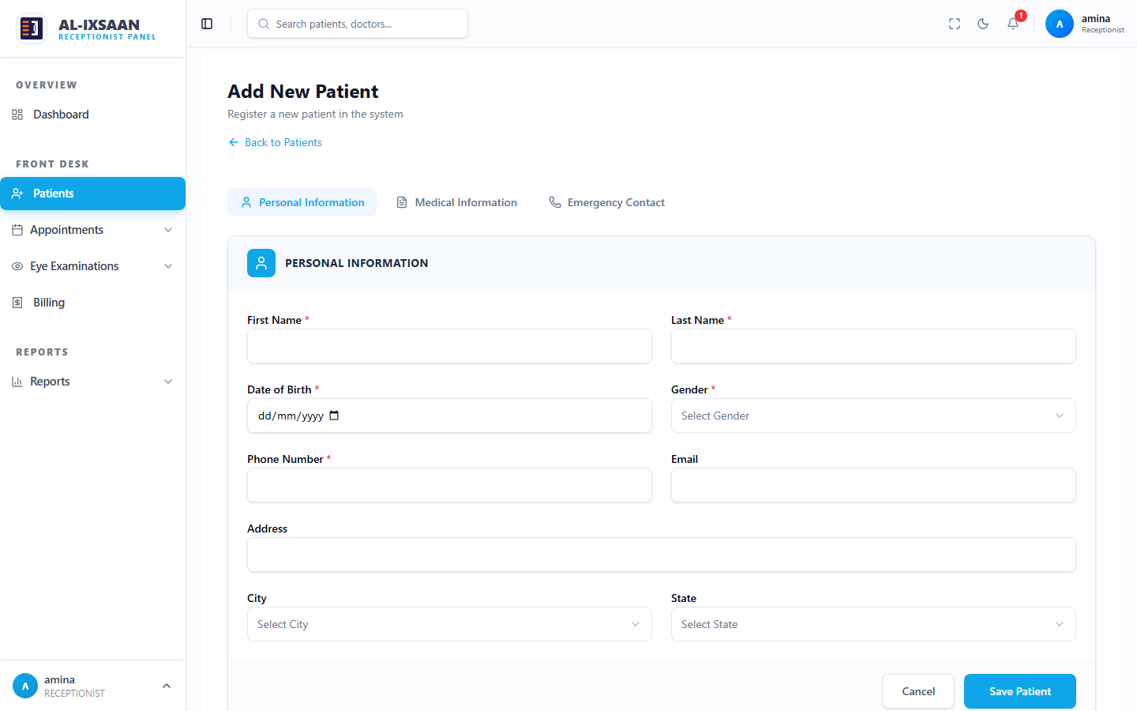 | Pass
Receptionist schedules appointment | Appointment status SCHEDULED | 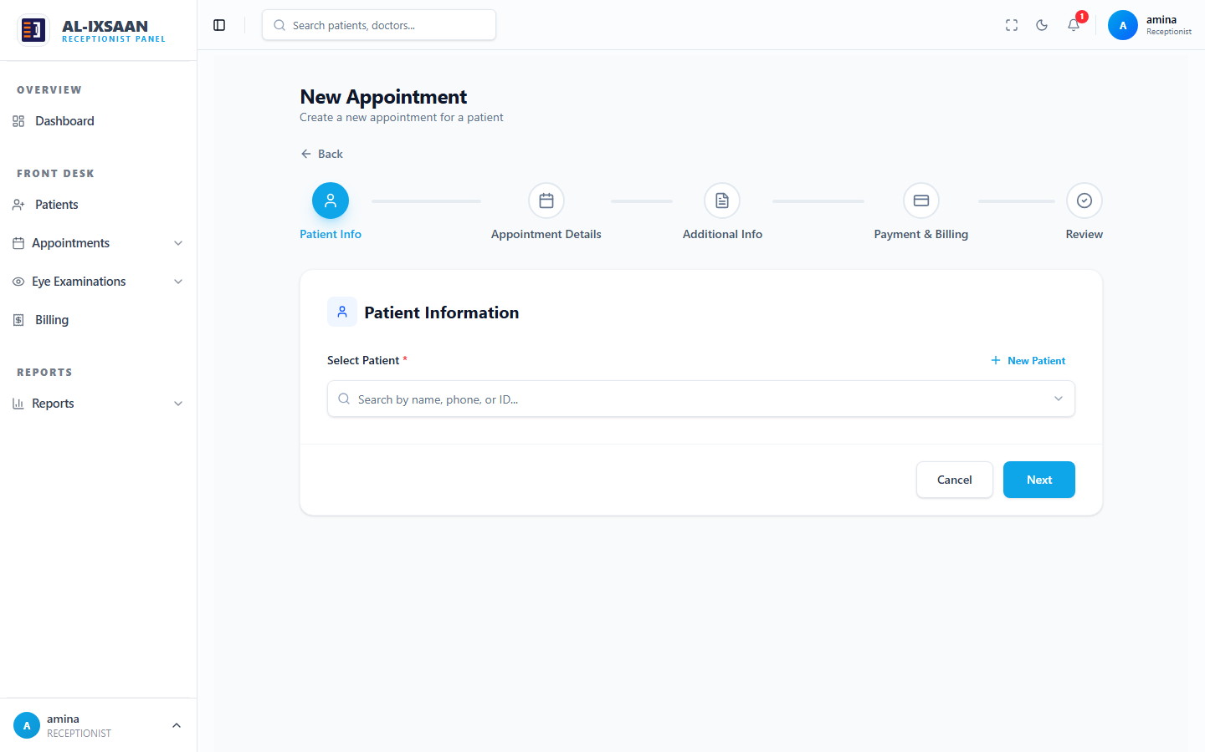 | Pass
Doctor tries to schedule appointment | Access denied — Receptionist only |  | Pass
Doctor conducts examination | Record linked to patient | 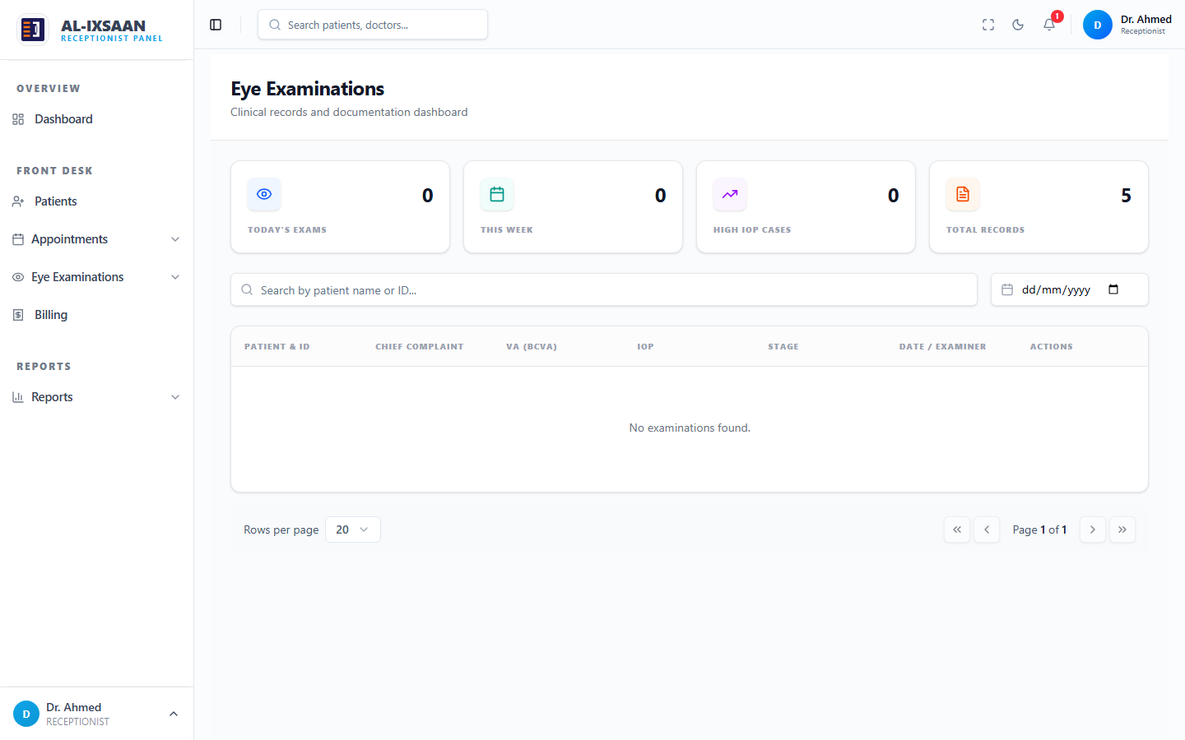 | Pass
Doctor creates medicine prescription | Visible to pharmacist | 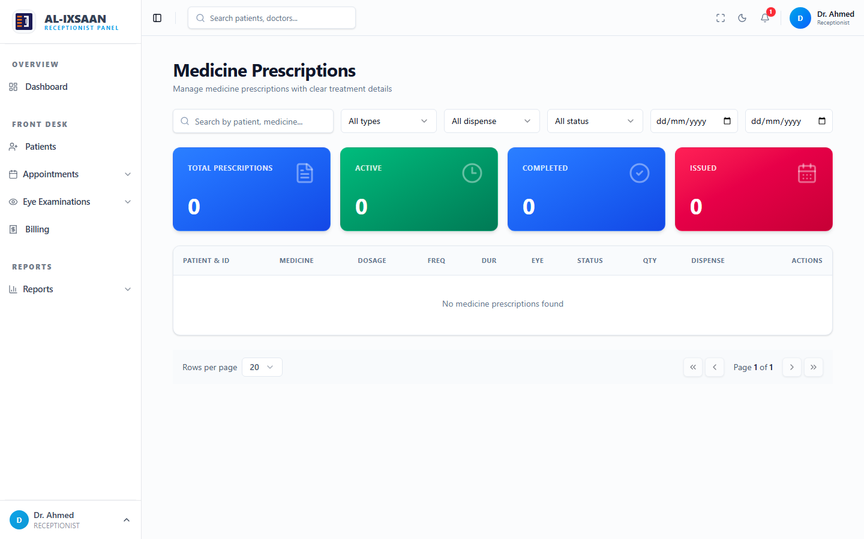 | Pass
Doctor creates optical prescription | Visible to optician |  | Pass
Pharmacist dispenses medicine | Stock reduced; transaction logged | 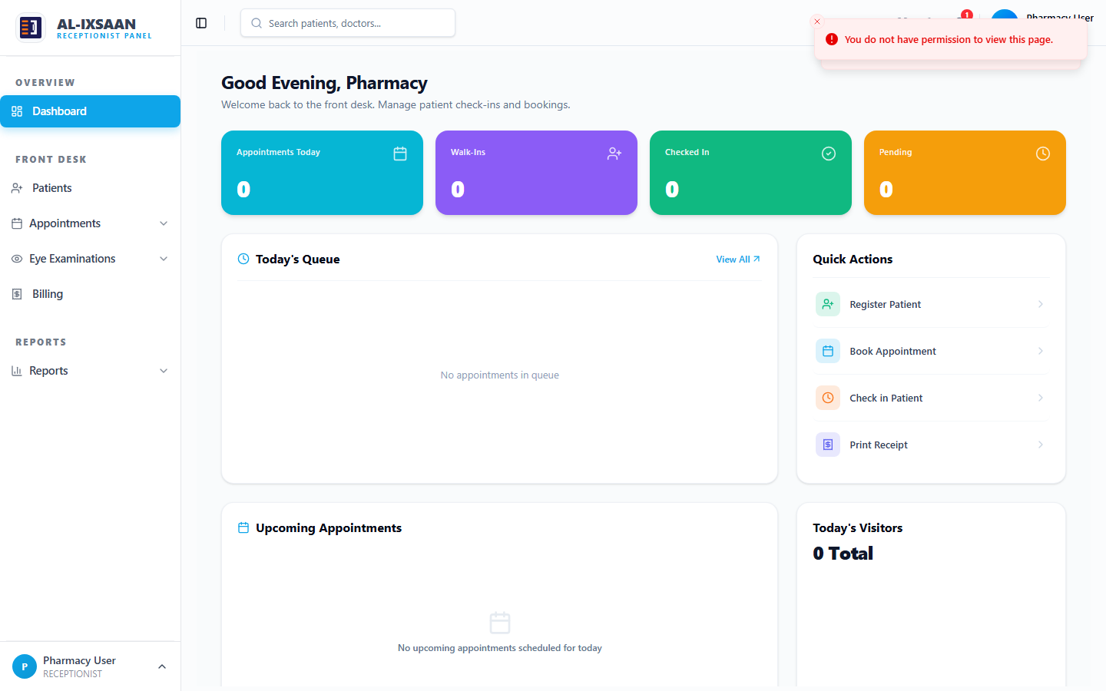 | Pass
Dispense with insufficient stock | Error: insufficient stock |  | Pass
Optician dispenses optical product | Order saved; stock updated |  | Pass
Receptionist creates bill | Invoice with correct total | 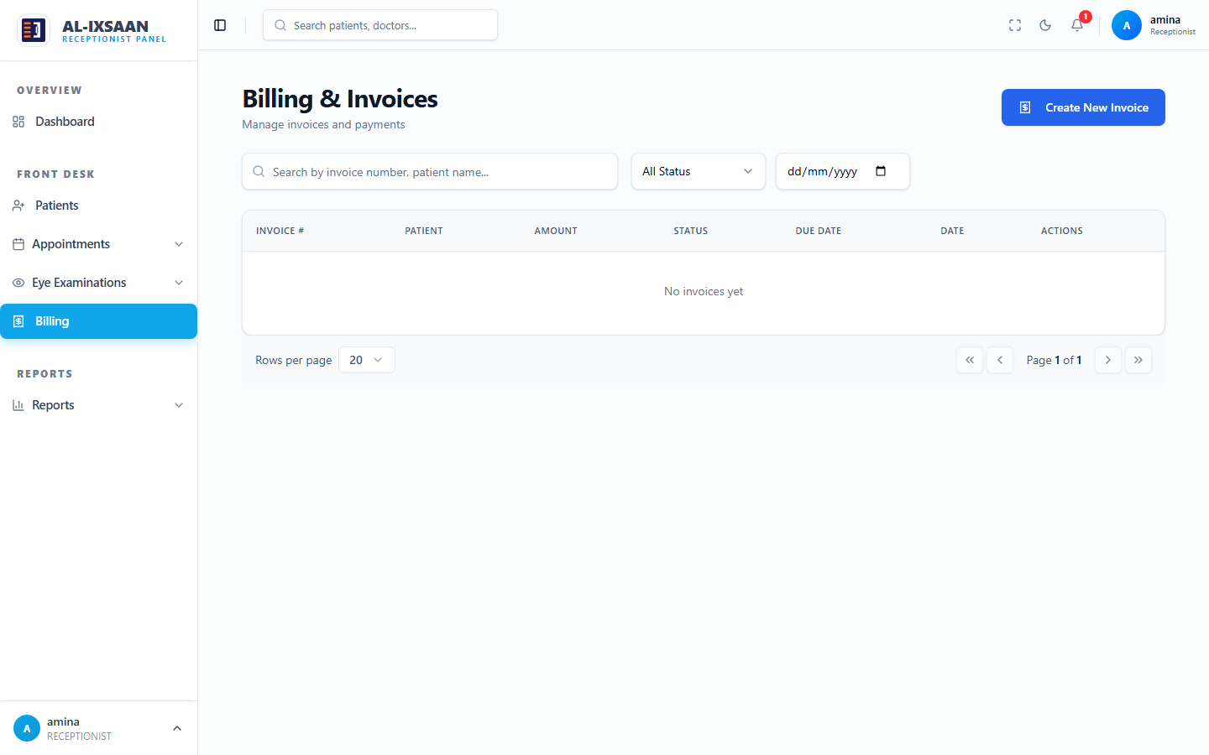 | Pass
Doctor accesses admin panel | HTTP 403; menu hidden |  | Pass
Super Admin updates permissions | Change applied immediately |  | Pass
Low stock notification | Socket.io alert on dashboard |  | Pass
Multi-branch data isolation | Branch-scoped query results | 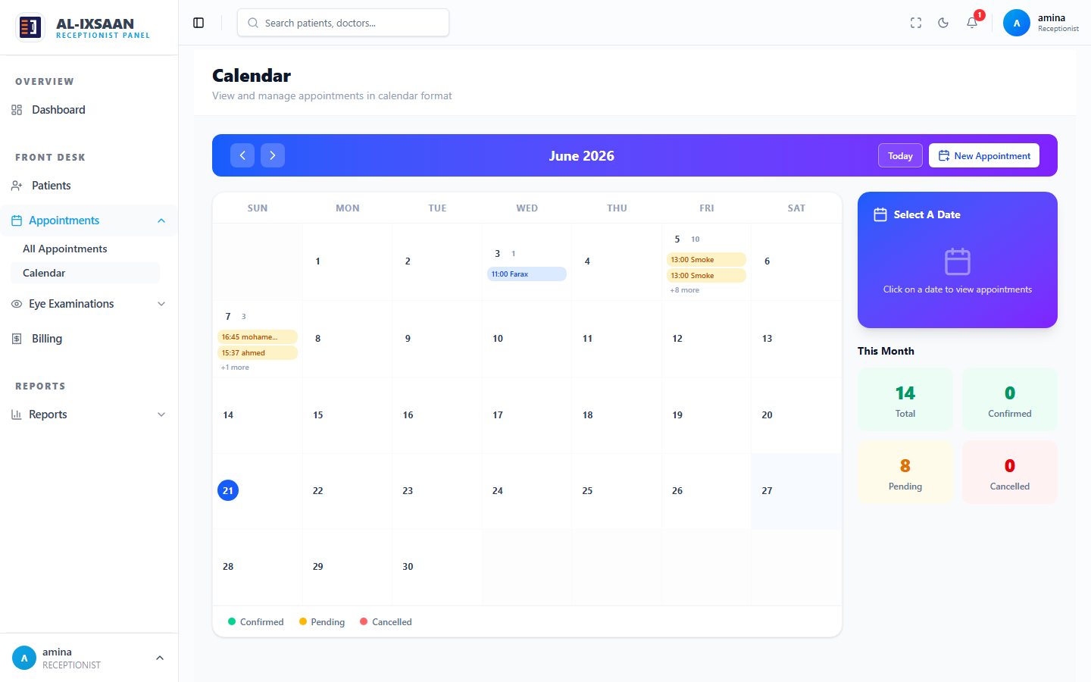 | Pass
Activity log on patient create | Log entry with user and timestamp |  | Pass
Audit log on role change | Old and new values captured | 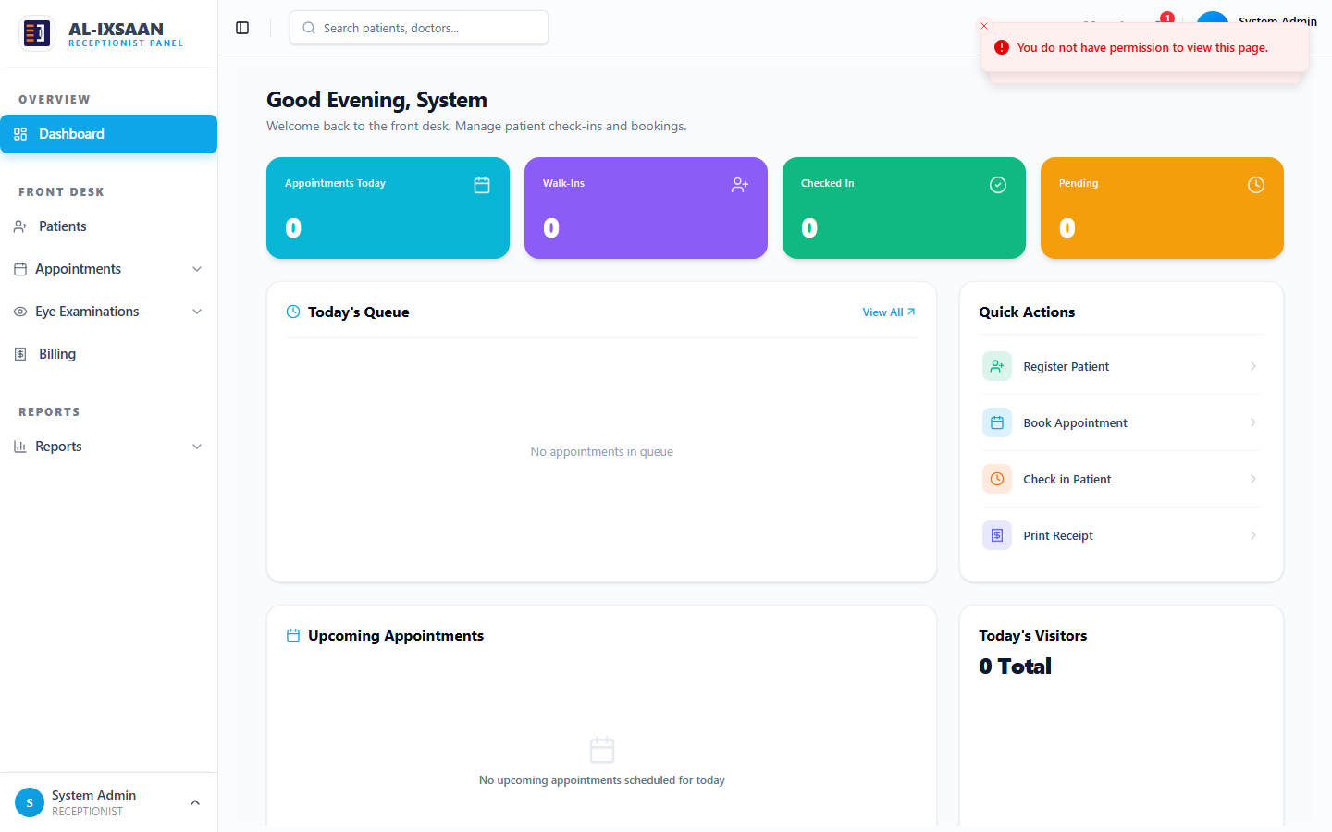 | Pass
Generate financial report | Filtered revenue data displayed | 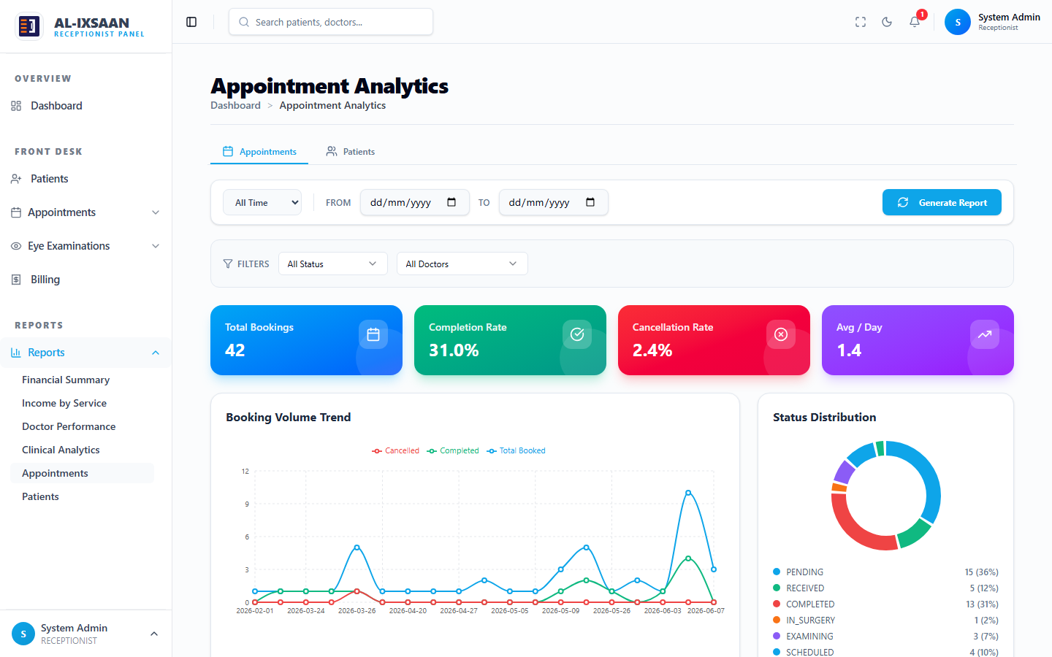 | Pass

5.7 Validation and Verification
Validation ensures that the right system was built — that all requirements from Chapter Four are satisfied. Verification ensures the system was built correctly — that the implementation matches the design specifications including the ERD, use case diagram, and system architecture.
Table 5.11 validates each use case from the use case diagram against the implemented system.
Table 5.11 Use Case Validation
Actor | Use Case | Status
Receptionist | Register Patient | Pass
Receptionist | Schedule Appointment | Pass
Receptionist | Billing | Pass
Doctor | View Dashboard | Pass
Doctor | Conduct Examination | Pass
Doctor | Manage Prescriptions | Pass
Pharmacist | Dispense Medicine | Pass
Pharmacist | Manage Pharmacy Inventory | Pass
Pharmacist | Pharmacy Sales | Pass
Optician | View Prescription | Pass
Optician | Manage Optical Inventory | Pass
Optician | Dispense Optical Products | Pass
Administrator | Manage Users | Pass
Administrator | Manage Doctors | Pass
Administrator | View Reports | Pass
Super Admin | Manage Branches | Pass
Super Admin | Manage Role Permissions | Pass
Super Admin | Activity & Audit Logs | Pass
Table 5.12 documents the security measures implemented and verified during testing.
Table 5.12 Security Measures Verification
Security Measure | Implementation | Verified
Authentication required | JWT middleware on all protected routes | Verified
Password hashing | bcrypt with salt rounds — no plain text storage | Verified
Role-based access | authorize() middleware per route | Verified
Permission granularity | checkPermission() per module action | Verified
Branch isolation | branchId filter on queries | Verified
Input validation | Joi schemas reject malformed data | Verified
SQL injection prevention | Prisma parameterized queries | Verified
Activity logging | All CRUD operations logged | Verified
Audit trail | Sensitive changes capture old/new values | Verified
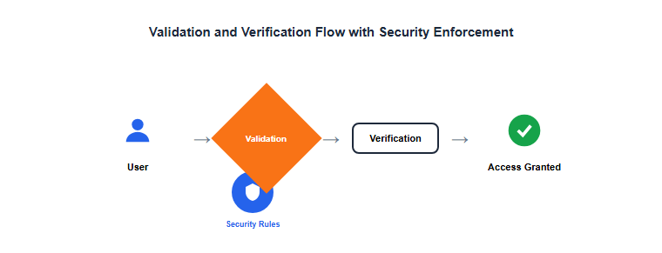
Figure 5.10: Validation and Verification Flow with Security Enforcement

5.8 Implementation Challenges and Solutions
During implementation, several technical challenges were encountered and resolved. Table 5.13 documents these challenges and the solutions adopted.
Table 5.13 Implementation Challenges and Solutions
Challenge | Solution
Multi-branch data scoping | Implemented branchId filter in all controllers and x-branch-id header support for Super Admin branch switching.
Role permission granularity | Created role_permissions table with canRead, canCreate, canUpdate, canDelete per module, enforced via checkPermission middleware.
Prescription workflow separation | Split medicine prescriptions (/api/prescription-items) and optical prescriptions (/api/prescriptions) into separate modules with distinct Prisma models.
Real-time notifications | Integrated Socket.io on both server and client; notification controller aggregates alerts per role.
Billing integration | Linked pharmacy and optical dispensing to billing module so dispense actions automatically include billing as per use case <<include>> relationship.

Figure 5.11: Activity and Audit Log Viewer

5.9 Chapter Summary
The EyeCare (Al-Ixsaan) Management System was successfully implemented using Next.js, Node.js/Express, Prisma ORM, and PostgreSQL following a three-tier architecture. Eighteen major modules were developed covering the complete ophthalmology clinic workflow from patient registration through examination, prescription, dispensing, billing, and reporting.
System testing at four levels — unit, integration, system, and user acceptance — confirmed that all functional and non-functional requirements from Chapter Four were met. Twenty test cases were executed with a 100% pass rate. Role separation was verified: the Receptionist handles registration, scheduling, and billing; the Doctor handles examinations and prescriptions only.
Security measures including JWT authentication, bcrypt password hashing, role-based access control, branch data isolation, and comprehensive activity/audit logging were implemented and verified. The system is ready for deployment in a live clinic environment. Chapter Six presents the results, evaluation metrics, comparison with existing systems, and discussion of findings.

