CHAPTER FOUR

ANALYSIS AND DESIGN

4.1 System Analysis and Design
System analysis is the process of studying an existing or proposed system to understand how it works, identify its weaknesses, and determine what improvements are necessary. In the context of the EyeCare Management System, the system analysis phase involved a careful examination of the current manual and fragmented processes used in eye care clinics to manage patient information, clinical documentation, appointments, prescriptions, and billing. By thoroughly investigating these operational challenges, it became possible to define the functional and technical requirements needed to build an effective digital solution.
The analysis revealed that many eye care clinics currently operate without a unified information system. Patient registration, appointment management, clinical examinations, pharmacy dispensing, optical sales, and billing are typically handled through separate tools such as paper registers, spreadsheets, or disconnected software applications. This fragmented approach creates significant barriers to efficient information flow, accurate data management, and coordinated patient care.
A key finding of the analysis was that data entered at one stage of patient care is rarely accessible in other departments without manual transfer. For instance, a prescription written by a doctor during a clinical examination may need to be physically carried to the pharmacy rather than being digitally routed. Similarly, billing staff may not have immediate access to a complete list of services rendered to a patient across departments, leading to potential revenue loss and administrative errors.
The system analysis also identified challenges related to data duplication and inconsistency. When patient information is maintained in multiple registers or files, it becomes difficult to ensure that all records are synchronized and up-to-date. Healthcare staff may work from outdated information, which can negatively affect clinical decision-making and patient care quality. Furthermore, the absence of role-based access control in manual systems means that sensitive clinical and financial records are not always adequately protected.
Based on these findings, the system analysis concluded that the EyeCare Management System must provide a centralized, integrated platform that eliminates the inefficiencies of the current fragmented approach. The proposed system must support seamless data flow between departments, ensure data accuracy and consistency, and provide secure access to clinical and administrative information for authorized users only.

4.2 Existing Approaches
Before the development of the EyeCare Management System, eye care clinics relied on a combination of manual processes and partially digitized tools to manage their operations. Understanding these existing approaches provides important context for the design of the proposed system and helps clarify why a fully integrated digital solution is necessary.

4.2.1 Paper-Based Record Systems
The most widely used approach in many clinics involves maintaining patient records in physical folders and registers. Patient registration details, examination findings, prescriptions, and appointment information are recorded by hand and stored in filing cabinets or shelves. While this approach is simple and does not require technological infrastructure, it introduces several significant challenges. Handwritten records are difficult to search and retrieve, particularly when a clinic serves hundreds or thousands of patients. Physical files are vulnerable to damage, loss, or unauthorized access, and maintaining data consistency across multiple departments using paper-based systems is extremely challenging.

4.2.2 Standalone Spreadsheet Applications
Some clinics have adopted the use of spreadsheet applications such as Microsoft Excel or Google Sheets to manage specific aspects of clinic operations, such as appointment scheduling or billing records. These tools offer improvements over purely paper-based systems by providing basic digital storage and calculation capabilities. However, standalone spreadsheets are not designed for multi-user access in real time, lack relational database structures needed for complex clinical data, and do not support role-based access control. Data entered in one spreadsheet is not automatically available in another, which means that the fragmentation problem is not fully resolved.

4.2.3 General-Purpose Practice Management Software
A small number of healthcare facilities use general-purpose practice management or hospital information system software that was not specifically designed for ophthalmology. These systems may provide modules for appointment scheduling and basic billing but typically lack specialized features required for eye care, such as visual acuity recording, intraocular pressure tracking, refraction data management, and optical inventory control. As a result, clinics using these systems often need to supplement them with additional tools, which reintroduces fragmentation.

4.2.4 Summary of Existing Approach Limitations
The table below summarizes the key limitations observed in the existing approaches used in eye care clinics:
Table 4.1: Summary of Existing Approaches and Their Limitations
Existing Approach | Key Features | Identified Limitations
Paper-Based Records | Simple, no technology needed | Data loss risk, difficult retrieval, no multi-department sharing
Spreadsheet Tools | Basic digital storage, calculations | No relational structure, no real-time multi-user access, fragmented data
General HMS Software | Appointment and billing modules | No ophthalmic specialization, missing clinical modules, not integrated
Manual Prescription Handling | Handwritten doctor prescriptions | Risk of misreading, no real-time pharmacy notification

4.3 The Proposed System
The proposed EyeCare Management System is a comprehensive, web-based platform specifically designed to address the operational challenges identified in the system analysis and to overcome the limitations of the existing approaches reviewed above. The system integrates all major clinical and administrative functions of an eye care clinic within a single, centralized digital platform, enabling seamless data flow between departments and providing authorized users with real-time access to accurate and up-to-date information.
At its core, the proposed system replaces fragmented manual processes with a structured electronic workflow. When a patient arrives at the clinic, their information is registered through the system's patient registration module. This information is immediately accessible to clinical staff, where preliminary examination data such as visual acuity and initial intraocular pressure readings are recorded. The clinical findings are then instantly available to the consulting ophthalmologist, who can complete the full examination, record diagnosis and treatment plans, and generate prescriptions through the system's examination and prescription modules.
The proposed system also integrates pharmacy and optical shop management directly with the clinical workflow. Prescriptions generated by the doctor are automatically routed to the pharmacist through the system, eliminating the need for physical document transfer. Similarly, refraction data recorded during examination is automatically available to the optical shop module when processing spectacle orders. All services provided are linked to the unified billing module, which consolidates charges from consultations, medications, optical products, and surgeries to generate a complete and accurate invoice for each patient.
The system is designed to support multi-branch clinic operations, allowing a clinic group with several physical locations to manage all branches through a single platform while maintaining strict data isolation between branches. Role-based access control ensures that each user type can only access and modify the information relevant to their specific role within the clinic.

4.4 Requirements
The system requirements were derived from the findings of the system analysis phase, the review of existing approaches, and the specific operational needs of eye care clinics. Requirements are divided into two categories: functional requirements, which describe the specific operations the system must perform, and non-functional requirements, which define the quality and performance standards the system must meet.

4.4.1 Functional Requirements
Functional requirements describe the specific features and behaviors that the EyeCare Management System must provide in order to support clinical and administrative operations effectively. Key functional requirements include secure user authentication and role-based authorization, patient registration and medical history management, appointment scheduling, triage and clinical examination recording, digital prescription management, surgery scheduling, pharmacy and optical inventory management, billing and payment processing, reporting and analytics, and multi-branch administration.
The following table provides a consolidated summary of the functional requirements:
Table 4.2: Summary of Functional Requirements
FR ID | Module | Description | User Role
FR-01 | Authentication | Secure login and role-based access | All Users
FR-02 | Patient Records | Register patients and manage medical history | Receptionist, Doctor
FR-03 | Appointments | Schedule, reschedule, and cancel appointments | Receptionist
FR-04 | Triage | Record VA, pinhole, and IOP readings | Doctor
FR-05 | Clinical Exam | Record refraction, diagnosis, and management plan | Doctor
FR-06 | Prescriptions | Generate digital prescriptions for pharmacy and optical | Doctor
FR-07 | Surgery | Schedule surgeries and record surgical outcomes | Doctor, Admin
FR-08 | Pharmacy | Manage drug inventory and dispense medications | Pharmacist
FR-09 | Optical Shop | Manage frame/lens inventory and spectacle orders | Optician
FR-10 | Billing | Generate invoices and manage payments | Receptionist
FR-11 | Reporting | Generate financial and operational reports | Admin, Manager
FR-12 | Multi-Branch | Manage multiple clinic locations from one dashboard | Super Admin

4.4.2 Non-Functional Requirements
Non-functional requirements define the quality attributes and performance standards that the EyeCare Management System must satisfy in order to be reliable, secure, and usable in a clinical environment. The system shall respond to standard user requests within three seconds under normal operating conditions and support at least fifty concurrent users across multiple branches.
Security requirements include encrypted password storage using bcrypt hashing, JWT-based session authentication, HTTPS encryption for data in transit, and role-based access control ensuring users can only access permitted modules and data. Reliability requirements include 99% availability during clinic hours and database backup mechanisms for data recovery.
Usability requirements specify an intuitive interface with consistent navigation, readable typography, and workflow progression matching the natural patient journey. Scalability, maintainability (modular TypeScript/Prisma codebase), and browser compatibility (Chrome, Edge, Firefox, Safari on desktop and tablet) are also required.

4.5 Feasibility Study
A feasibility study is an assessment conducted to determine whether a proposed system can be successfully developed and deployed given the available resources, technical capabilities, time constraints, and financial considerations. The feasibility study for the EyeCare Management System was conducted across four dimensions: technical feasibility, economic feasibility, schedule feasibility, and operational feasibility.

4.5.1 Technical Feasibility
Technical feasibility refers to whether the required technology, hardware, software, and development skills are available to design, build, deploy, and maintain the EyeCare (Al-Ixsaan) Management System. A technical feasibility assessment was conducted to confirm that the development team possesses the necessary programming knowledge and that the selected tools are mature, well-documented, and suitable for a production-grade clinic management platform.
The EyeCare system adopts a three-tier web architecture comprising a Next.js presentation layer, a Node.js/Express application layer, and a PostgreSQL data layer managed through Prisma ORM. All core technologies are open-source, actively maintained, and widely adopted in modern web development. The system requires only standard computing hardware and a modern web browser on client devices, making deployment practical for eye care clinics with limited IT infrastructure.
The following tables summarize the hardware and software requirements that confirm the technical feasibility of the proposed system.
Table 4.4: Hardware Requirements for Technical Feasibility
No. | Hardware Component | Quantity | Specification / Purpose
1 | Development Computer / Laptop | 5 units | Intel Core i5 or equivalent, 8 GB RAM minimum, 256 GB SSD, Windows 10/11 — one per team member
2 | Server / Hosting Environment | 1 unit | Cloud VPS or local server: 2 vCPU, 4 GB RAM, 40 GB SSD for API and database hosting
3 | Client Workstations | 3+ units | Desktop or laptop with modern browser for reception, doctor, pharmacy, and admin use
4 | Network Infrastructure | 1 | Stable broadband internet (minimum 10 Mbps) for development, deployment, and clinic access
5 | Backup Storage | 1 | External drive or cloud backup for database dumps and project files
6 | Printer (optional) | 1 | For printing invoices, receipts, and reports at clinic reception
Table 4.4 confirms that the development team has access to suitable hardware for building and demonstrating the EyeCare system. Client workstations at the clinic require only a standard computer with a modern web browser, eliminating the need for specialized ophthalmic hardware integration.
Table 4.5: Software Requirements for Technical Feasibility
No. | Software / Tool | Version / Type | Purpose in EyeCare System
1 | Operating System | Windows 10/11, Linux (Ubuntu), or macOS | Development and server environments
2 | Node.js 18+ & npm | JavaScript runtime and package manager | Backend API and frontend build tooling
3 | Next.js 16 & React 19 | Frontend web framework | Presentation layer and dashboard UI
4 | TypeScript 5 | Typed JavaScript superset | Type-safe frontend development
5 | Express.js 5 | REST API framework | Application layer and route handling
6 | PostgreSQL 14+ | Relational database management system | Persistent data storage
7 | Prisma ORM 6.4 | Database toolkit | Schema definition, migrations, and queries
8 | Visual Studio Code | Integrated development environment | Code editing, debugging, and Git integration
9 | Git & GitHub | Version control | Collaborative development and source backup
10 | Web Browser | Chrome, Edge, or Firefox (latest) | UI testing and end-user access
11 | Postman / Thunder Client | API testing tool | REST endpoint verification during development
12 | Socket.io 4.8 | Real-time communication library | Live notifications for appointments and inventory
Based on the hardware and software assessment above, the EyeCare Management System is technically feasible. The development team has access to suitable computers, all required software tools are freely available, and the chosen technology stack is well supported by official documentation and community resources. The web-based architecture eliminates the need for specialized client-side installation, allowing clinic staff to access the system from any authorized device with a browser.

4.5.2 Economic Feasibility
Economic feasibility evaluates whether the benefits of implementing the EyeCare Management System justify the financial investment required during development and deployment. Although the system is built primarily using open-source technologies that do not require commercial software licenses, the project still incurs direct and indirect costs related to infrastructure, connectivity, transportation, documentation, and hosting.
The table below presents a detailed breakdown of the estimated project costs incurred by the development team during the Final Year Project period from February 2026 to June 2026. Costs are expressed in United States Dollars (USD), which is commonly used for academic and technology-related expenses in the region.
Table 4.6: Project Cost Estimation — Economic Feasibility
No. | Item | Category | Quantity | Unit Cost | Total Cost (USD)
1 | Internet Subscription | Connectivity | 5 months | $25.00 / month | $125.00
2 | Mobile Data / Communication | Communication | 5 months | $6.00 / month | $30.00
3 | Cloud Hosting (VPS) | Infrastructure | 3 months | $20.00 / month | $60.00
4 | Domain Name | Infrastructure | 1 year | $12.00 / year | $12.00
5 | Transportation | Travel | 10 trips | $5.00 / trip | $50.00
6 | Printing & Binding | Documentation | 1 set | $45.00 | $45.00
7 | USB Flash Drive / Storage | Equipment | 2 units | $6.00 / unit | $12.00
8 | Electricity | Utilities | 5 months | $7.00 / month | $35.00
9 | Software Tools | Software | — | Free (open-source) | $0.00
10 | Development Hardware | Equipment | 5 laptops | Already owned | $0.00
 | TOTAL |  |  | Total Estimated Project Cost | $369.00
The cost breakdown in Table 4.6 shows that the total estimated project expenditure is approximately $369.00. The majority of software tools used in development are open-source and incur no licensing fees. The primary costs relate to internet connectivity, cloud hosting for demonstration deployment, transportation for requirements gathering and supervisor meetings, and documentation printing.
Beyond direct development costs, the system delivers significant operational benefits that justify the investment:
• Elimination of paper register costs and reduced physical storage requirements for patient files.
• Improved billing accuracy reduces revenue leakage from missed charges across pharmacy, optical, and clinical services.
• Automated inventory tracking reduces medicine and optical stock wastage through low-stock alerts.
• Faster patient lookup and appointment management reduce receptionist administrative time.
• Digital reports replace manual compilation, saving administrator hours per week.
• Long-term savings from using open-source stack with no recurring license fees unlike commercial HMS products.
The total estimated development cost of approximately $369.00 is modest compared to the operational benefits the system delivers to a clinic. Once deployed, ongoing costs are limited to hosting and internet connectivity, while the system continues to improve efficiency, data accuracy, and patient service quality. Therefore, the EyeCare Management System is economically feasible and provides a favourable cost–benefit ratio for adoption by eye care facilities such as Al-Ixsaan Medical Group.

4.5.3 Schedule Feasibility
Schedule feasibility evaluates whether the proposed system can be developed, tested, and delivered within the available timeframe. The EyeCare Management System was planned for development within the period from February 2026 to June 2026, providing approximately five months for the completion of all development phases.
The project timeline was structured using an iterative and incremental development model, allowing each major module to be developed and validated before proceeding to the next. The following table presents the project schedule:
Table 4.3: Project Development Schedule
No. | Development Phase | Duration | Target Period
1 | Requirement Analysis and Planning | 2 weeks | February 2026
2 | System Design (Architecture, DFD, ERD) | 2 weeks | Late February 2026
3 | Database Design and Setup | 1 week | Early March 2026
4 | Core Module Development (Auth, Patients, Appointments) | 3 weeks | March 2026
5 | Clinical Modules (Triage, Exam, Prescriptions, Surgery) | 3 weeks | Late March – April 2026
6 | Pharmacy, Optical, and Billing Modules | 3 weeks | April 2026
7 | Reporting, Multi-Branch and Admin Features | 2 weeks | Early May 2026
8 | System Testing and Bug Fixing | 2 weeks | May 2026
9 | Documentation and Final Submission | 2 weeks | June 2026
The schedule was considered achievable given the scope of the project and the iterative development methodology adopted. Regular progress reviews throughout the development period ensured that any delays in individual modules could be identified and addressed before affecting the overall project timeline. Based on this assessment, the schedule feasibility of the proposed system is confirmed.

4.5.4 Operational Feasibility
Operational feasibility evaluates whether the proposed system will function effectively within the organization and be accepted by its users. The EyeCare Management System is operationally feasible because it is designed to be user-friendly and easy to use for clinic staff such as administrators, receptionists, doctors, and pharmacists. The system supports daily operations including patient registration, appointment scheduling, examination recording, billing, and inventory management, which aligns with existing workflows in eye care clinics. In addition, minimal training is required for users due to the simple and intuitive interface. By improving data management, reducing manual work, and enhancing coordination between departments, the system is expected to be widely accepted and effectively used in the organization.

4.6 System Design
System design translates the requirements identified during the analysis phase into a detailed technical blueprint that guides the development of the EyeCare Management System. This section presents the key design models used to represent the system's structure, behavior, and data flows, including Use Case Diagrams and Entity Relationship Diagrams.

4.6.1 Use Case Diagram
The Use Case Diagram identifies the different actors who interact with the EyeCare Management System and describes the primary use cases, or functional activities, associated with each actor. The main actors in the system are the Super Admin, Administrator, Doctor, Receptionist, Pharmacist, and Optician.
The Receptionist handles patient registration, appointment scheduling, and billing. The Doctor conducts examinations and manages prescriptions but does not schedule appointments. The Pharmacist and Optician handle dispensing workflows linked to prescriptions and billing.
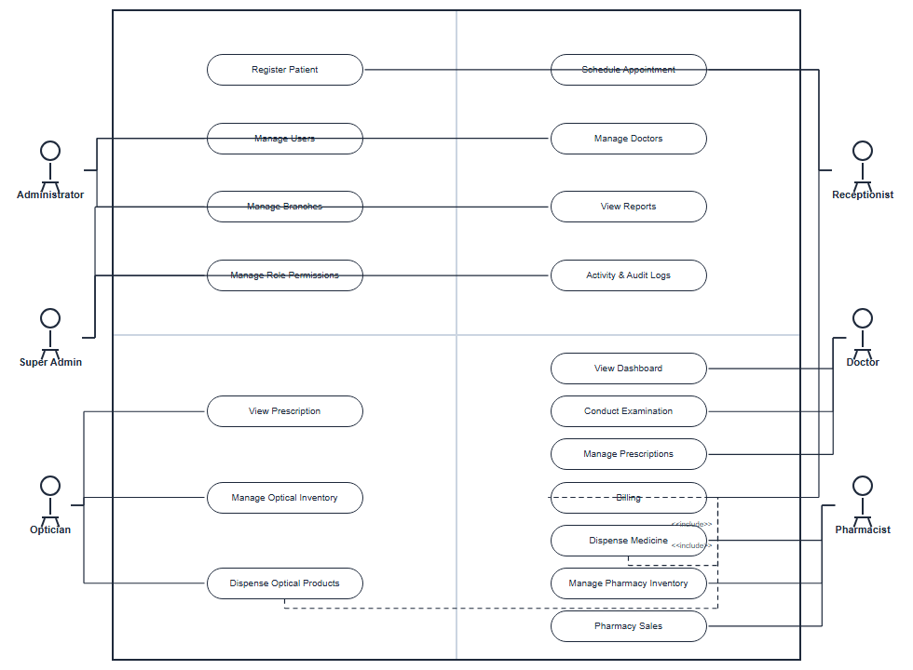
Figure 4.2: Use Case Diagram — EyeCare Management System
Table 4.7: Primary Use Cases by Actor
Actor | Primary Use Cases | Responsibility
Super Admin | Manage branches, configure role permissions, view audit logs | System-wide administration
Administrator | Manage users, view reports, oversee clinic operations | Clinic administration
Receptionist | Register patients, schedule appointments, generate billing | Front-desk operations
Doctor | View dashboard, conduct examinations, manage prescriptions | Clinical care
Pharmacist | View prescriptions, manage pharmacy inventory, dispense medicines | Pharmacy operations
Optician | View optical prescriptions, manage frames/lenses, process orders | Optical shop operations

4.6.2 ERD Diagram
The Entity Relationship Diagram (ERD) illustrates the database structure of the EyeCare Management System and shows the relationships between major entities such as Patients, Users, Appointments, Clinical Examinations, Prescriptions, Billing, Pharmacy, and Optical Management. The diagram provides a visual representation of how data is organized and interconnected within the system to ensure efficient data management and integrity.
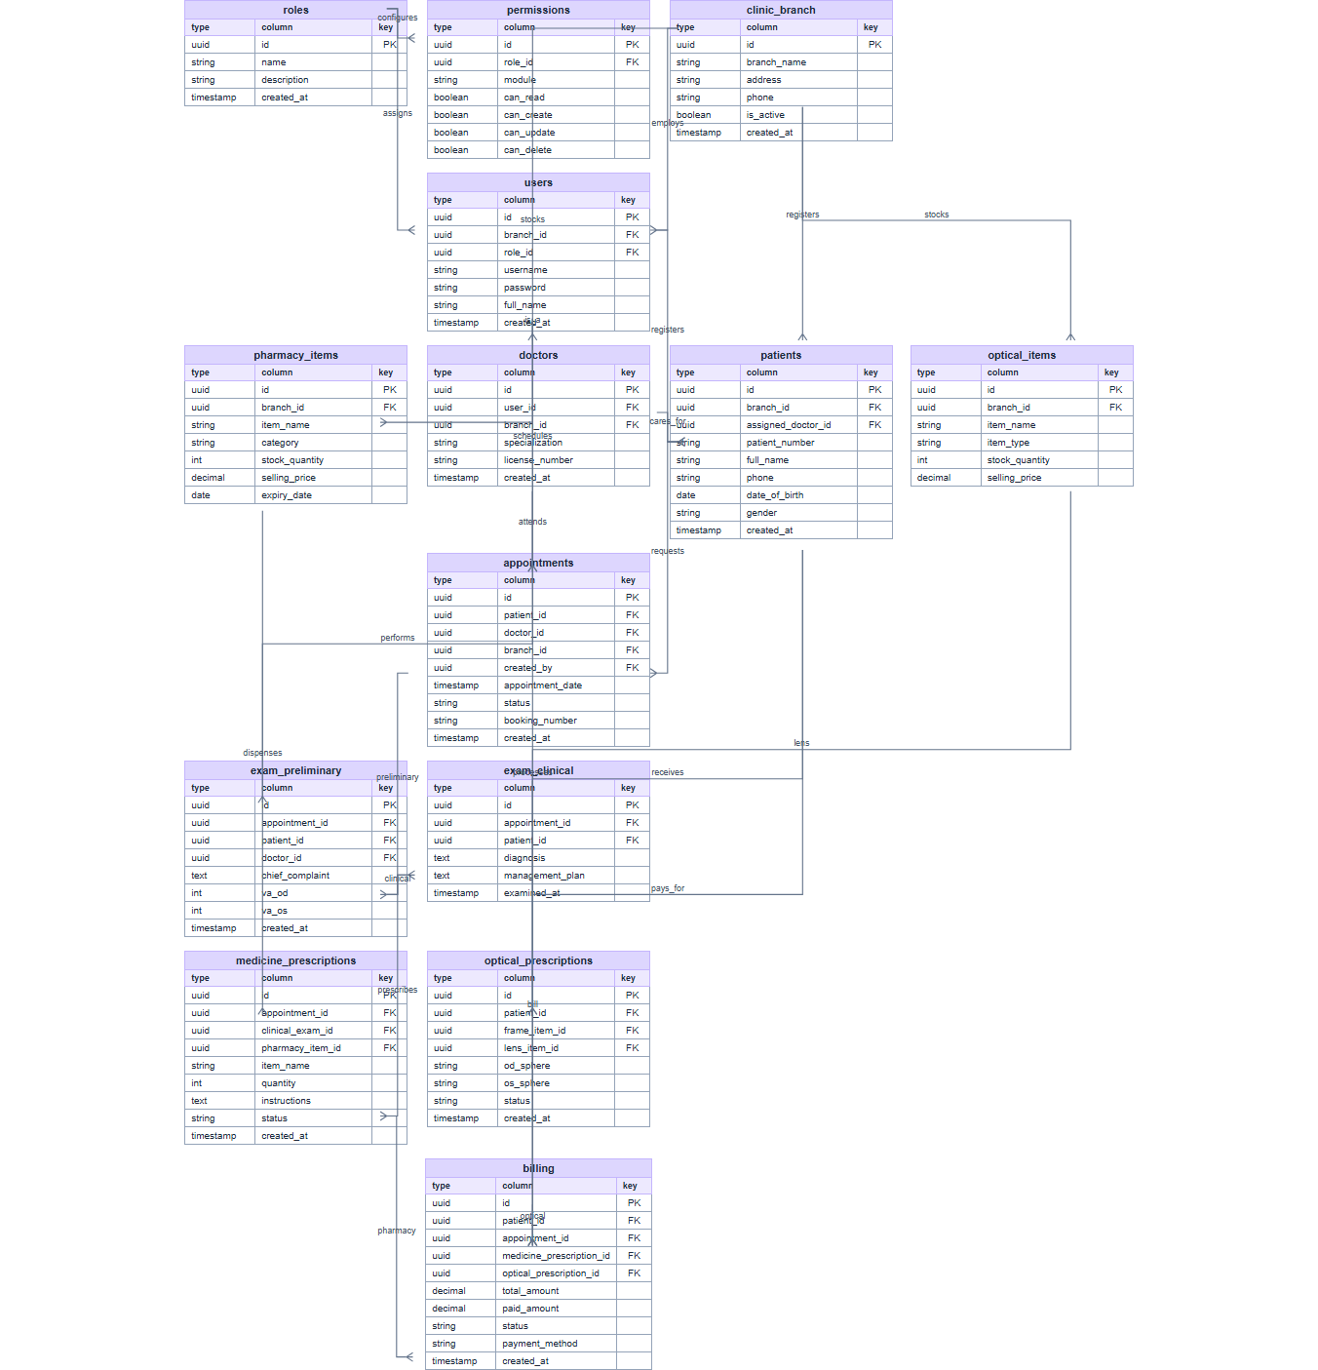
Figure 4.5: Entity Relationship Diagram (ERD) — EyeCare Management System

4.6.3 Database Design
The database design defines the structure of the PostgreSQL relational database used to store all data managed by the EyeCare Management System. The database is designed based on the entity-relationship model described in the previous section and implemented using Prisma ORM, which provides schema definition, migration management, and type-safe database access.
The database adopts a normalized relational structure to minimize data redundancy and ensure data integrity. Foreign key constraints are used to enforce referential integrity between related tables. Each table uses an auto-generated UUID as its primary key to ensure globally unique record identification across branches.
Table 4.8: Database Tables, Attributes, and Relationships
Table Name | Key Attributes | Relationships
Branch | id, name, address, phone, isActive | Has many Users, Patients, Inventory items
User | id, name, email, passwordHash, role, branchId | Belongs to Branch; handles Appointments as Doctor
Patient | id, fullName, dateOfBirth, gender, phone, branchId | Belongs to Branch; has many Appointments, Exams, Bills
Appointment | id, patientId, doctorId, date, time, status, branchId | Belongs to Patient and User (Doctor)
TriageRecord | id, patientId, vaRight, vaLeft, iopRight, iopLeft, recordedAt | Belongs to Patient and Appointment
ClinicalExam | id, patientId, appointmentId, sphRight, cylRight, axisRight, diagnosis, plan | Belongs to Patient and Appointment; has Prescriptions
Prescription | id, examId, patientId, type, notes | Belongs to ClinicalExam; has many PrescriptionItems
PrescriptionItem | id, prescriptionId, itemId, itemType, dosage, quantity | Belongs to Prescription; links to PharmacyItem or Frame
Surgery | id, patientId, doctorId, surgeryType, scheduledDate, status, outcome | Belongs to Patient; linked to Bill
PharmacyItem | id, name, category, stock, reorderLevel, unitPrice, branchId | Belongs to Branch; referenced in PrescriptionItems
OpticalFrame | id, brand, model, color, stock, price, branchId | Belongs to Branch; referenced in OpticalOrders
Bill | id, patientId, totalAmount, paidAmount, status, createdAt | Belongs to Patient; has many BillItems and Payments
BillItem | id, billId, description, serviceType, amount | Belongs to Bill; references Appointment, Surgery, or Item
Payment | id, billId, amount, paymentMethod, paidAt | Belongs to Bill; tracks individual payment transactions
The database design prioritizes data normalization, referential integrity, and query efficiency. Indexes are applied to frequently queried columns such as patient name, appointment date, and branch ID to improve system performance. The multi-branch architecture is enforced at the database level by including a branchId foreign key in all branch-specific tables.

4.8 System Architecture Diagram
The System Architecture Diagram illustrates the overall structure of the EyeCare (Al-Ixsaan) Management System and the interaction between its major components across three distinct tiers. At the top, clinic users — including Super Admin, Administrator, Receptionist, Doctor, Pharmacist, and Optician — interact with the system through standard web browsers on desktop or laptop computers without installing any client software.
The Presentation Layer is implemented using Next.js 16 and React 19 with TypeScript and Tailwind CSS. This layer renders role-specific dashboards, forms, calendars, and reports. All data exchange with the backend occurs through REST API calls using Axios, while real-time notifications (appointment alerts, low-stock warnings) are delivered via Socket.io client connections.
The Application Layer runs on Node.js with Express.js 5. It exposes RESTful API endpoints organised into modules for authentication, patients, appointments, examinations, prescriptions, pharmacy, optical shop, billing, reports, and administration. JWT-based authentication middleware validates every protected request. Joi validates input data, and role-based access control middleware enforces permissions per user role and branch.
The Data Layer uses PostgreSQL 14+ as the relational database, accessed exclusively through Prisma ORM which manages schema migrations, type-safe queries, and referential integrity. All patient records, clinical data, inventory, and financial transactions are persisted in normalized tables with branch-scoped foreign keys. Optional external services include SMTP email for password reset and file storage for profile images via Multer.
This layered architecture ensures separation of concerns, maintainability, and scalability. Each tier can be updated independently, and the system can be deployed on a single cloud VPS or scaled across separate frontend, API, and database servers as clinic demand grows.
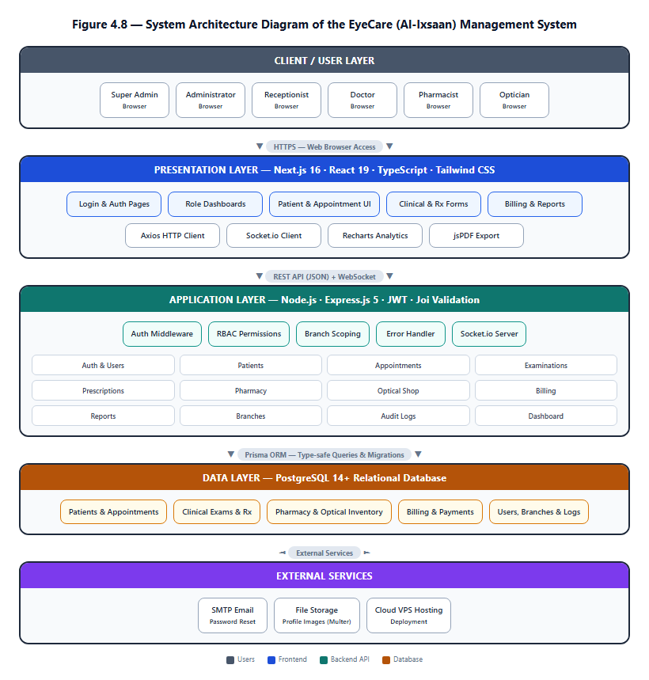
Figure 4.8: System Architecture Diagram of the EyeCare (Al-Ixsaan) Management System

4.9 Chapter Summary
This chapter presented the system analysis and design of the proposed EyeCare Management System. The analysis of existing eye care clinic operations revealed several challenges, including fragmented data management, manual record keeping, limited information sharing between departments, data duplication, and security concerns. Existing approaches such as paper-based records, spreadsheet applications, and general-purpose healthcare systems were reviewed, and their limitations were identified.
Based on these findings, a centralized and integrated web-based EyeCare Management System was proposed to streamline clinical and administrative processes within eye care clinics. The chapter outlined the system's functional and non-functional requirements, evaluated feasibility from technical, economic, schedule, and operational perspectives with detailed hardware, software, and cost tables, and presented system design models including the Use Case Diagram, ERD, database design, and three-tier system architecture diagram.
Overall, the analysis and design activities established a strong foundation for the development of the EyeCare Management System and provided a clear framework for implementing an integrated solution that improves patient care, operational efficiency, and information management in eye care clinics.

