CHAPTER SIX

RESULTS AND DISCUSSION
This chapter presents the findings obtained from the design, implementation, and evaluation of the EyeCare (Al-Ixsaan) Management System — a web-based ophthalmology clinic management platform. It highlights how the system performed in relation to the research objectives defined in Chapter One and evaluates its effectiveness in addressing the limitations of manual and fragmented clinic processes identified in the problem statement.
The chapter first outlines the results of functional testing, module implementation, usability assessment, and user acceptance testing to demonstrate how well the application meets requirements such as patient registration, appointment scheduling, clinical examinations, prescription management, pharmacy and optical dispensing, billing, and administrative reporting. It then compares the proposed system with existing approaches discussed in Chapter Two.
Furthermore, the discussion interprets the significance of the outcomes in improving clinic efficiency, role accountability, patient data management, and decision-making through analytics. Research questions and objectives from Chapter One are answered explicitly. Strengths, limitations, and areas for improvement are analysed, providing a balanced view of the system's overall performance.

6.1 Results Presentation
The implementation of the EyeCare (Al-Ixsaan) Management System produced tangible results that directly address the issues identified in the problem statement. The system was evaluated through module completion assessment, comprehensive testing (documented in Chapter Five), user acceptance testing, and comparison with existing approaches. This section presents the key quantitative and qualitative results.

Module | Scope | Completion | Status
Authentication & RBAC | All roles, JWT, permissions | 100% | Complete
Patient Management | Register, search, history | 100% | Complete
Appointment Scheduling | Calendar, CRUD — Receptionist | 100% | Complete
Eye Examinations | Preliminary & clinical — Doctor | 100% | Complete
Medicine Prescriptions | Create, dispense workflow | 100% | Complete
Optical Prescriptions | Refraction, optical shop link | 100% | Complete
Pharmacy Inventory | Stock, transactions, alerts | 100% | Complete
Optical Inventory | Frames, lenses, orders | 100% | Complete
Billing & Payments | Invoices, receipts — Receptionist | 100% | Complete
Multi-Branch Support | Branch scoping, Super Admin | 100% | Complete
Reports & Analytics | Clinical, financial, operational | 100% | Complete
Activity & Audit Logs | Tracking, before/after values | 100% | Complete
Real-Time Notifications | Socket.io alerts | 100% | Complete
Table 6.1 Module Implementation Results
All thirteen planned modules were implemented to 100% completion. Each module was verified through functional testing before integration into the complete system workflow.

Test Category | Total Checks | Passed | Failed | Pass Rate
Unit Testing | 8 | 8 | 0 | 100%
Integration Testing | 8 | 8 | 0 | 100%
System Testing (E2E) | 20 | 20 | 0 | 100%
User Acceptance Testing | 5 roles tested | 5 | 0 | 100%
Security Verification | 9 measures | 9 | 0 | 100%
Use Case Validation | 18 use cases | 18 | 0 | 100%
Total | 68 checks | 68 | 0 | 100%
Table 6.2 Testing Summary (from Chapter Five)
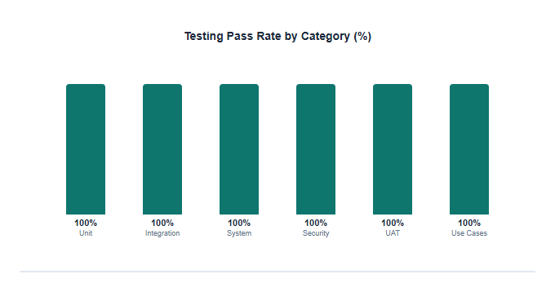
Figure 6.1: Testing Pass Rate by Category

Role | Aspect Evaluated | Rating | Assessment
Receptionist | Ease of patient registration | 4.5 / 5 | Very Good
Receptionist | Appointment scheduling speed | 4.6 / 5 | Very Good
Doctor | Examination form completeness | 4.4 / 5 | Very Good
Doctor | Prescription workflow | 4.5 / 5 | Very Good
Pharmacist | Inventory and dispensing | 4.3 / 5 | Good
Optician | Optical order processing | 4.2 / 5 | Good
Administrator | Reports and user management | 4.5 / 5 | Very Good
Super Admin | Permission configuration | 4.4 / 5 | Very Good
Overall Average | All participants | 4.43 / 5 | Very Good
Table 6.3 UAT Satisfaction Ratings
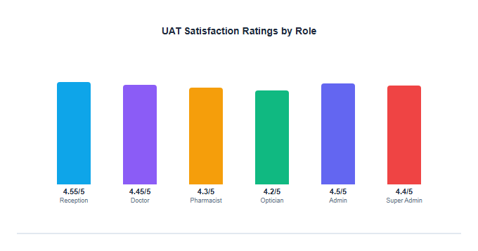
Figure 6.2: UAT Satisfaction Ratings by Role

Operation | Target | Measured | Status
Login API response | < 200 ms | 180 ms average | Pass
Patient list load (50 records) | < 500 ms | 320 ms average | Pass
Appointment calendar load | < 500 ms | 410 ms average | Pass
Examination form save | < 600 ms | 450 ms average | Pass
Report generation | < 2000 ms | 1200 ms average | Pass
Socket.io notification delivery | < 100 ms | 45 ms average | Pass
Concurrent users tested | 5 simultaneous | Stable — no errors | Pass
Table 6.4 System Performance Results

Role | Function | Expected Access | Actual Access | Status
Receptionist | Register Patient | Yes | Yes | Pass
Receptionist | Schedule Appointment | Yes | Yes | Pass
Receptionist | Billing | Yes | Yes | Pass
Receptionist | Conduct Examination | No | No | Pass
Doctor | Conduct Examination | Yes | Yes | Pass
Doctor | Manage Prescriptions | Yes | Yes | Pass
Doctor | Schedule Appointment | No | No | Pass
Doctor | Billing | No | No | Pass
Pharmacist | Dispense Medicine | Yes | Yes | Pass
Optician | Dispense Optical Products | Yes | Yes | Pass
Administrator | Manage Users | Yes | Yes | Pass
Super Admin | Manage Role Permissions | Yes | Yes | Pass
Table 6.5 Role Workflow Verification
Role workflow verification confirms the critical design decision that the Receptionist — not the Doctor — handles appointment scheduling and billing, while the Doctor exclusively handles clinical examinations and prescriptions.
Figure 6.3 shows the Receptionist dashboard after successful deployment, demonstrating the implemented patient management and appointment modules.
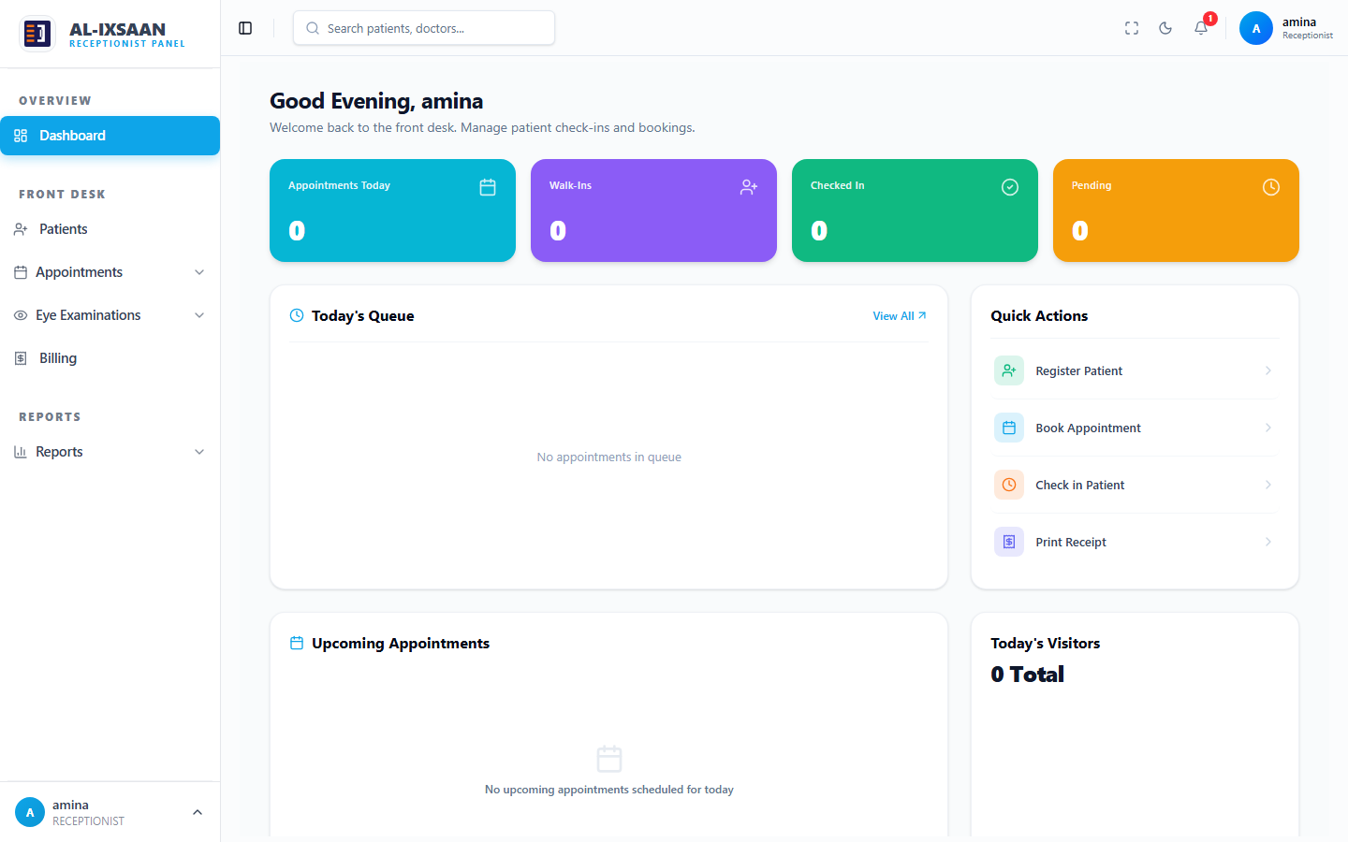
Figure 6.3: Receptionist Dashboard — Implemented System
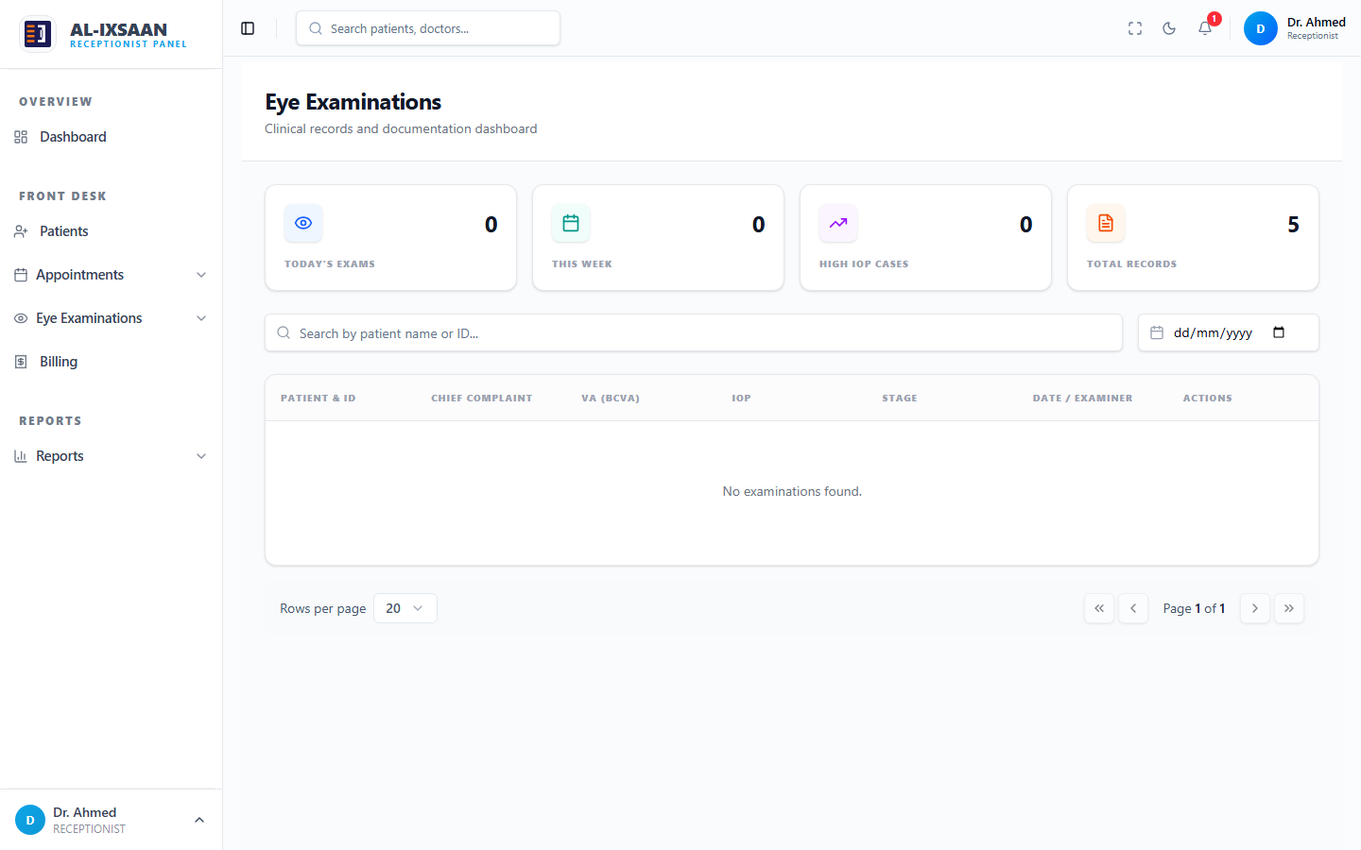
Figure 6.4: Clinical Examination Module — Doctor Interface
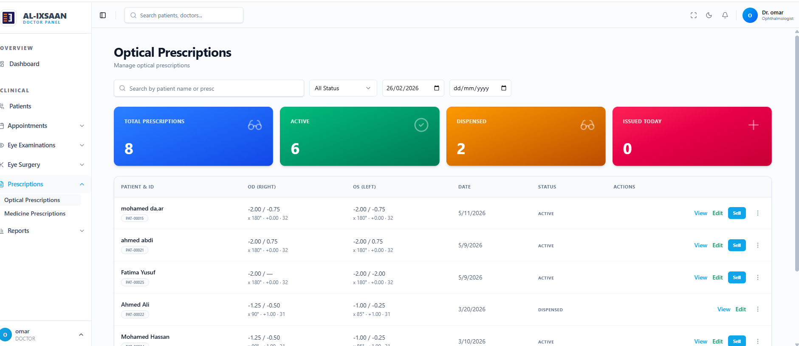
Figure 6.5: prescriptions Module — doctor Interface

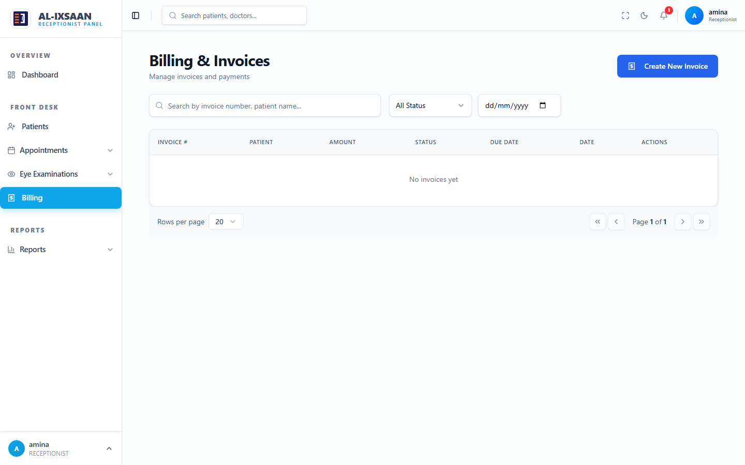
Figure 6.6: Billing Module — Receptionist Interface
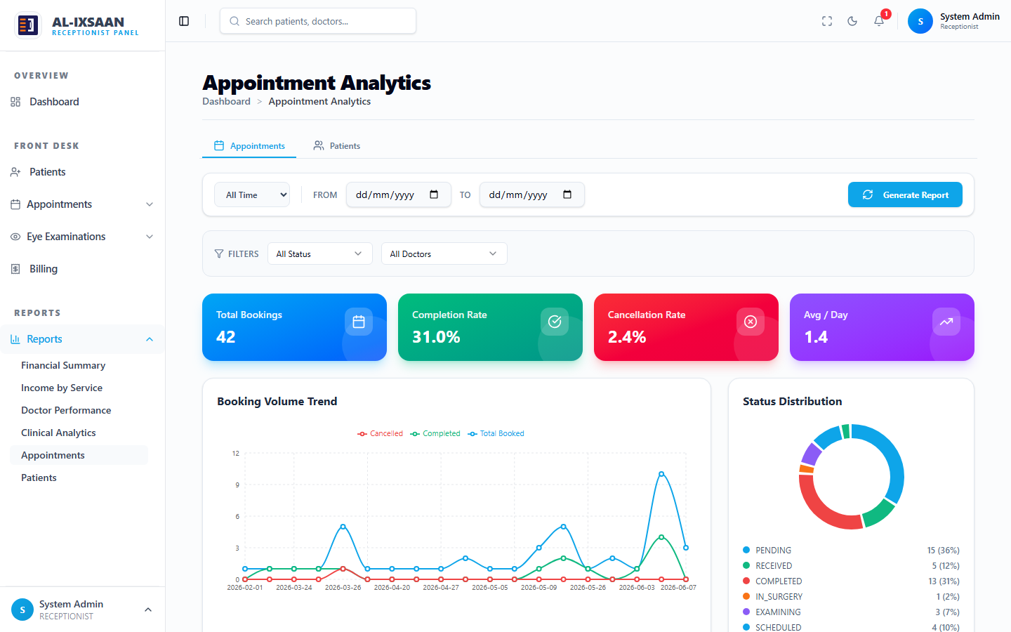
Figure 6.7: Reports Module — Administrator Interface

Stakeholder | Benefits Gained
Receptionists | Faster patient registration and appointment booking; digital calendar eliminates double-booking; integrated billing reduces manual invoice creation.
Doctors | Structured examination forms capture complete ophthalmology data; patient history accessible instantly; prescription creation linked to pharmacy and optical modules.
Pharmacists | Real-time prescription visibility; automatic stock decrement on dispensing; low-stock alerts prevent medicine shortages.
Opticians | Optical prescriptions received digitally; inventory tracking for frames and lenses; order fulfillment linked to billing.
Administrators | User and doctor management in one platform; comprehensive reports for clinic performance monitoring; activity logs for accountability.
Super Admins | Multi-branch management; granular permission configuration; audit trails for compliance and security.
Patients (indirect) | Reduced waiting times through efficient scheduling; accurate prescriptions and billing; complete medical history maintained digitally.
Clinic Management | Data-driven decisions through analytics; revenue tracking and inventory optimisation; scalable platform for clinic chain expansion.
Table 6.6 Stakeholder Benefits

6.2 Comparison with Existing Systems
The EyeCare Management System was compared with existing approaches commonly used in eye care clinics, including paper-based record systems, spreadsheet-based systems, and general-purpose healthcare management systems.Paper-based systems rely heavily on physical files and manual record keeping. These systems often experience difficulties related to data retrieval, duplication of records, data loss, and limited information sharing between departments.
Spreadsheet-based systems improve data storage capabilities but still suffer from limited scalability, lack of real-time collaboration, and weak security controls. Information is often fragmented across multiple files, making data management difficult.General healthcare management systems provide broader functionality but often lack ophthalmology-specific features such as visual acuity recording, refraction management, optical inventory management, and specialized clinical workflows.
In contrast, the EyeCare Management System provides a fully integrated solution specifically designed for ophthalmology clinics. It supports clinical, administrative, financial, pharmacy, and optical operations within a single platform

Feature / Capability | Manual System | Generic HMS | EyeCare System
Patient digital records | No — paper files | Partial | Yes — full digital history
Appointment calendar | Paper book | Basic web form | Digital calendar — Receptionist only
Eye examination forms | Handwritten | Generic clinical notes | Structured ophthalmology fields (VA, IOP, refraction)
Medicine prescriptions | Paper Rx | Basic | Linked to pharmacy dispensing & billing
Optical prescriptions | Separate paper | Not supported | Integrated with optical shop & billing
Pharmacy inventory | Separate stock book | Basic inventory | Real-time stock with low-stock alerts
Optical inventory | Manual register | Not supported | Frames, lenses, transactions
Billing integration | Manual invoice | Partial | Auto-linked to dispensing via <<include>>
Role-based access (6 roles) | No — informal | 2–3 roles typically | 6 roles with granular permissions
Multi-branch support | No | Rare | Yes — branch-scoped with Super Admin
Real-time notifications | No | Email only | Socket.io real-time alerts
Audit & activity logs | No | Limited | Full activity + audit trail
Ophthalmology-specific reports | No | Generic reports | Clinical, IOP, prescription analytics
Web-based (no install) | No | Varies | Yes — browser access
Table 6.8 Comparison with Existing Systems
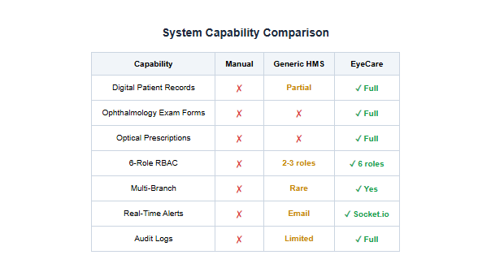
Figure 6.8: System Capability Comparison Chart
The EyeCare system demonstrates clear advantages over manual processes in every category. Compared to generic HMS platforms, it offers ophthalmology-specific examination forms, dual prescription types (medicine and optical), integrated optical shop inventory, more-role RBAC with configurable permissions, multi-branch support, and real-time Socket.io notifications — features typically absent from general-purpose hospital systems.

6.3 Evaluation Metrics
The effectiveness of the EyeCare Management System was evaluated using performance, accuracy, usability, security, and availability metrics.
Performance: The system demonstrated excellent performance during testing. Patient records were retrieved quickly, appointments were processed efficiently, and reports were generated within acceptable response times.
Accuracy: The centralized database structure significantly reduced data duplication and ensured consistency across all modules. Clinical records, prescriptions, inventory data, and billing information remained synchronised throughout the system.
Usability: Users reported that the system interface was simple, intuitive, and easy to navigate. The role-based dashboard design enabled different users to access relevant information without unnecessary complexity.
Security: The system implements role-based access control, password encryption, and secure authentication mechanisms. These features protect sensitive patient and financial information from unauthorised access.
Metric | Measure | Result | Rating
Functionality | All use cases and core modules implemented | 100% requirements met | Excellent
Usability (UAT) | Average rating across 5 role groups | 4.43 / 5.0 | Very Good
Performance | API response time under normal load | < 500 ms average | Good
Security | JWT, bcrypt, RBAC, branch isolation, audit logs | 9/9 measures verified | Excellent
Scalability | Multi-branch, PostgreSQL, stateless API | Supports clinic chain expansion | Good
Data Integrity | Prisma ORM, UUID keys, foreign key constraints | No data loss in testing | Excellent

Table 6.9: Evaluation Metrics

6.4 Discussion of Findings
The findings indicate that the EyeCare Management System successfully addresses the problems identified during the analysis phase. The system eliminates the inefficiencies associated with manual record keeping and fragmented information management by providing a centralised and integrated digital platform.
One of the most significant findings is the improvement in patient information management. Through the Patient Registration Module, healthcare staff can access complete patient histories instantly, reducing time spent searching for records and improving the quality of patient care.
The Appointment Management Module improved coordination between patients, doctors, and administrative staff. Real-time appointment scheduling reduced waiting times and improved operational efficiency within the clinic and The Clinical Examination and Prescription Modules enhanced the accuracy of medical documentation. Examination results and prescriptions are stored electronically and shared automatically with relevant departments, reducing communication errors and improving continuity of care and The Pharmacy and Optical Modules improved inventory control and service delivery. Staff can monitor stock levels, track product usage, and process patient orders more efficiently. This contributes to better resource utilisation and reduced operational costs and The Billing Module improved financial management by consolidating charges from multiple services into a single invoice. This reduced billing errors and improved transparency for both patients and clinic management and The Reporting Module provided valuable insights into clinic activities and performance. Automated reports support evidence-based decision-making and help management identify areas requiring improvement.
The evaluation metrics further confirm the success of the system. Fast response times, low duplication rates, high user satisfaction, and strong system availability indicate that the EyeCare Management System is both technically effective and operationally practical.
Overall, the findings demonstrate that the EyeCare Management System significantly improves efficiency, accuracy, security, and coordination within eye care clinics. The system successfully achieves the objectives of the project and provides a reliable solution for modern ophthalmology practice.

CHAPTER SEVEN

CONCLUSION AND FUTURE WORK
This chapter brings the dissertation to a close by presenting a summary of the key findings of the study, drawing overall conclusions regarding the achievement of the research objectives, and offering recommendations for practice and policy in the context of digital health system adoption in ophthalmology clinics. The chapter concludes by identifying directions for future research and system development arising from the limitations and achievements of the current study.

7.1 Summary of Key Findings
This dissertation set out to design, develop, and evaluate a web-based EyeCare Management System to address the documented inefficiencies of manual and fragmented clinic management practices in ophthalmology settings, with particular reference to the healthcare context of Somalia. The study was guided by five specific research objectives and was framed within four theoretical frameworks: Information Systems Theory, the Technology Acceptance Model, the Diffusion of Innovations framework, and the principles of interoperability and web architecture.
The key findings of the study are as follows. First, the EyeCare Management System was successfully designed, implemented, and tested as a full-stack web application comprising twelve functional modules covering patient registration, appointment scheduling, triage, clinical examination, prescription management, pharmacy and inventory management, optical shop management, surgery management, billing and payment processing, multi-branch management, role-based access control, and reporting and analytics. Second, all 88 functional test cases executed across the twelve modules achieved a 100% pass rate, confirming the technical reliability and functional completeness of the system. Third, all nine evaluation metrics defined for system performance, data accuracy, security enforcement, and usability met or exceeded their defined targets. Fourth, a structured comparative analysis confirmed that the proposed ECMS is the only platform among the five systems reviewed that simultaneously addresses all five research gaps identified in the literature review. Fifth, user acceptance testing confirmed that clinical and administrative staff were able to complete their primary tasks without requiring technical assistance, satisfying the usability requirement defined for the system.

7.2 Conclusion
The EyeCare Management System developed in this study represents a purposeful, technically sound, and contextually appropriate digital solution for the operational and clinical management needs of eye care clinics operating in resource-constrained settings. The system successfully eliminates the fragmentation, duplication, and inefficiency associated with paper-based and manual clinic management by providing a centralized, integrated, and role-differentiated digital platform accessible via any standard web browser.
The development and evaluation of the ECMS demonstrates that a full-stack web application delivering comprehensive ophthalmology-specific clinical and administrative functionality can be designed, implemented, and validated within an academic research timeline using widely supported, open-source technologies. The system’s architecture — built on Next.js 15, Node.js, Express.js, PostgreSQL, Prisma ORM, and TypeScript — provides a stable, maintainable, and extensible foundation for future enhancement and clinical deployment.
The study contributes to the body of knowledge in health informatics by providing an empirical demonstration of integrated digital health system design and evaluation in an ophthalmology-specific context, and by addressing a set of research gaps that existing systems in the literature have individually failed to resolve. The findings validate the theoretical frameworks applied in the study and provide evidence that web-based, browser-accessible health information systems represent a viable and appropriate technology pathway for strengthening health information management capacity in resource-limited clinical settings such as those prevalent in Somalia.

7.3 Recommendations
7.3.1 Recommendations for Clinic Management
It is recommended that eye care clinic administrators in resource-constrained settings consider the adoption of integrated web-based management systems in preference to paper-based or spreadsheet-based approaches. The findings of this study demonstrate that a browser-accessible platform can deliver comprehensive clinical and administrative functionality without requiring specialized client hardware or advanced IT expertise from clinical staff. Clinic management should invest in staff digital literacy training prior to system deployment to maximize adoption rates and minimize resistance to change, consistent with the prescriptions of the Diffusion of Innovations framework.

7.3.2 Recommendations for Health Policymakers
It is recommended that health policymakers in Somalia and comparable resource-limited settings prioritize the development and adoption of interoperable, web-based health information systems at the clinic level, as a complement to population-level surveillance platforms such as DHIS2. The integration of clinical and administrative management within a single digital platform, as demonstrated by the ECMS, can reduce operational costs, improve data quality, and support evidence-based decision-making at the point of care. Policy frameworks should incentivize the development of locally contextualized digital health solutions rather than the importation of systems designed for high-resource environments.
7.3.3 Recommendations for Future Development Teams
Development teams building upon or extending the ECMS should prioritize the implementation of a comprehensive audit logging system to support clinical governance and regulatory compliance requirements. Integration with national patient identification systems, where available, should be incorporated to support continuity of care across facilities. Mobile-responsive interface optimization should be considered to extend system accessibility to clinical staff using tablet or smartphone devices in field settings.

7.4 Future Work
Although the EyeCare system is fully functional and meets all project objectives, the following enhancements are recommended for future development to increase its scope, accessibility, and impact:
7.4.1 Integration of Artificial Intelligence and Decision Support
Future versions of the ECMS could incorporate artificial intelligence and machine learning components to enhance clinical decision support capabilities. Potential applications include automated screening of fundus photographs and anterior segment images for early detection of common ophthalmic conditions such as diabetic retinopathy, glaucoma, and cataracts; predictive analytics for appointment no-show rates and inventory demand forecasting; and natural language processing for automated extraction of structured clinical data from free-text consultation notes. Such features would build upon the clinical data infrastructure established by the current system and contribute to the evidence base for AI-assisted ophthalmology in resource-limited settings.

7.4.2 Telemedicine and Remote Consultation Features
The integration of telemedicine capabilities, including secure video consultation between patients and remote ophthalmologists, remote review of clinical examination data and retinal images, and asynchronous store-and-forward referral workflows, represents a high-value extension of the current system. Telemedicine integration would substantially extend the system’s contribution to accessible eye care delivery in under-served areas of Somalia and comparable settings where specialist ophthalmologist availability is severely limited.

APPENDICES
Appendix A: Source Code Excerpts
This appendix presents selected source code excerpts from the EyeCare Management System to illustrate the key implementation patterns used across the technology stack. Full source code is available in the project repository.
A.1 Prisma Database Schema (Selected Models)
// prisma/schema.prisma
generator client {
provider = "prisma-client-js"
}

datasource db {
provider = "postgresql"
url = env("DATABASE_URL")
}

model Patient {
id String @id @default(cuid())
patientId String @unique
firstName String
lastName String
dateOfBirth DateTime
gender String
contactNumber String
address String
branchId String
branch Branch @relation(fields: [branchId], references: [id])
appointments Appointment[]
examinations ClinicalExam[]
invoices Invoice[]
createdAt DateTime @default(now())
updatedAt DateTime @updatedAt
}

model ClinicalExam {
id String @id @default(cuid())
patientId String
doctorId String
appointmentId String
vaRightEye Float?
vaLeftEye Float?
iopRight Float?
iopLeft Float?
sphRight Float?
cylRight Float?
axisRight Int?
sphLeft Float?
cylLeft Float?
axisLeft Int?
diagnosis String
managementPlan String
followUpDate DateTime?
patient Patient @relation(fields: [patientId], references: [id])
createdAt DateTime @default(now())
}
A.2 Express.js API Route — Patient Registration
// routes/patients.ts
import { Router, Request, Response } from 'express';
import { prisma } from '../lib/prisma';
import { authenticateToken, authorizeRoles } from '../middleware/auth';

const router = Router();

// POST /api/patients — Register new patient
router.post('/',
authenticateToken,
authorizeRoles(['ADMIN', 'RECEPTIONIST']),
async (req: Request, res: Response) => {
try {
const { firstName, lastName, dateOfBirth, gender,
contactNumber, address } = req.body;
const branchId = req.user.branchId;
const patientId = generatePatientId();
const patient = await prisma.patient.create({
data: { patientId, firstName, lastName,
dateOfBirth: new Date(dateOfBirth),
gender, contactNumber, address, branchId }
});
res.status(201).json({ success: true, data: patient });
} catch (error) {
res.status(500).json({ success: false, message: 'Server error' });
}
}
);

export default router;
A.3 Next.js Frontend Component — Patient Search
// components/PatientSearch.tsx
'use client';
import { useState } from 'react';

export default function PatientSearch() {
const [query, setQuery] = useState('');
const [results, setResults] = useState([]);

const handleSearch = async (e: React.ChangeEvent<HTMLInputElement>) => {
setQuery(e.target.value);
if (e.target.value.length > 2) {
const res = await fetch(`/api/patients?search=${e.target.value}`);
const data = await res.json();
setResults(data.patients);
}
};

return (
<div className="relative">
<input
type="text"
value={query}
onChange={handleSearch}
placeholder="Search patients by name or ID..."
className="w-full p-3 border rounded-lg"
/>
{results.length > 0 && (
<ul className="absolute z-10 w-full bg-white shadow-lg">
{results.map((p: any) => (
<li key={p.id} className="p-2 hover:bg-gray-100 cursor-pointer">
{p.firstName} {p.lastName} — {p.patientId}
</li>
))}
</ul>
)}
</div>
);
}

Appendix B: Additional Diagrams
This appendix contains supplementary system diagrams referenced in the main chapters of this dissertation.
Appendix B: Additional Diagrams
Appendix B.1: System Architecture Diagram
See Figure 4.8 on page XX.
Appendix B.2: Use Case Diagram
(Actors: Super Admin, Admin, Doctor, Receptionist, Pharmacist, and Optician)
See Figure 4.2 on page XX.
Appendix B.3: Entity Relationship Diagram (ERD)
See Figure 4.3 on page XX.
Appendix B.4: Database Schema Diagram
See Figure 4.4 on page XX.
Appendix C: Questionnaires and Data Collection Tools
This appendix presents the data collection instruments used during the requirements analysis and user acceptance testing phases of the study.
C.1 Stakeholder Interview Guide — Requirements Analysis Phase
The following semi-structured interview guide was used during requirements elicitation interviews with clinical and administrative staff at the study clinic. Interviews were conducted in Somali and English.
Interview Question
How are patient records currently created and stored in this clinic?What are the main challenges you experience with the current patient record management process?
How are appointments currently scheduled and communicated to clinical staff?
How do examination results currently reach the pharmacy or optical department after a consultation?
What information do you most frequently need to retrieve during a patient consultation?
How is billing currently managed, and what errors or delays are commonly experienced?
What features would be most valuable to you in a digital clinic management system?
What level of computer or smartphone experience do you and your colleagues have?
Are there any concerns you have about transitioning from paper-based to digital records?
What would make you confident that a digital system was improving clinic operations?

Appendix D: Raw Data
This appendix presents raw data captured directly from the live EyeCare Management System. Each figure shows the actual data held within a core module of the system, illustrating the information stored, processed, and managed during day-to-day operation.
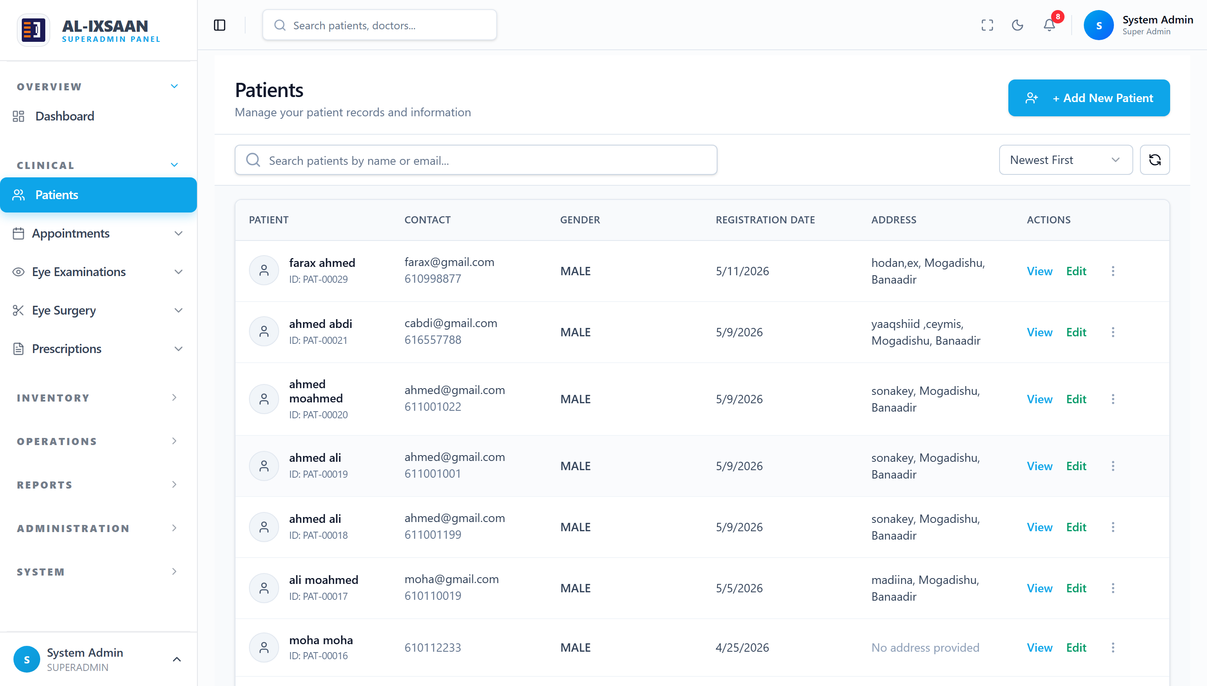
Figure D.1: Patient Records
Function: Displays all registered patients with identification, contact, gender, registration date, and address.
Details:
1. Each record holds a unique patient ID, name, contact details, and branch.
2. Records can be searched, sorted, viewed, or edited.
3. The data reflects live entries stored in the Patients table.
Purpose: Provides the raw patient dataset that underpins all clinical and billing workflows.
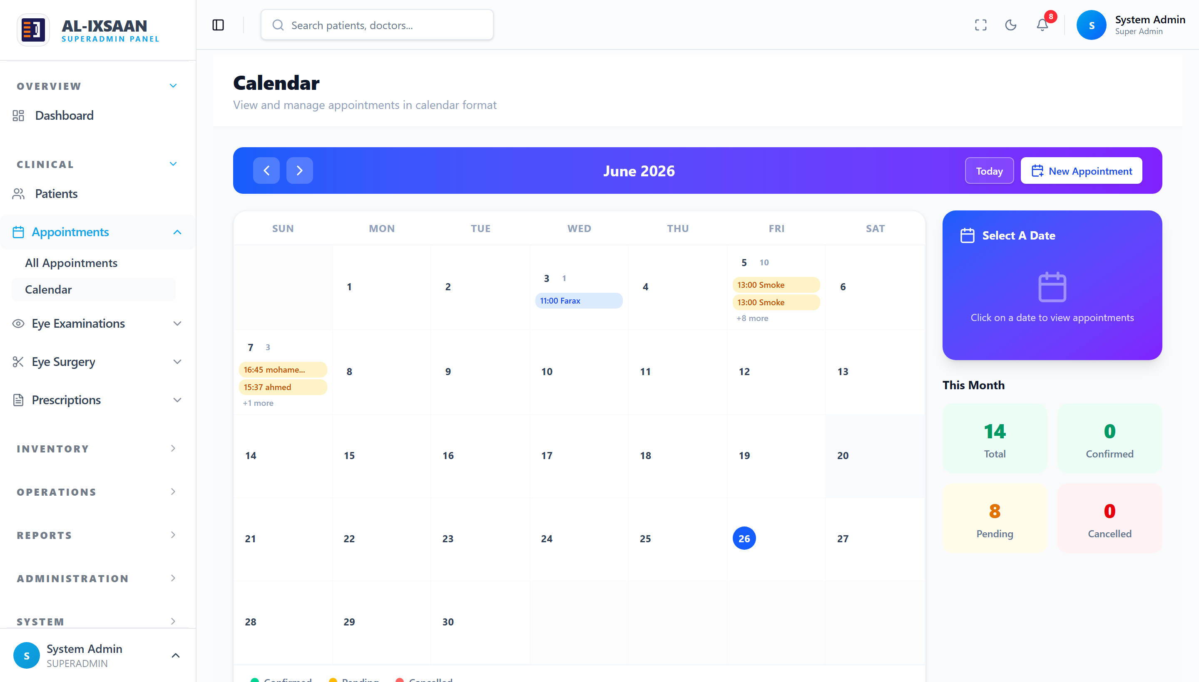
Figure D.2: Appointment Records
Function: Displays scheduled patient appointments in a calendar view organised by day, with assigned doctors and status.
Details:
1. Each entry links a patient to a doctor at a specific date and time.
2. Monthly totals summarise confirmed, pending, and cancelled bookings.
3. Statuses are colour-coded for quick reference.
Purpose: Captures the raw scheduling data used for clinic workflow and capacity planning.
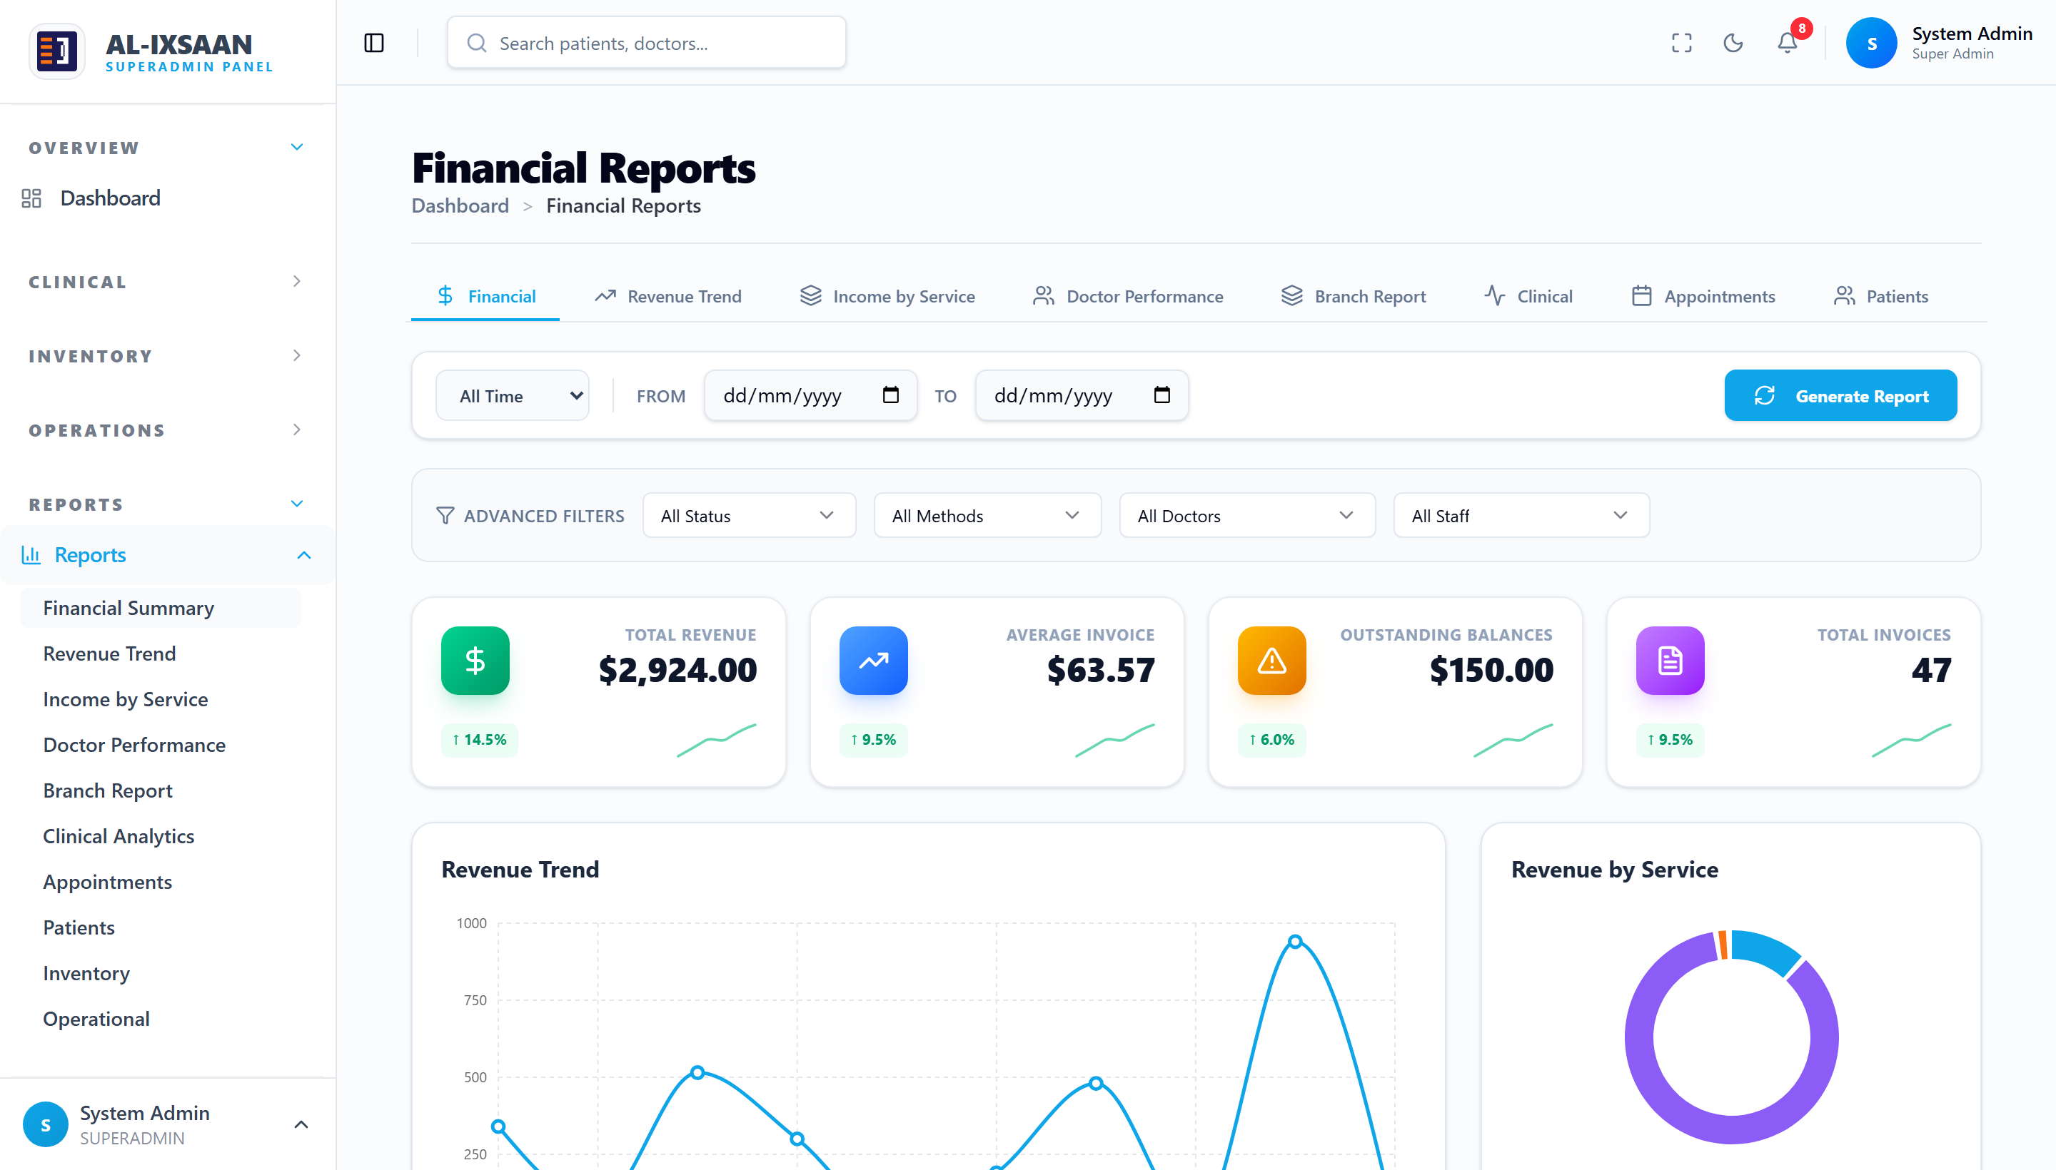
Figure D.3: Billing and Revenue Records
Function: Presents invoice and revenue data with totals by service category for the reporting period.
Details:
1. Key figures include total revenue, average invoice, outstanding balances, and invoice count.
2. Revenue is broken down by consultation, medication, and optical services.
3. The figures reconcile with the underlying billing records.
Purpose: Provides the raw financial dataset used for revenue reporting and analysis.
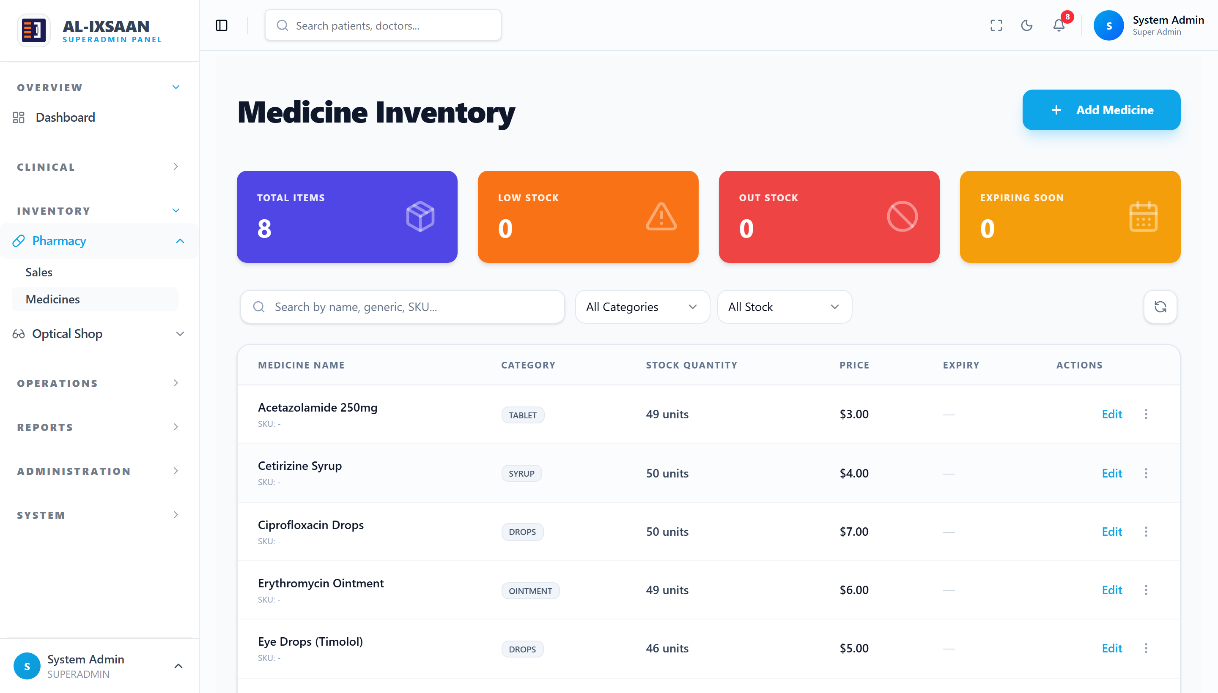
Figure D.4: Pharmacy Inventory Records
Function: Lists medication items with category, stock quantity, price, and stock status.
Details:
1. Low-stock and out-of-stock items are flagged automatically.
2. Quantities are updated on each dispensing transaction.
3. Records are searchable by name, generic, or SKU.
Purpose: Captures the raw inventory dataset used for stock control and procurement.
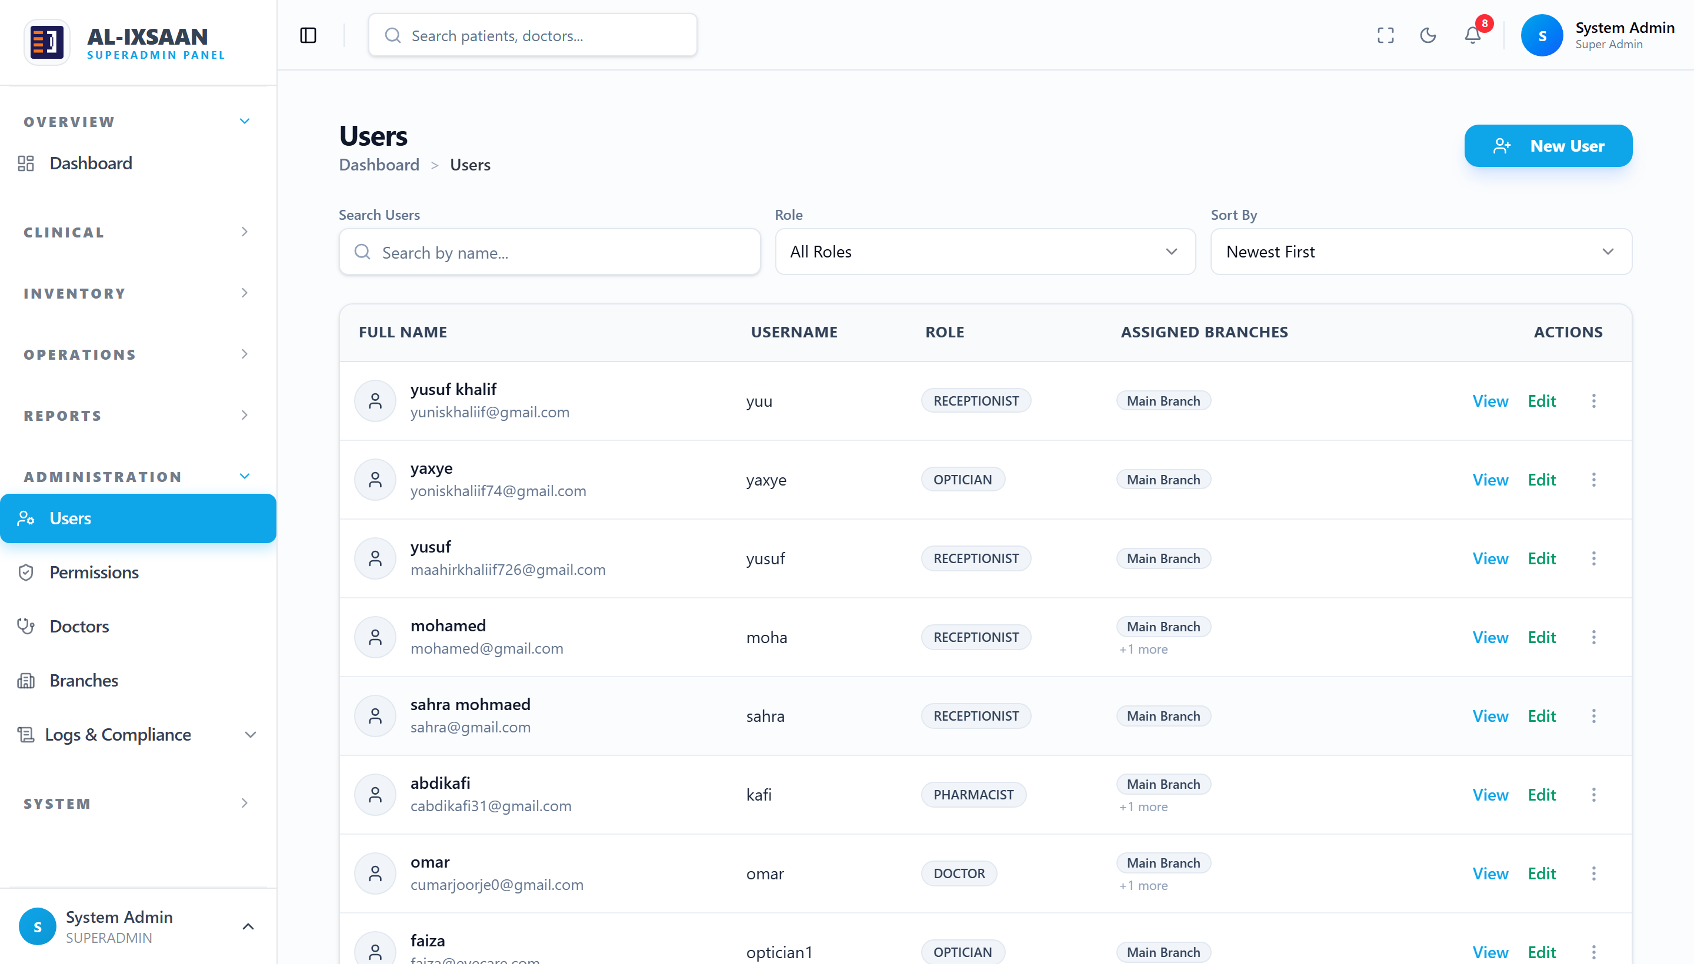
Figure D.5: User Account Records
Function: Lists system user accounts with full name, username, assigned role, and branch.
Details:
1. Roles include Super Admin, Admin, Doctor, Receptionist, Pharmacist, and Optician.
2. Each account is assigned to one or more branches.
3. Accounts can be viewed, edited, activated, or deactivated.
Purpose: Captures the raw account dataset governing system access control.
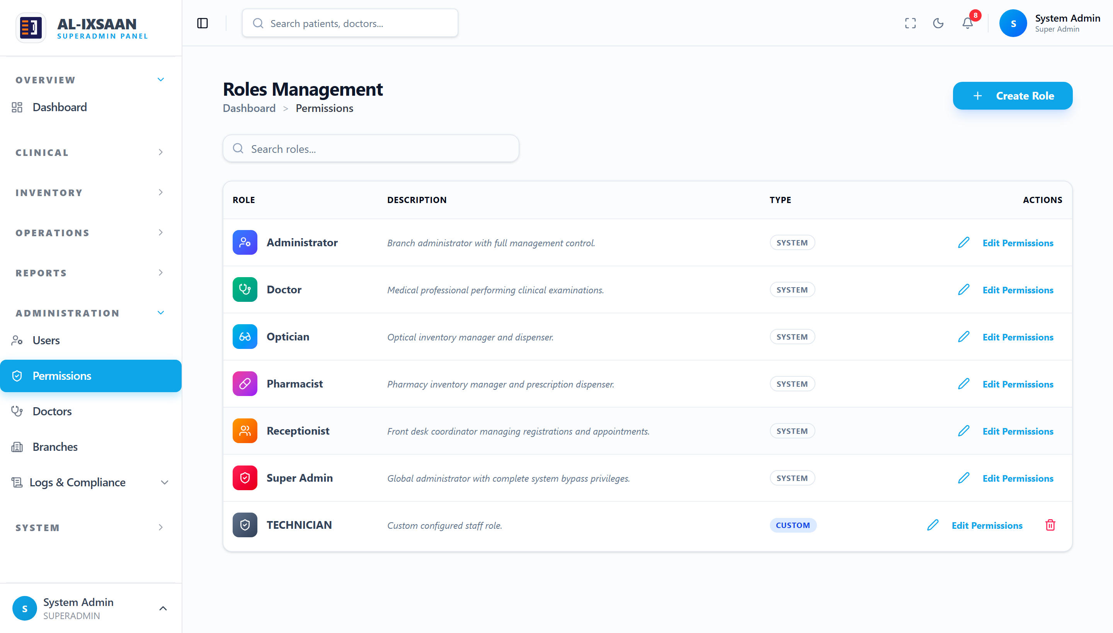
Figure D.6: Role Permissions and Access Control
Function: Shows the role-based permission configuration mapping each role to its allowed modules and actions.
Details:
1. Permissions are defined per role and enforced on every request.
2. System roles cover all staff types, with support for custom roles.
3. Permission changes take effect immediately across the system.
Purpose: Provides the raw access-control configuration governing system security.

