CAHIER DES CHARGES
Requirements Specification
SecureWaste
Sensitive Data Exposure Prevention Platform
Item | Value
Document | Cahier des charges — version 0.1 (Milestone 0)
Date | 29 October 2026
Project type | Team portfolio project (5 members)
Institution | [to be completed]
Supervisor | [to be completed]
Team members & roles | [to be completed]
Status | Draft for review

Table of contents

1. General presentation

1.1 Context
Organisations exchange documents every day: invoices, contracts, payslips, customer lists, internal reports. Many of them contain data that must not leave a controlled audience — payment-card numbers, bank account identifiers, national identity numbers, credentials such as API keys, or documents explicitly labelled CONFIDENTIAL. A single mistaken attachment can expose this data.
Data Loss Prevention (DLP) is the family of tools that detect such sensitive content and help prevent its unintended disclosure. Enterprise DLP suites exist, but they are tied to large cloud ecosystems and are rarely accessible to small organisations or transparent enough for teaching.

1.2 The project
SecureWaste is a local web application, built in Python with Flask, that analyses a PDF or TXT document before it is shared. It detects potentially sensitive information, validates candidates where possible, estimates the risk with an explainable score, lets a human reviewer confirm or dismiss each finding, and produces a genuinely redacted copy of PDFs. It is developed by a team of five cybersecurity students as a portfolio project.

1.3 Purpose of this document
This cahier des charges defines what SecureWaste must do and under which constraints, and it presents the design chosen to achieve it. It is the reference for planning, implementation, testing and evaluation. Every requirement carries an identifier (US-, FR-, NFR-, T-, ST-) that is reused in the repository documentation, GitHub issues and tests.

1.4 Disclaimer
SecureWaste is an educational project. It produces potential findings that require human review, it will miss some sensitive data and flag some harmless data, and its risk score is an application-defined estimate. It does not certify compliance with GDPR, PCI DSS, Tunisia's Organic Law 2004-63 or any other regulation. Only synthetic, fictional data is used for development and demonstration.

2. Problem statement
Before sharing a document, an employee should know whether it contains sensitive data and what to do about it. Today, small organisations typically rely on manual reading, which is:
- Slow — a 30-page report cannot be reviewed line by line for every send.
- Inconsistent — two reviewers flag different things; nothing is recorded.
- Unreliable for hidden data — a card number in a table footer, an API key in an appendix or an ID number in metadata are easy to miss.
- Unsafe at the remediation step — drawing black boxes over text in a PDF leaves the text extractable; many real leaks happened this way.
Problem: How can a small team detect, explain and remove sensitive information from documents before sharing them, using a transparent tool that does not itself become a new place where that information leaks?

3. Study of existing solutions

3.1 Method
We selected five representative tools covering enterprise DLP suites, cloud detection services, an open-source PII framework and an open-source secret scanner. For each, we read the official documentation pages listed in the references and compared them against the needs of our target users (small organisations, local use, explainability, verified redaction).

3.2 Tools studied

Microsoft Purview Data Loss Prevention [1]
Purview DLP applies organisation-wide policies across Microsoft 365 services (Exchange, SharePoint, OneDrive, Teams), Office apps and managed Windows/macOS endpoints. Detection combines keywords and regular expressions with internal function validation, secondary matches near the primary match, and machine learning. Policy actions include warning users with policy tips, blocking sharing (with or without override) and quarantining items at rest; activity flows into the Microsoft 365 audit log and alert dashboards.

Google Cloud Sensitive Data Protection [2]
Google's service scans content through a cloud API for infoTypes (email addresses, card numbers, ID numbers, …). It offers built-in country-specific and global detectors, custom regex and dictionary detectors, checksum validation, hotword rules that raise or lower likelihood based on nearby context, and a likelihood level for every finding. The documentation itself notes that detectors are not perfectly accurate and cannot guarantee regulatory compliance.

Amazon Macie [3]
Macie discovers sensitive data in Amazon S3 using managed data identifiers (financial data, credentials, passport numbers, …), custom regex identifiers with optional proximity keywords, and allow lists to suppress known values. Objects must be stored in supported S3 buckets and formats to be analysed; findings follow a standard schema for further processing.

Microsoft Presidio [4]
Presidio is an MIT-licensed open-source SDK for detecting and anonymising personal data in text and images. Its analysers combine patterns, checksums and context, and it uses trained machine-learning models; its documentation warns that there is no guarantee it will find all sensitive information. It is a library to integrate rather than an end-user application.

Gitleaks [5]
Gitleaks is an MIT-licensed open-source tool that detects hard-coded secrets (passwords, API keys, tokens) in Git repositories and files using configurable rules. It is focused on source code and is not designed for personal data in business documents.

3.3 Comparison
Criterion | Purview DLP | Google SDP | Amazon Macie | Presidio | Gitleaks | SecureWaste (target)
Type / licence | Commercial suite | Commercial cloud API | Commercial cloud service | Open source (MIT) SDK | Open source (MIT) CLI | Open source (AGPL-3.0 proposed) app
Where it runs | Microsoft 365 + endpoints | Google Cloud | AWS (S3) | Your code / container | Local or CI | Local machine
Data leaves the organisation? | Within M365 tenant | Sent to cloud API | Must be in S3 | No (local) | No (local) | No (local)
PDF / TXT documents | Yes (M365 content) | Via API | Objects in S3 | Text input (needs extraction) | Files / repos | Yes (text PDFs, TXT)
Detection methods | Regex, keywords, validation, proximity, ML | Built-in + custom, checksums, hotwords, likelihood | Managed + custom identifiers, allow lists | Patterns, checksums, context, ML | Configurable secret rules | Regex + Luhn/IBAN validators + context words
Explainable per-document risk | Policy matches & alerts | Per-finding likelihood | Findings + severity | Per-entity score | Per-finding rule | Weighted score with listed reasons
Human review workflow | Alerts / incidents | — | Findings management | — | — | Confirm / false positive / resolve
Verified PDF redaction | — | — | — | Anonymiser (text/images) | — | Yes, with re-extraction check
Suits a small team / teaching | Needs M365 licensing | Needs GCP account | Needs AWS account | Needs integration work | Code only | Yes — that is its purpose
“—” means the capability is not part of the documentation we reviewed; it does not mean the product could never support it.

3.4 Critique
- Enterprise suites (Purview, SDP, Macie) are powerful but ecosystem-bound. They assume the organisation already lives in one cloud, needs administrators to configure policies, and in the case of SDP and Macie requires the data to be sent to or stored in the provider's cloud. For a 20-person firm this is costly and opaque.
- Open-source building blocks are not end-user products. Presidio offers excellent detection primitives but no upload workflow, review state, audit trail or verified PDF redaction; Gitleaks covers secrets in code only.
- Explainability is limited. Most tools report per-finding confidence; few explain a single overall “is this document safe to share?” answer in plain language.
- Redaction verification is rarely visible to the user. None of the reviewed tools presents an explicit “we re-extracted the text and the value is gone” proof for a sanitized PDF.
- Their accuracy far exceeds ours. SecureWaste will detect fewer categories, with simpler rules, in fewer formats. Its contribution is transparency, a complete local workflow and educational value — not detection breadth.

3.5 Positioning
SecureWaste targets the gap between enterprise DLP and raw libraries: a local, explainable, document-centric workflow — upload, detect, assess, review, redact with verification, report — that a small team can run, read and audit end to end.

4. Proposed solution and objectives

4.1 Solution overview
A Flask web application with a modular processing pipeline: upload validation → page-aware text extraction → rule-based detection with validators → masking → explainable risk scoring → persistence → review → verified redaction → HTML report. Raw sensitive values never leave memory; the database stores masked values and keyed hashes only.

4.2 Objectives
ID | Objective | Success indicator
G-1 | Detect the MVP categories in TXT and text-based PDF files | Detection tests on the synthetic corpus pass
G-2 | Explain every finding and the overall risk | Each finding has explanation + recommendation; risk card lists weighted reasons
G-3 | Never become a leak itself | No raw value in DB, logs, HTML or reports (automated test)
G-4 | Keep a human in control | Every finding has a review status; no automatic deletion or sharing
G-5 | Produce unrecoverable redactions | Re-extraction finds 0 selected values; original unchanged
G-6 | Be reproducible and credible as a portfolio | README works on a clean machine; CI green; docs match code

4.3 Scope (MVP) and non-goals
In scope: PDF (text layer) and TXT; e-mail, phone, configurable keywords, payment cards (Luhn), IBAN (mod-97), secrets/tokens, confidentiality labels, Tunisian CIN (context-gated); risk score; dashboard; review; redaction; HTML report; audit log; single local user.
Not in scope: OCR, other formats, accounts and roles, AI classification, e-mail/endpoint/cloud integrations, automatic blocking, internet deployment. These appear in the *Future direction* (section 13.3).

5. Actors and use cases

5.1 Actors
Actor | Type | Description
Analyst | Primary, human | IT administrator or security analyst who uploads documents, reviews findings, redacts and deletes documents (personas Sana and Youssef).
Compliance officer | Secondary, human | Reads dashboards, findings and reports to verify that documents were reviewed (persona Leila). In the MVP she uses the same single local account.
File system / SQLite | System | Store originals, sanitized copies and masked results. Not actors in the UML sense but external resources.

5.2 Use case diagram
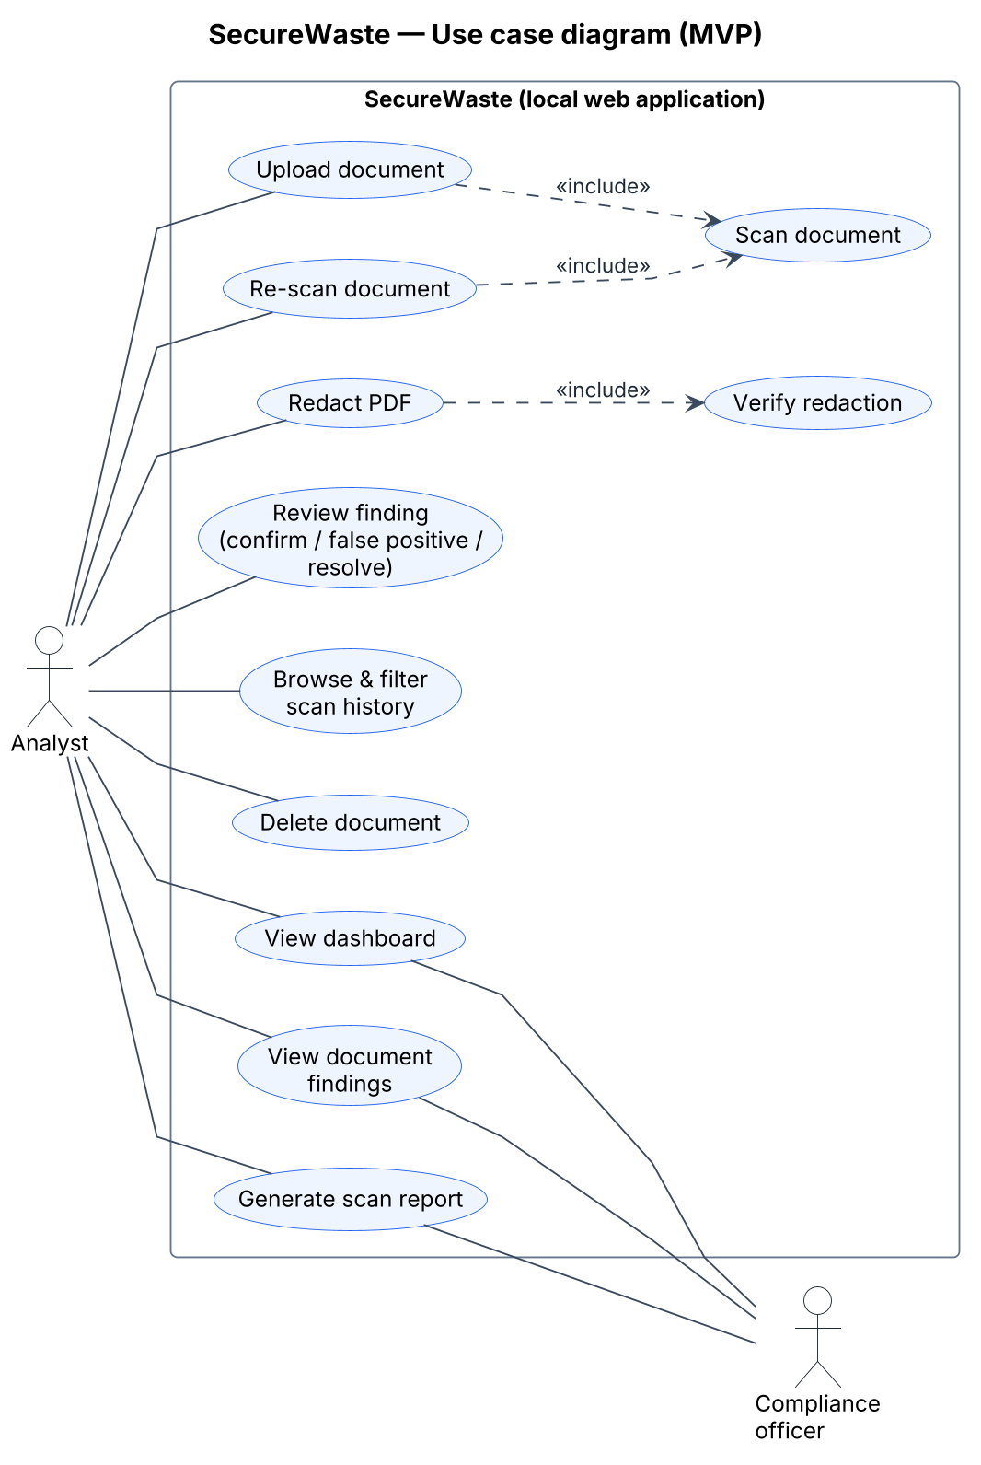
Figure 1 — Use case diagram (MVP)
How to read it. Stick figures are actors outside the system; ellipses inside the rectangle are goals they can achieve with SecureWaste. A plain line means the actor takes part in that use case. A dashed arrow labelled «include» means the first use case always performs the second one — uploading always triggers a scan, and redacting always triggers a verification.

6. Functional requirements

6.1 Requirements table
Priorities use MoSCoW: Must, Should, Could, Won't (this release).
ID | Requirement | Priority | Story
FR-01 | Accept .pdf and .txt uploads and show accepted formats and size limit. | Must | US-01
FR-02 | Reject files above MAX_UPLOAD_MB (default 10 MB) with HTTP 413. | Must | US-02
FR-03 | Determine the real type from content (PDF magic bytes and successful open; TXT = UTF-8 without NUL bytes). | Must | US-02
FR-04 | Reject encrypted, malformed, too long (>100 pages) or text-less PDFs with distinct error codes. | Must | US-02
FR-05 | Store uploads under random server names outside the web root; keep the original name only as escaped display text. | Must | US-01
FR-06 | Compute and store the SHA-256 of each upload. | Must | US-15
FR-07 | Extract text page by page and keep page numbers; cap extracted characters. | Must | US-03
FR-08 | Run every enabled detection rule; each returns category, page, offsets, confidence and rule ID. | Must | US-04
FR-09 | MVP rules: e-mail, phone, keywords; payment card + Luhn; IBAN + mod-97; secrets; labels; TN CIN (context-gated). | Must / Should | US-04–07, 20
FR-10 | Adjust confidence with validation and context; discard candidates below MIN_CONFIDENCE. | Must | US-05
FR-11 | Merge duplicate matches into one finding with an occurrence count. | Must | US-08
FR-12 | Attach severity, explanation and recommendation to every finding. | Must | US-08
FR-13 | Mask values before they leave the detection engine; short masked context only. | Must | US-08
FR-14 | Compute a 0–100 risk score from weights, confidence, repetition, labels and combinations. | Must | US-09
FR-15 | Map the score to five levels with floors for validated secrets and cards. | Must | US-09
FR-16 | Show the weighted reasons; label the score an application-defined estimate. | Must | US-09
FR-17 | Exclude false positives and recompute the risk. | Must | US-13
FR-18 | Persist documents, scans, findings, reviews, redactions and audit events in SQLite with foreign keys. | Must | US-10
FR-19 | Dashboard: totals, risk distribution, findings by category, recent scans, unresolved findings. | Must | US-11
FR-20 | Filter history by severity, category, review status and date. | Should | US-16
FR-21 | Document page with metadata, scan status, risk card and grouped findings. | Must | US-12
FR-22 | Change review status following the state machine; store each change. | Must | US-13
FR-23 | Delete a document with its files, scans and findings; keep a value-free audit event. | Must | US-14
FR-24 | Record audit events for upload, scan, review, redaction, report and deletion. | Must | US-15
FR-25 | Apply genuine PDF redactions to selected findings, scrub metadata, save a separate __SANITIZED copy. | Should | US-17
FR-26 | Verify redaction by re-extracting text and re-running the selected rules. | Should | US-17
FR-27 | Report findings that cannot be located as unmappable; mark the redaction incomplete. | Should | US-18
FR-28 | Generate an HTML report with masked values only. | Should | US-19
FR-29 | Re-scan a document as a new scan job. | Should | US-21

6.2 Textual use case descriptions

UC-01 — Upload and scan a document
Field | Description
Actor(s) | Analyst
Preconditions | The application is running on 127.0.0.1; the analyst has a PDF or TXT file.
Main success scenario | 1. The analyst opens the upload page and selects a file.  2. The system checks the CSRF token and request size.  3. The system validates the real format and limits.  4. The system stores the file under a random name and creates a scan job (running).  5. The system extracts text per page, runs the detection rules, masks values and computes confidence.  6. The system computes the risk score and reasons, saves findings, marks the scan completed and records audit events.  7. The system shows the document details page.
Alternative flows | 3a. Invalid file (too large, wrong type, encrypted, empty): the system shows an error code and message; nothing is stored.  5a. No text layer: the scan is marked failed with NO_TEXT_LAYER and the analyst is told OCR is not supported.
Postconditions | A document, a completed or failed scan, masked findings and audit events exist.

UC-02 — Review a finding
Field | Description
Actor(s) | Analyst
Preconditions | A completed scan with at least one finding.
Main success scenario | 1. The analyst opens a finding and reads its masked value, explanation and recommendation.  2. The analyst selects confirmed, false positive or resolved and may add a note.  3. The system checks that the transition is allowed, stores the new status and a review action.  4. The system recomputes the document risk (excluding false positives) and records an audit event.  5. The page updates the finding badge and the risk card.
Alternative flows | 3a. Transition not allowed (e.g. resolved → confirmed): the system answers 409 and nothing changes.  1a. Unknown finding ID: 404.
Postconditions | The finding has a new status, its history is recorded, and the risk reflects human judgement.

UC-03 — Redact a PDF
Field | Description
Actor(s) | Analyst
Preconditions | A completed scan of a PDF; the original file is still stored.
Main success scenario | 1. The analyst opens the redaction page and selects findings.  2. The system re-scans the original in memory and matches candidates to the selected findings by page and keyed hash.  3. For each located value the system adds redaction areas and applies them, removing the underlying content.  4. The system removes metadata, annotations and embedded files and saves a new __SANITIZED.pdf.  5. The system re-extracts the text of the copy and re-runs the selected rules.  6. The system records the redaction (verified) and an audit event and offers the download.
Alternative flows | 2a. A value cannot be located: it is listed as unmappable and the redaction is marked incomplete.  5a. A value is still present: the redaction is marked failed and the copy is not offered for download.
Postconditions | A separate sanitized copy and a redaction record exist; the original is unchanged.

UC-04 — Generate a scan report
Field | Description
Actor(s) | Analyst, Compliance officer
Preconditions | A completed scan.
Main success scenario | 1. The user opens the report for a scan.  2. The system assembles metadata, counts by severity, risk score and reasons, recommendations, review statuses and redaction history — masked values only.  3. The user prints the page or saves it as PDF from the browser.  4. The system records an audit event.
Alternative flows | 1a. Unknown scan ID: 404.
Postconditions | The user has a printable report.

UC-05 — Delete a document
Field | Description
Actor(s) | Analyst
Preconditions | The document exists.
Main success scenario | 1. The analyst clicks Delete and confirms.  2. The system deletes the original and sanitized files, then the scans, findings, review actions and redactions.  3. The system records a document.deleted audit event without the filename.  4. The system returns to the history page.
Alternative flows | 2a. A file is already missing: deletion continues and the event notes it.
Postconditions | No copy of the document or its findings remains in the application.

7. Non-functional requirements
ID | Category | Requirement
NFR-01 | Security | No raw sensitive value is written to the database, logs, HTML, reports or audit events; only masked values and HMAC-SHA256 keyed hashes.
NFR-02 | Security | CSRF tokens on all state-changing requests; HttpOnly and SameSite=Lax cookies.
NFR-03 | Security | Strict Content-Security-Policy, nosniff, no-referrer, frame blocking; Jinja2 auto-escaping on.
NFR-04 | Security | Binds to 127.0.0.1 by default; debug off; secrets from environment variables.
NFR-05 | Security | Parameterised SQL only.
NFR-06 | Performance | A 10-page text PDF is scanned in under 3 seconds on a typical student laptop.
NFR-07 | Reliability | Malformed files never crash the app; temporary files are always removed.
NFR-08 | Maintainability | Business logic in plain Python modules under core/, without Flask imports.
NFR-09 | Testability | ≥ 80 % line coverage on detection, risk and redaction modules; CI on every pull request.
NFR-10 | Usability | Responsive from 390 px; WCAG 2.1 AA contrast; keyboard accessible; severity never shown by colour alone.
NFR-11 | Portability | Windows, macOS, Linux with Python 3.12; no external services.
NFR-12 | Privacy | Synthetic data only in the repository; secret scanning before release.
NFR-13 | Transparency | Documented, versioned rule catalogue (RULESET_VERSION) stored with each scan.
NFR-14 | Retention | Files kept until the user deletes them; no hidden copies; deletion is complete.

8. Static design
Static design describes what the system is made of — its stored data, the states its objects can be in and its classes — independently of time.

8.1 Data model
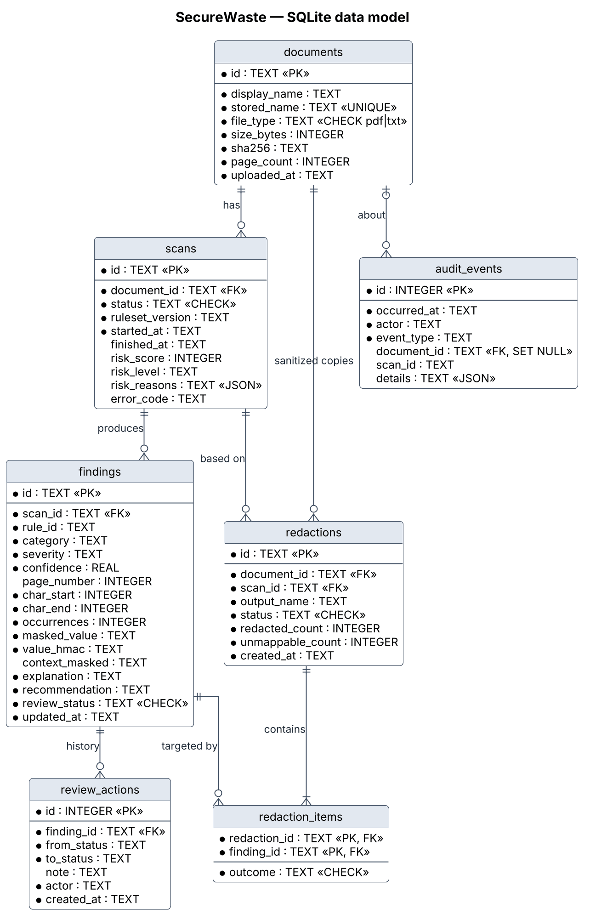
Figure 2 — SQLite data model
How to read it. Each box is a database table with its columns; PK marks the primary key and FK a foreign key that points to another table. The symbols at the line ends give cardinality: two bars mean “exactly one”, a circle with a crow's foot means “zero or many”. For example, one document has zero or many scans, and each scan belongs to exactly one document.

8.2 State machines
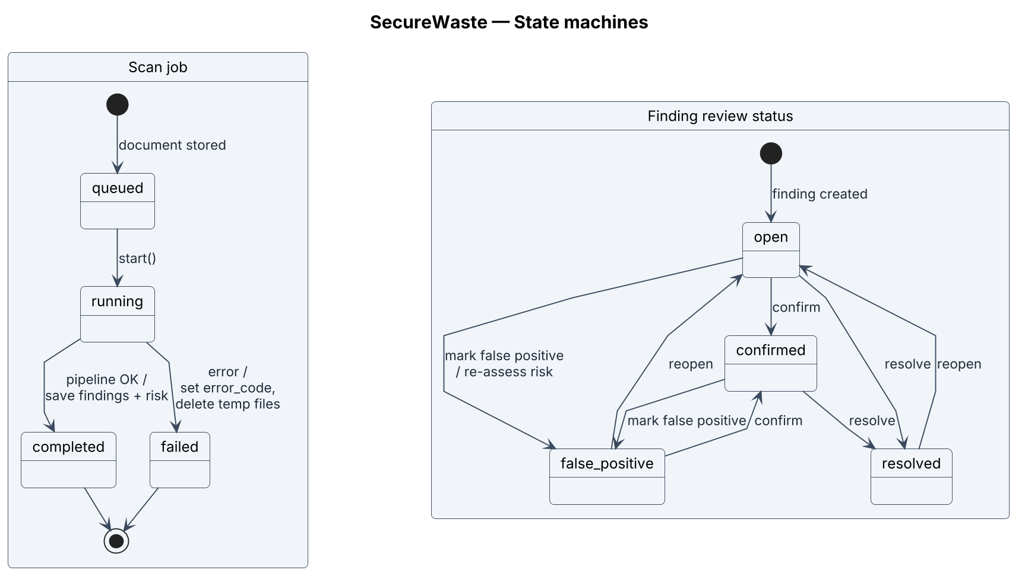
Figure 3 — Scan job and finding review state machines
How to read it. Rounded boxes are states and arrows are transitions labelled “event / action”. The black dot is where an object starts and the ringed dot where it ends. Read the right-hand machine as the rules of the review workflow: for instance a resolved finding can only be reopened, never directly marked as a false positive.

8.3 Class diagram
How to read it. Each box is a class: its name, then its attributes (data it holds), then its operations (what it can do). A filled diamond means composition — the whole owns the part and deleting a Document deletes its ScanJobs; a hollow triangle means inheritance (EmailRule is a RegexRule); a dashed arrow is a dependency such as “creates” or “uses”. Numbers like 1 and 0..* say how many objects can be linked.
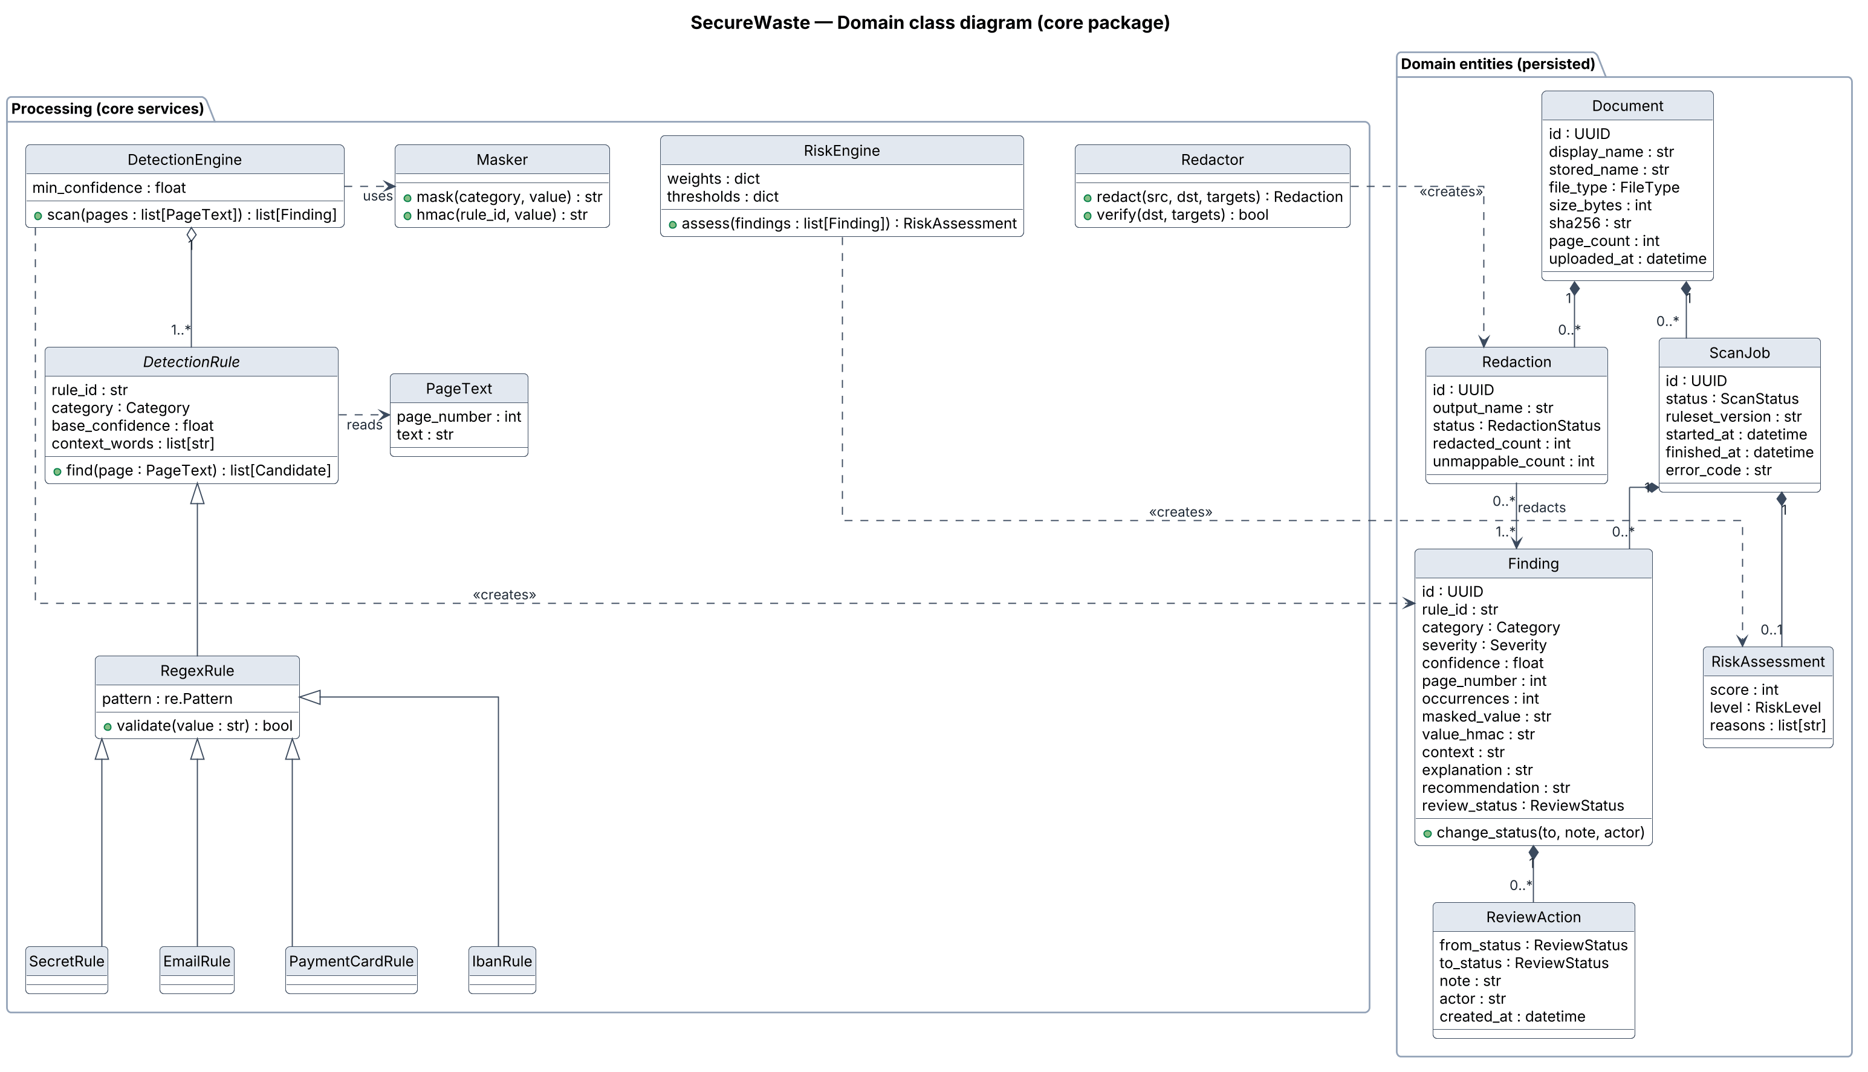
Figure 4 — Domain class diagram

9. Dynamic design
Dynamic design describes behaviour over time: first the whole workflow as an activity diagram, then the three main scenarios as sequence diagrams (each on its own landscape page so the messages stay legible).

9.1 End-to-end activity
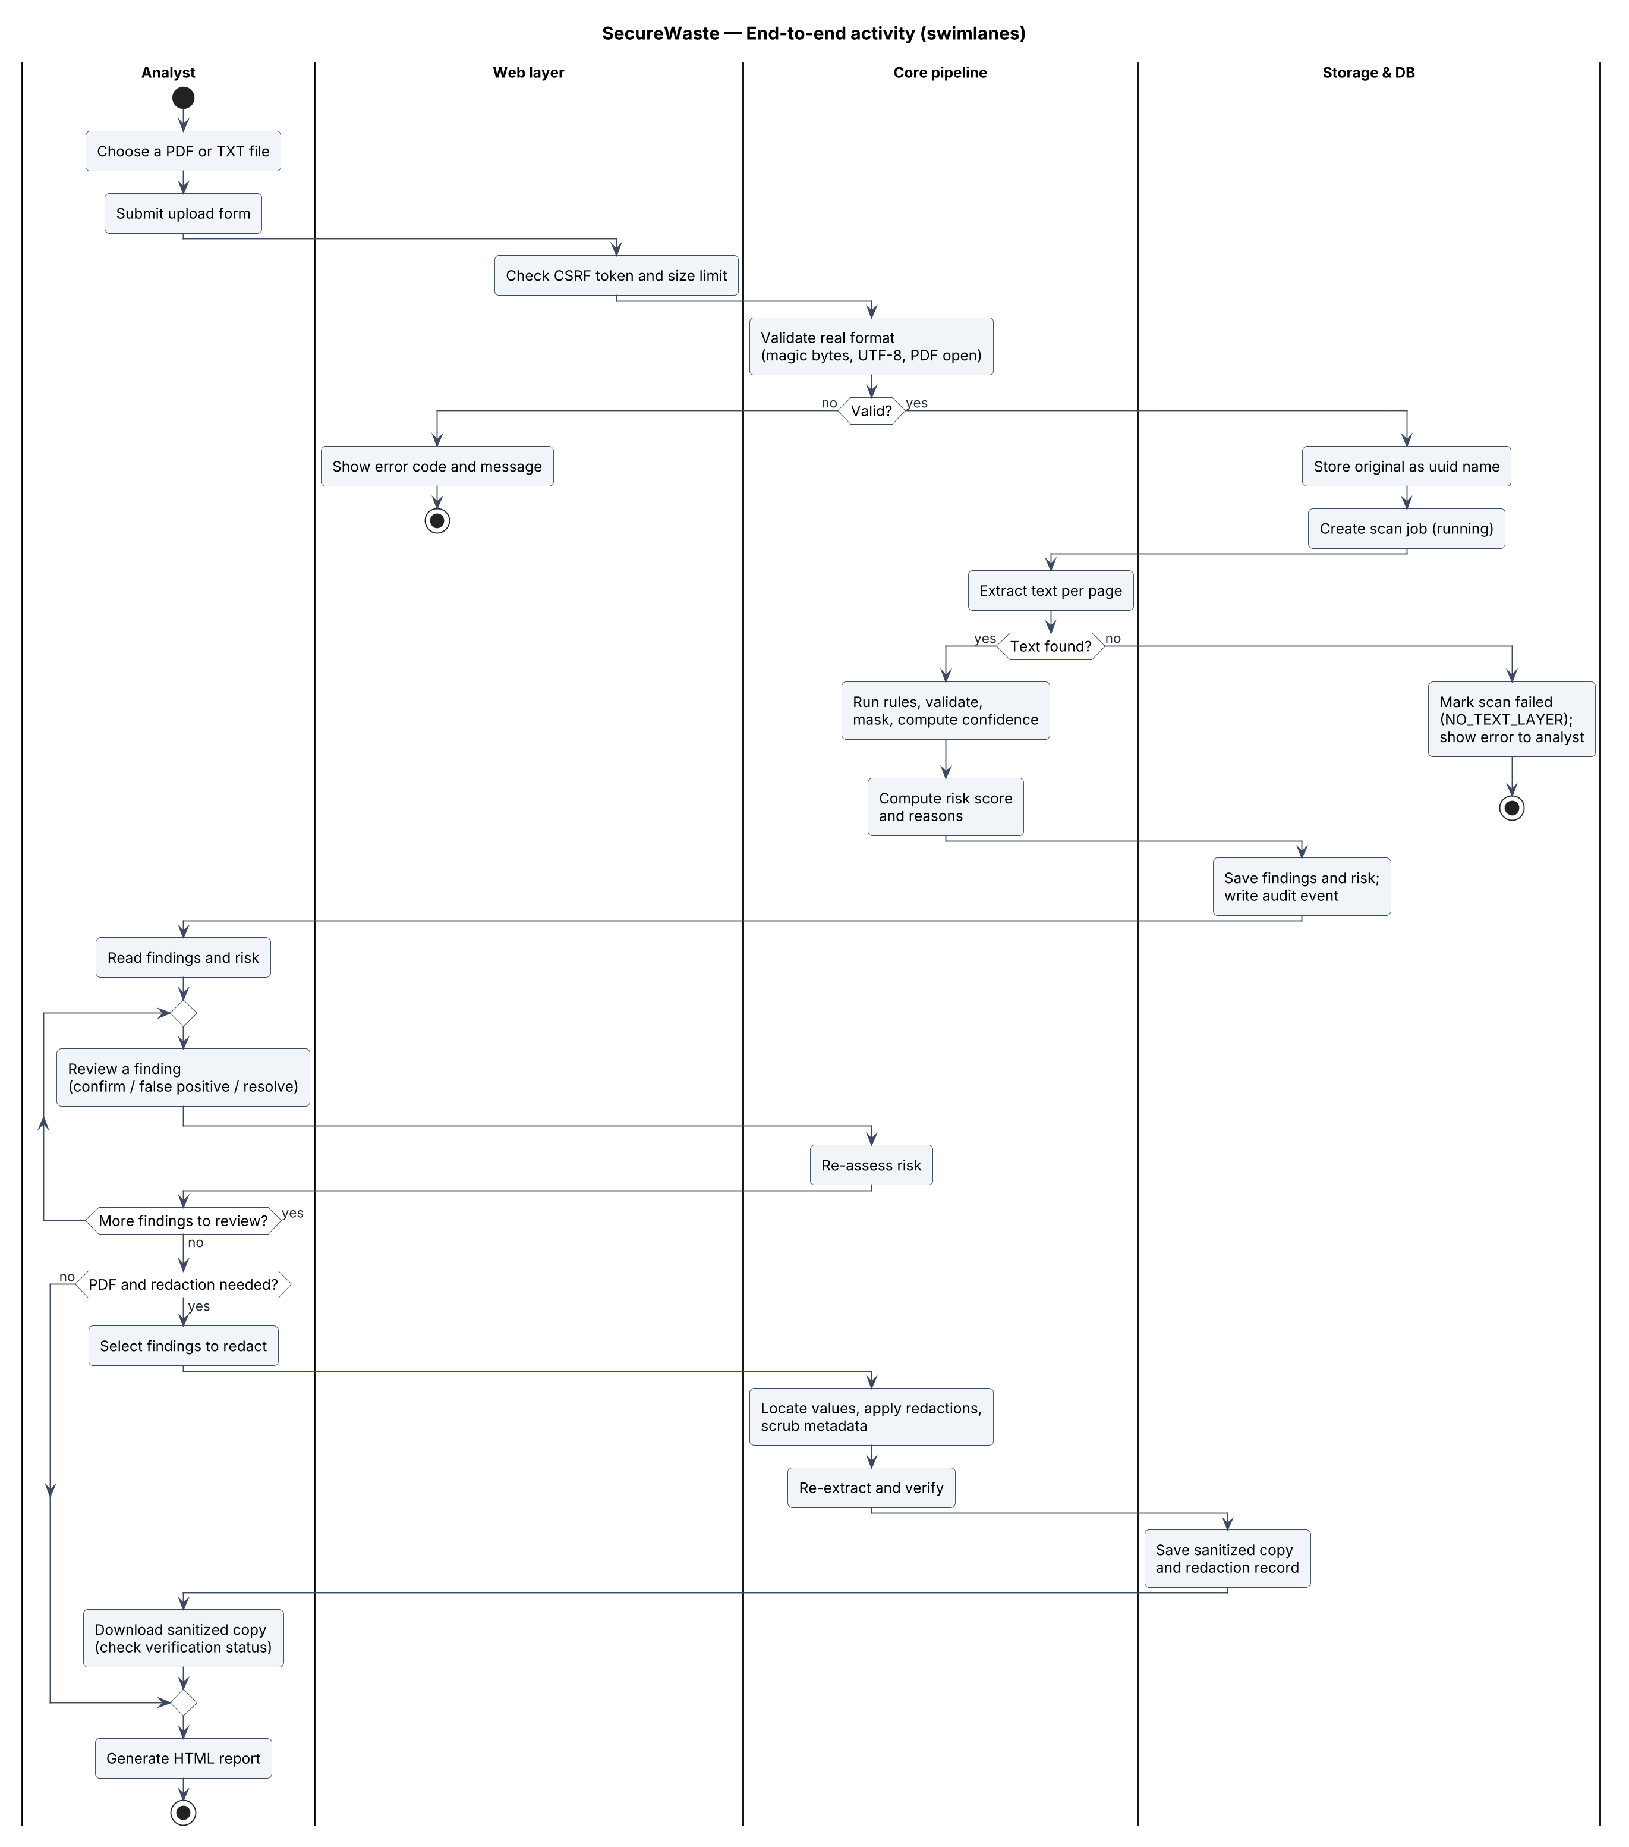
Figure 5 — Activity diagram with swimlanes
How to read it. Each vertical lane is a responsible party, so you can see who does what. Rounded boxes are actions, diamonds are decisions whose exits are labelled with a condition in square brackets, the black dot is the start and the ringed dots are possible ends. Follow the arrows from top to bottom to read the whole workflow.

9.2 Upload and scan
How to read it. Each column is a participant and time flows downwards. Solid arrows are calls, dashed arrows are returns, and the numbers give the order. The “alt” frame shows two alternatives (rejected or accepted file) separated by a dashed line; the “loop” frame repeats for every rule and page.
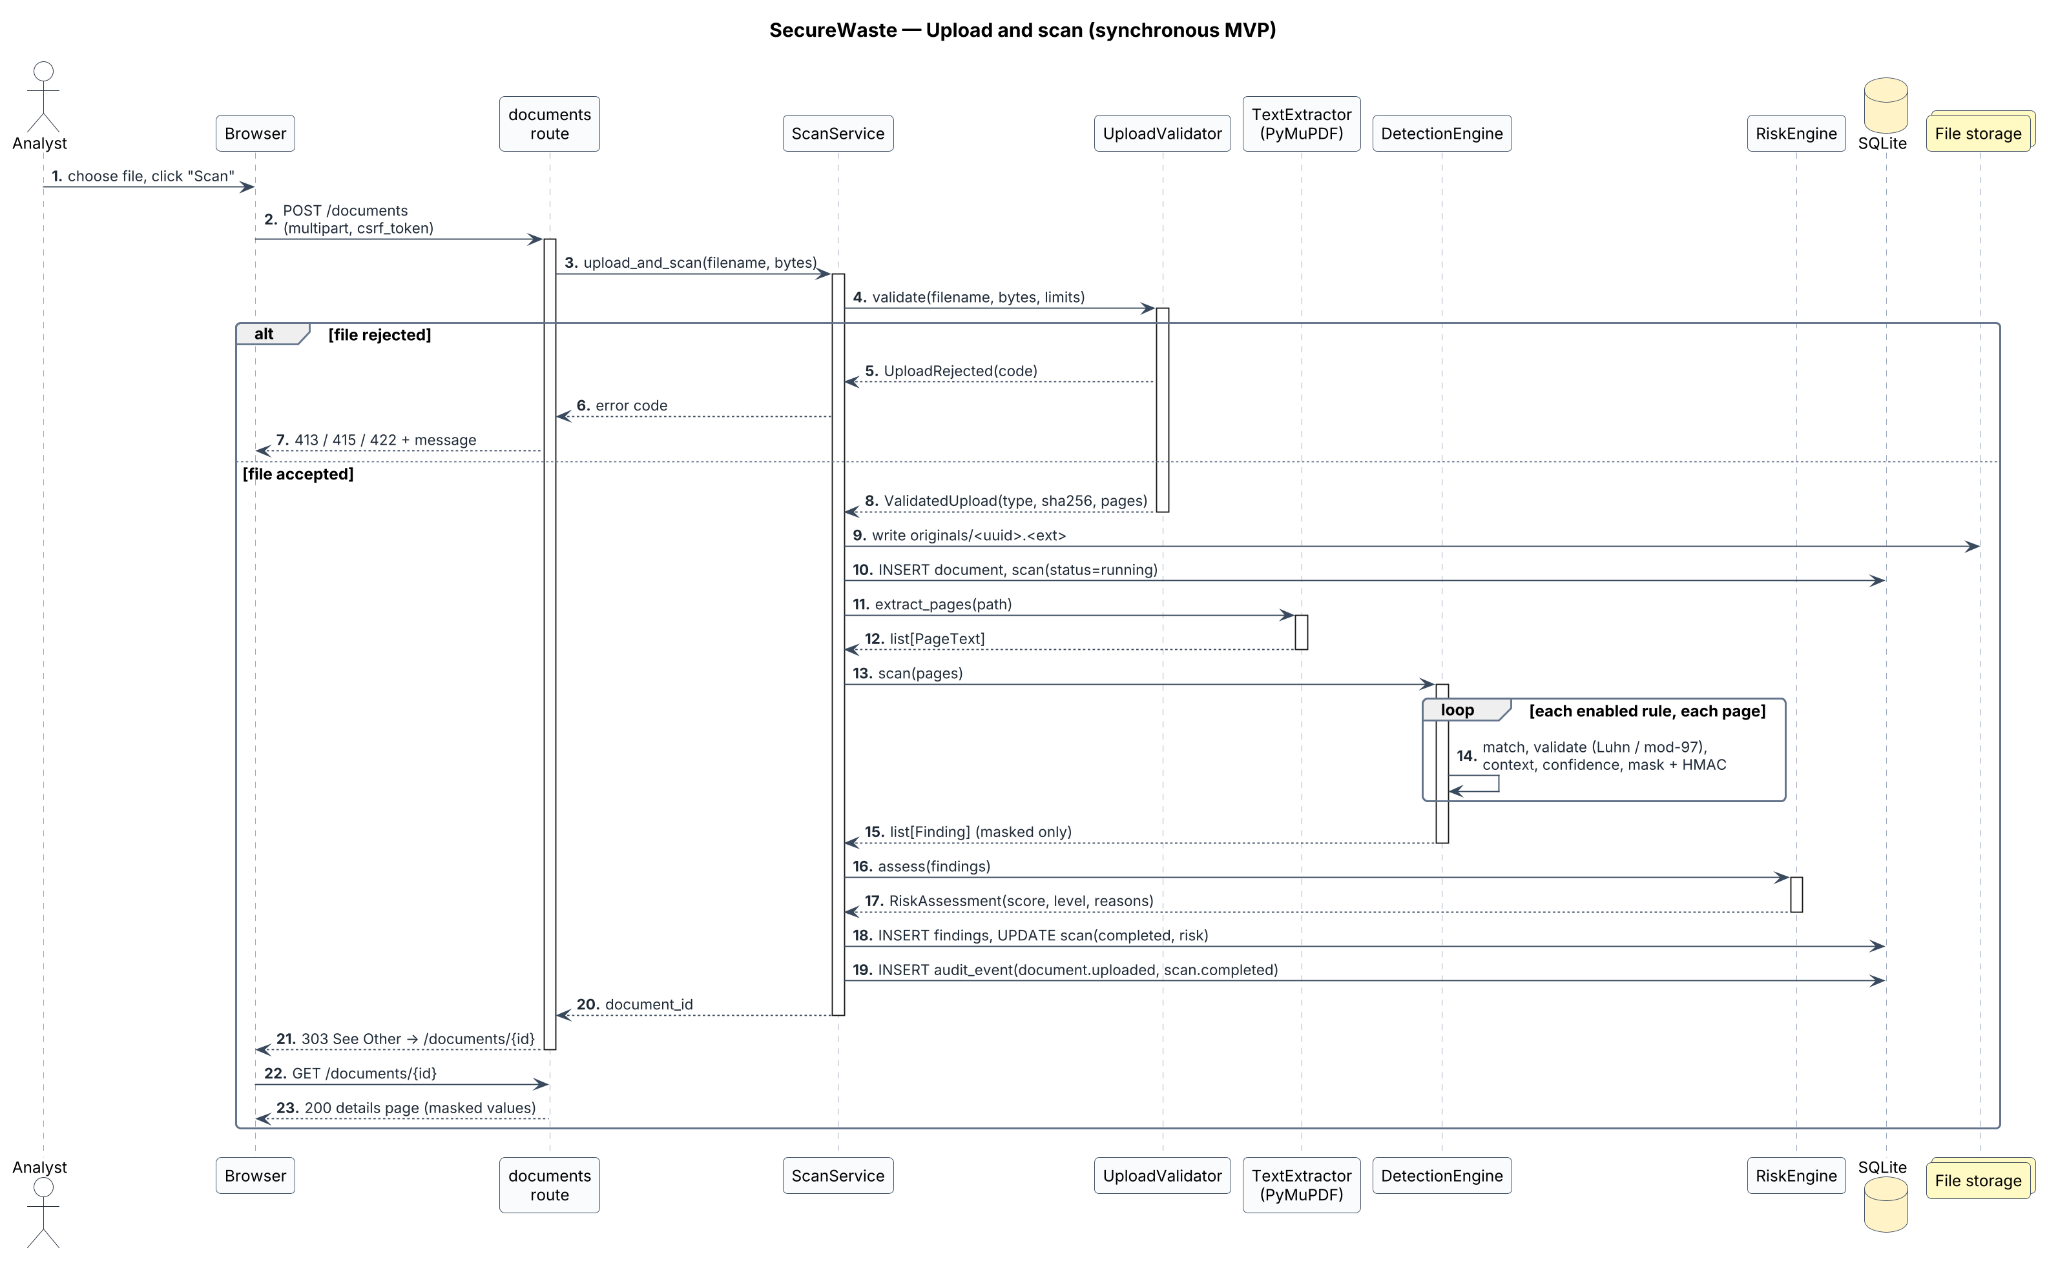
Figure 6 — Sequence diagram — upload and scan

9.3 Review a finding
How to read it. This diagram follows one JSON request from the browser. The alt frame lists the three possible outcomes — not found, transition not allowed, allowed — and only the last one changes data and recomputes the risk.
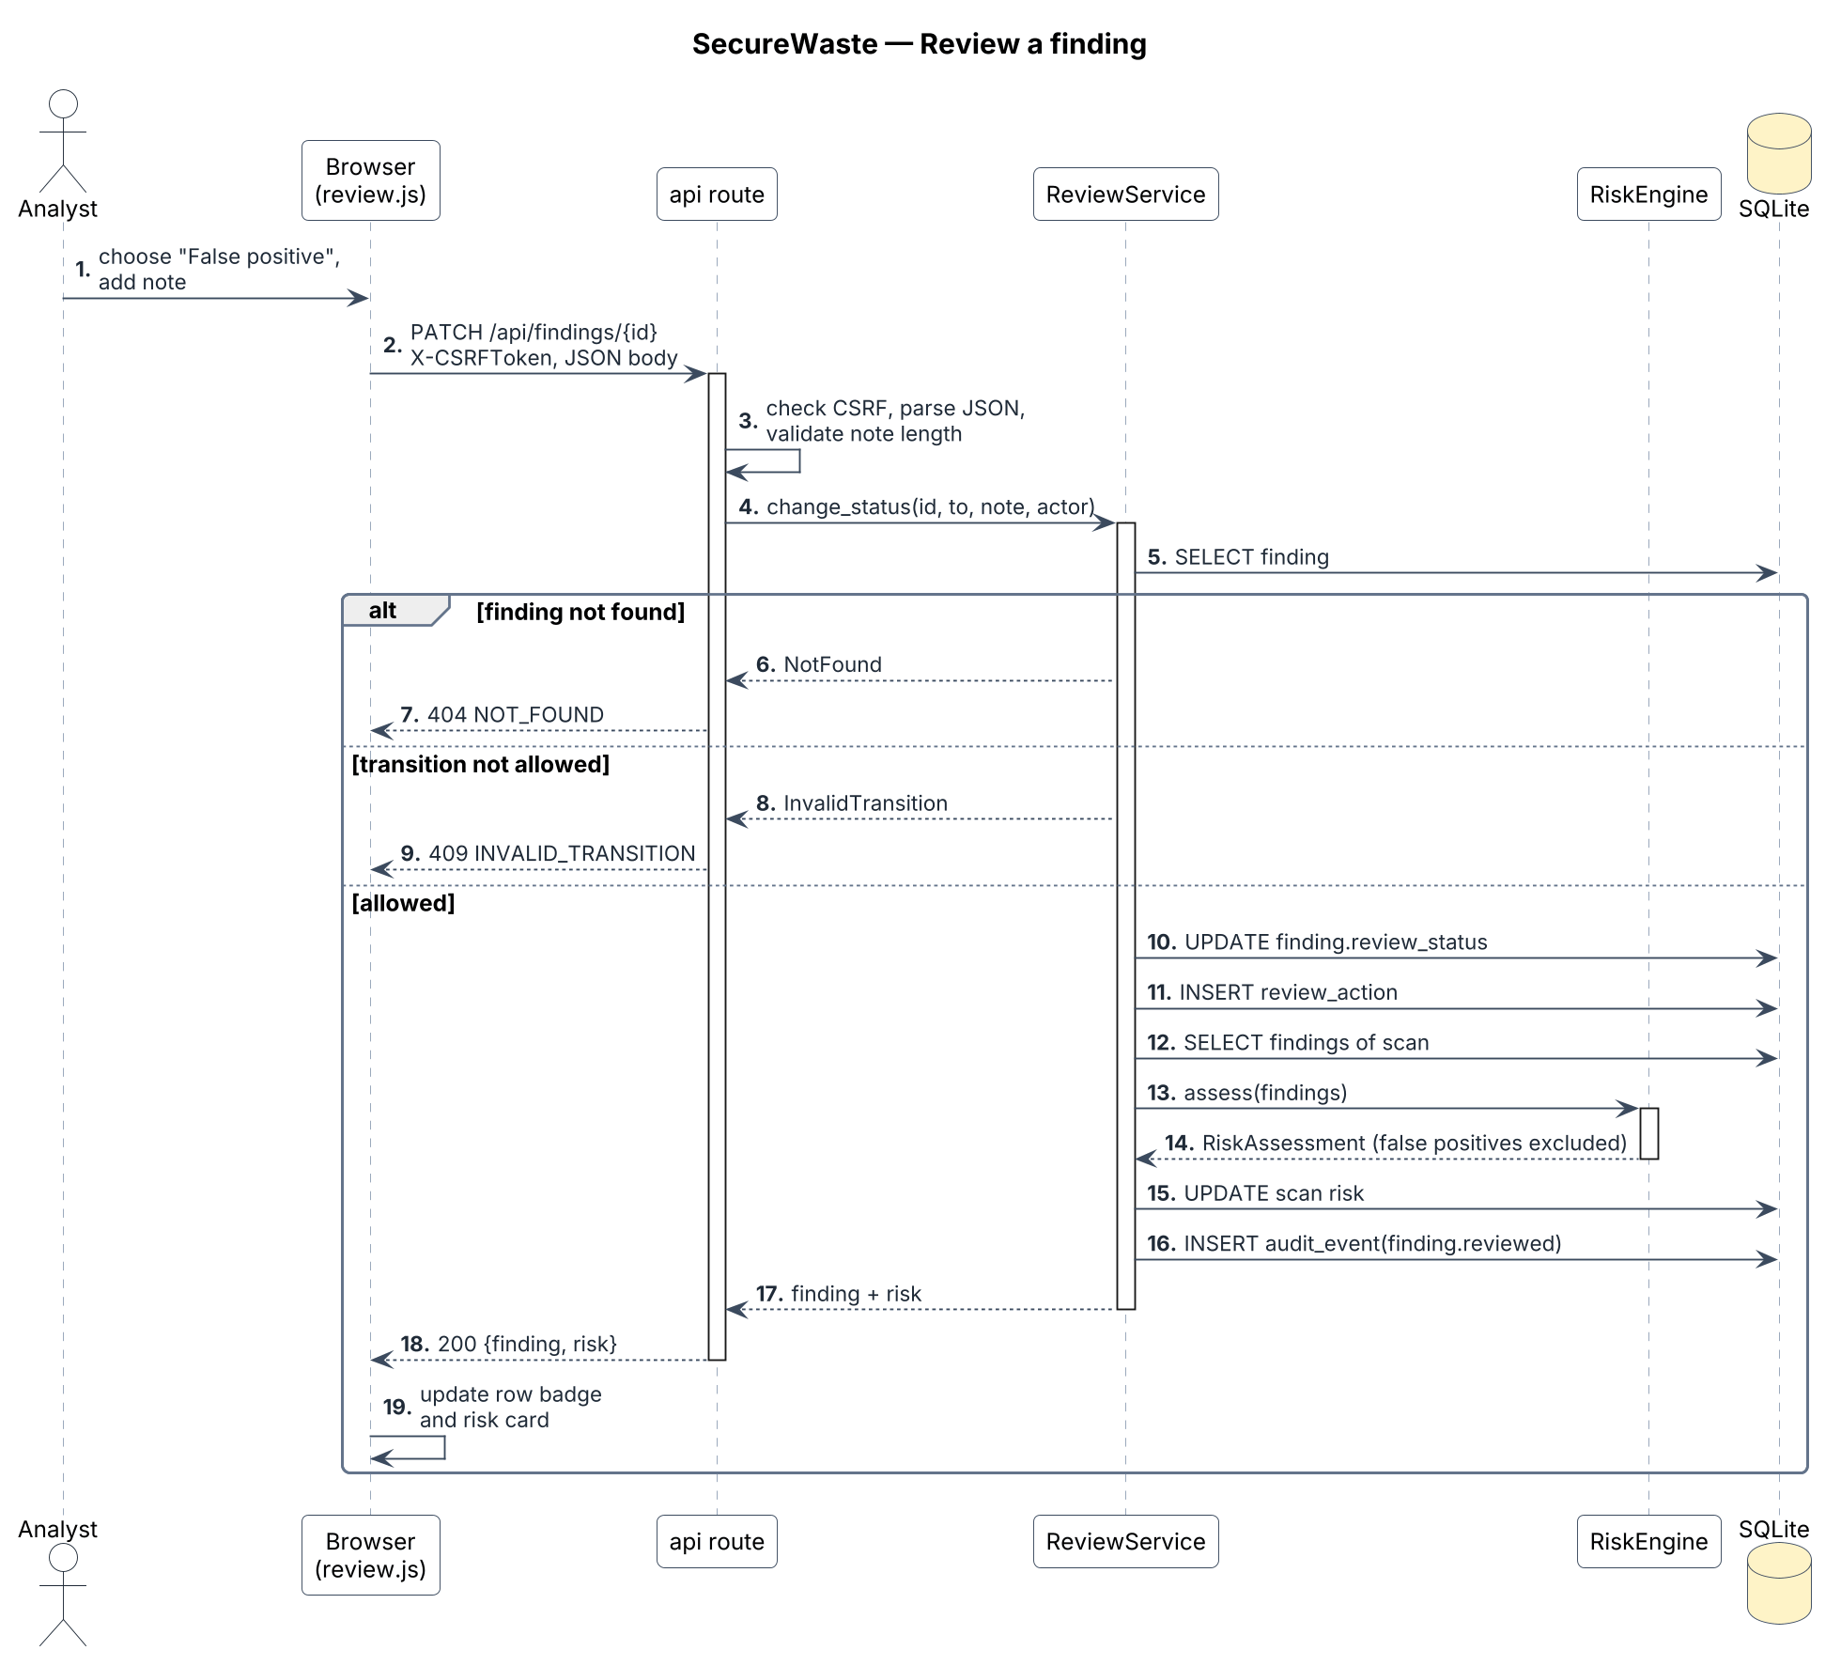
Figure 7 — Sequence diagram — review a finding

9.4 Redact a PDF
How to read it. Notice that the database is read for the selected findings but never for raw values: the service re-scans the original file in memory (steps 6–8) to recover them. Arrows that loop back to the same column are internal steps. The verification steps after the redaction are what allow the report to claim the copy is clean.
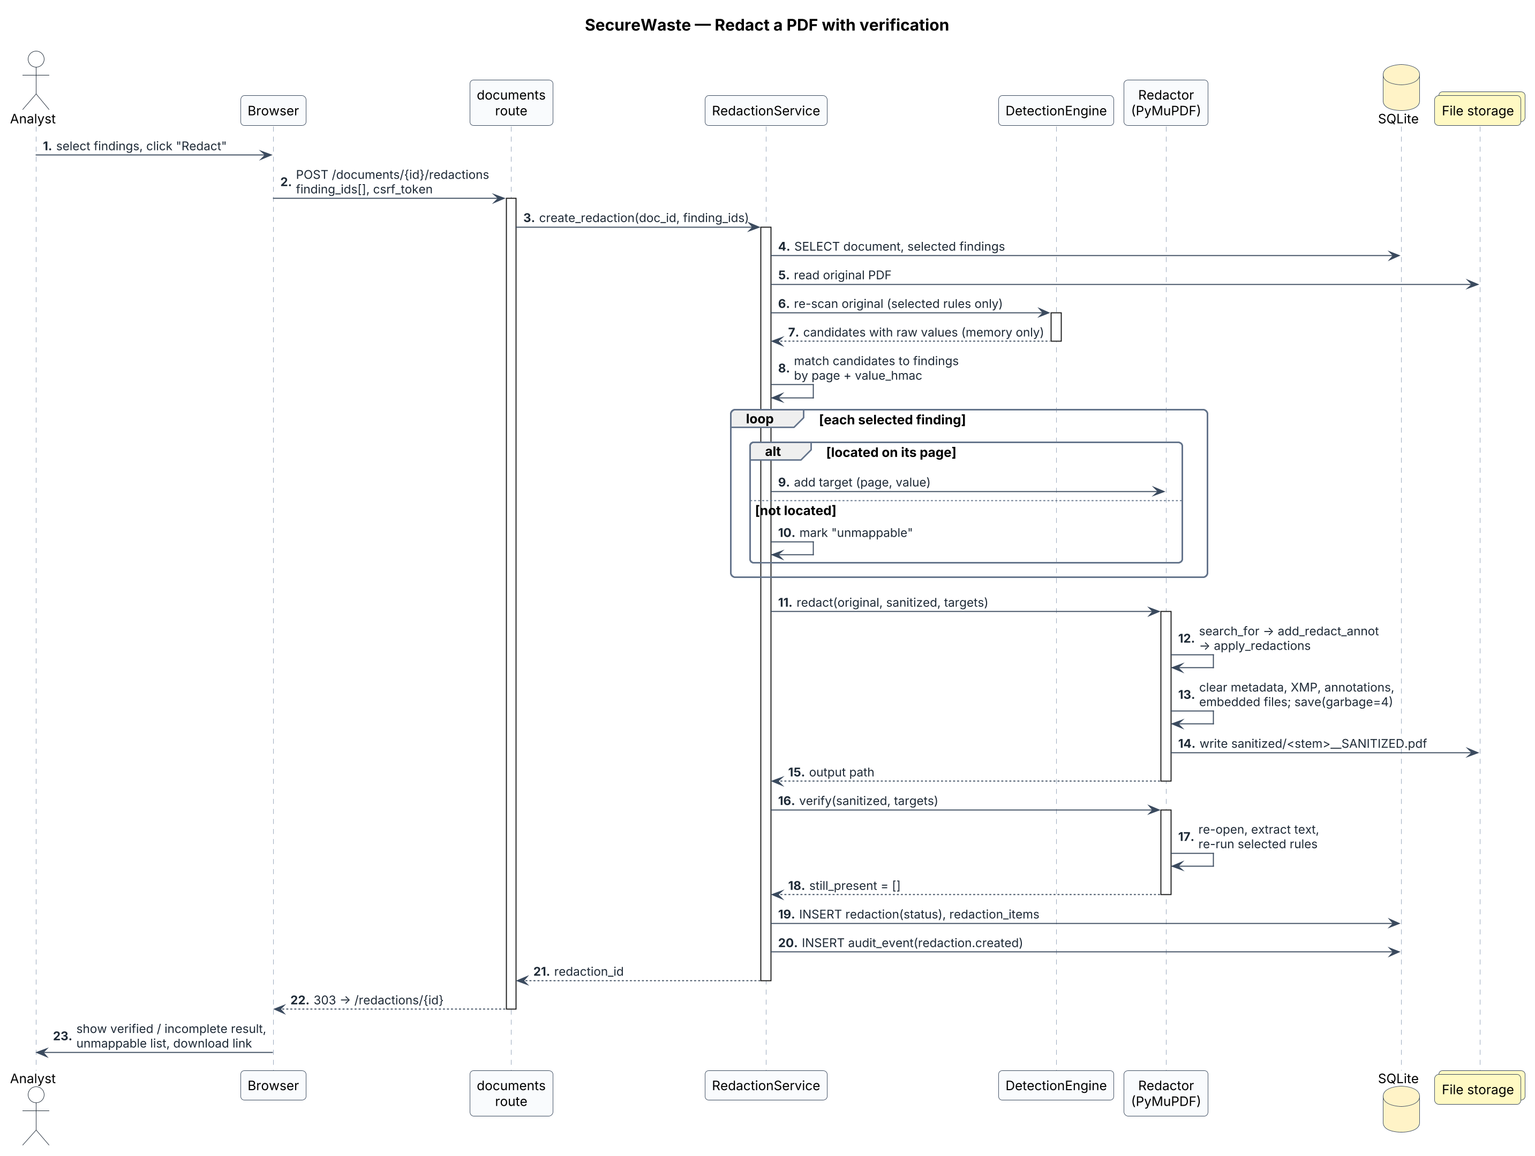
Figure 8 — Sequence diagram — redaction with verification

10. Architecture
The architecture is a layered monolith: one Flask process, one SQLite file, strict dependency direction web → services → core.

10.1 Components
How to read it. Boxes with the small tabs are components — replaceable parts with one responsibility — grouped in folders that are Python packages. An arrow from A to B means “A uses B”. The layers are strict: web calls services, services call core, and only services touch the database and file storage.
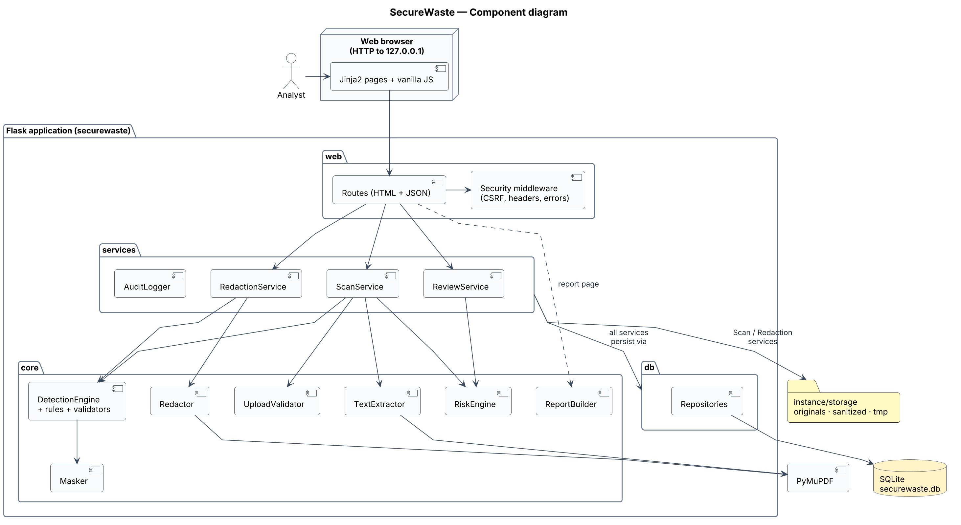
Figure 9 — Component diagram

10.2 Deployment
How to read it. 3-D boxes are nodes — machines or execution environments — and the folded-corner boxes are artifacts deployed on them. Lines are communication paths labelled with the protocol. Everything in the MVP runs on one laptop; GitHub only hosts code and runs tests on synthetic data.
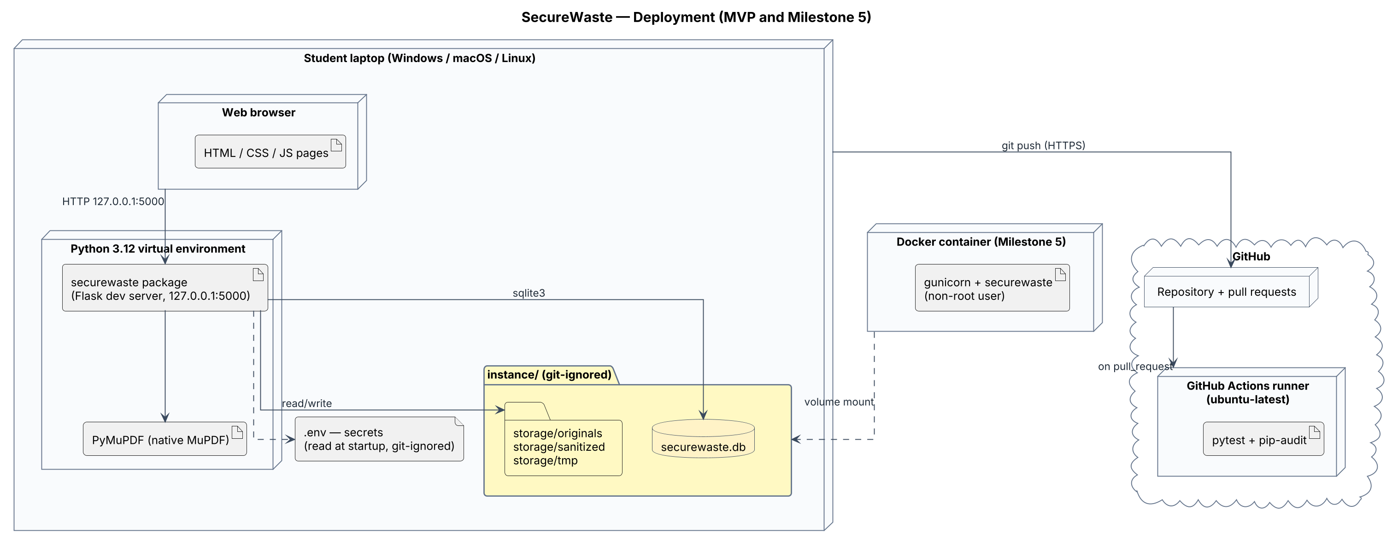
Figure 10 — Deployment diagram

10.3 Technical choices
Need | Choice | Alternatives considered | Reason
Language | Python 3.12 | Java, JavaScript/Node | Rich document and security libraries; readable for a learning team
Web framework | Flask 3 + Jinja2 | Django, FastAPI + SPA, Streamlit | Small and explicit; strong XSS/CSRF defaults; no build step (ADR-0002)
PDF processing | PyMuPDF | pypdf, pdfplumber, pikepdf | Extraction with positions and genuine redaction in one library; AGPL licence (ADR-0004)
Detection | Regex + validators + context | Presidio, ML/LLM classifier | Explainable, testable baseline for later comparison (ADR-0005)
Database | SQLite via sqlite3 | SQLAlchemy, PostgreSQL | Zero setup, real SQL, constraints (ADR-0003)
Sensitive storage | Masked values + HMAC | Raw values, encryption, plain hash | A stolen DB alone reveals nothing usable (ADR-0006)
Scan execution | Synchronous with job states | Celery/RQ queue, threads | Simple now, worker-ready later (ADR-0007)
Risk model | Weighted additive score | Count, max severity, ML, CVSS-like | Transparent and tunable (ADR-0008)
Front end | HTML, CSS, vanilla JS | React, Angular | No build tooling; design tokens from the Figma design system
CSRF / forms | Flask-WTF | Hand-rolled tokens | Proven implementation
Tests / CI | pytest + GitHub Actions + pip-audit | unittest, other CI | De-facto standards, free for public repos
Packaging | Docker (M5) | Plain venv only | Reproducible demos

11. Security requirements and threat model

11.1 Assets
ID | Asset | Why it matters
A1 | Original uploaded documents | Contain the sensitive data
A2 | Sanitized copies | Users will share them believing they are safe
A3 | Findings (masked values, hashes, context) | Reveal where sensitive data is
A4 | Audit trail | Accountability and evidence of review
A5 | Secret keys (.env) | Session/CSRF integrity and hash resistance
A6 | Availability | A result is needed before sharing
A7 | Source repository and CI | Integrity of the code everyone runs

11.2 Trust boundaries
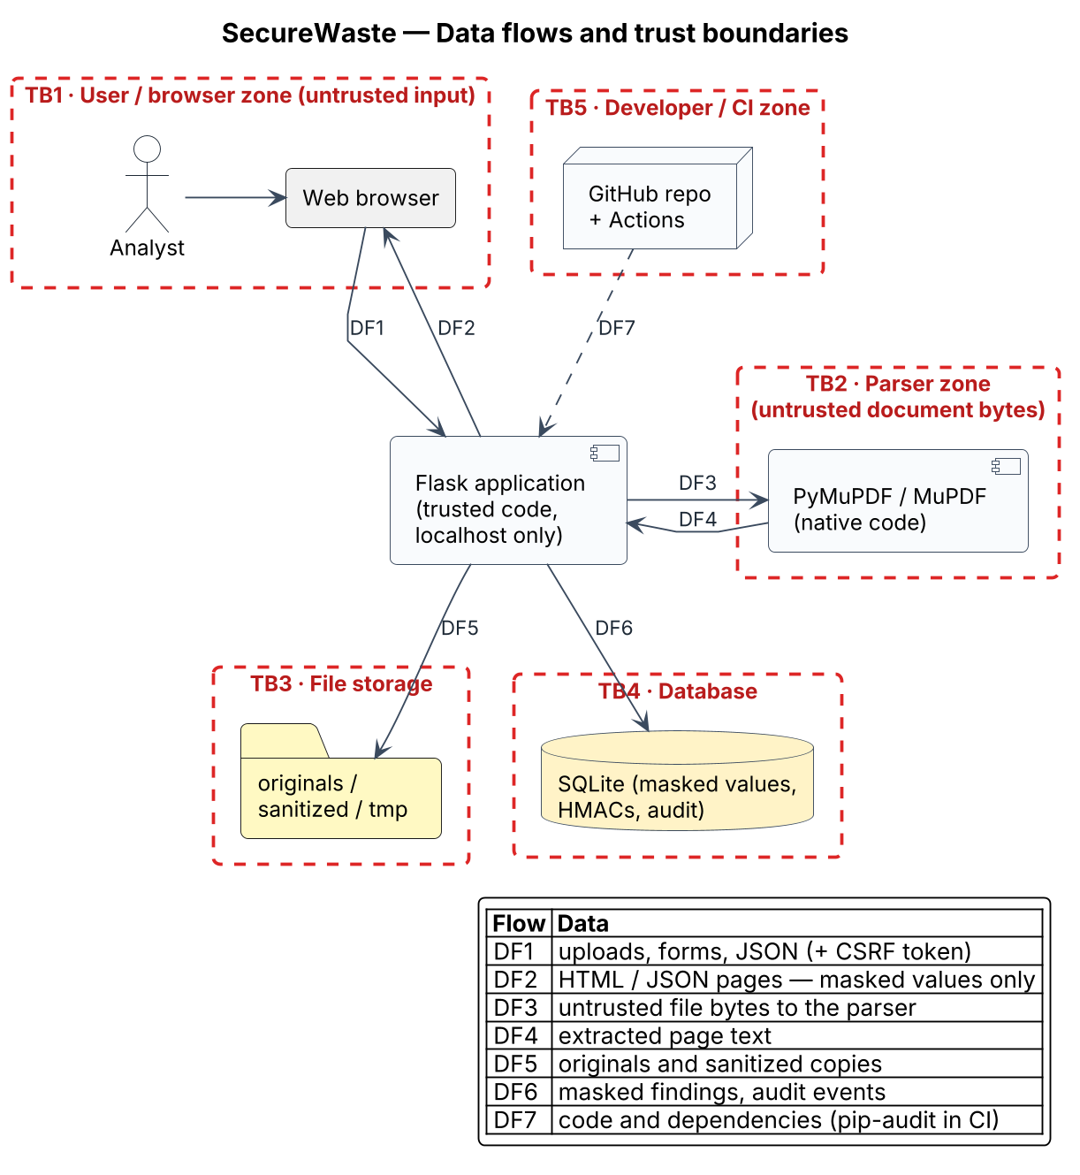
Figure 11 — Data flows and trust boundaries
How to read it. Dashed red rectangles are trust boundaries: data that crosses one must be checked, because the zone on the other side is less trusted. The labelled arrows DF1–DF7 are data flows, described in the legend. The most dangerous flow is DF3, where untrusted document bytes reach native parsing code.

11.3 STRIDE analysis (summary)
STRIDE classifies threats as Spoofing, Tampering, Repudiation, Information disclosure, Denial of service and Elevation of privilege. The full table (T-01 to T-21) is in docs/04-threat-model.md.
ID | STRIDE | Threat | Mitigation
T-01 | S | Cross-site request forgery deletes documents or changes reviews | CSRF tokens, SameSite cookies
T-03 | T | Path traversal through a crafted filename | UUID storage names; resolved path must stay in STORAGE_DIR
T-04 | T | Fake redaction leaves text extractable | apply_redactions + re-extraction verification
T-05 | T | SQL injection in filters | Parameterised queries, whitelisted values
T-07 | R | Reviewer denies a decision | Append-only review actions and audit events
T-08/09 | I | Raw values in logs or DB | Masking + HMAC; no-leak tests
T-10 | I | Stored XSS through filename or note | Autoescaping, CSP
T-11 | I | Metadata survives redaction | Metadata, XMP, annotation and attachment removal
T-16/17 | D | Huge upload or PDF bomb | Size, page and character limits
T-18 | D | Regex catastrophic backtracking | Bounded patterns, adversarial tests
T-19 | E | Memory-safety bug in the native parser | Updates, non-root container, future sandbox
T-20 | E | Debugger enabled on a reachable host | Debug off by default; refuse debug on non-local host

11.4 Accepted residual risks
- No authentication in the MVP (single local user) — revisited at the accounts milestone.
- Short identifiers could be brute-forced from keyed hashes if both the database and the HMAC key are stolen.
- Context snippets may show undetected sensitive text next to a finding.
- Originals are stored unencrypted at rest; disk encryption is the user's responsibility.
- Pattern-based detection will miss some sensitive data (false negatives).

11.5 Security test cases
Fifteen security tests (ST-01 to ST-15) are defined in the threat model, for example: grep the database, logs and report for every raw fixture value (expect zero matches); upload ../../evil.pdf (expect a UUID name inside the storage folder); redact and re-extract with two different PDF tools (expect no selected value and empty metadata); post without a CSRF token (expect 400 and no change).

12. Planning
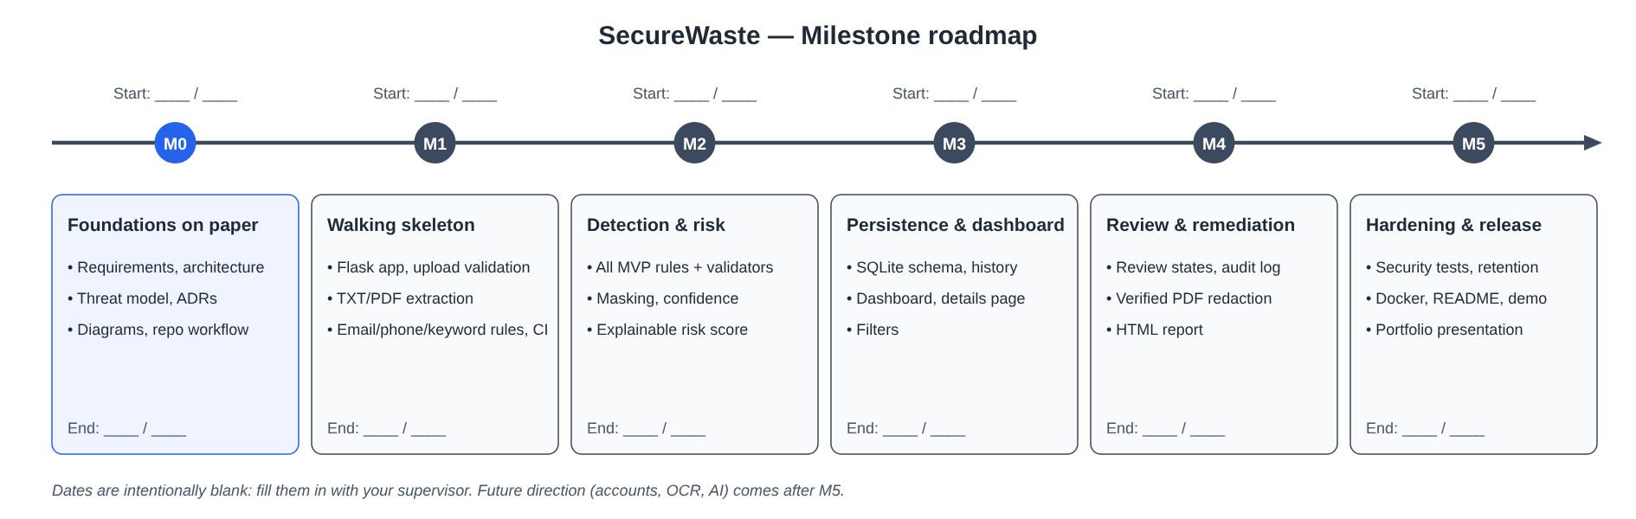
Figure 12 — Milestone roadmap (dates to be completed)
How to read it. Milestones are read from left to right; each card lists what must be demonstrably working at its end. Start and end dates are left blank on purpose so the team can set them with the supervisor. A milestone ends only when its acceptance criteria pass in CI.
Milestone | Content | Start | End | Exit criterion
M0 | Requirements, architecture, threat model, ADRs, diagrams, repository workflow |  |  | Docs merged on main
M1 | Flask skeleton, validated upload, extraction, first rules, CI |  |  | Upload → findings JSON in tests
M2 | All MVP rules, validators, masking, confidence, risk score |  |  | Unit tests ≥ 80 % on detection/risk
M3 | SQLite, history, dashboard, details, filters |  |  | Persisted scans visible in UI
M4 | Review, recommendations, verified redaction, report, audit log |  |  | MVP acceptance criteria 1–8
M5 | Security tests, retention, Docker, README, demo, presentation |  |  | Release v1.0.0 tagged

13. Deliverables, constraints and risks

13.1 Deliverables
- Source code in a public GitHub repository with CI.
- Repository documentation: README, requirements, architecture, interface contract, threat model, ADRs, diagrams (PlantUML and draw.io).
- This cahier des charges (Word and PDF).
- Automated test suite with synthetic fixtures and coverage report.
- Demonstration with fictional documents and a short recorded walkthrough.
- Portfolio presentation: problem, solution, architecture, security controls, limitations, future work.

13.2 Constraints
- Technical: Python, Flask, PyMuPDF, SQLite, vanilla front end; no microservices or heavy frameworks in the first version.
- Legal / licensing: PyMuPDF is AGPL-3.0; the project licence must be compatible (proposed AGPL-3.0).
- Data: only synthetic data; no real customer documents, identifiers or keys anywhere.
- Team: five students working part-time alongside courses; all work through issues and reviewed pull requests.
- Scope honesty: no claim of compliance or completeness.

13.3 Future direction (not committed)
- User accounts, roles and per-user document separation.
- Background job queue; parser isolation in a sandboxed subprocess.
- OCR for scanned PDFs; DOCX/XLSX/e-mail formats.
- Context-aware or AI-assisted classification, preferably local, measured against the rule-based baseline.
- Labelled benchmark corpus with precision, recall and false-positive rate.

13.4 Project risks
Risk | Likelihood | Impact | Mitigation
Scope creep (OCR, AI, accounts too early) | High | High | MoSCoW priorities; Future direction list; milestone reviews
Redaction cannot map some values | Medium | High | Report unmappable values; verification step; never claim success silently
Too many false positives annoy users | Medium | Medium | Validators, context gating, false-positive review, tuning per RULESET_VERSION
Uneven contributions in the team | Medium | Medium | Issues with owners, small PRs, weekly sync, review rotation
Real personal data committed by mistake | Low | High | .gitignore, fixture generator, secret scanning, PR checklist
Dependency vulnerability (PyMuPDF, Flask) | Medium | Medium | Pinned versions, pip-audit in CI, Dependabot
Learning curve delays M1 | Medium | Medium | Learning guide, pair programming, smallest working slice first

14. Glossary
Term | Definition
ADR | Architecture Decision Record — a short document recording one technical decision and its reasons.
Audit event | A record that an important action happened (who, what, when), without sensitive values.
CSRF | Cross-Site Request Forgery — a malicious page making the user's browser send an unwanted request.
CSP | Content-Security-Policy — a response header telling the browser which scripts and resources it may load.
DLP | Data Loss Prevention — tools and practices that detect and prevent unintended disclosure of sensitive data.
False positive / negative | A harmless value wrongly flagged / a sensitive value missed.
HMAC | Hash-based Message Authentication Code — a hash computed with a secret key, so it cannot be recomputed without the key.
IBAN | International Bank Account Number; its last check is the mod-97 calculation.
Luhn checksum | A simple check-digit algorithm used by payment-card numbers to catch typing errors.
Masking | Replacing most characters of a value with symbols so it can be displayed safely.
MoSCoW | Prioritisation: Must, Should, Could, Won't (this time).
Redaction | Permanently removing content from a document, not just hiding it.
STRIDE | Threat categories: Spoofing, Tampering, Repudiation, Information disclosure, Denial of service, Elevation of privilege.
Trust boundary | A line in the system where data passes between zones with different levels of trust.
UML | Unified Modeling Language — standard diagram notations for software design.

References
Pages consulted on 29 October 2026.
[1] Microsoft Learn — Describe data loss prevention in Microsoft Purview. https://learn.microsoft.com/nb-no/training/modules/describe-purview-data-solutions/4-describe-data-loss-prevention
[2] Google Cloud — InfoTypes and infoType detectors (Sensitive Data Protection). https://docs.cloud.google.com/sensitive-data-protection/docs/concepts-infotypes
[3] AWS — Discovering sensitive data with Amazon Macie. https://docs.aws.amazon.com/macie/latest/user/data-classification.html
[4] Microsoft Presidio — package documentation. https://pkg.go.dev/github.com/microsoft/presidio
[5] Help Net Security — Gitleaks: open-source solution for detecting secrets in your code (2024). https://www.helpnetsecurity.com/2024/06/27/gitleaks-open-source-solution-detecting-secrets-in-code/
[6] Arch Linux package page — gitleaks (licence MIT). https://www.archlinux.org/packages/extra/x86_64/gitleaks
[7] PyPI — PyMuPDF (dual AGPL / commercial licence). https://pypi.org/project/PyMuPDF/1.19.6/

