# 

# 

# 

# Problem Statement 3: Final destination

Design Document

**TEAM # 09**

**Waqas Shahid**

**Syed Khalilullah**

**Osama-ur-Rehman**

**PROBLEM STATEMENT**

Customers frequently travel the same routes. Given where the customer has asked to be picked up, suggest a destination for a Careem-tastic experience.

**SOLUTION STATEMENT**

Suggesting a destination to user can not only make the ride booking process fast but will also give the user a very customized user experience.

Providing users with suggestions for Destinations will not only make their lives easy, but will also make the experience worthwhile for the Drivers. Knowing where the ride will end beforehand can allow the system to dispatch jobs to drivers based on the expected ride end-time. This would allow drivers to make the most of their time.

Our system will monitor user’s current locations by leveraging Android’s location services. Server will then request for suggestions from a dedicated Suggestions Service. Suggestions Service will create a list of destination suggestions for user based on different parameters such as time and location etc. Suggestions results will be stored in In-Memory DB.

When the user decides to book a ride, they will first select a pick up location. In response, the app will request for suggestions from the API. The API will query the In-Memory DB and return the results if available. In case the suggestions are not available immediately, API server will setup request suggestions server to generate suggestions. Once the results are ready, API will send a push notification to mobile app, which will in turn fetch suggestions and show them to the user.

**DIAGRAMS:**

**ARCHITECTURE DIAGRAM:**

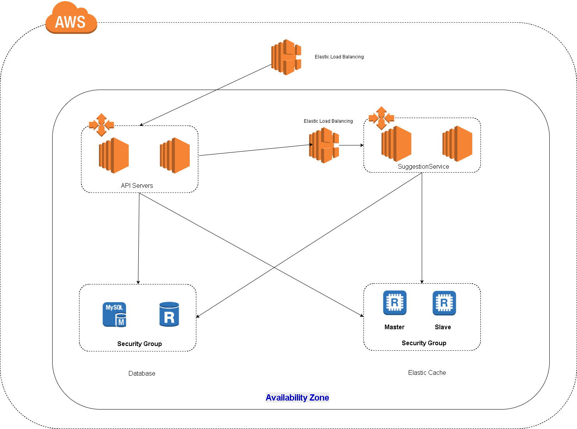

**SEQUENCE DIAGRAM:**

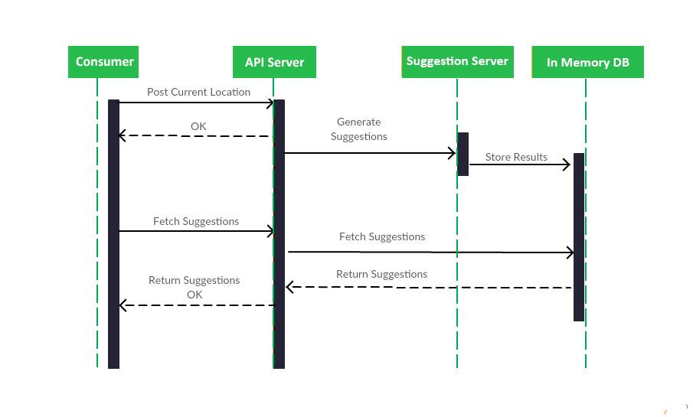

**TECHNOLOGY STACK:**

**BACKEND TECHNOLOGY - JAVA :**

It’s a vastly used language and it has several libraries available for any purpose. With the Java 8 version out. It has helped the team to speed up the development and to focus more on business logic. It has also introduced many functional programming features to the language.

**FRONTEND TECHNOLOGY - ANDROID**:

Reasons for using android is mobile devices now driving more than 50% of traffic to web and android is the most popular platform.

**CACHE - REDIS:**

Reason for using Redis is to swiftly access the suggestions for a user. Redis provides several data structures, which could really help, not only with suggestions but also with other types of data. It also has support for multiple databases and supports persistence as well.

**DATABASE - MYSQL:**

MySQLis the choice which comes as an open source database which is widely used and which fulfills our purpose for managing our data. It also now supports JSON data type and provides with the methods to search from it.