**Students Club Manager**

**Help guide :**

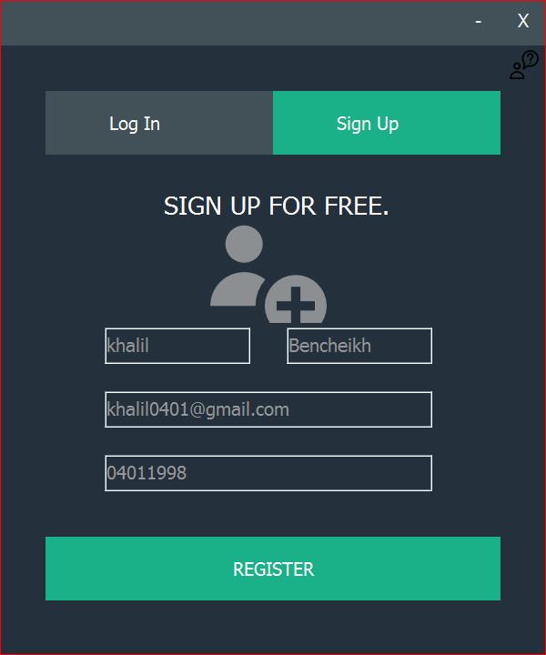Welcome dear user in our desktop application that manage the procese of adding students to some clubs. We build it to be easy and simple any one can use it, its not the first one but its the best.

This is the first step click on sign up and feal in the text field with your information to register your self

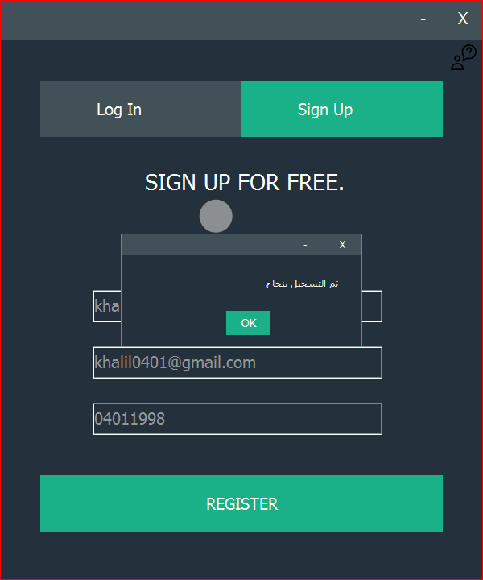

This message it means that you are seccesfully registred

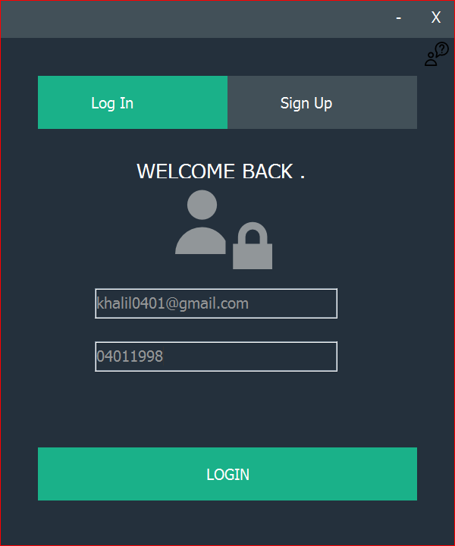

Click on log in then enter the information that you used to register before (email;password) then click sign in to enter your control panel

)

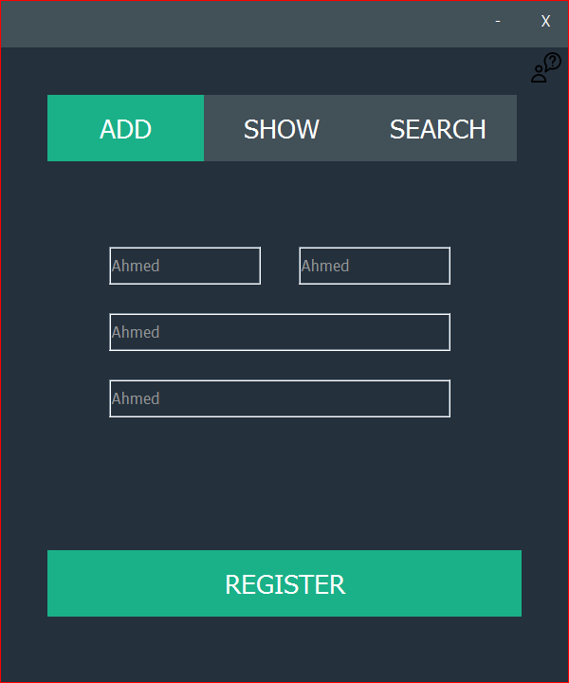

Now you are in the control panel her you can add the new members to your club or whatever .

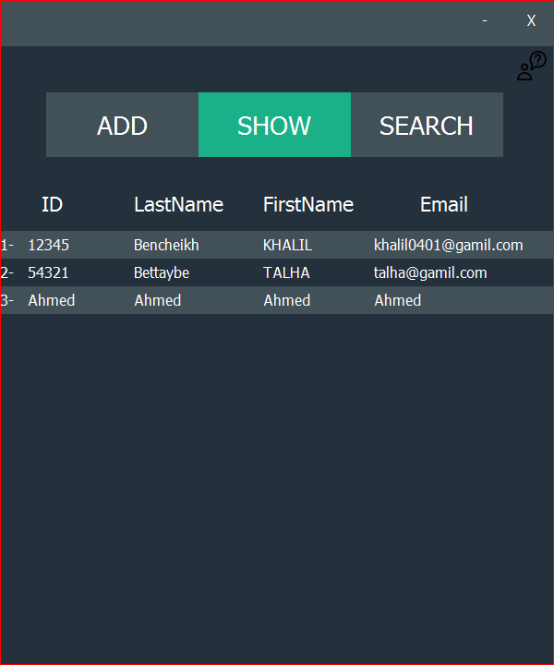

Here you can see the registred member list orgenawed by the registration time.

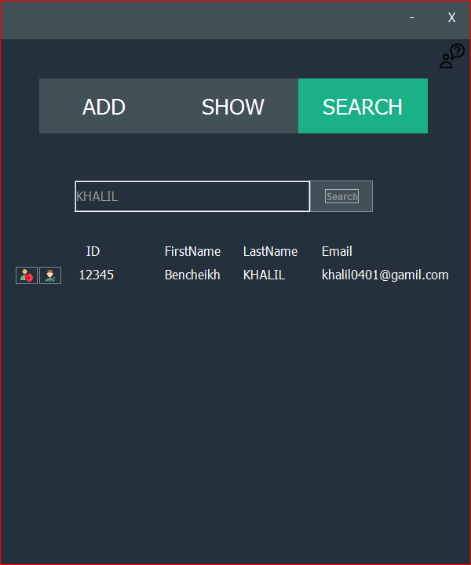

Here you can search in list of members you can find any one and see his detailes you can search by name or second name or email and even the ID



C:\Users\khalil\Documents\NetBeansProjects\IHM\src\ihm\user (5).png

Delete member

C:\Users\khalil\Documents\NetBeansProjects\IHM\src\ihm\user (6).png

Edit member information