Abdur Rahman
180380
Micro Controller & Micro Processor CEP
Designing a Maze Solver Robot

Table of Contents
No table of contents entries found.

Introduction:
A Robot is any machine which is completely automatic, i.e. it starts on its own, decides its own way of work and stops on its own. It can be controlled pneumatically or using hydraulic ways or using the simple electronic control ways.
Robots can be fixed robots or mobile robots. Mobile Robots are robots with a mobile base which enables the robot to move freely in the environment around. One of the advanced mobile robots is the Line Follower Robot. It is basically a robot which follows a particular path or trajectory and decides its own actions by interacting with obstacles or any other path. The path can be a black lines on the white floor (visible) or a magnetic field (invisible).
A maze solving robot is designed to move in a maze and escape through it by following different paths. A maze solving robot is quite similar to a line follower. Like a line follower has to follow black strip lines and follow some algorithm to come out from the maze, a maze follower first explore the whole maze in order to find the best possible path and starts following it until it finds an escape route. The only difference in a line and a maze solver is from software base and they are almost similar in hardware.

Objective:
The main objective of this complex engineering problem is divided into two parts
- Design a line following robot by using AT89C51/PIC18F452 microcontroller, DC motors and line sensors. Use H-bridge IC to derive motors.
- After line following robot convert it to a maze solving robot.
- Design H-bridge for this project.
- Design IR Senses for this project.

Problem Statement:
The main problem here is to design a line following robot, the main issue is not all the designed robots works smoothly, i.e. there motor’s speed does not controlled well so that’s why they do not work smoothly.

Project Review:

PIC Microcontroller:
PIC is a Peripheral Interface Microcontroller which was developed in 1993 by the General Instruments Microcontrollers. It is controlled by software and programmed in such a way that it performs different tasks and controls other component connected to it. PIC microcontrollers are used in different new applications such as smartphones, audio accessories, and advanced medical devices.
For this Complex engineering problem PIC18f452 is used. It can be programmed in higher level languages like C which makes it easy to use and also it is cheap, widely available and widely used microcontroller in Industry also. This makes it a great choice for engineers and hobbyist.

PIN Configurations:

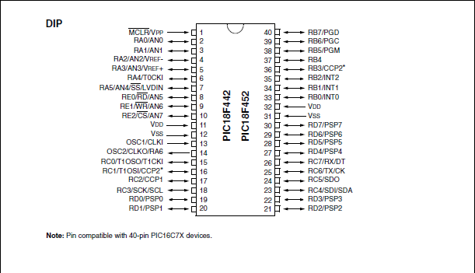
Figure 1: PIC18F452 Pin configurations

Specifications:
Features | PIC18F452
Operating Frequency | DC - 40 MHz
Program Memory (Bytes) | 32K
Program Memory (Instructions) | 16384
Data Memory (Bytes) | 1536
Data EEPROM Memory (Bytes) | 256
Interrupt Sources | 18
I/O Ports | Ports A, B, C, D, E
Timers | 4
Capture/Compare/PWM Modules | 2
Serial Communications | MSSP,  Addressable  USART
Parallel Communications | PSP
10-bit Analog-to-Digital Module | 8 input channels
RESETS (and Delays) | POR, BOR,  RESET Instruction,  Stack Full,  Stack Underflow  (PWRT, OST)
Programmable Low Voltage  Detect | Yes
Programmable Brown-out Reset | Yes
Instruction Set | 75 Instructions
Packages | 40-pin DIP  44-pin PLCC  44-pin TQFP

H-Bridge:
H-Bridge is a simple circuit which is mostly use to control inductive loads like motors. H-Bridge can control both direction and speed of a motor.

Working of H-Bridge:
A simple schematics is shown below.
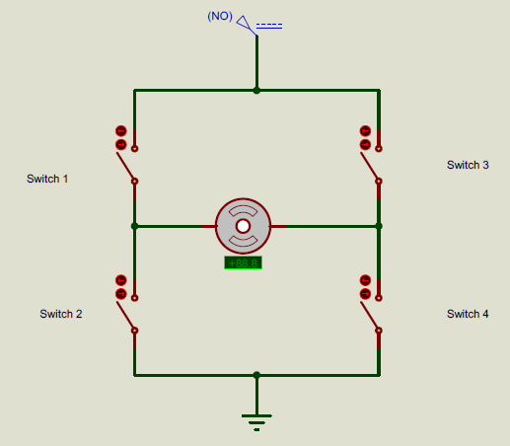
Figure 2: A simple H-Bridge Circuit
By using different combinations of two of the above switches we can derive motor in required direction.
Like for anti-clockwise rotation of motor we can close Switch 1 and Switch 2 and it will complete the circuit is such a way that motor will rotates in anti-clockwise direction as shown below.
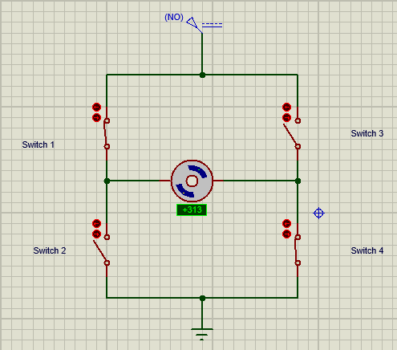
Figure 3: Anti-Clock wise rotation of motor
For clockwise rotation of motor Switch 3 and Switch 2 can be closed and by doing this circuit will close in such a way that motor will rotate in clockwise direction as shown
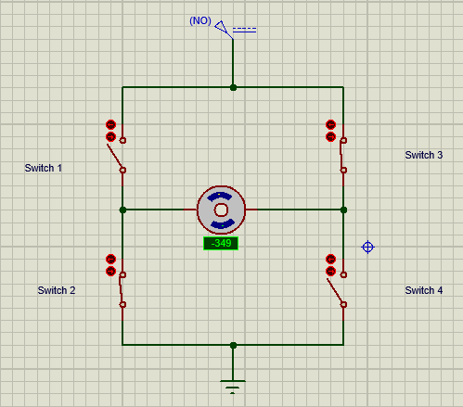
Figure 4: Clock wise rotation of motor

Why to use H-Bridge?
Most of the micro-controllers can give output of about 5V with much less current in orders of mille amps which is much less for most of the DC motors to derive them. H-Bridge use signals from micro-controller and use an external power supply to derive the DC motor instead of taking power directly from micro-controller. So simply H-Bridge separate power supply of micro-controller and for DC motor.

Here in this complex engineering problem as we have to derive two DC motors so we require two H-Bridges.

L293D:
L293D is IC which have two H-bridges in it as we required for this complex engineering problem.

PIN configurations:

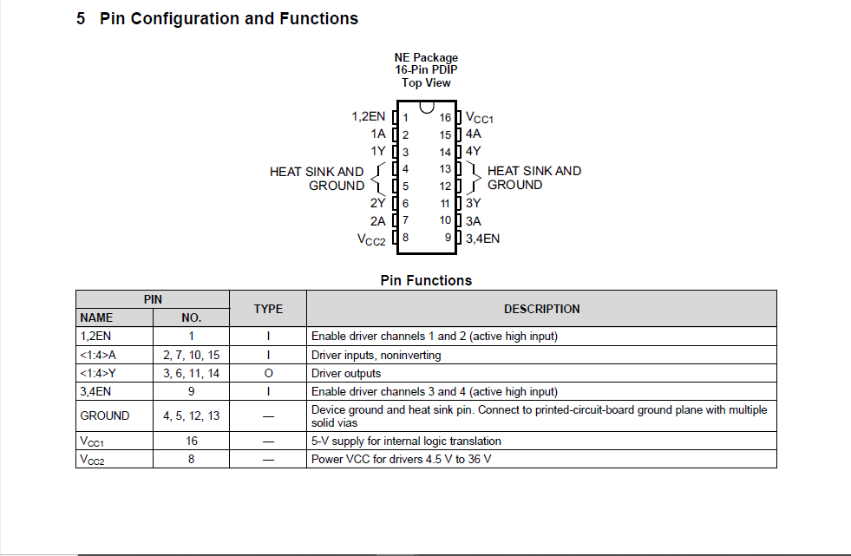
Figure 5: L293D Pin configurations

PIN functions:
Figure 6: PIN functionality of L293D IC

IR sensor:
IR sensor is a simple device which can detect infrared radiations form environment and converts them to electrical pulses which than received by micro-controller and used for decisions making.

Working Principle:
The IR sensor consists of an IR transmitter and an IR receiver. The IR transmitter emits infrared radiations which when reflected by a surface gets received by the IR receiver.
The fact that black color absorbs any kind of radiation can be used to detect a black line on white background. When an IR transmitter emits infrared radiation, the white background reflects the radiation to be received by the IR receiver giving 0v or logic 0 as its output but the black line absorbs the radiation and nothing gets received by the IR receiver and +5v or logic 1 is given as output.
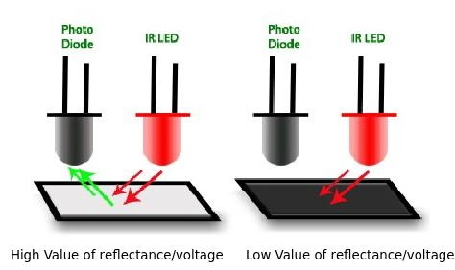
Figure 7: Detection of Black line by IR sensor

IR sensor module:
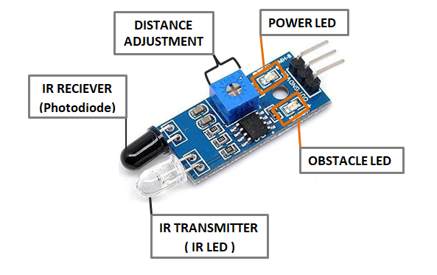
Figure 8: IR sensor module

PIN Configurations:
IR sensor module has 3 pins on it - VCC (+5V), GND (0V) and OUT.
Where VCC and GND or the power pins for IR sensor module and OUT pin give output signal which is given to micro-controller to make a decision weather a line is detected or not.

DC motor:
A DC motor works by converting electric power into mechanical work. This is accomplished by forcing current through a coil and producing a magnetic field that spins the motor.
For this project a DC gear motor is used. A gear motor is simple a motor but with high torque due to the gears mounted to increase the torque.
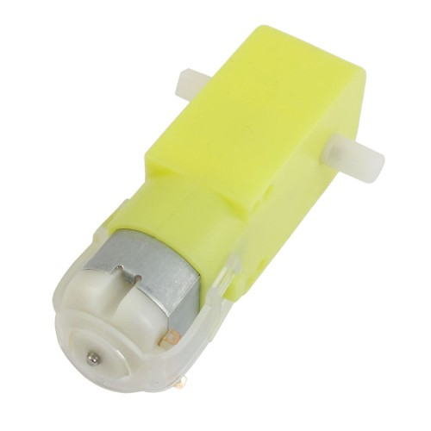
Figure 9: A DC gear motor

Power specifications:
Required voltage: 5V
Current: 200 mA
Gear Ratio: 1:48

Designing Power Supply:
A power supply a device which provide constant power to a load. For electronics constant power supply is very important and any glitch in voltage levels can cause them to burn or not working correctly. So to be able to work as supposed to be we need to provide constant voltage to different components.

Voltage requirements:
For this complex engineering problem there are two different voltage levels are required as follows
- 5 V to power PIC and H-Bridge
- 9 V to derive motors ( reason for 9 V is that some of the voltage may be dropped by H-bridge)

Voltage Regulator:
As 9 V battery is being used for this CEP to get 5 V a voltage regulation IC 7805 is used. This IC gives constant supply of 5 V.

PIN configurations:
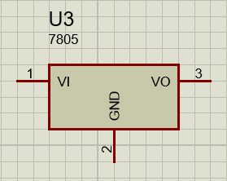
Figure 10: 7805 IC pin configurations
- VI is the Input voltage pin it should be greater or equal to 7 V.
- GND is the command ground pin
- VO is the output voltage which is 5 V constant

Power Supply Schematics:
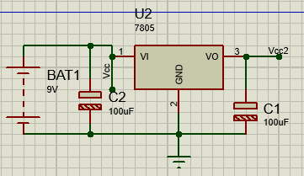
Figure 11: Power supply schematics
Here 9 V from battery is used as input to the voltage regulator. At both ends capacitors of 100uF are added more stabilization to the power.

Designing Hardwar for Line following robot:
As mentioned above line follower is a mobile robot which follows the black line. For this 1st part of CEP we have to design a line following robot.

Working Principle of Line follower:
Block diagram of line for line follower is shown below
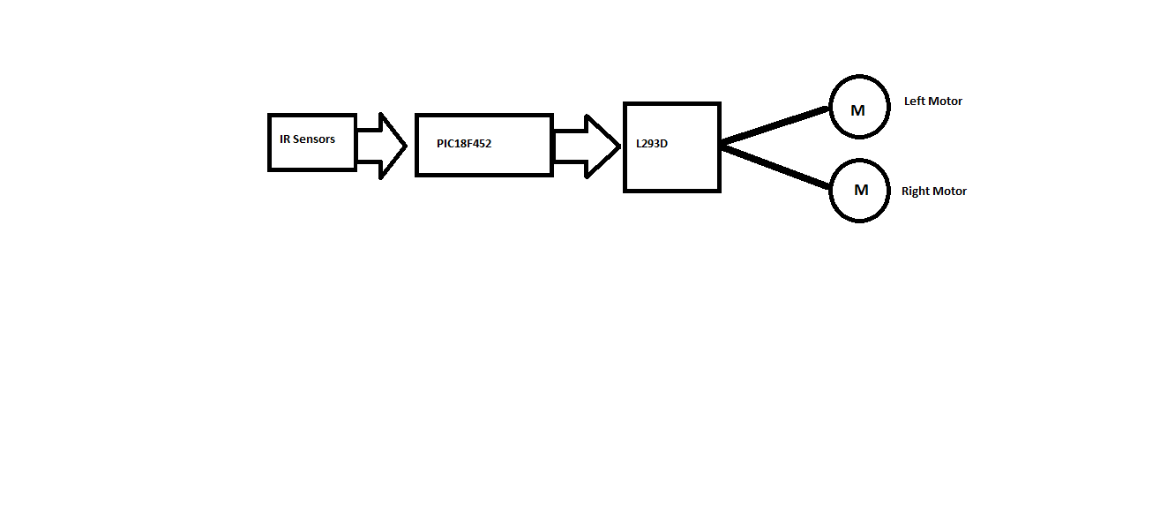
Figure 12: Block diagram for Line follower
IR sensors will detect black lines on the white floor and sends signal to the PIC controller which will determine which way to go based on the signals provided, than PIC will generate specified signal to derive motors as required.

IR sensors:
For this CEP six of the IR sensors are being used with their appropriate place to detect black lines.

Placement of IR sensors at appropriate place:

- Two of them will be used as Head sensor (it will detect weather robot is on the line or not).
- One for central Right and central Left with distance slightly greater than 1.5 inches (greater than the width of the Black line as provided to stabilize the motion of the robot).
- One for Most Right. It will detect weather there is a Right path or not.
- One for Most Left. It will detect weather there is a Left path or not.
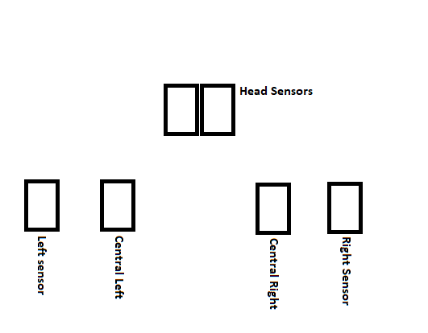
Figure 13: Sensors positions on robot

Connecting Sensors with PIC:
As there are six sensors which we have to connect with PIC. These sensors gives digital outputs so we can connect them to any port which can read digital input.
In this CEP I have connected sensors with PORT B from pin 0 to pin 5.

Connecting L293D and Motors with PIC:
L293D have two H-bridge in it and each H-bridge have five pins
- Vss pin of H-bridge is connected with Vcc2 pin of power supply. It provides power to H-bridge for its working.
- Enable pins EN1 and EN2 are connected with Port C pin 1 and 2 respectively which are PWM pins for PIC so we can control moto’s speed.
- Vs pin which is power pin for motors, connected directly with battery.
- Out 1 and Out 2 pins are connected with motor 1.
- Out 3 and Out 4 pins are connected with motor 2.
- IN1 and IN2 is for direction control pins for motor 1, connected with D0 and D1 of PIC respectively.
- IN3 and IN4 pins are for direction control for motor 2, connected with D2 and D3 of PIC respectively.

Truth table for H-Bridge:
Input Pin 1 or IN1 | Input Pin 2 or IN2 | Motor Status
0 | 0 | Off
0 | 1 | Clock wise
1 | 0 | Anti-clock wise
1 | 1 | Off
Same for 2nd H-Bridge.

Line following Schematics:
V
c
c
V
c
c
V
c
c
2
Vcc2
VI
1
VO
3
G
N
D
2
7805
BAT1
9
V
+88.8
Volts
+88.8
Volts
C1
uF
100
C2
100
uF
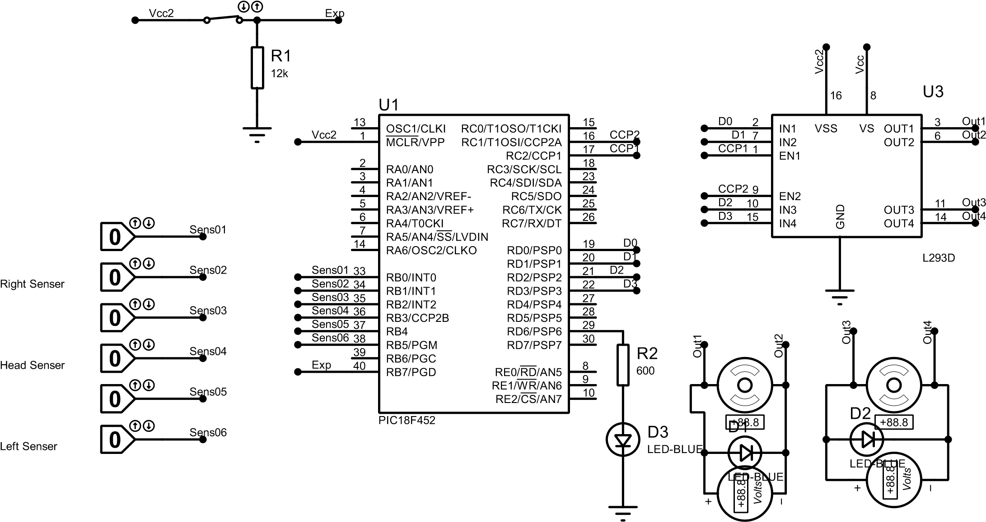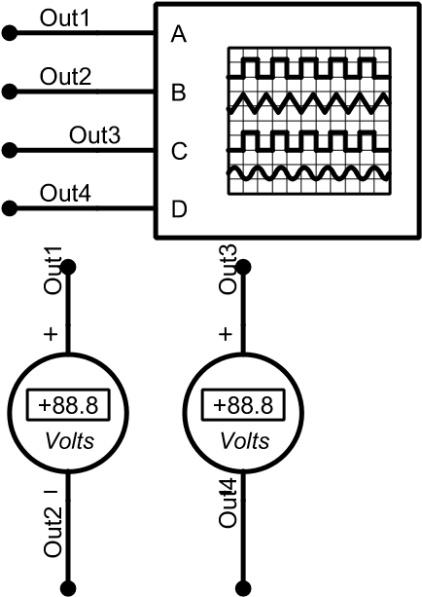
Figure 14: Line following Schematics
In the above schematics voltmeters and oscilloscope are only for the purpose of checking that everything works fine.

Detecting Turns:
In this section it is explained how sensors will behave when any turn will arrive and what will be there values, so that I can use to design line following algorithm.

Detecting Right turn:
On right turn situation would be like
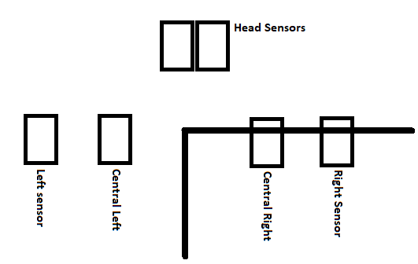
Figure 15: On right turn
So from above figure only Central Right and Right Sensor will detect line which mean they will give high value and all other will give low output.

Detecting Left turn:
On left turn situation would be like
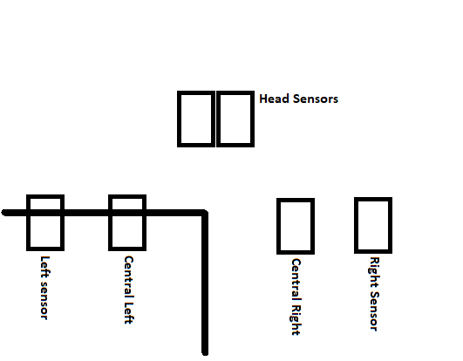
Figure 16: Left turn detection
So from above figure only Central Left and Left Sensor will detect line which mean they will give high value and all other will give low output.

Detecting straight path:
On a straight path only head sensors will detect the line
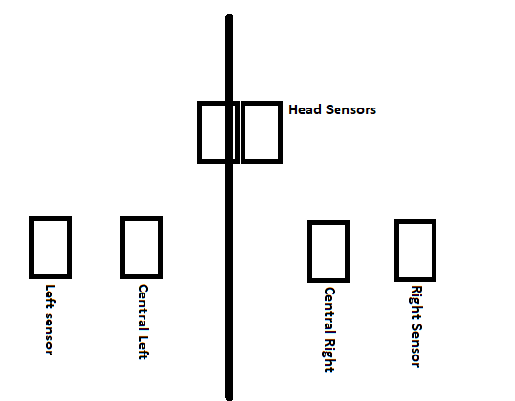
Figure 17: Detecting straight path

Detecting T type path:
On “T” type path all the sensors will detect line except Head sensors.
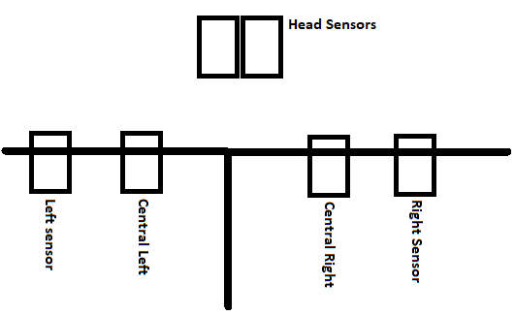
Figure 18: detecting T type path

On “+” type path:
On “+” type path where all the path exist all the sensors will detect lines.
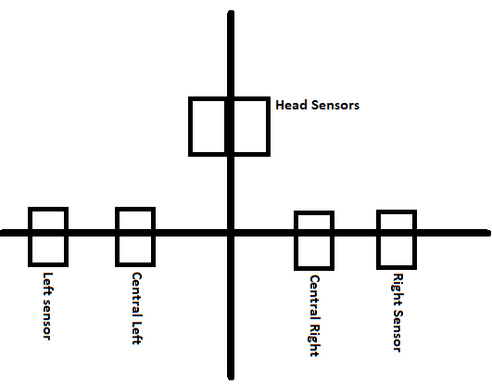
Figure 19: Detecting "+" type path

Line following algorithm:
In this CEP “Right hand on the wall” algorithm is implemented as given below

IF can go Right
THAN go right
ELSE IF can go straight
THAN go straight
ELSE IF can go left
THAN go LEFT
ELSE IF dead end
THAN turn around

In the algorithm highest order is given below
Right > Straight > Left > dead end

Taking turns:

Going straight:
To go straight derive both motors at the same speed, by this robot will go straight.

Taking a left turn:
For taking left turn stop the left motor or slow down it and turn on or increase the speed of right motor, by this robot will turn left.

Taking right turn:
For taking a right turn stop or slow down the right side motor and turn on or increase the speed of left motor, by this robot will take a right turn.

Line following implementation in C:
Above mentioned algorithm is implemented in C language checkout on GitHub.

