1. This one not updated:  
   Can you change below “Maximum 20 slides”

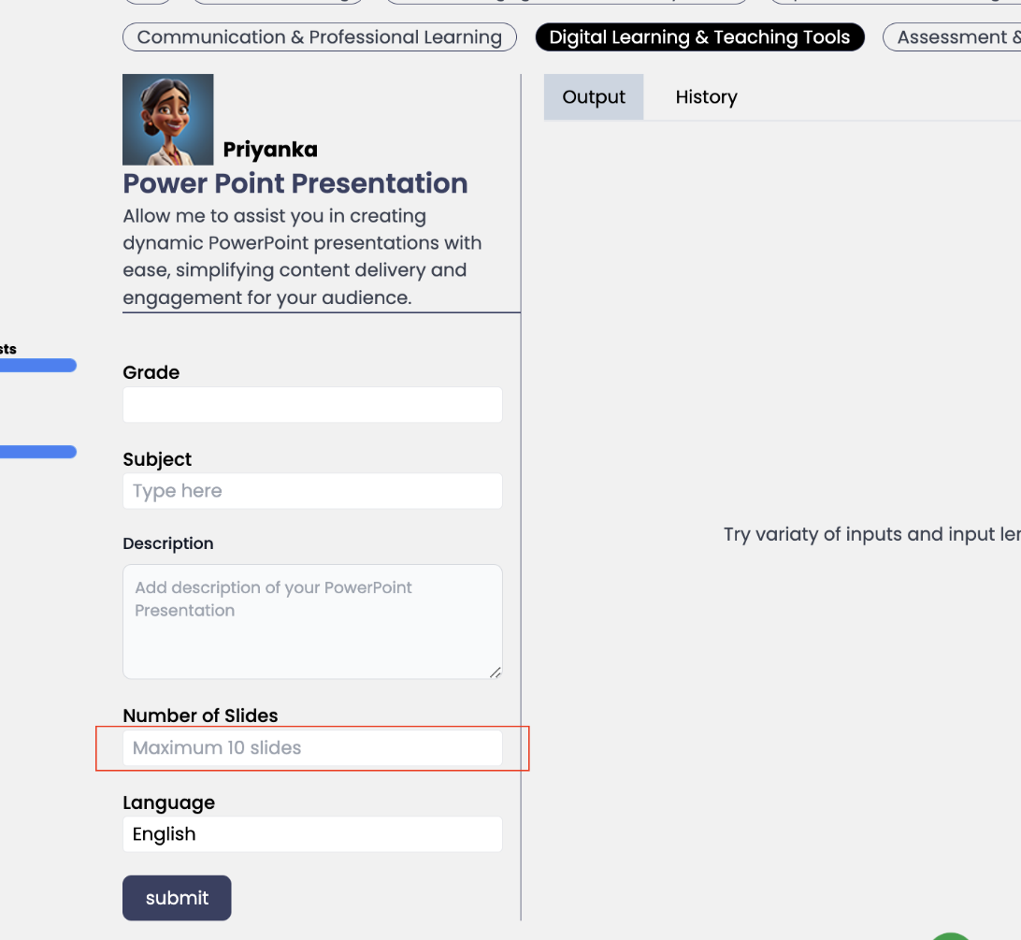

1. Can you change the background image its currently blurry to the attached:  
   <https://www.teachassistai.com/login>

<https://www.teachassistai.com/signup>

1. On mobile only can make this heading “Meet our AI Teacher Assistants” keep desktop as the current same this change is only for mobile and make the heading size the same as other titles on mobile?

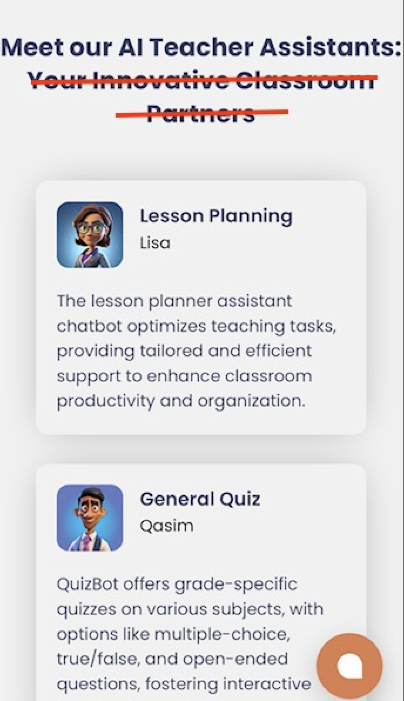

1. Remove this heading in mobile only don’t change desktop.

