1. On mobile only please centre title and remove the text below it (mobile only) and keep desktop as is.

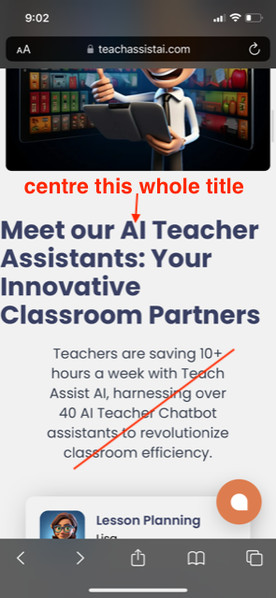

1. Remove the title sorry I might not have mentioned this below as shown below.

Also the quality of the banner is not good the text on the countrys are blury I have added a png file can you upload this with the same title and text on banner.

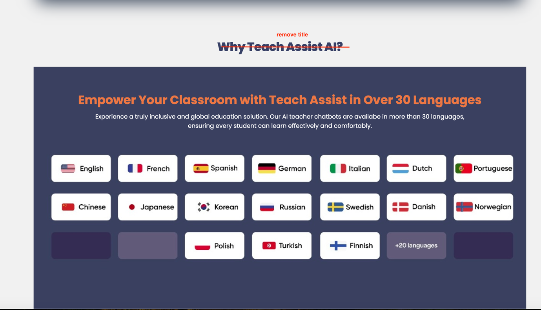

1. Chatbot code for website did you add this one?:  Can you check my account its not showing the chatbot on website?

It is showing

|  |
| --- |
| Chatwood Chat |
| <https://www.chatwoot.com/> |
| [info@teachassistai.com](mailto:info@teachassistai.com) |
| Westerntigers10# |

1. Sorry I released this is bit long can we shorted to this text replace the one in red writing:

Empower English Second Language (ESL) students to excel in English language skills with our ESL Activity Suggestion Chatbot. Offering a wealth of sample ESL activities targeting key language elements like nouns, verbs, and adjectives, it's your essential tool for language mastery.

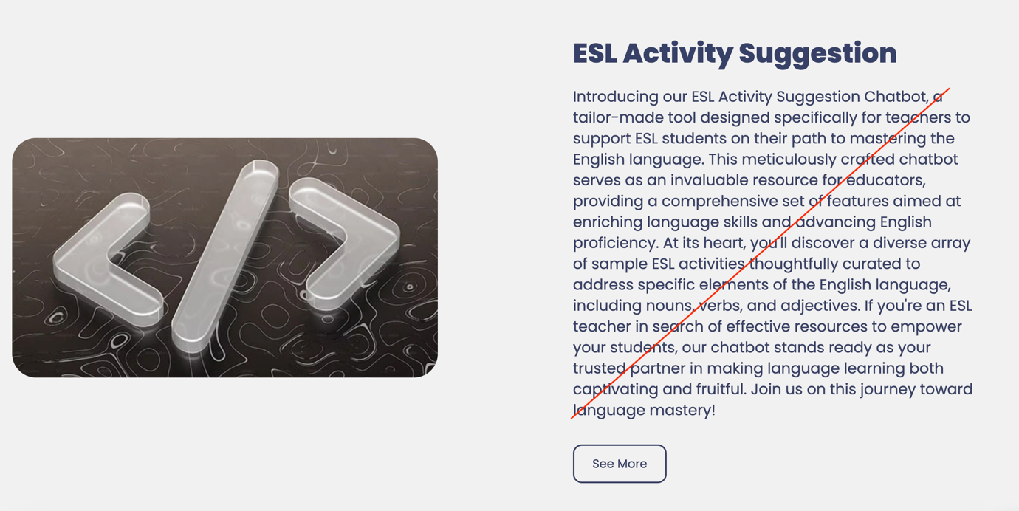

1. Centre this title under image:

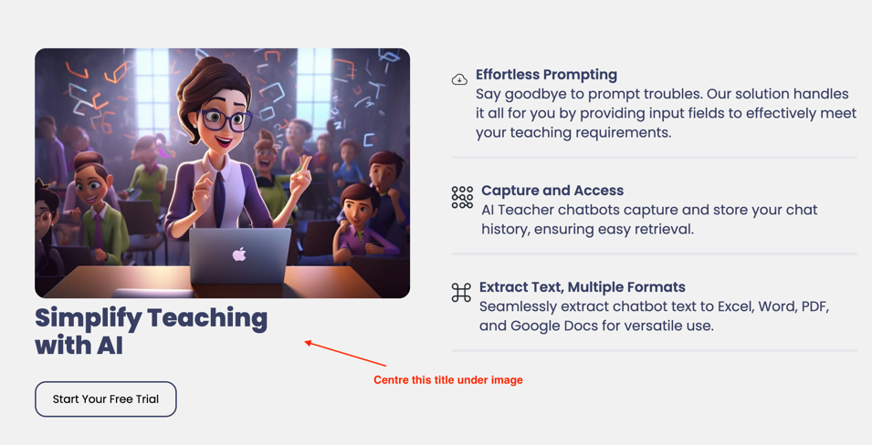

1. Update the form below:

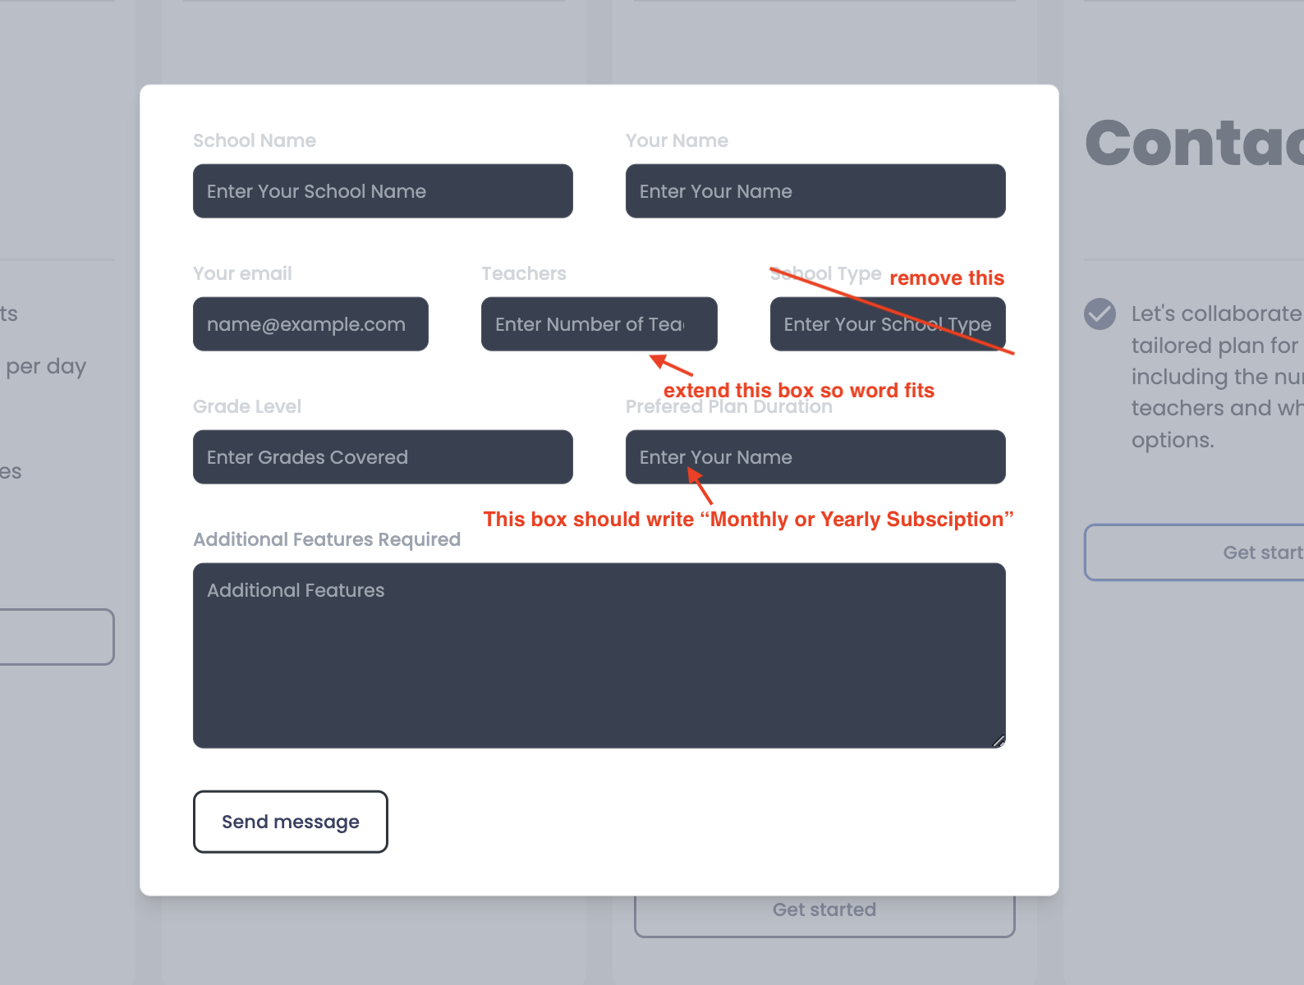

1. I am so sorry can we please add Instagram back

Instagram link is - <https://www.instagram.com/teachassist_ai/>

Update LinkedIn link - <https://www.linkedin.com/company/teach-assist-ai>

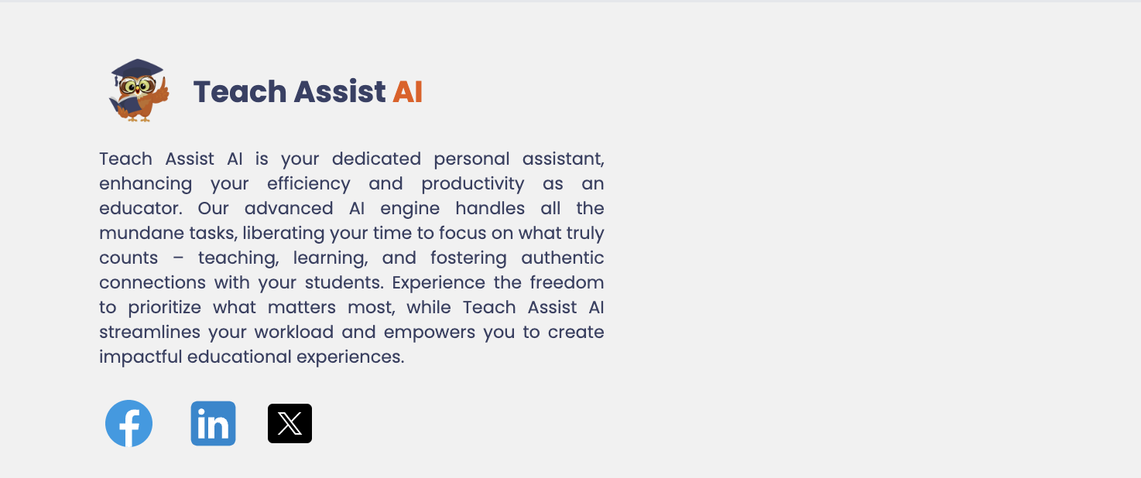

1. This one not updated:  
   Can you change below “Maximum 20 slides”

