**Final Project Report Submitted to**

**The Department of Computer Science**

**Faculty of Computer and Information Technology**

**Jordan University of Science and Technology**

**In Partial Fulfillment of the Requirements for the Degree of**

**Bachelors of Science in Computer Science**

**By**

**Khalil Abdallah Ali Alquraan (125028)**

**Hosni Mohammad Husni Hasan (127560)**

**Ali Amjed Saleem Khraim (123995)**

**Supervisor**

**Ahmad G. Alzu'bi**

**Semester**

**Fall (2020/2021)**

**نموذج حقوق الملكية الفكرية لمشاريع التخرج في قسم علوم الحاسوب**

**يتم قراءة وتوقيع هذا النموذج من قبل الطلاب المسجلين لمشاريع التخرج في قسم علوم الحاسوب**

تعود حقوق الملكية الفكرية لمشاريع التخرج ونتائجها (مثل براءات الاختراع أو أي منتج قابل للتسويق) إلى جامعة العلوم والتكنولوجيا الأردنية، وتخضع هذه الحقوق إلى قوانين وأنظمة وتعليمات الجامعة المتعلقة بالملكية الفكرية وبراءات الاختراع.

بناءا على ما سبق أوافق على ما يلي:

1. أن أحفظ كافة حقوق الملكية الفكرية لجامعة العلوم والتكنولوجيا الأردنية في مشروع التخرج.
2. أن ألتزم بوضع اسم جامعة العلوم والتكنولوجيا الأردنية وأسماء جميع الباحثين المشاركين في المشروع على أي نشرة علمية للمشروع كاملا أو لنتائجه. ويشمل ذلك النشر في المجلات والمؤتمرات العلمية عامة أو النشر على المواقع الإلكترونية أو براءات الاختراع أو المسابقات العلمية.
3. أن ألتزم بأسس حقوق التأليف المعتمدة في جامعة العلوم والتكنولوجيا الأردنية.
4. أن أقوم بإعلام الجهة المختصة في الجامعة عن أي اختراع أو اكتشاف قد ينتج عن هذا المشروع وأن ألتزم السرية التامة في ذلك وأن أعمل من خلال الجامعة على الحصول على براءة الاختراع التي قد تنتج عن هذا المشروع.
5. أن تكون جامعة العلوم والتكنولوجيا الأردنية هي المالك لأي براءة اختراع قد تنتج عن هذا المشروع وتشمل هذه الملكية حق الجامعة في إعطاء التراخيص والتسويق والبيع كمؤسسة راعية وداعمة لكافة الأنشطة البحثية. ويكون حق للطالب شمول اسمه على براءة الاختراع كأحد المخترعين، وفي حال تم إعطاء تراخيص أو تسويق وبيع لأي من منتجات المشروع يمنح المخترعون بما فيهم الطالب نسبة من الإيرادات حسب تعليمات البحث العلمي في جامعة العلوم والتكنولوجيا الأردنية.

إسم الطالب  *التوقيع*  إسم الطالب  *التوقيع*

إسم الطالب  *التوقيع*

إسم الطالب  *التوقيع*

**إسم المشرف  *التوقيع***

تاريخ 1/2/2021

# ABSTRACT

The covid-19 pandemic, known as coronavirus pandemic, has defined a global health crisis worldwide. The virus is primarily transmitted from person-to-person by coming into contact with an infected person. Because of the seriousness of this pandemic consequences, there is a demand to employ technology in order to monitor people and to identify the areas in Jordan with the aim at protecting them and save lives. Therefore, we inspired by these pandemic concerns and motivated to help the Jordanian government and people by offering a HealthMap system for Covid-19 tracking and monitoring. This project main goal is to facilitate and customize the existing services providing on Covid-19 cases them in more efficient and organized manner for all Jordan regions. In this system we divide Jordan map into several sub areas and make the Jordanian government and other audiences up to date on this pandemic by providing timely information and instructions using a dynamic interactive heat map with detailed statistics such as the total numbers of cases in Jordan and the current state of a specific region (safe, moderate, severe), death rates, and many other important information for protecting people and for making proper timely decisions based on our Covid-19 health map.

# TABLE OF CONTENTS

ABSTRACT 3

TABLE OF CONTENTS 4

LIST OF TABLES 6

LIST OF FIGURES 7

CHAPTER 1 8

1.1 Overview 8

1.1.1Motivation 8

1.1.2 Problem Definition 8

1.1.3 Technology Solution 9

1.2 Project Methodology 9

1.3 Summary of Project Functionalities 9

CHAPTER 2 11

2.1 Covid-19 Technology Solutions 11

2.2 Healthcare Maps 12

CHAPTER 3 13

3.1 System Planning 13

3.1.1 System Development Approach 13

3.1.2 Gantt chart 14

3.1.3 System Breakdown Structure 15

3.1.4 Teamwork Duties 16

3.2 Requirements Gathering 16

3.2.1 Quesionnair Forms 16

3.2.2 Quesionnair Results and Analysis 16

3.3 Requirements 19

3.3.1 System and user Requirements 19

3.3.2 Functional Requirements 19

3.3.3 Non-Functional Requirements 20

3.4 Organizational Structure 20

3.5 System Modelling 20

3.5.1 Use-Case diagram 21

3.5.2 Data Flow Diagram (Context Diagram) 22

3.5.3 DFD level-0 22

3.5.4 Activity Diagram 23

3.5.5 Sequence Diagram 24

3.5.6 E-R Diagram 25

3.5.7 Class Diagram 26

3.6 System Designs 27

3.6.1 Database Design 27

3.6.2 Form and Reports 28

3.6.3 Graphical User Interface (GUI) 32

CHAPTER 4 33

4.1 Web technologies 33

4.2 Web development 33

4.2.1 Front-End 33

4.2.2 Back**-**End 33

4.2.3 Framework 34

4.2.4 Data Base 34

4.2.5 Model-View-Controller (MVC) 34

4.2.6 API’s 34

4.3 Problem Solving. 35

1- Drawing the Jordan map and how to color a certain part of the map with a specific color we did not find any tool that will help us on that so after searching for a solution for this problem we found Google API’s and we solved the problem by using it. 35

2 -Taking information from every person based on their location and we solved that problem by using location IQ that provide us with the information of the location such as the region and the city names by using the Latitude and longitude of that region. 35

3 -you faced some problem with page redirection, and we solved that problem by using a pre-defined function. 35

CHAPTER 5 36

5.1 Testing 36

5.2 Validate 36

5.3 Update and Insert. 38

5.4 Functionality 39

CHAPTER 6 40

CONCLUSION 40

References 40

APPENDIX A 42

Meeting Minutes 42

APPENDIX B 49

Additional Questionnaire Results 49

# LIST OF TABLES

**Table 3.1** Team Activities 16

# LIST OF FIGURES

**Figure 3. 1** Waterfall Module 14

**Figure 3. 2** Gant chart. 14

**Figure 3. 3** System activates. 15

**Figure 3. 4** System Breakdown Structure 15

**Figure 3. 5** Results based on age interval. 17

**Figure 3. 6** Where people prefer to see the app 17

**Figure 3. 7** If field hospital existence is helpful. 18

**Figure 3. 8** if knowing the age of patients going to be useful. 18

**Figure 3. 9** use case diagram 21

**Figure 3. 10** Context diagram 22

**Figure 3. 11** DFD level 0 22

**Figure 3. 12** Level-0 DFD 22

**Figure 3. 13** Activity Diagram 23

**Figure 3. 14** Healthcare Manager Sequence Diagram 24

**Figure 3. 15** Guest Sequence Diagram 24

**Figure 3. 16** E-R Diagram 25

**Figure 3. 17** Class diagram 26

**Figure 3. 18** Database Relational Model 27

**Figure 3. 19** Login Form. 28

**Figure 3. 20** Signup Form. 29

**Figure 3. 21** New Case Form. 29

**Figure 3. 22** Report on the epidemiology situation on Jordan. 30

**Figure 3. 23** Report on the epidemiology situation on specific zone in Jordan. 31

**Figure 3. 24** Home Page. 32

**Figure B. 1** Results based on age interval. 49

**Figure B. 2** Results based on Governorates. 49

**Figure B. 3** Where people prefer to see the app 50

**Figure B. 4** If isolated regions Where people prefer to inform you. 50

**Figure B. 5** The extent of the people's satisfaction with knowing the epidemiological situation. 51

**Figure B. 6** People's interest in knowing the ages of the cases 51

**Figure B. 7** If field hospital existence is helpful. 52

**Figure B. 8** If knowing the age of patients going to be useful. 52

**CHAPTER** **1**  
introduction

This project work is proposed to help the government and support the Jordanian people in protecting themselves from Coronavirus. It will contribute in tracking the spread of the epidemic so that people can protect themselves and their families, and the government will also take appropriate measures to limit the virus spread and effects.

## **1.1 Overview**

**We attempt limiting the spread of the disease, assisting experts and scientists in tracking the spread of the disease in Jordan, and also providing a huge database to** study **the virus. Also, we aim at knowing the general epidemiological situation in Jordan and warning citizens of endemic areas, and alerting them in cases of closure (institutions, schools, governmental sector, regions).**

### 1.1.1Motivation

This pandemic has affected thousands of peoples, who are either sick or being killed due to the spread of this disease. COVID-19 (Coronavirus) has affected day to day life and is slowing down the global economy. And we all know the size of the Corona crisis in Jordan and its impact on all medical, economic, and social aspects, so it was necessary to make use of technology to limit the spread of the virus.

### 1.1.2 Problem Definition

Being a new viral disease affecting humans for the first time, vaccines are not yet available, the emphasis is on taking extensive precautions such as extensive hygiene protocol (regularly washing of hands, avoidance of face-to-face interaction, etc.), social distancing, and wearing of masks, and so on.

This virus is spreading exponentially region wise. Countries are banning gatherings of people to spread and break the exponential curve. Many countries are locking their population and enforcing strict quarantine to control the spread of the havoc of this highly communicable disease.

The reason for the covid-19 occurrence people started practicing social distancing as it is the best way to reduce the spread of coronavirus disease and started to avoid the public areas. Even there are some countries abandoned flying for certain countries, the impacts of COVID-19 in nowadays are extensive and have far-reaching consequences.

These can be divided into three categories:

* Healthcare
* Economic
* Social

### 1.1.3 Technology Solution

A website will be developed to provide updated information and instructions. It will be a dynamic interactive heat map about Covid-19 in all Jordanian regions so people can protect themselves and their families and take appropriate measures to reduce the virus impacts. This graphical health map will also concentrate on enabling front-line health workers to make the diagnosis more quickly and more accurately, which will in turn reduce the risk of further spread of the virus.

This system is supposed to connect the people, E-health parties, centers of rapid point-of-care diagnostic tests, and the government. And providing the latest instructions developments about the disease from reliable sources such as the World Health Organization, which contributes to raising awareness of citizens and contributing to the elimination of the disease.

## **1.2 Project Methodology**

This project uses ArcMap where you display and explore GIS datasets for you in Jordan, and Spring Boot makes it easy to create standalone web applications that are connected to a database of infected people's information.

This platform will link people, E-health parties, and government

through the following steps:

* Create an account either by natural people or E-health parties on this platform.
* Natural people can see some services like (total Cases and Case-Fatality, number of active cases, filed hospital, etc.)

• E-health parties can view all services, enter new cases, and track the virus.

## **1.3 Summary of Project Functionalities**

* **View map:** guest can view the map; it will contain detail about Covid-19 and detail of the location of cases and hospital, the map provides colored zones represent numbers of cases in specific area
* **Statistics:** guest can see the result for data collected and analyzed of Covid-19
* **Healthy instruction:** guest can take information and instruction of Covid-19.
* **Generate Report:** user can generate report about some statistics and state of system.
* **Notification:** user can generate notification to some region
* **Update data:** user can manipulate data (edit, delete, add)

**1.4 Summary of the Results**

Many people will benefit from our system since the system provides people with the necessary information to help them protect themselves and reduce the number of injuries and ways to deal with cases. The system provides visitors about the areas with high casualties and places where the centers are located where the system colors the dangerous areas with a red balloon and the safe areas with a green balloon. The system sends notifications to the site’s visitors. It also helps the medical teams in fighting the epidemic and knowing the places in which the cases is increasing, which helps them perform their work and reduce the spread of the epidemic and control it then enter data specialists in the health sector.

# **CHAPTER** 2

**REVIEW OF RELATED LITERATURE**

The aim of this review is to highlight the existing projects and benefit from the experiences exerted in them to build on them and improve their services. This helps in shortening the time and exploring the errors and obstacles that others systems have faced, which leads to a better and more reliable monitoring system.

## **2.1 Covid-19 Technology Solutions**

With high transmissibility and no effective vaccine or therapy, COVID-19 is now a global pandemic. Government-coordinated efforts across the globe have focused on containment and mitigation, with varying degrees of success. Countries that have maintained low COVID-19 per-capita mortality rates appear to share strategies that include early surveillance, testing, contact tracing, and strict quarantine. The scale of coordination and data management required for effective implementation of these strategies has—in most successful countries—relied on adopting digital technology and integrating it into policy and health care. This Viewpoint provides a framework for the application of digital technologies in pandemic management and response, highlighting ways in which successful countries have adopted these technologies for pandemic planning, surveillance, testing, contact tracing, quarantine, and health care.

Digital health technology can facilitate pandemic strategy and response in ways that are difficult to achieve manually. Countries such as South Korea have integrated digital technology into government-coordinated containment and mitigation processes—including surveillance, testing, contact tracing, and strict quarantine—which could be associated with the early flattening of their incidence curves. Although South Korea has incurred only 0·5 COVID-19 deaths per 100 000 people, the USA, with three times as many intensive care unit beds per 100 000 people and ranked number one in pandemic preparedness before the COVID-19 pandemic, has sustained ten times as many deaths per capita.

This Viewpoint provides a framework for the application of digital technologies in pandemic management and response, highlighting ways in which successful countries have adopted and integrated digital technologies for pandemic planning, surveillance, testing, contact tracing, quarantine, and health care [1].

## **2.2 Healthcare Maps**

COVID-19 is a big problem faced in this period; it makes for the world a lot of problems. it is our interest to optimize and customize existing services by providing them in a better and easier way and more detailed for the Jordan region, in this section I mention some of the existing systems providing this service and determine some point about it, there is a lot of features shared between them.

* **World Health Organization (Map)** [2]**:**

The World Health Organization provided a service to find out the number of cases, the number of deaths in each country, the total number of cases in the world, the number of daily cases, and the total number of deaths. These were provided on the service in the form of a map. And the colors of the countries on the map indicate the number of cases in them.

* **Jordanian Ministry of Health (without Map)** [3]**:**

The Jordanian Ministry of Health is the official body to announce the number of cases and the number of deaths and displays the number of daily examinations, daily recovery, and the percentage of positive examinations, total cases, total deaths, and active cases. The Ministry of Health provides educational information such as methods of transmission, symptoms of injury, and preventive measures.

* **HealthMap | Covid-19 (Map)** [4]:

Website to view the number of cases in the world and the number of cases in each country and the classification of countries depending on the number of cases and the site provides an electronic timeline for the spread of cases since the start of the pandemic.

# CHAPTER 3

**SYSTEM ANALYSIS AND DESIGN**

This chapter presents the system planning phase, requirements and how we gathered them, system structures and modelling, and initial design draft of database, forms/reports, and main GUIs. As will be illustrated next, we used two ways to gather our requirements: the first one is questioner by making forms and we made two type of forms the first one we share it with everyone because we want to know the people opinions and what they need to see in our application. The second form is shared with the medical specialists (doctors, nurses and anyone who is dealing with covid-19 in the medical section) and we tried to reach the largest number of the people who is involved because they know better how to deal with covid-19 and how to protect people from. Finally, we adopted the business document analysis (the existing systems), and we tried our best to gather the largest number of data to make our information more accurate to add any helpful features for the citizens and the medical field.

## **3.1 System Planning**

### 3.1.1 System Development Approach

We have used Waterfall model for our system which is a software development model in which development is seen as flowing steadily downwards (like a waterfall) through the phases of requirements. We have used Analysis, design, implementation, and testing phases, as shown in Figure 3.1.

1. **Planning**: as our system proceeds from one phase to another in sequential and systematic manner i.e., the phases are well segregated and only after the completion of one phase, the development of software moves to the next phase.
2. **Analysis:** as our system is simple to implement and represents processes which are easy to manage and measure.
3. **Design:** all the requirements stated by the user are known before hand and are well understood.
4. **Implementation:** this is a short duration project as shown in Figure 3.1

**Figure 3.1** Show presentation for the step of the Waterfall Model

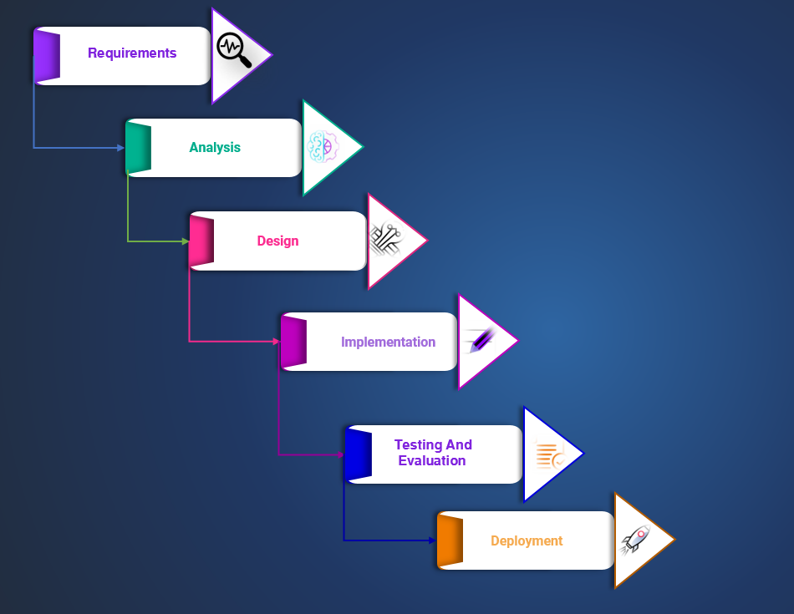

**Figure 3. 1** Waterfall Module

### 3.1.2 Gantt chart

Figure 3.2Show the processing timeline of system development that we attempt to accomplish. Figure 3.3also shows the main system activates with time durations.

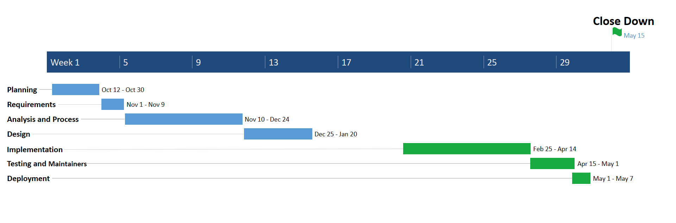

**Figure 3. 2** Gant chart.

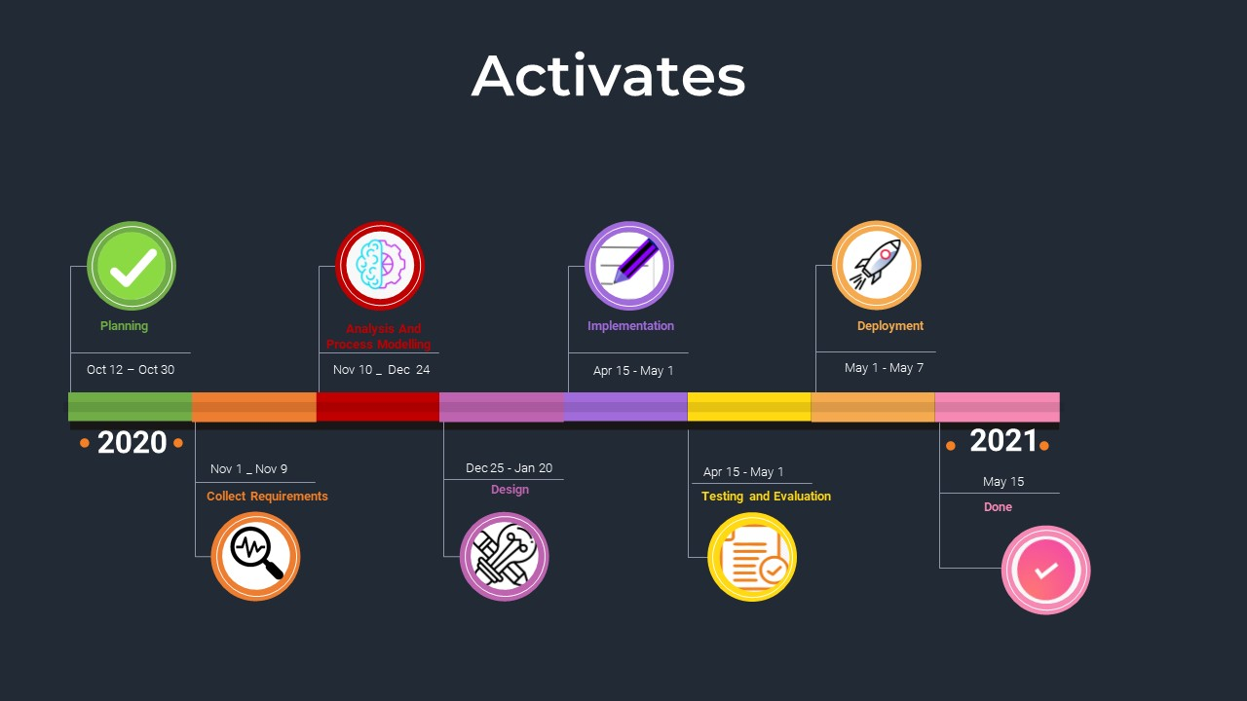

**Figure 3. 3** System activates.

### 3.1.3 System Breakdown Structure

A hierarchy of elements, related life cycle processes, and personnel used to assign development teams, conduct technical reviews, and to partition out the assigned work and associated resource allocations to each of the tasks necessary to accomplish the objectives of the project.

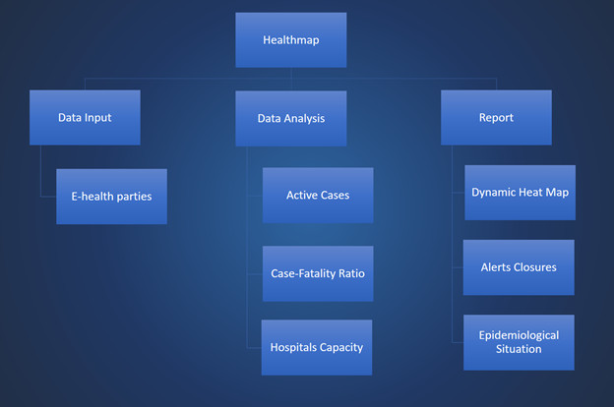

**Figure 3. 4** System Breakdown Structure

### 3.1.4 Teamwork Duties

Teamwork is the collaborative effort of a group to achieve a common goal or to complete a task in the most effective and efficient way.Teamwork is present in any context where a group of people is working together to achieve a common goal.

**Table 1** Team Activities

|  |  |
| --- | --- |
| **Phase** | **Team members** |
| **Planning** | **Ali and Hosni** |
| **Requirement** | **Ali** |
| **Analysis and Process** | **Khalil and Hosni** |
| **Implementation** | **Hosni, Khalil and Ali** |
| **Testing and Maintenance** | **Ali and Hosni** |
| **Deployment** | **Khalil** |

## **3.2 Requirements Gathering**

Approchaes (interviews/ questionnaires /observation/existing systems analysis), and because of the covid-19 situation we could not use interview or observation method so we went to the questionnaires method .

### 3.2.1 Quesionnair Forms

We made the general because we wanted to see what people want to see in our application and what they think is going to be helpful, more result samples shown in **Appendix B.** We made the specialists form to gather information from the specialists and see how our appllication should work, more result samples shown in **Appendix B.**

### 3.2.2 Quesionnair Results and Analysis

we made two types of forms the first one if for the normal people and the scound one is for the midical field.

* **The general form**

In this form we were aiming to get people oponions about wjat tjey want to see in our application such as they want to be notified about the near areas that having a big number of inficted people or to remind them to ware masks by sending notification to them . And after asking the specialist we figure out some features it must be in our application and how to classify the areas and how to help with dealing the positive cases .

Figure 3.5 shows the results of the age range of the people who participate in filling the questionnaires.

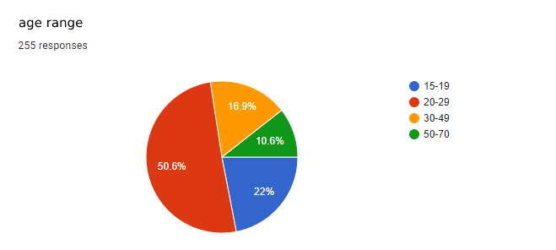

**Figure 3. 5** Results based on age interval.

**Figure 3.6** shows how if having a field hospital going to be helpful with dealing with covid-19.

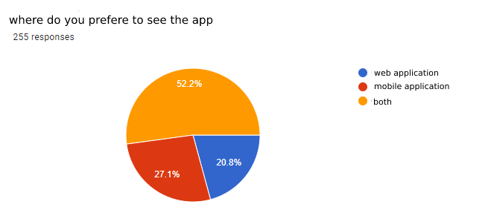

**Figure 3. 6** Where people prefer to see the app

* **The midical field form.**

In this form we were aiming to get the expert oponions about some covid-19 protocols such as what is the standers of classfecate the red , yellow amd green areas were the most answers foucesd on the number of infected people to the number of tests.

**Figure 3.7** shows how if having a field hospital going to be helpful with dealing with covid-19.

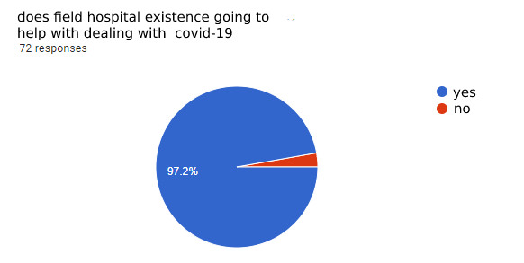

**Figure 3. 7** If field hospital existence is helpful.

**Figure 3.8** shows if knowing the infected age is going to be useful for the doctors.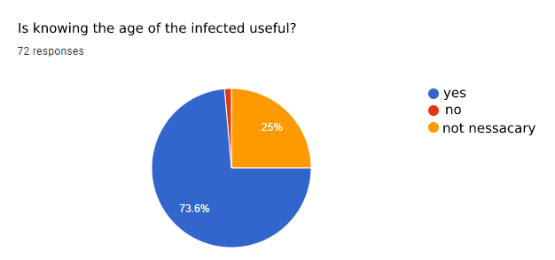

**Figure 3. 8** if knowing the age of patients going to be useful.

## **3.3 Requirements**

After we gathered as discussed in Sections 3.1, we present here the list of functional and the nun-functional requirements.

### 3.3.1 System and user Requirements

* Browsers
* operating system
* Video card hardware and drivers
* spring boot platform

### 3.3.2 Functional Requirements

* **Detailed Jordan map:** An epidemiological map detailing all parts of the Kingdom showing the nature of the spread of the virus between district "Liwaa".
* **Heat map:** Description of the district in different colors according to the epidemiological situation in the city, starting with the green color "low cases" To a dark red "Epidemic propagation.".
* **Instruction of dealing with COVID-19:** providing updated information and instructions about the disease from reliable sources such as the World Health Organization.
* **Number of cumulative cases in Jordan:** Show the total Cases and Case-Fatality in Jordan and all-district.
* **Number of deaths in Jordan:** number of deaths in Jordan and distributed it for each city and determine the age of deaths (show number of deaths per day and total death for each city).
* **Active case in Jordan:** number of active cases in Jordan and distributed it for each city.
* **Death rate:** The death rate of COVID-19 in Jordan and distributed it for each city.
* **Testing rate:** number of tests in Jordan and distributed it for each city and rate positive test to negative test.
* **Number of recovered cases**.
* **Daily cases:** The daily number of cases dividing and counting the cases by region.
* **Number of the case in the hospital:** The number of the case in the hospital appear the number of cases that are recovering in the hospital.
* **Chart for a confirmed case:** covid-19 confirmed cases chart drawing a curve chart that displays the increase and decreases cases daily.
* **Locations of the hospital (filed hospital):** hospital (filed hospital) Location adds the location of the hospitals and the field hospitals that deal with covid-19 on the map.
* **Covid-19 testing clinics locations:** Covid-19 testing clinics locations add the location of the clinics the do covid-19 test.
* **Defining the age of cases:** Defining the age of cases by region dividing the cases by age per region.

### 3.3.3 Non-Functional Requirements

* **Usability:** is a measure of how well a specific user in a specific context can use a product/design to achieve a defined goal effectively.
* **Reliability:** The probability of failure-free **software** operation for a specified period in a specified environment. It can be an important factor affecting system reliability.
* **Performance and Supportability:** How fast does the system return results? How much will this performance change with higher workloads?
* **Security:** as part of the [software development process](https://en.wikipedia.org/wiki/Software_development_process), is an ongoing process involving people and practices, and ensures application confidentiality, integrity.
* **Maintainability:** phase in the [software development cycle](https://raygun.com/blog/software-development-life-cycle/#the-seven-phases) that starts after the customer has received the product.

## **3.4 Organizational Structure**

Organizational structure outlines how certain activities are directed to achieve the goals of an organization. These activities can include rules, roles, and responsibilities [5]. The organizational structure also determines how information flows between levels within the company. We have presented a mirror of this structure in a form of break down structure in **section 3.1.3**.

## **3.5 System Modelling**

System modeling is the process of developing abstract models of a system, with each model presenting a different view or perspective of that system. It is about representing a system using some kind of graphical notation, which is now almost always based on notations in the **Unified Modeling Language** (**UML**). Models help the analyst to understand the functionality of the system; they are used to communicate with customers.

### 3.5.1 Use-Case diagram

Use case diagrams are typically developed in the early stage of development and people often apply use case modeling for

* Specify the context of a system.
* Capture the requirements of a system.
* Validate a system architecture.
* Drive implementation and generate test cases.
* Developed by analysts together with domain experts.

**Figure 3. 9** use case diagram

### 3.5.2 Data Flow Diagram (Context Diagram)

[Context diagram](https://www.modernanalyst.com/Resources/Articles/tabid/115/ID/1355/Introduction-to-Context-Diagrams.aspx) shows the system under consideration as a single high-level process and then shows the relationship that the system has with other external entities.

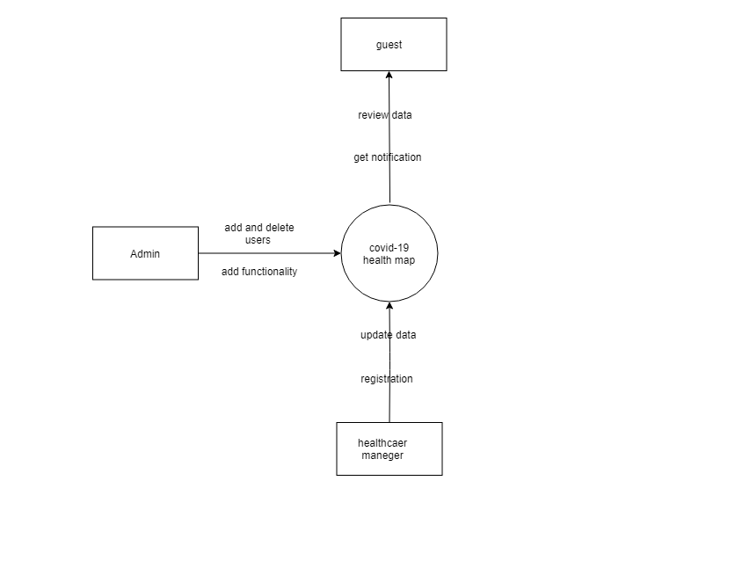

**Figure 3. 10** Context diagram

### 3.5.3 DFD level-0

Data flow diagram (DFD) is a graphical representation of the "flow" of data through an information system, modelling its process aspects.

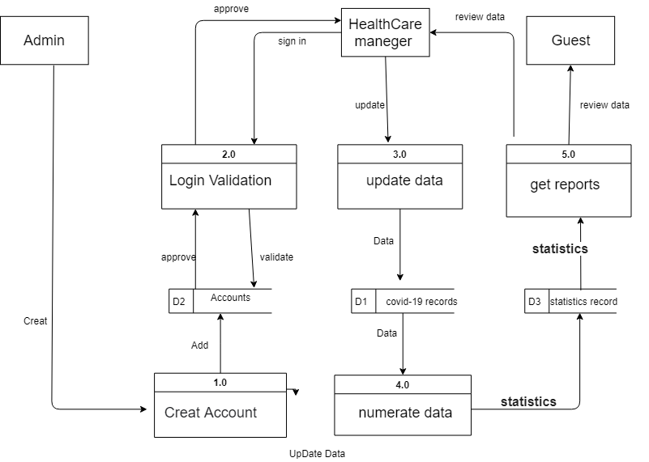

**Figure 3. 11** DFD level 0

**Figure 3. 12** Level-0 DFD

### 3.5.4 Activity Diagram

Activity diagram is essentially an advanced version of flow chart that modeling the flow from one activity to another activity.

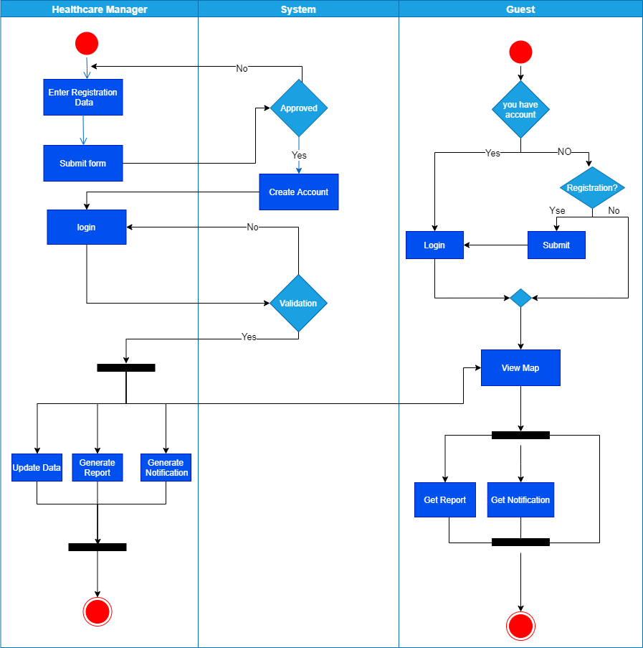

**Figure 3. 13** Activity Diagram

### 3.5.5 Sequence Diagram

Sequence Diagrams are interaction diagrams that detail how operations are carried out. They capture the interaction between objects in the context of a collaboration.

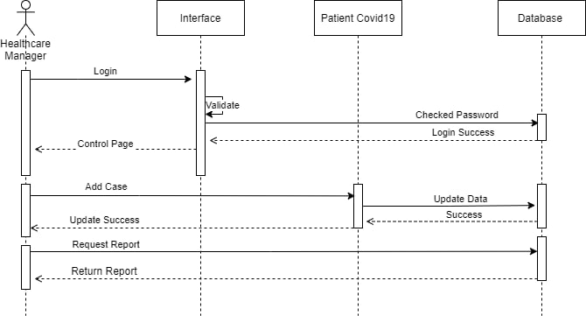

**Figure 3. 14** Healthcare Manager Sequence Diagram

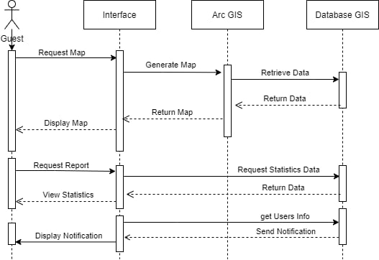

**Figure 3. 15** Guest Sequence Diagram

### 3.5.6 E-R Diagram

Entity-Relationship Diagram (ERD) shows the relationships of entity sets stored in a database. An entity in this context is an object, a component of data.

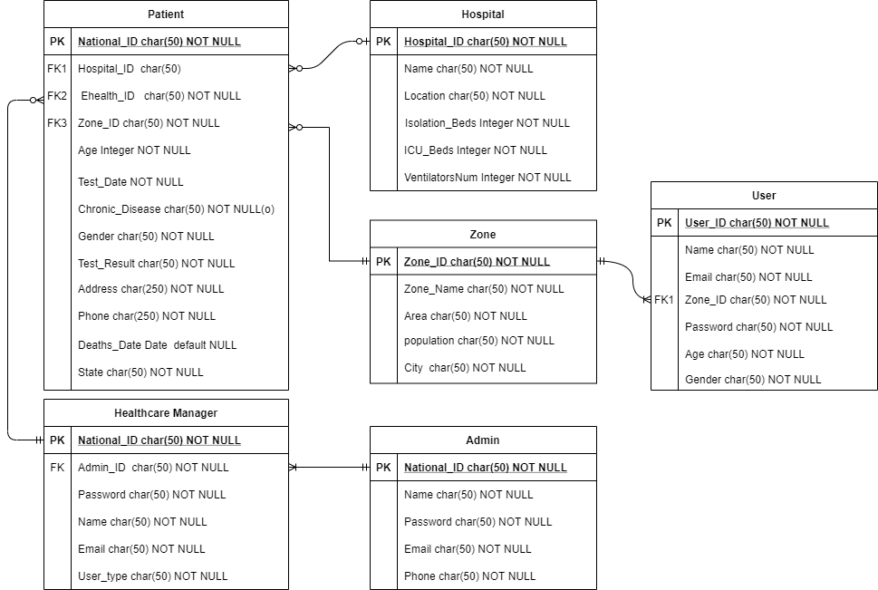

**Figure 3. 16** E-R Diagram

### 3.5.7 Class Diagram

It describes the structure of a system by showing the system's classes, their attributes, operations (or methods), and the relationships among objects.

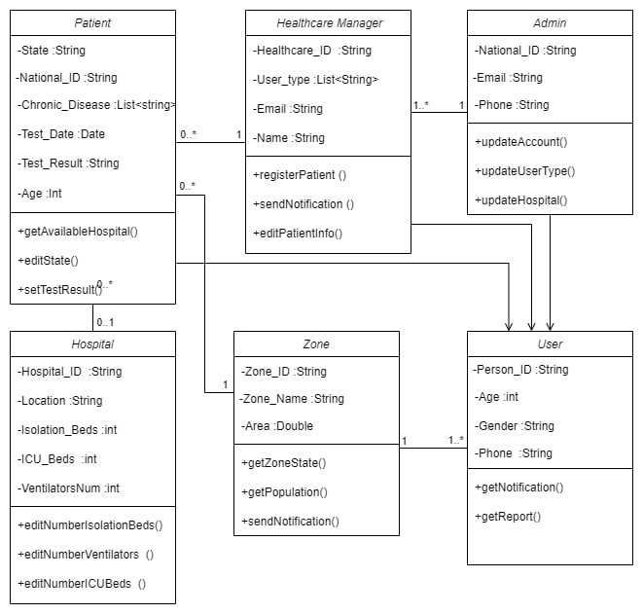

**Figure 3. 17** Class diagram

## **3.6 System Designs**

Systems design is the process of defining elements of a system like modules, architecture, components and their interfaces and data for a system based on the specified requirements. It is the process of defining, developing, and designing systems which satisfies the specific needs and requirements of a business or organization.

### 3.6.1 Database Design

Database design is the organization of data according to a database model. The designer determines what data must be stored and how the data elements interrelate. With this information, they can begin to fit the data to the database model.(6)

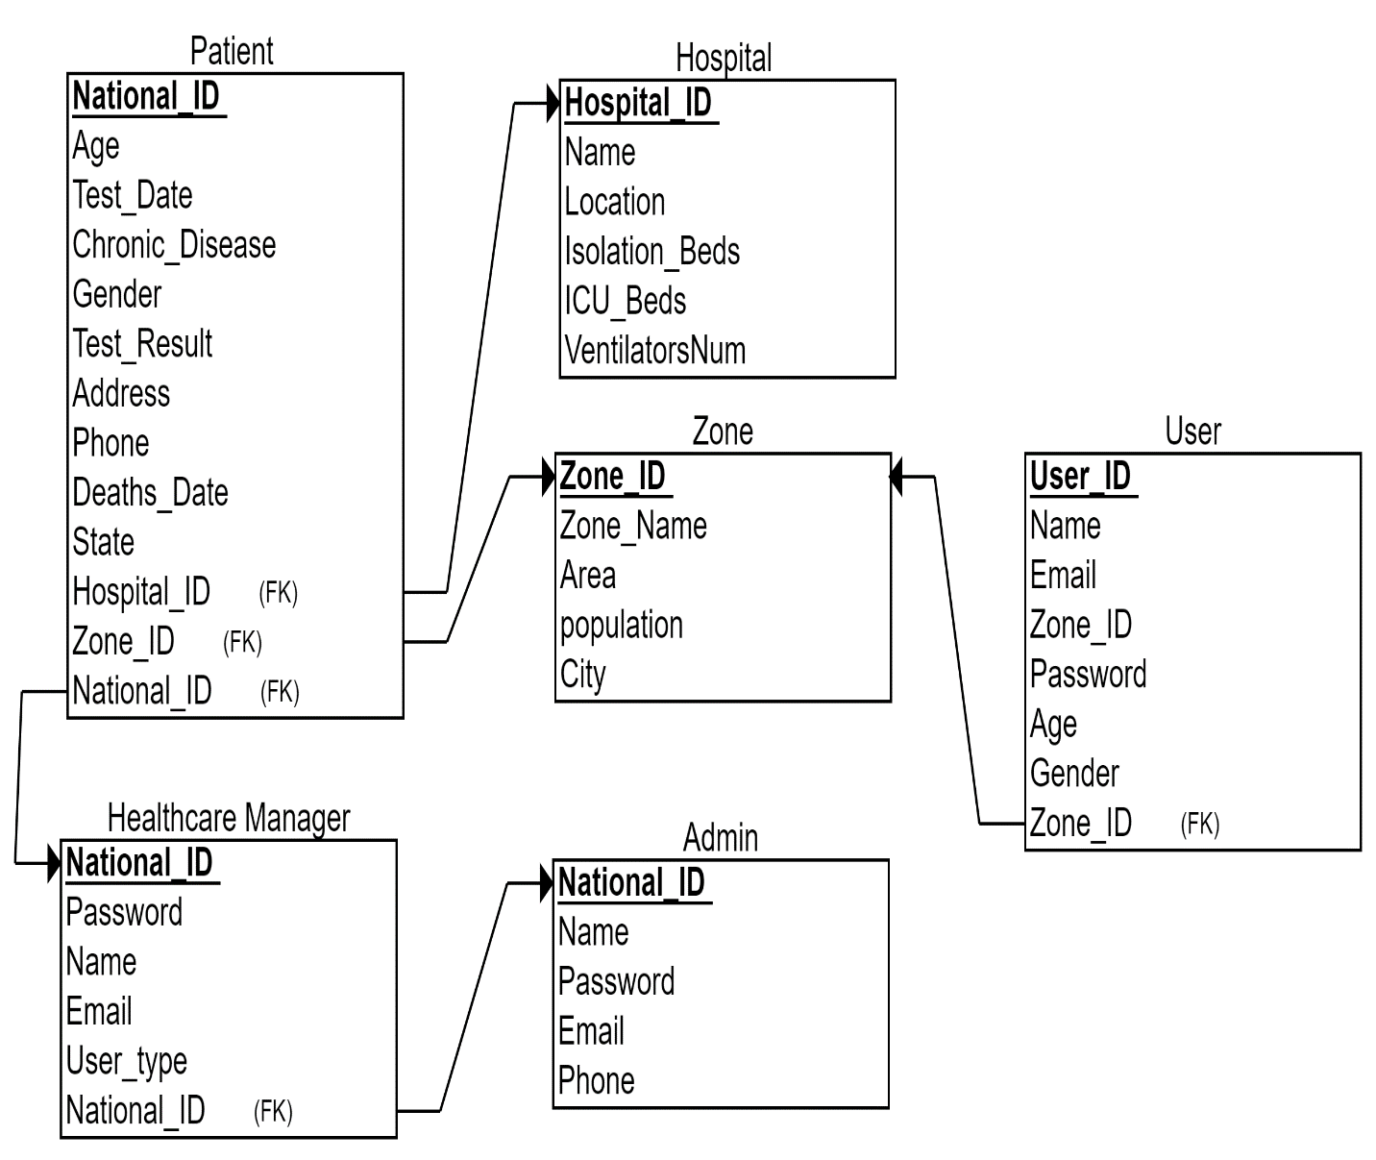

**Figure 3. 18** Database Relational Model

### 3.6.2 Form and Reports

A **form** is used to input data whereas a **report** is generated from the data that has been inputted and report is a summary of an information.

* **Forms**

**Forms** are Input to the information system.

A Login form is used to enter authentication credentials to access a restricted page or form. The login form contains a field for the username and another for the password. 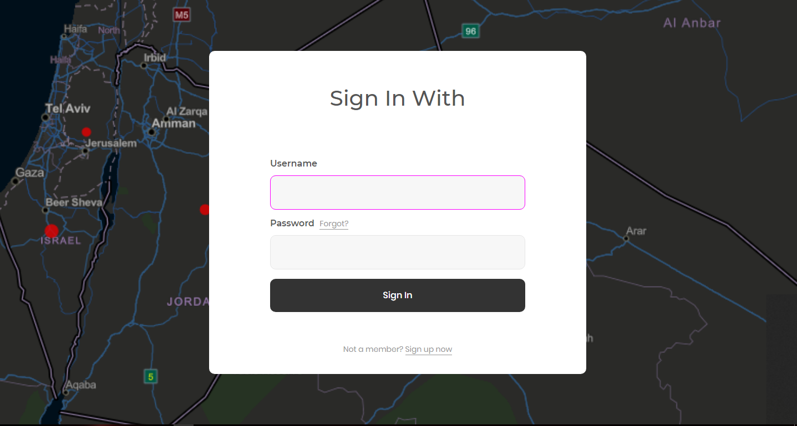

**Figure 3. 19** Login Form.

 signup form allows for the collection of the essential pieces of information for a constituent and a means to subscribe that constituent to your email list.

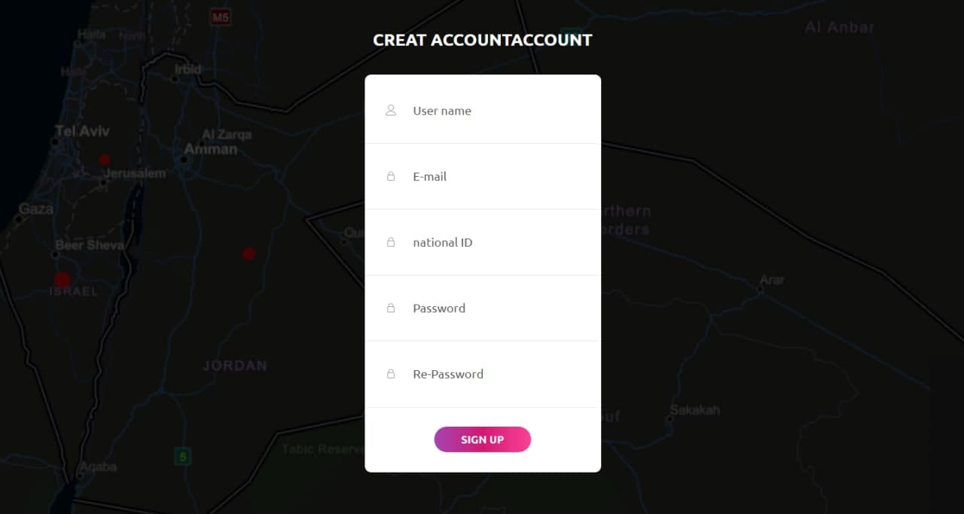

**Figure 3. 20** Signup Form.

New Case form allows health care manager to add new case and add the essential information about the case.

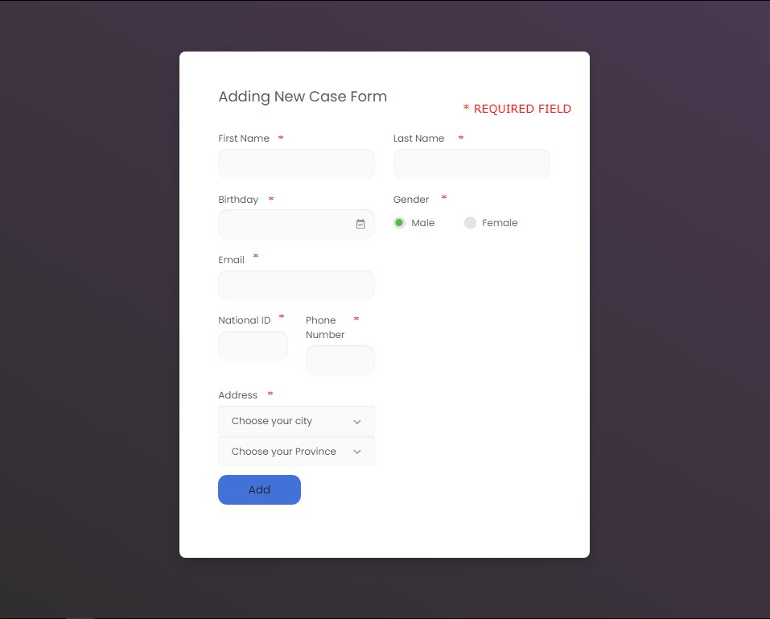

**Figure 3. 21** New Case Form.

* **Reports**

Report use for show summary of information in system.

Report on the epidemiology situation on Jordan show all information about the epidemiology situation in Jordan and information in each City.

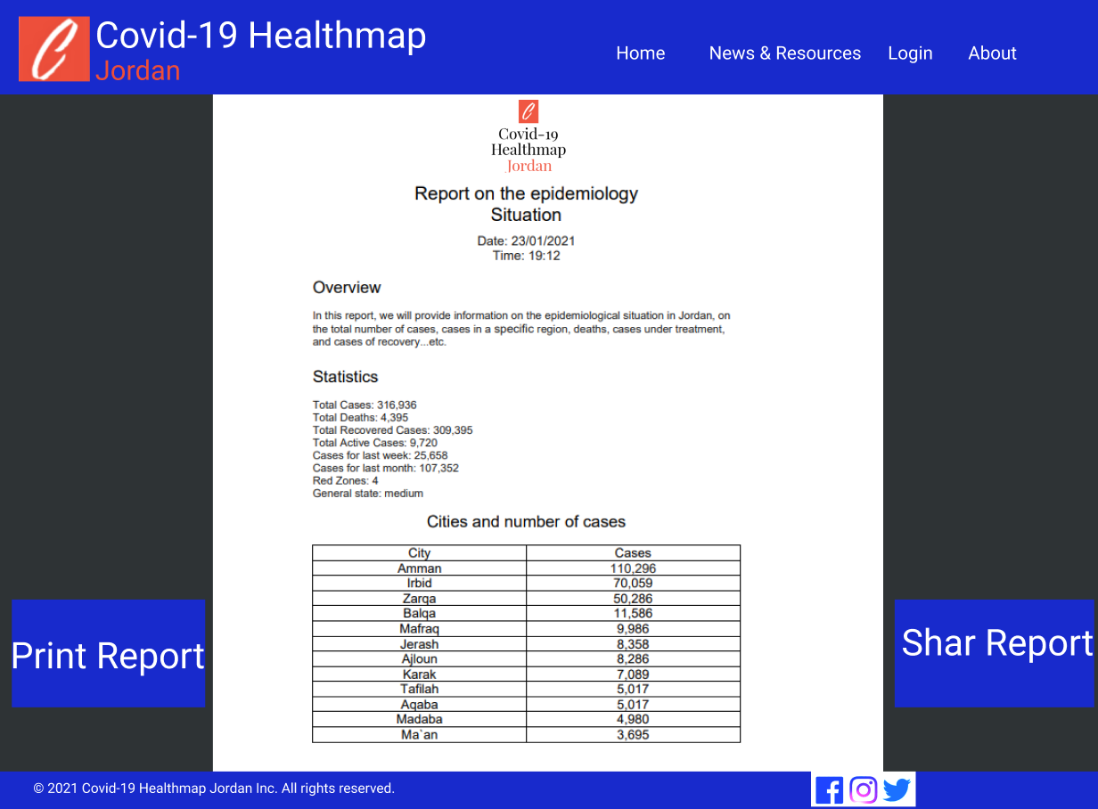

**Figure 3. 22** Report on the epidemiology situation on Jordan.

Report on the epidemiology situation on specific zone in Jordan show all infromation about epidemiology in specific zone in Jordan.

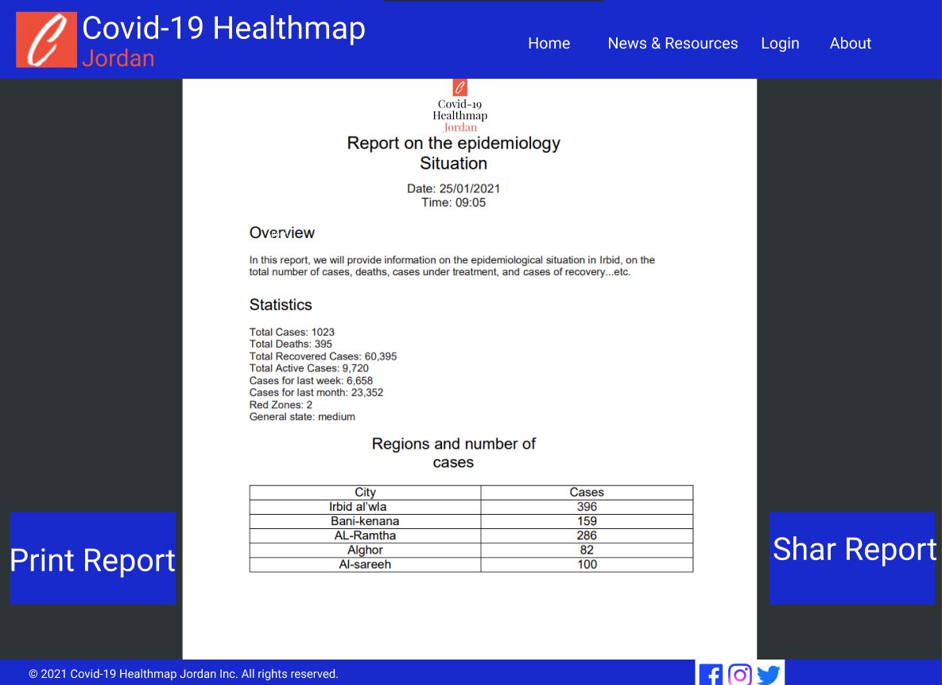

**Figure 3. 23** Report on the epidemiology situation on specific zone in Jordan.

### 3.6.3 Graphical User Interface (GUI)

A **GUI** (**graphical user interface**) is interactive visual components for computer software. A **GUI** displays objects that convey information and represent actions that can be taken by the user. The objects change color, size, or visibility when the user interacts with them. [7]

 A **home page** is a webpage that serves as the starting point of **website**. It is the default webpage that loads when you visit a web address.

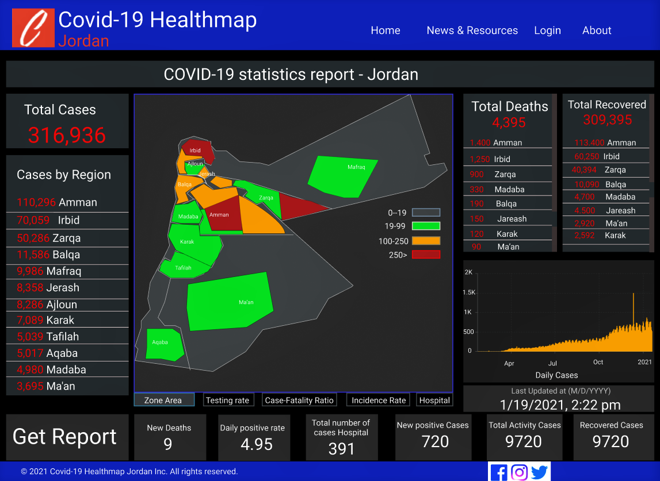

**Figure 3. 24** Home Page.

# CHAPTER 4

IMPLEMENTATION

## **4.1 Web technologies**

we can simply define web technologies that a different tool and

techniques that are used in the process of communication between

different types of devices over the internet.

There are a different types of web technologies such as:

1- web browsers   
  
2-Programming languages and frameworks which are used in the

development of websites.

3- Databases that are used at the backend to store data required or   
 collected by websites.

## **4.2 Web development**

### 4.2.1 Front-End

we can define front-end as a practice of producing HTML, CSS and JavaScript for a website or Web Application so that a user can see and interact with them directly.  
in our web application tried to make a good UX and UI to make our application easy to use by using HTML, CSS, Java-Script, Bootstrap, Ajax and other libraries that support our purpose.

### Back**-**End

we can define Back-End as a server-side development. It focuses on databases, scripting, website architecture. It contains behind-the-scenes activities that occur when performing any action on a website.   
  
in our application we used PHP as programming language for several reasons such as that php can interact with many different database languages including MySQL, the **Fast Load Time of php,** **Database Flexibility,** a large collection of open source addons.

### Framework

we can define the framework as a platform that provides a foundation for developing software applications. Think of it as a template of a working program that can be selectively modified by adding code. It uses shared resources such as libraries, image files, and reference documents and puts them. Together in one package.

We used php cack as a framework Cake PHP is an open-source PHP framework for building web applications faster. Most importantly, it helps make the task simpler by minimizing the need to build your application from scratch.

### Data Base

is a collection of data that is organized so the information within can be easily accessed later. Your data will be more accurate, reliable, and easy to use if you have a database. In our application we used MySQL, MySQL, is the most popular Open-Source SQL database management system, is developed, distributed, and supported by Oracle Corporation.   
and we is MySQL because it’s Advantages such as Data Security, On-Demand Scalability, High Performance, The Flexibility Of Open Source.

### Model-View-Controller (MVC)

is an architectural pattern that separates an application into three main logical components: the model, the view, and the controller. Each of these components are built to handle specific development aspects of an application. MVC is one of the most frequently used industry-standard web development framework to create scalable and extensible projects We used MVC because of its advantages such as Faster Development Process, Ability to Provide Multiple Views, Ability to Provide Multiple Views the Modification Does Not Affect the Entire Model and MVC Model Returns The Data Without Formatting.

### API’s

is a set of programming code that enables data transmission between one software product and another. It also contains the terms of this data exchange. We used “Blazing fast Location APIs” it is a web serves by location,  
and we used Google heat map API to draw the map.

## **4.3 Problem Solving.**

### 1- Drawing the Jordan map and how to color a certain part of the map with a specific color we did not find any tool that will help us on that so after searching for a solution for this problem we found Google API’s and we solved the problem by using it.

### 2 -Taking information from every person based on their location and we solved that problem by using location IQ that provide us with the information of the location such as the region and the city names by using the Latitude and longitude of that region.

### 3 -you faced some problem with page redirection, and we solved that problem by using a pre-defined function.

# CHAPTER 5

TESTING AND EVALUATION

## **5.1 Testing**

is a method to check whether the actual software product matches expected requirements and to ensure that software product is Defect free. It involves execution of software/system components using manual or automated tools to evaluate one or more properties of interest. The purpose of software testing is to identify errors, gaps or missing requirements in contrast to actual requirements.

## **5.2 Validate**

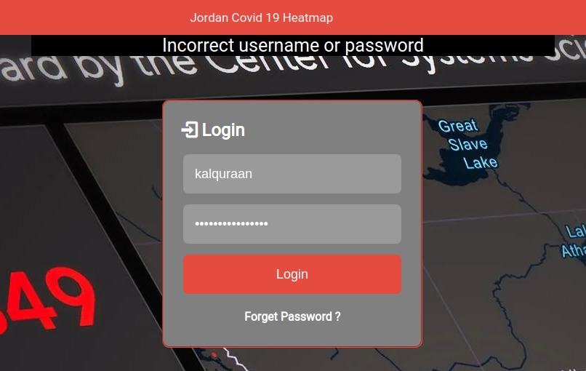

**Figure 5.2.1** Login Validate.

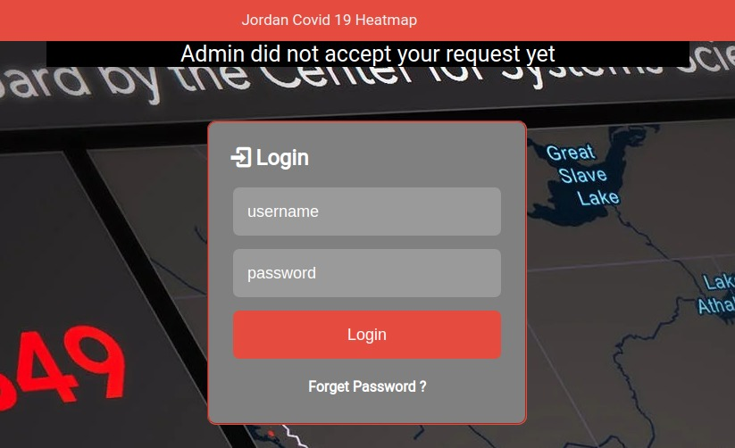

**Figure** 5.2.2 Permission Validate.

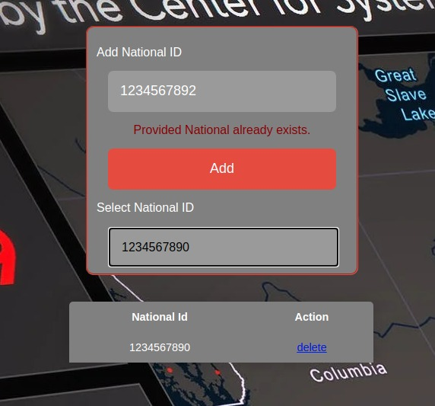

**Figure** 5.2.3 Already Exits Validate.

## **5.3 Update and Insert.**

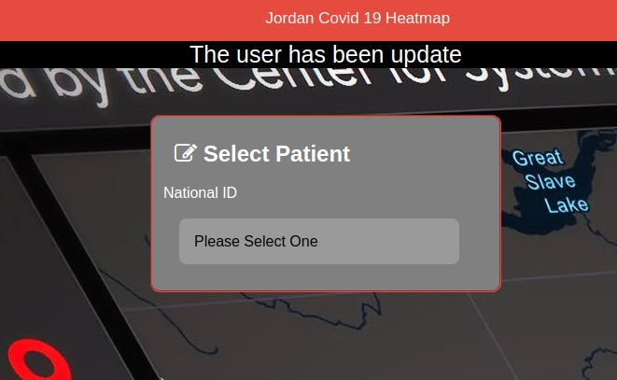

**Figure** 5.3.1 Update Case.

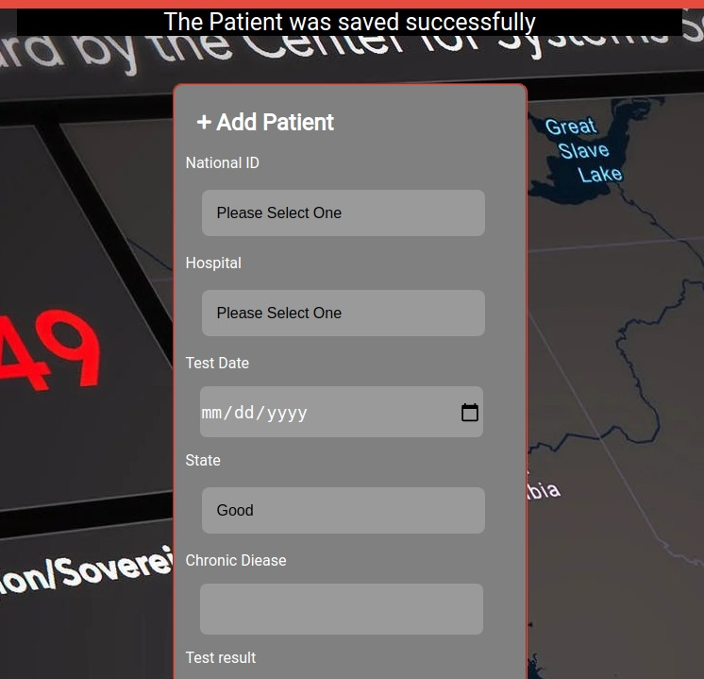

**Figure** 5.3.2 Insert Case.

## **5.4 Functionality**

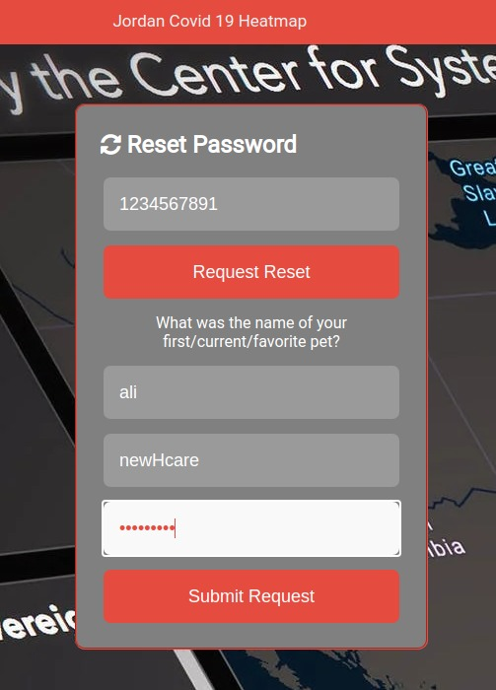

**Figure** 5.4.1 Reset Password

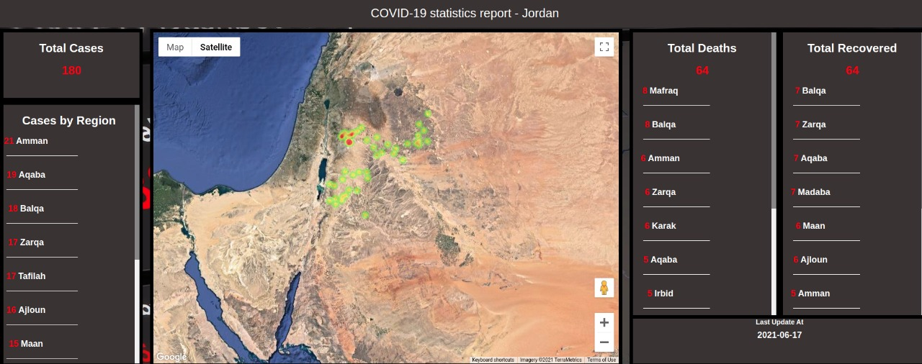

**Figure** 5.4.2 Home Page.

# CHAPTER 6

## **CONCLUSION**

After all our system aims to make the process of avoiding the area’s that contains a lot of covid-19 cases easier by only looking to the responsive heat map and to help the medical sector to detective the covid-19 cases were every case in the map is spotted with a dot ,every group of dots are making the area appear with a light red color if the cases are a lot the area will appear as a red area .

Our System’s strengths and weaknesses:

• Strengths:

o Secure as every user gets one account on his National ID.

o Easy to use with a good UI/UX.

o Responsive heat map where the map is updated immediately whenever the case is added.

• Weaknesses:

• You cannot generate a report

• The system is built on an old technology.

# References

[1] Retrieved from https://www.sciencedirect.com/science/article/pii/S2589750020301424

[2] Retrieved from https://covid19.who.int/

[3] Retrieved from https://www.healthmap.org/covid-19/

[4] Retrieved from https://corona.moh.gov.jo/ar

[5] Retrieved from https://www.investopedia.com/terms/o/organizational-structure.asp#:~:text=An%20organizational%20structure%20is%20a,between%20levels%20within%20the%20company

[6] Retrieved from https://en.wikipedia.org/wiki/Database_design#:~:text=Database%20design%20is%20the%20organization,how%20the%20data%20elements%20interrelate.&text=Database%20design%20involves%20classifying%20data,data%20is%20called%20an%20ontology.

[7] Retrieved from https://www.computerhope.com/jargon/g/gui.htm#:~:text=A%20GUI%20(graphical%20user%20interface)%20is%20a%20system%20of%20interactive,the%20user%20interacts%20with%20them.

## **APPENDIX A**

## **Meeting Minutes**

**Meeting Minutes (1)**

* **Date and Time:** Sunday 1/11/2020
* **Attendee:** Ali, Khalil, Hosni
* **Summary of the previous meeting tasks**: Gathering information about an existing project of covid-19 maps.
* **What was achieved of them:** All?
* **Description of any new problems:** none
* **Planned tasks to be achieved before the next meeting:** write Description for project and make questionnaire for gathering information.

**Meeting Minutes (2)**

* **Date and Time:** Wednesday 11/11/2020
* **Attendee:** Ali, Khalil, Hosni
* **Summary of the previous meeting tasks**: write Description for project and make questionnaire to gathering information.
* **What was achieved of them:** All?
* **Description of any new problems:** none
* **Planned tasks to be achieved before the next meeting:** gathering information using questionnaire and work on chapter 1 and chapter 2

**Meeting Minutes (3)**

* **Date and Time:** Tuesday 22/11/2020
* **Attendee:** Ali, Khalil, Hosni
* **Summary of the previous meeting tasks**: gathering information using questionnaire and work on chapter 1 and chapter 2.
* **What was achieved of them:** All?
* **Description of any new problems:** none

**Planned tasks to be achieved before the next meeting:** working on Gantt chart, waterfall and make some edit on chapter 1, 2, 3.

**Meeting Minutes (4)**

* **Date and Time:** Monday 30/11/2020
* **Attendee:** Ali, Khalil, Hosni
* **Summary of the previous meeting tasks**: working on Gantt chart, waterfall and make some edit on chapter 1,2,3.
* **What was achieved of them:** All?
* **Description of any new problems:** none

**Planned tasks to be achieved before the next meeting:** working on use case diagram.

**Meeting Minutes (5)**

* **Date and Time:** Sunday 6/12/2020
* **Attendee:** Ali, Khalil, Hosni
* **Summary of the previous meeting tasks**: working on use case diagram.
* **What was achieved of them:** All?
* **Description of any new problems:** none

**Planned tasks to be achieved before the next meeting:** working on context and activity diagram.

**Meeting Minutes (6)**

* **Date and Time:** Wednesday 16/12/2020
* **Attendee:** Ali, Khalil, Hosni
* **Summary of the previous meeting tasks**: working on context and activity diagram.
* **What was achieved of them:** All?
* **Description of any new problems:** none

**Planned tasks to be achieved before the next meeting:** working on sequence and level-0 context.

**Meeting Minutes (7)**

* **Date and Time:** Wednesday 03/01/2021
* **Attendee:** Ali, Khalil, Hosni
* **Summary of the previous meeting tasks**: working on sequence and level-0 context.
* **What was achieved of them:** All?
* **Description of any new problems:** none

**Planned tasks to be achieved before the next meeting:** working on class and ER diagram.

**Meeting Minutes (8)**

* **Date and Time:** Wednesday 11/01/2021
* **Attendee:** Ali, Khalil, Hosni
* **Summary of the previous meeting tasks**: working on class and ER diagram.
* **What was achieved of them:** All?
* **Description of any new problems:** problem in class and ER diagram.

**Planned tasks to be achieved before the next meeting:** Edit on class and ER diagram.

**Meeting Minutes (9)**

* **Date and Time:** Wednesday 19/01/2021
* **Attendee:** Ali, Khalil, Hosni
* **Summary of the previous meeting tasks**: Edit on class and ER diagram.
* **What was achieved of them:** All?
* **Description of any new problems:** none.

**Planned tasks to be achieved before the next meeting:** working on Database design, Report and GUI.

**Meeting Minutes (10)**

* **Date and Time:** Wednesday 24/01/2021
* **Attendee:** Ali, Khalil, Hosni

**Summary of the previous meeting tasks**: working on Database design, Report and GUI.

* **What was achieved of them:** All?
* **Description of any new problems:** none.

**Planned tasks to be achieved before the next meeting:** final check.

**Meeting Minutes (11)**

* **Date and Time:** Wednesday 19/03/2021
* **Attendee:** Ali, Khalil, Hosni
* **Summary of the previous meeting tasks**: Archive database Design.
* **What was achieved of them:** All?
* **Description of any new problems:** none.

**Planned tasks to be achieved before the next meeting:** Find framework and Technologies.

**Meeting Minutes (12)**

* **Date and Time:** Wednesday 24/04/2021
* **Attendee:** Ali, Khalil, Hosni

**Summary of the previous meeting tasks**: Find framework.

**What was achieved of them:** All?

* **Description of any new problems:** none.

**Planned tasks to be achieved before the next meeting:** final API for geographic information.

**Meeting Minutes (13)**

* **Date and Time:** Wednesday 19/05/2021
* **Attendee:** Ali, Khalil, Hosni
* **Summary of the previous meeting tasks**: Find API.
* **What was achieved of them:** All?
* **Description of any new problems:** none.

**Planned tasks to be achieved before the next meeting:** Start Implementation.

**Meeting Minutes (14)**

* **Date and Time:** Wednesday 14/06/2021
* **Attendee:** Ali, Khalil, Hosni

**Summary of the previous meeting tasks**: Implementation.

**What was achieved of them:** All?

* **Description of any new problems:** none.

**Planned tasks to be achieved before the next meeting:** Testing and Evaluation.

`

## **APPENDIX B**

## **Additional Questionnaire Results**

* **The normal form**

We conducted an opinion poll about creating a **covid_19 HealthMap** for Jordan, and nearly 360 people participated in the poll from all governorates and age groups, and the results of the poll were as follows:



**Figure B. 1** *Results based on age interval.*

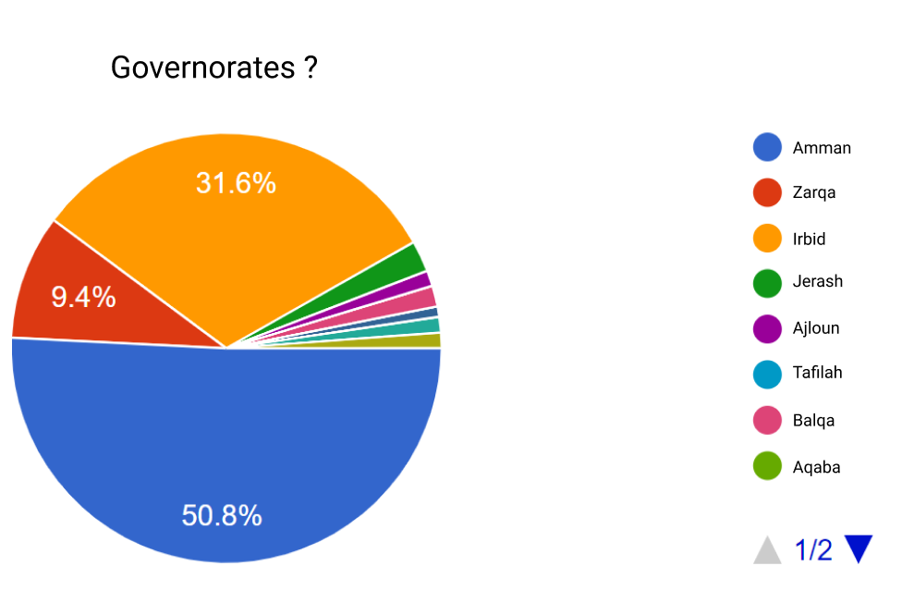

**Figure B. 2** Results based on Governorates.



**Figure B. 3** Where people prefer to see the app

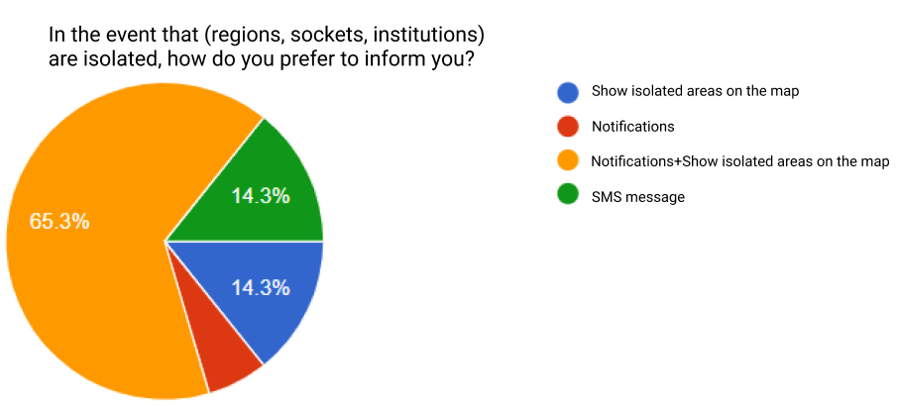

**Figure B. 4** If isolated regions where people prefer to inform you.

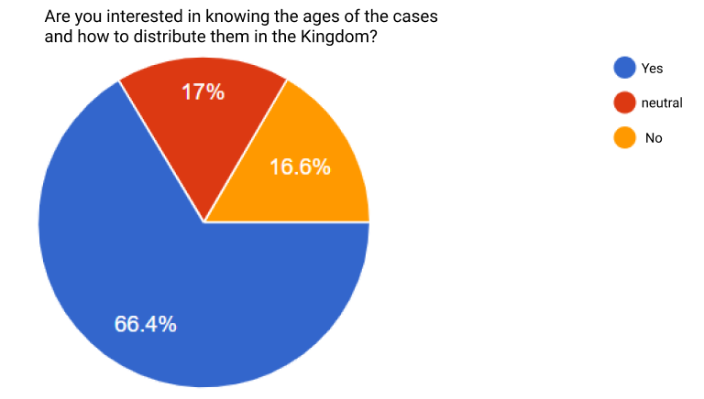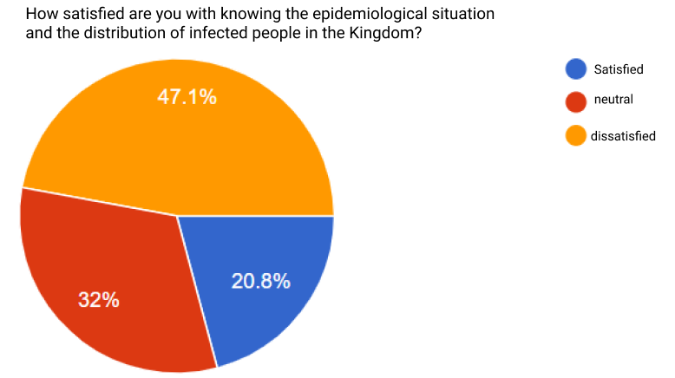

**Figure B. 5** The extent of the people's satisfaction with knowing the epidemiological situation.

**Figure B. 6** People's interest in knowing the ages of the cases

* **The midical field form.**



**Figure B. 7** If field hospital existence is helpful.



**Figure B. 8** if knowing the age of patients going to be useful.