# **Design and Implementation of IS: Assignment Bonus**

# **UML**

**System Name:** CHEERS

**Semester:** A 2025

**Submitted by Group:** KD_RB

**GitHub Repository URL:** **https://github.com/Design-and-Implementation-of-IS/bouns-kd_rb**

**https://github.com/RiadBk99/bouns-kd_rb.git**

**Assumptions:**

This is an optional section for essential assumptions; Please provide concise information aimed at clarifying key aspects for the exercise evaluator; Ensure that the content does not replicate details already presented in the system description narrative.

# 1.1.a. The Final Use Case Diagram:

Verify readability of the figure.

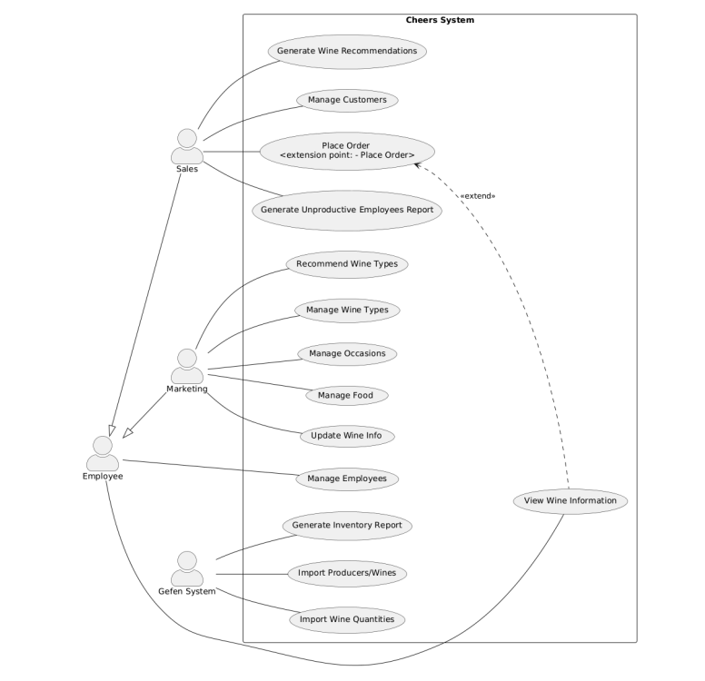

# 1.1.b. The Final Descriptions of the Use Cases:

Make sure the descriptions are short and concisely describe the responsibilities of the various use cases.

**Use Case Descriptions:**

**1. Place Order**

1. Sales staff initiate the order process for a customer.
2. The system captures order details, including order number, date, and customer information (ID, name, phone, address, email, and first contact date).
3. Orders can be **regular** (multiple customers) or **urgent** (single customer with priority levels from 1 to 5).
4. The system records the assigned employee’s information (ID, name, phone, office address, email, and start date).
5. The system tracks selected wines and their quantities for each customer in the order.
6. After an order is completed, the system updates inventory accordingly.
7. The system maintains the order’s status (e.g., **in process, dispatched, delivered, paid, suspended, or canceled**).

**2. Update Wine Info**

1. Marketing staff access wine information management.
2. Staff can update wine prices and modify product images.
3. Wines are linked to their respective categories.
4. The system stores updated details, including wine name, description, production year, price per bottle, sweetness level, and product image.

**3. Recommend Wine Types**

1. Marketing staff input recommendations for different wine types.
2. Staff specify food pairings with links to up to five recipes.
3. Occasion-based recommendations are added, including details like description, season, and location (indoor/outdoor).
4. The system saves these recommendations for future reference.

**4. View Wine Information**

1. Employees access wine details in a read-only mode.
2. The system displays comprehensive wine details, such as name, serial number, manufacturer details, type, price, storage location, and inventory levels.
3. **(Extended by Place Order):** Sales staff can access wine details when placing an order to verify product information.

**5. Manage Wine Types**

1. Marketing staff handle wine-type categorization.
2. Staff can create, update, and maintain wine types, including **red, white, sparkling, fortified, rosé, and dessert wines**.
3. The system assigns unique serial numbers to each wine type.

**6. Manage Occasions**

1. Marketing staff manage occasion-based wine recommendations.
2. Staff enter details for each occasion, including **description, season, and location**.
3. The system links occasions to relevant wine types.

**7. Manage Food**

1. Marketing staff handle food pairing management.
2. Staff input **food names and recipe URLs** for suggested pairings.
3. The system links specific food items to compatible wine types.

**8. Generate Unproductive Employees Report**

1. Sales staff define the **time period** for the report.
2. The system identifies employees with fewer than **two urgent orders** or **fewer than four regular orders**.
3. The report includes **employee personal information** for performance evaluation.

**9. Generate Inventory Report**

1. The system automatically generates a **weekly inventory report**.
2. The report includes **current stock levels** for all wines across storage locations.
3. The system **sends the report** to the Gefen system in **JSON format**.

**10. Generate Wine Recommendations**

1. Sales staff enter **customer preferences**.
2. The system matches preferences with available wines based on **food pairings, occasion, and wine type**.
3. The system generates a **personalized wine recommendation list**.

**11. Import Producers/Wines**

1. The system **receives** monthly XML data from the Gefen system.
2. The system processes manufacturer details such as **name, phone, address, and email**.
3. New manufacturers are assigned **unique identifiers**.
4. The wine catalog is **updated with new entries**.

**12. Import Wine Quantities**

1. The system **receives weekly updates** from Gefen.
2. The system **updates the purchased quantity** for each wine.
3. The system maintains accurate **current inventory levels** across different storage locations.

**13. Manage Customers**

1. Sales staff manage **customer information**.
2. The system stores **customer details**: ID, name, phone, delivery address, email, and first contact date.
3. The system tracks **customer participation** in joint orders.

**14. Manage Employees**

1. The system maintains **employee records**.
2. Employee details include **ID, name, phone, office address, email, and start date**.
3. The system tracks **employee roles and access permissions**

# **1.1.c. UML Class Diagram:**

This section will not be checked again and is intended to understand the context.

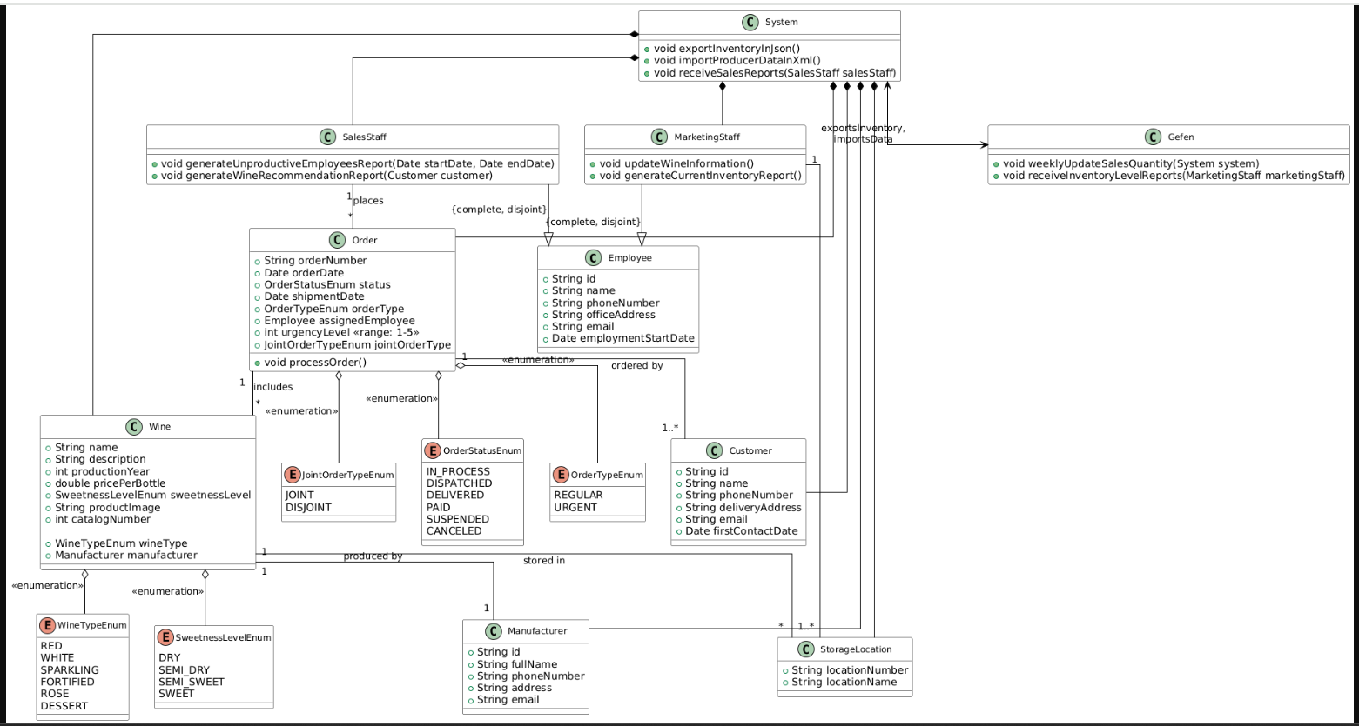

**2.1 The Final Statechart Diagram:**

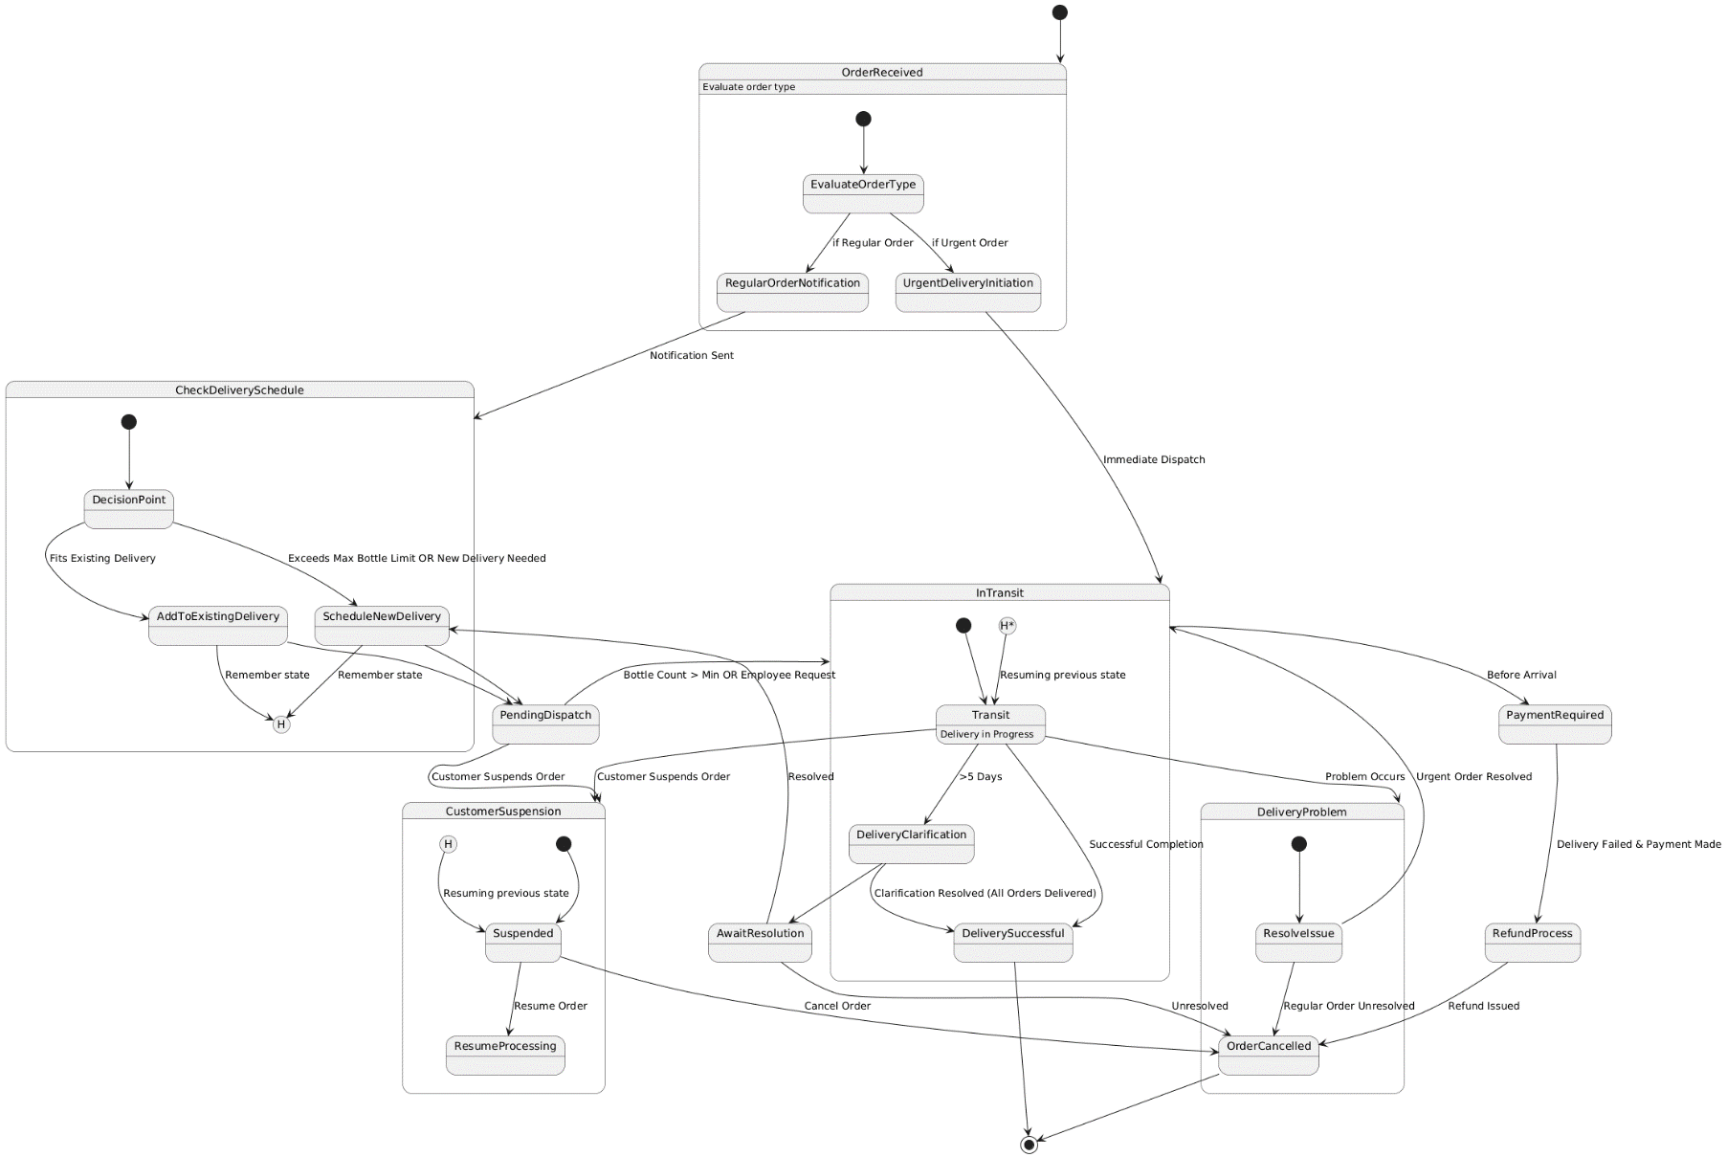Verify readability of the figure.

**Description of the model:**

|  |  |
| --- | --- |
| **Event / Variable** | **Description** |
| **OrderReceived** | **Initial state when an order is received. Evaluates the type of the order.** |
| **EvaluateOrderType** | **Determines whether the order is a Regular Order or an Urgent Order.** |
| **RegularOrderNotification** | **Notification is sent for a regular order.** |
| **UrgentDeliveryInitiation** | **Initiates immediate delivery for an urgent order.** |
| **CheckDeliverySchedule** | **Verifies the current delivery schedule to see if the order fits into an existing delivery or needs a new one.** |
| **AddToExistingDelivery** | **Adds the order to an existing delivery schedule.** |
| **ScheduleNewDelivery** | **Creates a new delivery schedule for the order if it cannot fit into an existing schedule.** |
| **PendingDispatch** | **The state where the order is waiting for dispatch.** |
| **InTransit** | **Indicates that the delivery is in progress.** |
| **Transit** | **Substate of InTransit, representing the actual progress of the delivery.** |
| **DeliverySuccessful** | **Delivery is successfully completed.** |
| **DeliveryProblem** | **A problem occurred during delivery that needs resolution.** |
| **ResolveIssue** | **Attempts to resolve a delivery issue.** |
| **OrderCancelled** | **The order is canceled due to unresolved issues or customer action.** |
| **DeliveryClarification** | **Clarification required for delivery when it exceeds 5 days.** |
| **AwaitResolution** | **The state where delivery clarification is pending resolution.** |
| **CustomerSuspension** | **Customer has suspended the order, halting its progress.** |
| **Suspended** | **Substate of CustomerSuspension, representing the suspended state.** |
| **ResumeProcessing** | **Customer resumes the suspended order.** |
| **PaymentRequired** | **Payment needs to be completed before the delivery arrival.** |
| **RefundProcess** | **Refund is initiated when the delivery fails after payment is made.** |
| **DecisionPoint** | **A decision point for evaluating whether the order can fit into an existing delivery or needs a new schedule.** |
| **Bottle Count > Min** | **Trigger for dispatch when the number of bottles exceeds the minimum threshold.** |
| **Immediate Dispatch** | **Immediate dispatch for urgent orders.** |
| **Fits Existing Delivery** | **Condition where the order fits into an existing delivery schedule.** |
| **Exceeds Max Bottle Limit** | **Condition indicating the order exceeds the maximum limit and requires a new delivery.** |
| **Clarification Resolved** | **Condition where delivery clarification is resolved, allowing successful delivery.** |
| **Refund Issued** | **Refund is completed for a canceled order due to failed delivery.** |
| **Successful Completion** | **The delivery is finalized successfully.** |
| **Problem Occurs** | **Indicates an issue during delivery.** |
| **Cancel Order** | **Action to terminate the order.** |

**2.2 Design Class Diagram of** 

Verify readability of the figure. For each diagram, the relevant screenshots must be presented (the titles can be reproduced if needed).

**Screenshot:**

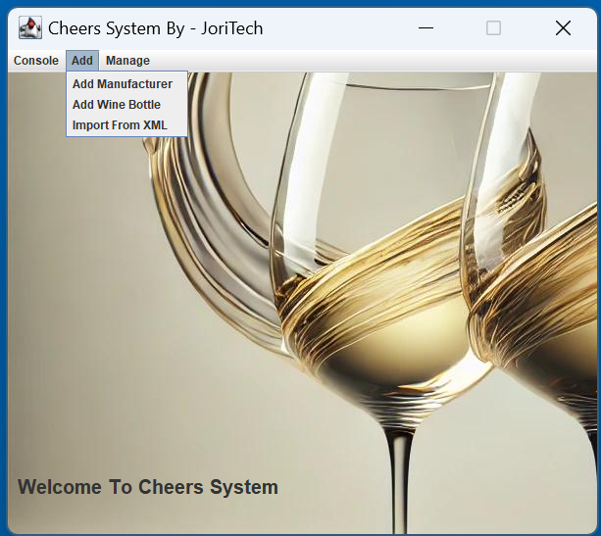

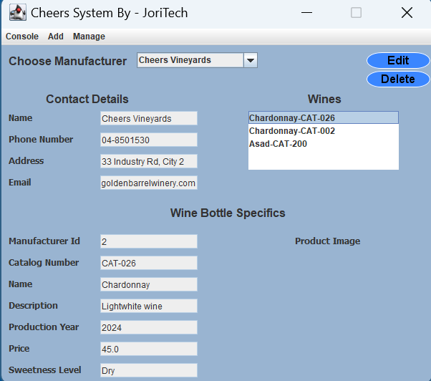

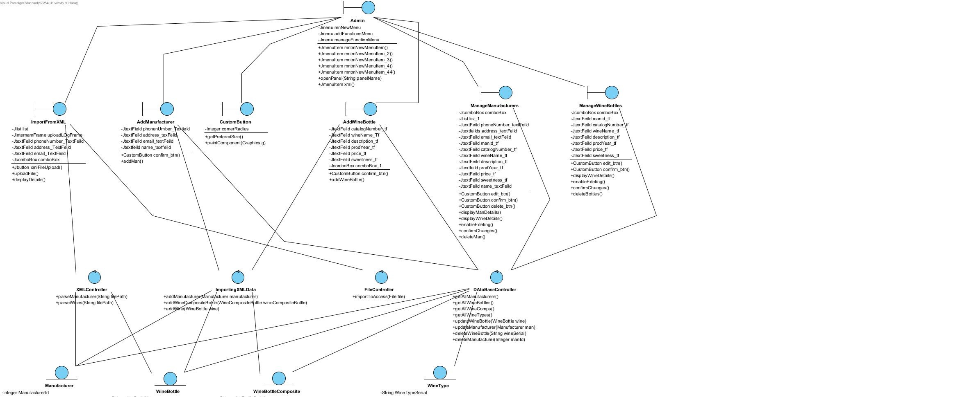**Diagram:**

**3.1.a Design Class Diagram of** 

Verify readability of the figure. For each diagram, the relevant screenshots must be presented (the titles can be reproduced if needed).

**Screenshot:**

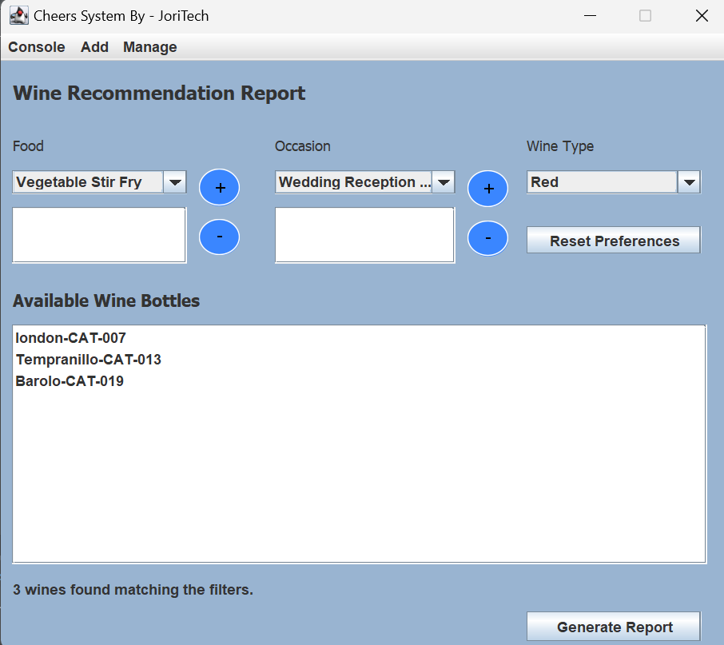

**Diagram:**

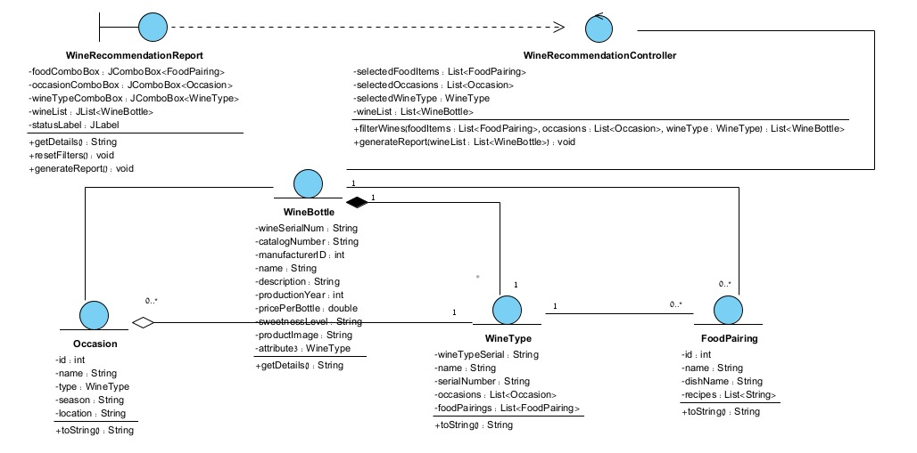

**3.1.b Sequence Diagram of cheers wine recommendation report**

Verify readability of the figure.

