CEH v13 — EXAM-FOCUSED SUMMARY
Module 17 — Hacking Mobile Platforms
Beginner-friendly · Scenario-ready · What to memorize cold

Sources: Project documents (17.1–17.5 study sheets) + Google Drive (CEH V13 Master Study Guide). Mr-Infect notes style for mnemonics. General CEH knowledge where noted.

1) Definition
Hacking mobile platforms means attacking phones/tablets (Android, iOS), their apps, the networks they use, and the backend cloud. Mobiles are high-value targets because they are always connected and hold personal + corporate data (banking, OTPs).
The pocket-computer picture
• A phone is a full computer that you carry everywhere, always online, holding your logins, OTPs and messages.
• Attackers reach it on three fronts: the DEVICE (OS/apps), the NETWORK (Wi-Fi/MITM), and the CLOUD (backend servers).
• Core sentence: always-on + personal data = prime target.

2) The 3 attack points & mobile attack surface
Point | Target | Example attacks
1. Device | OS, apps, hardware | Rooting/jailbreak, malicious apps, insecure storage
2. Network | Wi-Fi, cellular, Bluetooth | Wi-Fi sniffing, MITM, SSL stripping, rogue AP
3. Data center / Cloud | Web servers, databases | SQLi, XSS, misconfig, brute force
Exam takeaway: A mobile application can be attacked at three levels: the device, the network, and the backend infrastructure. Securing only the phone is not enough.

OWASP Mobile Top 10 (2024) — memorize the list
ID | Risk | Simple explanation to remember
M1 | Improper Credential Usage | Mishandling passwords, API keys, or login credentials.
M2 | Inadequate Supply Chain Security | Using compromised or vulnerable third-party libraries or components.
M3 | Insecure Authentication/Authorization | Weak login checks or allowing users to access data they shouldn't.
M4 | Insufficient Input/Output Validation | Failing to check input or output, potentially allowing malicious data or injection attacks.
M5 | Insecure Communication | Sending data over insecure connections, allowing interception or manipulation.
M6 | Inadequate Privacy Controls | Collecting, using, or exposing more personal data than necessary.
M7 | Insufficient Binary Protections | Making the app easier to reverse-engineer, modify, or repackage.
M8 | Security Misconfiguration | Incorrect security settings, such as debug mode enabled in production.
M9 | Insecure Data Storage | Storing sensitive data insecurely on the phone, such as passwords in plain text.
M10 | Insufficient Cryptography | Using weak encryption, outdated algorithms, or incorrect cryptographic implementation.

Memory hook
• 'Vectors → Android → iOS → MDM → Defense' (the 5 objectives).
• After compromise: Spy → Steal → Spread → Impersonate (surveillance, data theft, botnet, impersonation).

3) Android vs iOS (very high yield)
Feature | Android | iOS
Source model | Open-source (Linux-based, Google) | Closed-source (Apple)
Root access term | Rooting | Jailbreaking
App vetting | Weak (third-party stores allowed) | Strong (App Store review)
Custom ROMs | Yes | No
Enterprise-cert abuse | Less | More

Memory hook
• 'Android = open risk, iOS = controlled risk.'
• Root (Android) = Jailbreak (iOS): both gain superuser and BREAK the sandbox + MDM controls.
Custom ROM: An alternative Android system installed by the user.
Enterprise-cert abuse: Misusing a company's app-distribution certificate to install malicious apps outside the official app store.

4) Android threats & attacks
- Architecture: Linux Kernel → HAL → Native libraries → Android Runtime (ART) → App framework → Apps.

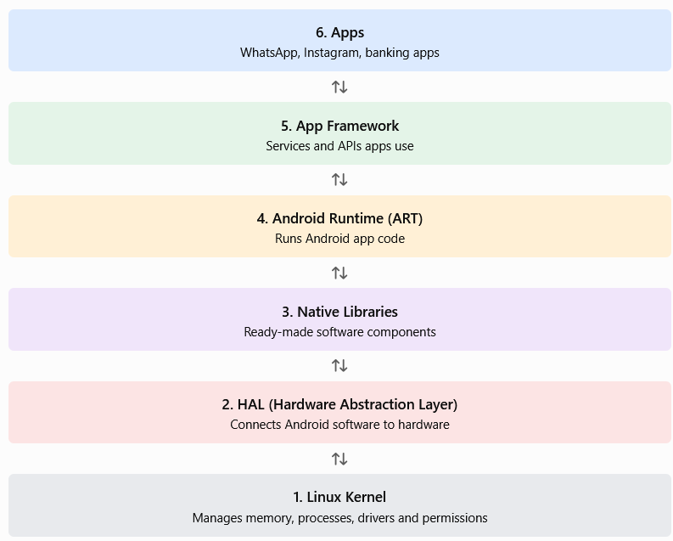

Key Android attacks
Attack | Simple explanation
Repackaging | Attacker takes a legitimate app, adds malicious code, and redistributes it as a fake app.
Drive-by download | Visiting a malicious website triggers a malware download, sometimes without the user's awareness.
SMS-based attacks | Fake SMS messages trick users (smishing), cause premium SMS charges, or help steal OTP codes.
Man-in-the-Mobile (MitMo) | Mobile malware steals banking information or intercepts SMS verification codes to bypass security.
Clickjacking | A hidden or misleading screen tricks the user into tapping something unintended.
Android botnets | Infected phones are remotely controlled to send spam, launch DDoS attacks, or steal data.

Rooting & permission abuse
- Rooting = superuser access: disables sandboxing, bypasses permissions, breaks MDM. 'Root = no rules.'
- Rooting does not automatically disable all sandboxing or permissions, but it can weaken security and undermine MDM controls.
- Dangerous permissions: READ_SMS (OTP theft), SEND_SMS (fraud), RECORD_AUDIO/CAMERA (spy), LOCATION (tracking). 'SMS = money, mic = spy.'

Android permission identifier | What it allows | Security risk — how it can be abused
READ_SMS | Read SMS messages | OTP theft: Malware reads verification codes sent by SMS and may use them to access the victim's accounts.
SEND_SMS | Send SMS messages | SMS fraud: A malicious app sends messages to premium-rate numbers, potentially causing unexpected charges.
RECORD_AUDIO | Record sound | Eavesdropping: Malware records private conversations or listens to surrounding sounds when it has the necessary access.
CAMERA | Access the camera | Surveillance: A malicious app may capture photos or videos without the user's informed consent, subject to OS restrictions.
LOCATION | Access the device's location, if granted | Tracking: Malware collects location data to discover where the victim lives, works, or travels.

ADB (Android Debug Bridge) — know the commands

ADB = a tool that lets a computer communicate with an Android device for debugging and administration.

Memory hook: devices = list, shell = command line, pull = phone → PC, push = PC → phone, install = APK installation.

adb devices # list connected devices
adb shell # open a shell on the device
adb pull / push # copy files from / to the device
adb install app.apk # install an APK

5) iOS threats & attacks
- iOS security model: code signing (only signed apps run) + sandboxing + secure boot chain + App Store vetting + Data Protection API. 'Sign → Sandbox → Secure Boot.'
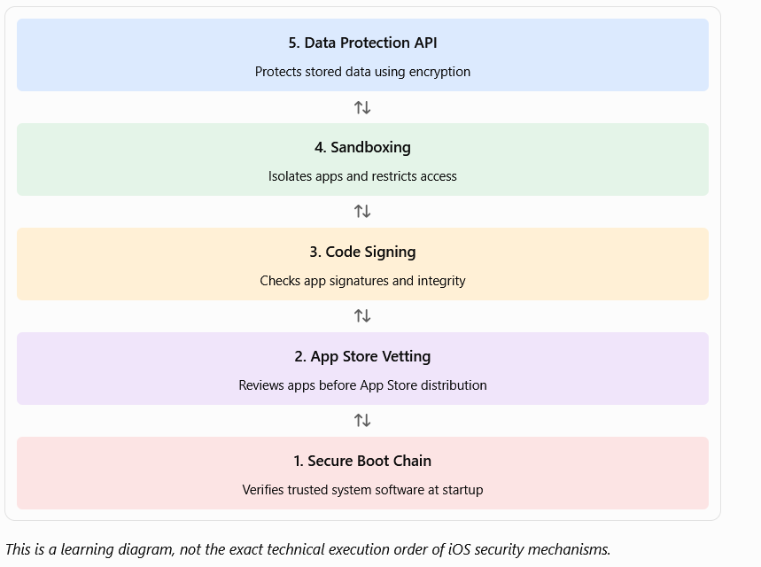

Jailbreaking (iOS root access)
Jailbreak type | Meaning
Tethered | Needs a computer at every boot
Semi-tethered | Boots, but needs a computer for jailbreak features
Untethered | Persistent — survives reboot without a computer
- Impact: disables code signing, bypasses sandbox, breaks MDM. 'Jailbreak = root access.'

CEH V13 — Jailbreaking (iOS)
- Meaning: Modify an iPhone to bypass some Apple restrictions and gain greater control over iOS.
- Tethered: Needs a computer to boot the jailbroken device.
- Semi-tethered: iPhone boots normally, but jailbreak features stop until restored using a computer.
- Untethered: Jailbreak remains active after reboot without a computer.
- Security impact: May weaken code signing, app sandboxing, and MDM protections.

Key iOS attacks
Attack | How it works
Malicious apps | Via third-party stores / jailbroken devices
Enterprise certificate abuse | Misuse Apple enterprise certs to install unsigned apps ('bypass gatekeeper')
Configuration profile attacks | Malicious profile installs rogue VPN/proxy/cert → traffic interception
iOS spyware | Call recording, SMS/GPS tracking, app-data theft
Network-based | Rogue Wi-Fi, MITM, SSL stripping, fake certificates

6) Mobile Device Management (MDM)
MDM = centralized control of mobile devices: push policies, manage apps, and perform remote actions.

Remote action | Use
Remote wipe / Selective wipe | Erase all data, or just corporate data (lost device)
Device lock / Password reset | Secure a lost or compromised device
Containerization | Separate corporate vs personal data (BYOD-friendly, selective wipe)

- MDM vs EMM vs UEM: MDM (device) ⊂ EMM (device+apps+content) ⊂ UEM (unified endpoint). Tools: Intune, Workspace ONE, MaaS360, MobileIron, Meraki.

MDM is a general technology concept, not the name of one specific software. ✅
Think of it like this:
- MDM = the technology/category used to manage mobile devices.
- Microsoft Intune = a commercial product that provides MDM features.
- VMware Workspace ONE = another commercial product that provides MDM features.
Simple example
A company has 500 employee phones. Instead of configuring every phone manually, the IT administrator uses MDM software to manage them centrally.

Term | Full name | Example / meaning
MDM | Mobile Device Management | Technology to manage mobile devices
EMM | Enterprise Mobility Management | Manages devices, apps, and corporate content
UEM | Unified Endpoint Management | Manages multiple endpoint types centrally
Microsoft Intune | Commercial product name | Software providing MDM and broader device-management features
Workspace ONE | Commercial product name | Enterprise device and workspace management solution

Exam trap — MDM is NOT invincible
• MDM cannot stop zero-day exploits.
• Rooted/jailbroken devices bypass MDM controls.
• It depends on user compliance and is limited against social engineering.

7) Tools (know tool → purpose)
Tool | Platform | Purpose
Drozer | Android | Security assessment / attack surface
APKTool | Android | Reverse-engineer / repackage APKs
JADX | Android | Decompile DEX to Java
ADB | Android | Device control via command line
Frida | Both | Runtime instrumentation (hook functions)
Objection | Both | Runtime manipulation (built on Frida)
MobSF | Both | Automated static+dynamic app analysis
Cydia | iOS | Package manager on jailbroken devices
Burp Suite | Both | Intercept/MITM app traffic

Analysis types (MAST)
• SAST = static (reads code/binary) · DAST = dynamic (runtime behavior) · IAST = interactive (both). 'Static sees code, Dynamic sees behavior.'

Below are 3 types of mobile application security testing:

SAST (Static Application Security Testing): Examine the code to find a hardcoded password.

DAST (Dynamic Application Security Testing): Run the app and test whether its login accepts an attack.

IAST (Interactive Application Security Testing): Run the app with an analysis agent to identify a vulnerability as the vulnerable code executes.

8) Practical example (scenario style)
Scenario walk-through
• An attacker takes a popular free game, decompiles it with APKTool, inserts spyware, re-signs it, and posts it on a third-party store (repackaging).
• A victim side-loads it; the app requests READ_SMS and RECORD_AUDIO permissions.
• It now steals banking OTPs (READ_SMS) and records the mic — classic permission abuse.
• If the phone is rooted, sandboxing is gone and the malware persists and evades MDM.
• Fix: install only from official stores, review permissions, avoid rooted devices, enforce MDM compliance checks.

9) Countermeasures & guidelines
- Device: strong screen lock + biometrics, encrypt storage, disable USB debugging, enable remote wipe, patch OS.
- Apps: install only from trusted stores, review permissions, avoid rooted/jailbroken devices, remove unused apps.
- Network: avoid public Wi-Fi, use VPN, disable auto-connect, verify SSL certificates (block user-installed CAs).
- Data: encrypt at rest and in transit, no plaintext storage, secure key management, secure backups.
- Enterprise: enforce MDM + containerization + compliance/posture checks.

Attack → defense mapping (exam favorite)
Attack | Defense
Malware | App vetting + MDM
Smishing | User awareness
MITM | VPN + TLS
Root/Jailbreak | Device compliance checks
Data leakage | Encryption
Rogue Wi-Fi | Disable auto-connect

10) Exam traps (read twice)
Traps that catch people
• Rooting = Android; Jailbreaking = iOS. Both give root and break the sandbox + MDM.
• Android = open-source (weak vetting); iOS = closed-source (strong vetting) but still attacked.
• Untethered jailbreak = persistent (survives reboot); tethered needs a PC each boot.
• Man-in-the-Mobile (MitMo) = mobile malware beating banking apps via overlay + SMS interception.
• Enterprise certificate abuse lets UNSIGNED apps run on iOS (bypasses the gatekeeper).
• MDM can't stop zero-days and is bypassed on rooted/jailbroken devices.
• ADB is the Android control channel (adb shell, pull, push, install).

11) Mnemonics
- Objectives: 'Vectors, Android, iOS, MDM, Defense.'
- Attack points: 'Device → Network → Cloud.'
- After compromise: 'Spy, Steal, Spread, Impersonate.'
- Android vs iOS: 'Open risk vs controlled risk' · 'Root = Jailbreak.'
- Permissions: 'SMS = money, mic = spy.'
- MDM scope: 'MDM ⊂ EMM ⊂ UEM.'

12) What to memorize COLD
Fast recall before the exam
• Mobile = high-value (always on + personal data). 3 attack points: Device, Network, Cloud.
• OWASP Mobile Top 10 2024: M1 Improper Credential Usage ... M9 Insecure Data Storage, M10 Insufficient Cryptography.
• Android = open-source, rooting, weak vetting, custom ROMs. iOS = closed, jailbreaking, strong vetting.
• Root/Jailbreak: disables sandbox, bypasses permissions, breaks MDM.
• Android attacks: repackaging, drive-by, smishing, MitMo, clickjacking, botnets.
• Dangerous perms: READ_SMS (OTP), SEND_SMS (fraud), RECORD_AUDIO/CAMERA (spy), LOCATION.
• iOS security: code signing + sandbox + secure boot. Jailbreak types: tethered, semi-tethered, untethered (persistent).
• iOS attacks: malicious apps, enterprise cert abuse, config profiles, spyware, network MITM.
• ADB commands: devices, shell, pull, push, install.
• Tools: Drozer, APKTool, JADX, ADB (Android); Cydia (iOS); Frida, Objection, MobSF, Burp (both).
• MDM: remote wipe, selective wipe, lock, containerization. MDM ⊂ EMM ⊂ UEM. Not invincible vs zero-day/root.
• Defense: official stores, review permissions, VPN on public Wi-Fi, encrypt data, enforce MDM.
End of Module 17 — Hacking Mobile Platforms. Next up: quiz this module, or move to Module 18 (IoT & OT Hacking).

