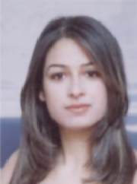

**Ing . Wejdene SAIED**

Email : [wejdenesaied@yahoo.fr](mailto:wejdenesaied@yahoo.fr)

Mobile : +216 97 668 828

**BIOGRAPHY:**

Wejdene SAIED received in 2004 a Computer Engineering degree with distinction from the National School of Computer Science (E.N.S.I – Tunisia). She received in 2007 a Master’s degree in computer science from National School of Engineers of Tunis (E.N.I.T – Tunisia).

Wejdene SAIED is currently a Computer technologist at the ISET Higher Institute of Technology Studies in Tunisia. She is also a PhD student in computer science on the «Digital Security» Research Unit, at the Sup’Com Engineering School of Telecommunications in Tunisia. His research interests include in particular Software Defined Networking, Policy Modeling, Deployement and Formal verification.

Wejdene SAIED was invited to give seminars/talks, in numerous universities and laboratories, namely, in France. She was also invited as visiting researcher to reputed institution like the Computer Science Research Laboratory of Bordeaux “LaBRI” (Bordeaux – France).

Wejdene SAIED is 36 years old. she is married and mother to two children.