PSL Match Win Predictor

Project Report

***1. Objective:*** The primary objective of the PSL Match Win Predictor project is to develop a predictive model that accurately forecasts the outcome of Pakistan Super League (PSL) cricket matches. The goal is to leverage historical match data and other relevant features to create a model capable of predicting which team is likely to win a given match. This predictive tool aims to assist cricket enthusiasts, fantasy league participants, and other stakeholders in making informed decisions based on data-driven insights.

***2. Background of the Problem:*** Cricket is a game with inherent uncertainties, and predicting match outcomes is a challenging task. The PSL, being a highly popular T20 cricket league, attracts a vast audience interested in predicting match results. The PSL Match Win Predictor addresses this demand by employing machine learning techniques to analyze historical data and identify patterns that may influence match outcomes. The project aims to provide a valuable resource for cricket fans and stakeholders who seek more accurate predictions for their engagements with PSL matches.

***3. Data Collection:*** Data for the project is sourced from reliable cricket databases, official PSL records, and other reputable platforms that provide comprehensive match statistics. The dataset includes information on team performance, venue details, and historical match results. Special attention is given to collecting data relevant to match-specific conditions, such toss winner, toss decision, venue.

***4. Data Preprocessing:*** Before feeding the data into the predictive model, extensive preprocessing is carried out. This involves handling missing values, encoding categorical variables, normalizing numerical features, and addressing outliers. Data preprocessing ensures that the model receives clean and meaningful input, improving its overall predictive accuracy.

***5. Modelling and Evaluation*:** Various machine learning algorithms, including but not limited to ***DECISION TREE, RANDOM FORESTS, AND NAÏVE BAYS*** , are employed to build the predictive model. The dataset is split into training and testing sets to evaluate the model's performance. The predictive model is evaluated based on metrics such as accuracy, precision, recall, and F1 score to assess its effectiveness in predicting match outcomes.

***6. Results:*** The results section presents the performance metrics of the developed PSL Match Win Predictor. It includes a detailed analysis of the model's accuracy and its ability to correctly predict match winners. The results of different models were different but as compare to the other models, the result of decision tree was better

**Decision Tree Results:**

Modeling:

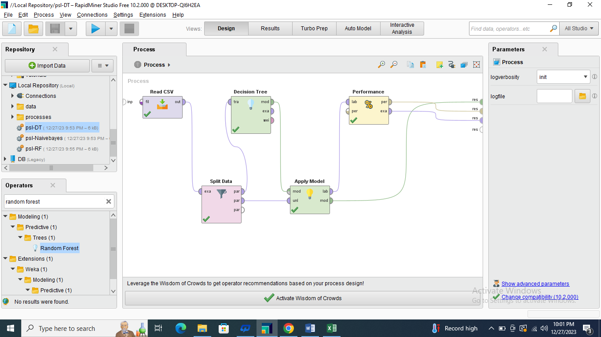

Performance vector:

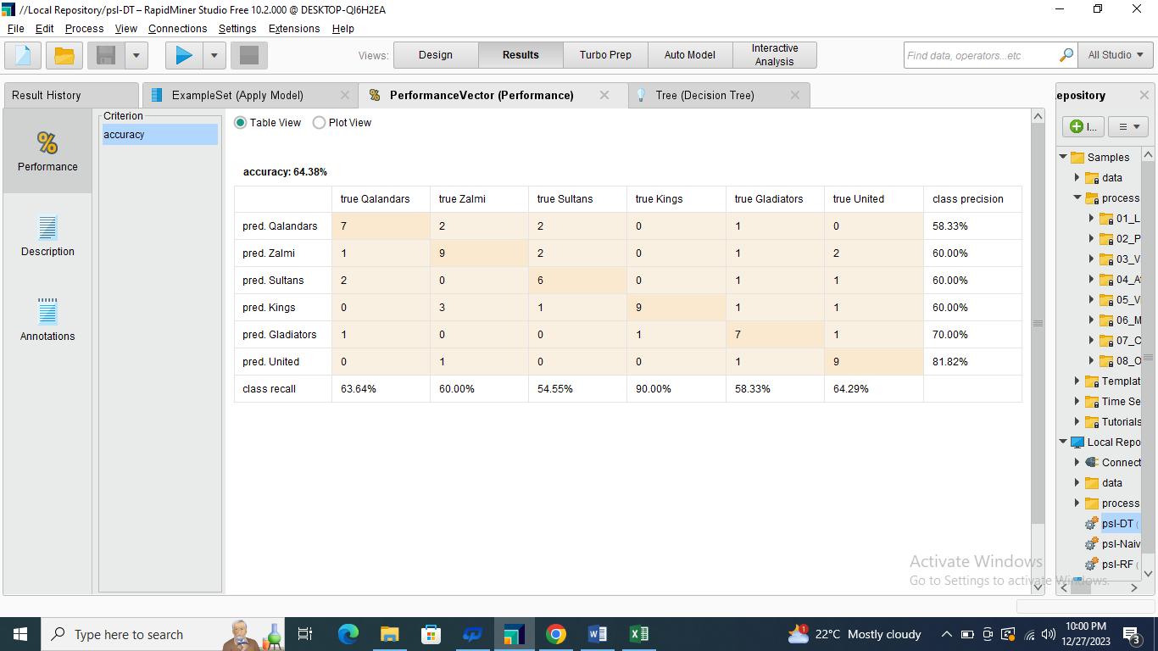

Apply Model Result

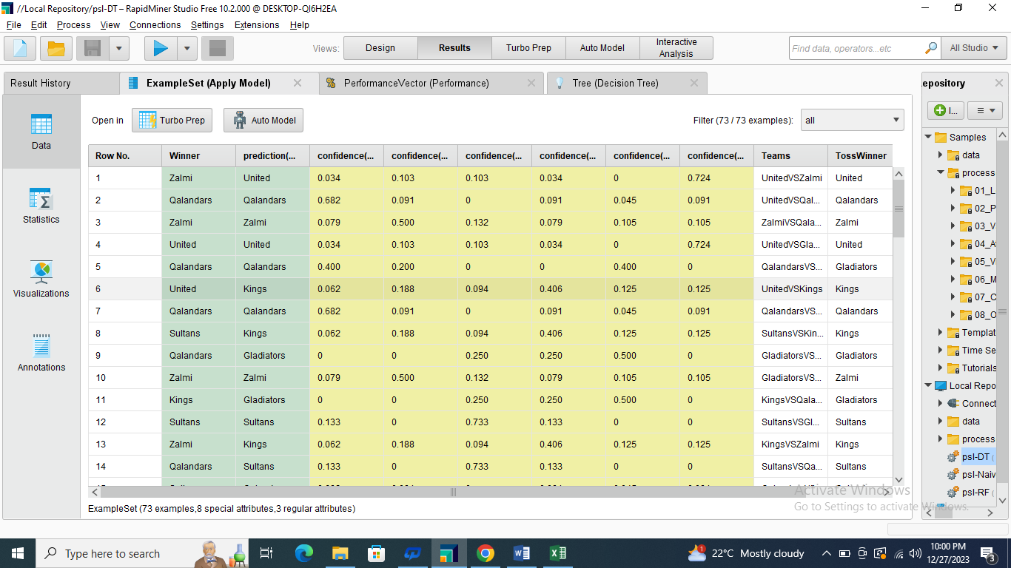

***7. Conclusions*:** In conclusion, the PSL Match Win Predictor project demonstrates the feasibility of using machine learning techniques to predict cricket match outcomes. The accuracy and reliability of the model are discussed, along with potential areas for improvement. The report also outlines the practical applications of the predictive tool for cricket enthusiasts, fantasy league participants, and other stakeholders interested in making informed decisions related to PSL matches. Future work may involve continuous model refinement and the incorporation of additional features for improved predictive capabilities.

***8.GitHub Link*:** **https://github.com/khalilullah1234/Data-Mining**

***Submitted By: KHALIL ULLAH***

***Section: B***

***Seat No: 19122009***

***Submitted To: Miss Dr. Uzma Afzal***