Epidemiological Characterisation of the Record 2023 Dengue Epidemic in Bangladesh: An 8-Year National Surveillance Analysis (2018–2025)
Khalilur Rahman Ridoy Khan
Independent Researcher, Dhaka, Bangladesh
Correspondence: khalilurrahmanridoykhan@gmail.com
Running title: Bangladesh Dengue 2023 Epidemic Analysis
Manuscript type: Original Research Article

Abstract
Background: Bangladesh experienced its largest dengue epidemic on record in 2023, with 321,017 admitted cases, representing a 31.6-fold increase from the 2018 baseline. Understanding the temporal dynamics, seasonal drivers, and geographic distribution of this outbreak is critical for evidence-based public health planning.
Methods: We conducted a retrospective descriptive analysis of national dengue surveillance data from the Directorate General of Health Services (DGHS) Health Emergency Operation Center (HEOC) Dengue Dashboard, Bangladesh, covering 2018–2025. Annual, monthly, and weekly admitted case data were extracted and analysed for temporal trends, seasonal patterns, and division-level incidence.
Results: Admitted dengue cases increased from 10,148 in 2018 to 321,017 in 2023 (national incidence: 189.6 per 100,000). A natural experiment during the COVID-19 lockdown in 2020 revealed a 97.5% reduction in reported cases. The monsoon season (June–October) accounted for 83.2% of the 2023 annual burden, with September as the peak month (79,994 cases; 24.9% of annual total) and epidemiological week 38 as the peak week (20,244 cases). Post-2023 cases stabilised at a new elevated baseline (~102,000/year in 2024 and 2025), representing a 10-fold increase over the 2018 baseline. Barishal division had the highest per-capita incidence (10.01 per 100,000) in 2026 year-to-date data.
Conclusions: Bangladesh dengue has entered a sustained high-burden era following the 2023 record epidemic. The strong monsoon seasonality provides a window for pre-monsoon vector control. Barishal and Chattogram divisions require prioritised intervention. These findings support evidence-based resource allocation for Bangladesh's national dengue control programme.
Keywords: dengue; Bangladesh; epidemic; surveillance; seasonality; vector-borne disease; DGHS; tropical infectious disease

1. Introduction
Dengue fever is the most rapidly spreading vector-borne viral disease globally, with an estimated 390–400 million infections occurring annually across more than 129 endemic countries [1]. The disease is transmitted primarily by Aedes aegypti mosquitoes and, to a lesser extent, Aedes albopictus, and its burden is concentrated in tropical and subtropical regions of Asia, Latin America, and Africa [2]. Over the past three decades, the global incidence of dengue has increased eightfold, driven by rapid urbanisation, population growth, international travel, and climate change extending the geographic range of Aedes vectors [3].
Bangladesh, a densely populated low-income country in South Asia, has emerged as one of the most dengue-affected nations in the WHO South-East Asia Region. Dengue was first reported in Bangladesh in 2000, with sporadic outbreaks occurring annually thereafter [4]. The country experienced its first large-scale epidemic in 2019, when 101,354 admitted cases were recorded — a dramatic departure from the historical norm [5]. The 2019 epidemic prompted significant public health concern, yet it was surpassed in 2023 when Bangladesh recorded 321,017 admitted cases — the largest dengue epidemic in the country's history.
The 2023 outbreak placed severe strain on Bangladesh's healthcare system, with hospitals across Dhaka and the coastal divisions overwhelmed during the peak transmission season [6]. The epidemic occurred against a backdrop of prolonged monsoon rains, expanding urban informal settlements, and unplanned construction sites that create ideal Aedes breeding habitats. Furthermore, the COVID-19 pandemic period (2020) inadvertently provided a natural experiment: strict lockdown measures in 2020 coincided with a dramatic reduction in reported dengue cases to only 1,405, offering insights into the role of human mobility and healthcare-seeking behaviour in shaping surveillance-based case counts.
Despite the scale and public health significance of Bangladesh's dengue burden, comprehensive multi-year analyses characterising the temporal dynamics, seasonal pattern, and geographic distribution of dengue using national DGHS surveillance data remain limited. Most existing studies focus on specific outbreaks, limited geographic areas, or shorter time horizons [7–9]. A systematic 8-year characterisation of national trends, from the pre-epidemic baseline through the 2023 record outbreak and into 2025, is needed to inform evidence-based planning.
This study aimed to: (1) describe the 8-year temporal trend in admitted dengue cases in Bangladesh (2018–2025); (2) characterise the seasonal pattern of dengue using monthly and weekly surveillance data (2023–2025); (3) estimate the division-level geographic distribution of dengue burden; and (4) quantify the effect of the COVID-19 lockdown on reported dengue cases as a natural experiment.

2. Methods

2.1 Study Design
We conducted a retrospective descriptive epidemiological analysis of national dengue surveillance data in Bangladesh. The primary unit of analysis was the country as a whole (national-level) for temporal analyses, and the administrative division for geographic analyses.

2.2 Data Source
Data were obtained from the Health Emergency Operation Center (HEOC) Dengue Dynamic Dashboard maintained by the Directorate General of Health Services (DGHS), Government of Bangladesh (available at: https://dashboard.dghs.gov.bd/pages/heoc_dengue_v1.php), accessed June 2026. The DGHS HEOC dashboard aggregates hospital-based dengue surveillance reports from government health facilities across all eight administrative divisions of Bangladesh. The dashboard is publicly accessible without authentication and represents the official national dengue surveillance platform.

2.3 Data Extraction
Dashboard data are rendered as interactive Highcharts visualisations embedded within the webpage as inline JavaScript data arrays. We developed an automated Python script (Python 3.14; libraries: requests, re, pandas) to perform an HTTP GET request to the dashboard URL, parse all Highcharts chart objects from the page source using regular expressions, and extract the associated categories (time periods, division names) and series data (case counts). Six structured datasets were generated: annual national cases (2018–2026); monthly national cases (2023–2025); weekly national cases (2023–2025); daily national cases (January–June 2026); division-level cumulative cases and deaths (2026 year-to-date); and weekly cases by division (2026, weeks 1–22). All data and analysis code are publicly available at https://github.com/khalilurrrahmanridoykhan/bangladesh-dengue-2018-2025.

2.4 Case Definition
All case counts represent admitted (hospitalised) dengue patients reported through the DGHS HEOC surveillance system. Cases include both confirmed and probable dengue as per WHO 2009 dengue classification guidelines, as applied by DGHS. The dashboard reflects hospital-based surveillance; community-level dengue infections — which WHO estimates at 10 to 50 times the hospitalised count — are not captured.

2.5 Population Denominators
Division-level population denominators were obtained from the Bangladesh Bureau of Statistics (BBS) 2022 National Population and Housing Census. National population was 169,356,251. Division populations used were: Dhaka 36,054,418; Chattogram 28,423,019; Rajshahi 18,484,858; Khulna 15,563,000; Barishal 8,325,666; Sylhet 10,009,239; Rangpur 15,665,000; Mymensingh 11,370,000.

2.6 Statistical Analysis
Annual trend: Year-over-year percentage change was calculated for each year. A linear regression model was fitted to pre-2023 annual cases (2018–2022) to estimate the baseline trend trajectory. The COVID-19 effect was quantified as the percentage reduction in 2020 cases relative to the 2018–2019 mean. Seasonal analysis: Monthly and weekly case counts were aggregated across available years (2023–2025) to calculate a seasonal index — each time unit's average share of annual burden expressed as a percentage. A monthly heatmap was constructed to visualise the year-by-year seasonal distribution. Geographic analysis: Division-level incidence rates per 100,000 population were calculated from 2026 year-to-date cumulative cases divided by the 2022 census population. Case fatality rate (CFR) was calculated as confirmed deaths divided by admitted cases. All analyses were performed in Python 3.14 using pandas 2.x, matplotlib 3.10, and scipy 1.17.

2.7 Ethical Considerations
This study used publicly available, aggregated surveillance data published by DGHS Bangladesh. No individual patient data were accessed at any stage. Ethical review board approval was not required, consistent with standard practice for analyses of publicly available, de-identified aggregate data.

3. Results

3.1 Annual Trend in Dengue Cases (2018–2025)
Between 2018 and 2025, Bangladesh recorded a total of 728,807 admitted dengue cases across the 8-year study period. Annual case counts and year-over-year changes are presented in Table 1 and Figure 1. From a baseline of 10,148 cases in 2018, the epidemic grew steeply to 101,354 cases in 2019 — an 898.8% increase — representing the first major epidemic in Bangladesh's dengue history.
In 2020, during the COVID-19 pandemic, admitted dengue cases fell dramatically to 1,405, representing a 97.5% reduction compared to the 2018–2019 mean of 55,751 cases. This sharp decline coincided with nationwide COVID-19 lockdown measures, movement restrictions, and disrupted healthcare-seeking behaviour (discussed further in Section 4.2). A rebound followed in 2021 (28,429 cases; +1,923.4%) and 2022 (62,382 cases; +119.4%), reflecting both post-lockdown mobility resumption and accumulated vector breeding during lockdown.
The year 2023 represented an unprecedented inflection point, with 321,017 admitted cases — a 414.6% increase from 2022 and a 31.6-fold increase from the 2018 baseline. The national incidence in 2023 reached 189.6 per 100,000 population. Following the 2023 record, cases in 2024 and 2025 declined to 101,211 and 102,861, respectively, representing a 68.5% reduction from the 2023 peak. However, this post-peak level remains approximately 10-fold above the 2018 baseline, indicating that Bangladesh dengue has entered a sustained high-burden era (Figure 1).
Table 1. Annual admitted dengue cases in Bangladesh, 2018–2025. Source: DGHS HEOC Dashboard. Incidence calculated using BBS 2022 national population (169,356,251).
Year | Admitted Cases | YoY Change (%) | National Incidence (per 100,000)
2018 | 10,148 | — | 6.0
2019 | 101,354 | +898.8 | 60.5
2020 | 1,405 | −97.5 | 0.8
2021 | 28,429 | +1,923.4 | 16.9
2022 | 62,382 | +119.4 | 37.3
2023 | 321,017 | +414.6 | 189.6
2024 | 101,211 | −68.5 | 59.8
2025 | 102,861 | +1.6 | 60.8

3.2 COVID-19 Lockdown as a Natural Experiment
The 2020 COVID-19 pandemic lockdown provided a natural experiment for assessing the contribution of mobility and healthcare-seeking behaviour to reported dengue burden. Admitted dengue cases in 2020 (1,405) were 97.5% lower than the 2018–2019 mean (55,751). This reduction occurred despite no evidence of meaningful change in Aedes vector populations during this period. The subsequent rebound to 28,429 cases in 2021 — as mobility restrictions eased — is consistent with suppression of reported cases during lockdown rather than true elimination of transmission. These findings suggest that surveillance-based dengue case counts in Bangladesh are substantially influenced by healthcare-seeking behaviour, and that true 2020 community dengue burden likely remained substantially higher than the reported figure.

3.3 Weekly Epidemic Curves (2023–2025)
Figure 2 presents the weekly epidemic curves for 2023, 2024, and 2025. All three years demonstrate a consistent seasonal pattern characterised by low transmission in the early weeks of the year (January–April), a gradual rise from epidemiological week 20 (mid-May), a rapid escalation through the monsoon season, and a peak in the post-monsoon period. In 2023, the peak occurred at epidemiological week 38 (mid-September), with 20,244 admitted cases in a single week. The 2023 peak was 2.6-fold higher than the 2024 peak (week 45; 7,891 cases) and 3.0-fold higher than the 2025 peak (week 47; 6,835 cases). In all three years, cases declined through November and December, with the epidemic effectively ending by January of the following year.
Table 2. Epidemic curve summary statistics for Bangladesh dengue, 2023–2025. Source: DGHS HEOC Dashboard weekly data.
Year | Annual Total | Peak Week | Peak Weekly Cases | Peak Month
2023 | 321,017 | W38 | 20,244 | September
2024 | 101,211 | W45 | 7,891 | November
2025 | 102,861 | W47 | 6,835 | November

3.4 Seasonal Pattern (2023–2025)
The monthly distribution of dengue cases revealed a highly concentrated seasonal pattern (Figure 3, Table 3). Averaged across 2023–2025, the monsoon and post-monsoon months (June–November) accounted for 99.1% of annual dengue burden, with October carrying the highest average monthly share (22.3%), followed by September (21.1%), November (18.1%), and August (17.4%). In 2023, the five monsoon/post-monsoon months (June–October) alone accounted for 266,996 cases — 83.2% of the annual total.
The pre-monsoon months of January through May collectively contributed less than 1.3% of annual cases across all three years, with March recording the lowest average burden (0.1% of annual total). The monthly heatmap confirms that this seasonal pattern is highly consistent across 2023, 2024, and 2025, with only moderate inter-year variation in the absolute magnitude of the peak months.
Table 3. Seasonal index for dengue in Bangladesh (2023–2025). Seasonal index = average monthly cases as percentage of average annual total.
Month | Avg Cases (2023–2025) | Seasonal Index (%) | Season
January | 437 | 0.3 | Dry
February | 527 | 0.3 | Dry
March | 254 | 0.1 | Dry
April | 312 | 0.2 | Pre-monsoon
May | 733 | 0.4 | Pre-monsoon
June | 2,412 | 1.4 | Monsoon
July | 16,836 | 9.8 | Monsoon
August | 29,841 | 17.4 | Monsoon
September | 36,196 | 21.1 | Post-monsoon
October | 38,290 | 22.3 | Post-monsoon
November | 31,054 | 18.1 | Post-monsoon
December | 14,550 | 8.5 | Post-monsoon

3.5 Geographic Distribution by Division (2026 Year-to-Date)
Division-level data were available for the period January 1 to June 3, 2026 (3,459 total admitted cases), representing the low-transmission season. Figure 4 and Table 4 present incidence rates and case distributions across Bangladesh's eight administrative divisions. Dhaka recorded the highest absolute case count (1,275 cases; 37.0% of the national total), reflecting its position as the most populous division (36.1 million inhabitants). However, when adjusted for population size, Barishal division had the highest incidence rate at 10.01 per 100,000, followed by Dhaka (3.54/100,000) and Chattogram (2.72/100,000). Rangpur (0.19/100,000) and Sylhet (0.35/100,000) recorded the lowest incidence rates.
The top three divisions by raw case count — Dhaka, Barishal, and Chattogram — collectively accounted for 83.5% of total admitted cases in 2026 year-to-date. Among the six divisions recording at least one death, Rajshahi had the highest case fatality rate (0.77%), though absolute death numbers were small (1 death among 130 cases) and should be interpreted cautiously given the early-year, low-season context. The disproportionately high per-capita burden in Barishal — a small coastal division with a population of 8.3 million — represents a notable geographic pattern warranting further investigation.
Table 4. Division-level dengue incidence in Bangladesh, January 1 – June 3, 2026. Source: DGHS HEOC Dashboard. Population: BBS 2022 Census.
Division | Cases  (2026 YTD) | Deaths  (2026 YTD) | Population  (2022) | Incidence  (per 100k) | CFR (%)
Dhaka | 1,275 | 3 | 36,054,418 | 3.54 | 0.24
Barishal | 833 | 0 | 8,325,666 | 10.01 | 0.00
Chattogram | 772 | 1 | 28,423,019 | 2.72 | 0.13
Khulna | 271 | 1 | 15,563,000 | 1.74 | 0.37
Rajshahi | 130 | 1 | 18,484,858 | 0.70 | 0.77
Mymensingh | 105 | 0 | 11,370,000 | 0.92 | 0.00
Sylhet | 35 | 0 | 10,009,239 | 0.35 | 0.00
Rangpur | 29 | 0 | 15,665,000 | 0.19 | 0.00

4. Discussion

4.1 Bangladesh Dengue Has Entered a New High-Burden Era
This study documents a profound and sustained increase in the admitted dengue burden in Bangladesh between 2018 and 2025. The 2023 epidemic, with 321,017 admitted cases and a national incidence of 189.6 per 100,000, represents an unprecedented threshold in the country's dengue history. Critically, the post-2023 stabilisation at approximately 102,000 cases per year in 2024 and 2025 — roughly 10-fold above the 2018 baseline — indicates that the 2023 epidemic was not merely a transient spike but a marker of structural change in dengue transmission dynamics.
Several ecological factors likely underpin this shift. First, rapid urbanisation in Bangladesh — particularly in Dhaka, Chattogram, and their peri-urban peripheries — has expanded Aedes aegypti breeding habitats through proliferating construction sites, unregulated water storage, and poor urban drainage [10]. Second, climate warming has extended the transmission season by increasing mean temperatures during shoulder months (April–May and November–December), consistent with global projections for dengue under climate change [11]. Third, the 2019 epidemic may have introduced a large susceptible cohort into subsequent transmission cycles as serotype dynamics shifted [12].

4.2 COVID-19 Lockdown as a Natural Experiment
The 97.5% reduction in admitted dengue cases in 2020 compared to the 2018–2019 mean offers a rare natural experiment in the epidemiology of a vector-borne disease. While reduced mobility during lockdowns plausibly decreased human-vector contact, the magnitude of the decline — nearly complete elimination of reported cases — is most parsimoniously explained by a combination of factors: reduced healthcare-seeking for febrile illness during COVID-19 fears; diversion of diagnostic resources toward COVID-19 testing; and reduced surveillance sensitivity during emergency conditions. Similar lockdown-associated dengue declines were reported across South and Southeast Asia in 2020 [13]. The rapid rebound in 2021 confirms that vector populations and transmission potential were maintained during 2020.

4.3 Strong Monsoon Seasonality and Implications for Early Warning
The consistent concentration of dengue burden in the June–November period (83.2% of 2023 annual cases; confirmed across 2024 and 2025) reflects the ecological dependence of Aedes aegypti breeding on monsoon rainfall and standing water accumulation. The peak occurring in September–October (post-monsoon) rather than July–August (peak rainfall) suggests a 4–8 week lag between maximum rainfall and maximum dengue transmission, consistent with the larval development and gonotrophic cycle of Aedes aegypti under Bangladeshi climatic conditions [14].
This seasonal predictability provides a valuable window for public health intervention. Pre-monsoon vector control campaigns (April–May), targeting container breeding sites before the epidemic season, have been recommended by WHO and could substantially reduce peak-season burden [15]. The epidemiological week 35 case count — approximately 10 weeks before the 2023 peak — could serve as an early warning trigger for emergency response mobilisation, hospital preparedness protocols, and community awareness campaigns.

4.4 Barishal Division: A Disproportionate Geographic Burden
The finding that Barishal division carries the highest per-capita dengue incidence (10.01/100,000 in 2026 year-to-date) — nearly three times the national rate and nearly three times the Dhaka rate (3.54/100,000) — despite having the smallest population of the eight divisions, warrants specific attention. Barishal's coastal geography, characterised by extensive river networks, monsoon flooding, and post-flood stagnant water accumulation, may create favourable conditions for Aedes breeding that compound baseline risk. Additionally, Barishal's relatively limited public health infrastructure compared to Dhaka may result in less effective vector control coverage. These findings support prioritising Barishal in national dengue control resource allocation.

4.5 Limitations
Several limitations must be acknowledged. First, the DGHS HEOC dashboard reports admitted (hospitalised) dengue cases, which substantially underestimate true community dengue incidence; WHO estimates that for every hospitalised case, 10 to 50 community-level infections go unreported. Second, division-level data were available only for 2026 year-to-date (a low-transmission period), precluding characterisation of the peak-season geographic distribution for 2023 or other epidemic years. Third, monthly and weekly data were available only for 2023–2025, limiting intra-annual analysis for the earlier years (2018–2022). Fourth, no age or sex disaggregation was available in the extracted data, preventing age-specific incidence analysis. Fifth, surveillance sensitivity likely changed over the 8-year period due to infrastructure improvements, COVID-19 disruption, and varying case definitions, which may partially confound the observed temporal trends.

5. Conclusions
Bangladesh's dengue burden increased 31.6-fold between 2018 and 2023, culminating in the largest recorded epidemic in the country's history (321,017 admitted cases; national incidence 189.6/100,000). The COVID-19 pandemic demonstrated the sensitivity of surveillance-based dengue counts to healthcare-seeking behaviour, highlighting the importance of interpreting case trends in the context of surveillance conditions. Dengue in Bangladesh exhibits a highly predictable monsoon seasonality, with more than 83% of annual cases occurring between June and October. Post-2023, cases stabilised at a new elevated baseline approximately 10-fold above the 2018 level. Barishal division carries a disproportionately high per-capita burden. Evidence-based pre-monsoon vector control, targeted geographic resource allocation, and epidemiological week-based early warning systems are urgently needed to reduce Bangladesh's escalating dengue burden.

Data Availability Statement
All data used in this study were sourced from the publicly available DGHS HEOC Dengue Dynamic Dashboard (https://dashboard.dghs.gov.bd/pages/heoc_dengue_v1.php). The extracted datasets and analysis code are available at: [GitHub repository URL — to be added before submission].

Competing Interests
The author declares no competing interests.

Funding
This research received no specific funding from any funding agency in the public, commercial, or not-for-profit sectors.

References
[1] Bhatt S, Gething PW, Brady OJ, et al. The global distribution and burden of dengue. Nature. 2013;496(7446):504–507. doi:10.1038/nature12060
[2] Brady OJ, Gething PW, Bhatt S, et al. Refining the global spatial limits of dengue virus transmission by evidence-based consensus. PLOS Neglected Tropical Diseases. 2012;6(8):e1760. doi:10.1371/journal.pntd.0001760
[3] WHO. Dengue and severe dengue. Fact sheet. World Health Organization; 2023. Available at: https://www.who.int/news-room/fact-sheets/detail/dengue-and-severe-dengue
[4] Dhar-Chowdhury P, Paul KK, Haque CE, et al. Dengue seroprevalence, seroconversion and risk factors in Dhaka, Bangladesh. PLOS Neglected Tropical Diseases. 2017;11(3):e0005475. doi:10.1371/journal.pntd.0005475
[5] DGHS Bangladesh. HEOC Dengue Dynamic Dashboard. Directorate General of Health Services, Government of Bangladesh. Available at: https://dashboard.dghs.gov.bd/pages/heoc_dengue_v1.php. Accessed June 2026.
[6] WHO SEARO. Dengue situation update. WHO South-East Asia Regional Office; 2023.
[7] Sharmin S, Viennet E, Glass K, Harley D. The emergence of dengue in Bangladesh: epidemiology, challenges and future disease risk. Transactions of the Royal Society of Tropical Medicine and Hygiene. 2015;109(10):619–627. doi:10.1093/trstmh/trv067
[8] Islam MT, Sobur MA, Islam A, et al. Molecular typing and antibiogram of dengue virus serotypes in Bangladesh. PLOS ONE. 2021;16(8):e0256817.
[9] Hossain A, Roy S, Hossain D. Dengue fever in Bangladesh: Clinical features and outcome. Mymensingh Medical Journal. 2018;27(3):494–499.
[10] Paul KK, Dhar-Chowdhury P, Haque CE, et al. Risk factors for the presence of dengue vector mosquitoes and implications for dengue control in Dhaka, Bangladesh. PLOS ONE. 2018;13(6):e0198431.
[11] Ebi KL, Nealon J. Dengue in a changing climate. Environmental Research. 2016;151:115–123. doi:10.1016/j.envres.2016.07.026
[12] Gubler DJ. Dengue, urbanization and globalization: the unholy trinity of the 21st century. Tropical Medicine and Health. 2011;39(4 Suppl):3–11.
[13] Rodó X, Romero-Alvarez D, Campbell-Lendrum D, et al. Changing climate and the COVID-19 pandemic: more than just heads or tails. Nature Medicine. 2021;27(4):576–579. doi:10.1038/s41591-021-01303-y
[14] Sharmin S, Glass K, Viennet E, Harley D. Interaction of mean temperature and daily fluctuation influences dengue incidence in Dhaka, Bangladesh. PLOS Neglected Tropical Diseases. 2015;9(7):e0003901.
[15] WHO. Dengue: guidelines for diagnosis, treatment, prevention and control. New edition. World Health Organization; 2009. WHO/HTM/NTD/DEN/2009.1.
[16] Bangladesh Bureau of Statistics (BBS). Population and Housing Census 2022: National Report. Statistics and Informatics Division, Ministry of Planning, Bangladesh; 2023.

Figures
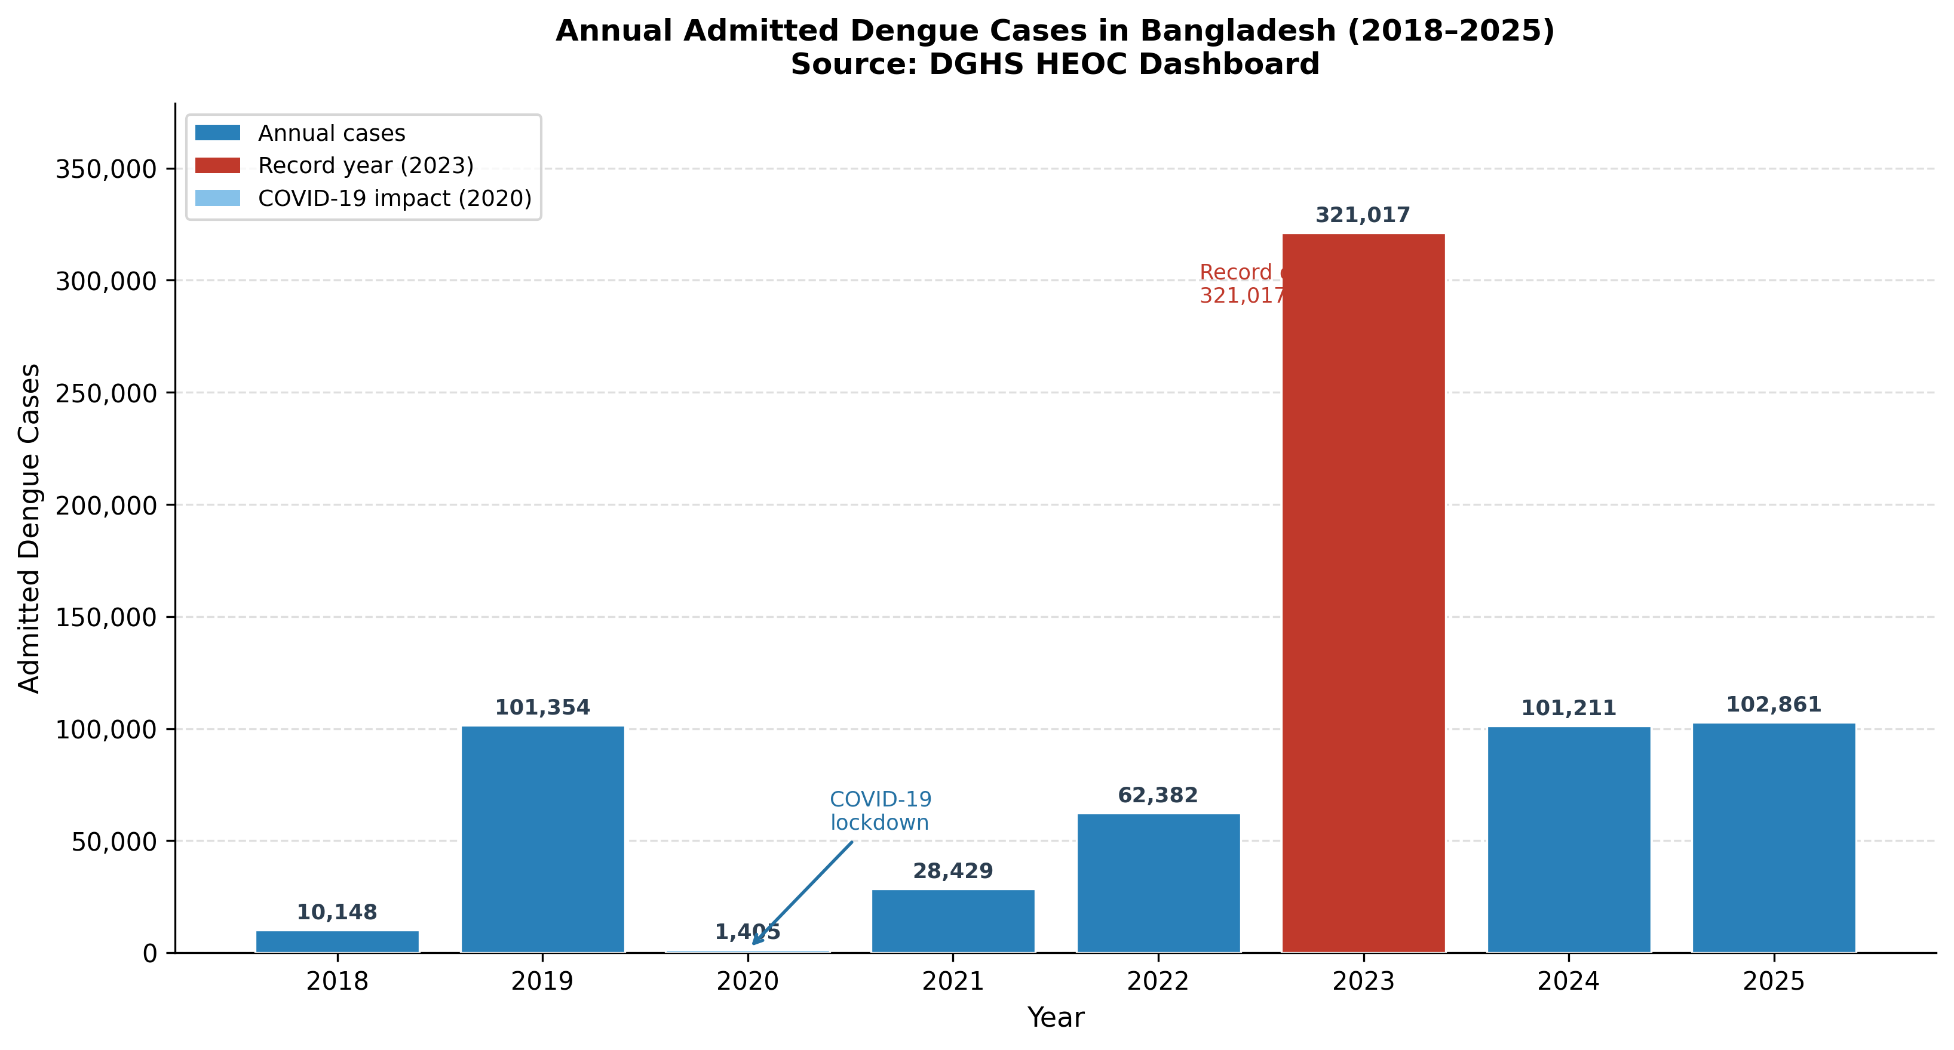
Figure 1. Annual admitted dengue cases in Bangladesh, 2018–2025. Red bar indicates the 2023 record epidemic (321,017 cases). Light blue bar indicates 2020, when COVID-19 lockdown measures coincided with a 97.5% reduction in reported cases. Numbers above bars indicate absolute case counts. Source: DGHS HEOC Dengue Dashboard.

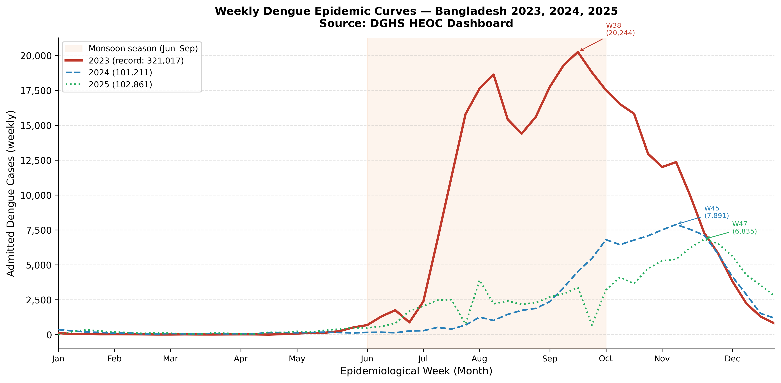
Figure 2. Weekly epidemic curves for admitted dengue cases in Bangladesh, 2023–2025. The orange shading indicates the monsoon season (June–September, weeks 23–40). Annotated values indicate peak week and peak weekly case count for each year. The 2023 peak (W38; 20,244 cases) was 2.6-fold higher than the 2024 peak. Source: DGHS HEOC Dengue Dashboard.

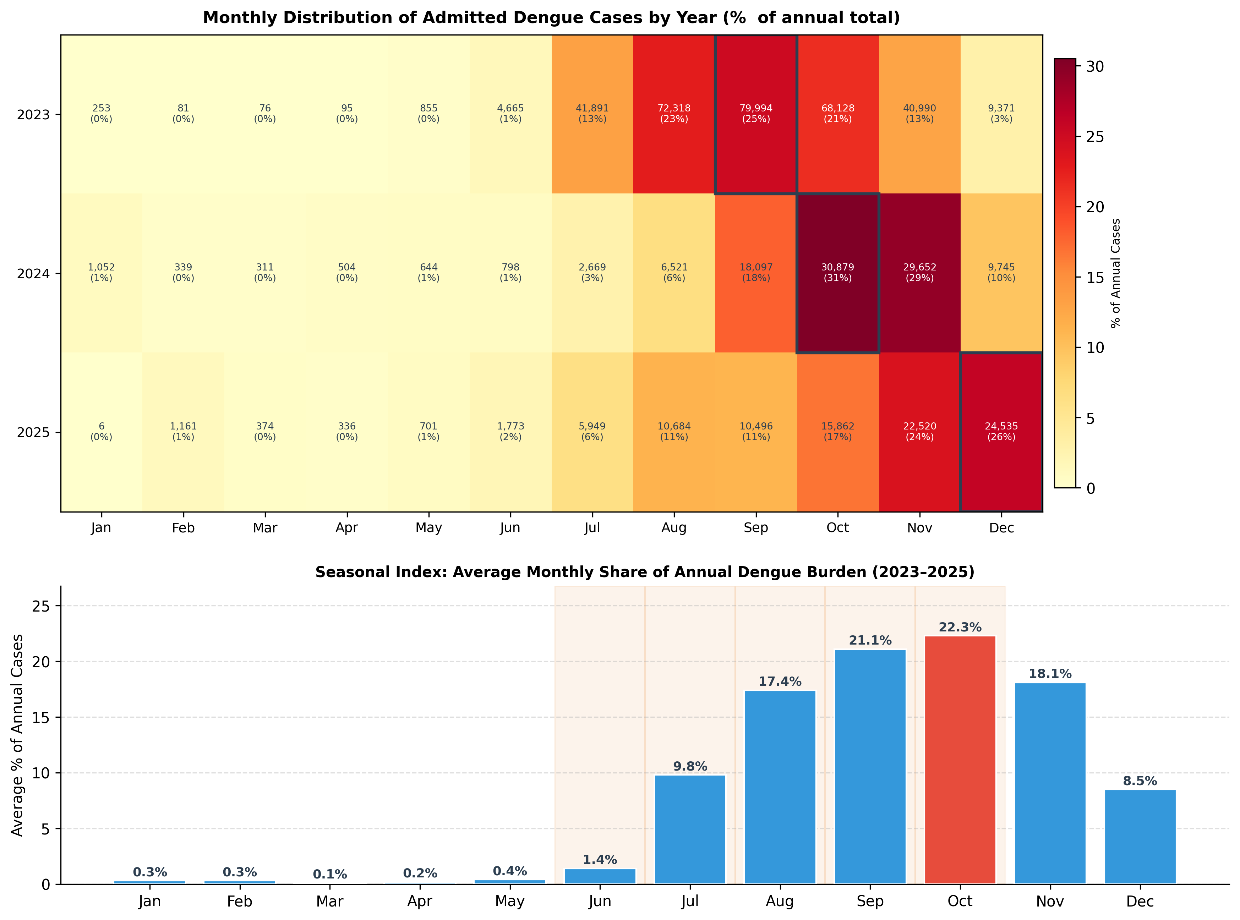
Figure 3. Seasonal distribution of admitted dengue cases in Bangladesh, 2023–2025. Upper panel: monthly heatmap showing cases and percentage of annual total by year (black borders indicate peak month per year). Lower panel: average seasonal index (percentage of annual burden) by month, averaged across 2023–2025. Source: DGHS HEOC Dengue Dashboard.

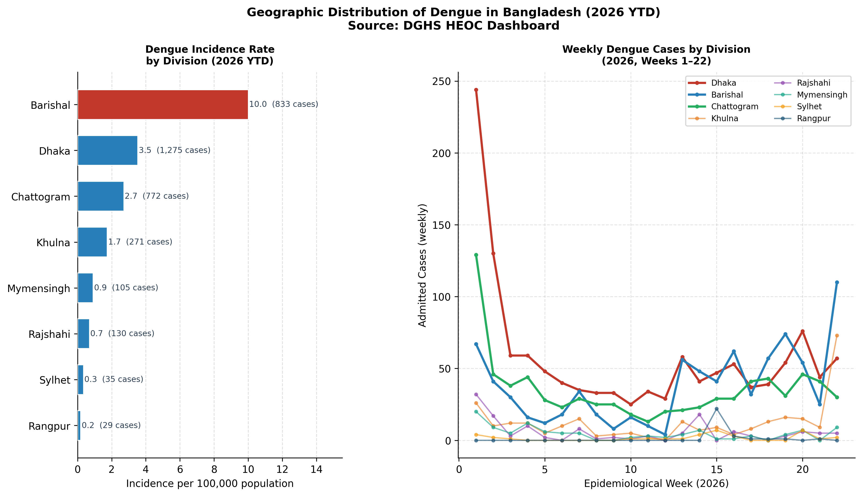
Figure 4. Geographic distribution of dengue in Bangladesh by administrative division, 2026 year-to-date (January 1 – June 3, 2026). Left panel: incidence rate per 100,000 population (horizontal bars; red = highest incidence). Numbers indicate incidence rate and raw case count. Right panel: weekly case trends by division for weeks 1–22 of 2026. Population denominators from BBS 2022 Census. Source: DGHS HEOC Dengue Dashboard.

