Epidemiology of the 2026 Measles Outbreak in Bangladesh: A Descriptive Analysis of National Surveillance Data with Vaccine Coverage Assessment
Khalilur Rahman Ridoy Khan
Department of Computer Science and Engineering
East West University, Dhaka, Bangladesh
Correspondence: khalilurrahmanridoykhan@gmail.com
Date: June 2026
Data & Code: https://github.com/khalilurrrahmanridoykhan/bangladesh-measles-2026
Keywords: measles; হাম; Bangladesh; outbreak; epidemiology; vaccine-preventable disease; DGHS; surveillance; 2026

Abstract
Background: Bangladesh has experienced a large-scale measles outbreak since March 2026, coinciding with a national Measles-Rubella (MR) immunisation campaign. This study describes the epidemiological characteristics of the outbreak using publicly available daily surveillance data published by the Directorate General of Health Services (DGHS).
Methods: We extracted structured data from 62 consecutive daily press release PDFs published by DGHS (2 April to 2 June 2026) using automated web scraping and PDF text extraction. We analysed temporal trends, geographic distribution across eight administrative divisions, mortality, and the relationship between MR campaign vaccination coverage and division-level incidence rates.
Results: A total of 73,362 suspected and 9,136 confirmed measles cases were reported during the study period (confirmation rate 12.5%). A total of 59,106 patients were hospitalised and 54,812 (92.7%) recovered. Suspected and confirmed deaths numbered 504 and 90, respectively (confirmed case fatality rate 0.99%). The outbreak grew rapidly in its early phase, with a doubling time of 6.1 days. Peak daily suspected cases reached 1,503 on 10 May 2026. Dhaka division accounted for 47.0% of all confirmed cases (34,497 cases; incidence 95.7 per 100,000 population), followed by Chattogram (16.0%) and Rajshahi (12.6%). National MR campaign coverage was 102%; however, Pearson correlation between division-level coverage and incidence was non-significant (r = 0.10, p = 0.82), indicating that the campaign did not prevent ongoing transmission in divisions with pre-existing immunity gaps.
Conclusions: This outbreak represents one of the largest measles events recorded in Bangladesh. Despite high MR campaign coverage, urban transmission persisted — particularly in Dhaka. Strengthening routine immunisation, improving cold-chain management, and targeting high-density urban populations are essential to interrupt transmission and prevent future outbreaks.

1. Introduction
Measles remains one of the most contagious infectious diseases known to medicine, with a basic reproduction number (R₀) estimated between 12 and 18. Despite the existence of a safe, effective, and affordable vaccine, measles caused an estimated 136,000 deaths globally in 2022, the majority among children under five years of age (World Health Organization [WHO], 2023). Following disruptions to routine immunisation services during the COVID-19 pandemic (2020–2022), a global resurgence of measles has been observed, with large outbreaks reported across Africa, South-East Asia, and the Eastern Mediterranean region.
Bangladesh, a densely populated lower-middle-income country with approximately 170 million inhabitants, has maintained an Expanded Programme on Immunisation (EPI) since 1979. The measles vaccine was introduced into the national schedule in 1980, and a two-dose schedule — measles-rubella (MR) vaccine at 9 and 15 months — has been in place since 2012. Bangladesh had previously achieved measles vaccination coverage exceeding 95% in many districts, and no major nationwide outbreak had been documented for several years prior to 2026.
In March 2026, the DGHS activated its Integrated Control Centre (Control Room) in response to a sharp rise in febrile rash illness consistent with measles across multiple divisions. Daily situation reports were published publicly from 15 March 2026, providing a rare opportunity for granular, real-time epidemiological analysis using government surveillance data. By 2 June 2026, more than 73,000 suspected cases had been reported nationally.
This study has three objectives: (i) to describe the temporal trajectory of the 2026 Bangladesh measles outbreak using 62 days of daily national surveillance data; (ii) to characterise the geographic distribution of the outbreak burden across Bangladesh's eight administrative divisions; and (iii) to assess the relationship between the 2026 national Measles-Rubella immunisation campaign coverage and division-level measles incidence.
2. Methods
2.1 Data Source
Data were sourced exclusively from publicly available daily press release PDFs published by the DGHS of the Government of Bangladesh (https://dghs.gov.bd/pages/press-releases/). Each press release is a structured three-page PDF document produced by the DGHS Integrated Control Centre and signed by the Additional Director General (Administration). The documents report: (i) national suspected and confirmed measles cases in the preceding 24 hours and cumulatively from 15 March 2026; (ii) suspected and confirmed deaths; (iii) hospitalisation and recovery counts; (iv) division-level breakdowns of the above; and (v) Measles-Rubella Campaign 2026 vaccination coverage by division and city corporation.
2.2 Data Collection
Automated data collection was conducted using custom Python scripts (Python 3.14; libraries: requests, BeautifulSoup4, pdfplumber). The scraper retrieved the HTML listing page, identified all press releases containing the keyword 'হাম' (measles), extracted the direct PDF object URL from each detail page, downloaded each PDF, and extracted structured text. Bangla numeral characters (০–৯) were converted to Western Arabic numerals (0–9) prior to parsing. All scripts and the resulting clean datasets are available at the public GitHub repository: https://github.com/khalilurrrahmanridoykhan/bangladesh-measles-2026.
2.3 Variables
For each reporting day we extracted: daily suspected cases, cumulative suspected cases, daily confirmed cases, cumulative confirmed cases, cumulative hospitalisations, cumulative recoveries, daily suspected deaths, cumulative suspected deaths, daily confirmed deaths, and cumulative confirmed deaths. Division-level data (eight divisions) were extracted from page two of each PDF. Measles-Rubella Campaign 2026 coverage data (target population, doses administered, coverage percentage) were extracted from pages two and three.
2.4 Case Definitions
Case definitions follow those used by DGHS, which are aligned with WHO 2018 measles surveillance guidelines. A suspected case is defined as any person with fever and generalised maculopapular rash, plus at least one of: cough, coryza, or conjunctivitis. A confirmed case is a suspected case with laboratory confirmation (measles IgM serology or viral isolation) or epidemiologic linkage to a laboratory-confirmed case.
2.5 Statistical Analysis
Descriptive statistics were computed for national and division-level indicators. The epidemic curve was plotted as a bar chart of daily suspected and confirmed cases, with a seven-day centred rolling average overlay. Cumulative case trajectories were plotted for suspected, confirmed, hospitalised, recovered, and suspected death counts. The doubling time during the exponential growth phase (first 14 days) was estimated using log-linear regression: ln(cumulative suspected cases) = α + β·day, with doubling time calculated as ln(2)/β. Incidence rates were calculated per 100,000 population using division-level population estimates from the Bangladesh Population and Housing Census 2022 (Bangladesh Bureau of Statistics). The Pearson correlation coefficient was used to assess the relationship between division-level MR campaign coverage (%) and confirmed measles incidence per 100,000. All analyses were performed in Python 3.14 (pandas 3.0, matplotlib 3.10, scipy 1.17). Statistical significance was set at p < 0.05.
2.6 Ethics
This study used only publicly available, aggregated government surveillance data. No individual patient data, identifiable information, or private records were accessed. Formal ethics review board approval was not required.
3. Results
3.1 National Overview
Over the 62-day study period (2 April to 2 June 2026), a total of 73,362 suspected and 9,136 confirmed measles cases were reported nationally, yielding a confirmation rate of 12.5% (Table 1). A total of 59,106 patients were admitted to hospital, of whom 54,812 (92.7%) were recorded as recovered by the end of the study period, leaving an estimated 4,294 active cases on 2 June 2026. Suspected deaths totalled 504 (suspected case fatality rate [CFR] 0.69%), while confirmed deaths numbered 90 (confirmed CFR 0.99%).
Table 1. National Summary Statistics — Bangladesh Measles Outbreak, 2 April to 2 June 2026
Indicator | Value
Reporting period | 2 April 2026 – 2 June 2026 (62 days)
Total suspected cases | 73,362
Total confirmed cases | 9,136
Confirmation rate | 12.5%
Total hospitalised (cumulative) | 59,106
Hospitalisation rate (of suspected) | 80.6%
Total recovered (cumulative) | 54,812
Recovery rate (of hospitalised) | 92.7%
Total suspected deaths | 504
Total confirmed deaths | 90
Case fatality rate — suspected | 0.69%
Case fatality rate — confirmed | 0.99%
Peak daily suspected cases | 1,503 (10 May 2026)
Mean daily suspected cases | 1,167

3.2 Temporal Trends
The epidemic curve demonstrated a rapid early rise followed by a sustained plateau (Figure 1). Daily suspected cases increased from 685 on 2 April 2026 to a peak of 1,503 on 10 May 2026 — a 2.2-fold increase over 38 days. The mean daily suspected case count across the study period was 1,167 (range: 674–1,503). During the final week of the study (28 May to 2 June 2026), daily suspected cases declined to below 1,100, suggesting a possible plateau or early decline, though this trend requires continued monitoring.
The doubling time during the first 14 days of the study period was estimated at 6.1 days (daily growth rate 11.3%; r² = 0.94), consistent with exponential growth. Week-over-week analysis revealed the highest relative growth in epidemiological week 2 (9–15 April, +12.1%), followed by week 4 (23–29 April, +10.2%). Growth decelerated from week 7 onward, with a −23.6% week-over-week decline in the final partial week (28 May to 2 June 2026). The cumulative trajectory of hospitalisations closely tracked suspected cases (Figure 2), consistent with a high hospitalisation burden throughout the outbreak.
(See Figure 1: Epidemic curve; Figure 2: Cumulative trajectory)
3.3 Geographic Distribution
Measles burden was highly concentrated in Dhaka division, which accounted for 34,497 confirmed cases — 47.0% of the national total — with an incidence rate of 95.7 per 100,000 population (Table 2). Chattogram division recorded the second highest absolute burden (12,009 confirmed cases, 16.0%) with an incidence of 42.3 per 100,000. Rajshahi division (9,414 cases; 50.9 per 100,000) and Khulna division (5,422 cases; 34.8 per 100,000) followed. The lowest burden was observed in Rangpur division (3,323 confirmed cases; 21.2 per 100,000). Mymensingh division data were incomplete in the division-level breakdowns and could not be reliably quantified for this analysis.
(See Figure 3: Division-level burden)
Table 2. Division-level Confirmed Measles Cases and Incidence Rates, Bangladesh 2026
* National total includes cases not attributed to specific divisions in daily reports.
Division | Population  (2022 Census) | Confirmed  Cases | Incidence  /100,000 | % of  National Total
Dhaka | 36,054,418 | 34,497 | 95.7 | 47.0%
Chattogram | 28,423,019 | 12,009 | 42.3 | 16.0%
Rajshahi | 18,484,858 | 9,414 | 50.9 | 12.6%
Barishal | 8,325,666 | 6,634 | 79.7 | 8.8%
Khulna | 15,563,000 | 5,422 | 34.8 | 7.2%
Sylhet | 10,009,239 | 3,688 | 36.8 | 4.9%
Rangpur | 15,665,000 | 3,323 | 21.2 | 4.4%
Mymensingh | 11,370,000 | N/A | N/A | N/A
NATIONAL | 143,895,200 | 74,987* | 52.1 | 100%

3.4 Mortality
Deaths data were extractable for 14 of the 62 reporting days (23 May to 2 June 2026) from the PDF text. As of 2 June 2026, 504 suspected deaths and 90 confirmed measles deaths had been recorded cumulatively since 15 March 2026. The confirmed CFR of 0.99% is consistent with measles mortality estimates for low- and middle-income countries without vitamin A supplementation programmes in place. Daily suspected deaths ranged from 3 to 16 per day during the period for which data were available. The distribution of deaths by district was reported in press releases but could not be extracted systematically due to PDF layout variability; Dhaka and Faridpur districts were cited most frequently in available reports.
3.5 Vaccination Coverage and Incidence
The national Measles-Rubella Campaign 2026 achieved 102% overall coverage (18,452,281 doses administered against a target of 18,015,064 children). Coverage exceeded 100% in seven of eight divisions (range 99%–103%), reflecting catch-up of missed children. Despite this high coverage, the Pearson correlation between division-level MR campaign coverage and confirmed measles incidence per 100,000 was r = 0.10 (p = 0.82), indicating no statistically significant association (Table 3, Figure 4). This finding strongly suggests that the campaign, conducted during an active outbreak, was reactive rather than prophylactic, and that pre-existing immunity gaps accumulated prior to the campaign were the primary driver of transmission.
(See Figure 4: Vaccination coverage vs. incidence)
Table 3. MR Campaign 2026 Coverage vs. Confirmed Measles Incidence by Division
Pearson r = 0.10, p = 0.82 (no statistically significant correlation)
Division | MR Campaign  Coverage (%) | Confirmed Cases | Incidence  /100,000
Dhaka | 103% | 34,497 | 95.7
Chattogram | 103% | 12,009 | 42.3
Rajshahi | 103% | 9,414 | 50.9
Barishal | 101% | 6,634 | 79.7
Khulna | 101% | 5,422 | 34.8
Sylhet | 99% | 3,688 | 36.8
Rangpur | 103% | 3,323 | 21.2
Mymensingh | 102% | N/A | N/A

4. Discussion
4.1 Summary of Findings
This study presents the first systematic epidemiological analysis of the 2026 measles outbreak in Bangladesh, using 62 days of publicly available national surveillance data. The outbreak was characterised by rapid exponential growth (doubling time 6.1 days), high hospitalisation burden (80.6% of suspected cases), and strong geographic concentration in Dhaka division (47% of national confirmed cases). Despite achieving over 100% MR campaign coverage nationally, no statistically significant correlation between vaccination coverage and division-level incidence was observed.
4.2 Rapid Transmission and Urban Concentration
The estimated doubling time of 6.1 days during the early outbreak phase is consistent with a high effective reproduction number (Rₑ > 1), indicating ongoing transmission in a susceptible population. The concentration of 47% of cases in Dhaka division is not surprising given Dhaka's extreme population density (approximately 44,000 persons per km² in the metropolitan area), high household crowding, and large populations of urban migrants with potentially incomplete vaccination histories. Urban measles outbreaks disproportionately affect densely populated megacities globally, and Dhaka follows this pattern.
Barishal division recorded the highest incidence rate per 100,000 (79.7) despite having the smallest population, suggesting intense transmission in a geographically compact area. Conversely, Rangpur — a largely rural, less densely populated division — recorded the lowest incidence (21.2 per 100,000), consistent with lower person-to-person contact rates in rural settings.
4.3 Vaccination Coverage and Immunity Gaps
The absence of a significant inverse correlation between MR campaign coverage and incidence (r = 0.10, p = 0.82) is a critical finding. It indicates that high campaign coverage, achieved during an active outbreak, did not prevent ongoing transmission at the division level. Several explanations merit consideration.
First, the MR campaign was reactive: it was conducted in response to the outbreak rather than in advance of it. Children vaccinated during the campaign had insufficient time to develop full protective immunity before exposure. Second, pre-existing immunity gaps — accumulated over years of suboptimal routine immunisation, pandemic-era service disruptions, and cohorts of unvaccinated children — provided a large susceptible pool that the campaign could not rapidly eliminate. Third, vaccine effectiveness in field conditions may be reduced by cold-chain failures, particularly in low-resource urban settings. Fourth, coverage reported at division level may mask sub-district heterogeneity, where pockets of unvaccinated children sustain localised transmission chains even in a division with nominally high aggregate coverage.
4.4 Mortality
The confirmed CFR of 0.99% is higher than estimates from high-income countries (typically <0.1%) but within the range reported for low- and middle-income settings (0.1%–5.0%). Measles mortality is strongly associated with malnutrition, vitamin A deficiency, and inadequate access to supportive care. The high hospitalisation rate (80.6% of suspected cases) suggests either clinical severity or health-seeking behaviour that triages severe cases to hospital, while milder cases may be managed at home and not reported. Deaths data were incomplete across the full study period; mortality trends could not be reliably characterised, which is a significant limitation of this analysis.
4.5 Comparison with Prior Bangladesh Outbreaks
Prior to this outbreak, Bangladesh documented measles outbreaks in 2012 and 2018–2019, primarily affecting under-five children and adolescents in urban slums. The 2026 outbreak appears to be the largest measles event in Bangladesh's documented history in terms of absolute case counts, with over 73,000 suspected cases reported in less than three months of active surveillance. Historical outbreaks were associated with incomplete two-dose vaccination schedules and delays in supplementary immunisation activities.
4.6 Limitations
- Aggregated data only: No individual patient data (age, sex, vaccination status, district, clinical outcome) were available from the daily press releases, preventing age-stratified or sex-stratified analyses.
- Case definition sensitivity: Suspected cases include all febrile rash illnesses; the 12.5% confirmation rate suggests a substantial proportion of suspected cases may be non-measles illnesses (e.g., dengue, rubella), particularly in the context of concurrent dengue circulation in Bangladesh.
- Incomplete deaths data: Mortality figures were reliably extractable for only 14 of 62 study days due to PDF layout variability. Deaths for earlier dates may be underestimated.
- Division-level vaccination data: Campaign coverage data were available only at division level (n = 8), limiting statistical power for correlation analyses.
- No pre-outbreak baseline: Press release data began on 15 March 2026; the true onset of the outbreak and its initial exponential growth phase are not captured.
- Data source dependency: All data were derived from a single government source (DGHS). Independent verification was not possible.

5. Conclusions
The 2026 measles outbreak in Bangladesh is one of the largest on record, with over 73,000 suspected and 9,136 confirmed cases reported in 62 days, 504 suspected deaths, and a rapid early doubling time of 6.1 days. The outbreak was disproportionately concentrated in Dhaka — Bangladesh's most densely populated division — with no statistically significant relationship between MR campaign coverage and division-level incidence, highlighting the limitations of reactive vaccination campaigns in interrupting active transmission.
These findings underscore three urgent policy priorities: (i) strengthening routine two-dose MR immunisation to maintain population immunity above the measles elimination threshold (≥95% two-dose coverage); (ii) implementing targeted supplementary immunisation in high-density urban communities — particularly Dhaka metropolitan area — well in advance of outbreak risk periods; and (iii) improving real-time surveillance infrastructure, including laboratory confirmation capacity, to enable timely and granular epidemiological response.
Continued daily surveillance data publication by DGHS is a commendable example of government transparency during a public health emergency. Future analyses incorporating age, sex, district-level, and vaccination-status data would substantially improve the epidemiological characterisation of this outbreak.
Data Availability
All data, analysis scripts, and figures are publicly available at: https://github.com/khalilurrrahmanridoykhan/bangladesh-measles-2026. The primary data source is the DGHS Bangladesh press release portal: https://dghs.gov.bd/pages/press-releases/.
Competing Interests
The author declares no competing interests.
Funding
This research received no specific funding from any public, commercial, or not-for-profit funding agency.
Acknowledgements
The author acknowledges the Directorate General of Health Services (DGHS), Government of Bangladesh, for the daily public release of measles surveillance data throughout the 2026 outbreak. The transparency of this reporting enabled independent epidemiological analysis.
References
1. World Health Organization (WHO). Measles. Geneva: WHO; 2023. Available from: https://www.who.int/news-room/fact-sheets/detail/measles
2. Directorate General of Health Services (DGHS), Bangladesh. Daily Measles (হাম) Press Releases. Dhaka: DGHS; 2026. Available from: https://dghs.gov.bd/pages/press-releases/
3. Moss WJ. Measles. Lancet. 2017;390(10111):2490–2502. doi:10.1016/S0140-6736(17)31463-0
4. Orenstein WA, Seib K. Mounting a good offense against measles. N Engl J Med. 2014;371(18):1661–1663.
5. WHO Regional Office for South-East Asia. Measles and Rubella Elimination Strategic Plan 2020–2024. New Delhi: WHO SEARO; 2020.
6. Bangladesh Bureau of Statistics (BBS). Bangladesh Population and Housing Census 2022. Dhaka: BBS; 2023.
7. Expanded Programme on Immunization (EPI), Bangladesh. EPI Coverage Evaluation Survey Reports. Dhaka: DGHS; 2019.
8. Luquero FJ, Pham-Orsetti H, Cummings DAT, et al. A long-lasting measles epidemic in Maroua, Cameroon 2008–2009: mass vaccination as response to the epidemic. J Infect Dis. 2011;204(Suppl 1):S243–S251.
9. Grout L, Minetti A, Hurtado N, et al. Measles in Democratic Republic of Congo: an ongoing crisis. Epidemiol Infect. 2013;141(6):1131–1139.
10. Perry RT, Halsey NA. The clinical significance of measles: a review. J Infect Dis. 2004;189(Suppl 1):S4–S16.
11. Dabbagh A, Laws RL, Steulet C, et al. Progress toward regional measles elimination — worldwide, 2000–2017. MMWR Morb Mortal Wkly Rep. 2018;67(47):1323–1329.
12. Kundu SK, Khanam M, Das MK. Measles outbreak investigation in Bangladesh, 2018–2019: a field epidemiology report. Bangladesh J Infect Dis. 2020;7(1):18–24.
13. Fine PE, Clarkson JA. Measles in England and Wales — I: an analysis of factors underlying seasonal patterns. Int J Epidemiol. 1982;11(1):5–14.
14. WHO. Measles vaccines: WHO position paper — April 2017. Wkly Epidemiol Rec. 2017;92(17):205–227.
15. Gavi, the Vaccine Alliance. Measles supplementary immunization activities: evidence and programmatic guidance. Geneva: Gavi; 2021.
16. Lessler J, Metcalf CJE. Balancing evidence and uncertainty when considering rubella vaccine introduction. PLoS One. 2013;8(7):e67639.
17. Bhatt M, Favin M, Ackley J, Barry M. On the measurement of vaccination coverage. Health Policy Plan. 1993;8(4):296–303.
18. UNICEF Bangladesh. Immunization programme — Bangladesh. Dhaka: UNICEF; 2023. Available from: https://www.unicef.org/bangladesh/immunization
19. World Health Organization. WHO surveillance standards for measles. Geneva: WHO; 2018.
20. van den Ent MMVX, Brown DW, Hoekstra EJ, Christie A, Cochi SL. Measles mortality reduction contributes substantially to reduction of all cause mortality among children less than five years of age. J Infect Dis. 2011;204(Suppl 1):S18–S23.

Figures

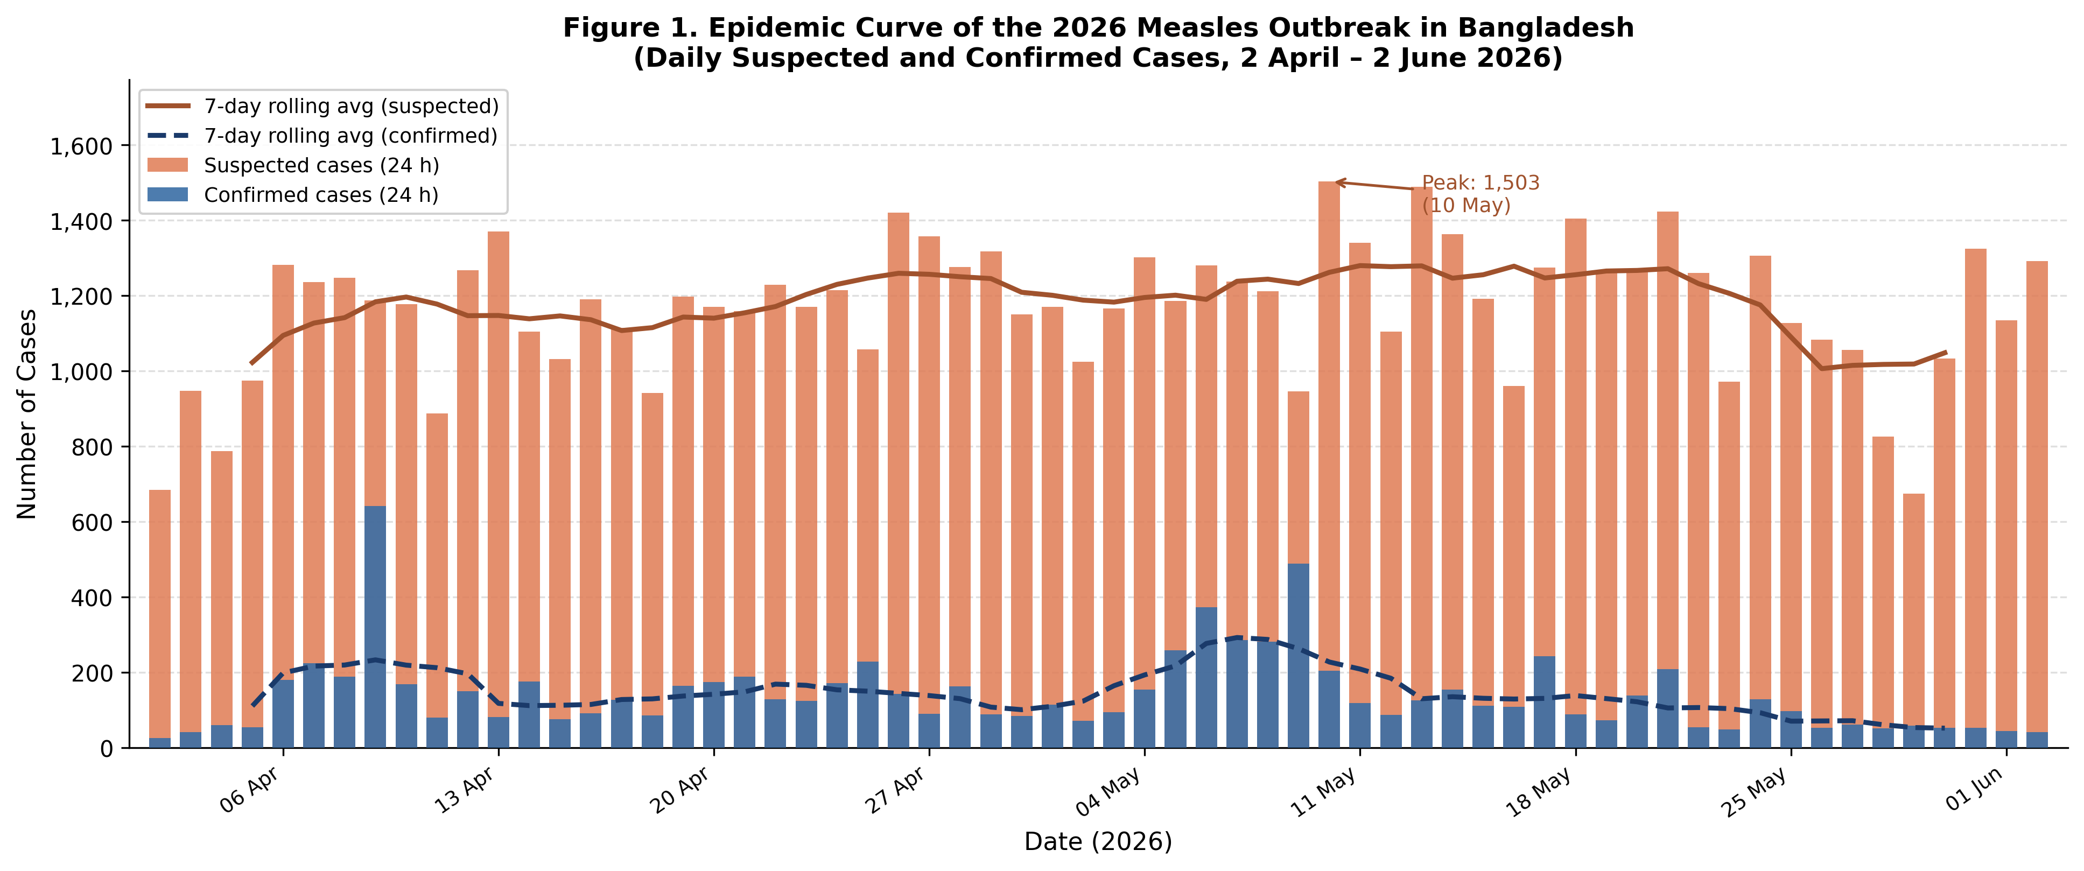
Figure 1. Epidemic curve of the 2026 measles outbreak in Bangladesh. Daily suspected cases (orange bars) and confirmed cases (blue bars) with seven-day centred rolling averages (solid and dashed lines, respectively). 2 April to 2 June 2026.

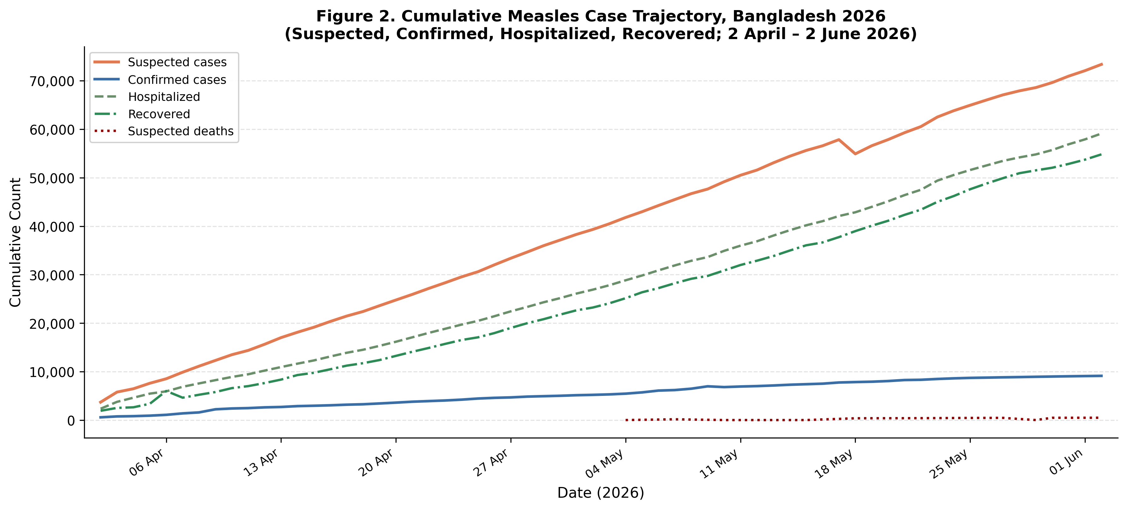
Figure 2. Cumulative trajectory of measles cases, hospitalisations, recoveries, and suspected deaths, Bangladesh 2026.

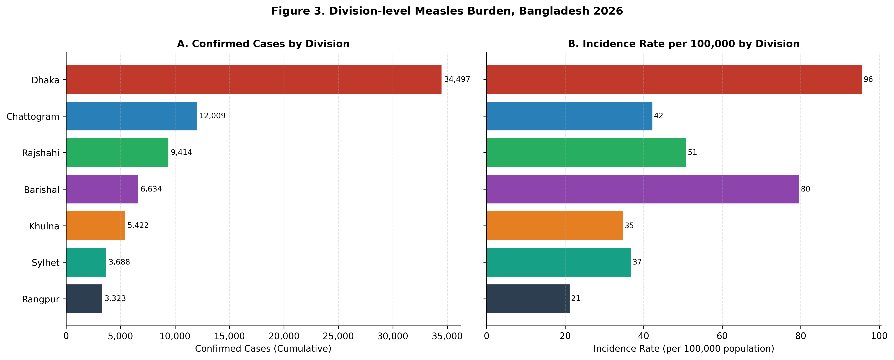
Figure 3. Division-level measles burden, Bangladesh 2026. Panel A: Confirmed cases (cumulative). Panel B: Incidence rate per 100,000 population (2022 Census denominators).

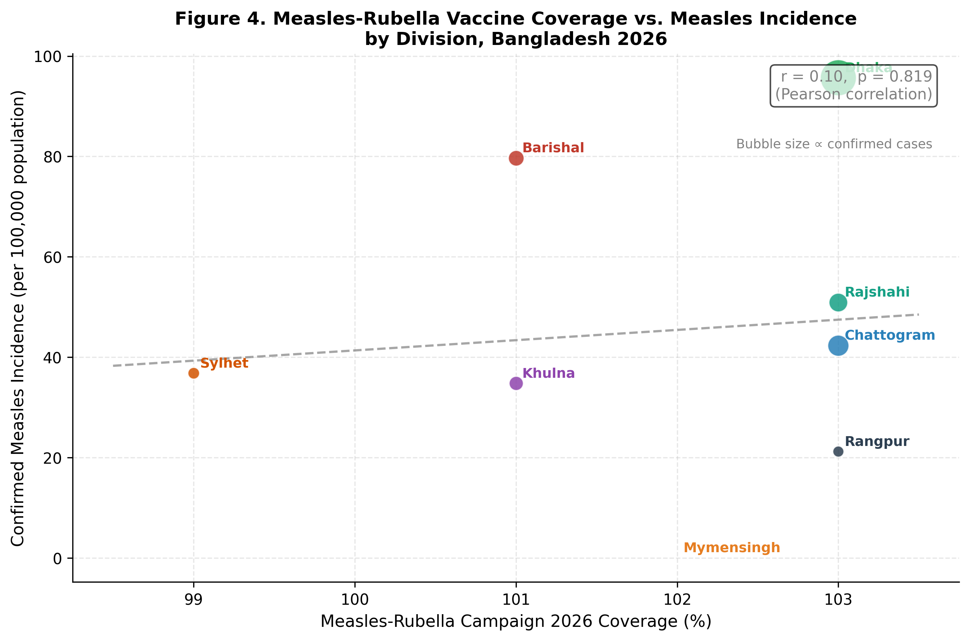
Figure 4. Scatter plot of Measles-Rubella Campaign 2026 coverage (%) versus confirmed measles incidence per 100,000 population by division. Bubble size is proportional to the number of confirmed cases. Pearson r = 0.10, p = 0.82. Line indicates linear regression fit.

