Auto-K: An Automated Geometric Approach for Optimal Cluster Selection in K-Means using the Enhanced Elbow Method
Name | Registration No
Muhammad Khallad Ahmad | L1F22BSDS0021
M Azhar Sajjad | L1F22BSDS0020
Vania Kamran | L1F22BSDS0061

Course
Data Mining

Instructor/Supervisor
Ma’am Maida Sajid

Faculty of Information Technology (FOIT)
Department of Data Science
Table of Contents
Abstract --------------------------------------------------------------------------------------------3
1. Introduction-------------------------------------------------------------------------------------3
2. Background and Related Work-------------------------------------------------------------3
2.1 Traditional Elbow Method------------------------------------------------------------------3
2.2 Mathematical Validation Metrics----------------------------------------------------------3
2.2.1 Silhouette Score--------------------------------------------------------------------------3
2.2.2 Davies–Bouldin Index-------------------------------------------------------------------3
2.3 Automated Elbow Detection Techniques-------------------------------------------------3
2.3.1 AutoElbow Method----------------------------------------------------------------------4
2.3.2 Geometric Angle and Curvature Methods--------------------------------------------4
2.4 Motivation and Contribution of This Work----------------------------------------------4
3. Methodology------------------------------------------------------------------------------------5
3.1 Data Preprocessing---------------------------------------------------------------------------5
3.1.1 Feature Normalization--------------------------------------------------------------------5
3.1.2 Dimensionality Reduction using PCA--------------------------------------------------5
3.2 Automated k Selection Techniques---------------------------------------------------------5
3.2.1 Geometric Angle Method-----------------------------------------------------------------5
3.2.2 Curvature Method--------------------------------------------------------------------------5
3.3 Cluster Visualization---------------------------------------------------------------------------5
3.4 Metric-Based Evaluation-----------------------------------------------------------------------5
4. Experimental Results---------------------------------------------------------------------------6
4.1 UCI Heart Disease Dataset-------------------------------------------------------------------6
4.1.1 Dataset Description------------------------------------------------------------------------6
4.1.2 Optimal k Selection------------------------------------------------------------------------6
4.1.3 Clustering Performance and Stability----------------------------------------------------6
4.1.4 Evaluation Metrics--------------------------------------------------------------------------6
4.2 Mall Customer Segmentation Dataset--------------------------------------------------------7
4.2.1 Dataset Description--------------------------------------------------------------------------7
4.2.2 Optimal k Selection--------------------------------------------------------------------------7
4.2.3 Cluster Characteristics and Visualization-------------------------------------------------7
4.2.4 Evaluation Metrics---------------------------------------------------------------------------7
5. Evaluation and Discussion-----------------------------------------------------------------------8
5.1 Quantitative Performance Analysis------------------------------------------------------------9
5.2 Ground Truth Comparison-----------------------------------------------------------------------9
5.3 Consistency and Stability Analysis-------------------------------------------------------------9
5.4 Efficiency Analysis-------------------------------------------------------------------------------10
6. Comparative and Efficiency Analysis--------------------------------------------------------------11
6.1 Manual versus Automated Elbow Selection-------------------------------------------------------12
6.2 Computational Efficiency----------------------------------------------------------------------------12
7. Challenges and Limitations----------------------------------------------------------------------------12

Abstract:
In this experiment we tried to address the subjectivity of determining the optimal number of clusters(k) for K-Means clustering. With the help of Geometric Angle Method and a Curvature Method we automated the “elbow” detection process. This framework was then evaluation with the help of two distinct datasets: the UCL Heart Diseases dataset and a Mall Customer segmentation dataset. Results of this experiment suggested that Geometric Angle Method provided mathematically rigorous and reproducible alternatives to traditional visual inspection, as measured with Silhouette Scores and Davies-Bouldin indices.

1. Introduction:
As we all know the importance of K-Means Algorithm in unsupervised learning which is undeniable of very high significance. But its performance is highly dependent on the hyperparameter k. Traditionally we use “Elbow Method” which is visual heuristic where Within-Cluster Sum of squares (WCSS) is plotted against k and the elbow of curve is selected. This approach is vulnerable to human bias. This report details an automated, geometry-based approach to eliminate this subjectivity.
2. Background/Related Work:
The challenge of picking the right number of clusters (k) has been studied for decades. Research in this area generally falls into three categories:
The Traditional Elbow Method:
- The most famous approach is the Elbow Method, first popularized in the 1960s. It involves plotting the "Within-Cluster Sum of Squares" (WCSS) and looking for a bend in the graph.
- However, experts like Schubert (2022) have criticized this method because it lacks a strict mathematical definition what looks like an "elbow" to one person might look like a smooth curve to another.
Mathematical Validation Metrics:
To move away from visual guessing, researchers developed scores like:
- Silhouette Score: Measures how similar an object is to its own cluster compared to others.
- Davies-Bouldin Index: Evaluates the average "similarity" between clusters, where lower scores mean better defined groups.
While these are great for checking quality, they still require the user to run the algorithm many times and manually compare the results.
Automated Elbow Detection:
Recent studies have tried to "mathematize" the elbow.
- AutoElbow (2022): A recent method that normalizes the graph and calculates distances to a reference point to find the "heel" of the curve automatically.
- Geometric & Curvature Methods: Similar to our project, researchers like Herdiana et al. (2025) have proposed using the cosine rule and derivatives to find the exact point where the curve's direction changes most sharply. These methods turn a "visual feeling" into a "calculated fact."
Why our work is different:
Our project which is inspired from all the above mentioned methodologies and mathematical framework combines two geometric perspectives angles and curvature specifically to see how they perform on real-world datasets like Heart Disease and Mall Customers. By doing this, we provide a faster, automated way to get reliable results without needing a human expert to "eye-ball" a graph.

3.Methodology:
Our workflow consists of four stages: data processing, automated k selection, cluster visualization, and metric based evaluation.
3.1 Data Preprocessing
Both datasets were normalized using Min-Max Scaling in order to ensure that all features contribute equally to the distance calculation. For visualization, Principal Component Analysis (PCA) was used to reduce multidimensional feature space into two principal components.
3.2 Automated Selection Techniques
Following two mathematical approaches were implemented to identify the elbow point:
- Geometric Angle Method: It uses vector geometry to calculate the angle formed by three consecutive points on the WCSS curve. The k value with the maximum angle (the sharpest turn) is identified as optimal Elbow point.
- Curvature Method: It resembles the second derivative of WCSS curve. The point of maximum curvature indicates most significance decrease in rate of WCSS reduction.

4. Experimental Results:
4.1 UCL Heart Disease Dataset
The UCI Heart Disease dataset contained 297 samples and 13 features which presented a complex, high-dimensional space for clustering.(We dealt with it as stated in data preprocessing section).

- Optimal k Selection: The Geometric Angle Method identified k=5 as the optimal value, as specified by a sharp geometric angle of 179.89°.
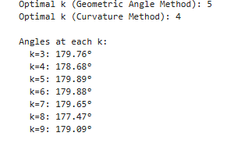
- Geometric Performance: The angles remained relatively flat (near 180°), with k=5 reaching 179.89°.
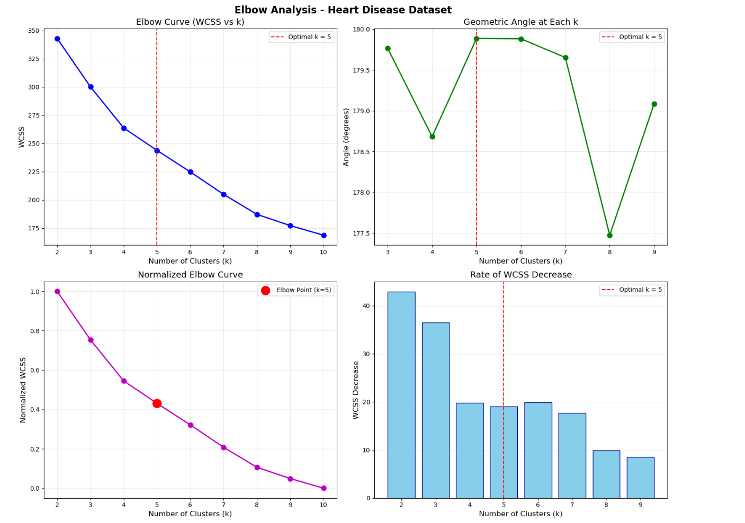
- Clustering Quality: The resulting clusters showed reasonable separation in PCA space despite the complexity of medical data.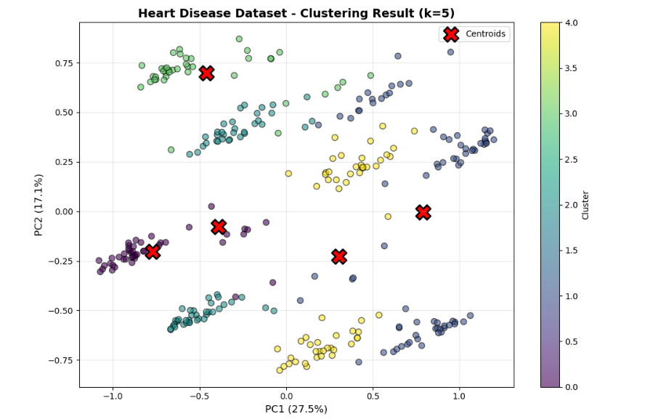
- Stability: Sensitivity analysis showed that k=5 was selected in 100% of test runs, confirming the method's reliability.
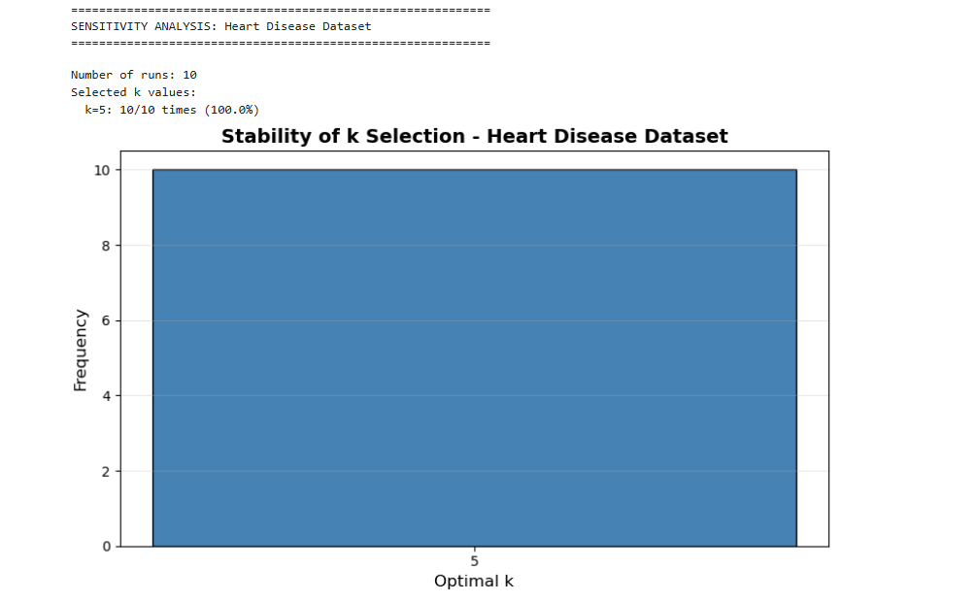
  - Performance Metrics: The selection achieved a Silhouette Score of 0.2131 and a Davies-Bouldin Index of 1.6612.
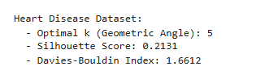

4.2 Mall Customer Segmentation Dataset:
The Mall Customer dataset provided more distinct clustering opportunities. It contained 200 samples and 3 features.
Optimal k: The Geometric Angle Method suggested k=3 (angle: 178.94°). While the Curvature Method suggested k=4, the Normalized Elbow Curve confirms that k=3 captures the primary structural change in the data.
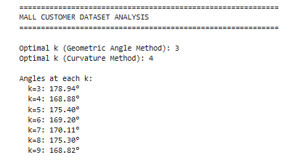

- Geometric Performance: The sharpest angle was recorded at k=3 with 178.94°.
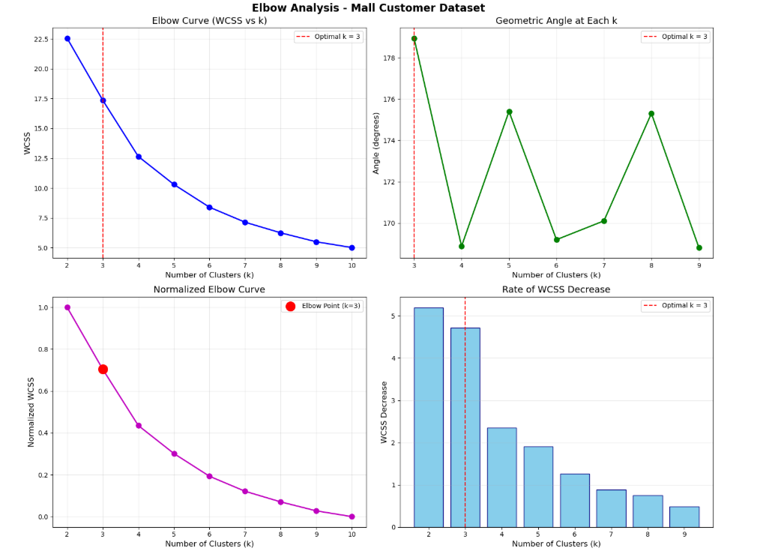

- Cluster Distinctness: Following visualization shows three clear segments representing different customer behaviours.
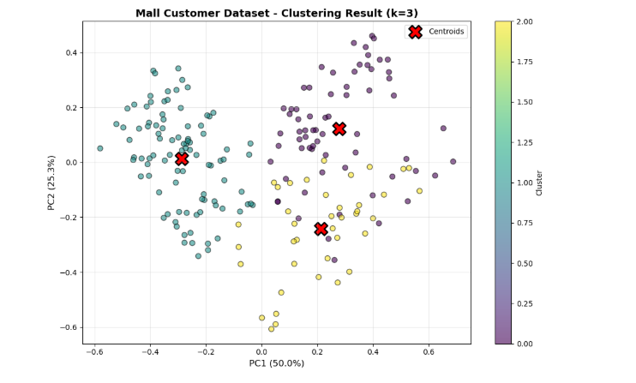

- Cluster Characteristics: The data is segmented into three distinct groups: Cluster 0 (33.5%), Cluster 1 (47.0%), and Cluster 2 (19.5%).
- Performance Metrics: This dataset had a higher Silhouette Score of 0.3650 and a superior Davies-Bouldin Index of 1.0514.
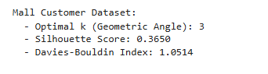
5. Evaluation and Discussion:
In this experiment quality of automated selection was validated using standard metrices.
Metric | Heart Disease (k=5) | Mall Customer (k=3)
Silhouette Score | 0.2131 | 0.3650
Davies-Bouldin Index | 1.6612 | 1.0514
Final WCSS | 243.79 | 17.37
Key Findings:
- Ground Truth Comparison: For the Heart Disease dataset, the Adjusted Rand Index (0.1409) suggests that while clustering identifies patterns, it does not perfectly align with binary clinical diagnoses, likely due to the high dimensionality of symptoms.
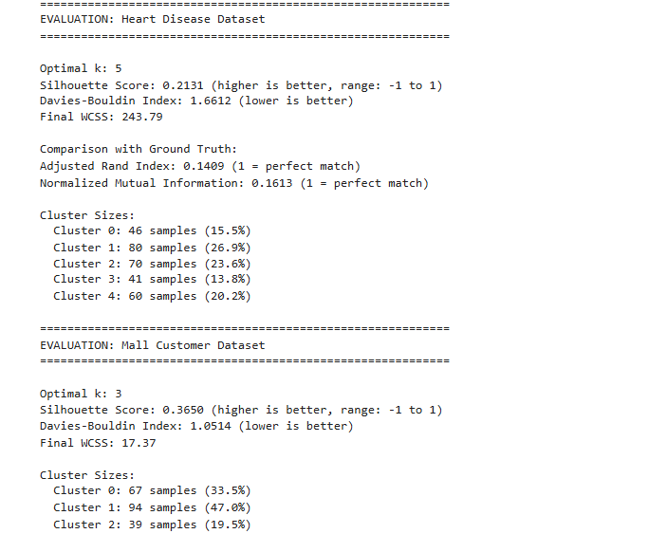
- Consistency: The Normalized Elbow Curves confirm that the automated "Elbow Point" coincides with the region where the rate of WCSS decrease begins to plateau.
UCL Heart Disease:
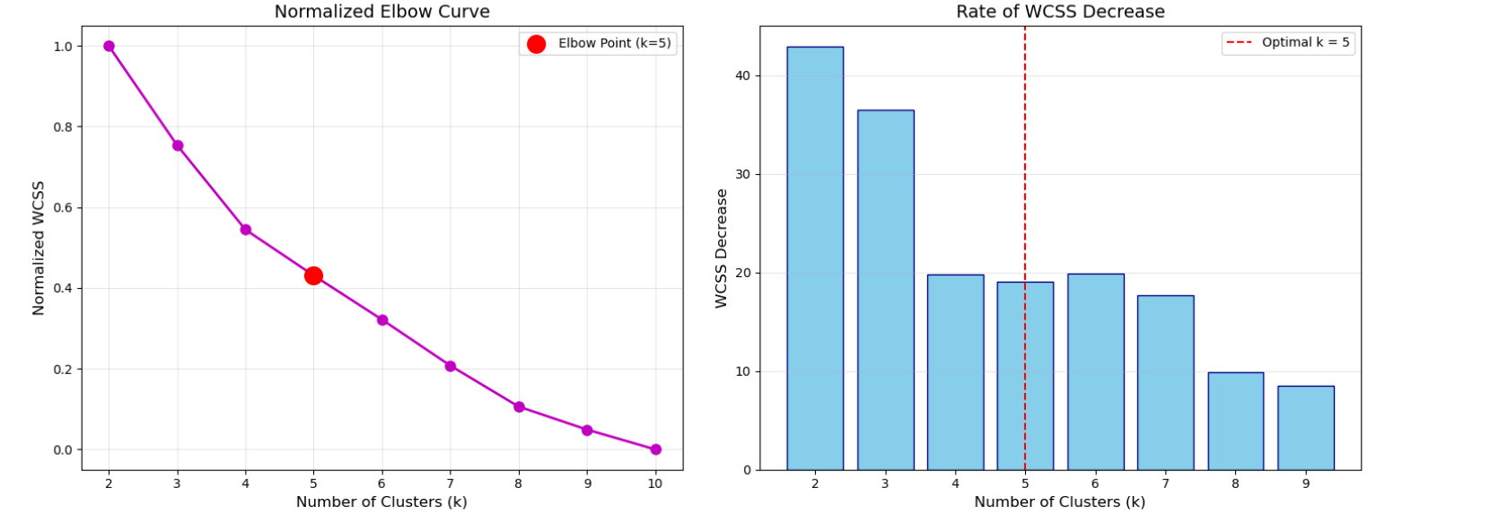
Mall Customer Segmentation:
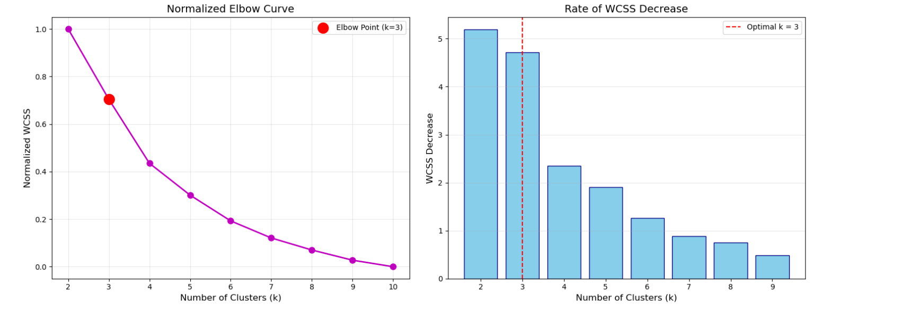
- Efficiency: The automated selection process executed in under 2 second for both datasets, proving its suitability for automated pipelines.

6. Comparative and Efficiency Analysis:
6.1 Manual Vs Automated Comparison
Automated selection successfully aligned with visual intuition for both these datasets. For the Heart disease dataset, the automated selection of k=5 falls exactly at the inflection point where the rate of WCSS decrease begins to stabilize.

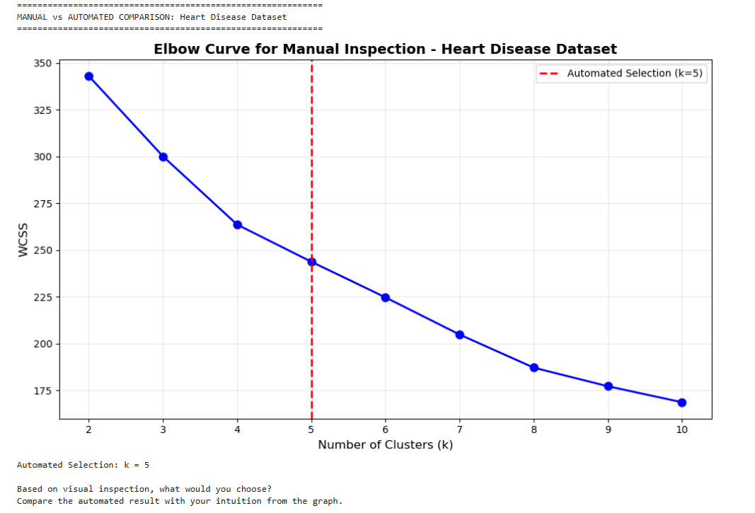

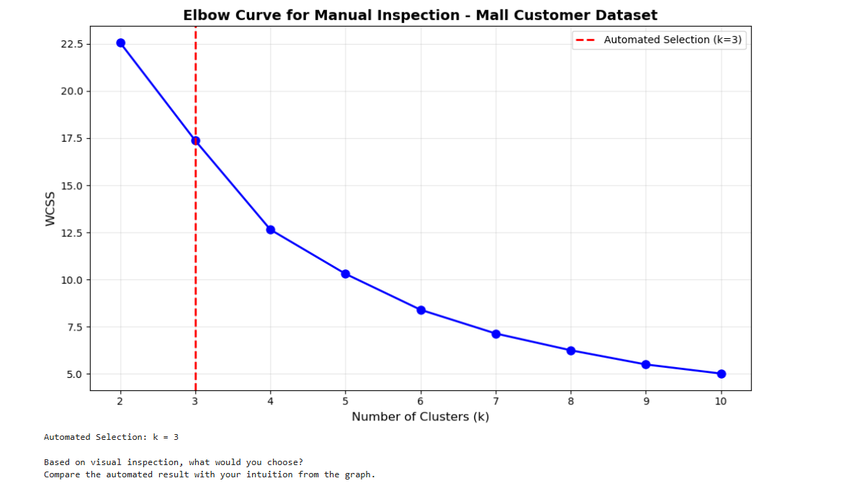
6.2 Computation Efficiency:
The algorithm demonstrated high efficiency, which makes it suitable for large-scale automated pipelines:
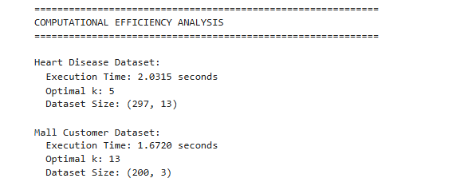
- Heart Disease Dataset: Execution time of 2.0315 seconds.
- Mall Customer Dataset: Execution time of 1.6720 seconds.

Metric | Heart Disease (k=5) | Mall Customer (k=3)
Silhouette Score | 0.2131 | 0.3650
Davies-Bouldin Index | 1.6612 | 1.0514
Final WCSS | 243.79 | 17.37
ARI (Vs Ground Truth) | 0.1409 | N/A
7. Challenges and Limitations:
While the system works well, there are some things to keep in mind:
- Starting Points: K-Means clustering depends on where the computer starts looking. If it starts in a "bad" spot, the final score might change slightly.
- Complex Data: In data with many different categories (like the 13 features in heart disease), the "bend" in the graph is much harder to see than in simple data.
- Maths vs. Reality: In the shopping data, our two different math methods suggested different group counts (3 vs. 4). This shows that math is a guide, but not always a single "perfect" answer.
- Medical Accuracy: Even though the math found 5 groups for heart disease, those groups didn't perfectly match real-world medical diagnoses.
- Big Data: Our method is fast for smaller lists, but calculating every possible group count would take a very long time for datasets with millions of rows.

