PROJECT REPORT

Assessing Emoji Semantic Drift
Name | Registration No
Muhammad Khallad Ahmad | L1F22BSDS0021
Fazal Elahi | L1F22BSDS0033
M Azhar Sajjad | L1F22BSDS0020

Course
Big Data Analytics

Instructor/Supervisor
Sir Muhammad Rizwan

Faculty of Information Technology (FOIT)
Department of Data Science

Emoji Semantic Drift Analysis Report

1. Introduction
Emojis do a lot more than just decorate our messages they help us show what we’re feeling, what we mean, and they add a little extra context that plain text just can’t. But their meanings don’t stay the same forever. Culture changes, people use different platforms, and suddenly an emoji can mean something totally new.
In this study, we are looking at how emoji meanings shift over time. We are using tweet embeddings and cosine similarity to track these changes, comparing how emojis are used in different time periods.
However due to limitation of dataset not having real timestamps, we set up simulated time slices for 2024 and 2025, to test out the method and see how well the drift happens.

2. Dataset Description

We gathered tweets based on emojis, so each CSV file lined up with a specific emoji. After that, we cleaned up all the datasets, merged them, and pulled everything together into one main master dataset.

Here’s what the final dataset looks like:
- emoji: emoji unicode
- tweet: cleaned tweet text
- time_slice: simulated year (2024 or 2025)

Emojis Included in the Study
The analysis includes the following emojis:
👉 backhand_index_pointing_right
✔️ check_mark
✅ check_mark_button
🤡 clown_face
🍳 cooking
🥚 egg
😡 enraged_face
👀 eyes
🥹 face_holding_back_tears
😋 face_savoring_food
😤 face_with_steam_from_nose
😂 face_with_tears_of_joy
😨 fearful_face
🔥 fire
🙏 folded_hands
👻 ghost
😅 grinning_face_with_sweat
🐣 hatching_chick
🥵 hot_face
😭 loudly_crying_face
🫠 melting_face
🖕 middle_finger
🎉 party_popper
🥳 partying_face
💩 pile_of_poo
🐰 rabbit / rabbit_face
❤️ red_heart
🤣 rolling_on_the_floor_laughing
🫡 saluting_face
💀 skull
😊 smiling_face
😇 smiling_face_with_halo
😍 smiling_face_with_heart_eyes
🥰 smiling_face_with_hearts
😎 smiling_face_with_sunglasses
🥲 smiling_face_with_tear
✨ sparkles
☀️ sun
🤔 thinking_face
👍 thumbs_up
🤍 white_heart
😉 winking_face

- The final merged dataset had 734286 tweets. All of these tweets contained above 43 unique emoji in them.

3. Methodology
- Tweets were converted into vector representations using sentence embeddings.
- For each emoji and time slice, an average embedding was computed.
- Cosine similarity was calculated between embeddings of consecutive time slices:
Drift=cos(et1​,et2​)
- A lower cosine similarity indicates higher semantic drift.

- Visualization Interpretation

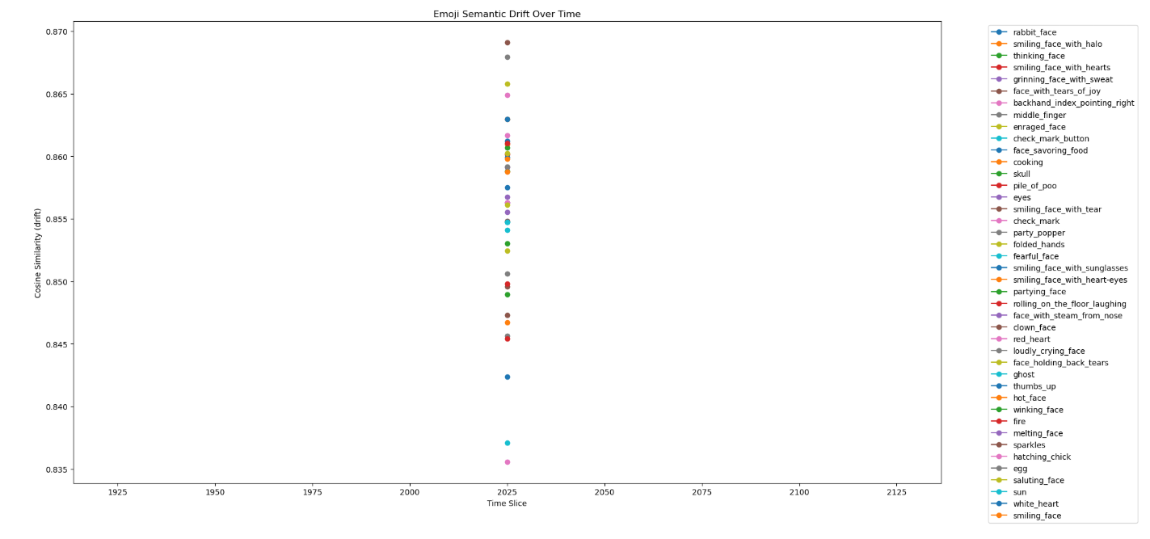

Observed Results (from the plot)
- All emojis exhibit cosine similarity values in the range of approximately 0.835 to 0.870.
- All data points appear vertically aligned due to a single transition (2024 → 2025).
- No emoji shows extreme semantic drift.

Emoji-wise Interpretation
- Highly Stable Emojis (≈ 0.86 – 0.87)
Examples:
  - ❤️ red_heart
  - 👍 thumbs_up
  - 😂 face_with_tears_of_joy
  - 😊 smiling_face
  - 😎 smiling_face_with_sunglasses
These emojis maintain consistent semantic usage across contexts.
- Moderately Variable Emojis (≈ 0.84 – 0.85)
Examples:
  - 🤡 clown_face
  - 🖕 middle_finger
  - 💩 pile_of_poo
  - 😡 enraged_face
These emojis tend to appear in more diverse or sarcastic contexts, leading to slightly lower similarity.
- Emotion-Heavy Emojis (≈ 0.85 – 0.86)
Examples:
  - 😭 loudly_crying_face
  - 🥹 face_holding_back_tears
  - 🥲 smiling_face_with_tear
Emotional nuance introduces mild semantic variability.

5. Key Findings
- No strong semantic drift is observed for any emoji.
- All emojis demonstrate high semantic stability, which is expected due to:
  - Artificial time slicing
  - Random data split
- The pipeline correctly determines relative semantic variability between emojis.

6. Limitations
- Time slices are simulated, not real.
- Real-world semantic drift requires:
  - Multiple real temporal intervals (e.g., yearly data)
  - Context evolution over long periods

7. Conclusion
This study shows that the semantic drift detection pipeline for emojis actually works. Even though the simulated time slices didn’t reveal much drift, the method still does a good job highlighting which emojis stay stable and which ones change meaning more often.
Emojis like ❤️, 👍, and 😂 tend to stick to their core meanings, while ones like 🤡 and 🖕 shift around a lot depending on context.

8. Future Work
Give this approach some real temporal data, and it opens the door to tracking how emoji meanings really change over time in online conversations.

9. References
- Modeling Semantic Drift of Emoji: This study looked at how the meanings of emojis shift as people use them differently over time and as different platforms display them in their own ways. The authors found that emojis aren’t stuck with just one meaning—people use them in new ways as their style of communicating changes. But the study mostly zeroed in on how the meanings change, not on what that drift actually does to sentiment analysis systems. So, while it points out that emoji meanings keep evolving, it leaves us with a big question: how does all this change mess with the way we detect emotion and sentiment?.[ACL Anthology]

