Postman tests:

1. Get All Products

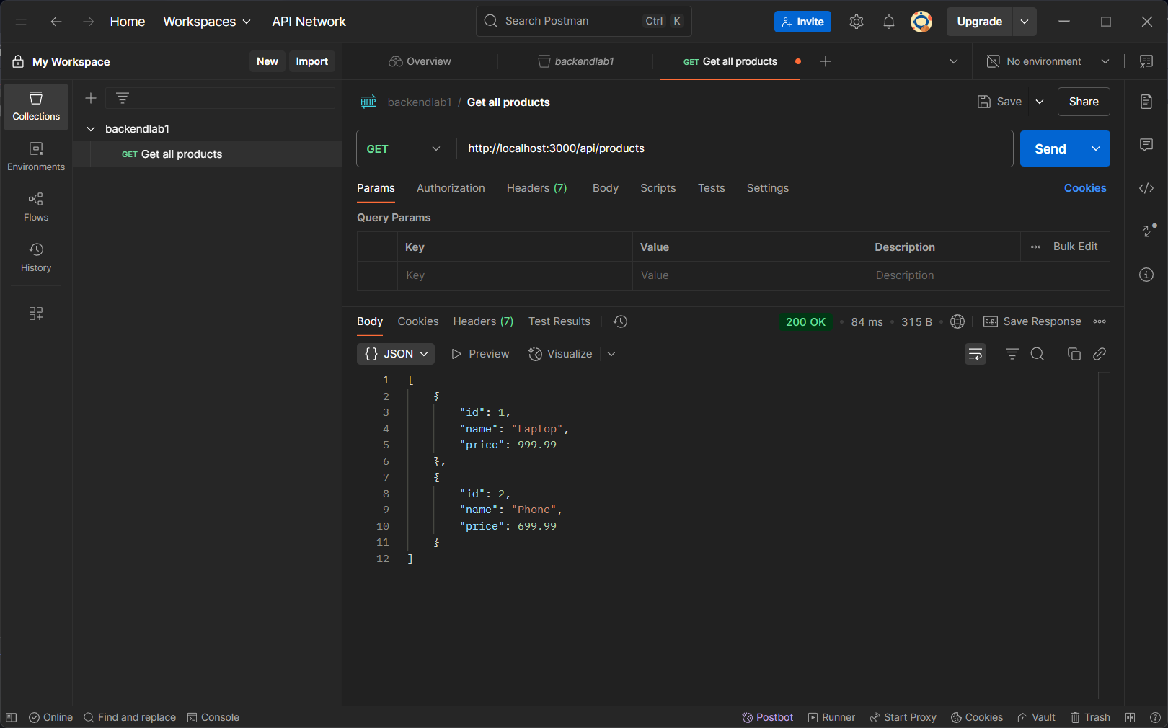

2. Get Single Product

3. Add New Product

4. Update Product

5. Delete Product

