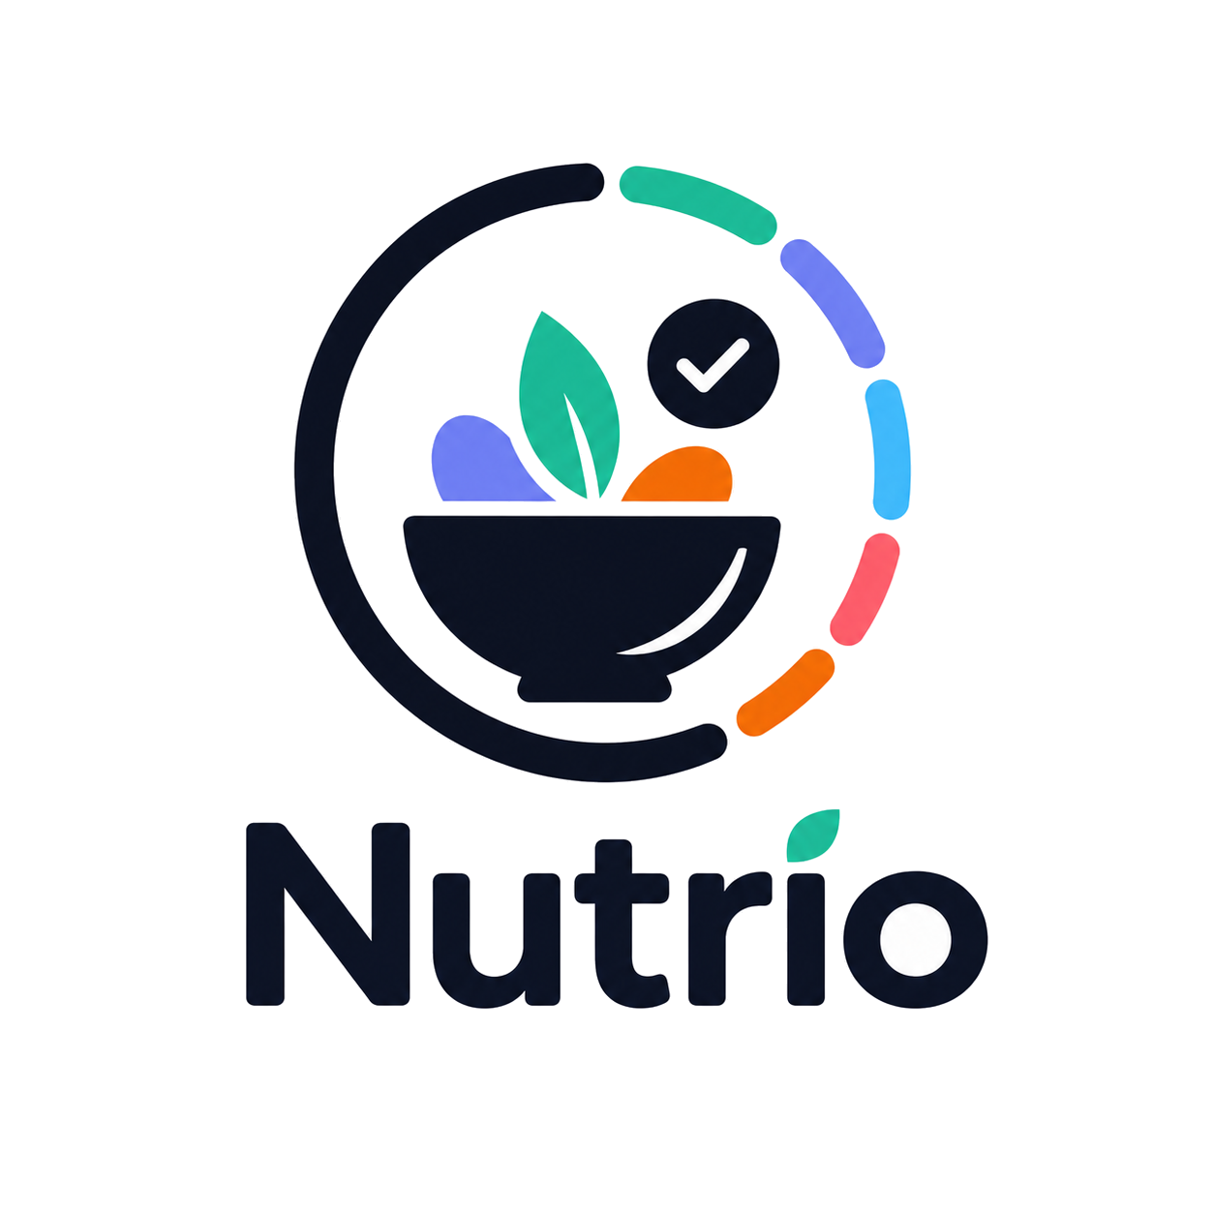
NUTRIO
Brand Guidelines
Mobile-first identity system for product, UI/UX, marketing, and partnerships
Version 1.0 | July 2026

Contents
  - The permanent visual source of truth for Nutrio
01 | Brand foundation
02 | Logo system
03 | Color system
04 | Typography
05 | Shape language
06 | Photography and illustration
07 | Mobile UI principles
08 | Components and data visualization
09 | Motion and interaction
10 | Voice and tone
11 | Arabic RTL and accessibility
12 | Implementation checklist

01 Brand foundation
  - What Nutrio stands for and how it should feel

Brand purpose
Help people make healthier daily choices by connecting balanced meals, personalized nutrition, activity, and gym access in one simple experience.

Mission
Make healthy living convenient, motivating, and personal - without making users feel judged, overwhelmed, or excluded.

Vision
Become the region’s most trusted everyday wellness companion, starting with a mobile experience designed around real routines and culturally relevant habits.

Brand promise
Healthy progress made simple, personal, and achievable.

Personality
- Fresh, intelligent, and encouraging
- Premium but approachable
- Energetic without being aggressive
- Simple without feeling empty
- Supportive and non-judgmental
- Local-aware and bilingual by design

Positioning
Nutrio is not only a food-delivery app, calorie tracker, or gym directory. It is a unified wellness platform that turns healthy intent into practical daily action.

Primary audiences
- Busy adults who want structured healthy meals
- People working toward weight loss, muscle gain, or better daily balance
- Users who want simple guidance rather than complex medical dashboards
- Restaurant, gym, and delivery partners who need a trusted premium platform

02 Logo system
  - Recognition, protection, and practical usage
 | 

Meaning
- The bowl represents nourishment and everyday meals.
- The leaf expresses freshness, health, and growth.
- The circular path represents continuity, lifestyle, and daily progress.
- The checkmark represents achievement and confidence.
- The colored segments represent a balanced mix of nutrition, hydration, activity, and motivation.

Clear space and minimum size
Maintain clear space equal to the height of the checkmark circle around all sides of the primary logo. For digital use, the full vertical logo should not be smaller than 96 px wide. Use the symbol-only version below that size. Recommended app-icon symbol padding is 16-20% of the icon canvas.

Approved variants
- Primary full-color logo on white or very light backgrounds
- Reversed full-color logo on Deep Navy
- Symbol-only app icon
- One-color Deep Navy mark for documents
- One-color white mark for dark surfaces

Never
- Stretch, rotate, crop, outline, or recolor individual elements
- Add glow, heavy shadow, bevel, or 3D effects
- Place on busy or low-contrast photography
- Rebuild the wordmark using another font
- Repeat the complete logo as decoration inside every screen

03 Color system
  - A balanced palette derived from the supplied logo
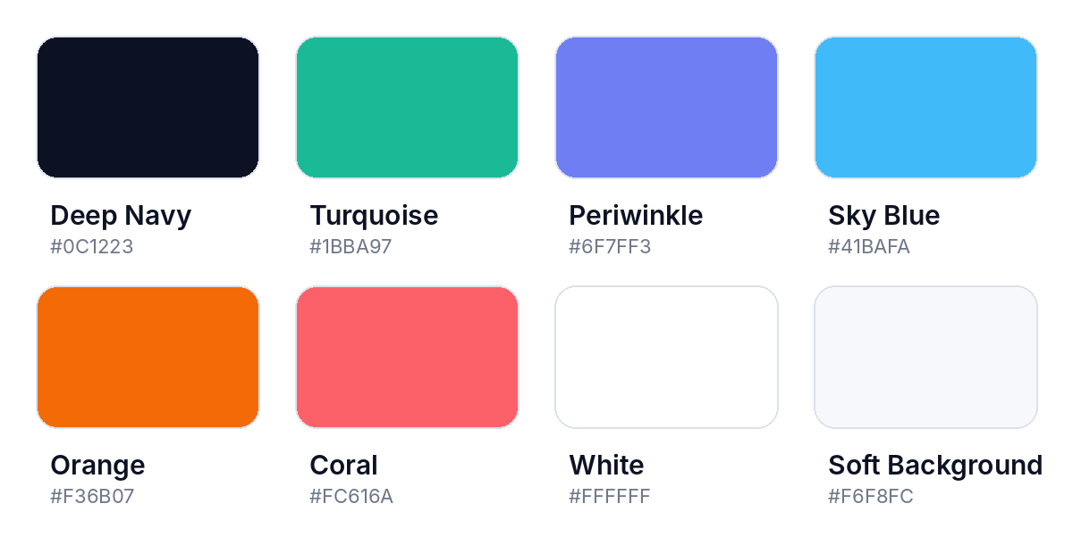

Core usage
- Deep Navy: structure, primary text, navigation, trust, premium surfaces.
- Turquoise: health, positive action, nutrition progress, success.
- Periwinkle: AI Coach, personalization, achievements, premium intelligence.
- Sky Blue: hydration, activity, information, movement.
- Orange: energy, calories, urgency, important highlights.
- Coral: warnings, errors, missed actions, attention states.

Color discipline
A normal screen should use one dominant accent and one supporting accent, with Navy and neutral surfaces providing structure. Do not display all accent colors at equal strength. Color must support hierarchy rather than replace it.

Approved gradients
- Turquoise -> Sky Blue for progress and movement
- Periwinkle -> Sky Blue for AI and personalized intelligence
- Orange -> Coral for energy and celebration
- Deep Navy -> Dark Navy for premium dark surfaces
Gradients are reserved for progress, selected states, hero moments, and small branded accents. They are not default button or card backgrounds.

04 Typography
  - Clear, friendly, bilingual, and mobile-ready

Recommended families
English: Inter or Inter Display. Arabic: Noto Sans Arabic or IBM Plex Sans Arabic. Use one Arabic family consistently across the product. Numeric metrics should remain highly legible and may use Inter even in Arabic screens when culturally and technically appropriate.
Style | Size | Weight | Line height | Use
Display | 32 | 700 | 38 | Campaign and onboarding hero
Screen title | 24 | 700 | 30 | Primary screen heading
Section title | 18 | 650 | 24 | Section hierarchy
Body | 16 | 400 | 24 | Main reading text
Body small | 14 | 400 | 20 | Supporting information
Label | 13 | 600 | 18 | Inputs and controls
Caption | 12 | 500 | 16 | Metadata and helper text
Metric | 32-48 | 700 | 1.0 | Calories, progress, weight

Rules
- Never shrink text to force dense content into a phone screen.
- Use sentence case, short titles, and strong hierarchy.
- Avoid overly technical or clinical styling.
- Test long Arabic labels and mixed Arabic-English nutrition units.
- Maintain at least 4.5:1 contrast for normal text.

05 Shape language
  - The logo becomes a system, not repeated decoration
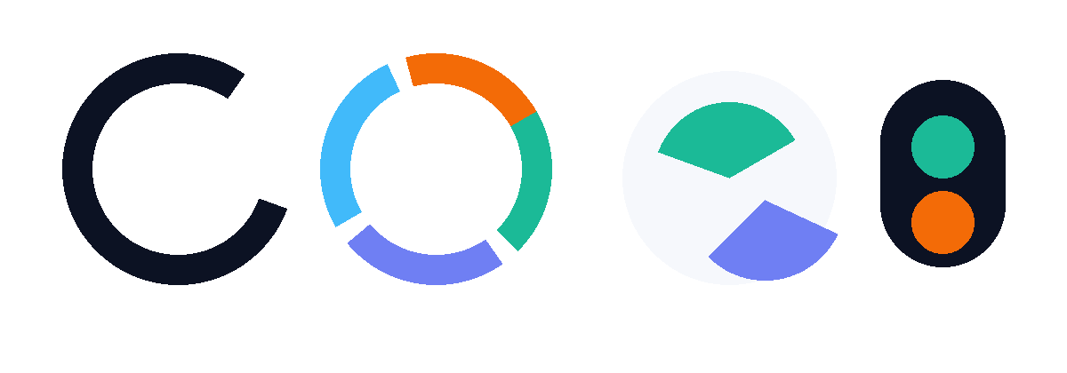

Core forms
- Segmented arcs for progress and selected states
- Organic leaf-like masks for meals and wellness imagery
- Soft asymmetry to avoid generic component-library geometry
- Circular motion for daily journeys and achievements
- Rounded edges with varied radii, not one radius everywhere
- Small color fragments used as visual anchors, never as random decoration

Where to apply
- Onboarding illustrations and goal setup
- Daily progress and nutrition summaries
- Meal imagery and timeline transitions
- AI Coach and achievement moments
- Bottom-navigation active state
- Empty, success, and loading states

Avoid
Do not turn every panel into a rounded card. The shape language should guide composition, spacing, images, and progress - not create more decorative containers.

06 Photography and illustration
  - Food should feel real, fresh, and desirable

Photography direction
- Natural light, fresh ingredients, realistic color, and visible texture
- Premium but achievable meals - not overly staged luxury food
- Human moments should feel active, diverse, and authentic
- Use close crops and organic masks to make food the visual focus
- Maintain consistency in warmth, contrast, and background cleanliness

Avoid
- Dark, oversaturated, low-resolution, or artificial food images
- Generic stock fitness poses and unrealistic body ideals
- Busy backgrounds that compete with nutrition information
- Applying a different filter or crop style on every screen

Illustration style
Use simplified organic geometry, smooth curves, limited depth, soft lighting, and selective Nutrio accents. Illustrations should be modern and premium rather than childish. Human illustrations must be inclusive and never promote unrealistic body standards.

Image treatment
- Organic or asymmetrical crops
- Edge-to-edge food imagery where appropriate
- Soft Navy or neutral overlays for text readability
- Floating nutrition labels used sparingly
- Consistent aspect ratios by content type

07 Mobile UI principles
  - Mobile first - custom by default

Design foundations
- Start at 360-430 px widths; never shrink a desktop dashboard.
- Prioritize one clear task and one focal point per screen.
- Place frequent actions within comfortable thumb reach.
- Use bottom sheets, full-screen flows, lists, and timelines instead of desktop modals and tables.
- Use cards only when content truly needs an independent container.
- Design loading, empty, offline, error, disabled, and success states from the start.

Spacing and interaction
Page padding | 16-20 px
Major section gap | 24-32 px
Related item gap | 8-12 px
Minimum touch target | 44 x 44 px
Primary button height | 50-56 px
Input height | 52-56 px

Generic UI is not acceptable
- No repeated four-card statistics grid
- No card-inside-card composition
- No default Shadcn, Material, Bootstrap, or generic Tailwind appearance
- No desktop sidebar as primary mobile navigation
- No color-only redesign of a generic template
- No wide table compressed into a phone

08 Components and data visualization
  - Reusable patterns with a recognizable Nutrio character

Core mobile component set
- Nutrio App Header
- Nutrio Bottom Navigation
- Primary, secondary, text, destructive, and icon buttons
- Mobile inputs, steppers, sliders, segmented controls, and selection sheets
- Meal timeline and meal preview
- Nutrition progress arc and integrated metric display
- AI Coach recommendation block
- Goal and achievement presentation
- Gym access and subscription status
- Bottom sheets, confirmation sheets, toast messages
- Loading, empty, error, offline, and success states

Component states
Each reusable component must define default, pressed, focused, selected, disabled, loading, success, error, and RTL behavior where relevant.

Data visualization
- Use segmented arcs, progress paths, thin indicators, large numeric values, and daily timelines.
- Do not display calories, protein, water, and activity as identical cards.
- Use text or symbols in addition to color, so status remains accessible.
- Keep charts understandable at 360 px without mandatory horizontal scrolling.

Bottom navigation
Use four or five primary destinations. The active state should use a subtle arc, segment, or organic highlight inspired by the logo. It must respect safe areas, never cover content, and work structurally in RTL and LTR.

09 Motion and interaction
  - Purposeful movement that reinforces progress

Motion principles
- Fast, subtle, responsive, and meaningful
- Show cause and effect rather than decoration
- Use movement to confirm selection, progress, navigation, and completion
- Respect reduced-motion preferences
Motion | Duration | Guidance
Tap feedback | 80-140 ms | Immediate compression, opacity, or scale response
Page transition | 220-320 ms | Smooth and directional
Bottom sheet | 260-360 ms | Natural deceleration with clear drag affordance
Progress update | 400-700 ms | Animate from previous value, not from zero every time
Achievement | 600-1000 ms | Celebratory but brief; never block the user

Interaction tone
The product should feel responsive and encouraging. Avoid excessive bouncing, floating decoration, long loaders, and animation that hides delays or prevents immediate action.

10 Voice and tone
  - Supportive, clear, and never judgmental

Voice characteristics
- Friendly and human
- Positive but realistic
- Clear and action-oriented
- Motivating without guilt or pressure
- Simple, culturally respectful, and bilingual

Writing principles
- Say what happened, why it matters, and what the user can do next.
- Use short labels and concrete actions.
- Avoid medical claims, shame, fear, or unrealistic promises.
- Celebrate consistency and progress, not perfection.
Situation | English | Arabic
Welcome | Good to see you. Let’s plan a balanced day. | سعداء بعودتك. لنخطط ليوم متوازن.
Progress | You’re getting closer to today’s goal. | أنت تقترب من هدف اليوم.
Missed meal | Plans change. Choose a new time or replace this meal. | تتغير الخطط. اختر وقتاً جديداً أو استبدل هذه الوجبة.
Error | We couldn’t load this right now. Try again. | تعذر تحميل المحتوى حالياً. حاول مرة أخرى.
Achievement | Great consistency - you completed your weekly goal. | استمراريتك رائعة - أكملت هدفك الأسبوعي.

11 Arabic RTL and accessibility
  - Inclusive by structure, not as an afterthought

RTL requirements
- Mirror layout direction, navigation, arrows, and directional gestures - not only text alignment.
- Test mixed Arabic and English names, units, numbers, dates, and prices.
- Allow long Arabic labels to wrap naturally without clipping.
- Review bottom-navigation order and back behavior in each language.
- Use Arabic fonts with clear weights and comfortable line height.

Accessibility baseline
- WCAG AA contrast for essential text and controls
- Minimum 44 x 44 px touch targets
- Visible focus and selected states
- Never communicate meaning using color alone
- Screen-reader labels for icons, progress, images, and controls
- Alternative text for meaningful food and campaign imagery
- Reduced-motion support
- Dynamic text scaling without broken layouts

Health and body language
Nutrio must avoid shaming language, unrealistic body comparisons, and appearance-based pressure. Progress communication should focus on healthy routines, personal goals, energy, consistency, and user choice.

12 Implementation checklist
  - How to keep every future screen unmistakably Nutrio

Design system assets
- Figma color, typography, effect, and spacing styles
- Semantic design tokens for light and dark surfaces
- Reusable mobile components with states and RTL variants
- Approved screen patterns for onboarding, home, meals, progress, AI Coach, gyms, subscriptions, and profile
- A library of approved photography, illustrations, and iconography
- A gallery of approved and rejected UI examples with reasons

Recommended token naming
- color.background.primary
- color.surface.elevated
- color.text.primary
- color.action.primary
- color.status.success
- color.status.error
- color.nutrition.progress
- color.hydration
- color.ai.primary
- spacing.page.mobile
- size.touch.minimum
- motion.duration.fast

Pre-release review
☐ Designed mobile-first at 360, 390, and 430 px
☐ Clearly feels like Nutrio rather than a generic health template
☐ One dominant focal point and clear primary action
☐ No unnecessary card grid or default library appearance
☐ Real content and long text tested
☐ Arabic RTL and English LTR tested
☐ Loading, empty, error, offline, and success states included
☐ Contrast, touch targets, labels, and reduced motion checked
☐ Bottom navigation and keyboard never cover actions
☐ Existing APIs, routes, logic, and permissions preserved

Final brand test
If the logo were removed, the product should still be recognizable as Nutrio through its color discipline, arcs, organic imagery, progress language, mobile composition, and supportive tone.

