The picture below shows the result of JavaC command after installed the JDK on my computer

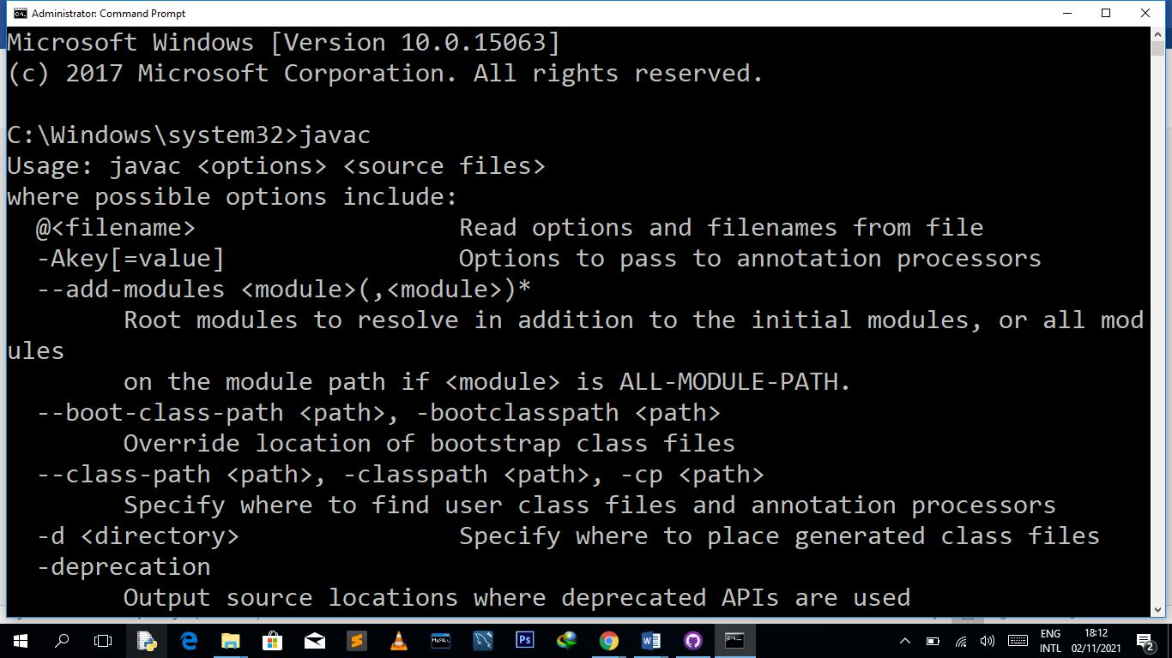

The picture bellow shows the result of Java Command after installed the JDK on my computer

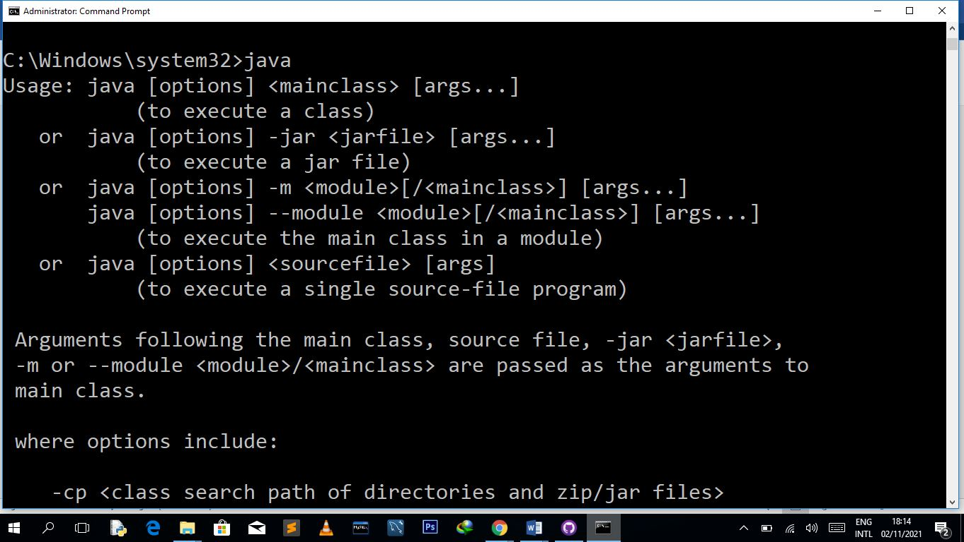

The picture bellow shows the result of Java --version Command after installed the JDK on my computer

