**Introduction to Processes in Dynamics 365**

**Practice Activities**

# **Module 1 - Practice Activity:**

## **Creating Workflows**

### Create a Workflow that will create follow-up Activities for new Leads

In this Exercise you will be creating a workflow that will create a series of follow-up tasks and Items when new leads are entered into the system.

You work for a company called Contoso Consulting, Contoso has their Account Executives perform a series of follow-up tasks on new leads that are created based on where the lead came from.  The specific task that are required are as follows:

* When a new Lead is created the is owned by any user
* If the Lead Source is a Trade Show:
* Create a Follow-up task for the lead owner to that is Due Three days after the Lead was created
* If the Lead Source is from the Web
* Create an Outgoing Phone Call for the Lead owner that is Due Two days after the lead was Created
* If the Lead Source is Other
* Create an Outgoing Phone Call for the Lead owner that is Due Three days after the Lead was created
* For all other Lead Sources
* Create a Follow-up task for the Lead Owner that is Due Five days after the lead was created.

#### High Level Steps

* Create a new background Workflow based on Lead Entity
* Name it Lead Source Follow-up
* Set the Scope to Organization
* Have it trigger when a new Lead is created
* Configure the Conditions and Actions as Follows
* If the Lead > Lead Source > Equals > Trade Show
* Create a New Task
* Subject = Trade Show Follow-up
* Owner = Owner of the Lead
* Due Date = 3 Days After the Lead Created on Date
* Else/If the Lead > Lead Source > Equals > Web
* Create a Phone Call
* Subject = Web Lead Follow-up Call
* Direction = Outgoing
* Owner = Owner of the Lead
* Due Date = 2 Days After the Lead Created on Date
* Else/If the Lead > Lead Source > Equals > Other
* Create a Phone Call
* Subject = Lead Follow-up Call
* Direction = Outgoing
* Owner = Owner of the Lead
* Due Date = 3 Days After the Lead Created on Date
* Otherwise
* Create a Task
* Subject = Generic Lead Follow-up Task
* Owner = Owner of the Lead
* Due Date = 5 Days After the Lead Created on Date

#### Detailed Steps

1. In Power Apps, go to your solution, switch to Classic
2. From the **Processes section on the left side**, click the **New** button
3. Complete the Create Process screen s follows:
   * **Process Name:** *Lead* *Source* *Follow*-*up*
   * **Category:** *Workflow*
   * **Entity:** *Lead*

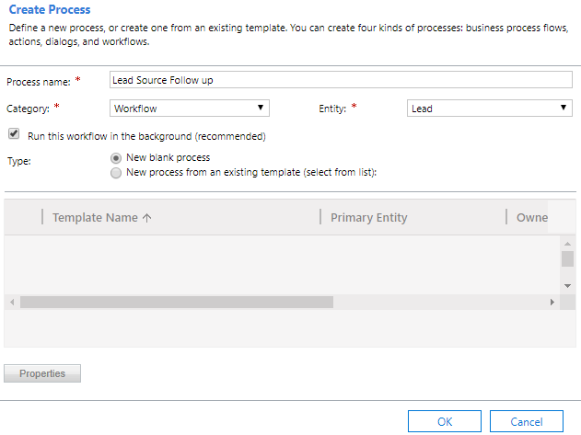

1. Click **OK**
2. Set the **Scope** of the Workflow to **Organization**.
3. Ensure that it is set to **Start when:** a **Record is created**.
4. Your workflow should resemble the image below:

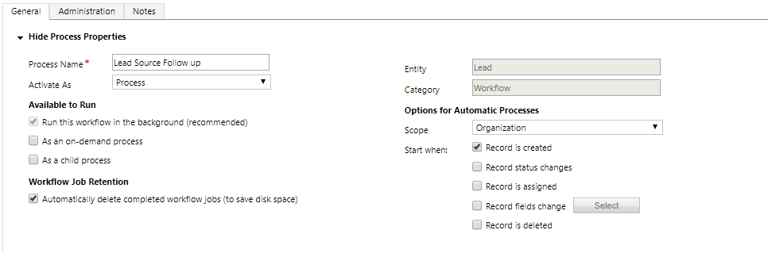

1. In the Workflow design section, click the **Add Step** 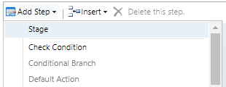 button.
2. From the menu that appears select **Check Condition**.

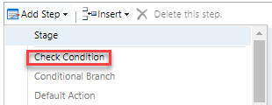

1. In the **Description** field, enter **Lead Source**
2. Click **<condition> (Click to configure)**
3. Configure the condition as follows:
   * **Lead** > **Lead Source** > **Equals** > **Trade show**

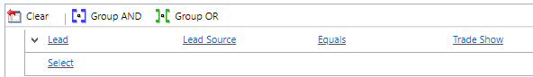

1. Click the **Save and Close**  button
2. Click **Select this row and Click Add Step.**
3. Click the **Add Step**  button, and from the menu that appears select **Create Record.**

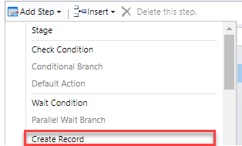

1. In the **Description** field, enter **Create Trade Show follow-up task.**
2. Select the **Task** entity, and click **Set Properties.**

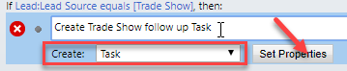

1. Set the **Subject** field to **Trade Show Follow up.**
2. Click the **Owner** Field.
3. In the **Form Assistant**, under **Look for**, choose **Lead** – **Owner**.

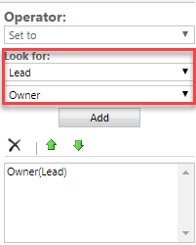

1. Click the **Add**  button
2. Click **OK**
3. Click the **Due Date** field.
4. In the **Form Assistant** configure as follows:
   * **3 Days** – **After** – **Lead** – **Created On**.

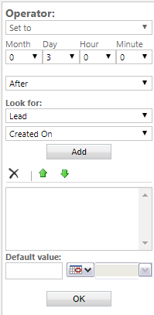

1. Click the **Add**  button.
2. Click **OK**
3. In the **Description** field, enter **Please follow-up with this lead that we received from a trade show.**
4. Your completed task should resemble the image below:

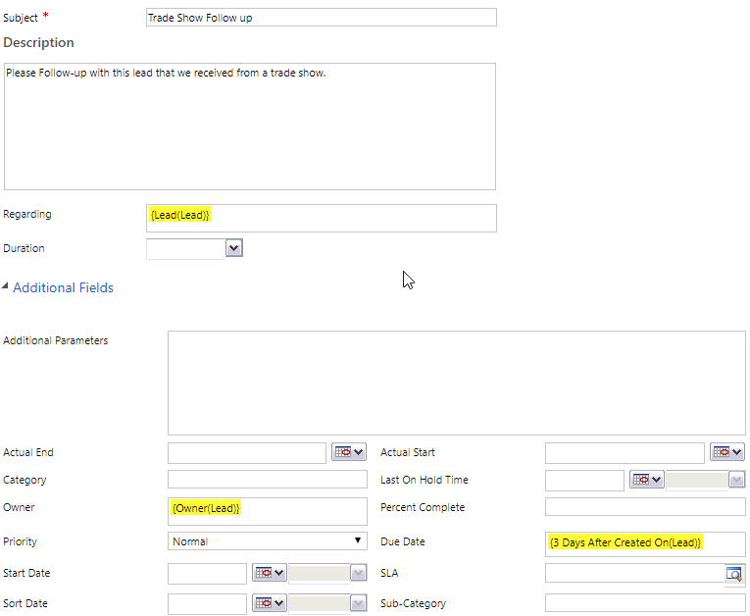

1. Click the **Save and Close**  button
2. Select **If Lead: Lead Source equals [Trade Show], then**:
3. Click the **Add Step**  button.
4. From the menu that appears, select **Conditional Branch**.

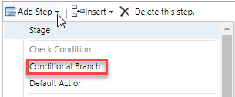

1. Select the **Otherwise if** condition.
2. Configure the condition as follows and then click **Save and Close**:
   * **Lead** – **Lead Source** – **Equals** – **Web**

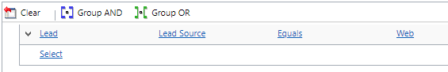

1. Click the **Add Step**  button, and from the menu that appears select **Create Record.**



1. In the **Description** field, enter **Create Web Lead Follow-up Phone Call.**
2. Select **Phone Call**, click **Set Properties**.

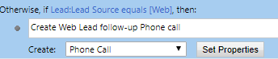

1. Configure the Phone Call as Follows:
   * **Subject:** *Web Lead Follow-up Call*
   * **Call From:** {*Owner(Lead)}*
   * **Call to**: {*Lead(Lead)}*
   * **Phone Number:** {*Business Phone(Lead)}*
   * **Description:** *Please follow-up with this lead that was received from the web*
   * **Owner:** *{Owner(Lead)}*
   * **Due:** *3 Days after Lead Created On*
2. Your completed Phone Call should resemble the following:

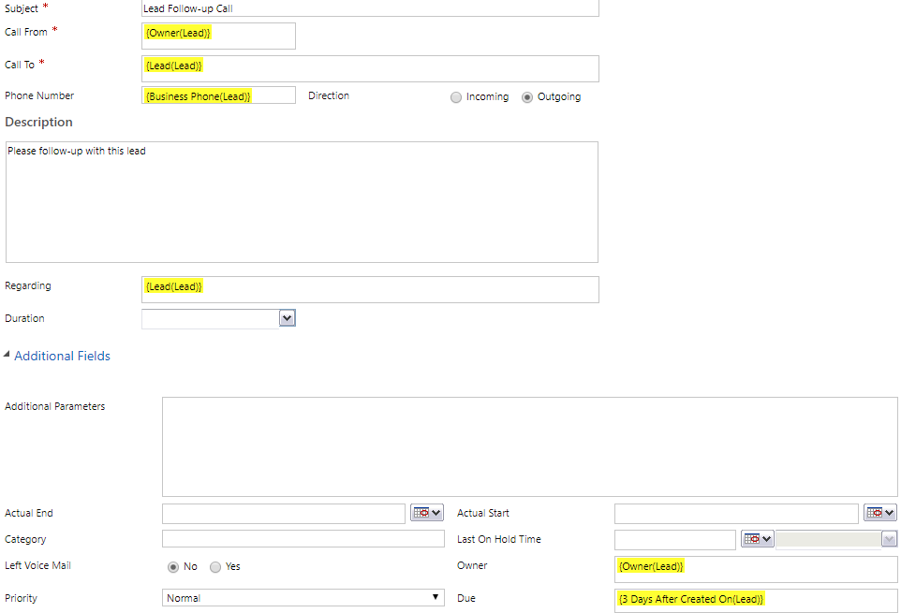

1. Click the **Save and Close**  button.
2. Select **If Lead: Lead Source equals [Web], then**:
3. Click the **Add Step**  button.
4. From the menu that appears, select **Conditional Branch**.



1. Select the **Otherwise if** condition.
2. Configure the condition as follows and then click **Save and Close**:
   * **Lead** – **Lead Source** – **Equals** – **Other**

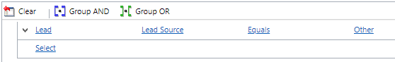

1. Click the **Add Step**  button, and from the menu that appears select **Create Record.**



1. In the **Description** field, enter **Create Other Lead Follow-up Phone Call.**
2. Select **Phone Call**, click **Set Properties**.

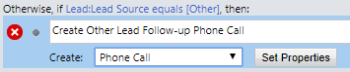

1. Configure the Phone Call as Follows:
   * **Subject:** *Lead Follow-up Call*
   * **Call From:** {*Owner(Lead)}*
   * **Call to**: {*Lead(Lead)}*
   * **Phone Number:** {*Business Phone(Lead)}*
   * **Description:** *Please follow-up with this lead*
   * **Owner:** *{Owner(Lead)}*
   * **Due:** *3 Days after Lead Created On*
2. Your completed Phone Call should resemble the following:



1. Click the **Save and Close**  button.
2. Select **If Lead: Lead Source equals [Trade], then**:
3. Click the **Add Step**  button.
4. From the menu that appears, select **Default Action**.

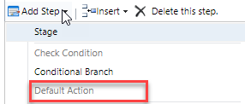

1. Select the **Otherwise** condition.
2. Click the **Add Step**  button, and from the menu that appears select **Create Record.**



1. In the **Description** field, enter **Standard Lead Follow-up.**
2. Select **Task**, click **Set Properties**.

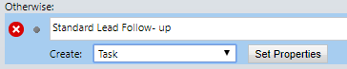

1. Configure the Task as Follows:
   * **Subject:** *Follow-up with Lead*
   * **Description:** *Please follow-up with this lead*
   * **Owner:** *{Owner(Lead)}*
   * **Due:** *5 Days after Lead Created On*
2. Your completed Task should resemble the following:

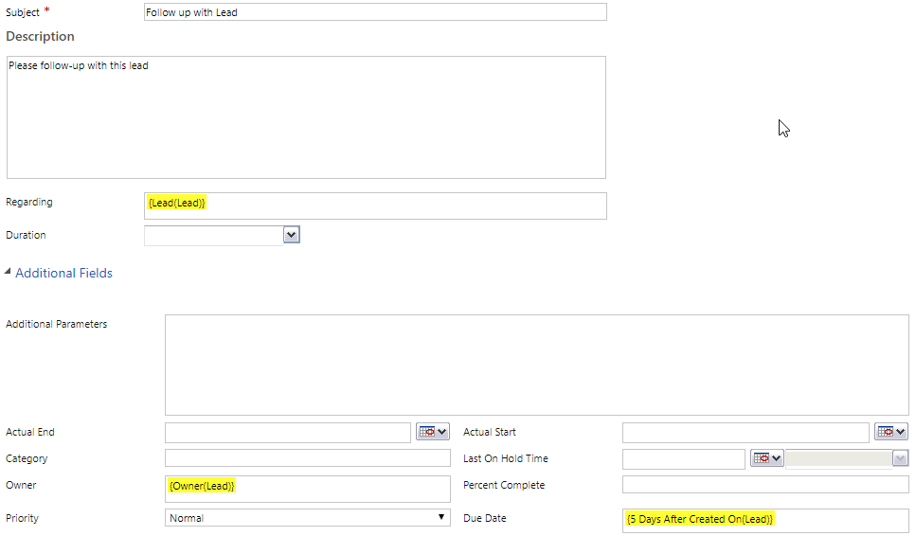

1. Click the **Save and Close**  button.
2. Your completed workflow logic should resemble the image below:

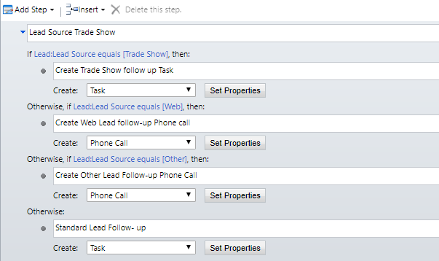

1. Click the **Save**  button to save the workflow.
2. On the **Command Bar**, click the **Activate**  button.
3. In the Process Activate Confirmation screen, click **Activate**.

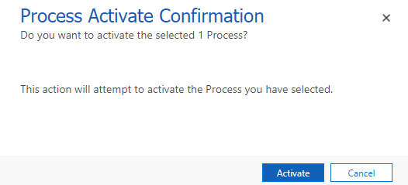

#### Test your Lead Source Workflow

1. In your Dynamics 365 instance, navigate to **Sales** > **Leads.**
2. On the **Command Bar**, click the **New**  button.
3. Complete your new lead as follows:
   * **Topic:** *Interested in several products*
   * **Name:** *Bryce Hogan*
   * **Job Title:** *President*
   * **Business Phone:** *705 555-3562*
   * **Email:** [*bryce@example.com*](mailto:bryce@example.com)
   * **Company:** *Hogan Chemicals*

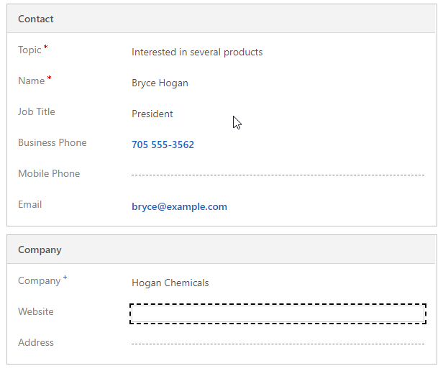

1. In the Lead record Header, set the **Lead Source** to **Trade Show**.

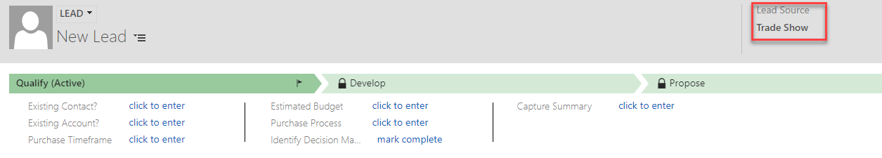

1. Click the **Save and Close**  button. *(Because this is a background workflow, it may take a minute or so for it to Populate the Task.)*
2. Open the **Lead** for **Bryce Hogan** that you just created.
3. Click the **Activities** tab. *(Notice that the Trade Show Follow-up Activity has been created)*

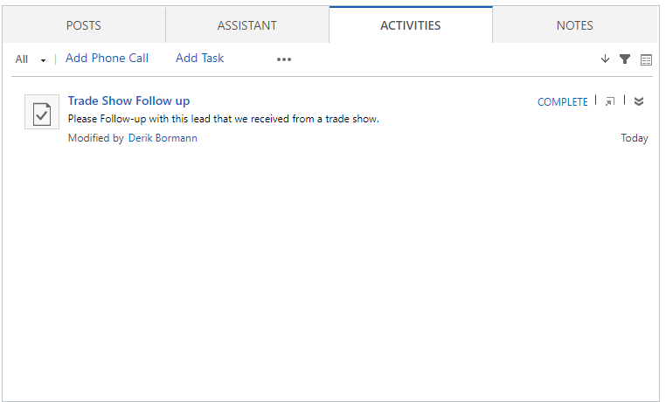

1. Test the Remaining Functionality by creating additional Leads with the following Lead Sources:
   1. **Linda Anderson** – **Lead Source:** *Web*
   2. **Mark Johnson** – **Lead Source:** *Other*
   3. **Jennifer Hansen** – **Lead Source:** *Word* *of* *Mouth*.

**NOTE**: *In most cases background workflows are recommended because they allow the system to process the request while the user continues to work on other item. There may be specific instances where a Workflow needs to run in real-time because a user needs that immediate feedback. In those cases, you can create a Real-Time workflow.*

### Convert your Lead Source Workflow to a Real-Time Workflow

1. In your Dynamics 365 instance, navigate to **Settings** > **Processes.**
2. Open the **Lead Source Follow-up** workflow you created earlier.
3. On the **Command Bar**, click the **Deactivate**  button to deactivate the Workflow.
4. On the **Command Bar**, click the **Convert to real-time workflow**  button.
5. On the **Command Bar**, click the **Activate**  button and confirm activation.
6. Close the Workflow designer.
7. Navigate to **Sales** > **Leads.**
8. On the **Command Bar**, click the **New**  button.
9. Complete your new lead as follows:
   1. **Topic:** *Interested in 5 products*
   2. **Name**: *Betty Jones*
   3. **Job** **Title**: *CEO*
   4. **Business** **Phone**: *701 555-9632*
   5. **Company**: *ABC Company*

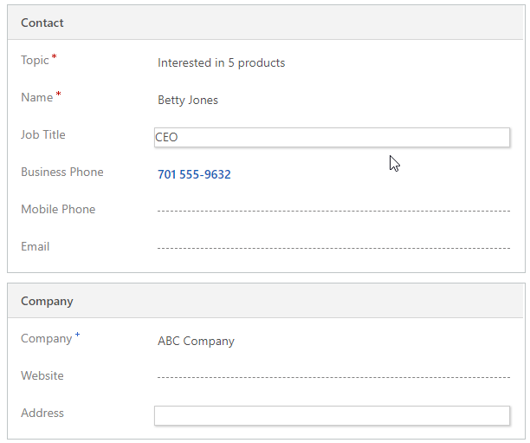

1. In the Lead record Header, set the **Lead Source** to **Web**.

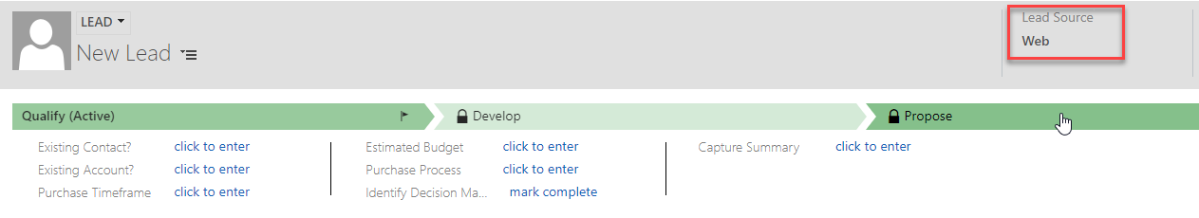

1. Click the **Save**  button.
2. After the Save is complete, click the Activities tab. (Notice that a Phone Call was added when the record was saved.)

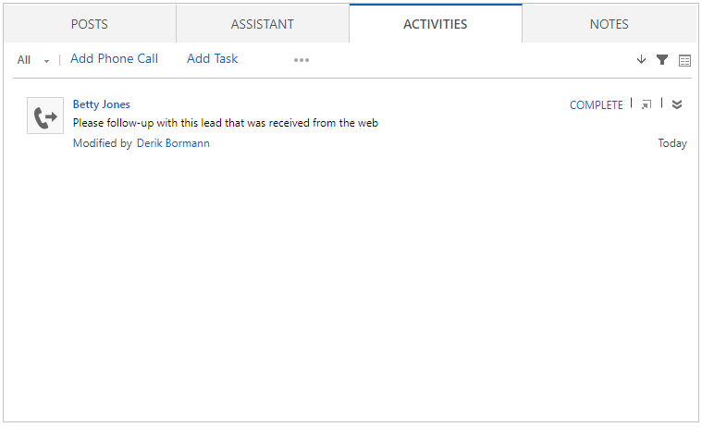

**NOTE:** *You can convert this workflow back to a background workflow* ***(Highly Recommended for most Instances)*** *at**any time, by following the same steps, and selecting the* ***Convert to background workflow*** *button.*

# **Module 2 - Practice Activity:**

## **Creating Business Process Flows:**

In this Exercise you will be creating a Business Process Flow that will be used when users are creating Opportunities in Dynamics 365.

You work for a company called Contoso Consulting.  Contoso Consulting’s Opportunities can fall into one of two possible Categories:

* **Audit / Consultation:** Audits or Consolations are service sold to customers where Contoso will evaluate their current structure and offer recommendations for items that could potentially be a problem and offer suggestions on how to rectify them.
* **Implementation:** Implementations are where customers are interested in having Contoso Implement a new offering. It could be a phone system, a Cloud Service, or any number of other potential Offerings.

Contoso has two very distinct processes that they follow depending on which specific service they are working with.  The table below describes process

|  |  |  |  |  |  |
| --- | --- | --- | --- | --- | --- |
| Audit / Consultation | Identification | Initial Consultation | Goal Identification | Propose | Close |
|  | Opportunity Type  Decision Process  Project Time Line | Type of Audit | Primary Audit Goal  Primary Objective  Constraints | Proposal Date  Proposal Approved | Signature Received |
| **Implementation** | **Identification** | **Strategy Formulation** | **Develop** | **Propose** | **Close** |
|  | Opportunity Type  Decision Process  Project Time Line | Win Theme | Decision Process  Solution Type | Proposal Date  Proposal Approved | Signature Received |

As you can see from above, both processes start the same, but will branch based on the type of Opportunity it is.  The both end with the Propose and Close Stages.  You need to create a business process flow that will allow this to occur

**High Level Steps**

* Customize the Opportunity Entity
* Add the Opportunity Type Field
* Add the Decision Process Field
* Add the Project Time Line Field
* Add the Type of Audit Field
* Add the Win Theme Field
* Add the Primary Audit Goal Field
* Add the Primary Objective Field
* Add the Constraints Field
* Add the Solution Type Field
* Add the Proposal Date Field
* Add the Proposal Approved Field
* Add the Signature Received Field
* Create a New Business Process flow for the Opportunity Entity
* Configure as noted above
* Add a branch based on the Opportunity Type Field after the Identification Stage
* Have the branch rejoin the at the Propose Stage.

### Customize the Opportunity Entity to support the need Information

1. In your Dynamics 365 instance, navigate to **Settings** > **Customizations** > **Customize the System**.
2. Expand **Entities**, and expand the **Opportunity** Entity
3. Click **Fields**, and from the toolbar, click the **New**  button:
4. Complete the Field as follows:
   1. In the **New Field** form, enter **Opportunity Type** into the **Display Name** field.
   2. In the **Data** **Type** field select **Option Set**.
5. Under **Options**, click the **New**  button.
6. Set the **Label** to **Audit / Consultation**

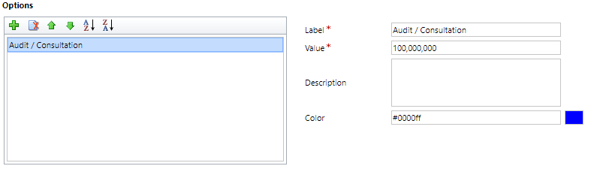

1. Click the **New**  Button
2. Set the **Label** to **Implementation**

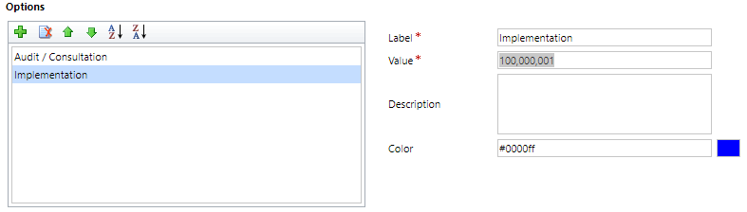

1. Click the **Save and New**  button.
2. **Complete the field as follows:** 
   1. In the **New Field** form, enter **Decision Process**into the **Display Name** field.
   2. In the **Data** **Type** field select **Option Set**.
3. Under **Options**, click the **New**  button.
4. Set the **Label** to **Committee**

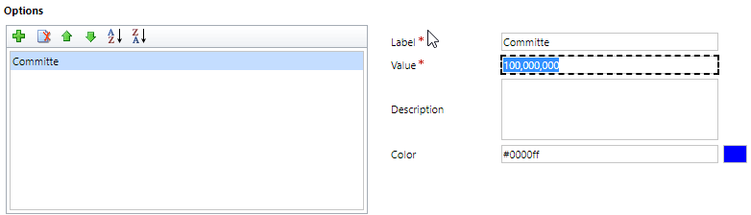

1. Click the **New**  Button
2. Set the **Label** to **Individual**

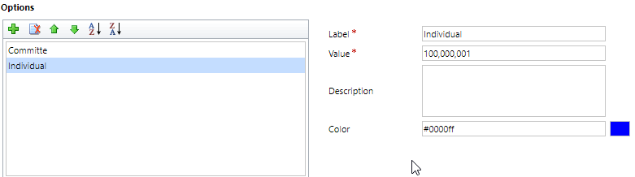

1. Click the **Save and New**  button.
2. **Complete the field as follows:**
   1. In the **New Field** form, enter **Project Time Line** into the **Display Name** field.
   2. In the **Data** **Type** field select **Option Set**.
3. Under **Options**, click the **New**  button.
4. Set the **Label** to **This Month**

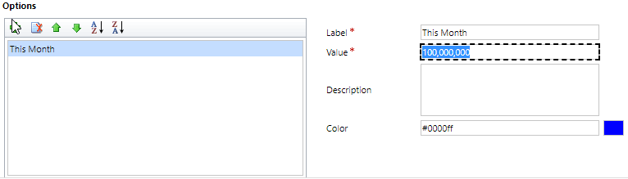

1. Click the **New**  Button
2. Set the **Label** to **This Quarter**

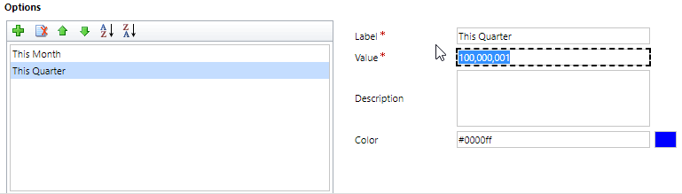

1. Click the **New**  Button
2. Set the **Label** to **This Year**

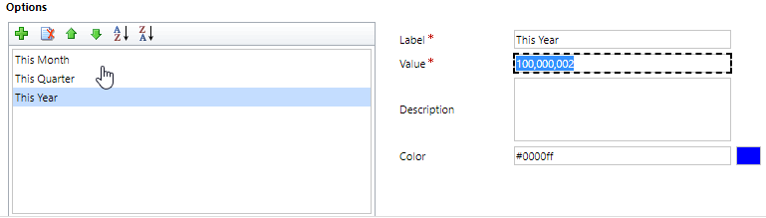

1. Click the **New**  Button
2. Set the **Label** to **Next Year**

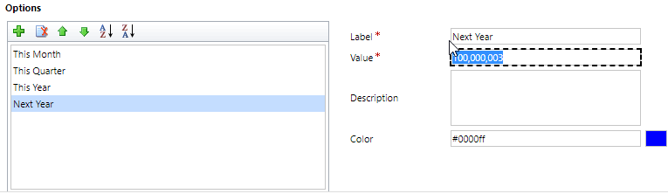

1. Click the **Save and New**  button.
2. **Complete the field as follows**:
   1. In the **New Field** form, enter **Audit Type** into the **Display Name** field.
   2. In the **Data** **Type** field select **Single Line of Text**.

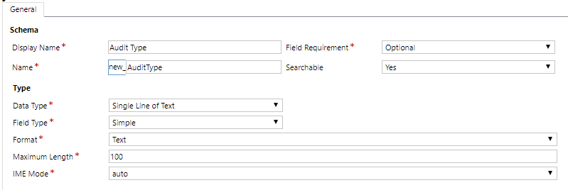

1. Click the **Save and New**  button.
2. **Complete the field as follows**:
   1. In the **New Field** form, enter **Win Theme** into the **Display Name** field.
   2. In the **Data** **Type** field select **Single Line of Text**.
3. Click the **Save and New**  button.
4. **Complete the field as follows**:
   1. In the **New Field** form, enter **Primary Audit Goal** into the **Display Name** field.
   2. In the **Data** **Type** field select **Single Line of Text**.
5. Click the **Save and New**  button.
6. **Complete the field as follows**:
   1. In the **New Field** form, enter **Primary Objective** into the **Display Name** field.
   2. In the **Data** **Type** field select **Option Set**.
7. Under **Options**, click the **New**  button.
8. Set the **Label** to **Streamline Process**

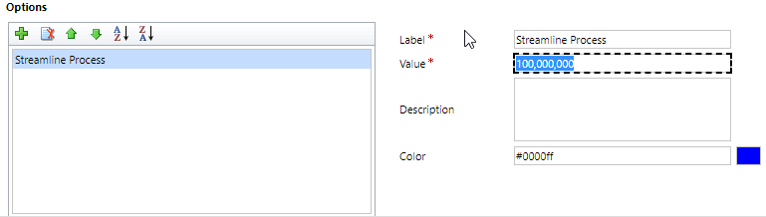

1. Click the **New**  Button
2. Set the **Label** to **Maximize Productivity**

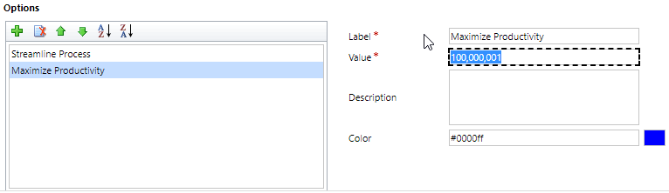

1. Click the **New**  Button
2. Set the **Label** to **Minimize Travel**

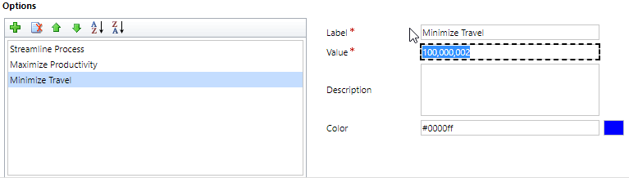

1. Click the **New**  Button
2. Set the **Label** to **Most Qualified**

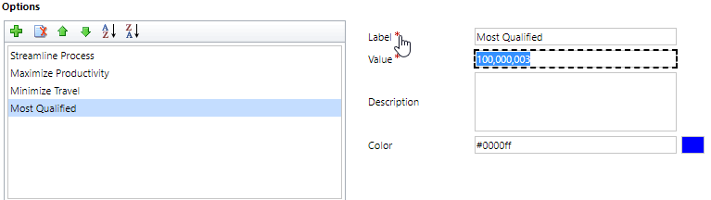

1. Click the **Save and New**  button.
2. **Complete the field as follows**:
   1. In the **New Field** form, enter **Constraints** into the **Display Name** field.
   2. In the **Data** **Type** field select **Option Set**.
3. Under **Options**, click the **New**  button.
4. Set the **Label** to **Within Working Hours**

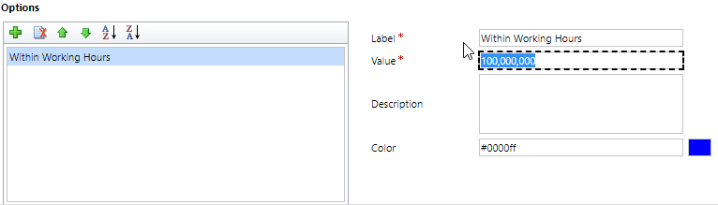

1. Click the **New**  Button
2. Set the **Label** to **Meet Minimum Skills**



1. Click the **Save and New**  button.
2. **Complete the field as follows**:
   1. In the **New Field** form, enter **Solution Type** into the **Display Name** field.
   2. In the **Data** **Type** field select **Single Line of Text**.
3. Click the **Save and New**  button.
4. **Complete the field as follows**:
   1. In the **New Field** form, enter **Proposal Date** into the **Display Name** field.
   2. In the **Data** **Type** field select **Date and Time**.
   3. In the **Behavior** field select **Date Only**
5. Click the **Save and New**  button.
6. **Complete the field as follows**:
   1. In the **New Field** form, enter **Proposal Approved** into the **Display Name** field.
   2. In the **Data** **Type** field select **Two Options**.
   3. In the **Default Value** field select **No**
7. Click the **Save and New**  button.
8. **Complete the field as follows**:
   1. In the **New Field** form, enter **Signature Received** into the **Display Name** field.
   2. In the **Data** **Type** field select **Two Options**.
   3. In the **Default Value** field select **No**
9. Click the **Save and Close**  button.
10. On the Solution click the **Publish All Customizations**  button.

### Design the New Business Process Flow for the Opportunity Entity

1. In your Dynamics 365 instance, navigate to **Settings** > **Processes**.
2. From the **My Processes** screen, click the **New** button
3. Complete the Create Process screen s follows:
   * **Process Name:** *Contoso Consultation Process*
   * **Category:** *Business Process Flow*
   * **Entity:** *Opportunity*

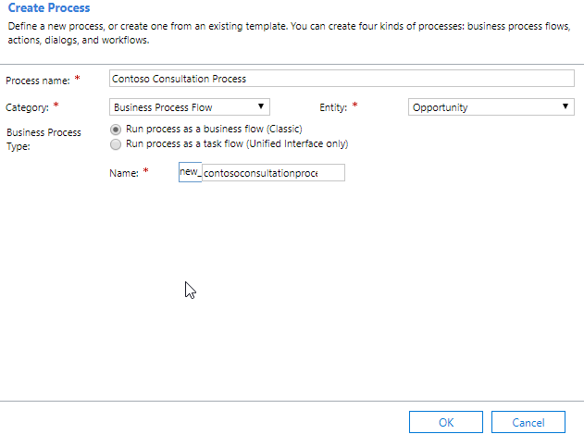

1. Click **OK.**
2. Select the **Opportunity New Stage**
3. Configure the **Stage Properties** as follows:
   * **Display Name:** *Identification*
   * **Entity:** *Opportunity*

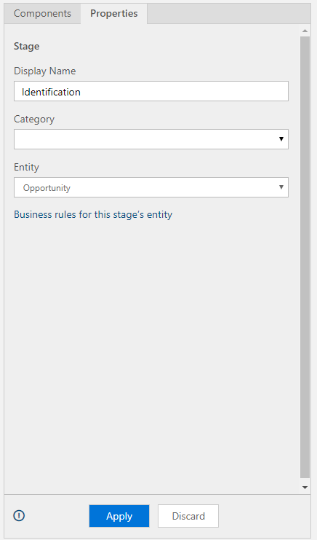

1. Click **Apply**
2. In the **Opportunity Identification** Stage, click **Details**.

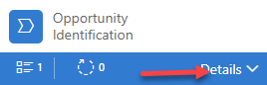

1. Select Data Step #1, and configure as follows:
   * **Step Name:** *Opportunity Type*
   * **Data Field:** *Opportunity Type*

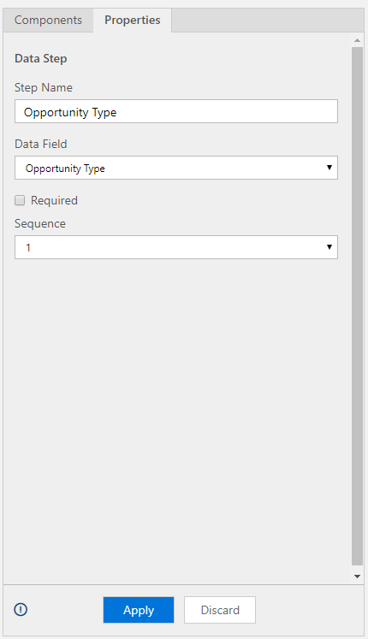

1. Click **Apply**
2. Click the **Components** tab and drag the **Data Step** below the **Opportunity Type** step.
3. Select Data Step #2, and configure as follows:
   * **Step Name:** *Decision Process*
   * **Data Field:** *Decision Process*

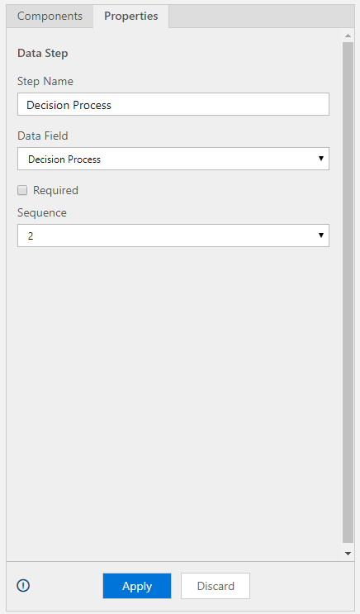

1. Click **Apply**.
2. Click the **Components** tab and drag the **Data Step** below the **Decision Process** step.
3. Select Data Step #3, and configure as follows:
   * **Step Name:** *Project Time Line*
   * **Data Field:** *Project Time Line*

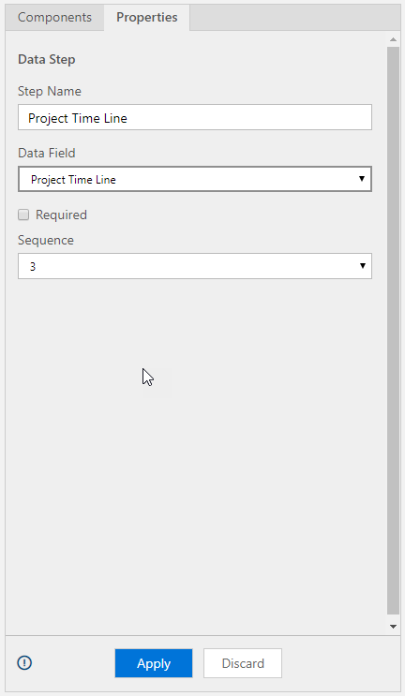

1. Click **Apply**.
2. Click the **Components** tab and drag the **Stage** to the right of the **Identification** stage.

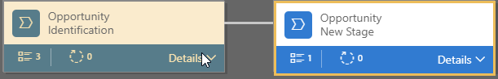

1. Select the **Opportunity New Stage**
2. Configure the **Stage Properties** as follows:
   * **Display Name:** *Initial Consultation*
   * **Entity:** *Opportunity*

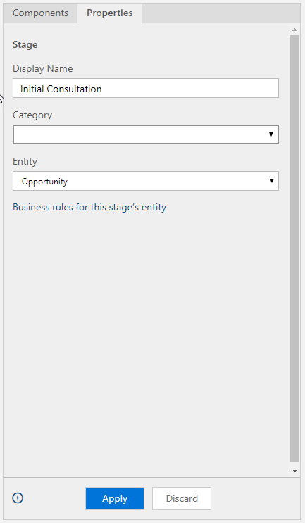

1. Click **Apply**
2. In the **Initial Consultation** stage, click **Details**.
3. Select Data Step #1, and configure as follows:
   * **Step Name:** *Audit Type*
   * **Data Field:** *Audit Type*

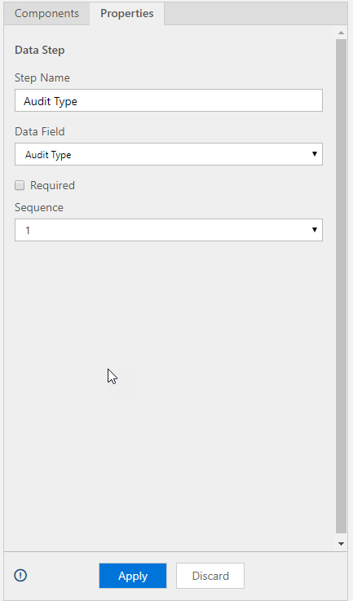

1. Click **Apply**
2. Click the **Components** tab and drag the **Stage** to the right of the **Initial Consultation** stage.
3. Select the **Opportunity New Stage**
4. Configure the **Stage Properties** as follows:
   * **Display Name:** *Goal Identification*
   * **Entity:** *Opportunity*

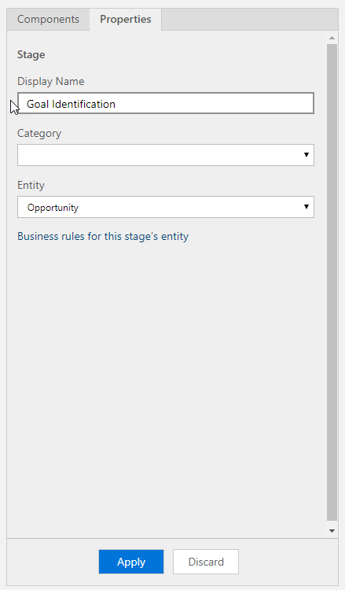

1. Click **Apply**
2. In the **Goal Consultation** stage, click **Details**.
3. Select Data Step #1, and configure as follows:
   * **Step Name:** *Primary Audit Goal*
   * **Data Field:** *Primary Audit Goal*

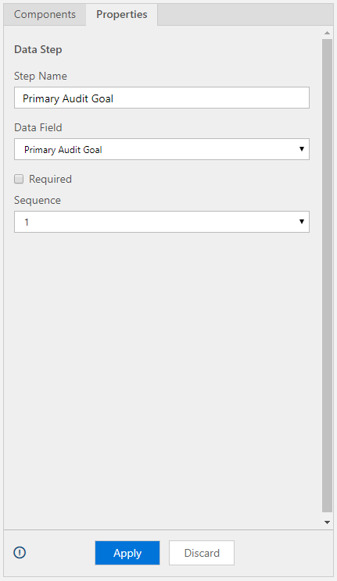

1. Click **Apply**
2. Click the **Components** tab and drag the **Data Step** below the **Primary Audit Goal** step.
3. Select Data Step #2, and configure as follows:
   * **Step Name:** *Primary Objective*
   * **Data Field:** *Primary Objective*

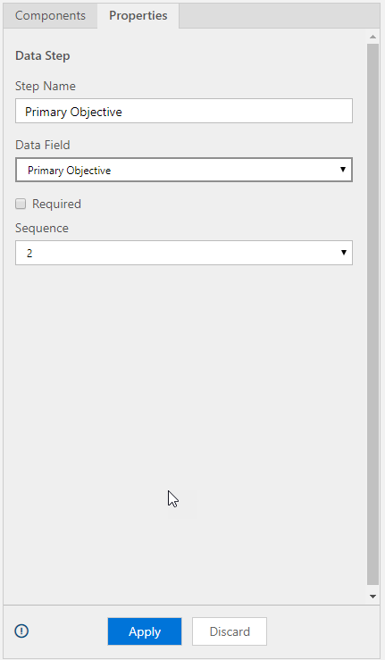

1. Click **Apply**.
2. Click the **Components** tab and drag the **Data Step** below the **Primary Objective** step.
3. Select Data Step #3, and configure as follows:
   * **Step Name:** *Constraints*
   * **Data Field:** *Constraints*

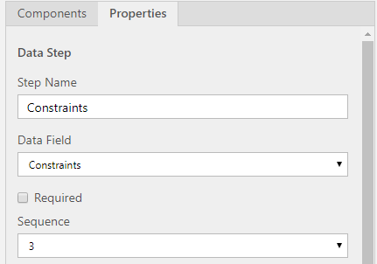

1. Click **Apply**.
2. Click the **Components** tab and drag the **Stage** to the right of the **Goal Identification** stage.
3. Select the **Opportunity New Stage**
4. Configure the **Stage Properties** as follows:
   * **Display Name:** *Propose*
   * **Entity:** *Opportunity*

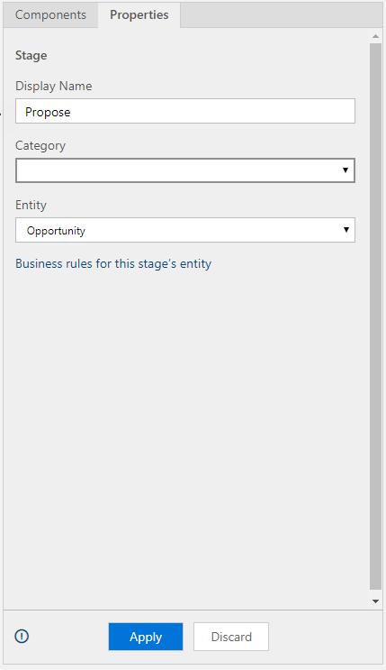

1. Click **Apply**
2. In the **Propose** stage, click **Details**.
3. Select Data Step #1, and configure as follows:
   * **Step Name:** *Proposal Date*
   * **Data Field:** *Proposal Date*

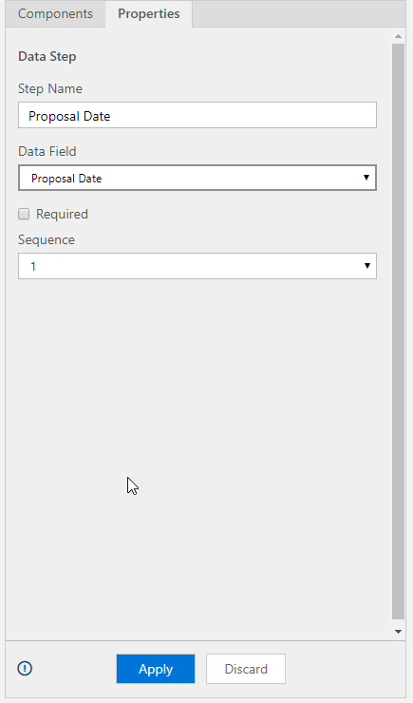

1. Click **Apply**
2. Click the **Components** tab and drag the **Data Step** below the **Proposal Date** step.
3. Select Data Step #2, and configure as follows:
   * **Step Name:** *Proposal Approved*
   * **Data Field:** *Proposal Approved*

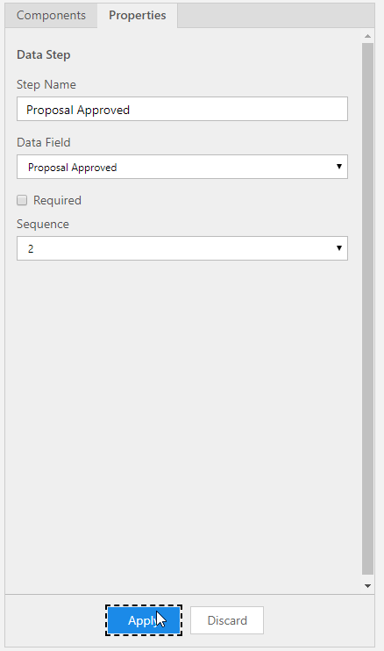

1. Click **Apply**.
2. Click the **Components** tab and drag the **Stage** to the right of the **Goal Identification** stage.
3. Select the **Opportunity New Stage**
4. Configure the **Stage Properties** as follows:
   * **Display Name:** *Close*
   * **Entity:** *Opportunity*

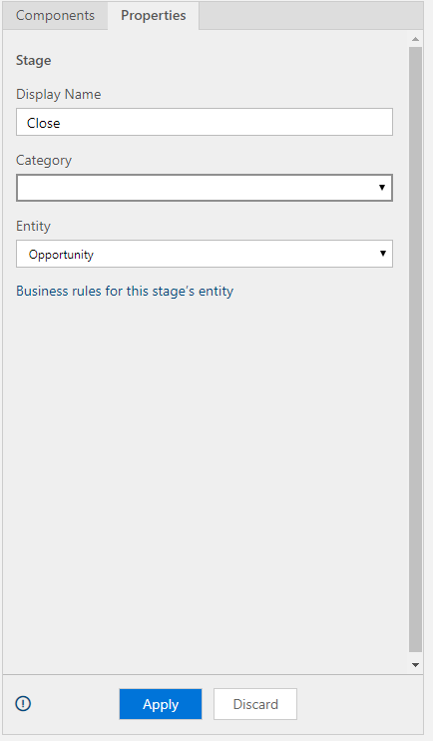

1. Click **Apply**
2. In the **Close** stage, click **Details**.
3. Select Data Step #1, and configure as follows:
   * **Step Name:** *Signature Received*
   * **Data Field:** *Signature Received*

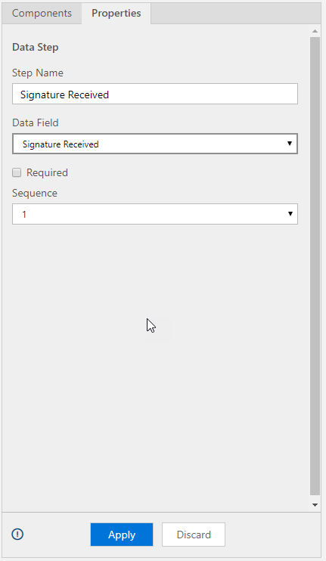

1. Click **Apply**
2. Click the **Components** tab and drag the **Condition** to the right of the **Identification** stage.
3. Configure the Condition as follows:
   * **Display Name:** *Opportunity Type*
   * **Field:** *Opportunity* *Type*
   * **Operator:** *Equals*
   * **Type:** *Value*
   * **Value:** *Audit* / *Consultation*

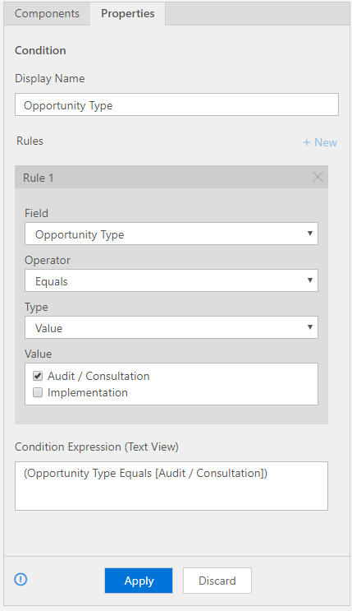

1. Click **Apply**.
2. Click the **Components** tab and drag the **Stage** to the below of the **Opportunity Type** Condition.
3. Select the **Opportunity New Stage**
4. Configure the **Stage Properties** as follows:
   * **Display Name:** *Strategy Formulation*
   * **Entity:** *Opportunity*

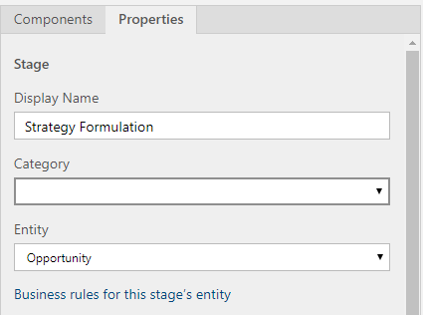

1. Click **Apply**
2. In the **Close** stage, click **Details**.
3. Select Data Step #1, and configure as follows:
   * **Step Name:** *Win Theme*
   * **Data Field:** *Win Theme*

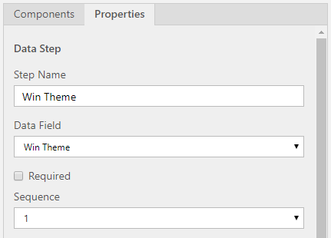

1. Click **Apply**
2. Click the **Components** tab and drag the **Stage** to the right of the **Strategy Formulation** Condition.
3. Select the **Opportunity New Stage**
4. Configure the **Stage Properties** as follows:
   * **Display Name:** *Develop*
   * **Entity:** *Opportunity*

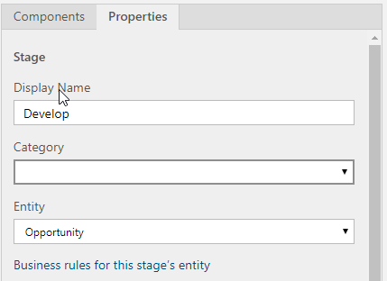

1. Click **Apply**
2. In the **Close** stage, click **Details**.
3. Select Data Step #1, and configure as follows:
   * **Step Name:** *Decision Process*
   * **Data Field:** *Decision Process*

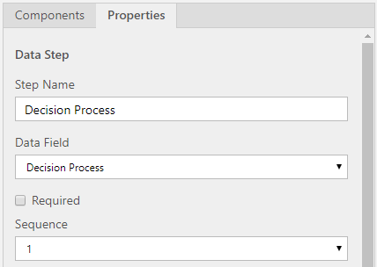

1. Click **Apply**
2. Click the **Components** tab and drag the **Data Step** below the **Decision Process** step.
3. Select Data Step #2, and configure as follows:
   * **Step Name:** *Solution Type*
   * **Data Field:** *Solution Type*

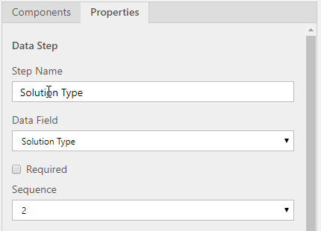

1. Click **Apply**.
2. Click to select the **Opportunity Develop** stage.
3. On the designer, click the **Connector** Icon.
4. From the menu that appears, select **Reconnect**.

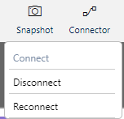

1. Select the **Opportunity Propose** stage as the 2nd Point.

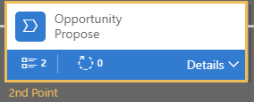

1. Your completed Consultation Process flow should resemble the Image below:

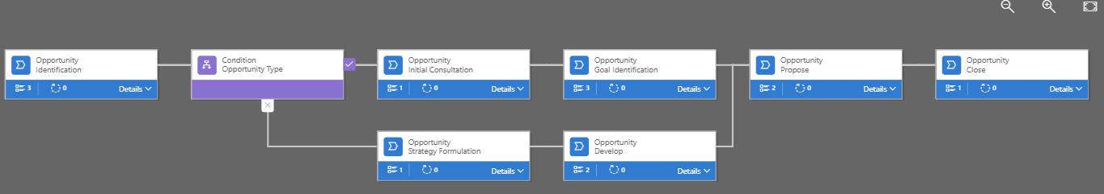

1. Click the **Save**  button to save your Process Flow.
2. Click the **Validate**  button to Validate your Process Flow.
   * **Fix any validation errors that you receive.**  *(Remember most errors occur when you forget to click Apply after making changes to a stage or step.)*
3. Click the **Order Process Flow**  button.
4. Select the **Contoso Consultation Process** and click the **up arrow**  until it is the first Process Flow listed.

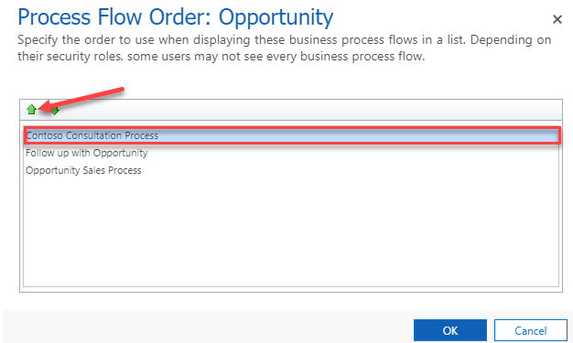

1. Click **OK**
2. Click the **Activate**  button to activate your **Contoso Consultation Process** flow.
3. On the **Process Activate Confirmation** screen, click **Activate**.

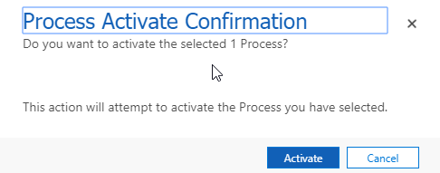

### Test your Contoso Consultation Process Flow

1. In your Dynamics 365 instance, navigate to **Sales** > **Opportunities.**
2. On the **Command Bar**, click the **New**  button.
3. In the **Identification** stage, set the **Opportunity Type** to **Audit / Consultation** *(Notice the Process changes).*

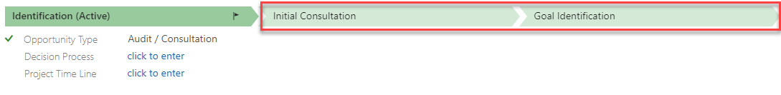

1. Set the **Opportunity Type** to **Implementation**. *(It will change to reflect the Implementation process).*

