

SCV RunBook

Prepared by: ATOS AMS for MAB

Version 1.0

Last updated: 19nd Jun 2020

Table of Contents

1 Revision History 2

1.1 Version / Change History 2

1.2 Verification 2

# Revision History

## Version / Change History

|  |  |  |  |
| --- | --- | --- | --- |
| Version | Last Modified On | Modified By | Changes Since Last Version |
| 1.0 | 19-June-2020 | Prashant Chauhan | Created |

## Verification

|  |  |  |
| --- | --- | --- |
|  | Name | Date |
| Reviewed By: | Suman Guduru | <DD-Mon-YYYY> |
| Approved By: | Wan Mohd Husni Wan Hussein | <DD-MM-YYYY> |

* **Data Load to Replica DB temp_load table**

**Issue Description:** User is need the latest data **||** **[SCV - REPLICA-Load Data in Temp_Load]**

**Resolution:**  Every month user sends a csv, xlsx file GD_AMS_SCV Team need to load into MABCRANE_PROD.temp_load table. This data is utilized by the data analytics team.

**Frequency:** Every month  
**Duration**: 01 - 02 hours  
  
Below are the **step** to load the data in "**MHSCV.TEMP_LOAD"**table & PFA process doc.

**1**. Connect to **SCVP** Database

**2.** Open DB:MHSCV_PROD à Schemas

**3.** Delete the existing records from **MHSCV**. **MABCRANE_PROD**.**TEMP_LOAD**table using the SQL

**[ Query : DELETE** **FROM** **mabcrane**_**prod**.**temp**_**load ]**

**4.** Create a new connection by going to database > New Connection.

**5.**Select the location of the folder where the file to be imported is saved.

**6.** Test the connection. If successful save it with an appropriate name.

**7.** Open MABCRANE_PROD schema and right click on TEMP_LOAD table.

**8.** Select Import table data option from the menu.

**9.** In the dialog box that opens select as shown. Select the file that has be imported into the TEMP_LOAD table

**10.** Select DB --> MHSVC PROD --> MABCRANE_PROD --> TEMP_LOAD --> Click:

**11**. Select Table Temp à table

**12**. Check the column & set target value: **COL1,2,3,4,5,6,7**

**13**. **Confirm table**

**14. Check record:** **[select** **count**(*) **from MABCRANE_PROD.TEMP_LOAD ]**

 ----------------------------------------------------------------------------------------------------------------------------------------------

**Support/Maintenance activities**

**🡪 Data Load to Replica DB temp_load table:** 

Every month user sends a csv file to load into MABCRANE_PROD.temp_load table. This data is utilized by the data analytics team  
  
🡪 **Detailed** **Process to load the data**.  
  
  
🡪 **Notebook**: **Inciden**t’s/ **knowledge article**

<https://mabitdept-my.sharepoint.com/:o:/g/personal/ext_prashant_chauhan_malaysiaairlines_com/En0yiSASrvhInlEFjAh2Ez8BWdY_O6gs8zFaVaKVITxmQA?e=cPlUnS>

**# Case :1**

🡪 In the Pre-fix adding zero in column if record is less than 9 or any number as per requirement. /Total record Approx.: 791582}

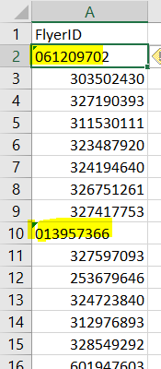 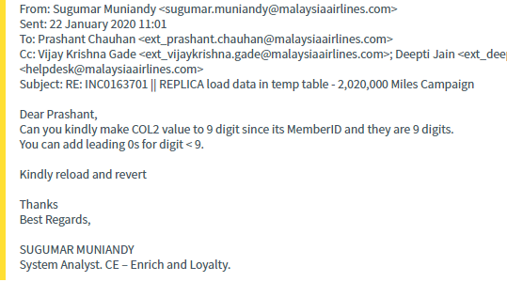

**# Case: 2**

🡪 Always convert .xlsx 🡪 to .csv

🡪 check & Remove extra lines in the .xlsx file. (Last , Middle)

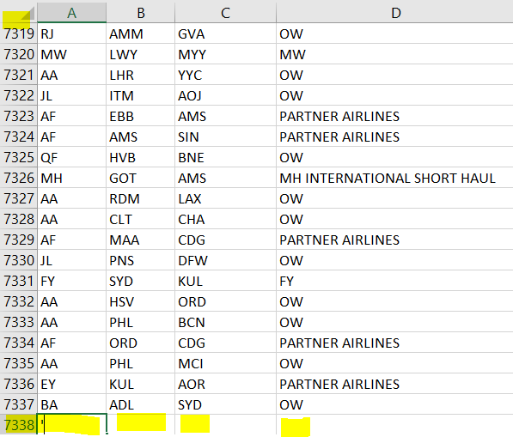

**# Case: 3**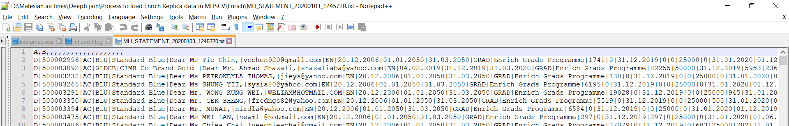KB0013322 **# Issue Description:**   
Users need to load a big file in TEMP_LOAD IN REPLICA.     
 **# Symptoms(s):**

**🡪** User send the file in **.txt** format:  MH-STATEMENT-20200103-1245770.txt / **337 MB** **file.**

We have created 2 logics :   
Reading ".txt" file and getting no. of files to be generated.( 4 files txt files ) and then convert .txt 🡪 to .CSV format, loaded into temp table.

**Step 1:**1**_**Logic**_**Split**_**Zip**_**File.java

**Step 2:** 2**_**Logic**_**TxtTOCSV.java

**Step 3:** merge csv files into one combined csv file

Step 4: Correct the Csv file. (before load)

**# Case :4**

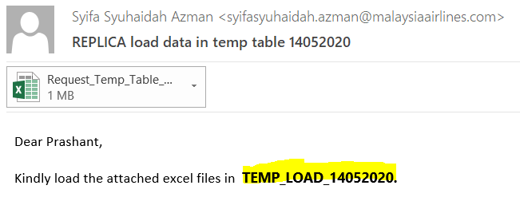

🡪. Sometime user suggested create new Temp table in the MABCREAN_PROD_DDMMYYYY.

**# Case : 5  
  
🡪 User send 2** or N files and we need to merge .xlsx 🡪 convert to .csv filein one & load in DB. **(In corrected format).**

