

MH Self Service Portal (MHSSP)
SYSTEM OPERATION DOCUMENT
MAB/GROUP IT/SOD/MHSSP/V1.0

Prepared by :

MHSSP Support Team

Application Management Services (AMS)

Group IT

ALL INFORMATION CONTAINED HEREIN IS RESTRICTED AND SHALL BE KEPT FOR INTERNAL USE ONLY. None of this information shall be divulged to persons other than Malaysia Airlines Berhad employees and contractors authorized by the nature of their duties to receive such information, or individuals or organisations authorised by Malaysia Airlines Berhad in accordance with existing policy regarding release of company information.

INTENTIONALLY LEFT BLANK

Prepared By | :
 |  | Ranjith T
 |  | MHSSP Support Team
 |  | Application Management Services
Reviewed By | :
 |  | Kiran Nallana
 |  | AMS Service Delivery Manager
 |  | Application Management Services
 | :
 |  | Noor Hafiza Bahruddin
 |  | IT - Service Delivery Management
 |  | Group IT
 | :
 |  | Emily Sheela Koshy
 |  | System Owner
 |  | Head, Customer Experience Assurance
Approved By | :
 |  | Ninuk Noviati Sachlin
 |  | Head IT Service Delivery Manager
 |  | Group IT

INTENTIONALLY LEFT BLANK
TABLE OF CONTENTS

Contents Page
PART 1 - MANUAL ADMINISTRATION 1-1
1.1. RECORD OF REVISION 1-2
1.2. LIST OF EFFECTIVE PAGES 1-3
1.3. DISTRIBUTION LIST 1-4
1.4. LIST OF ABBREVIATIONS 1-4
1.5. CONDITION OF USE 1-5
1.6. CONTROL OF MANUAL 1-5
PART 2 - MANUAL BACKGROUND 2-1
2.1 INTRODUCTION 2-2
2.2 PURPOSE 2-2
2.3 SCOPE AND APPLICATION 2-2
2.4 TERMINOLOGY 2-2
2.5 REFERENCES 2-2
PART 3 – OVERVIEW OF BUSINESS PROCESS 3-1
3.1 OVERVIEW OF BUSINESS PROCESS 3-2
PART 4 - MANUAL CONTENT TITLE 4-1
4.1 SYSTEM OVERVIEW 4-2
4.2 SYSTEM CONCEPT DIAGRAM 4-2
4.3 SYSTEM ARCHITECTURE 4-2
4.4 INTERFACES 4-3
4.4.1 User Interfaces 4-3
4.4.2 System Interfaces 4-4
4.5 WARRANTY AND MAINTENANCE PERIOD 4-5
4.6 ROLES AND RESPONSIBILITIES 4-5
4.7 TECHNICAL SPECIFICATIONS 4-5
4.7.1 Server Details 4-5
4.7.2 Hardware Specifications: 4-6
4.7.3 Software Specifications 4-6
4.7.4 Communication / Network Specification 4-7
4.7.5 User and Equipment Locations 4-9
4.7.6 File Management 4-9
4.8 TECHNICAL OPERATIONS GUIDE 4-10
4.8.1 Backup and Recovery 4-10
4.8.2 Monitoring Tools 4-11
4.8.3 Batch Jobs 4-11
4.8.4 Report Management 4-11
4.8.5 Baseline Performance Information 4-11
4.9 MAINTENANCE AND SUPPORT 4-11
4.9.1 Problem Logging 4-11
4.9.2 Problem Categorization and Escalation Matrix 4-12
4.9.3 Application / Technical Support 4-12
4.10 USER GUIDE 4-12
4.10.1 Accessing the Application 4-13
4.11 CONTRACT MANAGEMENT 4-13
4.12 HANDOVER ITEMS 4-13
4.13 INFORMATION SECURITY 4-13
4.13.1 Audit and Compliance Requirements 4-13
4.13.2 Password Policy Compliance 4-13
4.14 DOCUMENTATION AND REFERENCES 4-14
AppendiX i

- MANUAL ADMINISTRATION

RECORD OF REVISION

No. | Description Of Changes | Issue No. | Rev. No. | Author | Effective Date
1 | Initial draft | 1 | 0 | Abhilash Ch | 15-Jul-2018

LIST OF EFFECTIVE PAGES

Part | Page | Issue No. | Revision No. | Effective Date |  | Part | Page | Issue No. | Revision No. | Effective Date
1 | 1-1 | 1 | 0 | 15-07-18
 | 1-2 | 1 | 0 | 15-07-18
 | 1-3 | 1 | 0 | 15-07-18
 | 1-4 | 1 | 0 | 15-07-18
 | 1-5 | 1 | 0 | 15-07-18
 | 1-6 | 1 | 0 | 15-07-18
2 | 2-1 | 1 | 0 | 15-07-18
 | 2-2 | 1 | 0 | 15-07-18
 | 2-3 | 1 | 0 | 15-07-18
3 | 3-1 | 1 | 0 | 15-07-18
 | 3-2 | 1 | 0 | 15-07-18
4 | 4-1 | 1 | 0 | 15-07-18
 | 4-2 | 1 | 0 | 15-07-18
 | 4-3 | 1 | 0 | 15-07-18
 | 4-4 | 1 | 0 | 15-07-18
 | 4-5 | 1 | 0 | 15-07-18
 | 4-6 | 1 | 0 | 15-07-18
 | 4-7 | 1 | 0 | 15-07-18
 | 4-8 | 1 | 0 | 15-07-18
 | 4-9 | 1 | 0 | 15-07-18
 | 4-10 | 1 | 0 | 15-07-18
 | 4-11 | 1 | 0 | 15-07-18
 | 4-12 | 1 | 0 | 15-07-18
 | 4-13 | 1 | 0 | 15-07-18
 | 4-14 | 1 | 0 | 15-07-18

DISTRIBUTION LIST

NAME | DEPT / AREA | DESIGNATION
Emily Sheela Koshy | Head, Customer Experience Assurance | System Owner
Ninuk Noviati Sachlin | Group IT | Head IT SDM
Kiran Nallana | Group IT | SDM – TCS AMS
Noor Hafiza Bahruddin | Group IT | IT - Service Delivery Management
Table 1 – Distribution List

LIST OF ABBREVIATIONS
The following are the abbreviations used for the purpose of simplification.
Abbreviation | Denote
AMS | Application Maintenance & Support
SOD | System Operating Document
AODB | Airport Operations Database
SCV | Single Customer View
MH | Malaysian Hospitality / Malaysia Airlines
SSP | Sales Service Portal
Table 2 – List of Abbreviations

CONDITION OF USE
    - This manual is the property of Malaysia Airlines Berhad.
    - All copies assigned to individual position(s), section(s) or station(s) is on loan basis. If, for any reason, the position(s), section(s) or station(s) is abolished from the company organization, the respective copy(ies) of the manual must be returned to Head IT Service Delivery Manager.
    - In the event where the title of the position or section is changed, the department concerned shall inform Head IT Service Delivery Manager promptly.
    - The content of this manual shall not be copied, or communicated in part or as a whole, to any person not employed by the Company without the express written consent of the Head IT Service Delivery Manager.
    - It is the responsibility of the holder to ensure that his copy is updated to the latest amendments and is in good state of condition.

CONTROL OF MANUAL
    - The contents of this manual shall not be deleted, added, or altered in any way without the approval of the Head IT Service Delivery Manager.
    - Any page which carries an amendment must bear the new revision date. Any line which is amended shall be highlighted by a revision bar (i.e. dark vertical line) drawn close to the amended text on the outside border of the document.
    - A transmittal letter must accompany the amended pages to advise the holders how to effect the amendment to their copies.
    - Holders shall notify this department in writing for loss of manual and to obtain a replacement copy. Head IT Service Delivery Manager shall ensure that this manual reviewed at least once a year and effect necessary amendments as and when necessary. Should any person(s) envisage improvements needed for the contents of this manual, the person should direct the request to the Head IT Service Delivery Manager.

INTENTIONALLY LEFT BLANK

- MANUAL BACKGROUND

INTRODUCTION
This is the MHSSP SOD, hereinafter referred to as “the Policy” provides comprehensive operating procedures within the scope and application herein defined in Part 2 Section 3.0 for Malaysia Airlines Berhad (MAB).

PURPOSE
The objective of this document is to provide relevant information required to operate and “MH Self Service Portal”. The platform is ready for implementation and handover to IT Operations.

SCOPE AND APPLICATION
This document covers relevant information required to operate and support the MHSSP system in production environment. This covers the maintenance operation of the system, database and interfaces.
This SOD does not include the following:
- Application maintenance for the sub-systems interfaced by the core system.

TERMINOLOGY

No. | Term | Description
1. | App | Application
2. | DB | Database
4. | AD | Active Directory
5. | OS | Operating System
Table 3 - Terminology

REFERENCES

No. | Document | Description
1 | SOW | Statement of Work as supplied as agreed upon between TCS and MAB
2 | Technical Design Document | Document highlighting the Technical Design & architecture of the collaboration platform. This is supplied by TCS
3 | Test Plan Document | Document highlighting the Test plan for the collaboration platform. This is supplied by TCS
Table 4 - References

– OVERVIEW OF BUSINESS PROCESS

OVERVIEW OF BUSINESS PROCESS

Malaysia Airlines would like to provide its customers with a more seamless journey, several enhanced self-service options via their MH Self-Service Portal (MHSSP). Passengers can manage all their travel needs and requests at their convenience, by accessing a single platform.

The below are the modules under MHSSP for their Passenger needs:

- Insurance Module
- Travel Advisory Module

- eQMB - Mishandled Baggage Questionnaire Module

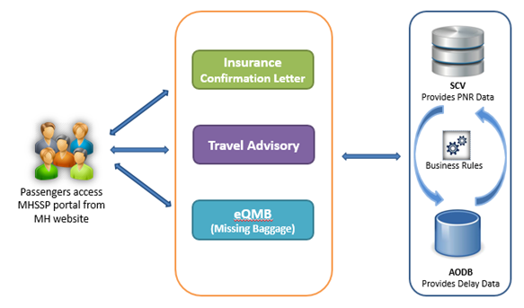
Figure 1 - Business Overview of MHSSP

- MANUAL CONTENT TITLE

SYSTEM OVERVIEW

Malaysia Airlines always like to provide its customers with best customer experience. Even though the paper-based forms and call center do their services, providing automated self-service solution to customer over internet helps customers with an easier way to access to the services required and enables more seamless journey. Passengers can manage all their travel needs and requests at their convenience, by accessing a single platform.
The objective of MHSSP is
- To enable self-service options to their customers
- To provide easy access to multiple travel needs

SYSTEM CONCEPT DIAGRAM

Figure 2- MHSSP System Concept Diagram

SYSTEM ARCHITECTURE
Server instances are maintained separately for Production, Disaster Recovery and Test / Development environments. The connectivity and isolation of server are shown in below image.

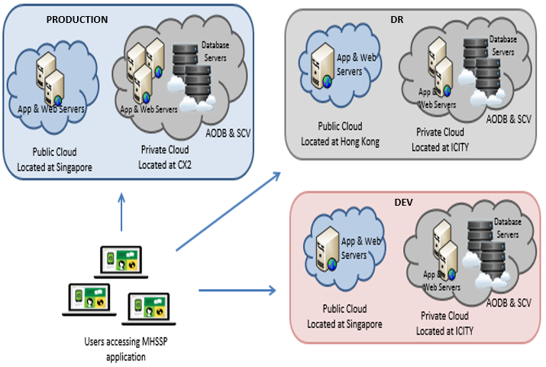
Figure 2 - Production, DR and Development environments isolation

INTERFACES

User Interfaces
MHSSP System has the below application modules with corresponding URLs:

Sl. No. | Apps | Application URL(PROD)
1 | Insurance Confirmation Letter | https://mhselfservice.malaysiaairlines.com/admin/#/login  https://mhselfservice.malaysiaairlines.com/user/#/home/userForm/
2 | Travel Advisory | https://www.iatatravelcentre.com/travelinformation.php
3 | eQMB | https://mhselfservice.malaysiaairlines.com/user/#/baggageMissing
Table 5 – Modules and Access URLs

The MHSSP portal was developed to automate the existing manual services that are offered by MAB to their passengers

- Insurance Module

Passengers can generate the insurance letter for this module for delayed and cancelled flights. The insurance module gets the basic info from the passenger and validates if the information provided and if valid then it generates the insurance letter for the passengers.

- Travel Advisory Module

Passengers can use the portal for gaining knowledge of on relevant details such as traveling documents required before they travel to a country. Portal also provides the frequent asked question and answers on the travel related details

- Mishandled Baggage Questionnaire Module

Passengers can use the portal raising e-MBQ requests online. Passengers can now fill-up the details of the mishandled baggage via the e-MQB form and submit the same online. The module will email the submitted e-MBQ form to MLO Team for further processing.

NOTE: Any lost/damaged/pilfered checked baggage must be reported immediately upon arrival at the Mishandled Baggage Office, before leaving the airport. In the unlikely event that your checked baggage is lost and is not found within 3 days from the date your report is submitted to the Mishandled Baggage Office the e-MBQ form(via the MH Self Service portal) can be submitted via MHSSP Portal.

System Interfaces
SCV System has the below user Interfaces:
No | Interfaced system | Description | Data access mode
1 | Passenger data from SCV | Daily bookings and updates of PNRs will be available in SCV | JDBC calls
2 | Flight data from AODB | Flight Delay, Cancellation related information | JDBC calls
Table 6 – System Interfaces

WARRANTY AND MAINTENANCE PERIOD

Warranted Items | Start Date | End Date
Linux Servers Hardware maintenance by Hitachi. | Renewal from last maintenance contract | 31 May 2021
SCV application maintenance by AMS support team | November 2017 | 30 Sep 2018
Postgres 11.5 AS maintenance by Postgres. Renewal from last maintenance contract. | Renewal from last maintenance contract
Tivoli Monitoring and Tivoli TSM | Enterprise License Agreement
Table 7 – Warranty and Maintenance

ROLES AND RESPONSIBILITIES

Role | Responsibility | Name | Company / Department | Contact (Phone & Email)
Application SME | Responsible for ID creation, modification, deletion and review of user access | Ranjith T | Tata Consultancy Services | +60176430341
Database Admin | Responsible for Database configuration and monitoring system performance | Abhinav Kishore | Tata Consultancy Services | +60173764522
Table 8 – Roles and Responsibilities
*Note: Proper handover must be performed if there is any change to the above roles and the matrix will be updated accordingly.

TECHNICAL SPECIFICATIONS

Server Details
Application (s) | Location | Hostname | IP Address | Environment | Server Function
MHSSP | MAHK (Public Cloud-Hongkong) | MAHK-2MHSSPAPP1 | 10.222.4.15 | DR | Application
MHSSP | MAHK (Public Cloud-Hongkong) | MAHK-2MHSSPWEB1 | 10.222.2.9 | DR | Web
MHSSP | MASG (Public Cloud- Singapore) | MASG-1MHSSPAPP1 | 10.221.4.51 | PROD | Application
MHSSP | MASG (Public Cloud- Singapore) | MASG-1MHSSPWEB1 | 10.221.2.13 | PROD | Web
MHSSP | MASG (Public Cloud- Singapore) | MASG-3MHSSPAPP1 | 10.221.12.26 | UAT | Application
SCV DB | Azure(public cloud singapore) | 1scvpgdb.mas.net | 10.221.6.50 | PROD | Database
SCV DB | CX2 (Private Cloud-CyberJaya) | CX2-1SCVDB2 | 10.223.6.49  10.223.37.26  10.223.6.52 | PROD | Database
SCV DB | Azure(public cloud singapore) | 3scvdb1.mas.net | 10.221.14.22 | UAT | Database
Table 9 – Server Information

Hardware Specifications:
Below are the server hardware specifications allocated for MHSSP application

Hostname/Application(s) | Azure VM Size | OS Version | CPU | Memory (GB) | SWAP (GB)
MAHK-2MHSSPAPP1 / MHSSP | Standard DS2 v2(2 cores, 7 GB memory) | RHEL 7.2 | 2 | 7 | 8
MAHK-2MHSSPWEB1 | Standard DS2 v2(2 cores, 7 GB memory) | RHEL 7.2 | 2 | 7 | 8
MASG-1MHSSPAPP1 / MHSSP | Standard DS2 v2(2 cores, 7 GB memory) | RHEL 7.2 | 2 | 7 | 8
MASG-1MHSSPWEB1 | Standard DS2 v2(2 cores, 7 GB memory) | RHEL 7.2 | 2 | 7 | 8
MASG-3MHSSPAPP1 / MHSSP | Standard A2_v2 (2 cores, 4 GB memory) | RHEL 7.2 | 2 | 4 | 8
CX2-1SCVDB1 | NA | RHEL 7.2 | 4 | 24 | 24
CX2-1SCVDB2 | NA | RHEL 7.2 | 4 | 24 | 24
ICTY-2SCVDB1 | NA | RHEL 7.2 | 4 | 36 | 40
ICTY-3SCVDB1 | NA | RHEL 7.2 | 4 | 20 | 12
Table 10 – Server Hardware Specifications

Software Specifications
No | Software | Specification
 | Application & Database Server Operating System | RHEL 7.2
 | Monitoring application | Tivoli 6.2
 | Programming Language - UI | Java, Webservices & JSP, JavaScript
 | Programming Language - DB | PL/SQL
 | Front-end | IE 8+, Firefox 5+, Chrome 18+, Safari 5+, Opera 9+
 | Database | Postgres 11.5
 | Operating System | Windows
 | Application | Tomcat 8.5.9
 | Webserver | Apache 2.4.23
Table 11 – Server Software Specifications

Communication / Network Specification

No | Category | Configuration
 | Protocol | Server: TCP/IP  Client: TCP/IP
 | Webservice | EAI - B2B
Table 12 – Communication Specification

The below image(Figure 3) shows the distribution of SCV Production, DR and development environment resources in MAB private and public cloud. The image also shows how the user to system interaction is occurring in MAB network.

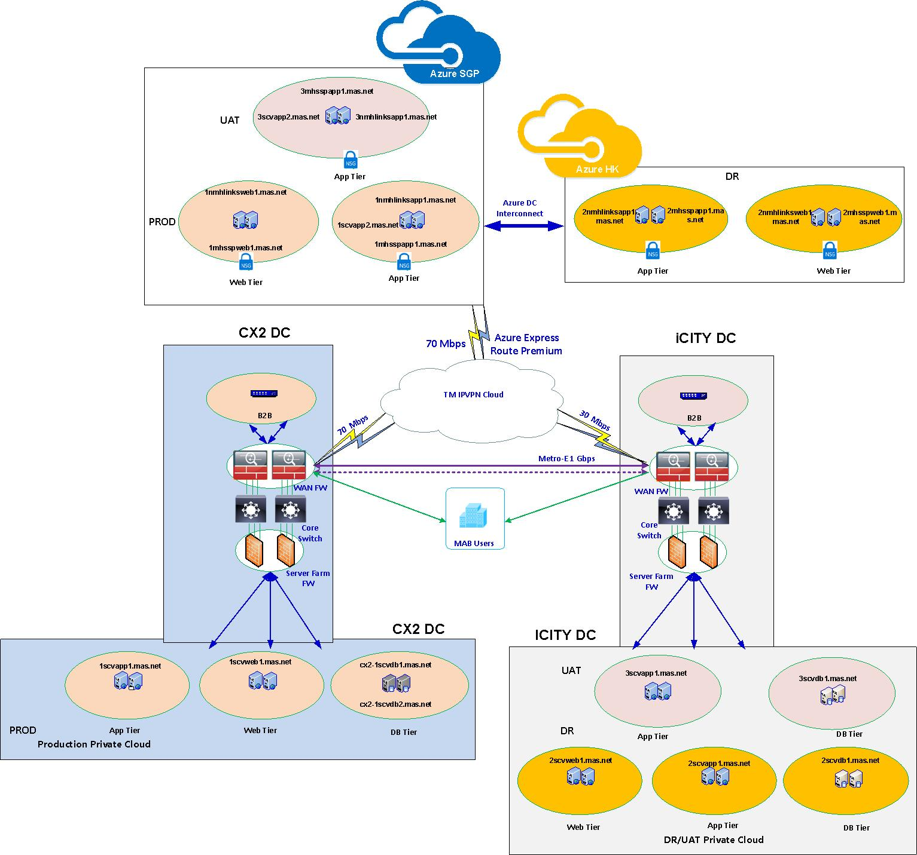
Figure 3 – Network and Server connectivity

User and Equipment Locations
Users need an appropriate browser to access the application. Supported browsers are listed in Section 4.2.

File Management

LIBRARIES AND FILES | LOCATION (MOUNT POINT)
Apache | /usr/local/apache
Tomcat | /tomcat
Application IDs home directory | /home/appadmin  /home/tomcatadmin
Table 13 – File Management

TECHNICAL OPERATIONS GUIDE

Backup and Recovery
Database backup will be taken daily. In case of any disruption, system can be recovered to older date.
Azure Public Cloud: Recovery Services vault is an entity that stores all the backups and recovery points that have been created over time. The vault also contains the backup policies that will be applied to the virtual machines being backed up. When the Recovery services initiates a backup job at the scheduled time, it triggers the backup extension to take a point-in-time snapshot. The Azure Recovery service uses the VMSnapshot extension in Windows, and the VMSnapshotLinux extension in Linux. The extension is installed during the first VM backup.Once the Azure Backup service takes the snapshot, the data is transferred to the vault. To maximize efficiency, the service identifies and transfers only the blocks of data that have changed since the previous backup. When the data transfer is complete, the snapshot is removed and a recovery point is created.
Private Cloud Servers: Commvault Backup

- Application Back-up:

Hostname / Application(s) | Backup Type | Frequency | Schedule Time (MYT) | Retention / No. of Versions | Remarks
MASG-1MHSSPAPP1 / MHSSP | Full | Every Saturday | 5:30 PM | 6 Versions | Monthly first Saturday backup retention is 2 months
MASG-1MHSSPWEB1 | Full | Every Saturday | 5:30 PM | 6 Versions | Monthly first Saturday backup retention is 2 months
MAHK-2MHSSPAPP1 / MHSSP | Full | Every Saturday | 8:00 PM | 5 Versions | Monthly first Saturday backup retention is 2 months
MAHK-2MHSSPWEB1 | Full | Every Saturday | 8:00 PM | 5 Versions | Monthly first Saturday backup retention is 2 months
MASG-3MHSSPAPP1 / MHSSP | Full | Every Saturday | 5:30 PM | 4 Versions | Monthly first Saturday backup retention is 2 months
Table 14 – Application Backup Frequency

- Database Back-up:

Type | Server Name | IP Address | Schedule |  | Retention
 |  |  | Full Backup | Tape Backup | Days
DB | CX2-1SCVDB1(SCVU) | 10.221.6.50 | Daily 2100 | Daily Every 3 hrs | 15
Table 15 – Database Backup Frequency

Monitoring Tools
MHSSP Production Server and Processes are monitored by SCOM. Refer to TEC Events escalation procedure for more details.

Batch Jobs
N/A

Report Management
N/A

Baseline Performance Information
No. | Activity | Expected Response Time
1. | Average time to generate response to requests | < 5 seconds
2. | Average time taken to load each page | < 5 seconds
Table 16 – Baseline Performance
Acceptable down time during operation hours is based on BCD 3 plan.

MAINTENANCE AND SUPPORT
This section provides information to Help Desk personnel who are expected to receive problem or error reports from the users.

Problem Logging
The Help Desk personnel should ask the users:
For a screenshot of the error/issue that they are facing
For the steps that need to be performed to recreate the error/issue
To check the same steps to recreate the error/issue on another machine
To check if others are also facing the same error/issue

Problem Categorization and Escalation Matrix
Problem Category | Severity Level | Problem Description | Escalation
System Completely Unusable | 1 | Page not loading | AMS - SCV
Functionality Completely Unusable | 2 | Part of the applications functionality | AMS - SCV
Minor Functionality Error | 3 | The application as a whole is working but some small functionality is not working | AMS – SCV
Cosmetic UI Error | 4 | The application and the concerned functionality is working but the UX is erroneous/misleading | AMS – SCV
Table 17 – Escalation Matrix
No. | Type of support | Contact Details
1. | Level 1:  IT Helpdesk | (006) 03 8777 2222  Helpdesk@malaysiaairlines.com
2. | Level 2: Application  SITO-SCV | SITO-SCV: +6 017 6430 341  GD_TCS_MHSCV@malaysiaairlines.com
3. | Level 2: System & Network Infra_Midrange & Database | Midrange: 1800817802 #3  GD_TCSMidrange@malaysiaairlines.com  Database: 1800817802 #1  GD_TCSDatabase@malaysiaairlines.com
Table 18 – Support Contact Information

Application / Technical Support

Support Team | Team Members | Contact Numbers
AMS – SCV | Ranjith  Senthil Kumar | HP: +60 176430341  Desk: +603 8777 2854  HP: +60 14233 7329  Desk: +603 8777 2852
Table 19 – Technical Support

USER GUIDE
NA

Accessing the Application
Users can access the application using the below URL

No | Application Name | Application Production URL
1 | MHSSP | https://mhselfservice.malaysiaairlines.com/admin/#/login  https://mhselfservice.malaysiaairlines.com/user/#/home/userForm/
Table 20 – Application Access

CONTRACT MANAGEMENT

No. | Contract | Parties
1. | Solution Delivery Contract | Signed between MAB and TCS
2. | Maintenance Contract | Signed between MAB and TCS
Table 21

HANDOVER ITEMS
The following documents/items will be handed over to Operations together with this System Operation Document during the Handover session:
- Technical Design Document
- Test Plan

INFORMATION SECURITY

Audit and Compliance Requirements

Activity | Frequency | Responsible Party
Perform ID review every quarter and submit result to IRS | Quarterly | ID Admin
Update user access matrix and submit to IRS | Yearly | System Owner
Install Critical Security Patches for the application and submit report to IRS | Quarterly | System Owner
Performed Backup restoration | Yearly | System Owner
Table 22 – Audit and Compliance

Password Policy Compliance
No. | Password Policy Requirements | Yes | No | Remarks
 | Password length at least 8 characters (minimum) | Yes |  | Uses LDAP authentication for login
 | Alphanumeric | Yes
 | Change temporary password at first logon | Yes
 | Password expiry = 90 days (maximum) | Yes
 | Password reuse generation = 5 (minimum) | Yes
 | Account lock out after 5 failed login attempts | Yes
 | Application shall disconnect or suspend inactive sessions= 15 Minutes | Yes
 | Wrong password shall be recorded in an audit log | Yes
Table 23 – Password Policy Compliance

DOCUMENTATION AND REFERENCES

No. | Document | Location and reference
1. | System Operation Document | https://mabitdept.sharepoint.com/sites/MyPulse/InformationTechnology/ServiceDeliveryManagement/
2. | Interface Control Document | https://mabitdept.sharepoint.com/sites/MyPulse/InformationTechnology/ServiceDeliveryManagement/
3. | User Guide | https://mabitdept.sharepoint.com/sites/MyPulse/InformationTechnology/ServiceDeliveryManagement/
Table 24 – Documentation and References

AppendiX

- DR PROCEDURE

  - Roles and Responsibilities

Role | Responsibilities
MAB IT Helpdesk | - As single point of contact to coordinate when MHSSP problems occurred.
MHSSP Application Administrator  (Infra) | - Responsible for identifying failed resources in Main site or disaster site.  - Responsible for following DR procedures to activate MHSSP DR procedure for disaster recovery  - Responsible for maintaining DR site systems in the event of disaster  - Responsible for backup and recovery MHSSP systems in the event of disaster.
MHSSP Application Support  (AMS) | - Responsible to support System Administrator during the disaster recovery process.  - Responsible to verify MHSSP has been successfully switched to the DR site and vice-versa after reverting to the normal production state.
PG Database Administrator  (Infra) | - Responsible to support MHSSP Application Administrator during the disaster recovery process.  - Responsible to verify MHSSP PG DB has been successfully switched to the DR site and vice-versa after reverting to the normal production state.
DNS Administrator  (Infra) | - Responsible to support MHSSP Application Administrator during the disaster recovery process.  - Responsible to change the DNS for MHSSP upon switching to DR and vice-versa after reverting to the normal production state.
Tivoli Administrator  (Infra) | - Responsible to support MHSSP Application Administrator during the disaster recovery process.  - Responsible to ensure MHSSP is monitored.
MHSSP User Support  (FRA) | - Responsible to organize end-users during the switching of MHSSP PROD to MHSSP DR and vice-versa.  - Responsible to validate business transaction and data in MHSSP DR during the disaster and MHSSP PROD after reverting to actual production site.

  - Disaster Recovery Procedure
In the event of a disaster or service is unavailable for an estimated period longer than BCD requirement, the following activities will be activated:

Step | Procedure | Responsible
1 | Inform all party concern on switching to DR. If this is a planned activity, inform via e-mail, otherwise via phone call and e-mail. | - Midrange SDM  - SCV Application Administrator
2 | Verify Production DB and APP servers in MASG/CX2 still accessible / running. | - MHSSP Application Administrator  - Infra-Database
3 | Shutdown Production Application in MASG/CX2 | - MSSP Application Administrator
4 | Failover database from MASG/CX2 to MAHK/ICITY (Production to DR) | - Infra-Database
5 | Change DNS to point DR server  flightdisrupt.mas.net  flightinfo.mas.net  1scvdb.mas.net  scv.mas.net | - Infra-Midrange  - SCV Application Administrator
6 | Change mhselfservice.malaysiaairlines.com DNS to point DR server in Akamai | - Infra-Midrange
7 | Mount file systems in DR application servers  Mount file systems in DR web servers | - Infra-Midrange
8 | Start tomcat application and apache web server in DR | - Infra-Midrange
9 | Verification | - MHSSP Application Administrator
10 | Request Key Users to verify and confirm MHSSP application is running smoothly in MAHK/ICITY | - MHSSP User Support Team
11 | Officially broadcast to BU and relevant support via e-mail that SCV is now on DR (MAHK/ICITY) | - MHSSP Application Administrator
12 | Take daily full RMAN backup if the system’s in DR site has operated more than 2 days (if the servers in PROD site in MASG/CX2 are not available/not accessible) | - MHSSP Application Administrator  - DBA

  - Reverting from Disaster Recovery site (MAHK/ICITY) to Production Site (MASG/CX2)
Once the Production site and SCV servers in MASG/CX2 are available for reverting from DR site (MAHK/ICITY), the following procedures will apply.

Note: Once the Production site and SCV servers in MASG/CX2 are available, start the DB replication from SCV DR (MAHK/ICITY) to SCV PROD (MASG/CX2). This is to minimize the RPO i.e. time taken to revert and recover data from DR.

Step | Procedure | Responsible
1 | Inform all party concern on switching back to PROD in MASG/CX2. This should be a planned activity, inform via e-mail. | - Mid-range SDM  - MSSP Application Administrator
2 | Shutdown DR Application in MAHK/ICITY | - MHSSP Application Administrator
3 | Switch over database from MAHK/ICITY to MASG/CX2 (DR to Production) | - Infra-Database
5 | Change DNS to point Production server  flightdisrupt.mas.net  flightinfo.mas.net  1scvdb.mas.net  scv.mas.net | - Infra-Midrange  - MHSSP Application Administrator
6 | Change mhselfservice.malaysiaairlines.com DNS to point DR server in Akamai | - Infra-Midrange
7 | Mount application file systems in DR APP server  Mount application file systems in DR Web server | - Infra-Midrange
8 | Start application in Production | - MHSSP Application Administrator  - Infra-Midrange
9 | Verification | - MHSSP Application Administrator
10 | Request Key Users to verify and confirm MHSSP application is running smoothly in MASG/CX2 | - MHSSP User Support Team
11 | Officially broadcast to BU and relevant support via e-mail that SCV is now on Production (MASG/CX2). | - MHSSP Application Administrator
12 | Enable DB replication from MASG/CX2 to MAHK/ICITY (Production to DR) | - MHSSP Application Administrator  - DBA
13 | Unmount application filesystems in DR APP server  Un-mount application file systems in DR Web Server | - Infra-Midrange

RELEASE MANAGEMENT REPORT

S.No. | Change Request | Implementation Date | Change Description | Document Version
1 | CHG0011224 | 20-10-2017 | To change the MHSSP UI as per MH Website | 1.0
2 | CHG0011544 | 29-11-2017 | To create a new self-service option in MHSSP called "Travel Advisory" | 1.0
3 | CHG0011955 | 15-03-2018 | To create a new self-service option in MHSSP called "eQMB" | 1.0
4 | CHG008517 | 26-02-2021 | Oracle to Postgres Migration | 1.0
Table 25 – Release Management Report

PATCH MANAGEMENT REPORT

Application : ____NIL__________________________________________________

Owner : ____NIL__________________________________________________

Date | Patch / Service Pack Applied
NIL | NIL
Table 26 – Patch Management Report

Prepared By: Approved By:

.................................................... ....................................................
System Admin System Owner

BACKUP RESTORATION REPORT

Application : ______NIL________________________________________________

Owner : ______NIL________________________________________________

Date | Status of Restoration
NIL | NIL
Table 27 – Backup Restoration Report

Prepared By: Approved By:

.................................................... ....................................................
Backup Admin System Owner

NON COMPLIANCE REPORT

Application : _______NIL_______________________________________________

Owner : _______NIL_______________________________________________

Date | Reference Number | Description
NIL | NIL | NIL
Table 28 – Non Compliance Report

Prepared By: Approved By:

.................................................... ....................................................
System Admin System Owner

END OF DOCUMENT

