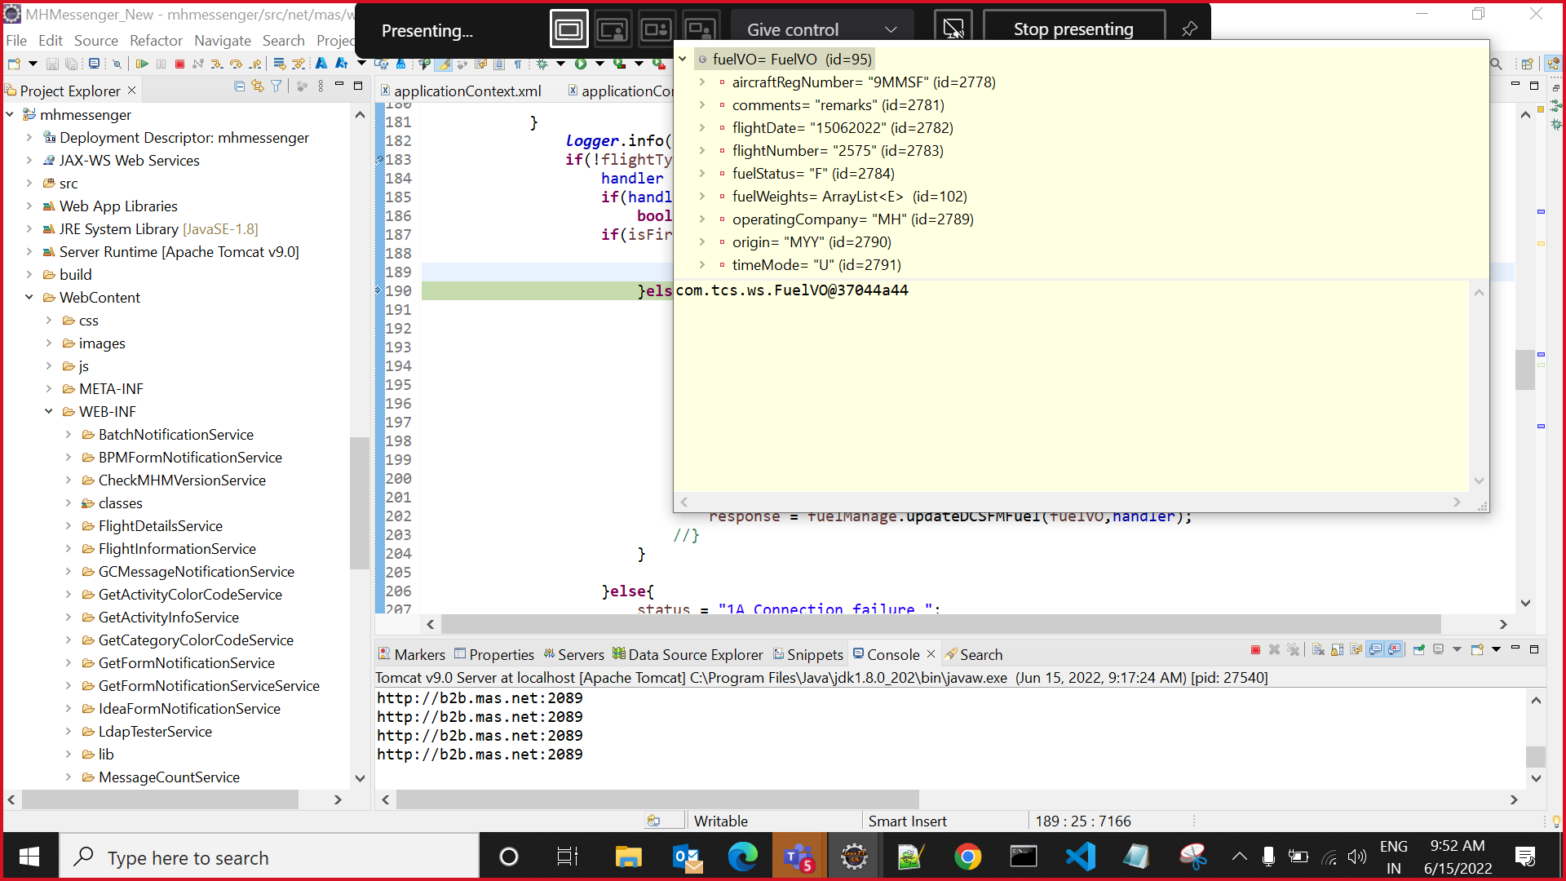

{request=null, response=null, errorTrace=[Ljava.lang.StackTraceElement;@2b3d35f7, error=Unexpected error. Please contact System administrator}

