**BAGGING**

This code attached to this assignment is an extension of the Decision Tree assignment. It extends the same code to create k Decision Trees where k is the number of bags specified during run-time.

**The Bagging Procedure:**

1. The records are read from the training file. Randomly sampled examples from the training file are saved into k different files. Each of these files are temporarily saved into the same folder as the original training file.
2. Each of these individual temporary training file creates its own decision tree using the Assignment 1 code.
3. The result set obtained from each of these decision trees are compared. The majority class for a particular example is evaluated and the accuracy is populated.

Since Decision Tree is an unstable classifier Bagging improves the accuracy of Decision Tree considerably.

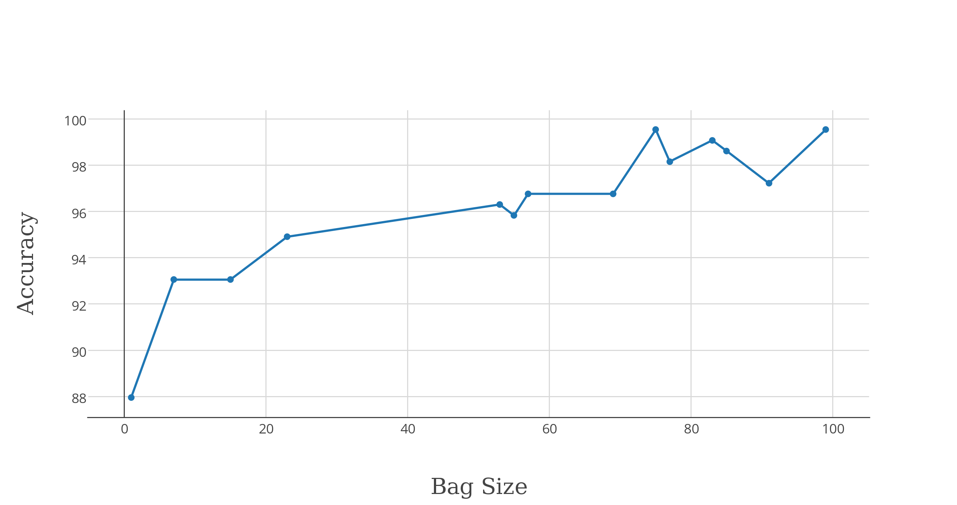

**A plot showing change in accuracy with change in bag size for train-1.dat and test-1.dat:**