**MINISTRY OF THE HIGHER AND SECONDARY SPECIAL**

**EDUCATION OF THE REPUBLIC OF UZBEKISTAN**

**THE ACADEMIC LUCEUM OF UZBEKISTAN STATE WORLD**

**LANGUAGES UNIVERSITY**

**COURSE WORK**

**INTRODUCTION TO THE SPECIALTY OF THE OFFICE MANAGEMENT.BASIC CONCEPTS AND TERMINOLOGY**

**DONE BY: LATIFBEKOVA SABINA DAVRONBEK QIZI**

**TEACHER: KHAYITOVA MUATTAR ADHAMOVNA**

**TASHKENT-2022**

**CONTENTS**

**WHAT IS THE OFFICE MANAGEMENT?..................................... 3**

**TYPES OF OFFICE MANAGEMENT JOBS……………………… 5**

**SIX BASIC COMCEPTS OF THE OFFICE MANAGEMENT........6**

**WHAT ARE OFFICE MANAGER QUALITIES?.............................9**

**WHAT IS THE TERMINOLOGY?....................................................12**

**WHAT IS THE OFFICE MANAGEMENT?**

Office management involves the planning, design, implementation of work in an organization and its offices. This includes creating a focused work environment, and guiding and coordinating the activities of office personnel to achieve business goals. These activities are evaluated and adjusted to improve and maintain efficiency, effectiveness, and productivity.

The focus of this definition is on the personnel because the road to an efficient workplace is paved with hardworking, efficiently managed individuals. Office managers are often responsible for desk space, supplies, office or administrative budget, staff training, arranging travel, and managing other facility staff. A successful office manager in any field must understand the behavior and needs of their employees, so they can learn how to best motivate their workers with the appropriate incentives.

Office management is used within various fields, although there are many similarities across the board. Each office management job contains specific aspects that set them apart from the rest.

The success of a business depends upon the efficiency of its office. The volume of paper work in offices has increased due to industrialization, population explosion, government control and application of various tax and labour laws. Efficiency and effectiveness, which are keywords in management are achieved only through proper planning and control of activities, reduction of office costs and coordination of all activities of business.

An office without organization is unthinkable. Office management is needed in all organizations. It manages support services of various departments in the organization. No organization can run effectively without efficient office management.

Office management helps to maintain a close relationship between the different departments and people. It regularly supplies order, command and instruction to different people. Office management helps in increasing office efficiency, smooth flow work, maintaining public relations, minimization of cost, managing and accepting the new challenges which help in achievement of goals of the organization.

The office Manager uses a human and non-human recourse for the achievement of the business objective. In systematically managed office, the manager develops systems and procedures to make effective use of the resource. It helps to reduce wastage of time, resource and misuse of the resource also for maximum utilization of it.

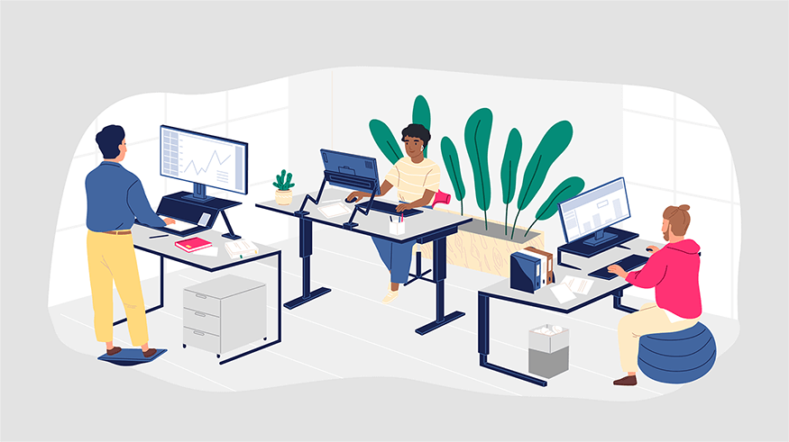

The office works as a coordinate of different unit of business and people. It regularly supplies updated information to required people and department. Regular communication avoids conflict, misunderstanding. Therefore, office management promotes coordination.

Office management plays important role in keeping the organization alive. Change in technology and methods must be anticipated and adapted for survival and growth. It is only management which can to do so molds the enterprise in such changing environment.

Today’s business environment is continuously changing. Office management is well dynamic concept. It will collect the information regarding changes in the environment and suggest them to apply in business. Systematic office management promotes research and development to address changes in the market. Systematic management is always adopting new changes and it has appropriate facilities.

**TYPES OF THE OFFICE MANAGEMENT JOBS**

There are a variety of office management jobs, however, the basic duties of these managers are quite similar. Besides supervising the smooth running of a company's administration, making sure that needed supplies are provided and that office equipment is in working order, office managers can sometimes hire, fire, train, and promote employees.

**CORPORATE OFFICE MANAGEMENT**

Corporate office management jobs include the manager at each branch of a given company. The district manager (typically located at the head office) oversees all other branch managers, therefore traveling between company branch locations is often a main aspect of the job. Additionally, corporate office managers plan new organizational approaches for human resources and marketing campaigns.

**MEDICAL OFFICE MANAGEMENT**

Medical office management requires detailed knowledge of anatomy and lab procedures, as well as health care laws. Medical office managers typically work in doctor's offices, where they supervise all medical assistants. Additional crucial responsibilities include patient confidentiality and the proper disposal of medical waste.

**LEGAL OFFICE MANAGEMENT**

Legal office management jobs require practical law experience and an extensive understanding of law procedures. Law office managers oversee a practice's legal administrative assistants, payroll management, and the firm's human resources department.

**VIRTUAL OFFICE MANAGEMENT**

Rather than work for one business at a time as a full-time employee, virtual office managers often work for several smaller companies part-time. This is due to the tendency of small businesses to contract out virtual office management jobs. It's no surprise that remote jobs of all caliber are on the rise, therefore virtual office managers are an attractive option for steadily growing small businesses that don't yet require an on-site office manager.

**6 BASIC COMCEPTS OF OFFICE MANAGEMENT**

**1.PLANNING.**

Creating a structure of the responsibilities required to achieve the objectives of your company is a key function of office management. When you fully recognize the short and long term goals of your respective business, you can then plan your approach to achieving the goals. Detailed planning and meeting organization is the first step toward efficient operations and facilitating control.

**2.ORGANIZING RESOURCES.**

Organizing resources walks hand in hand toward achieving company goals with planning. These resources include materials, personnel, and financial backing. The next stage after planning for office managers is task delegation, such as identifying which materials are necessary and assigning those materials to chosen personnel. The best office managers consistently coordinate tasks in order to keep these resources moving toward planned goals.

**3.STAFFING.**

Another key responsibility of the office manager is staffing. Executive office managers run lead or coordinate with human resources on all matters of staffing recruitment, compensation, promotion, and retirement of subordinate managers.

**4.COMMUNICATION**.

Effective communication, a staple of any high-functioning operation, is a necessary factor of office management. If an office manager is unable to properly dictate the needs of the company to its employees, then optimum efficiency will not be possible. Does one team need a certain sized meeting space to hold their weekly meetings? Do they have the technology they need in that space? Remember, good communication goes both ways. If this same office manager is unable to articulate the needs of your company, then the issue may be that this office manager is not a good fit for your organization. Effective communication, a staple of any high-functioning operation, is a necessary factor of office management. If an office manager is unable to properly dictate the needs of the company to its employees, then optimum efficiency will not be possible. Does one team need a certain sized meeting space to hold their weekly meetings? Do they have the technology they need in that space? Remember, good communication goes both ways. If this same office manager is unable to articulate the needs of your company, then the issue may be that this office manager is not a good fit for your organization.

**5.WORKING WITH IT.**

Modern office managers use technology quite a bit on the job. They may use software for their own day to day role and also help to manage the software and technology for employees. Perhaps your company uses digital facilities management software. Office managers also work with the IT department to ensure that all meeting rooms are running smoothly, and should be trained on all video conferencing technology and WIFI connection for employees and guests.

**6.MOTIVATION**.

A highly complex factor of office management, motivation comes in two forms. Self-motivation and external motivation. When your employees are self-motivated, the job of the office manager is made easier. But when they are not, that is where the job of office management is to externally motivate. This motivation should satisfy the employees' needs while being competitive, productive, and comprehensive. When external motivation does all of this, your office workers will have high morale and be more likely to improve their performance.

Office managers are some of the few people who interact with every level of employee, either virtually or face-to-face every day. As office cultures around the world continue to expand and shift, the significance of the office manager role will increase.



**WHAT ARE OFFICE MANAGER QUALITIES?**

Office manager qualities are the soft and hard skills that help an office manager do their duties. An office manager is tasked with managing the day-to-day operations of the office and the development of certain skills can make them more

effective in their role. These skills help them facilitate the daily responsibilities of the office, ensuring that everything runs smoothly and efficiently.

Learning to recognize these important skills will help you choose an effective

Office manager that maintains the efficiency and organization of an office.

In addition to the skills needed for a specific industry, it is also helpful for office managers to have the following qualities:

**1. OPTIMISM**

An office manager is not only the person who maintains the organization of the office, but they are also in charge of leading the team and are often the first person a customer communicates with when visiting. Office managers who are optimistic tend to be more communicative, friendly and welcoming. They tend to have a more positive outlook and their optimism can directly affect the culture and morale of the company.

**2. COMMUNICATION**

Communication skills are critical when working as an office manager. Nonverbal communication skills will help with providing clear directions to team members and customers. Verbal communication skills can help an office manager effectively understand the needs of team members and be able to translate them to the management team. Office managers are also often involved in reporting policy

changes to team members. Good communication skills are needed to maintain open communication and ensure all important information is shared. These communication skills can also help provide clear direction to employees, so they know exactly what is expected of them. In addition to strong communication skills, the ability to communicate with team members of all levels is important as an office manager, as they will usually work with store-level employees, as well as management.

**3. FLEXIBILITY**

The day-to-day operations and typical workday for an office manager can frequently change and having a flexible office manager can be useful. Not only does this help the rest of the office transition to new requirements, but it can also help the office stay on track, despite these changes. Additionally, the office manager may need to accommodate numerous work styles, both with team members and management, and being flexible can help them adjust to these differences.

**4. CREATIVITY**

Creativity is often overlooked but can provide many benefits to an office. Creativity skills can help an office manager come up with unique solutions to problems. By bringing a creative mindset to office discrepancies or issues, they can improve the morale of the office and implement a fresh approach. This can also help to keep other staff members motivated. Additionally, they set the tone for a creative work environment.

**5. TIME MANAGEMENT**

Managing time is another important quality of an office manager. The ability to set, and maintain, schedules will help them complete projects within the specified

timeline. Good time management skills can also help the office manager learn when

to delegate tasks within a project. They are also more likely to be on time for scheduled meetings or other important work events.

**6. ORGANIZATION AND PROJECT MANAGEMENT**

An office manager may be in charge of multiple projects at one time. The ability to multi-task and maintain organization among busy schedules is beneficial. A good office manager with effective project management skills can delegate tasks, while still following up on progress and ensuring that each project is completed to company satisfaction.

**7. LEADERSHIP**

While leading a team may only be a small part of the office manager's position, it is a crucial one. By choosing an office manager with strong team leadership skills, you know that they will motivate and encourage team members to work efficiently. This can help to maintain company morale, which can help reduce retention rates while encouraging the development of a good team. Leadership skills can also help the office manager collaborate, delegate, guide and lead the team effectively.

**8. DEDICATION**

A good office manager does more than the minimum required. They are dedicated to their job and they often go above and beyond expectations. Choosing an office manager who is not only dedicated but also passionate about the position can help other team members develop the same passion. This dedication can improve many aspects of their position, including interacting with customers and hiring and training staff.

**9. HONESTY**

Honesty is an important quality in all team members but is especially necessary for an office manager. If you have an honest office manager, you can entrust the daily practices of the business to them. You can entrust in them the ability to make important decisions, manage banking information, manage team members in an honest way and trust their opinion on hiring decisions.

**10. FINANCIAL**

Depending on the work environment, an office manager may also be involved in minor financial duties of the office. This means that basic financial and mathematical skills can be helpful. The office manager may need to add up staff hours, payments or they may even be in charge of making deposits at the bank. The office manager may also be tasked with compiling data from the accounting team to create reports.



**WHAT IS THE TERMINOLOGY?**

Terminology is the language used to describe a specific thing, or the language used within a specific field. **Special language used by scientists** is an example of science terminology. The doctrine of terms; a theory of terms or appellations; a treatise on terms, a system of specialized terms. Terminology plays an important role in the understanding of the contexts and specialized texts. Understanding the intricate terminological details of the technical and scientific context helps students comprehend what the main message of the document is and it helps specialists to transmit the content more effectively. It also develops interests of the formation of the new words and terms. Studying terminology is the foundation of the all subject fields. Apart from creating solutions to the terminological difficulties and the challenges many specialists or non-specialists face, it paves the way for the development of the languages and terminology that improves the quality of communications, either internationally or nationally. Without studying terminology, technicians and specialists would probably never realize how important protecting and maintaining a language is for communicative purposes and cultural identity.



**COMMON TERMS OF OFFICE MANAGEMENT**

1.Account receivables

The amount of money an organization has the right to receive within some specified period (say 30 days) against the delivery of products/services.

2.Bell desk

An extension of front desk that deals with personalized guest services.

3. Cancellation charges

They are the charges borne by the guest on cancellation of a confirmed reservation or for not showing-up on confirmed reservation.

4.Concierge

Information desk that assists guests for transportation, booking of events outside the hotel.

5.GRC

Guest Registration Card, which the guest needs to fill in with personal formation at the time of registration.

6.IP-PBX

Internet Protocol Private Branch Exchange, where internet protocol is used for call transmission.

7.OHMS

Online Hotel Management System, a software system to manage all back-office operations of a hotel.

8.Non-guest

Customer of a hotel business not being served at the moment.

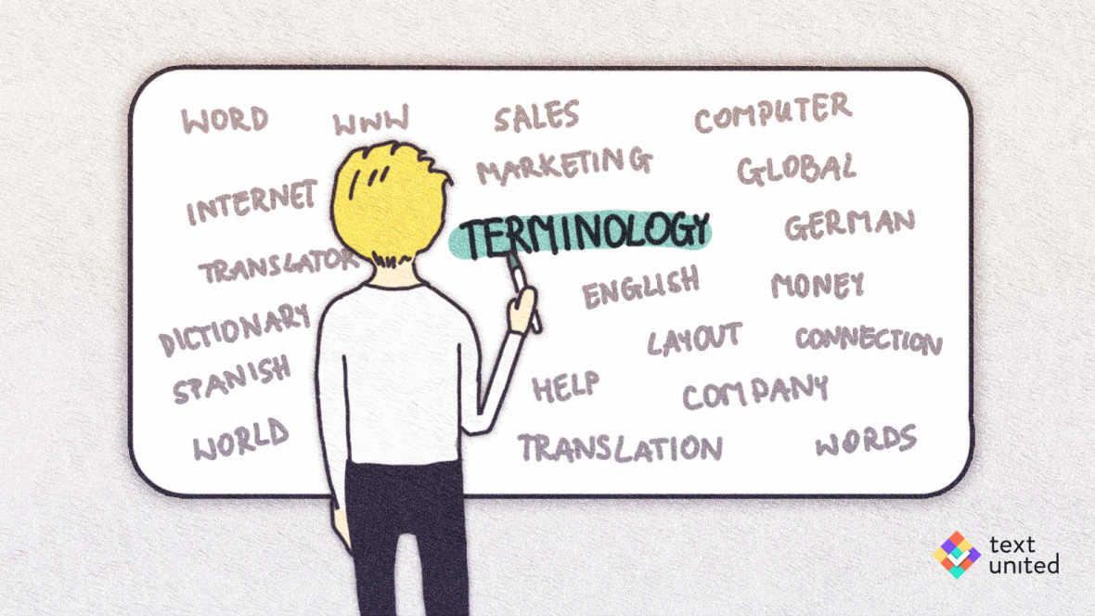

9.No-show

A guest who has reserved an accommodation neither turns up nor cancels it.

10. Uniformed services

Personalized services provided to the guests.

Sources:

<https://terminosophyblog.wordpress.com>

[https://www.tutorialspoint.com](https://www.tutorialspoint.com https://resources.owllabs.com/blog/office-management)

[https://resources.owllabs.com/blog/office-management](https://www.tutorialspoint.com https://resources.owllabs.com/blog/office-management)