**Software Requirements Specification**

**Exam Grades Management System**

**Version 1.0 approved**



**This work was based on the submissions of the project of the course Software Engineering (CS223) and was prepared by**

**Sohail Khan (B16CS036)**

**Aniket Parate (B16CS023)**

***Software Requirements Specification for Exam Grades Management System*** ***Page iii***

**Table of Contents**

|  |  |  |
| --- | --- | --- |
| **Table of Contents ........................................................................................................................** | | **iiii** |
| **Revision History ..........................................................................................................................** | | **iiii** |
| **1. Introduction ..............................................................................................................................** | | **1** |
| 1.1 | Purpose ............................................................................................................................................ | 1 |
| 1.2 | Product Scope .................................................................................................................................. | 1 |
| 1.3 | Glossary ........................................................................................................................................... | 1 |
| 1.4 | References ........................................................................................................................................ | 1 |

|  |  |  |
| --- | --- | --- |
| **2. Overall Description ..................................................................................................................** | | **1** |
| 2.1 | Product Functions ............................................................................................................................ | 1 |
| 2.2 | Use Case Diagram ........................................................................................................................... | 2 |
| 2.3 | Class Diagram .................................................................................................................................. | 3 |
| 2.4 | Activity Diagram ............................................................................................................................. | 4 |
| 2.5 | Sequence Diagram ........................................................................................................................... | 7 |
| 2.6 | Assumptions and Dependencies ...................................................................................................... | 9 |

|  |  |  |  |
| --- | --- | --- | --- |
| **3.** | **System Requirements ..............................................................................................................** | | **9** |
|  | 3.1 | Use Case Description ....................................................................................................................... | 9 |
|  | 3.1.1 | Login ............................................................................................................................................... | 9 |
|  | 3.1.2 | Register ......................................................................................................................................... | 10 |
|  | 3.1.3 | Modify Profile .............................................................................................................................. | 10 |
|  | 3.1.4 | Edit Profile .................................................................................................................................... | 10 |
|  | 3.1.5 | Select Courses ............................................................................................................................... | 11 |
|  | 3.1.6 | Put Marks ...................................................................................................................................... | 11 |
|  | 3.1.7 | Modify Grades .............................................................................................................................. | 11 |
|  | 3.1.8 | View Stats ..................................................................................................................................... | 12 |
| **4.** | **Non- functional Requirements ..............................................................................................** | | **12** |

**Revision History**

|  |  |  |  |
| --- | --- | --- | --- |
| **Date** | **Version** | **Description** | **People** |
|  |  |  |  |
|  |  |  |  |
| 18-02-18 | 1.0 | First Draft | Aniket Parate |
|  |  |  | Sohail Khan |
|  |  |  |  |
| 11-03-18 | 2.0 | Update draft | Sohail Khan |
|  |  |  | Aniket Parate |
| 24-04-18 | 3.0 | Final Version | Sohail Khan |
|  |  |  | Aniket Parate |
|  |  |  |  |

***Software Requirements Specification for Grades Management System***

***Page 1***

**1. Introduction**

**1.1 Purpose**

This software package is developed from scratch exclusively for Indian Institute of Technology, Jodhpur in order to

To enable student to view their marks and grades any time from their home. No need to meet the professors personally.

To enable faculty to upload marks and submit grades from his/her office. No need to mail and wait it to be forwarded to all mailing groups.

To manage the complete grading process without any third managing authority.

**1.2 Product Scope**

The scope of student Grade Management System is

To provide faculty with an easy way to submit grades. To allow student to quickly access their grades.

This system can be implemented in every institute to smoothen the grades management process.

**1.3 Glossary**

|  |  |
| --- | --- |
| Student | The user who would be studying in the institute where the system will be |
|  | implemented. |
| Faculty | The user who would be teaching any of the courses in the institute where |
|  | the system would be implemented. |

**1.4 References**

The following references are used in preparing this SRS

The SRS Template and Sample sent by the faculty. Wikipedia.

***Software Requirements Specification for Grades Management System***

***Page 2***

**2. Overall Description**

**2.1 Product Functions**

This software package is expected to offer the following services:

1. For Student:
   1. Facility to view and modify their personal details.
   2. Facility to add their enrolled courses.
   3. Facility to view their marks, grades and pointers.
2. For Faculty:
   1. Facility to view and modify their personal details.
   2. Facility to add their teaching courses.
   3. Facility to add student’s marks, grades and pointers.

**2.2 Use Case Diagram**

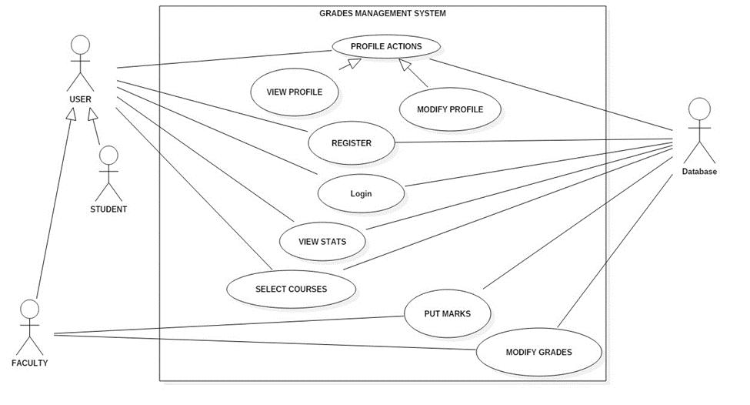

***Software Requirements Specification for Grades Management System***

***Page 3***

**2.3 Class Diagram**

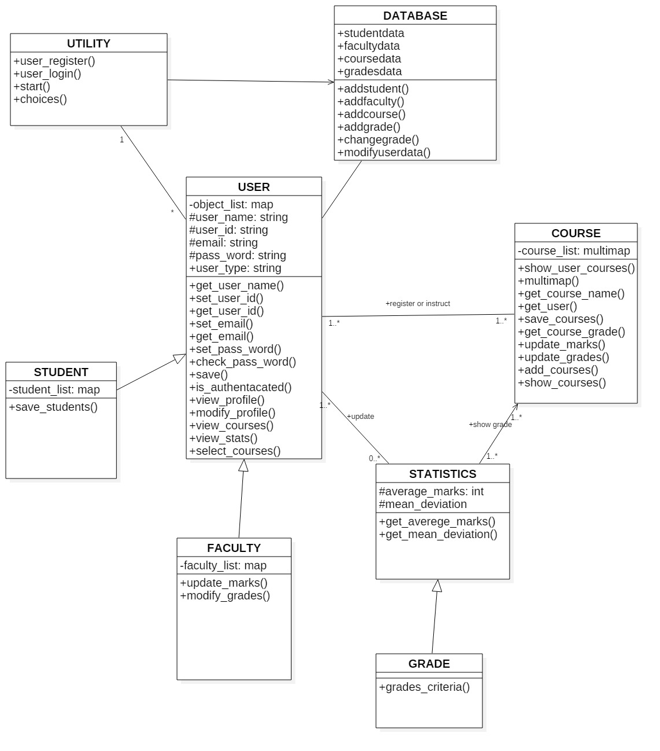

***Software Requirements Specification for Grades Management System***

***Page 4***

**2.4 Activity Diagram**

1. Activity diagram for login/register activity

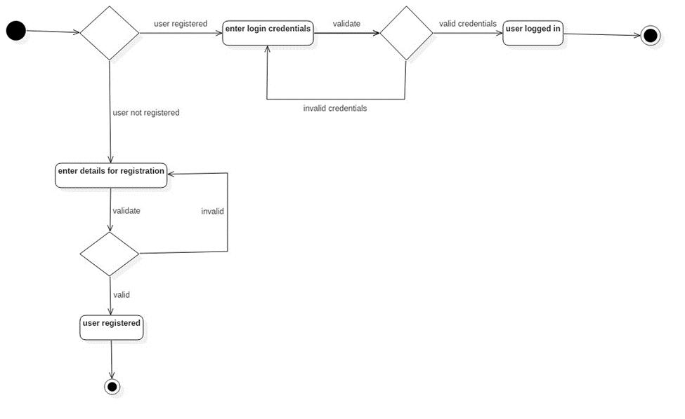

***Software Requirements Specification for Grades Management System***

***Page 5***

2.Activty diagram for update marks / modify grades Precondition is that the user is registered and is faculty.

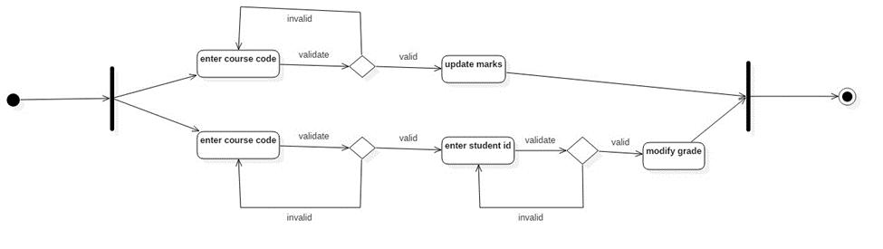

***Software Requirements Specification for Grades Management System***

***Page 6***

3.Activity diagram for view statistics activity after the registered user is logged in.

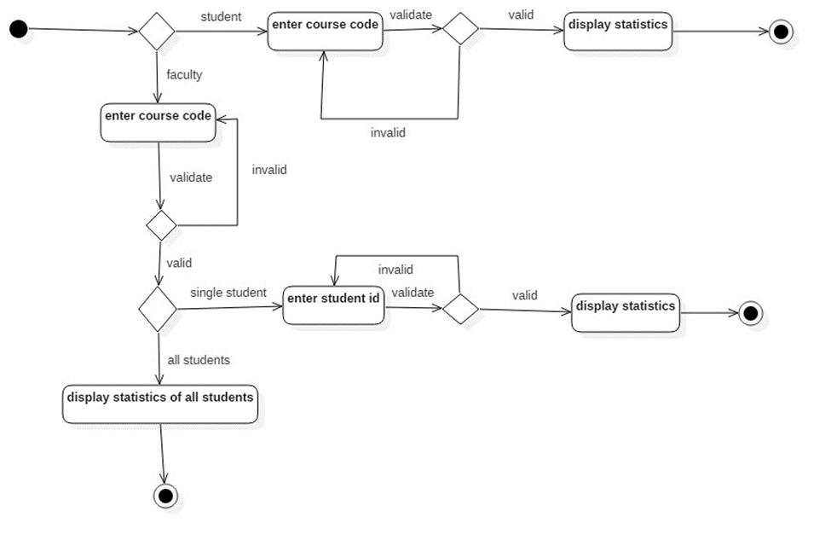

***Software Requirements Specification for Grades Management System***

***Page 7***

**2.5 Sequence Diagram**

1. Sequence Diagram for view Grades.

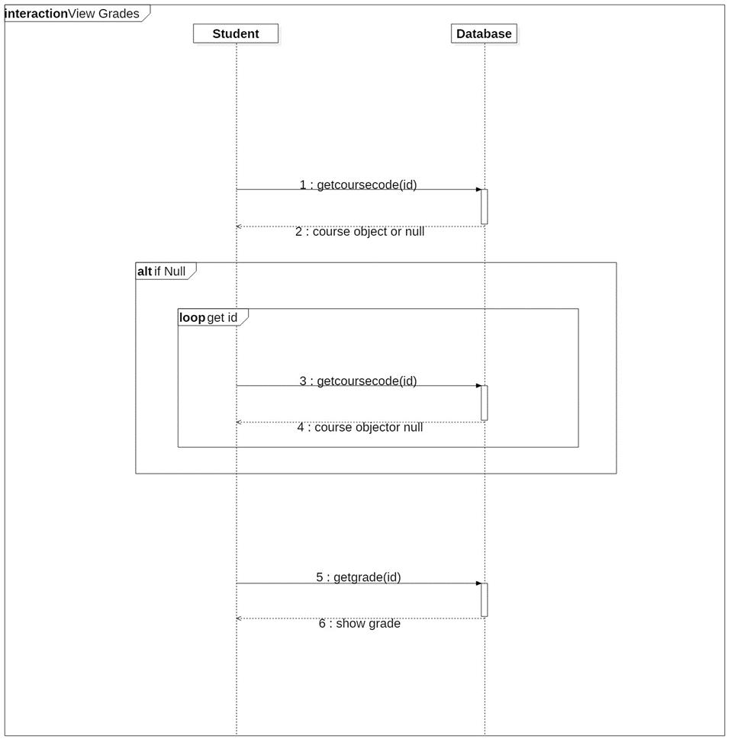

***Software Requirements Specification for Grades Management System***

***Page 8***

2. Sequence diagram for Grades update

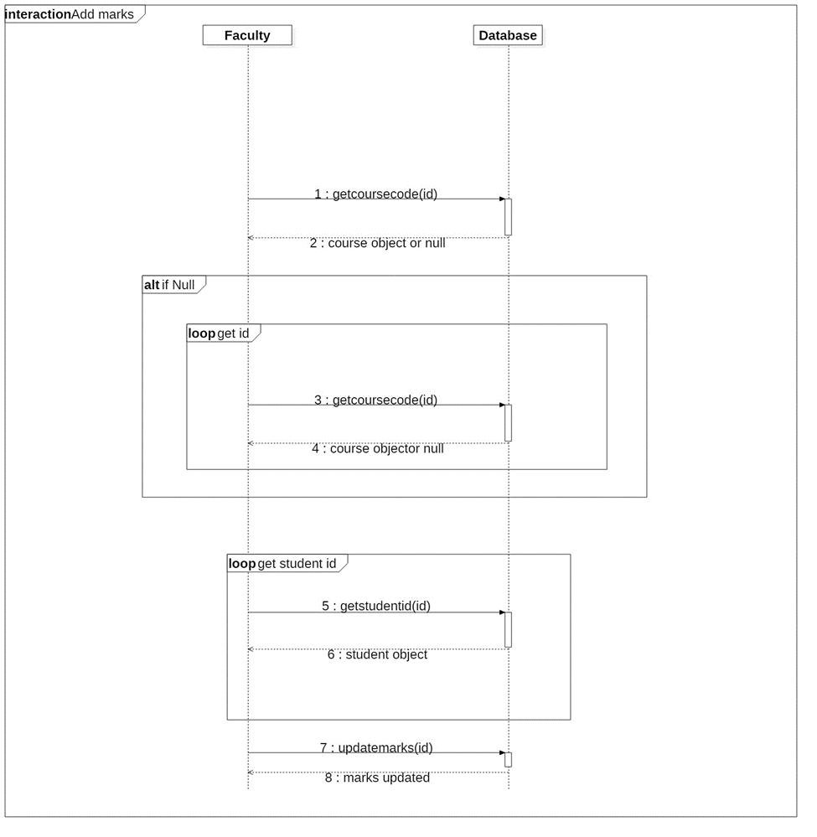

***Software Requirements Specification for Grades Management System***

***Page 9***

**2.6 Assumptions and Dependencies**

* 1. The list of courses to be selected by both faculty and students is provided at the start of the semester.
  2. Grades should be given to each students registered in a particular course.
  3. The following are the valid grades: A,B,C,D,F.
  4. Grades are calculated by the following formula A- Marks > [average marks + 1.5*(mean deviation)]

B- Marks between [average marks + mean deviation] and [average marks + 1.5*(mean deviation)]

C- Marks between [average marks] and [average marks + mean deviation] D- Marks between [average marks – mean deviation] and [average marks] E- Invalid grade

F- Marks less than [average marks – mean deviation]

1. **System Requirements**

The requirements for the student Grade Management system are as following:

**3.1 Use Case Description**

**3.1.1 Login**

|  |  |
| --- | --- |
| Use Case Name | Login |
| Actors | Student, Faculty, Database |
| Trigger | User fills the login credentials. |
| Precondition | The User must be registered. |
| Basic Path | User enters its user ID and Password. |
| Alternative Path | No alternative path. |
| Post Condition | The user is taken to his profile page. |
| Exception Paths | All fields must be filled. |
| Others | None |

***Software Requirements Specification for Grades Management System***

***Page 10***

**3.1.2 Register**

|  |  |
| --- | --- |
| Use Case Name | Register |
| Actors | Student, Faculty, Database |
| Trigger | User chooses register option. |
| Precondition | The User must have an institute LDAP |
|  | credential. |
| Basic Path | User enters his details. |
| Alternative Path | No alternative path. |
| Post Condition | The user is registered successfully. |
| Exception Paths | All fields must be filled. |
| Others | None |

**3.1.3 Modify Profile**

|  |  |
| --- | --- |
| Use Case Name | Modify Profile |
| Actors | Student, Faculty, Database |
| Trigger | User chooses modify profile option from his |
|  | profile action menu. |
| Precondition | The user must be logged in. |
| Basic Path | User enters his updated personal details. |
| Alternative Path | No alternative path. |
| Post Condition | The user is taken (back) to his profile page. |
| Exception Paths | All fields must be filled. |
| Others | None |

**3.1.4 View Profile**

|  |  |
| --- | --- |
| Use Case Name | View Profile |
| Actors | Student, Faculty, Database |
| Trigger | User chooses view profile option from his |
|  | Profile action menu. |
| Precondition | The user must be logged in. |
| Basic Path | Database retrieves user information. |
| Alternative Path | No alternative path. |
| Post Condition | The user is taken to his profile page. |
| Exception Paths | None. |
| Others | None |

***Software Requirements Specification for Grades Management System***

***Page 11***

**3.1.5 Select Courses**

|  |  |
| --- | --- |
| Use Case Name | Select Courses |
| Actors | Student, Faculty |
| Trigger | User chooses select courses option. |
| Precondition | The user must be logged in. |
| Basic Path | User chooses enrolled/teaching courses from |
|  | the list of courses. |
| Alternative Path | No alternative path. |
| Post Condition | User gets the list of enrolled/teaching courses. |
| Exception Paths | None |
| Others | None |

**3.1.6 Put Marks**

|  |  |
| --- | --- |
| Use Case Name | Put Marks |
| Actor | Faculty, Database |
| Trigger | User chooses put marks option. |
| Precondition | The user must be logged in. |
| Basic Path | User selects the course from the list of |
|  | teaching courses and then enters marks in the |
|  | database. |
| Alternative Path | No alternative path. |
| Post Condition | Database stores the marks of selected courses. |
| Exception Paths | All fields must be filled. |
| Others | None |

**3.1.7 Modify Grades**

|  |  |
| --- | --- |
| Use Case Name | Add Grades |
| Actor | Faculty, Database |
| Trigger | User chooses modify grades option. |
| Precondition | 1. The user must be logged in. |
|  | 2. The user must put marks. |
| Basic Path | User select the course from the list of teaching |
|  | courses and then enters grades for all |
|  | students(by id). |
| Alternative Path | No alternative path. |
| Post Condition | Database stores the grades of selected courses. |
| Exception Paths | None |
| Others | None |

***Software Requirements Specification for Grades Management System***

***Page 12***

**3.1.8 View Stats**

|  |  |
| --- | --- |
| Use Case Name | View Stats |
| Actor | Student, Professor, Database |
| Trigger | User chooses view stats option. |
| Precondition | 1. The user must be logged in. |
|  | 2. Faculty must put marks. |
| Basic Path | User select course from the list of selected |
|  | courses and Database retrieves stats of the |
|  | courses selected. |
| Alternative Path | No alternative path. |
| Post Condition | User gets the stats of the selected courses. |
| Exception Paths | None |
| Others | None |

**4. Non-functional Requirements:**

1. The system is supposed to provide a platform for grades management thus it shall be scalable to the institute level.
2. Sufficient network bandwidth is required for all the functions to work smoothly.
3. System should be efficient enough to handle all the students at the same time.