Project Report

On

Resturant Management Desktop Application



Supervisors

Sir Sarfaraz Natha
Miss Mahwish

Submitted By

Muhammad Shaharyar Ilyas 2014-CE-200
Dawood Shamim 2014-CE-02
Marium ziaduddin 2014-CE-10

1. Introduction Error! Bookmark not defined.
1.1 Objective Error! Bookmark not defined.
1.2 Scope Error! Bookmark not defined.
2. Problem Statement & Technological backgroundError! Bookmark not defined.
2.1 Problem Area Error! Bookmark not defined.
2.2 Analysis & Soloution Of Problem Error! Bookmark not defined.
3. User Guide Error! Bookmark not defined.
3.1 Cashier Login…………………………………………….
3.2 Admin Login………………………………………………..
4. DIAGRAMTIC ILLUSTRATION Error! Bookmark not defined.
5. System Designing Error! Bookmark not defined.
6. REQUIREMENT Error! Bookmark not defined.
7. Software USED Error! Bookmark not defined.
8. LANGUAGES Error! Bookmark not defined.
9. SCHEMA……...……………………………………
10. ERD………………………………………………………..
11. NORMALIZATION……………………………………………
12. USE CASE DIAGRAM……………………………………
13. SCREEN SHOTS………………………………………….
14. CONCLUSION…………………………………………………

Preface

This Report has been written by M.Shaharyar , Dawood Shamim & Marium Ziauddin of Computer Engineering under the supervision of Sir Sarfraz Natha

We would like to thank to our supervisors Sir Sarfraz Natha for their valuable comments and advices for this project.

We would also like to thank Miss Mahwish for keenly extending their help.

Acknowledgment



I Muhammad Shaharyar with my fellows Dawood Shamim and Marium Ziauddin have taken efforts in this project.
However, it would not have been possible without the kind support and help of many individuals.
I would like to extend my sincere thanks to all of them.
I am highly indebted to SIR SARFRAZ NATHA for their guidance and constant supervision as well as for providing necessary information regarding the project & also for their support in completing the project who have willingly helped me out with their abilities.

Thanking You!

- INTRODUCTION

  - Objective

The main objective of this project is to develop a Resturant Recipt and Inventry System, which deals with menu , price , calculating and printing receipt.

The system has two parts first for the customers and the other for the management side.

The customer side allows to order and cashier or admin can view menu list according to the time of delivery he desires for that specific time.

The management side the staff is allowed to edit information regarding menu list, price etc.

  - Scope

We are greatly constrained by “Time limitations” as only 14 weeks are given to complete the project. So we limited our scope of project to “front end dealing” only.

The sole purpose of the project is to learn the desktop application development in Java, how databases works for the desktop application and how to co-ordinate Java with databases to produce more commercial desktop applications for daily business.

We will try our best to make better usage of java (swing),Sql and surely all in a better team work.

- PROBLEM STATEMENT

  - Problem Area

Restaurant is a kind of business that serves people all over world with ready made food. Currently this industry is going on with lot of flare. People feel more comfortable with lot of variations in the selection and consumption of their food in their busy life.

For each booking he has to register manually on paper and puts the order in a queue with specific priority according to time and quantity,

There are lots of areas to be solved for current restaurants using modern IT World. Many areas come like human resource management, accounts management, etc.

  - Problem Analysis & Solution

Software is design to do all the inventory work and booking, maintenance record on the finger tip.

It will be easy to manage for both cashier, admin and any higher authority to analysis the complete record of sales and purchase.

Records of costumers can be easily managed.

Stocks of sales and purchase can be easy to managed.

Admin Security is reviewed

3. User Guide & Functions

3.1 Cashier Login

- Multiple order selection
- Quantity management
- Automated price calculation
- Data save
- Receipt generated
- Print option
- About & help

3.2 Admin Panel

- Login security
- View all costumers
- Update price
- Update stock
- View stock

4 Diagrammatic Illustration

User and System Interaction

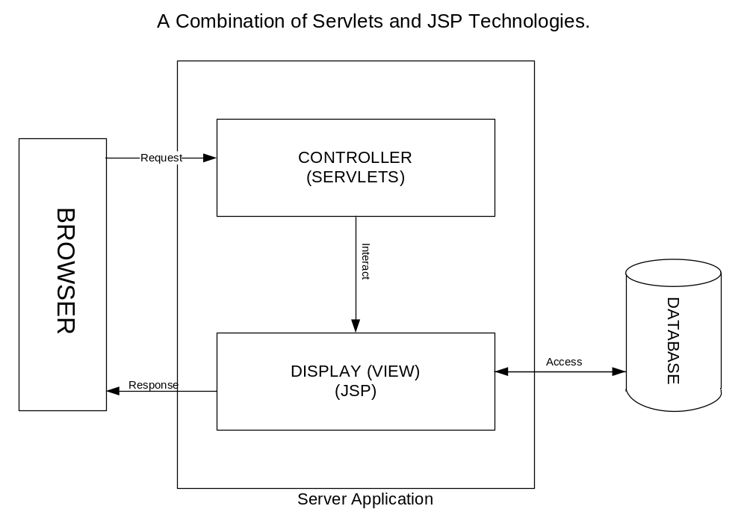
DESKTOP

Desktop > Request > Controller/ Database Server > Response

Database Table Diagram

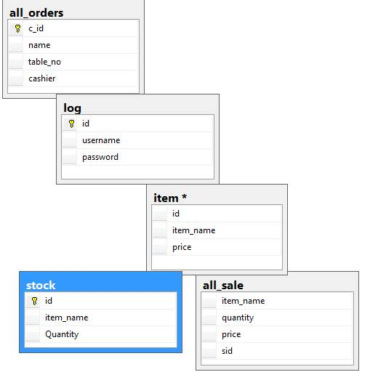

- REQUIREMENT SPECIFICATIONS
- WINDOWS 7 MINIMUM
- 2GB RAM
- 10 GB MINIMUM HARD DRIVE

6 Software Used:
- Net beans IDE
- SQL SERVER 2014

7 Languages:
- Java
- SQL

8 Schema

The structure of a database system, described in a formal language supported by the database management system (DBMS). In a relational database,

the schema defines the tables, the fields in each table, and the relationships between fields and tables.

Schemas are generally stored in a data dictionary. Although a schema is defined in text database language, the term is often used to refer to a graphical depiction of the database structure

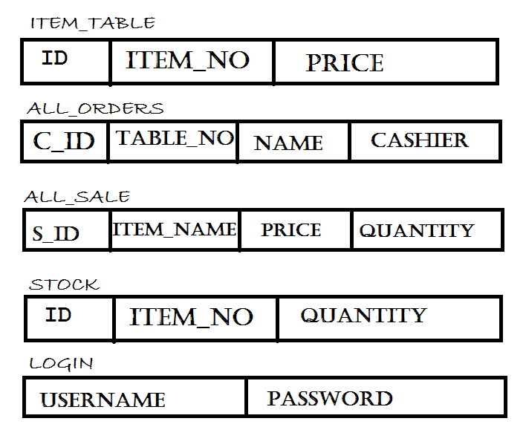

9 normalization

Database normalization is the process of organizing the columns (attributes) and tables (relations) of a relational database to minimize data redundancy.

Normalization involves decomposing a table into less redundant (and smaller) tables without losing information; defining foreign keys in the old table referencing the primary keys of the new ones.
The objective is to isolate data so that additions, deletions, and modifications of an attribute can be made in just one table and then propagated through the rest of the database using the defined foreign keys.

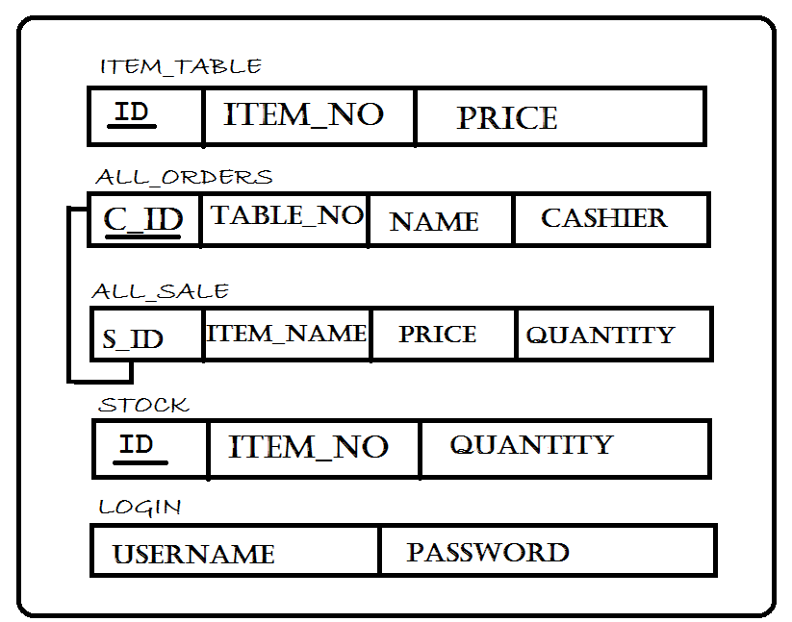
10 ERD

An entity-relationship diagram (ERD) is a data modeling technique that graphically illustrates an information system’s entities and the relationships between those entities.
An ERD is a conceptual and representational model of data used to represent the entity framework infrastructure.
The elements of an ERD are:
- Entities
- Relationships
- Attributes
Steps involved in creating an ERD include:
- Identifying and defining the entities
- Determining all interactions between the entities
- Analyzing the nature of interactions/determining the cardinality of the relationships
- Creating the ERD

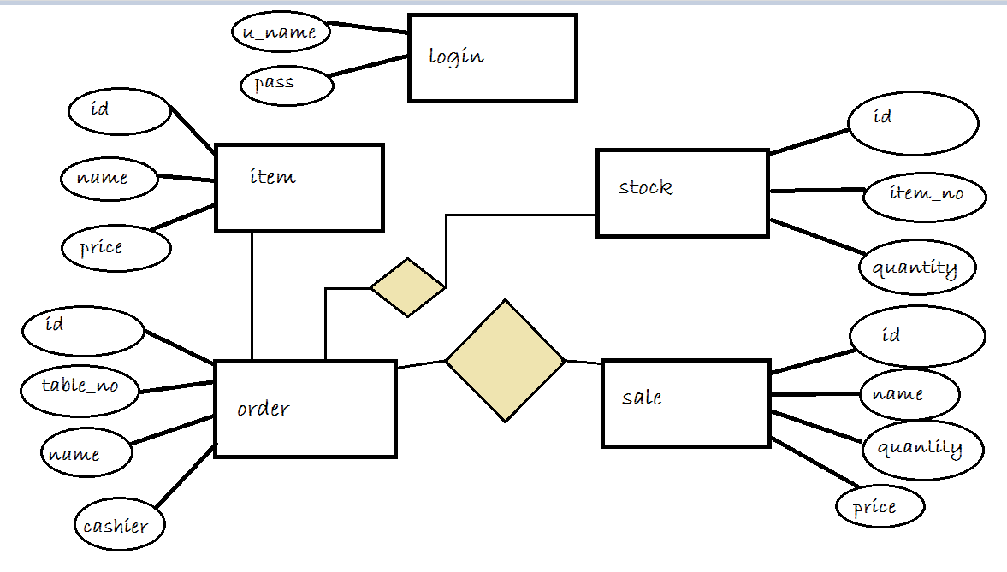
11 Usecase diagram

Use case diagrams are used to gather the requirements of a system including internal and external influences.

These requirements are mostly design requirements. So when a system is analyzed to gather its functionalities use cases are prepared and actors are identified.

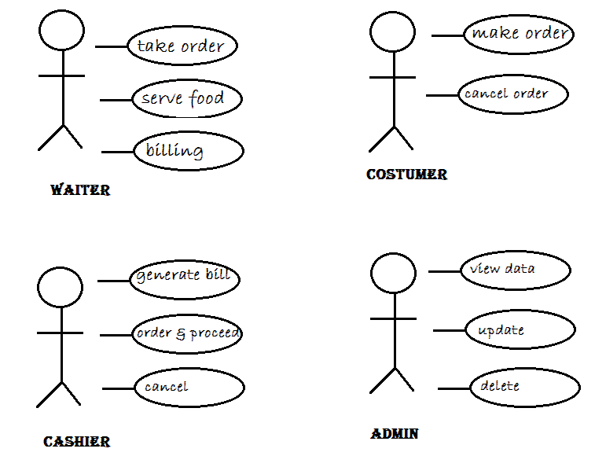

Screen Shots:
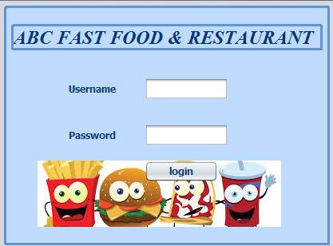

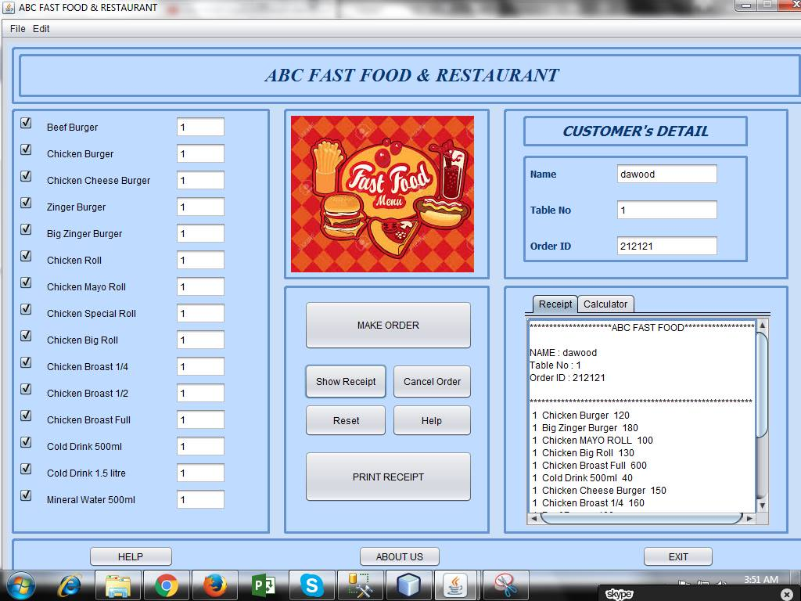
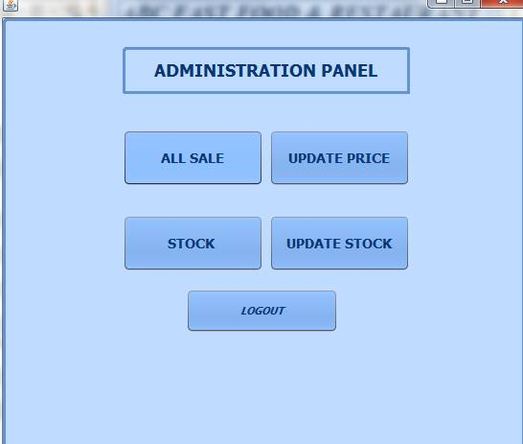

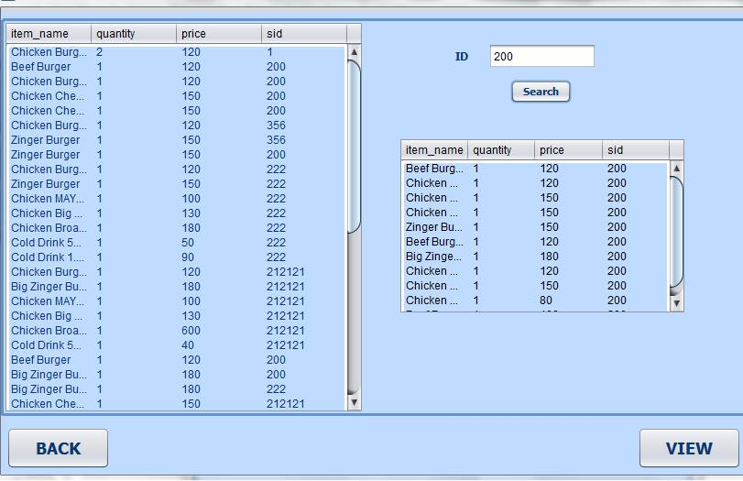

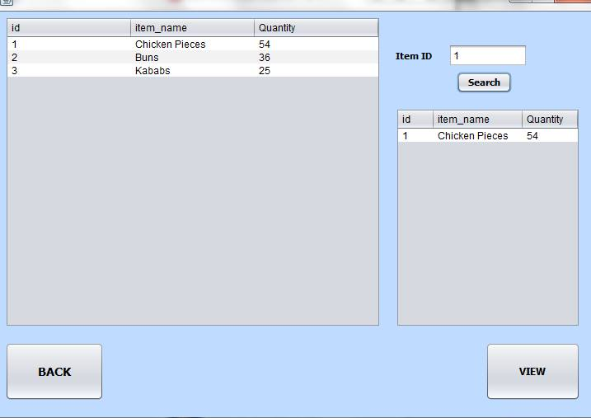

Conclusion:

This project is ready to launch in market as an initial stage or trail version. Throughout the project we have learned a lot about SQL and queries and some concepts of management and accounts. This project give us wise knowledge about the database management system.

