**A New Technique for Automated Presentation Control Using Smart Gesture**

Amit Kumar Verma, Aslam Khan, Anuj Singh, Ramandeep Singh(Assistant Professor)

[kumarverma.amit007@gmail.com](mailto:kumarverma.amit007@gmail.com), [khan.aslam056212345@gmail.com](mailto:khan.aslam056212345@gmail.com), [anujsinghgdic@gmail.com](mailto:anujsinghgdic@gmail.com) , ramandeep.singh@niet.co.in

***Abstract***—Presentations are a vital communication tool used in various fields, including education, business, and research. Effective presentation delivery relies heavily on smooth transitions and audience engagement. Traditional presentation control methods using keyboards, mice, or clickers can be disruptive and hinder the presenter's flow. This article explores a practical use of computer vision technology in controlling presentations through simple gestures, eliminating the need for physical touch inputs. This application becomes particularly valuable in the current post-COVID-19 era where awareness of virus transmission through touch is heightened. Our project leverages media pipe and open CV applications to facilitate this functionality.

**Keywords:** Computer vision, OpenCV, mediapipe, (Human resource Interaction) HRI

**INTRODUCTION**

Presentations are a vital communication tool used in various fields, including education, business, and research. Effective presentation delivery relies heavily on smooth transitions and audience engagement. Traditional presentation control methods using keyboards, mouse, or clickers can be disruptive and hinder the presenter's flow. Existing presentation control methods lack intuitiveness and require the presenter to shift focus away from the audience to manipulate controls. This paper aims to address this limitation by proposing a new technique for automated presentation control using smart gesture recognition. The rising hurdle to creating the optimally presentation is due to several of aspect, including the slide, the keys for changing the slides, and the calm of audience. This paper proposes a novel technique that leverages smart gesture recognition technology to enable hands-free and intuitive presentation control. An intelligent presentation system using hand signals gives a simple way to update or controlling the slides. There are several of pauses during presentations for operating the presentation using the keyboards. The system objective is to enable users to use hand signals for control and exploring the slideshows. The technique using gizmo learning for identify various hand signals for many tasks. A recognition technique offers an interface for human system communicates. The interfaces been developed continuously over the last many years. Constructed a speedy and easy motion picture-based methodology for recognizing vibrant hand signals. This technique grants users to control the demonstrations more naturally, reasonably, and easily.

**RELATED WORK**

Dr. Melanie J. Ashleigh and Damiete O. Lawrence Impact of Human-Computer Interaction was discussed by the author. Users in the Higher Education System a (HCI): Southampton University as A Case Study”. In this paper, Perception in Human-Computer Interaction (HCI) the University of Southampton in the United Kingdom, and the landscape Page No: 02 www.mkscienceset.com Sci Set J of Cardiology Res 2023 of advanced literacy was assessed. The effect of HCI positive, and it's at Southampton University. showed that becoming acquainted with HCI fundamentals increase the effectiveness and commerce of a stoner. In summary, it can be argued that HCI has had an impact on the impact of literacy on another corresponding fields environment [1].

Joshua Patterson and Sebastian Raschka and author Corey Nolet discussed "Machine Learning in Python: Key Innovations and Technological Trends Artificial Intelligence, Machine Learning, and Data Intelligence”. They discussed heavily trafficked libraries and generalizations gathered for comprehensive comparison, with the objective of guiding the anthology's education and Python machine learning is progressing Morris Siu Yung, Xiaoyan Chu, Ching Sing Chai, and Xuesong Zhai Jong, Andreja Istenic, Jia-Bao Liu, Michael Spector, and Jing Yuan and Yan Li's Review of Artificial Intelligence From 2010, intelligence (AI) in education [2]. This research handed a content analysis of research seeking to expose the use of artificial intelligence (AI) in the investigate the implicit exploration in the educational sector AI in education: Trends and Challenges [3].

**LITRATURE REVIEW**

According to a review of numerous alternative methodologies, the primary objective of the researchers is to assist speakers for an effective presentation with improved interaction that comes naturally using a computer The proposal was made by Jadhav & Lobo, who were both static and Together, dynamic gestures and Power Point are used. presentation. to take and identify pictures Utilizing segmentation approach. Additionally, it introduces Motion detection is a slide-changing feature [4]. To Zhou Ren ZhengyouZhang, Junsong Yuan, and Jingjing Meng "Robust Part-Based Hand Gesture" by the author Kinect Sensor Recognition They displayed a powerful hand motion recognition system that is partially grounded use the Kinect sensor Diversity is measured using a new distance metric called Finger Earth Mover's Distance (FEMD). utilizing measure, which depicts the hand as a hand with each piece of the cutlet in a cluster, penalizing the empty cuts in the meat. To be more precise, our FEMD based System for recognizing hand gestures obtains 93.2 mean using the takes 0.0750 seconds per frame and is delicate system for cutting corruption cutlet discovery [5].

The writers of Harika et al. suggested and used a method. employing computer-assisted slide presentations that utilize vision-based gesture detection. methods such as Kalman filter, Skin color sampling and the HSL color model are employed. If we Considering the proposed model's accuracy, Skin color detection has a success rate of around 72.4% overall, single accuracy for fingertip detection is 74.0%, and success rate is 77% of slides move well, and managing the 80% of actions involve pointing the finger [6].

Wahid et al. suggested approached a technique to identify hand gestures by Algorithms for machine learning. If we take precision of this proposed model, The SVM algorithm yielded the most accurate categorization considering both the original EMG 97.56 % of the characteristics and normalized EMG features among NB, RF, KNN, and DA (98.73%) [7].

Authors: Ajay Talele, Aseem Patil, and Bhushan Barse "Detection of Real Time Objects Using OpenCV and TensorFlow. This article described a modern, computer-based vision technology approach for detecting all obstructions in cellular and its bundles, generation. Each pixel in a character picture is categorized as either being a hindrance based completely on the look. This publication introduced a novel method for detecting obstructions using just a webcam electronic camera [8].

**METHEDOLOGY**

A. Block Diagram

B. Method

C. Testing

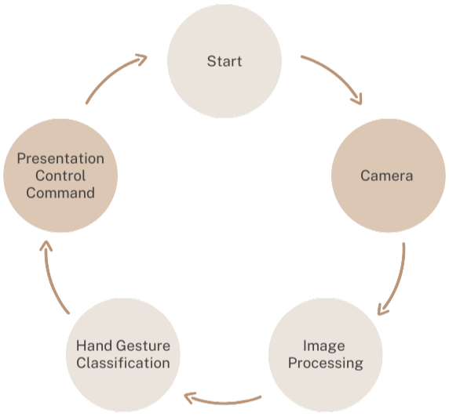

**Figure 1:** Block Diagram

**B. Method**

**1. System Design**

**Gesture selections:** Developing an arrangement of natural and easily remembered hand motions for control different actions during presenting, like assigning different fingers for left/right for navigate, and using multiples fingers for highlight and pointers.

**Hardware Selection:** A laptop with a good webcam.

**Software Selection:** A Python IDE (ex. PyCharm or VS Code) to start your project. OpenCV, MediaPipe, Numpy, OS libraries to develop your project in python.

**2. Software Development**

During the starting point of our software development process, we make the usage of Python next to computer vision libraries like OpenCV and Google MediaPipe for make the module needed for the project.

**Gesture Recognition Module:** In the later step we write the code in IDE to recognise our hand and fingers accurately on the camera.

**Presentation Control Module:** Secondly, we write the code to assign each finger with a specific function to perform a specific task. Now ideally, we have an index number assigned to each finger and each index number can have a value of 0 or 1, meaning 0 for finger down and 1 for finger up. We can adjust the function of each gesture that it triggers. The finger function contains 5 elements in the array for fingers [0,0,0,0,0].

**C. Testing**

**Gesture 1: to next slide [0,0,0,0,1]**

This finger is assigned to change to the next slide.

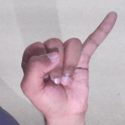

**Figure 2: Gesture 1**

**Gesture 2: to Previous slide [1,0,0,0,0]**

Only the thumb is open in this gesture, whereas the other fingers are all closed. This will change the slide to the previous one.

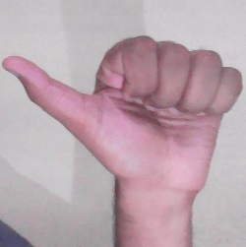

**Figure 3: Gesture 2**

**Gesture 3: to obtain the pointer [0,1,1,0,0]**

In this gesture, the forefinger and middle finger are both open, while the remaining fingers are all closed. This will turn the pointer on.



**Figure 4: Gesture 3**

**Gesture 4: to write on the slides [0,1,0,0,0]**

In this gesture, just the forefinger is open; the other four are all closed. Moving this finger will help you write on slide.

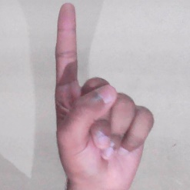

**Figure 5: Gesture 4**

**Gesture 5: Undo [0,1,1,1,0]**

In this gesture, just the forefinger, middle finger, and ring finger are open; all the other fingers are closed. The most recent written part is to be erased with this gesture.

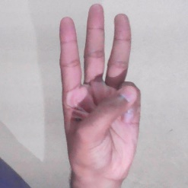

**Figure 6: Gesture 5**

**RESULTS**

To assess how well the system worked, we carried out different tests. Initially, we looked into how accurately hand gestures could be detected and classified. The results showed that the system successfully identified and categorized gestures most of the time, achieving an average accuracy rate of 96%. Following that, we examined how well the system could a presentation through hand gestures. It was observed that the system effectively navigated slides, executing actions like pointers and highlighting the text and undoing it. Below are some of the diagrams of the results.

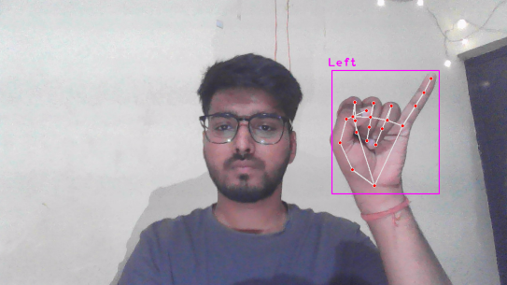

**Figure 8: Next Slide**

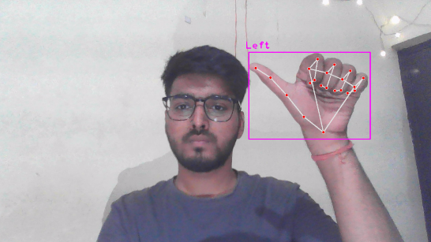

**Figure 9: Previous Slide**

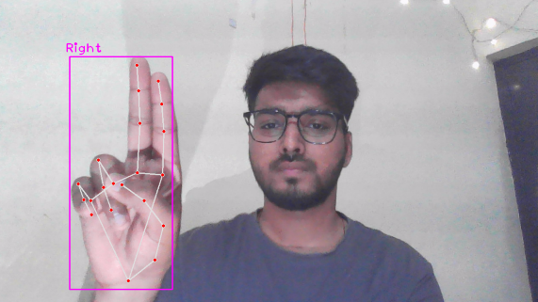

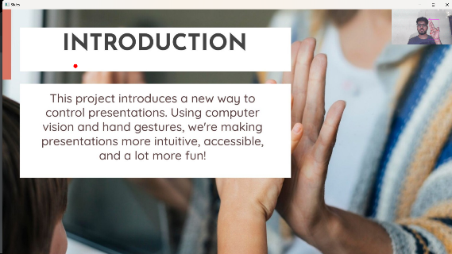

**Figure 11: Pointer/ Cursor Control**

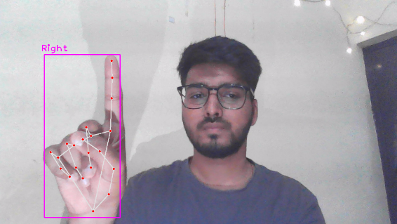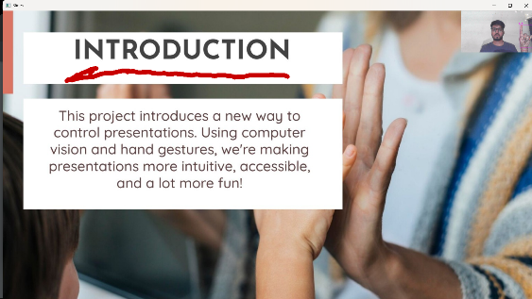

**Figure 12: Highlighting the text**

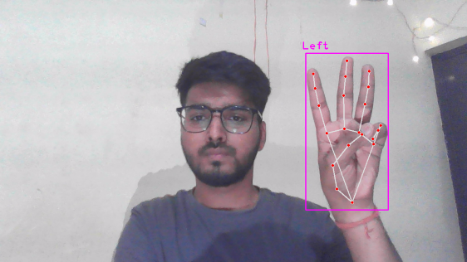

**Figure 13: Undo**

**LIMITATIONS**

The main focus currently is on the distance factor, as the range is limited for detection purposes. Gestures play a crucial role in various fields within computer science. This project utilizes gestures to assist presenters in their presentations and enhance students' experience with Human-Computer Interaction (HCI). Gestures have the ability to manage almost all aspects of our computer systems. By combining gestures with speech recognition, we could create a system that removes the necessity to memorize specific commands or techniques to interact with a machine. Instead, communication could be carried out naturally.

**FUTURE SCOPE**

In various fields, gestures play a vital role and hold significant importance. They represent the future of instant interactions. With the current situation, there is a demand for a more natural way of communicating with computers and technology. When gestures are incorporated, technology assists individuals in interacting with computers more humanely. By incorporating additional movements, we can command computer functions like cut, copy, and paste. Furthermore, we can extend this system to oversee applications like PowerPoint. This technology or algorithm can be applied universally, eliminating the need for multiple methods for each purpose.

**CONCLUSION**

In this document, we introduced A New Technique for Automated Presentation Control Using Smart Gesture. This system was developed using Python and computer vision methods. With this system, presenters can navigate slides with ease by making simple hand movements, creating a user-friendly and instinctive method for managing presentations. By conducting multiple experiments, we showcased the system's efficiency and capabilities. We are convinced that this system has the ability to enhance the presentation experience as a whole and make presentations more interactive and captivating.

**REFERENCES**

1. Lawrence, Damiete O, Ashleigh, Melanie (2019) Impact of Human-Computer Interaction (Hci) on Users in Higher Educational System: Southampton University. A Case Study 6: 1-12.

2. Sebastian Raschka, Joshua Patterson, Corey Nolet (2020) Machine Learning in Python: Main Developments and Technology Trends in Data Science. Machine Learning, and Artificial Intelligence 11: 193.

3. Xuesong Zhai, Xiaoyan Chu, Ching Sing Chai, Morris Siu Yung Jong, Andreja Istenic et al. (2021) A Review of Artificial Intelligence (AI) in Education from 2010 to 2020. 2021: 8812542.

4. Dnyanada Jadhav, L M R J Lobo (2014) Hand Gesture Recognition System to Control Slide Show Navigation. IJAIEM 3: 4.

5. Zhou Ren, Junsong Yuan, Jingjing Meng, Zhengyou Zhang (2013) Robust part-based hand gesture recognition using kinect sensor. IEEE transactions on multimedia 15: 1110-1120.

6. Maisevli Harika, Ary Setijadi P, Hilwadi Hindersah, BongKee Sin (2016) FingerPointing Gesture Analysis for Slide Presentation. Bong-Kee Sin Journal of Korea Multimedia Society 19: 1225-1235.

7. Md Ferdous Wahid, Reza Tafreshi, Mubarak Al-Sowaidi, Reza Langari (2018) An Efficient Approach to Recognize Hand Gestures Using Machine-learning algorithms. MECBME.

8. Ajay Talele, Aseem Patil, Bhushan Barse (2019) Detection of Real Time Objects Using TensorFlow and OpenCV. Asian Journal of Convergence in Technology 5: 1.